

LEVEL 5 ASSESSMENT SPECIFICATION
Module: | Business Inquiry & Research
Module code: | BMSP5007 | Contribution to Overall Module Assessment (%): | 30%
Lecturer: | Dr Alex Bell | Internal Verifier: | Dr Roisin Mullins
Assignment Title: | Assessment 2: Quantitative Study | Word count (or equivalent): | 1500
Submission deadline: | April 29th, 2020 | Return date of provisional marks & written feedback: | 20/05/2020
Submission method: | All written assessments, where practical and possible, must be submitted via Turnitin unless otherwise instructed by the Lecturer. (Please DO NOT put this assessment specification into Turnitin or it will match many similarities with other students’ submissions.)  Alternative submission method (if applicable):  Late submission of the assessment will result in a late penalty mark. Penalties for late submission: Up to one week late, maximum mark of 40%. Over one week late, 0%. Only the Extenuating Circumstances Panel may approve a change to submission dates.
Academic honesty / referencing: | Academic honesty is required. In the main body of your submission you must give credit to authors on whose research and ideas your work is based. Append to your submission a reference list that indicates the books, articles, etc. that you have used, cited or quoted in order to complete this assessment.

Name: Erin Smith

Student number: 1803017

Programme of Study: Outdoor Education

Module: Business Inquiry and Research

Tutor: Dr Alex Bell

Date:

In the business inquiry and research module a survey and data collection of the general public was undertaken about experiences on outdoor adventure activities. To explore if gender, age and/or the weather has an impact on the amount of activities the respondents take part in, another reason was to see whether outdoor activities are truly male dominated or not.

A Google form was used to design the survey, the layout was easy to use and was simple but effective that allowed the participants to have a full understanding on what was required of them. Links via social media were used in order to get a range of participants to take part. The survey was not biased, allowing choice of whom wished to take participate.

By designing and writing a series of questions determining what the participates experiences were of taking part in outdoor education pursuits. The questions ranged from, types of activities, what activities, reasons for those activities and whether or not why they would prefer to go outdoors or stay indoors. Questions were also asked on whether or not the weather had an impact on the amount of time being outside.
Quantitative and quantitate data was collected on age and gender, so in comparing and contrasting data, it is evident how many people took part in a particularly activity and how gender and age impacted on this. 58 responses were received which simplified to 20 overall responses.
The analysis looked at age ranges from 15 or less; 16-20; 21-30; 31-40; 41-50; 51-60 and 61+. The analysis went up in bands of 9s for most of the options; on reflection the 15 or less; or 16-20 should be in the bands of 9s, as this would impact on the data collected because it is not consistent throughout.
The analysis looked at Gender – Male, Female and Other. The data also looked at, if this group had ever taken part in an outdoor activity before? If the multiple choice response was No, what activities would they like to try and why? Those people who chose Yes, were asked what activity/activities were their favourite and why?
The survey also looked at more popular outdoor activity compared to the rest and whether age and gender also had a difference on what type of activity they enjoyed. Questions were also focused on asking about the outdoors as a whole. The survey held multiple choice, tick-boxed questions and an open text-box for comments.

I looked at qualitative and quantative data which looked at using the sample of the 20 responses to the survey. Using an excel spreadsheet, in order to discover raw data and questions. Then inputted onto an SPSS programme so charts could be added and data compared and contrasted.

Table 1
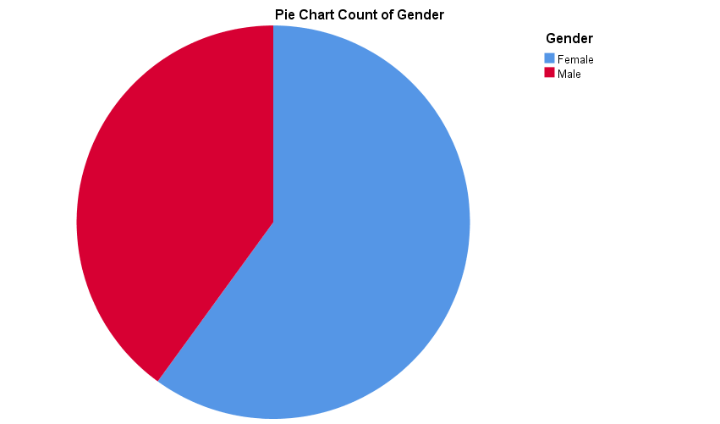
Gender
 |  | Frequency | Percent | Valid Percent | Cumulative Percent
Valid | Female | 12 | 60.0 | 60.0 | 60.0
Valid | Male | 8 | 40.0 | 40.0 | 100.0
Valid | Total | 20 | 100.0 | 100.0

60% females compared to 40% males took part in the survey. From the analysis of the responses more females appeared to be more willing to take part in the survey then males.

Table 2
Age
 |  | Frequency | Percent | Valid Percent | Cumulative Percent
Valid | 16-20 | 9 | 45.0 | 45.0 | 45.0
Valid | 21-30 | 6 | 30.0 | 30.0 | 75.0
Valid | 41-50 | 4 | 20.0 | 20.0 | 95.0
Valid | 51-60 | 1 | 5.0 | 5.0 | 100.0
Valid | Total | 20 | 100.0 | 100.0

Table 2 - 45% of the participants were 16-20 year olds and 30% were 21-30 year olds. On reflection this response rate could be because this age range is similar to the recipient’s generation, it is therefore logical to have respondents in this age range who took part. The remaining 25% participants were in the age ranges of 41-50 and 51-60 (See appendix A).

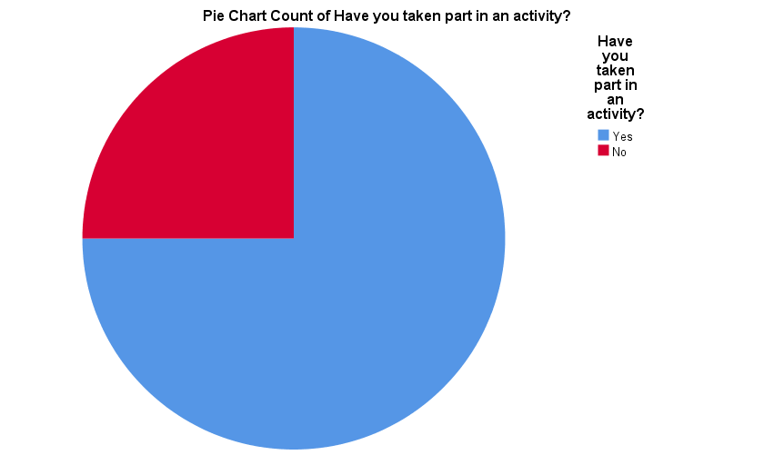
Table 5 (a-d)
Have you taken part in an activity?
 |  | Frequency | Percent | Valid Percent | Cumulative Percent
Valid | Yes | 15 | 75.0 | 75.0 | 75.0
Valid | No | 5 | 25.0 | 25.0 | 100.0
Valid | Total | 20 | 100.0 | 100.0

Table 3 - 75% of people have taken part in an outdoor activity, compared to 25% that have not done any activities (See Appendix B for more analysis).

Table 5 (c)
Column1 | Total percentage who has taken part in an activity
Female | 53%
Male | 47%

The data shows in table 1, more females took part in the survey, if you compare the ratios of males and females, you can see for table 3 (c) that 53% of females have taken part in an outdoor activity compared to 47% of males. It seems evident that more females take part in outdoor activities then males. However, if you look at the data in the table below you can see 80% of females still do not take part in an outdoor activity compared to only 20% of males.
According to research done by outdoor retailer REI, 72% of women say they feel liberated or free when they are outdoors, but only 32% describe themselves as “outdoorsy.” One of the most cited reasons for this is the primarily male-dominated news, social media, and marketing around the outdoor industry (REI Is Taking The Fight For Gender Equality Outside, 2017). That is a huge decrease in the number of women who take part in outdoor activities and unfortunately the data collected just proves this study to be correct. And sadly, it’s not just outdoor activities that males dominated in. Sports magazines, Media, Elections and pay gaps are also not gender equal (Gender equality within outdoor adventure - Vertebrate Publishing, 2017).

Table 5 (d)
Column1 | Total percentage who has not taken part in an activity
Female | 80%
Male | 20%

Non- Activity Data
60% of people would try Mountain walking whereas the remaining 40% will try kayaking. It was interesting to see the 5 participants choose either walking or kayaking considering there was a variety of activities to choose from. (See appendix C)

It was interesting to see that all 5 participants picked ‘it seemed like something I would enjoy’ considering the question was multiple choice. (See appendix D)

Activity Data
Table A

What activities have you done?
 |  | Frequency | Percent | Valid Percent | Cumulative Percent
Valid | Water activities | 5 | 25.0 | 33.3 | 33.3
Valid | Land activities | 7 | 35.0 | 46.7 | 80.0
Valid | Both | 3 | 15.0 | 20.0 | 100.0
Valid | Total | 15 | 75.0 | 100.0
Missing | System | 5 | 25.0
Total |  | 20 | 100.0

Table A - 7 out of 15 people have done land activities, and 5 out of 15 have done water activates, the results do not show a huge difference in comparison.

Outdoor hobbies
65% - ‘hang out with friends’ 40% were Female and 25% were male (See appendix E).
75%- ‘go for a walk’ 45% were female and 30% were male (See appendix F).
5% - ‘go to the skate park’ (See appendix G).
60% - ‘go to the beach’ 45% were female and 15% were male (See appendix H).
15% - ‘go to the park’ 10% were female and 5% were male (See appendix I).

Table B
Do you spend enough time outside?
 |  | Frequency | Percent | Valid Percent | Cumulative Percent
Valid | Yes | 8 | 40.0 | 40.0 | 40.0
Valid | No | 6 | 30.0 | 30.0 | 70.0
Valid | Sometimes | 6 | 30.0 | 30.0 | 100.0
Valid | Total | 20 | 100.0 | 100.0

Data shows 40% do spend enough time outside, 30% of people said no they don’t and 30% said sometimes (see appendix J for further analysis).

Table C
Does the weather have an impact on the amount of time you spend outside?
 |  | Frequency | Percent | Valid Percent | Cumulative Percent
Valid | Yes | 16 | 80.0 | 80.0 | 80.0
Valid | No | 4 | 20.0 | 20.0 | 100.0
Valid | Total | 20 | 100.0 | 100.0

Table D
If you had the choice to go out or stay in what would you choose?
 |  | Frequency | Percent | Valid Percent | Cumulative Percent
Valid | Stay in | 3 | 15.0 | 15.0 | 15.0
Valid | Go outside | 13 | 65.0 | 65.0 | 80.0
Valid | Other | 4 | 20.0 | 20.0 | 100.0
Valid | Total | 20 | 100.0 | 100.0

65% of people would choose to go outside, 20% said other and 15% they would stay in.

Conclusion
The difference in the gender data was evident that more females preferred to do water-sports and preferred to do more “relaxing” activities than males who evidenced more of the extreme sports. The data also showed that in some cases regardless of their age have not ever taken part in an outdoor activity or attempted to do something external. Some responses to the questions were interesting in that if they had the choice to go outdoors or stay inside, some responded that they would prefer to stay inside. Of those responses analysed the data shows that not many would opt to go to a park but prefer to do an actual activity.
The responses to the questions posed where understood, seeking outcomes on who does what and why this might be. There was data analysis that showed similarity on what each individual picked in the survey.
On reflection, if this survey was run again I would ensure that the age ranges and the amount of questions asked were more focused and provide more in-depth questions. It is hoped that the questions could be more elaborate to include more “how” rather than “do” type questions. The use of different questioning or giving the participants more options, may have seen a difference in the outcomes of data. Gathering data on where participants lived would have also given a different focus on the results.
Analysing the cross-section of the results, on reflection in order for the data to be fully comparable the survey could have been designed to be more selective in the quantative data in males and females.
Evidence suggests that the media is more male dominated in some instances, e.g., mountain biking (images 1-3 – Appendix K).

Word Count: 1,592

References
Bryn Williams Mountaineering, 2019. [image] Available at: <https://www.bwmountaineering.com/> [Accessed 27 April 2020].
Fast Company. 2017. REI Is Taking The Fight For Gender Equality Outside. [online] Available at: <https://www.fastcompany.com/40401325/rei-is-taking-the-fight-for-gender-equality-outside> [Accessed 15 April 2020].
Herd, S., n.d. [image] Available at: <https://www.cyclewise.co.uk/content/view/32/60> [Accessed 27 April 2020].
n.d. Vision Control Line And Grip. [image] Available at: <https://cycleactive.com/index.php/mountain-bike-skills-courses/get-started-beginner> [Accessed 27 April 2020].
Sportengland-production-files.s3.eu-west-2.amazonaws.com. 2015. Getting Active Outdoors: A Study Of Demography, Motivation, Participation And Provision In Outdoor Sport And Recreation In England. [online] Available at: <https://sportengland-production-files.s3.eu-west-2.amazonaws.com/s3fs-public/outdoors-participation-report-v2-lr.pdf?_2SJK6Ube9RCSPcrYJD5vxFnGzBSiO5M> [Accessed 15 April 2020].

Appendices

Appendix A
Table 3

Age range | Gender- Male | Percentage
15 or less | 0 | 0%
16-20 | 2 | 25%
21-30 | 4 | 50%
31-40 | 0 | 0%
41-50 | 1 | 12.5%
51-60 | 1 | 12.5%
61+ | 0 | 0%
Table 4 -The two highest responses in the age range of 21-30 equates to 50% Males, compared to the age range of 16-20 which resulted in 25% of Males that took part.

Table 4

Age range | Gender- Female | Percentage
15 or less | 0 | 0%
16-20 | 7 | 58%
21-30 | 2 | 17%
31-40 | 0 | 0%
41-50 | 3 | 25%
51-60 | 0 | 0%
61 + | 0 | 0%
Table 5 - 58% of the Females were 16-20, 25% of Females were 41-50 and 17% of Females were 21-30.
Looking at comparisons, against both age range data tables it is evident that more Males in the 21-30 age range took part compared to Females but more Females in the 16-20 age took part compared to males.

Appendix B
Table 5 (a)
Column1 | Female | Percentage
Has taken part in an activity | 8 | 67%
Has not taken part in an activity | 4 | 33%

Table 3(a) - 67% of Females has taken part in an activity, compared to 33% that have not done any activities.

Table 5 (b)
Column1 | Male | Percentage
Has taken part in an activity | 7 | 87.5%
Has not taken part in an activity | 1 | 12.5%

Table 3(b) - 87.5% of Males have taken part in an activity, compared to 12.5% that have not done any activities.

Non-Activity Data
Appendix C
If you had the choice what activity would you do?
 |  | Frequency | Percent | Valid Percent | Cumulative Percent
Valid | Kayaking | 2 | 10.0 | 40.0 | 40.0
Valid | Mountain walking | 3 | 15.0 | 60.0 | 100.0
Valid | Total | 5 | 25.0 | 100.0
Missing | System | 15 | 75.0
Total |  | 20 | 100.0

Why would you choose that activity specifically?

Appendix D
 |  | Frequency | Percent | Valid Percent | Cumulative Percent
Valid | It seemed like something I would enjoy | 5 | 25.0 | 100.0 | 100.0
Missing | System | 15 | 75.0
Total |  | 20 | 100.0

Appendix E
What do you do when you go outside?
 |  | Frequency | Percent | Valid Percent | Cumulative Percent
Valid | N/A | 7 | 35.0 | 35.0 | 35.0
Valid | Hang out with friends | 13 | 65.0 | 65.0 | 100.0
Valid | Total | 20 | 100.0 | 100.0

 | Frequency | Percentage %
N/A | 7 | 35
Hang out with friends (M) | 5 | 25
Hang out with friends (F) | 8 | 40
Total | 20 | 100

Appendix F
Hobbies2
 |  | Frequency | Percent | Valid Percent | Cumulative Percent
Valid | N/A | 5 | 25.0 | 25.0 | 25.0
Valid | Go for a walk | 15 | 75.0 | 75.0 | 100.0
Valid | Total | 20 | 100.0 | 100.0

 | Frequency | Percentage %
N/A | 5 | 25
Go for a walk (M) | 6 | 30
Go for a walk (F) | 9 | 45
Total | 20 | 100

Appendix G
Hobbies3
 |  | Frequency | Percent | Valid Percent | Cumulative Percent
Valid | N/A | 19 | 95.0 | 95.0 | 95.0
Valid | Go to the skate park | 1 | 5.0 | 5.0 | 100.0
Valid | Total | 20 | 100.0 | 100.0

Appendix H
Hobbies4
 |  | Frequency | Percent | Valid Percent | Cumulative Percent
Valid | N/A | 8 | 40.0 | 40.0 | 40.0
Valid | Go to the beach | 12 | 60.0 | 60.0 | 100.0
Valid | Total | 20 | 100.0 | 100.0

 | Frequency | Percentage %
N/A | 8 | 35
Go to the beach (M) | 3 | 15
Go to the beach (F) | 9 | 45
Total | 20 | 100

Appendix I
Hobbies5
 |  | Frequency | Percent | Valid Percent | Cumulative Percent
Valid | N/A | 17 | 85.0 | 85.0 | 85.0
Valid | Go to the park | 3 | 15.0 | 15.0 | 100.0
Valid | Total | 20 | 100.0 | 100.0

 | Frequency | Percentage %
N/A | 17 | 85
Go to the park (M) | 1 | 5
Go to the park (F) | 2 | 10
Total | 20 | 100

Appendix J
 | Yes | No | Sometimes
Male | 5 (25%) | 2 (10%) | 1 (5%)
Female | 3 (15%) | 4 (20%) | 5 (25%)

From the data 25% of males said they spent enough time outside with 10% that said they haven’t, whereas only 15% of females said they spend enough time outside with 20% that don’t. Could this be due to outdoor activities being male dominated?

Appendix K
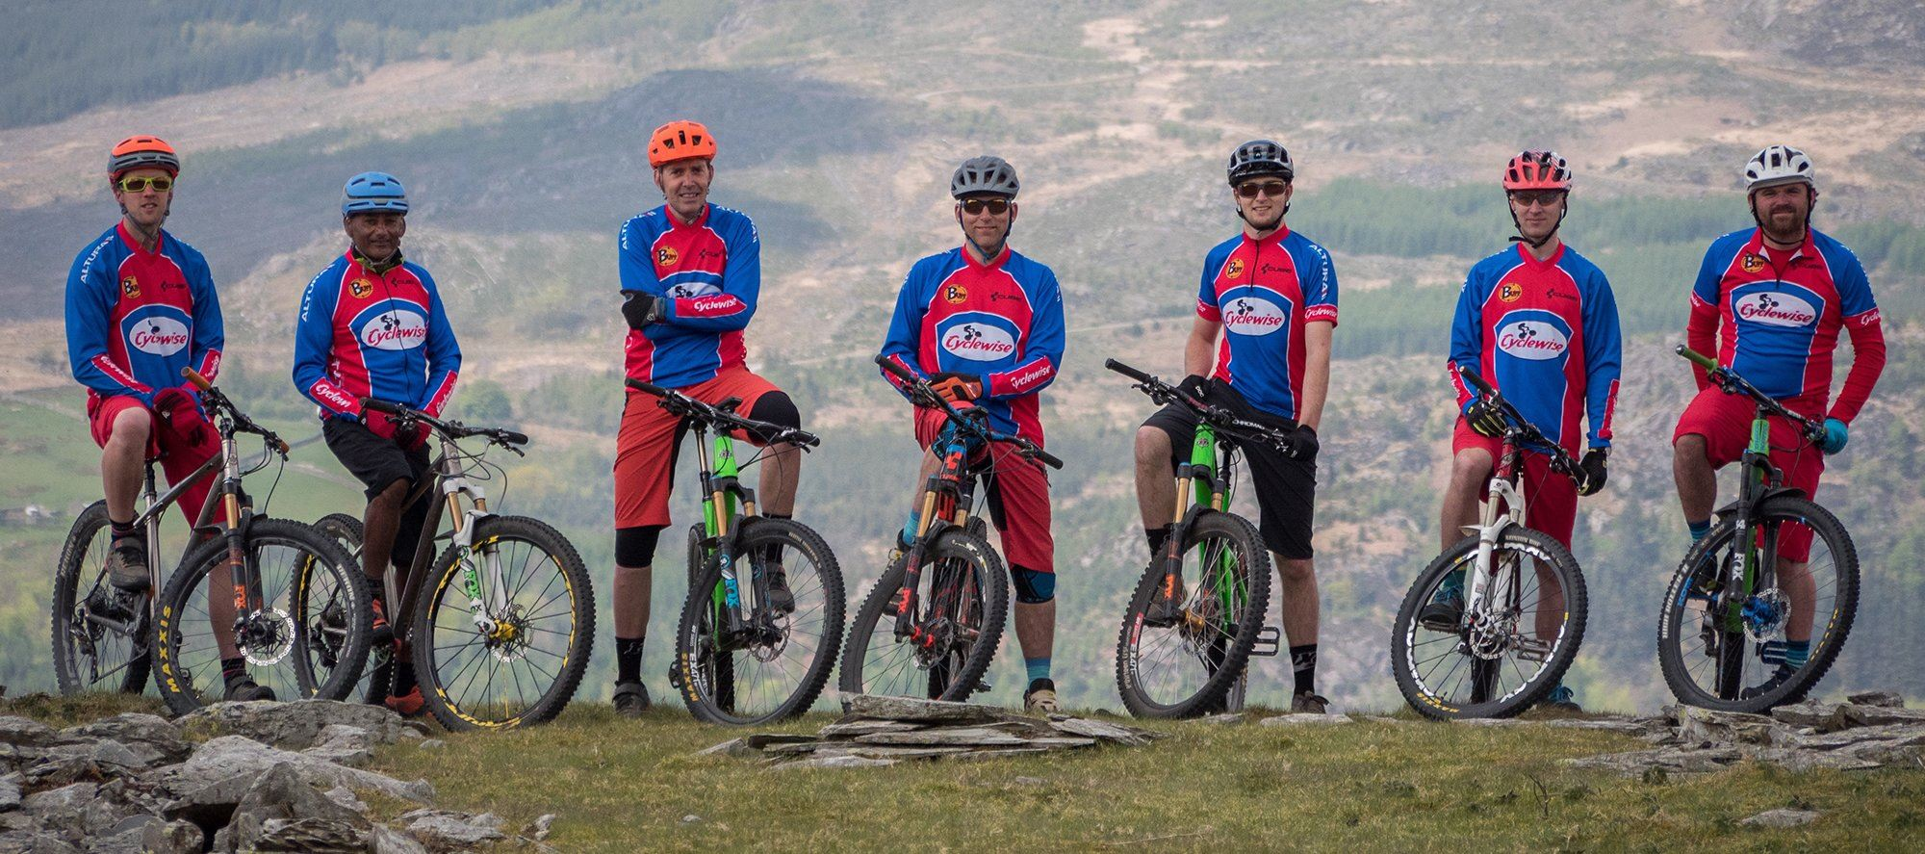
Research undertaken from web-based sites shows male dominance
Image from https://www.cyclewise.co.uk/
(Herd, n.d.)
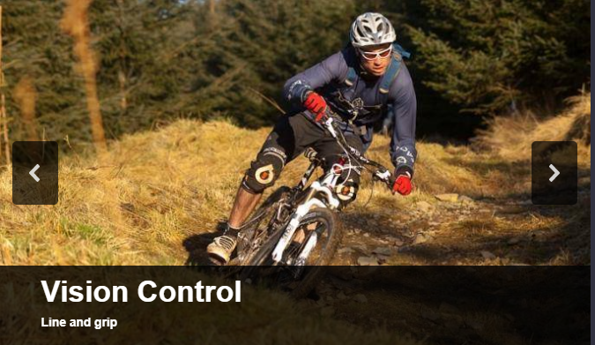
Image from https://cycleactive.com/index.php/mountain-bike-skills-courses/get-started-beginner
(vision control line and grip, n.d.)

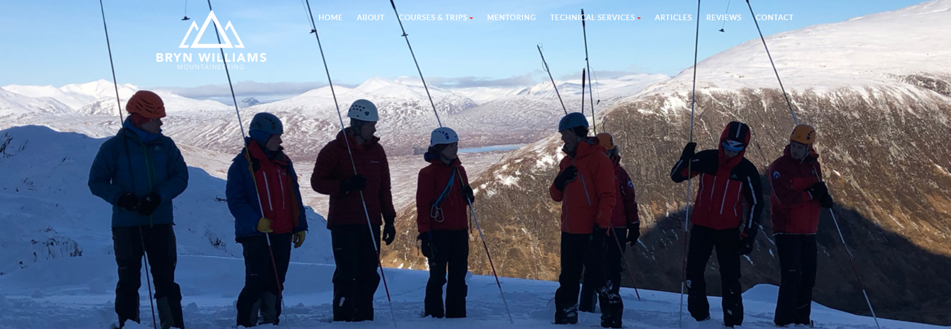
Image from https://www.bwmountaineering.com/
(Bryn Williams Mountaineering, 2019)

As you can see from the picture above mountain biking is advertised purely by males whereas the final image is mixed gender.

Appendix L

https://docs.google.com/forms/d/e/1FAIpQLSe7dz88N0BDLhzgCWTlZlVQ8jARga-6B1TMAB8WaN5By3GtVQ/viewform?fbclid=IwAR0Utm72OwFUq_Ouef0rc9vYVD48aXT6RSvhYPXDZr0SOmqgpX3dW41nYCU

