Programming 2
Name: Jonathan S. Davies
Student Number: 1707239

Module: Programming 2
Module Code: ACCA4006
Lecturer: Mike Dacey and Dr. Tim Bashford

Table of Contents

Table of Contents 1
Introduction 3
1. Part A – Understanding 3
1.1 Problem Solving 3
1.2 Approach to a Problem 3
1.2.1 Read the problem multiple times 3
1.2.2 Explain the problem 3
1.2.3 Make a list of what you know 3
1.3 Categorising Problems 3
1.3.1 Outlining the Problems 3
1.3.2 Name the problems 4
1.3.3 Ranking of problems 4
1.3.4 Work the code manually on paper 4
1.3.5 Writing pseudocode 5
1.4 Programming and testing 5
1.4.1 Creating the program 5
1.4.2 Testing 6
2. Part B – Testing 6
2.1 Why is testing important? 6
2.2 Testing the Provided Code 6
2.2.1 Problem 1 6
2.2.2 Problem 2 7
2.2.3 Problem 3 9
3. Part C – Implementation 12
3.1 Exercise 1 – Identifying Problems 12
3.2 Exercise 2 – Mapping Problem Space to Code 14
3.2.1 Test Results 15
3.3 Exercise 3 – Connect 4 16
References 17
Appendix 18
A1 Part B 18
A2 Part C– Exercise 1 19
A3 Part C – Exercise 3 22

Introduction

The aim of this report is to collate understanding of problem-solving techniques and provide evidence of these techniques that have been put forward into practice. Part A will explore different methods of tackling a problem and provide a step-by-step walkthrough of a strategy that has been incorporated by the author. Part B will shift focus towards the theoretical need for testing code and the actual testing of code itself. Part C shall funnel what has been learned from both Part A and B, and use the knowledge gained to attempt a series of exercises.

Part A – Understanding

Problem Solving
During the course of the Programming 2 module, it has become apparent that the ability to problem solve is one of the most important skills when creating a program. Learning the language and syntax is without a doubt a major factor in programming, but the ability to step back from a problem and break it down into its core foundations, and from that build up a solution that instead of tackling one large problem, has solved a series of smaller, bite-size problems. In order to effectively solve a problem, a generic systematic approach should be implemented that can be applied to any scenario and will ensure that the programmer does fall into the trap of immediately hitting a problem head on and potentially getting overwhelmed. Detailed below is a step-by-step walkthrough of a problem-solving technique that has been assembled and put into practice over the course of this assignment and the prior Programming 1 assignment [1]. During the course of this assignment, many problem-solving sources have been found, with the majority of them having a very similar approach the method that the author has constructed. The University of Kent have detailed steps that they believe are key in solving a problem and sorted them into the acronym labelled ‘IDEAL’ [2]. These steps have been taken and expanded upon and modified.

Approach to a Problem

Read the problem multiple times
As simplistic as it sounds, reading through the brief a number of times is the first step to understanding problem. Many key features of the program can be overlooked or issues that need not exist can arise simply because the programmer did not take the time to thoroughly read and dissect the problem [3].

Explain the problem
In order to ensure that one is completely sure of what the situation requires, it can sometimes help to explain what the problem is and also explain what a solution might be to another person. Even if they have no programming background, it may help to read the problem and possible solutions aloud and reinforce to one’s self what is required.

Make a list of what you know
Formulating a list of what the programmer knows whether on paper or in a document and comparing it to the list of known problems may potentially allow visual connections to be made.

Categorising Problems

Outlining the Problems
Within the brief of the main problem, outline and highlight key words or phrases that may be compartmentalized into smaller problems that can be targeted one at a time. These key words should be noted down and, using the previously drawn up list of what tools are known, compare and connect the problems to their respective solutions.

Name the problems
Once the problems have been outlined, a name can be given to it that best describes what the problem is. Each of these problems will likely turn into a function or class. An example of this would be if one part of the problem required two numbers to be multiplied. This problem could be made into a function and called MultiplyTwoNumbers(), within this function would contain the steps needed to perform the calculation. An example of this function can be seen in figure 1 below.

Figure 1

Ranking of problems
One technique for solving problems in programming is to not only list all of the problems that are expected to arise, but to filter them into a list that starts with the easier to solve leading up to the hardest to solve. Once this has been completed, tasks can be checked off the list and will allow the programmer to focus on the core elements of the harder tasks. Solving all the easier problems may even provide insight into how to tackle the harder tasks. Examples of problem solving tables can be found on page 10-11, table 1.

Work the code manually on paper
This step allows the programmer to see how the code is supposed to function and show how each aspect of the code will work with each other. There are many ways to do this but the chosen method in this assignment was to make a flow chart. The flow chart provides an excellent visual representation of how the program will work when it is done but also outlines different conditional statements and their placements. Flow charts are especially useful when mapping out loop conditions and how they will work in the program [4, pp. 16-18].
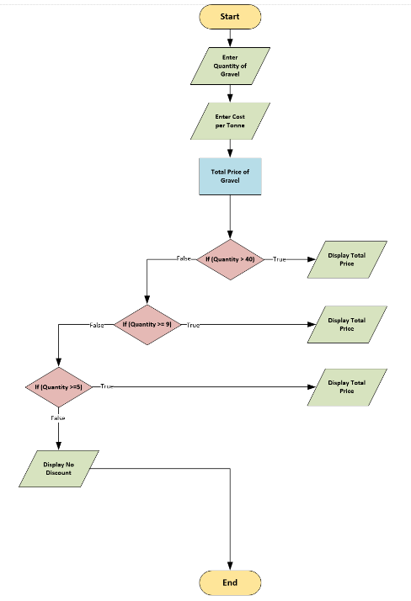
Figure 2 - Flowchart example

Writing pseudocode
Pseudocode is used to layout the framework of how the code is going to be structured. It does not have to be written with correct programming syntax but rather by using non-programming languages, such as English, to describe what the code is doing at any given time [4, pp. 13-15].
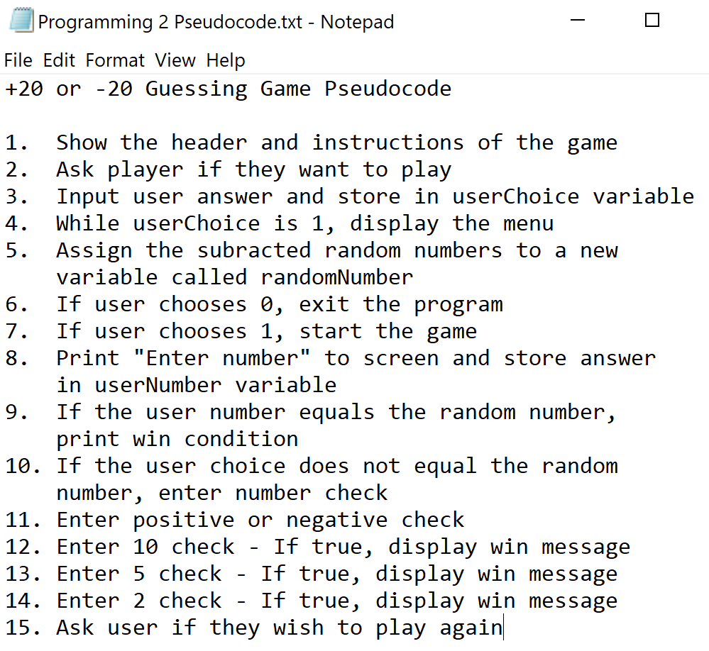
Figure 3 - Pseudocode example

Programming and testing

Creating the program
Once the programmer is satisfied with the structure, they can then either overwrite the pseudocode and replace it with actual programmable code or use the pseudocode as a reference whilst creating the program in a new file. Whilst writing the code it is important to make it as general as possible so that it can be moulded to fit as many problems as possible.

Testing
The final step is to design a test harness that will test all aspects of the code in ways that it was not originally designed to be used for. It is at this point that the code can show exactly what the its boundaries and limits are and where it can be improved for user interaction graphically or optimised for better performance. Test code can be seen on page 5 in test 1.

Part B – Testing

Why is testing important?
Upon near completion of the System Development Life Cycle (SDLC) the testing phase is introduced. It is within this phase that the developers, end users or programming testers can scrutinise the code using a test harness consisting of both tests that test not only the expected use of the software but also unexpected scenarios that the software was not specifically designed to handle. There are typically three phases of testing that software has to go through in order to be considered successful, these are listed below [5].
- Development Testing – This stage is undertaken while the software is still in development and is usually carried out by the programmers that are creating it.
- Release Testing – It is at this point that an independent testing unit will perform their own tests on the software. This eliminates favoured testing conditions that the development team may have unknowingly devised.
- User Testing – During the user testing phase, the end user has a chance to put the developed system into place to see how well the software integrates and performs within their own environment.

Testing the Provided Code

The code that is to be tested is a calculator that allows the user to enter as many numbers as they desire and once all the numbers have been entered into the system, it calculates the total sum and displays it centralised within a hashed boarder on the screen. Three problems have already been identified and evidence of their testing will be presented below. A section of the fixed code has been provided in Appendix A1.

Problem 1
The first problem is encountered when the user tries to enter a letter of the alphabet instead of an integer number as seen in figure 1.

01 Entering Text Instead of Numbers
Description: | User enters characters from the alphabet instead of numbers
Test Steps: | Option 1 is chosen from the main menu
Test Steps: | User enters text in place of numbers
Response: | The program should display an error message when a letter of the alphabet is entered
Status: | Date: | Description:
Fail | 20/02/2018  10.40 | Huge numbers were displayed instead of an error message. Figure 4
Fail | 20/02/2018  10.45 | An error message displayed when the user tried to quit the program. Figure 5
Pass | 20/02/2018  10.53 | The solution code was placed inside the wrong function, once moved to the right location, the code was fixed. Figure 6
Test 1
Screenshots of the working display has been provided below in respective order of the tests.
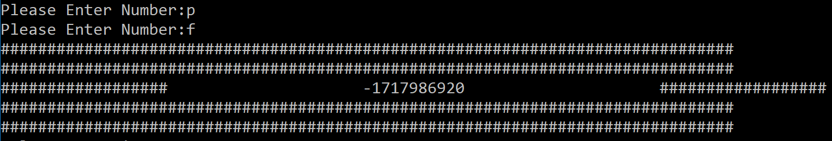
Figure 4 - Fail
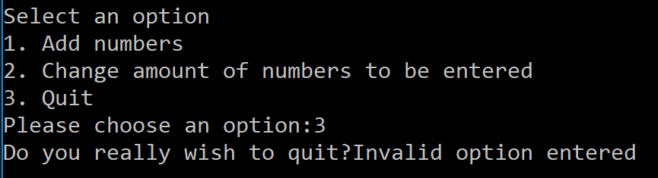
Figure 5 - Fail
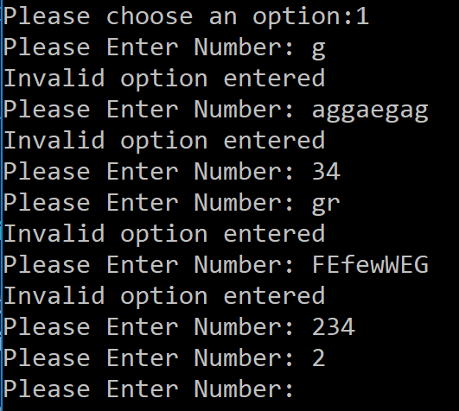
Figure 6 - Pass

Problem 2
The second problem arises when the user wishes to quit the program. In the original code, the word “YES” must be typed in all capitals for the program to quit. No other variation of the word would work. The solution to this problem was attempted in two different ways. The first method was to try and place a series of “OR” operators that would in theory change the acceptable response to any of the following statements. This did not work as the programs’ quitting function changed from quitting only when “YES” was entered, to quitting when any collection of words was entered. The test for this can been seen in test 2.

02 Variations on Quitting Response 1

Description: | User will enter a range of responses to check whether the new options can be accepted
Test Steps: | Option 3 is picked from the menu
Test Steps: | User enters either “Yes”, “y” or “yes” and confirms
Response: | The program should quit upon confirming the new exit option
Status: | Date: | Description:
Fail | 20/02/2018  14:42 | Program now quits no matter what input is provided. Figure 7-8
Pass | 20/02/2018  15:13 | Program quits when these variations of the word ‘yes’ are entered but does not quit if anything else is.
Test 2
Below are two screenshots showing both the changes to the code (figure 7) and also its effect at run time (figure 8).
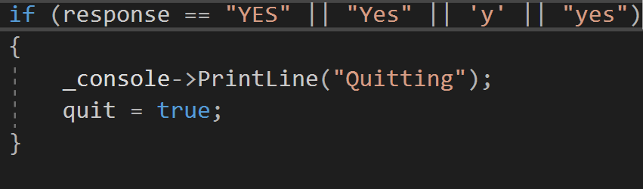
Figure 7 – Code changes
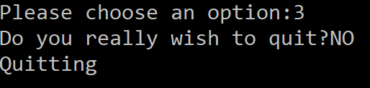
Figure 8 – Run time
This method did not work and so the test resulted in failure.

A second method was attempted that appears to have fixed the problem by way of adding more ‘IF’ statements. Each new statement checked to see if different variations of the word “YES” were entered and if they were, they would be accepted. A test table has been inserted to show a revised test of the problem along with screenshot evidence of the tests in action.
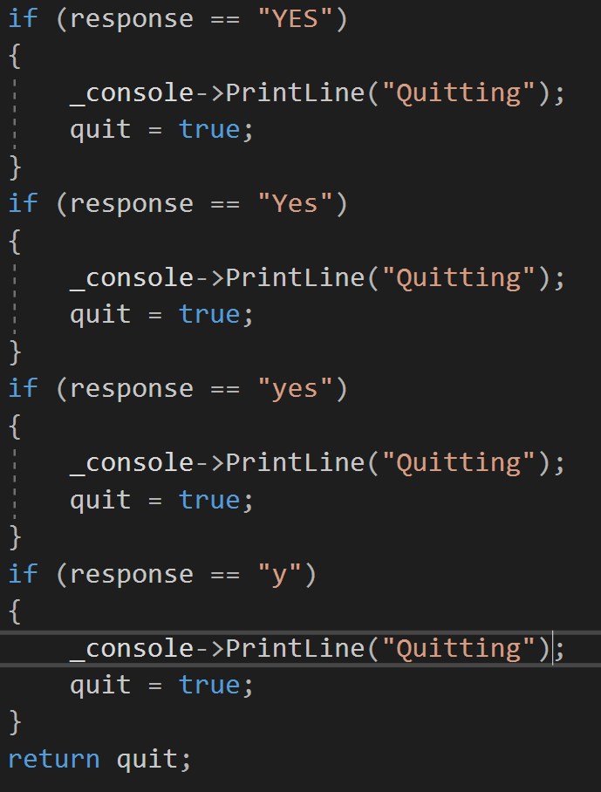
Provided below are two screenshots that display the amended code (figure 9) and also the working result (figure 10).
Figure 9 - Amended code
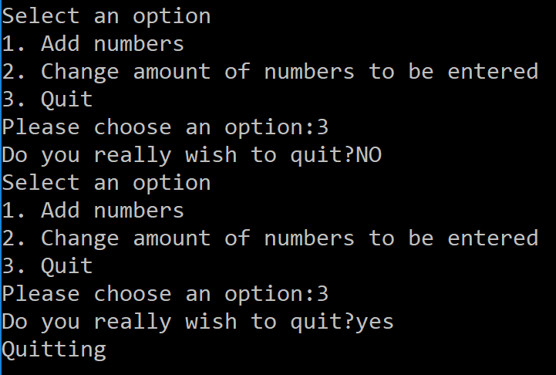
Figure 10 - Working code

Problem 3
The third problem is an issue relating to the displayed result on the screen. Should the result yield a single digit answer, then the hashed header will display correctly. If however the result returns any number that is larger than one digit in size, the hashes will shift a space to the right for every extra digit added. The tests for this problem are shown in test 3 below.

Problems –
  - The number of digits that the result contained is the amount of offset that hashes were set by.
    - Use the ‘to_string(result).size()’ function to convert the result into an integer that holds the number of digits
    - Store the value of ‘to_string(result).size()’ function inside a variable
    - Use that variable to minus the amount of spaces being printed to the screen during the result line
  - Converting the number of digits that result contains into an integer value.
  - Printing out the line that contains the result.
    - Use for-loops to print each hash and space
    - Print out the result in the centre
    - Minus the number of spaces by the amount of digits in the result
    - Print the other side of the display
    - Print a new line

04 Warped Display

Description: | Add multiple numbers together and keep the hashes in a uniformed order when displaying
Test Steps: | Choose option 1 in the main menu
Test Steps: | Select numbers that will return an answer of more than 1 digit
Response: | The display is expected to have a uniformed line of hashes
Status: | Date: | Description:
Fail | 20/02/2018  17.30 | Deleted the number of spaces on one side of the result to match up the lines but this would only unbalance the line if any other sized numbers were entered. Figure 11 & 12.
Fail | 21/02/18  21.42 | Create a series of ‘if’ statements that checked if the result was >9, >99, >999, >9999 etc. This quickly became tedious as code was being repeated. Also the conditions overlapped so multiple responses would be printed.
Pass | 21/02/2018  22.55 | The code passed the test. A description of how this was achieved can be found on page number 9 and 10.
Test 3

Inserted below are screenshots of the code and displayed result from failed test number one.
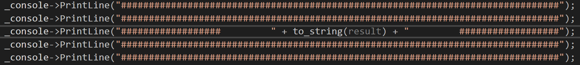
Figure 11 - Changed code
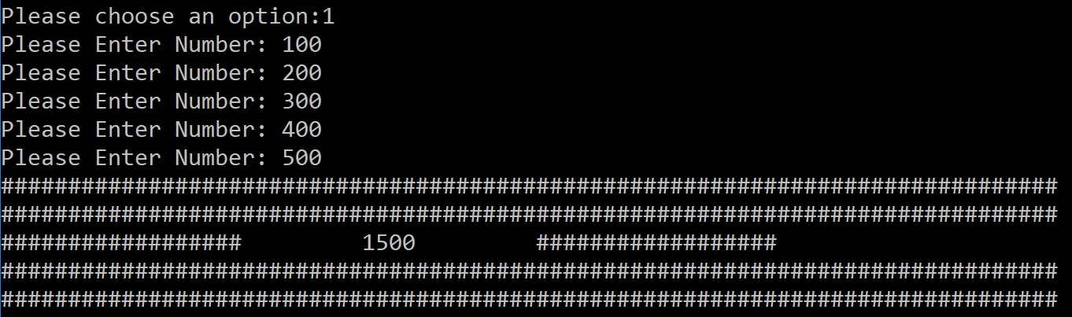
Figure 12 - Result of change
Description of how the fix worked –
Variables were created at the top of this method that set the number of spaces and the number of hashes to a specific number. The ‘to_string(result)’ function was removed from the display and assigned to a variable called resultSize with the addition of ‘.size()’ added to the end of it. The centre line of the ‘_console->PrintLine(“####...”)’ was deleted and replaced with a series of for-loops that printed each ‘#’ and ‘(space)‘ individually. The conditions of the loop were allocated using a variable named either ‘numHash’ or ‘numSpace’. After a complete cycle of both loops, the result was printed, and a simple mathematical equation was made that took the number of spaces and subtracted the result size from it and this answer was assigned to ‘numSpace’, followed by two more loops that mirrored the same conditions that came before.
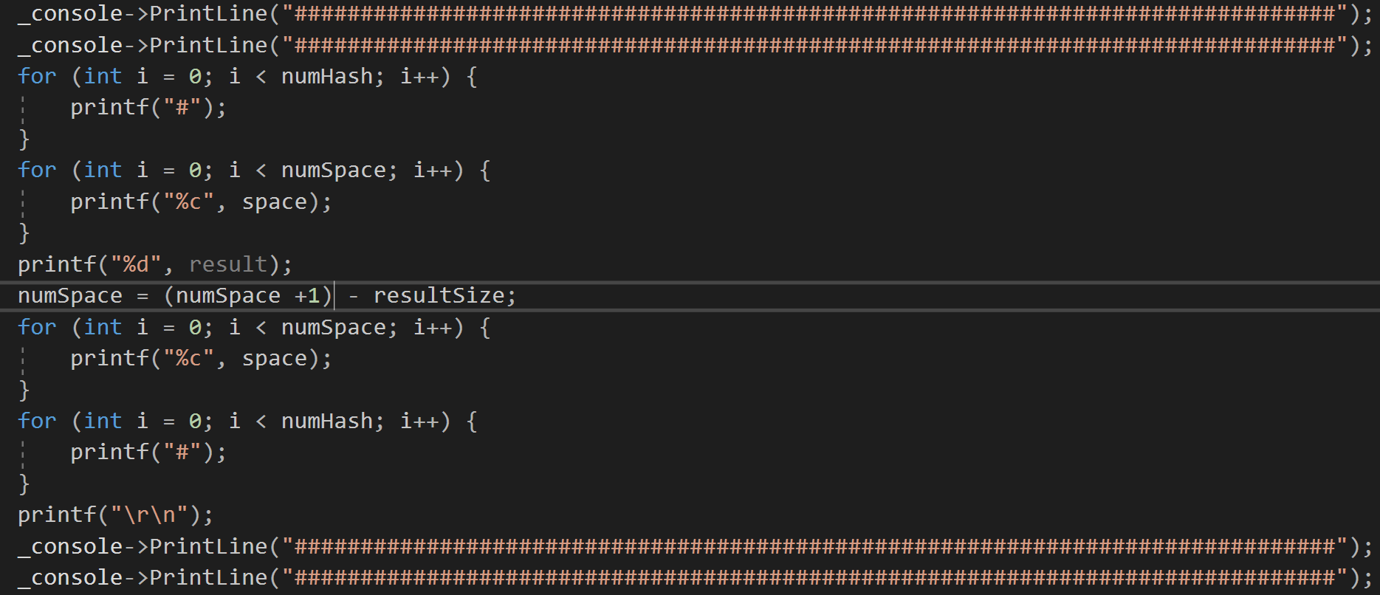
Figure 13 - Amended code
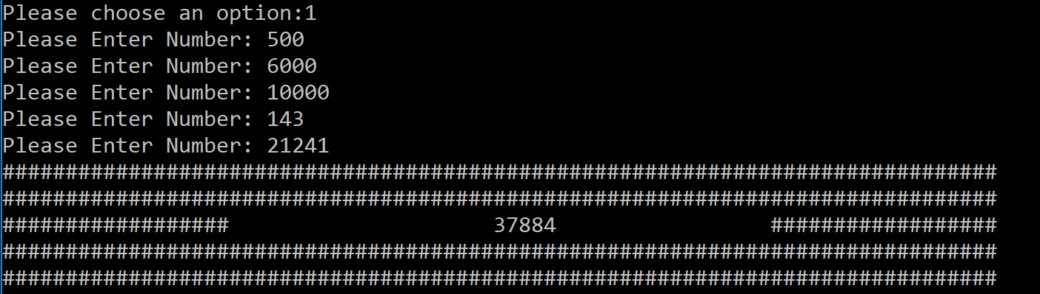
Figure 14 - Working code

Part C – Implementation

This section will look at three exercises and explore the problems that are associated with each of them. The problems will be taken and broken down into smaller, more manageable issues to be tackled. A list of the problems that are expected to arise have been collated and arranged from easiest to hardest, this approach allows the programmer to systematically engage each problem in an methodical manner.

Exercise 1 – Identifying Problems
For this exercise, a number game is required where the program will secretly choose a number between -20 and +20, the player is then prompted to make a guess. Should the user correctly guess the answer they will win, if they however guess wrong, they shall be given a series of hints to narrow them into the correct answer. For the sake of legibility, the problems will be sorted into a table and ranked from easier to harder, with the easier problems starting at the top. The code for the completed game can be found in Appendix A2.

Problems (Easiest to Hardest)

1. | The first line that is displayed to the player should be the instructions of the game. This will be done with a PRINTF statement.
2. | Hints are displayed if the player gets the answer wrong – PRINTF.
3. | Users chosen answer must be stored in variable. It will be an INT.
4. | Player guess? – a number must be read from the keyboard – this will use a SCANF.
5. | The user should be asked whether or not they would like to play the game – a SWITCH statement is needed here.
6. | The player has 5 attempts – a FOR-LOOP will control this.
7. | The program needs to select a number in secret, the random number generator that is set to generate a number between 0-20 can do this but will not display this number to screen.
8. | The random number function does not generate a number below zero. One method that can be used to circumvent this is to use the random number function twice and assign each randomised number to a VARIABLE. Finally subtract once variable from the other.
9. | Check to see if the number that the user has entered is within the +20 or -20 range, IF not PRINT "error".
10. | Check IF number is positive or negative - user number needs to be LESS THAN 0 and the random number is GREATER THAN 0 then the answer is positive and vice versa.  a) IF the user number is less than 0 AND the random number is greater than or equal to 0 -  PRINTF - "answer is positive".  b) IF user number is greater than or equal to 0 AND random number is less than 0 -  PRINTF - "answer is negative".
11. | Check IF the users number is within a range of 10 each side of the random number.  a) user number GREATER or EQUAL to random number -10 AND the user number LESS than random number -5  OR  b) user number LESS or EQUAL to random number +10 AND the user number GREATER than random number +5  PRINTF - "answer is plus or minus 10 away".
12. | Check IF the numbers are within range of 5 either side of the random number.  a) user number GREATER or EQUAL to random number -5 AND the user number LESS than random number -2  OR  b) user number LESS or EQUAL to random number +5 AND the user number GREATER than random number +2 -  PRINTF - "answer is plus or minus 5 away".
13. | Check IF the numbers are within range of 2 either side of the random number.  a) user number GREATER or EQUAL to random number -2 AND the user number less than random number  OR  b) user number LESS or EQUAL to random number +2 AND the user number GREATER than random number +5  PRINTF - "answer is plus or minus 2 away".
Table 1 - Ex.1 problems

Exercise 2 – Mapping Problem Space to Code

This program provided in this exercise has the purpose of taking a string that contains numbers and extracting them and placing them into an array. A test table has been inserted below.
Test Number | Input | Expected Response | Actual Response | Result
1. |  | splitSuccessful is expected to return true and the numbers are stored into an array |  | Pass
2. |  | splitSuccessful is expected to return true and the numbers are stored into an array |  | Pass
3. |  | splitSuccessful is expected to return true and the numbers are stored into an array |  | Fail
4. |  | splitSuccessful is expected to return true and the numbers are stored into an array |  | Fail
5. |  | splitSuccessful is expected to return true and the numbers are stored into an array |  | Pass
6. |  | splitSuccessful is expected to return true and the numbers are stored into an array | 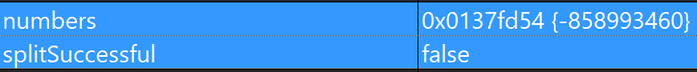 | Fail
Table 2 - Ex.2 test table

Test Results
These test results show that when a string of numbers is entered into the argument, the program can differentiate between the integers and the dashes and successfully derive the required information from it. It also shows that the code is ill-equipped to deal with multiple dashes within the string and also alphabetic characters. During the last test, an unexpected result show what happens if a single dash and a single integer are entered. The number could not be stored into memory even though all other obvious parameters had been appropriately satisfied.

Exercise 3 – Connect 4

Exercise 3 requires a game of connect for to be made. While the code for this exercise was not completed, the game grid was created and has been included in Appendix A3. The two tables below are both the rules that have been thought of for the game and the problems that are believed to have been encountered should the rest of the code have been finished.
Connect 4 – The Rules

1. | There can be only two players.
2. | Each player can place one chip per go.
3. | The chip must be placed inside the grid.
4. | Each player should have visually different chips in order to identify their own.
5. | The chip must fall to the lowest point of a chosen column.
6. | If the column already has chips place in it, any new chips must be stacked on top.
7. | If the grid is completely filled with chips, and neither player has won, the game is a draw.
8. | Players win by either stacking 4 chips vertically, horizontally or diagonally in either direction.
Table 3 - Connect 4 rules
Problems (Easiest to Hardest)

1. | Display messages to the screen. “You have won”, “You have lost”, “Player 1’s turn” or “Choose a column” etc. This will use a PRINTF.
2. | Input the user’s choice into a variable.
3. | Setting player1 and player2 as variables. This is an INT.
4. | Assigning a particular chip to each player. Player1 – ‘X’ and Player2 – ‘O’.
5. | Declaring a 2D ARRAY –  INT arrayName[1][2];
6. | Using nested FOR-LOOPS to PRINT a grid to the screen.
7. | Placing the grid inside a function.
8. | PRINT the number of the column and row alongside the grid.
9. | Player chip must sink to the lowest available point in the column. This can be done with an IF check.
10. | IF the grid is full -  PRINT “The game is a draw”.
11. | Win condition – Vertical  IF player has 4 sequential chips in the same column – PRINT “You have won!”.
12. | Win condition – Horizontal  IF player has 4 sequential chips in the same row – PRINT “You have won!”.
13. | Win Condition – Diagonal Right  IF player has 4 sequential chips where the rows are not equal AND  the columns are not equal AND the rows AND columns are  sequential – PRINT “You have won!”
Table 4 - Connect 4 problems

References

[1] | Chartered Management Institute, “Solving Problems,” Chartered Management Institute, Corby, 2014.
[2] | University of Kent, “Careers and Employability Service,” 2013. [Online]. Available: https://www.kent.ac.uk/careers/sk/problem-solving-skills.htm. [Accessed 14 03 2018].
[3] | M. Sprankle, “Summary,” in Problem Solving and Programming Concepts, Pearson Prentice Hall, 2006, p. 6.
[4] | W. Savitch, “Programming and Problem-Solving,” in Problem Solving with C++, Pearson Education, 2001.
[5] | I. Sommerville, “Software Testing,” in Software Engineering, 10th ed., Harlow, Pearson Education Limited, 2016, pp. 226-254.

Appendix

A1 Part B

A2 Part C – Exercise 1

A3 Part C – Exercise 3

