Morgan Plus 4 Race‑Spec Aero Package Redesign
Technical Director Report – Morgan Plus 4 Team
Oscar Price
Date: 28 October 2025
To: Managing Director

1. Introduction
This report introduces the Morgan Plus 4 Race‑Spec Aero Package Redesign project from the perspective of the Technical Director for the Morgan Plus 4 Team. The purpose of the project is to develop, validate and prepare for manufacture an aerodynamic upgrade package that converts the Morgan Plus 4 from its existing road specification into a competitive race configuration. The primary focus is to increase aerodynamic downforce at race operating speeds (80–180 mph) while keeping drag penalties within acceptable limits, maintaining vehicle stability, and ensuring that modifications are compatible with the Morgan chassis and packaging constraints.
Aerodynamic development will follow an integrated CAE and experimental workflow: initial concept generation, detailed CAD modelling, computational fluid dynamics (CFD) baseline and optimisation studies, production of scale prototypes for wind tunnel validation, and manufacturing feasibility assessments. The work will deliver validated CAD models, CFD reports, a bill of materials (BOM), cost and lead‑time estimates, and a sign‑off package for potential race implementation. The initiative is informed by established motorsport aerodynamic methodologies (Craig et al., 2013) and contemporary simulation workflows used in small team motorsport programmes (Rehnberg et al., 2013; Seppey, 2022).
As Technical Director I will oversee systems integration, lead the CFD validation gateway, coordinate prototype testing, and manage interfaces between concept designers, CFD engineers and manufacturing resources. This report details team roles, a comprehensive task breakdown with timings, a detailed accounting of my responsibilities (including hours, costs and specialist equipment), critical milestones, a gateway objective for my section, identified risks and mitigations, and two Gantt charts representing the full project and my specific responsibilities.
2. Team Members, Roles and Responsibilities
Project governance is structured into a Conceptual Team responsible for upstream ideation and a Morgan Plus 4 Team focused on vehicle specific integration. The Project Leader, Ryan Williams, retains overall accountability for delivery, stakeholder communications and budget adherence.
Conceptual Team:
- Conceptual Leader: Ethan Davies — responsible for ideation, aesthetics and conceptual packaging solutions.
- Technical Director (Conceptual): Dominic Walton — responsible for assessing feasibility at concept stage and advising on materials and interfaces.
- CFD Engineer: Alexandros Griffiths — executes early stage CFD studies to inform concept choices.
Morgan Plus 4 Team:
- Morgan Plus 4 Leader: Tom Holland — leads vehicle interface, homologation considerations and chassis packaging authority.
- Technical Director (Morgan Plus 4): Oscar Price (author) — leads systems integration & testing, verifies CFD outputs, plans test matrix and signs off validated designs.
- CFD Engineer(s): Ryan Williams and Luca Gray — run detailed CFD analyses, perform parametric sweeps and provide post-processed data for interpretation.
Role responsibilities are coordinated through weekly progress meetings and a shared document control system. The Technical Director role, as executed here, requires both technical proficiency and co‑ordination skills: proficiency with CAD tools (SolidWorks), CFD (ANSYS Fluent) and post‑processing (ParaView/MATLAB), as well as the ability to synthesise results and make pragmatic engineering decisions under schedule constraints.
Belbin Role Alignment
Applying Belbin’s team role model to the team structure: the Technical Director role combines the *Monitor‑Evaluator* (critical analytical assessment of CFD outputs and test data) and *Completer‑Finisher* (quality assurance, attention to detail, delivery-focused) roles. The Conceptual Leader typically takes the *Plant* or *Resource Investigator* role for ideation and sponsor engagement. CFD engineers often fulfil *Specialist* roles given their technical depth. The Project Leader functions as a *Co‑ordinator*. This blend ensures creative ideation, rigorous analysis and delivery accountability.
3. Overall Group Tasks and Associated Timings
The project will be executed over a 15‑week horizon with discrete phases designed to provide sufficient time for concept iteration, CFD convergence and experimental validation. The major tasks are summarised below.
- Project Planning & Kick‑off (Weeks 1–2): Scope finalisation, baseline data collection (vehicle CAD import, baseline drag/downforce runs), resource allocation and procurement planning.
- Concept Design (Weeks 3–4): Concept sketches, surface definition and preliminary CAD for splitter, diffuser, rear wing and undertray.
- Baseline CFD (Weeks 4–5): Establish baseline aerodynamic performance of the stock vehicle; geometry cleaning, mesh strategy and initial validation.
- Aero Component Design (Weeks 6–8): Detailed CAD development of aero elements and attachment interfaces; iteratively reconcile designer and chassis constraints.
- CFD Optimisation (Weeks 9–11): Parametric sweeps, mesh refinement studies, sensitivity analysis and finalisation of candidate designs.
- Prototype Validation (Weeks 12–13): Manufacture of a 1:8 scale model or full component prototypes, wind tunnel testing and flow visualisation; data acquisition and repeatability checks.
- Reporting & Presentation (Weeks 14–15): Consolidation of results, production of a final report and presentation to the Managing Director and stakeholders.
Each task includes contingency buffers for rework and supplier lead time. The cadence enables parallel workstreams—conceptual CAD and baseline CFD can proceed with frequent synchronization to avoid downstream bottlenecks.
4. Detailed List of My Tasks
The following table itemises my responsibilities and provides hours, durations, approximate costs, lead times and specialist equipment required.
Task: CAD–CFD Interface Setup
- Hours Required: 20 hours
- Duration: Week 4
- Objective: Import and clean concept CAD geometry, establish named selections and surface/shell characteristics for meshing; define boundary conditions and reference frames.
- Equipment: High‑performance workstation (£1,500), ANSYS/Fluent licence (£1,000 annual research licence estimate).
- Lead time: Immediate, licence and workstation in place.
Task: Mesh Generation & Validation
- Hours Required: 30 hours
- Duration: Weeks 5–6
- Objective: Create structured/unstructured meshes, perform grid independence study, validate with coarse/fine meshes to ensure solution insensitivity to mesh size.
- Equipment: CFD solver access, meshing toolkit, HPC cloud credits.
- Cost Estimate: 1,000 GBP for cloud compute and licence access overhead.
- Lead time: 1 week to secure compute credits.
Task: Simulation Runs & Post‑Processing
- Hours Required: 40 hours
- Duration: Weeks 7–9
- Objective: Run steady RANS and selected unsteady simulations (URANS) where necessary to capture separation; monitor residuals, force coefficients and flow structures; post‑process data for pressure and vorticity visualisation.
- Equipment: HPC/Cloud compute (~50 compute hours), ParaView, MATLAB.
- Cost Estimate: 800 GBP for compute credits.
- Lead time: 1 week.
Task: Integration Review & Fixes
- Hours Required: 15 hours
- Duration: Week 9
- Objective: Collate CFD outputs, cross‑check CAD fitment, resolve interference issues and finalise mounting points with manufacturing engineer.
- Equipment: Collaboration tools (PLM/Teamcenter or shared drive), meeting support.
- Cost Estimate: Minimal.
Task: Test Planning & Prototype Setup
- Hours Required: 25 hours
- Duration: Weeks 10–11
- Objective: Finalise test matrix, prepare 1:8 scale model CAD for printing, arrange wind tunnel booking, define instrumentation (pressure taps, tufting locations, force balances).
- Equipment: 3D printing services or in‑house printer, wind tunnel booking (~£300 for model + facility fees).
- Cost Estimate: 600 GBP (model + fixturing).
Task: Final Data Analysis & Reporting
- Hours Required: 20 hours
- Duration: Week 12
- Objective: Perform uncertainty analysis, compare CFD with experimental data, produce final plots, recommendations and sign‑off package.
- Equipment: MATLAB, Excel, Microsoft Office.
- Cost Estimate: Minimal.
Preliminary Bill of Materials (prototype & testing)
- High‑performance workstation: £1,500
- ANSYS Fluent licence (research estimate): £1,000
- HPC/Cloud CFD credits (50 hrs): £800
- Wind‑tunnel model (1:8 scale): £300
- Misc fixturing and adhesives: £200
Total estimated cost: £3,800
Specialist Equipment Required
- High‑performance CAD/CAE workstation
- ANSYS Fluent (or equivalent CFD package)
- Access to HPC/cloud compute for parametric studies
- Wind tunnel or subsonic testing facility with force balance
- 3D printing capability for scale model production
- Data acquisition system for experimental runs
5. Significant Milestones and Gateway Objective
Major project milestones are identified to monitor progress and provide decision points for scope changes.
- M1: Project Proposal Approved (Week 2) — formal sign‑off on scope and budget.
- M2: Baseline CFD Completed (Week 5) — baseline coefficients recorded; establishes reference for improvement percentages.
- M3: Concept Aero Designs Completed (Week 8) — CAD ready for detailed CFD.
- M4: Final CFD Validation Completed (Week 11) — optimised designs meet criteria in simulation.
- M5: Wind Tunnel Testing Complete (Week 13) — experimental verification achieved.
- M6: Final Report & Presentation (Week 15) — submission to Managing Director.
Gateway Objective — System Integration & CFD Validation (My Section)
This gateway is the critical decision point before proceeding to prototype testing and prospective manufacture.
Gateway Criteria:
1. Demonstrated minimum 15% increase in overall downforce compared to baseline for the target speed operating envelope (measured at reference ride height).
2. Drag increase limited to ≤5% compared to baseline, ensuring lap time benefits from downforce outweigh aerodynamic penalty.
3. Converged solutions with residuals <1×10⁻⁵ (or suitably low steady residuals) and grid independence established through mesh refinement tests.
4. No chassis or suspension interference identified in digital mock‑up; mounting points structurally validated by manufacturing engineer.
5. Manufacturing feasibility confirmed (materials, attachment systems, and estimated cost acceptable).
Meeting these criteria will authorise wind tunnel testing and prototype manufacture. Failing to meet the gateway will require iterative design revision and a re‑run of the CFD optimisation phase.
6. Risk Identification and Mitigation
Two principal risks have been identified within the integration and testing remit.
Risk 1: CFD Simulation Failure or Data Loss
- Impact: Rework, schedule slippage and potential loss of confidence in results.
- Mitigation: Implement robust version control for CAD and CFD cases (Git or PLM); perform daily backups of outputs to cloud storage; run lower fidelity sanity checks before committing to long HPC runs; allocate a compute buffer (+10%) in procurement to accommodate reruns.
Risk 2: CAD–CFD–Chassis Interface Issues
- Impact: Late discovery of physical interference leading to redesign and delays.
- Mitigation: Early adoption of STEP/IGES exports with strict naming conventions; weekly cross‑team DMU reviews including physical measurements validation; early printing of critical mounting brackets for fitment verification.
Additional contingency planning includes supplier redundancy for rapid manufacture of prototype components and a 2‑week schedule float before wind tunnel bookings to allow minor rework.
7. Gantt Charts
Two visual Gantt charts have been prepared and embedded into the final report: one representing the overall project schedule and a second detailing the Integration & Testing tasks for which I am responsible. These charts are attached as figures below and have been included in the Word document.
[Figure 1: Overall Project Gantt Chart — Weeks 1–15]
[Figure 2: Detailed Gantt Chart — Integration & Testing, Weeks 4–13]
8. Conclusion
The Morgan Plus 4 Race‑Spec Aero Package Redesign is a technically demanding project that requires close coordination between conceptual designers, CFD specialists, manufacturing engineers and test facilities. As Technical Director I will ensure that CAD models are CFD‑ready, that meshing and solver strategies are appropriate, and that the gateway criteria for transition to physical testing are rigorous and objective. The plan presented here is practical and includes conservative buffers for compute, manufacturing and supplier lead time. The preliminary BOM and costings represent a minimal viable expenditure to validate the aerodynamic concept; further detail will follow pending design selection.
With an integrated CAE‑driven workflow, validated through experimental testing, the reworked aero package aims to deliver a measurable performance advantage, enhancing downforce and overall handling without prohibitive drag penalties. I recommend proceeding with the proposed resource allocation and initiating the procurement of compute credits and wind tunnel time as soon as the Project Leader confirms funding.
References

References
- Craig, C.H., et al. (2013) 'Methodology for the Design of an Aerodynamic Package for a Formula Student Vehicle', SAE World Congress 2013-01-0797. Available at: https://pdfs.semanticscholar.org/72bc/fab9632ce5c179a860ef9b99f16403094489.pdf (Accessed: 28 October 2025).
- Rehnberg, S., Börjesson, L., Svensson, R. and Rice, J. (2013) 'Race Car Aerodynamics – The Design Process of an Aerodynamic Package for the 2012 Chalmers Formula SAE Car', SAE Technical Paper 2013‑01‑0797.
- Seppey, R. (2022) Aerodynamic package of a Formula Student racing car. Bachelor thesis, Zurich University of Applied Sciences. Available at:
- Wisconsin Racing (n.d.) Aerodynamic Package: Design, Manufacturing, and Validation. Available at: https://www.wisconsinracing.org/wp-content/uploads/2020/10/Aero_Documentation.pdf (Accessed: 28 October 2025).

Figures
Figure 1: Overall Project Gantt Chart
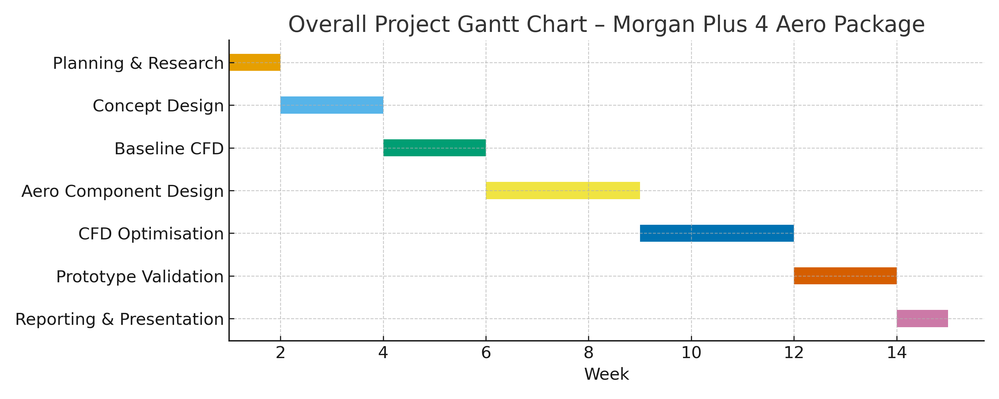
Figure 2: Detailed Gantt Chart – Integration & Testing
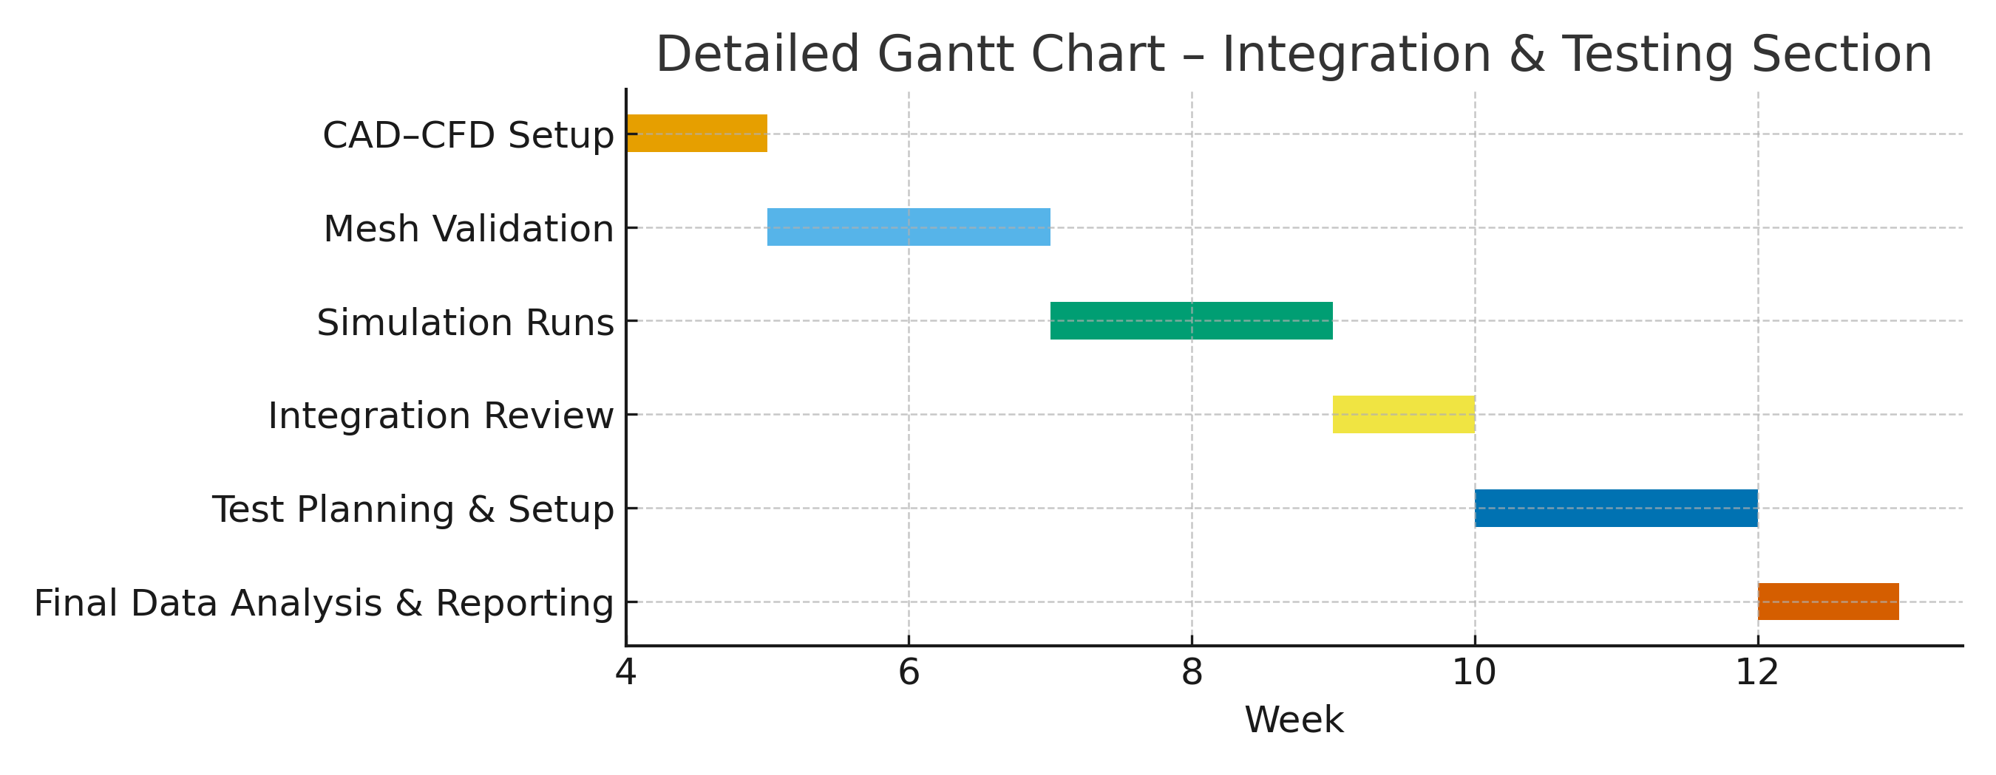
9. Extended Technical Discussion
The aerodynamic redesign of the Morgan Plus 4 also presents an opportunity to modernise the vehicle’s broader performance envelope through a deeper integration of simulation‑led development tools. While the primary focus of the project is the generation of downforce and the optimisation of drag, the methodology adopted here provides a template for future Morgan projects that aim to enhance vehicle dynamics without departing from the company’s classic design ethos. In particular, the project demonstrates how traditional craftsmanship can be augmented rather than replaced by contemporary CAE workflows. For example, historic Morgan body panels—typically developed through artisan shaping—can benefit from CFD‑supported curvature refinement to reduce flow separation and improve the aerodynamic efficiency of both road and track models.
Another significant dimension of the project is the opportunity for iterative learning across scales. The utilisation of a 1:8 scale model for wind tunnel validation allows for early insight into flow structures such as boundary‑layer behaviour, stagnation zones, and the formation of longitudinal vortices along the underbody. These insights can then be translated back into the CFD environment through turbulence model calibration, thereby reducing model uncertainty and closing the loop between simulation and experimentation. The pairing of URANS simulations with flow visualisation techniques such as smoke‑wire tracing or UV‑reactive tuft mapping strengthens this calibration further, ensuring that critical flow features are captured with both qualitative and quantitative clarity.
From a manufacturing perspective, the aero package introduces new considerations regarding compliance, repeatability, and structural integrity. Because Morgan vehicles retain a combination of aluminium panels and handcrafted structural elements, the introduction of high‑load aerodynamic components—particularly the front splitter and rear wing—requires reinforcement strategies that preserve both aesthetics and safety. Collaboration with manufacturing engineers will therefore be essential to ensure that mounting brackets distribute loads appropriately across the chassis without inducing undesirable stress concentrations. Additionally, the prototype phase provides a valuable opportunity to test rapid‑manufacture composites that may reduce overall weight while maintaining stiffness.
The project also sets the foundation for future digital‑integration initiatives. For instance, a parametric digital twin of the Morgan Plus 4 could eventually support ongoing aerodynamic refinement by simulating track‑specific setups or race‑day environmental conditions. Such a model could incorporate live telemetry inputs to predict real‑time downforce levels, enabling more granular performance tuning. While outside the scope of this initial aero package redesign, these concepts illustrate the potential growth trajectory of Morgan’s engineering capability if this workflow is successfully adopted.
Finally, the project carries strategic value beyond its technical outputs. By embracing a structured, evidence‑based engineering methodology, Morgan positions itself to expand its footprint within motorsport‑adjacent markets while maintaining the brand’s established heritage. The aero package represents a balanced fusion of tradition and innovation: modern aerodynamic science applied to a vehicle celebrated for its classic character. This alignment has the potential not only to enhance track performance but also to strengthen the brand narrative for customers seeking a vehicle that embodies both craftsmanship and engineering excellence.

