

Student name: Niculina Carmen Butnaru
Student ID: 2241990
Module name: Independent Project
Module code: BMHP 6020
Supervisor’s name: Chloe Harries

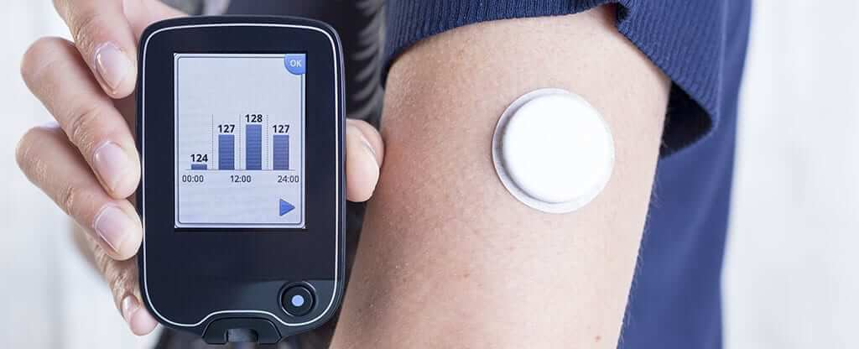 |  | Title and Aim of the Project  Title: The Role of Continuous Glucose Monitoring Systems (Libre and Dexcom) in Improving Diabetes Management at Home  Aim: This study examines the effectiveness of the Libre and Dexcom Continuous Glucose systems in the improvement of home-based diabetes management, self-care, adherence and communication.  Methods: Qualitative research will be conducted with a secondary approach, with references to peer-reviewed literature, clinical reports, and health policy documents published during 2020-2025. |  | 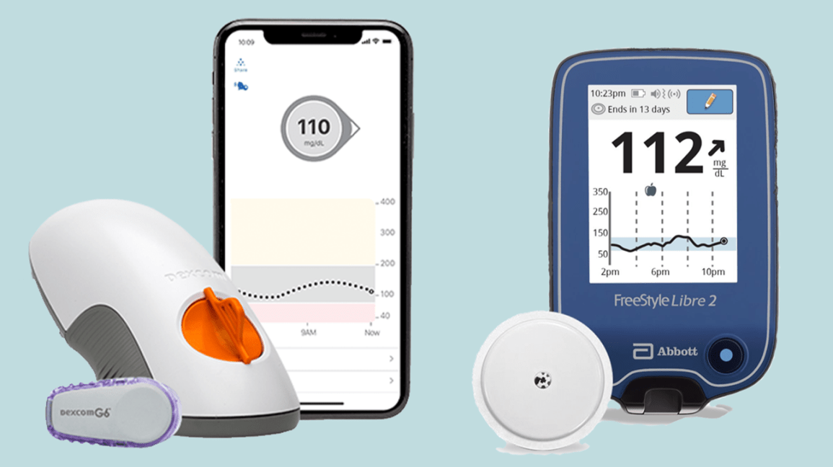
Methodology  The study is going to use a secondary qualitative design within the context of analysing the available evidence regarding CGM systems, and specifically, Freestyle Libre and Dexcom G7 available at Abbott. The thematic analysis will be used to reveal common themes, including the empowerment of patients, improvement of adherence, and the integration of digital health. The research adheres to a constructivist paradigm, as the knowledge is based on several data interpretations, instead of individual empirical evidence (Ratajczak et. al., 2025). |  |  |  | Data Analysis  The research will use thematic analysis to systematically interpret secondary qualitative data. The gathered material on Libre and Dexcom Continuous Glucose Monitoring systems will be coded to find common themes, such as self-care improvement, behavioural adherence, and digital health integration. Patterns of patient outcomes, practicality, and patient empowerment will be compared to determine the effectiveness of both systems. The data analysis will be inductive to ensure that the themes raised by the literature are brought to the table and not predetermined. This analysis process will facilitate the synthesis of the findings of various studies and indicate the benefits and obstacles to home-based diabetes management. This is in line with the practice of Yoo and Kim (2023) and Edward and Priefer (2023) that would guarantee sound interpretation and overall comprehension of the practices of continuous glucose monitoring.  Ethical Considerations  As secondary research, human subjects will not be involved in this research. The information will be obtained through sources that are validated publications. The issue of ethical integrity will be addressed by providing appropriate Harvard reference, source critical analysis, and recognition of all the authors (Ratajczak et. al., 2025).

Data Collection
This research will use academic databases such as PubMed, ScienceDirect, and Google Scholar as the source of secondary qualitative data. Keywords that will be used in applying a Boolean search strategy include “Libre, Dexcom, Continuous Glucose Monitoring, and home diabetes care. Peer-reviewed articles, clinical research, and official health policy reports published in the last 2020-2025 will be included. The sources will ensure the reliability, relevance, and credibility of the data and provide a complete picture of the efficacy of continuous glucose monitoring systems in diabetes management at home.

References
Edward, R. and Priefer, R. (2023). A comparison of continuous glucose monitors (CGMs) in diabetes management: A systematic literature review. Primary Care Diabetes, 17(6), pp.529–534. doi:https://doi.org/10.1016/j.pcd.2023.10.009
Rahimi, B., Nadri, H., Afshar, H.L. and Timpka, T. (2018). A Systematic Review of the Technology Acceptance Model in Health Informatics. Applied Clinical Informatics, online 09(03), pp.604–634. doi: https://doi.org/10.1055/s-0038-1668091
Rodbard, D. (2017). Continuous Glucose Monitoring: A Review of Recent Studies Demonstrating Improved Glycemic Outcomes. Diabetes Technology & Therapeutics, [online] 19(S3), p.S-25-S-37. doi: https://doi.org/10.1089/dia.2017.0035
Ratajczak, P., Oziewicz, K., Sommer, I., Kopciuch, D., Paczkowska, A., Zaprutko, T. and Kus, K. (2025). The Perspective on Secondary Research Practices: A Cross-Sectional Analysis. Healthcare, 13(8), p.927. doi:https://doi.org/10.3390/healthcare13080927.
Yoo, J.H. and Kim, J.H. (2023). Advances in Continuous Glucose Monitoring and Integrated Devices for Management of Diabetes with Insulin-Based Therapy: Improvement in Glycemic Control. Korean Diabetes Journal, 47(1). doi:https://doi.org/10.4093/dmj.2022.0271.

