I acknowledge the use of Chat GPT on 09/10/2024, 11/10/2024 and 11/01/2025 for my work. I used the prompt(s):
1. Identifying parts and headings
2. Compare
3. Proofreading
I confirm that I have not presented any AI generated text as my own work. I confirm I have copies of my drafts, notes, and I can provide evidences. I acknowledge the use of Chat GPT to check my Grammarly throughout the text.

Module Title: Financial Management for the Hotel Industry
Module Code: BMIH5007
Student Name: Cristina-Maria Petrache
Student ID: 2234360
Assignment Title: Business Report - Comparison of Two Hospitality Organisations Comparison of Shangri-La Hotels and Premier Inn

Table of Contents
1 Introduction 4
2 Comparative Analysis of Shangri-La Hotels and Premier Inn 5
2.1 Total Revenue 5
2.2 Market Position 7
2.3 Growth Potential 12
2.4 Financial Commitment to CSR 13
3 Conclusion 14
4 Recommendations 14
5 References 16

Table of Figures
Figure 1: Shangri-La Hotels and Resorts 4
Figure 2: Premier Inn 5
Figure 3: Financial highlights of Shangri-La Hotels 6
Figure 4: Financial highlights of Premier Inn 7
Figure 5: Income of selected hotel companies worldwide 8
Figure 6: Movement of Cash Flow 9
Figure 7: Number of Premier Inn (Whitbread) hotels in the United Kingdom and Ireland from 2012/13 to 2023/24 10
Figure 8: Occupancy rate of Premier Inn (Whitbread) hotel rooms in the United Kingdom and Ireland from 2011/12 to 2023/24 11
Figure 9: Shangri-La Occupancy Rate 12

Introduction
The multinational hospitality organisation Shangri-La Hotels and Resorts began its operation in 1971 with Robert Kuok, and its operation centre is in Quarry Bay, Hong Kong. The name of the project derives from the title of James Hilton's novel "Lost Horizon", which tells the story of a hidden valley known as Shangri-La (Shangri-La Hotels and Resorts, 2024). Renowned for its quality service, serene environment, and attractive architecture, Shangri-La hosts clients through a cultural tourism hospitality model of the Shangri-La lifestyle.
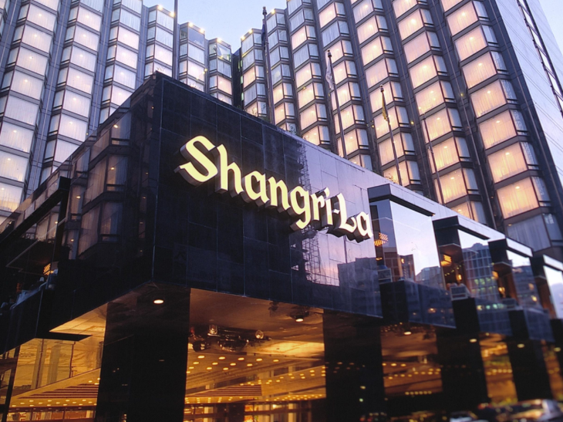
Figure 1: Shangri-La Hotels and Resorts
(Source: Shangri-La Hotels and Resorts, 2024)
Premier Inn, founded by Whitbread in 1987, has become the biggest hotel company in Great Britain. Premier Inn opened over 800 hotels and it has more than 72000 rooms and this chain covers city centres, suburbs, and airports (Premier Inn, 2024).
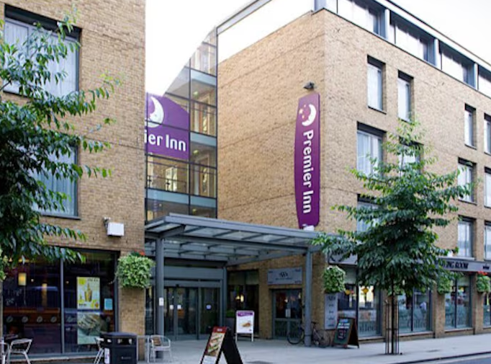
Figure 2: Premier Inn
(Source: Premier Inn, 2024)

Comparative Analysis of Shangri-La Hotels and Premier Inn

Total Revenue
It is illustrated from annual report that the growth in revenue was much higher in Shangri-La that posting a revenue of USD 2,141.8 million in 2023 (Annual Report, 2024). This increase has been supported by improvement in global tourism as tourists’ holiday destinations resumed in Middle East region. It basically operationalises through sales of hotel accommodations and food services which are mainstay of Shangri-La’s revenues.
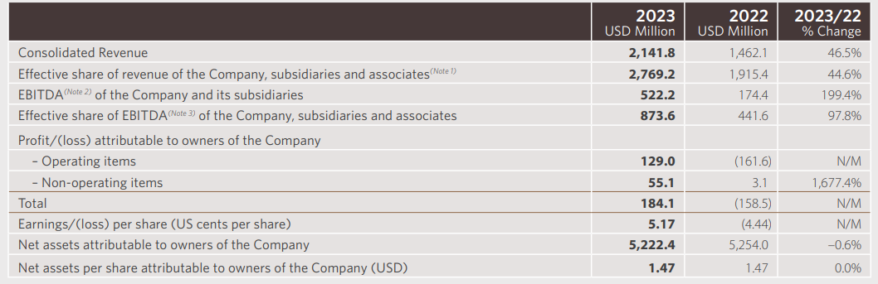
Figure 3: Financial highlights of Shangri-La Hotels
(Source: Annual Report, 2024)
In addition, the increase in EBITDA by 199.4% demonstrates that it was a highly profitable year for the company (Annual Report, 2024). Shangri-La was able to show a strong increase in cost efficiency; its EBITDA rose by approximately 200%, reaching USD 522.2m. Perhaps the company successfully developed economies of scale through its concentration on luxury properties, unique business partnerships and joint ventures. Effective cost management and an increase in the demand for luxury services hence bolstered the company's comprehensive profit margin in 2023 (Annual Report, 2024).
In the view of the annual report, Premier Inn's overall revenue has also been on the rise in FY24, showing the revival of the hospitality business in the UK with statutory revenue from £2,625 million in FY23 to £2,960 million in FY24 (Annual Report, 2024a). The most crucial income stream for Premier Inn is hotel accommodation, which has experienced growth in the demand of both corporate and other customers, which is enabled by travel. Inflation and increase in cost have been significantly averted by increased operational efficiency and a growth of 19% to £ 1,057 million on the adjusted EBITDAR (Annual Report, 2024a). This seems to have occurred due to a higher room occupancy rate that is probably accompanied by better pricing strategies in the UK market.
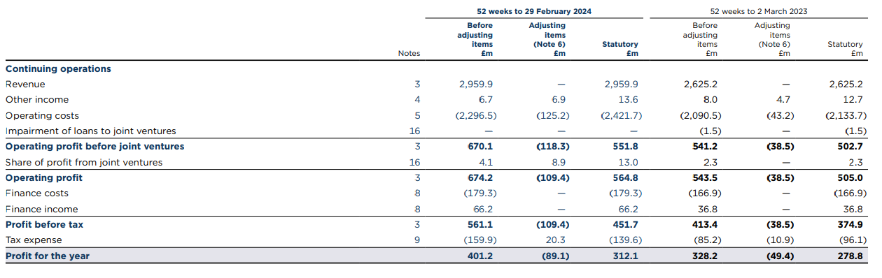
Figure 4: Financial highlights of Premier Inn
(Source: Annual Report, 2024a)
Cost of sales surged by 7% to £1,196 million in FY24 because of inflation and overall hike in operating costs at Premier Inn to £1,906 million due to operating leverage (Annual Report, 2024a). The increase in operating costs can be explained through higher tendencies of labour, energy and other maintenance costs, common to the industry during this phase of development (Tranter et al., 2014).

Market Position
Shangri-La Hotels is famous for offering luxurious lodgings to well-heeled visitors and offering superior services to guests (Mahathaven et al., 2021). Currently, it has properties in Asia, the Middle East, and Europe, catering for customer groups of high-end travellers, business people, and millionaires.
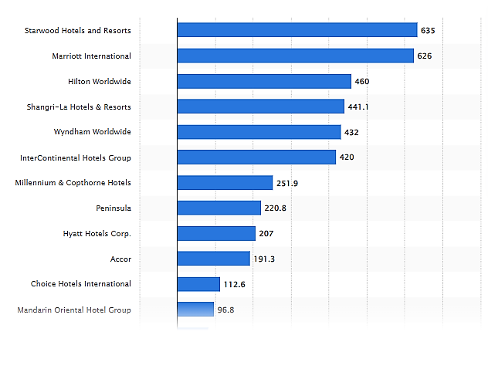
Figure 5: Income of selected hotel companies worldwide
(Source: Statista, 2024)
Shangri-La's market position is backed up by its international network, and its results indicate that the company performs well in the Asia-Pacific and Middle East regions of the world. Meanwhile, it recorded its revenues rising by 46.5% in 2023, primarily due to the improvement of luxury travel (Statista, 2024 in figure 5). The customer target of the brand is the high-end market that goes in search of a unique luxurious experience (Kee et al., 2020). Shangri-La has been established and popular as a luxury hotel chain; besides the loyalty programme and luxurious services, it positioned itself firmly between the world's leading hotel brands (Annual Report, 2024).
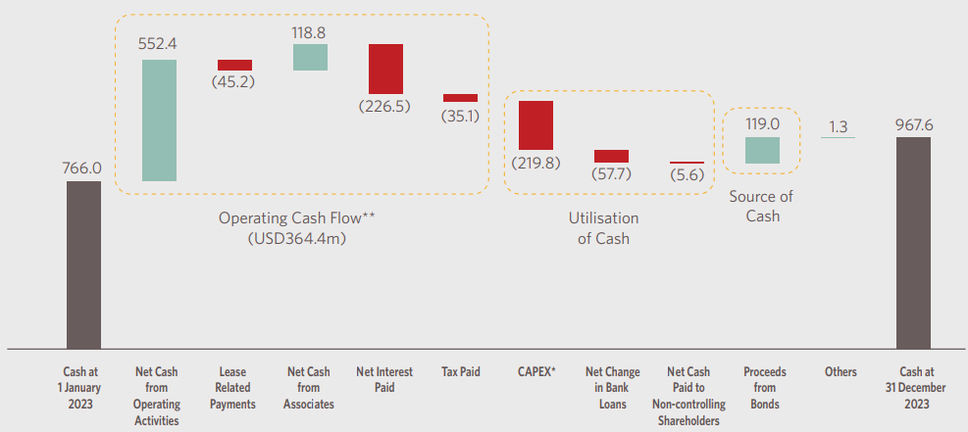
Figure 6: Movement of Cash Flow
(Source: Annual Report, 2024)
In contrast, Premier Inn remains one of the dominant companies in the UK’s budget and mid-segment hotel market (Page and Connell, 2020). Since FY24, the company's brand has established a network of more than 850 hotels across the UK and Ireland while it reported a healthy occupancy level of only 82.2%, which indicates it has a huge growth potential ( Statista, 2024a). It has a large market share in the UK, where it serves both business and leisure travellers. The competitive strategy with which Premier Inn has grown its business is to ensure extremely low prices while maintaining service quality across its hotels. The key features to promote the brand, which include reliability, convenience and cost-effectiveness, can appeal to different groups of consumers, including families and businessmen.
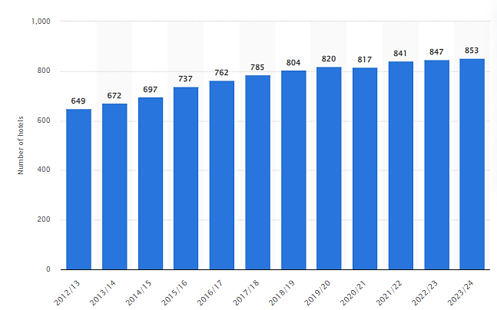
Figure 7: Number of Premier Inn (Whitbread) hotels in the United Kingdom and Ireland from 2012/13 to 2023/24
(Source: Statista, 2024a)
Premier Inn has ventured into the overseas market with its increasing outlets in different parts of Europe. Affordability, efficiency, and environmental consciousness are current and future value propositions of this company, which will appeal to profitability-focused customers.
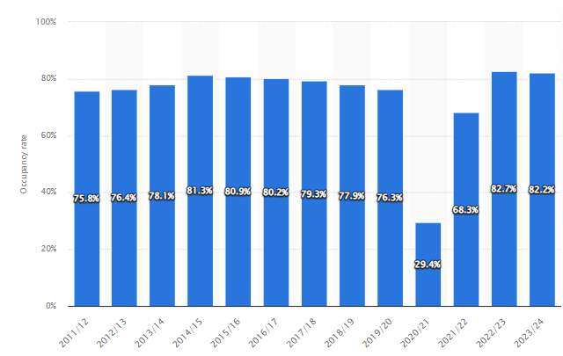
Figure 8: Occupancy rate of Premier Inn (Whitbread) hotel rooms in the United Kingdom and Ireland from 2011/12 to 2023/24
(Source: Statista, 2024b)
Efficiency is closely associated with customer demographics and brand image where Premier Inn has realised occupancy rate of 82.2 % in FY24 (Statista, 2024b), while Shangri-La a luxurious hotel has an occupancy of 61.6% in September 2024 for Shanghai star rated hotels (Shangri-La- Group, 2024b). Based on the above graph, Premier Inn targets cost sensitive customers such as families and those customers who are on business travels. The company has a robust occupancy rate understandable by its operational broad market demand all over the UK and Ireland helpful in positioning it as a low-cost room inventory provider. On the other hand, Shangri-La aims at its high-end business and leisure travellers offering luxurious products and services (Walker, 2021). The star-rated hotels in Shanghai have a lower occupancy as compared to general hotels because star-rated hotels are niche based, preferred by a particular sensitive section of the population which can be negatively impacted due to economic conditions and travel limitations. These differentiate demonstrate that customer demographics as well as brand image do produce direct effects on occupancy in the hospitality industry.
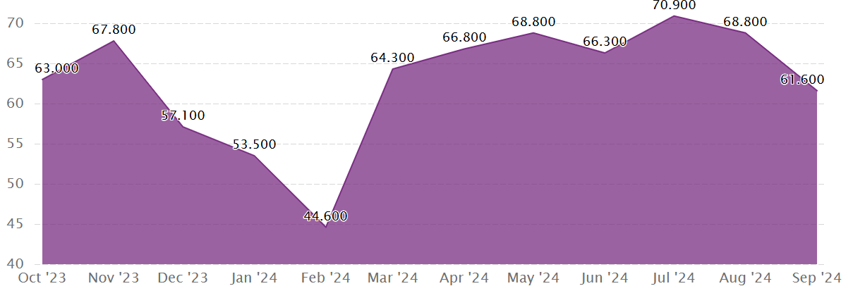
Figure 9: Shangri-La Occupancy Rate
(Source: Shangri-La Group, 2024b)

Growth Potential
Shangri-La Asia Limited holds great future earnings prospects based on the company's international market penetration objectives and the diversification business model. Through the need to reach new, high-end markets, Shangri-La has successfully expanded to Southeast Asia, the Middle East and China, which requires luxury hotels (Shangri-La Hotels, 2024). Also, the luxury brand and customer loyalty programmes make the company stand out since its guests will keep coming back, hence attracting high-end customers. It also aims to strengthen digital competencies, upgrade the satisfaction among the guests, and shift towards creating relevant services and products (Rohim et al., 2023). Another factor that favours the growth of the company is its strategic partnerships, joint ventures, and investments in luxury properties. Shangri-La is now able to build on places that are experiencing high growth in demand due to rising tourism, especially in Asia.
The growth strategy of Premier Inn is to expand its coverage in the UK and to enter international markets, mainly European (Enz, 2021). Since, Premier Inn is well known and recognised for offering affordable services in the hotel industry, it is well poised to capture a bigger market share of the home and abroad market (Yuan and Ren, 2023). Furthermore, integrating more sustainable functions into the business and adopting innovative digital media will drive growth that will benefit Premier Inn as the hospitality market progresses. Also, the robust results of the Premier Inn operation in the UK market mean that this segment offers a favourable starting point for expanding to new markets with similar conditions.

Financial Commitment to CSR
CSR is an important area in the business practice of Shangri-La Hotels and Resorts, which carries out a wide range of activities related to sustainability at the corporate level with the help of the CSR Committee. Main CSR activities include the EMBRACE project, which strives at community engagement, throwing support to the community in educational and health sectors in underprivileged areas (Bharwani and Mathews, 2021). For example, Shangri-La Surabaya has adopted a rural school that offers not only funds but also activities that will have an imperative impact on students and their families. This endeavour best represents Shangri-La's intent to support sustainable community growth and eradicate learning inequity. Another CSR agenda implemented by Shangri-La is the SANCTUARY project which aims to manage ecology and rebuild the thriving conventional habitat (Shangri-La Hotels, 2024a). Environmental conservation is another area of attention and investment that enables the firm to support the worldwide fight against climatic change. Programmes such as SANCTUARY also involve embracing conservation projects that are responsible for the restoration of ecosystems and the integrity of biodiversity, proving that Shangri-La's operational principles are environmentally friendly (Shangri-La Hotels, 2024a).
An important aspect of the company is that Premier Inn has shown considerable financial investment in CSR and sustainability, including a number of programmes aimed at bringing change into society and the environment. One of its CSR initiatives includes a £20 million responsibility to GOSH Charity that aims at building a children's cancer centre (Premier Inn, 2024a). In the same manner, meals bought also supported GOSH through bed-ins and fun runs that Premier Inn has undertaken, enabling the firm to raise £23 million for GOSH Charity (Premier Inn, 2024b). These donations and fundraising activities prove the constant interest in social needs and problems. From its corporate expression and product offerings, Premier Inn's sustainability plan is also reflected in its financial support for environmentally conscious programmes. Also, for sustainability, it currently works in collaboration with EQUANS installing high-powered electric vehicle charging stations at the hotels of Premier Inn UK (Premier Inn, 2024c). In the same way, Premier Inn is synchronising its financial responsibilities with its strategic objectives with respect to the more general concerns of environmental and social impact.

Conclusion
Conclusively, both Shangri-La and Premier Inn achieved their goal of defining their areas within the hospitality industry. Shangri-La is described as one of the leaders in the luxury segment with stores at the international level, and Premier Inn can be described mostly in the budget segment in the UK with a concentration of its stores through an efficient and affordable line of products. The two firms have considerable growth prospects resulting from market-led expansion strategies and CSR orientation. They have practical potential to succeed in the future in the competitive global hospitality market, depending on their capacity to manage the changing market environment and sustainability factors.

Recommendations
Based on the assessment of the growth prospects of Premier Inn, it should expand its operations in the international market, especially across Europe and North America, and prioritise the sustainability of the facility. People aware of the operations of Premier Inn will agree that it has a suitable business model; being efficient in the UK market, it offers cheap hotel services with quality service delivery (Mwaura et al., 2020). To demonstrate its environmental responsibility, Premier Inn has to focus on clients who are concerned about environmental protection. Net claims that by extending the goal of net-zero emissions by 2050, the company should focus on its renewable energy investments and green energy, such as solar panels for use by tourists visiting those regions.
In the case of Shangri-La, it needs to focus on strengthening digital innovation with regard to its customers and business workflows. Shangri-La has already come a long way when it comes to luxury services, and the company's excellent CSR strategies show that sustainability and community involvement are important (Pageand Connell, 2020). However, as customer expectations evolve, focusing even more on digital engagements and frictionless experiences, especially in the sphere of the luxury hotel business, Shangri-La needs to expand and upgrade its digital services. This can be done through enhancing its mobile applications and internet booking website to come up with an individualised feel of the facilities, the rooms, meal options, and even wellness services that are all well synchronised and AI-enabled from the time of booking up to cheque-out time.

References
Annual Reports, (2024). Our performance [Online] Available at https://sitecore-cd.shangri-la.com/-/media/Project/Shangri-La-Group/Investor/Files/Public-Disclosures/Latest-Top-Publications/2023_Annual_Report_E.pdf [Accessed 3rd December 2024].
Annual Reports, (2024a). Building on our advantage. [Online] Available at https://cdn.whitbread.co.uk/media/2024/05/Whitbread-PLC-Annual-Report-and-Accounts-2023_Single_pages-1.pdf [Accessed 3rd December 2024].
Bharwani, S. and Mathews, D. (2021). Techno-business strategies for enhancing guest experience in luxury hotels: a managerial perspective. Worldwide Hospitality and Tourism Themes, 13(2), pp.168-185.
Enz, C.A., (2021). Competing successfully with other hotels: The role of strategy. The Cornell School of Hotel Administration on hospitality: Cutting edge thinking and practice, pp.207-226.
Kee, D.M.H., Ang, Z.L., Woh, M.T., Soleimani, M., Jayant, J., Quttainah, M.A. and Pandey, R., (2020). Shangri-La Hotels and Resorts' People and Culture Strategy in Deriving Employee Satisfaction. Advances in Global Economics and Business Journal, 1(1), pp.1-11.
Mahathaven, M.T.W., Soleimani, M., Jayant, J., Anwar, M. and Quttainah, R.P., (2021). Shangri-La Hotels and Resorts' People and Culture Strategy in Deriving Employee Satisfaction.
Mwaura, G., Sutton, J. and Roberts, D., (2020). Corporate and national culture‐an irreconcilable dilemma for the hospitality manager?. International Journal of Contemporary Hospitality Management, 10(6), pp.212-220.
Page, S.J. and Connell, J., (2020). Tourism accommodation and hospitality services. In Tourism (pp. 216-241). Routledge.
Premier Inn, (2024). Winter breaks are coming! [Online] Available at https://www.premierinn.com/gb/en/home.html [Accessed 3rd December 2024].
Premier Inn, (2024a). Supporting Great Ormond Street Hospital Children’s Charity [Online] Available at https://www.premierinn.com/gb/en/why/gosh-childrens-charity.html [Accessed 3rd December 2024].
Premier Inn, (2024b). How we’re supporting build it. Beat it – Great Ormond Street Hospital Children’s Charity’s new fundraising campaign. [Online] Available at https://www.premierinn.com/gb/en/news/2023/build-it-beat-it.html [Accessed 3rd December 2024].
Premier Inn, (2024c). We're a Force for Good. [Online] Available at https://www.premierinn.com/gb/en/why/force-for-good.html [Accessed 3rd December 2024].
Rohim, C.Y., Fitriano, C.B. and Jufrizen, K.W., (2023). Reward Systems and Performance of Employees in Hospitality Industry. A Case Study of Shangri-La Singapore. Journal of Human Resource & Leadership, 7(5), pp.12-22.
Shangri-La Hotels and Resorts, (2024). Our services. [Online] Available at https://www.shangri-la.com [Accessed 3rd December 2024].
Shangri-La Hotels, (2024). Opening Doors to Opportunities. [Online] Available at https://www.shangri-la.com/group/investors/ [Accessed 3rd December 2024].
Shangri-La Hotels, (2024a). Our ESG Vision. [Online] Available at https://www.shangri-la.com/group/sustainability/ [Accessed 3rd December 2024].
Shangri-La Hotels, (2024b). Shangri-La Group Releases 2023 Interim Results. [Online] Available at https://www.shangri-la.com/group/media/media_post?post=Aug30_2023InterimResults#:~:text=Consolidated%20revenue%20of%20the%20Group,No%20interim%20dividend%20proposed. [Accessed 3rd December 2024].
Statista, (2024). Income of selected hotel companies worldwide. [Online] Available at https://www.statista.com/statistics/202265/net-income-of-selected-hotel-companies-worldwide/#:~:text=Published%20by%20Statista%20Research%20Department,251.9 [Accessed 3rd December 2024].
Statista, (2024a). Number of Premier Inn (Whitbread) hotels in the United Kingdom and Ireland from 2012/13 to 2023/24. [Online] Available at https://www.statista.com/statistics/739855/whitbread-premier-inn-hotels/#:~:text=Number%20of%20Premier%20Inn%20hotels%20in%20the%20UK%20and%20Ireland%202012%2D2024 [Accessed 3rd December 2024].
Statista, (2024b). Occupancy rate of Premier Inn (Whitbread) hotel rooms in the United Kingdom and Ireland from 2011/12 to 2023/24. [Online] Available at https://www.statista.com/statistics/739831/premier-inn-hotel-occupancy-rates/ [Accessed 3rd December 2024].
Tranter, K. Stuart-Hill, T. Parker, J. (2014) Introduction to Revenue Management for the Hospitality Industry, London, Pearson.
Walker J (2021) Introduction to Hospitality, Harlow, Pearson.
Yuan, Y. and Ren, T., (2023). Analysis of Hotel Financial Ability based on Dupont Analysis Method-Take Jinjiang Hotel as an Example. Frontiers in Economics and Management, 4(9), pp.147-160.

