
Impact of Ransomware Attacks on Business Operations: Mitigation Strategies and Recovery Framework


June 30, 2023
Christopher John Thomas 1252344
Macmillan Distribution
Munya Murira/Nitheesh Kaliyamurthy

Table of Contents
Chapter 1 – Introduction & Background Information 2
1.1 Introduction 2
1.2 Background Information 2
Chapter 2 – Security Vulnerabilities & Technologies 4
2.1 Security Vulnerabilities 4
2.2 Physical Security 4
2.3 Firewalls 5
2.4 Forcepoint Security 6
3. Aims & Objectives 7
3.1 Field of Study 7
3.2 Aims and Objectives 7
3.3 Expected Outcome 7
Chapter 4 – Methodology 8
4.1 Research Methodology 8
4.1.1 Philosophy 8
4.1.2 Approach 8
4.1.3 Strategies 8
4.1.4 Risks & Limitations 9
4.1 5 Ethical Issues 10
4.1.6 Validity, Reliability & Generalisability 10
4.1.7 Data Evaluation Methods 11
4.2 Development Methodology 11
5 Resources and Planning 12
5.1 Hardware Resources 12
5.2 Software Resources 12
5.3 Human Resources 12
5.4 Project Plan 13
Appendix – Tools Used. 2

Figure 1 The Varonis Alert that triggered the investigation. 4
Figure 2 Site Drawing of the Warehouse. 6
Figure 3 Image of a Domain-connected Laptop. 7
Figure 4 Excerpt document control being updated during the breach. 10
Figure 5 Asana task creation. 14
Figure 6 Project timeline. 0

Chapter 1 – Introduction & Background Information

1.1 Introduction
During June 2022 an end user working in the warehouse in Virginia received an email with an attachment, they had recognised who the sender was and they had opened the attachment. This type of attack is known as a phishing attack.
The type of Phishing attack in this instance was a Spear phishing attack. Spear attacks can target an individual or an organisation; they are sophisticated attacks, and each attack has a different attack vector and purpose, I.E an attempt to gather user login credentials, customer data, employee data, or to gain access to the infrastructure of a business and cause as much damage as possible[1].

1.2 Background Information
The user in the warehouse had received an email from a source they believed to be reputable, and once they downloaded the PDF attachment and opened the file, it was at this point the PC became compromised. With the PC now being compromised, the attackers could collect stored credentials from the device; what would quickly become apparent to them was that the compromised account was a local administrator giving them unrestricted access to that server. From here, the attackers were able to connect to a Citrix Server using the credentials that were harvested and were also able to compromise that server as well, but this would end up being a more significant compromise as the attackers were able to harvest Domain Administrator credentials [2].
The domain admin account is an account that has the highest privilege within the domain; with this account, the attack can cause mayhem and make any change that they want, e.g.;
- Creation of other Domain Admin accounts.
- Disabling of legitimate Domain Admin accounts.
- Active Directory attacks.
- Ability to login to any server within the business.
Once credentials have been harvested, the attackers can move around; from the compromised server, they could move from one child domain to another, but this is where the attackers were highly clever. Once high-level credentials were gathered, they installed legitimate remote desktop software and began moving from server to server, scanning the network and looking for targets to infect.
By this point, the attackers have infected many devices ranging from servers to desktop devices; what they proceeded to do then was start to encrypt files, which triggered an alert as seen in the figure below:
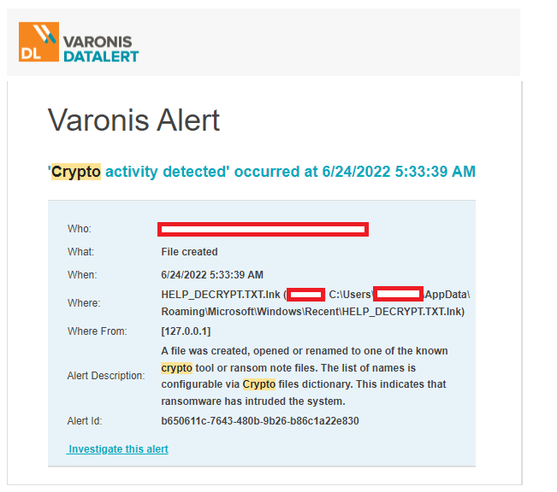
Figure 1 The Varonis Alert that triggered the investigation.
Once this alert was received, an initial investigation began; it was noted that the user account that triggered the alert was a member of the US infrastructure team, and it was 4:30 a.m. local time. The UK infrastructure team contacted the staff member, but it was noted that they were on annual leave, which raised further concerns; it was decided for security reasons that their domain admin (DA) account would be disabled while investigations take place.
As the security incident was being investigated, the UK team noticed that the once locked DA account had been unlocked by another US-based administrator, which again is very unusual due to the time of day; it was decided as we investigated to lock the first account and then the second account just to be safe. In total, there were four compromised DA accounts in the US; until we got a grasp of the situation, it was deemed for the security of the company that all US-based accounts be disabled and passwords reset, and new passwords would be handed out via a phone call [3].
The above background is a small snippet of the initial steps that began the investigation, the following chapters discuss some of the vulnerabilities and discuss what some of the future implemented technologies will be.

Chapter 2 – Security Vulnerabilities & Technologies

2.1 Security Vulnerabilities
One of the compromised servers was a Domain Controller, during the investigation it was found that the attackers had run Mimikatz.exe, Mimikatz is an open-source offensive utility that does a multitude of things such as [4]:
- Pass the hash – Is where the attacker doesn’t need to crack the password of an account but pastes in the exact password hash.
- Pass the ticket – Holds the password in a ‘ticket’ the attackers can steal that ticket and use it to login as that user.
- Overpass the hash – is fairly similar to pass the hash but utilizes a ticket gained from a Domain Controller.
- Kerberoast golden tickets – This attack uses an inbuilt account that exists in all Active directory instances. With the golden ticket it will give the attacker DA that does not expire over all machines in the network.
- Kerberoast silver tickets - This is the same attack as Gold tickets but targets service accounts.
- Pass the cache – Is a non-windows attack, which is like pass the hash but takes advantage of MAC/Linux devices with encrypted password [5] [6].

With the use of this tool and another tool called Procdump the attackers were able to use cached credentials, Procdump is used to dump the LSASS process and creates a file called LSASS.DMP with this the attackers we able to access any stored credentials for admin accounts. Once this was discovered all admin accounts had their passwords changed and the business even went to the extreme of creating new DA accounts and then the old ones were disabled and then removed at a later date [6]

2.2 Physical Security
Physical security is a crucial component of any business, as it involves various measures to prevent physical attacks. While it is rare for attackers to gain access to sites or buildings to target digital systems, it remains a significant risk that has occurred in the past. Vantage Data Centres, located in Newport, South Wales, is a large-scale data centre that provides services to various business’s and Internet Service Providers (ISPs) such as Virgin Media Business, BT Exponential-E, TalkTalk, and others. To provide these services, they prioritise infrastructure and security to protect users’ personal information and on-site hardware.
These sites are heavily secured with 24/7 on-site security that meets the strict specifications of the UK government and military agencies. Access is limited to authorised appointments, and rigorous security procedures are in place to ensure robustness and establish credibility. Vantage Data Centres demonstrates its commitment to data security and compliance through certifications such as BSI-ISO/IEC 27001 and SOC 2 [7].
In contrast to the high-security premises such as Vantage Data Centres, a factory warehouse may provide an easier access opportunity. Physical attacks in such locations may involve unauthorised individuals entering the site unnoticed and plugging into unsecured network ports, gaining access to the network via unpatched or misconfigured switch ports. Mitigation strategies include physically disconnecting the wall port from the patch panel and switch to prevent unauthorised network access attempts, although this is not considered best practice. Instead, it is recommended to disable any unused ports on the switch itself. Vulnerabilities exist around doors and dock doors, as they can be left open, creating potential vulnerabilities. To mitigate this risk, local cabinets should always be locked, with access limited to the on-site IT team, although this alone may not deter a determined attacker.
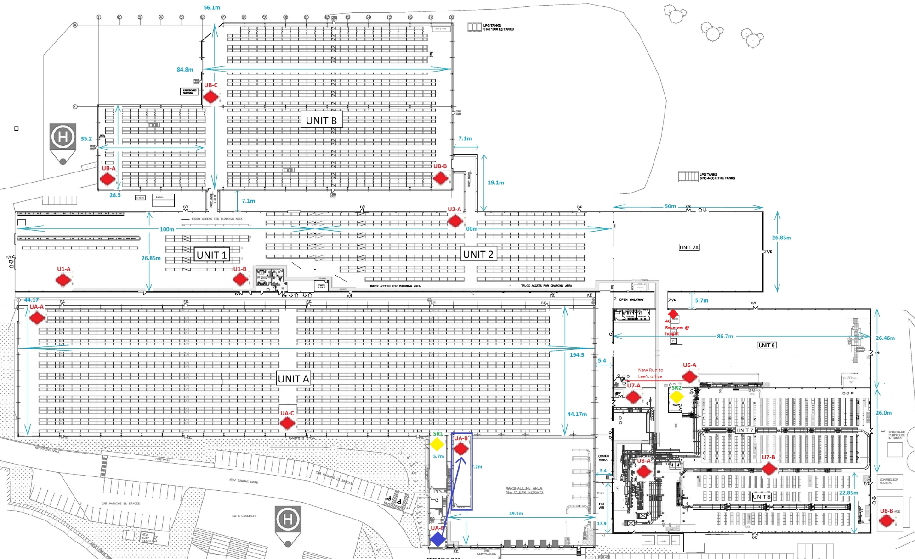
Figure 2 Site Drawing of the Warehouse.
In Figure 2, red diamonds represent the locations of small cabinets scattered across the warehouse, while yellow triangles indicate site server rooms. Server rooms offer higher levels of security than remote locations because they house the core network and other essential infrastructure equipment. Server room doors typically employ PIN codes and magnetic locks, allowing access only to authorised personnel. Similar security measures apply within the server rooms. Local cabinets, on the other hand, can be compromised a bit easier as the cabinets are easier to access and are not as robust as a door with a pin and a magnetic lock, with local IT teams ensuring that infrastructure cabinets are locked and regular checks to makes sure that the remote cabinets have not been tampered with.

2.3 Firewalls
Firewalls are essential to every business’s security infrastructure, typically housed in server rooms. Hardware firewalls, such as checkpoint firewalls or Cisco ASA firewalls, have dedicated hardware positioned at the network’s edge. Their primary function is to inspect incoming and outgoing traffic based on a set of preconfigured rules [8]. For example, if a packet is destined for subnet A, the firewall examines it and determines whether to allow or deny its passage. It is important to note that firewalls alone do not provide comprehensive protection, as they lack intrusion detection capabilities, and do not protect against internal attacks, and they cannot read encrypted traffic. However, one of their key protective functions is the ability to drop all active connections during a network breach, known as a “dead-man switch,” which protects the Local Area Network (LAN) by preventing any Wide Area Network (WAN) traffic from entering [9].
In addition to hardware firewalls, end-user devices such as laptops and desktops often include built-in software defence suites. For Windows devices, this functionality is located under Windows Security, allowing users to monitor system health and take appropriate action if issues arise. From an enterprise perspective, software firewalls are also installed on server hardware, providing an additional layer of defence One prime example of software firewalls is in the Windows Defender suite of software.
While most enterprise businesses predominantly use Windows devices, there is a need for antivirus solutions that cover other operating systems, such as Macintosh. Many antivirus vendors, including Symantec endpoint protection, Avast antivirus, and Microsoft Defender support MacOS[10].
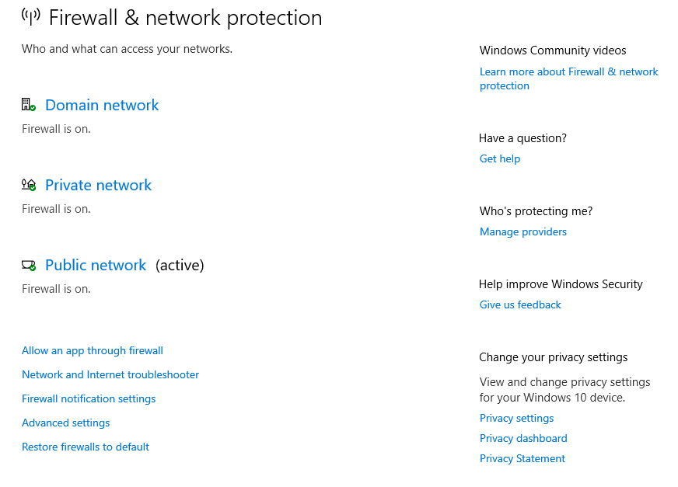
Figure 3 Image of a Domain-connected Laptop.

2.4 Forcepoint Security
Firewalls are not the only protection tool available to businesses. Forcepoint Web Security Manager, for example, goes beyond packet filtering and focuses on URL and file filtering. This suite, offered by Forcepoint, actively allows or blocks access to specific websites and incorporates live scanning capabilities. Suppose an end-user attempts to access a potentially dangerous site, when that attempt is made Forcepoint can block access based on its comprehensive database of safe and unsafe websites, providing real-time protection for the business there are instances that some websites need to be added manually to the database.
Forcepoint enables granular control over website access, allowing organisations to permit access to certain websites, such as LinkedIn, while preventing file uploads from corporate PCs or laptops. It can also adapt access based on business needs and policies, allowing access to specific subdomains such as “www.reddit.com/r/technology” while blocking access to “www.reddit.com.”
Moreover, Forcepoint offers a unified platform called Forcepoint One, which encompasses various software packages. This comprehensive suite includes features such as malware scanning for incoming and outgoing files or documents, protection for corporate software packages such as Office365 and Salesforce, and integration with Software as a Service (SaaS) products like Office 365. By implementing Forcepoint One, organisations can prevent employees or contractors from downloading corporate documents onto personal devices, ensuring the safety of company data [11].

3. Aims & Objectives

3.1 Field of Study
The current field of study at the University of Wales Trinity St David is Bachelor of Science: Computer Networks & Cybersecurity, part of the apprentice program. The final year project proposed within this document will be based on a breach in June 2022 where a distribution company was heavily affected, and what the remediation steps that were taken.

3.2 Aims and Objectives
This project proposal aims to overcome the network breach, how it was identified and the remedial work that has since taken place to strengthen the company’s position at a global and local level. The objectives listed below will be used to help achieve this aim:
- Conduct an in-depth examination of the security breach and to identify the root cause and entry point.
- To enhance and improve the company’s intrusion detection & monitoring systems.
- To implement further security measures and protocols for the Network to prevent further unauthorised access and data loss. For example, Microsoft Multifactor Authentication(MFA) and Duo authentication for server hardening.
- Procure new Cisco network switches and install new fibre optic cables for the warehouse.
- Implementation of new antivirus and malware protection globally.

3.3 Expected Outcome
There will be many outcomes that will come from the implementation of this project.
The first outcome will be the identification of the device that caused the breach to occur, from here seeing where the attackers have moved and pivoted within the network. Once the breach has been contained progress can be made to mitigate against the damage that was caused.
Once the incident has been contained the business can begin to check their infrastructure, every PC/Laptop, Server will be manually checked and logs uploaded to a specific FTP provided by Varonis to be checked.
Second expected outcome will be the installation of new antivirus, MFA, Duo and making sure that servers, desktops and VPN connections are checking in to the relevant portals.
The Third outcome is the installation of new Cisco networking equipment, Fibre, UPS’s within the local warehouse in Swansea.
The overall aim for this project is to harden the network and prevent further beaches, if that cannot be achieved then to make it as difficult as possible to pivot and move within the network.

Chapter 4 – Methodology

4.1 Research Methodology

4.1.1 Philosophy
For this proposed project, a mixed approach between positivistic and Phenomenological will be undertaken; data gathering for this project will come from multiple applications such as:
- Windows Defender Portal.
- Azure.
- Duo.
- LogRhythm.
- Varonis.
- Physical servers and end user devices.
This project takes elements from both positivism and phenomenology; from the positivism element, this is an experiment, but from the phenomenology side, there will be elements of case studies and document analysis.
The Aims/objectives mentioned in section 3.2 will use both philosophies. They will be classed as an experiment due to new applications being installed on servers and the infrastructure team needing to know how this will interact with the system and installed applications; the team will use case studies and whitepapers to complete the initial installs. It will then use the above applications to gather data from that device. The disadvantage would be installing the applications such as DUO or Windows Defender failing; for example, further investigations will need to be undertaken, and fixes will need to be implemented, which would slow the progress of the project.

4.1.2 Approach
The deductive approach will be used for the implementation of this project, this project will be fast paced, moving from theory to implementation and data gathering within a matter of hours. This approach has been chosen due to the project being based of existing knowledge and research the outcomes of this approach is gathered from the tools in section 4.1.1.
There will be a clear structure on how the implementation will start and how it will end and then the collection of quantitative data, but there is an element of this project that could be inductive, and that would be that the structure of the project may also need to be flexible due to the additional need of more research as the project implementation progresses [12]

4.1.3 Strategies
Action Research is the perfect strategy for this project due to its nature of investigation and then problem solving, When the business was compromised and the investigation began multiple teams began the investigation and were able to pivot to problem solving when issues arose, as the compromise was evolving the infrastructure team were able shut down and isolate infested systems.

4.1.3.2 Document Review
Document review is the second strategy in use, even after the compromise; as the situation was developing, all teams were documenting all changes being made, what servers were compromised, and end-user devices that were compromised.
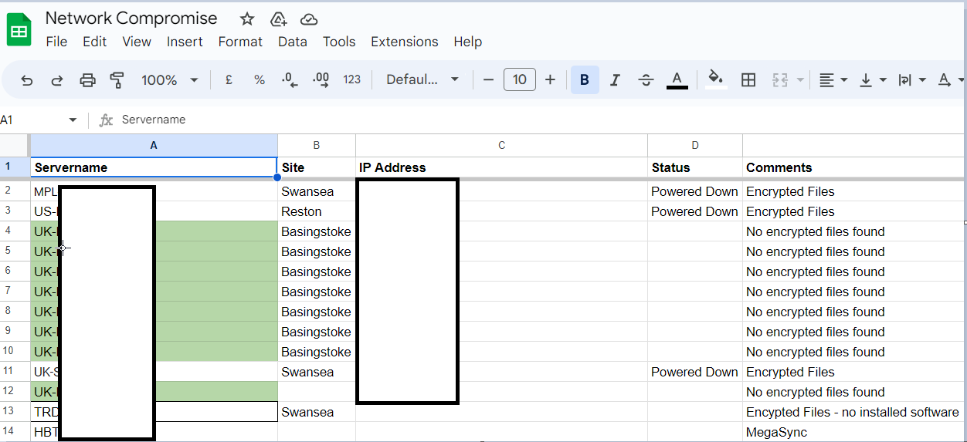
Figure 4 Excerpt document control being updated during the breach.
The team documenting the incident as it evolves will provide data for the route cause analysis and any future process improvements.

4.1.4 Risks & Limitations
The current risk for this project is not closing the vulnerability that caused the network breach and making sure that other attack vectors are closed within the network; a deep scan of every device connected to the network globally will need to be completed to prevent clean and new devices from connecting to the network.
VLANs have been shut down to prevent new and cleared devices, and a secure VLAN has been created on every site for local IT teams to connect to so that devices can be scanned and any end-user devices can be rebuilt.
One of the most significant risks is a device that has yet to be cleared, gaining access to the network and potentially becoming ground zero for another infection outbreak.
There are a few possible limitations with the rollout of remedial work;
- New software packages being rolled out, i.e. MFA, DUO.
- New network switches are being deployed in the warehouse.
- Deployment of a new antivirus solution.
- Procurement and deployment of new Palo Alto Firewalls.
Each of the limitations above will need to be trial and error due to the different configurations and different operating systems involved, e.g., Windows server 2008 r2 to Windows server datacentre 2022, and also, different applications running on these servers may react differently to the new antivirus installed for example.

4.1 5 Ethical Issues
There are no ethical issues related to this research. Still, there are ethical issues concerning the security breach, where user data is possibly stolen and customer and financial data lost. There needs to be a clear and concise plan to make sure that no data is lost, for example, by following/using;
- Drive encryption using Microsoft Bitlocker.
- Data retention policies.
- Following GDPR guidance.
No system is 100% secure, but the above steps aim to make it difficult for threat actors to pivot from within the network and to remove business-critical information for their gain.

4.1.6 Validity, Reliability & Generalisability

4.1.6.1 Validity
There are multiple ways of dealing with a security network breach; and each path will lead to the same outcome, which is;
- Intrusion detection.
- Remedial activities.
- Root cause analysis.
- Further remedial activities.
- Possible penetration/vulnerability testing.
- Resolution of incident.
The above five steps are one perfect way of dealing with a network compromise, and these steps will vary depending on the company, what teams are involved and what process documents have been created.

4.1.6.2 Reliability
It is very unlikely that if this work were to be reinvestigated, that it would produce the same results as there is too many mitigating factors;
- Server environments will be different on a per-company basis.
- Applications are different on each device.
- Server patching schedules are different.
- Different operating systems react differently to newly installed applications and updates.
- Desktop/laptop devices will be on different builds.
There is a possibility of having the ability top copy the type of attack that was used as these types of attacks are very well documented and structured and freely available on the Internet.

4.1.6.3 Generalisability
The results gained from the project will apply globally to the business, and it will also apply to different business sectors. The outcomes from the actual data may and most likely be different, but how the applications will be in use report the data will be the same across the board [13].

4.1.7 Data Evaluation Methods

4.1.7.1 Data Collection
As part of the remedial works that are taking place, the business will be able to gather large amounts of data from five different applications:
- Windows Defender Portal
- Azure
- Duo
- LogRhythm
- Varonis
The Windows Defender portal is linked to the Azure environment and will provide information from end-user devices and servers. The information it will gather is if the device has been infected with a virus or malware; it will let the technology team know what type of infection it is and if it has spread to other devices.
Azure is an environment that holds many different tools, from Active Directory, MFA, and Single Sign-on (SSO), and links in with other Microsoft applications.
Duo is another form of Multifactor authentication; this generates logs such as login times, was the login a failure or successful, and the location of the attempted login.
LogRhythm is a security information and event management (SIEM) application that helps the business monitor, detect and investigate security incidents or threats within the infrastructure.
Varonis is another SIEM application; it gathers logs from devices that it monitors and performs data security, file auditing, governance, and compliance

4.1.7.2 Data Evaluation
As seen in the data collection section, the applications that are being implemented will collect all the relevant data; these applications also can request live information from devices, allowing for a prompt reaction if there were to be another breach or incident.

4.2 Development Methodology

4.2.1 Prototyping Methodology
With the type of project that is being proposed, the prototyping methodology would be best suited. Due to the security breach, the remediation process needs to be swift.
The steps this methodology utilises are a perfect match for the number of deployments that are going to be made:
- The technology team gathers the requirements needed to secure the business.
- Design of the infrastructure needed to support the applications.
- Build and deployments of the infrastructure for testing purposes, one building in the United States and one in the United Kingdom.
- End-user evaluation – How this interreacts with other software deployments within the test areas.
- Global implementation and reiteration if required.

5 Resources and Planning

5.1 Hardware Resources
The hardware resources that will be in use for this project will vary from Servers to end-user devices and network switches:
- 5x HP ProLiant DL380 Gen 10.
- 1x Pure Storage FlashArray 15 Terabytes.
- 2x HPE 3PAR 8200.
- 7x Cisco UCS B200 M6 Blade Server.
- 500x Lenovo Think Centres M900.
- 250x Lenovo ThinkPad T460s, T470s, T14s.
- Cisco Switches, C3850, C3560, 9300, 9540X, 9516X.
- Palo Alto Firewalls, 3410, 450s.
All hardware in the above list is in the production environment and has been deployed apart from the Palo Alto firewalls, as they have been recently purchased to replace Cisco ASA firewalls and Checkpoints.

5.2 Software Resources
On going software resources that are going to be in use during and after this project are as follows:
- Microsoft Azure.
- Microsoft Bitlocker.
- Microsoft Multi Factor Authentication.
- Windows Defender
- Duo Security.
- LogRhythm.
- Varonis.
- Active Roles ( Active Directory management tool).
The following applications must be deployed to every machine on the network: Windows Defender and Bitlocker. Affected devices such as laptops/desktops and servers will need to be rebuilt using Windows 10 for end-user devices and Server 2016 – 2022 depending on the applications installed.

Human Resources
The project is a two-team implementation: Team One is the Networks team, and Team Two is the Infrastructure Administration team. With a mass deployment of new software hardening technology, there will be a lot of end-user involvement due to how it interacts with the end-user.
For example:
With the implementation of Microsoft MFA, which will be added to the Gmail mail login process, the VPN connection steps due to the implementation of Single Sign-On with MFA, there will be a need from end users to be involved in some testing plus the steps needed to set up the authenticator device on every user's device or an RSA SecurID token to be created.

5.4 Project Plan
To manage the progress and the addition of tasks for this project, Asana has been used, Asana is a collaborative project management tool with great functionality; it allows multi-user, same-time editing of a team project and tasks that can seamlessly be assigned to an individual. As seen in Figure 4 below, the project can be split into two or more main sections; in this case, Planning & Milestones have been created.
Within these sections’ tasks are placed and assigned to an individual with due dates and priorities assigned to the task.

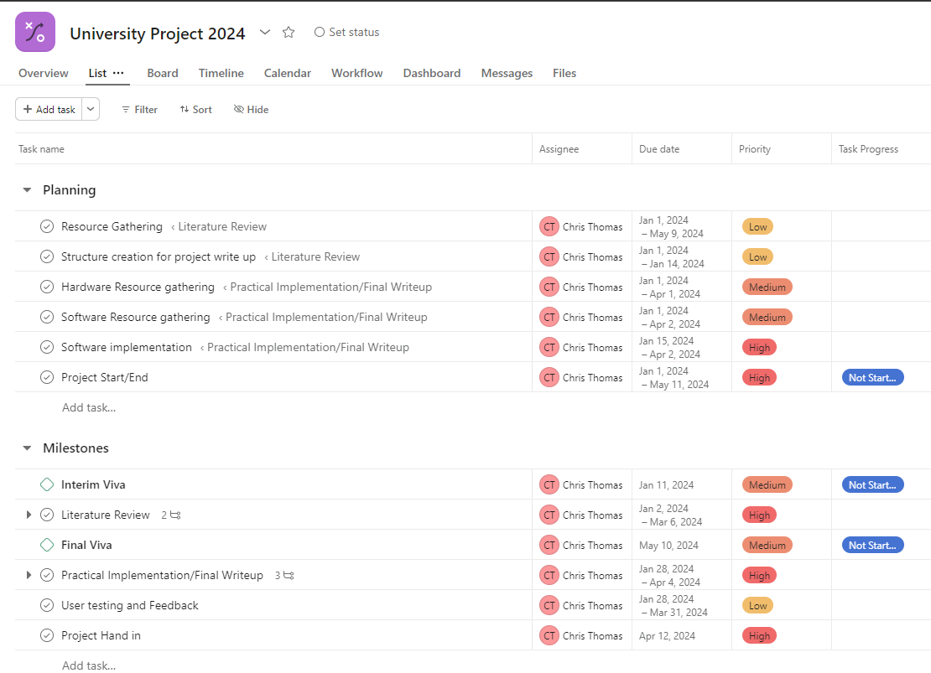
Figure 5 Asana task creation.
Figure 5 below is the over all project time line, the information that is displaying is from the information provided in Figure 4.

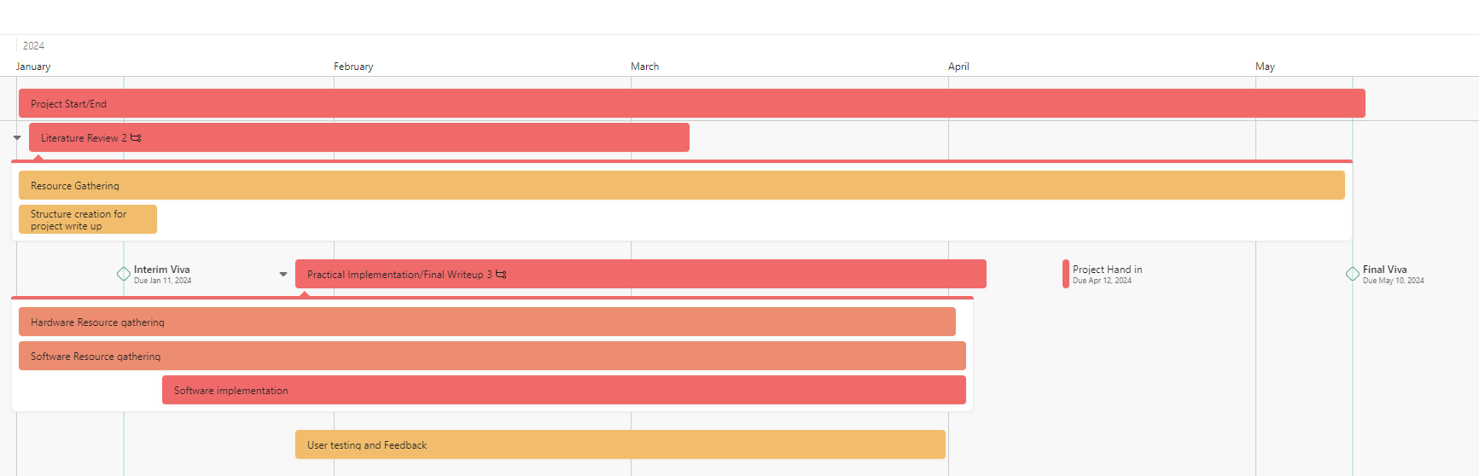
Figure 6 Project timeline.
References
[1] A. J. Burns, M. E. Johnson and D. D. Caputo. A. J. Burns, M. E. Johnson and D. D. Caputo. Spear phishing in a barrel: Insights from a targeted phishing campaign. Spear phishing in a barrel: Insights from a targeted phishing campaign. Journal of Organizational Computing and Electronic Commerce. Journal of Organizational Computing and Electronic Commerce. 2929(1), pp. 24-39. pp. 24-39. 2019. . DOI: 10.1080/10919392.2019.1552745.
[2] (05/18/). Active Directory accounts. Available: https://learn.microsoft.com/en-us/windows-server/identity/ad-ds/manage/understand-default-user-accounts#administrator-account.
[3] C. Thomas. C. Thomas. Security incident. Security incident. 2022.
[4] M. Humayun, M. Niazi, N. Z. Jhanjhi, M. Alshayeb and S. Mahmood. M. Humayun, M. Niazi, N. Z. Jhanjhi, M. Alshayeb and S. Mahmood. Cyber security threats and vulnerabilities: A systematic mapping study. Cyber security threats and vulnerabilities: A systematic mapping study. Arabian Journal for Science and Engineering (2011) Arabian Journal for Science and Engineering (2011) 4545(4), pp. 3171-3189. pp. 3171-3189. 2020. . DOI: 10.1007/s13369-019-04319-2.
[5] (August 26,). Kerberos Attack. Available: https://www.varonis.com/blog/what-is-mimikatz.
[6] Christopher J Thomas. ACCB6000 - Advanced Cyber Security. March 2023.
[7] (). Vantage Data Centers. Available: https://vantage-dc.com/wp-content/uploads/2020/09/VDC_DataSheet_Cardiff_English_2022.pdf.
[8] "Network security, firewalls, and VPNs," in Title: Network Security, Firewalls, and VPNsAnonymous Jones & Bartlett Learning, 2021, pp. 135,136.
[9] "How firewalls work and what firewalls do," in Title: Network Security, Firewalls, and VPNsAnonymous Jones & Bartlett Learning, 2021, pp. 145.
[10] (September 5th). What is Software Firewall? Difference between Hardware Firewall and Software Firewall. Available: https://www.sangfor.com/blog/cybersecurity/what-software-firewall-difference-between-hardware-firewall-and-software.
[11] (). Websense® Web Filter & Security. Available: https://www.forcepoint.com/sites/default/files/resources/files/datasheet_web_filtering_security_en_0.pdf.
[12] I. F. Bahrudin and J. Han. I. F. Bahrudin and J. Han. Circular reasoning for the evolution of research through A strategic construction of research methodologies. Circular reasoning for the evolution of research through A strategic construction of research methodologies. Ecrtd-Uk Ecrtd-Uk 88(3), pp. 5-6. pp. 5-6. 2020. Available: https://livrepository.liverpool.ac.uk/3102542/1/Circular-reasoning-for-the-evolution-of-research.pdf.
[13] D. Muijs. D. Muijs. Doing Quantitative Research in Education with SPSS Doing Quantitative Research in Education with SPSS 2010Available: https://search.ebscohost.com/login.aspx?direct=true&db=nlebk&AN=509362&site=ehost-live.

Appendix – Tools Used.
I have used ChatGPT for the following search terms:
- Q. Can you give me a project title with the words Ransomware attacks and how it affects a business
- Project Title: "Impact of Ransomware Attacks on Business Operations: Mitigation Strategies and Recovery Framework"

