Content:
The failover clustering 1
What is failover cluster 1
The detailed technical standpoints for the failover cluster 1
There are several steps to configure the cluster as following: 4
Some other principles 10
What is the difference between failover cluster and Network Load Balancing cluster? 10
References 11

The failover clustering

What is failover cluster
According to Microsoft Documentary and other website documentary [1] [2], failover cluster is a group consists of a number of independent computers, which work together in order to maintain high availability and increase scalability to the clustered applications or services (named clustered roles in the cluster aspect) and if any one of the nodes (clustered servers) fails or turn to shutdown condition accidently, another servers start to take over previous nodes to provide service. This process is named failover. What is more, the clustered servers mostly are linked by some software and physical cables and some nodes of failover cluster are monitored mutually by the alternative nodes (these servers will take over the nodes that cannot work normally and another formal name is standby server). In the meanwhile, a distributed namespace of the cluster that the computers of this cluster can use this namespace to access all nodes of this cluster and the shared storage, consistently, is provided by the failover cluster. This is basic concise failover cluster shown by figure 1:
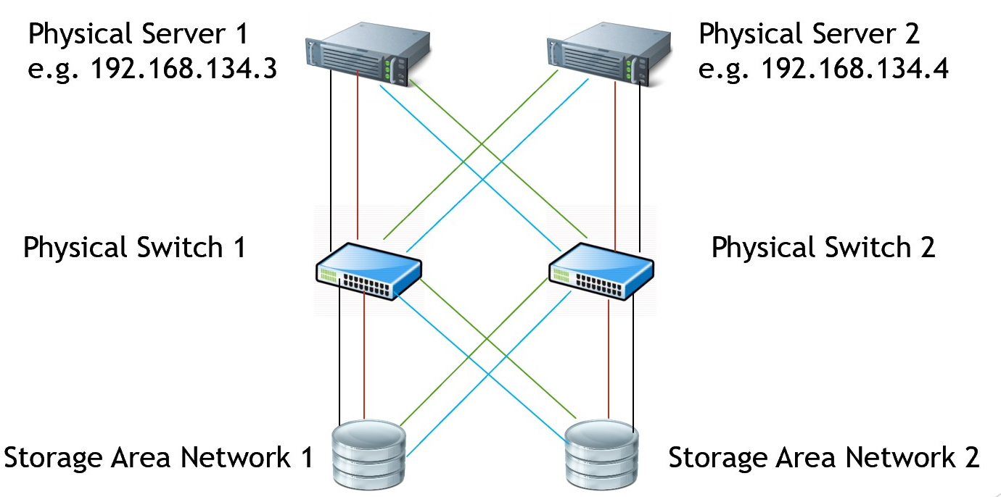
Figure 1
As it is shown above, in terms of servers, switches and the SANs, there all are failover measures at each step respectively, I will discuss these rationales behind the failover cluster in the next sections.

The detailed technical standpoints for the failover cluster
At the server aspect
According to the Failover Clustering in Windows Server, every active server must be of another standby server to prevent the active server down and especially, in order to be of a stable failover cluster, each nodes’ hardware conditions must be the same types and sharing storage is well working for the servers.
The “heartbeat” signals are the key technique for the failover cluster, which contributes to the communication between the active server and standby server over a dedicated network. When the failover cluster is working, the active server is initiating a series of “heartbeat” package and in the meanwhile send these packets to the standby server at the constant intervals, which is called push heartbeats. If the standby server has not received heartbeat package from active server within a certain duration time which is set previously, it will provide service as the new active server. What is more, standby server also can send “heartbeat” signals to the active server, which is called pull heartbeats. Same as push heartbeats, if active nodes start to not respond the heartbeat packages to the pull heartbeat within a certain duration time set previously, the result is same that standby computer takes over the active one.

At the switch aspect
Switch in the network is used to filter and forward data packets from one network device such as server, computer, switch, router, etc. to the other computers or some else devices [3].
In a word, the function of switch in the failover cluster is the cluster connectivity, if one switch does not work within a certain time, another one may take over it immediately.
At the storage aspect
There are two Storage Area Networks (SANs) in the above failover cluster. Therefore, what is the Storage Area Networks? Maggie Jones and Brien Posey thought [4], ‘A storage area network (SAN) is a dedicated high-speed network or subnetwork that interconnects and presents shared pools of storage devices to multiple servers.’
Currently, there are two kinds of SAN: FC-SAN and IP-SAN. The network of FC-SAN is by fibre channel using the SCSI-FCP protocol while the IP-SAN is by Gigabit Ethernet network which is considered as the lower cost and it is easier to manage and extend but in terms of the transmission, IP-SAN is slower to the FC-SAN.
In details, the SAN actually is the sum of many hard drives and moves these storage drives off the ordinary network and manage them to an independent and high-performance network, which make each server to access the shared storage resources. What is more, in terms of failover cluster configuration, there are two fields of storage required:
- Data: this area is to store the applications’ data.
- Quorum: this area is used to store some information about the cluster management, which is an algorithm to control and manage the data how to write it, which nodes to store it, how to manage the write and read and so on.
In addition, for the reasons that among the computer components, hard drive is always the component to be failed accidentally and for improving the speed of write and read on the disks, the hard drives of the SAN are redundant to be more fault-tolerated and faster in the writing and reading on the drives, which is called redundant array of independent disks (RAID) in an academic way.
Therefore, what is the RAID? According to Oxford English Dictionary and other literatures [5] [6] [7], RAID is used to the data storage virtualization that make many physical disks to the various combinations in order to prevent the data loss, improvement performance of the data storage and read functions between the computers with the disk array. In details, there are a variety of methods to configure the RAID such as RAID 0, RAID 1, RAID 2, RAID 3, RAID 4, RAID 5, RAID 6. Especially, a way that combines RAID 0 with the RAID 1 called RAID 10 is the quite practical in the cluster area. In addition, RAID 0, 1, 5, 6 often be used as well. There are some detailing principles from Tim’s PowerPoints which are the excellent and understandable pieces of work for the kinds of RAID:
- RAID 0: As it is shown in figure 2, the storage principle of RAID 0 is striping without mirroring or party similarly with the spanned volume of capacity and the storage capacity of it is the sum for the drives in the set. In details, when writing the data to RAID 0 storage resources, half data will be written to the disk 0, and the remaining data is written to the disk 1 in this situation in figure 2. Actually, it is not redundant, which means it perhaps could not to be considered as RAID. The advantage of RAID 0 is the improvement of speed to write and read with storage resources, but the disadvantage or called it risk is quite extreme because the data has been distributed stored in the each disk, so if any disk cannot work accidentally which is quite common phenomenon, the data will not be recovered anymore. Therefore, RAID 0 usually is used to the situation not very important just for its performance duo to the speed and the storage resources usage of disks.
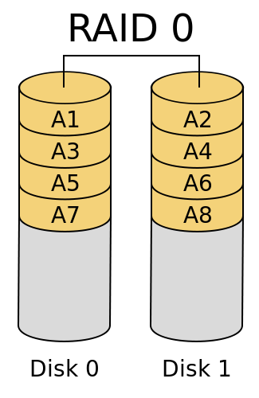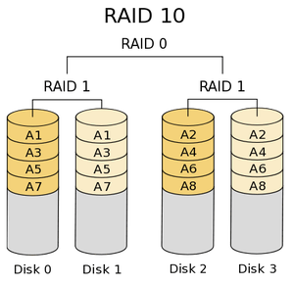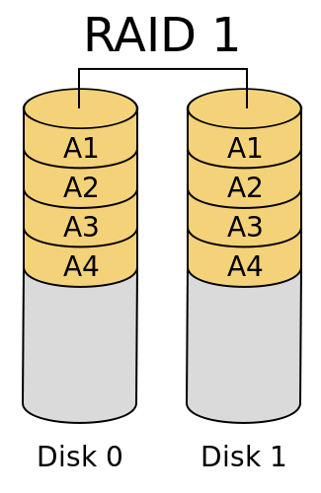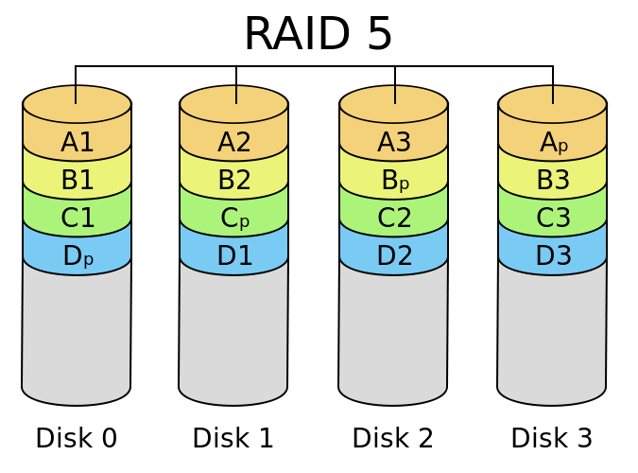
Figure 2
- RAID 1: the storage principle of it is to write all data completely into each disk, which means apparently each disk has the same data with other disks and this type be called mirroring. Then talking to functions, main advantage of which is guaranteed the data security because if any disk is broken suddenly, the data can be recovered from other disks, which is actually redundant and means more disks used in RAID 1, the much security the RAID 1 has. However, the storage size is the big problem to the RAID 1. For example, if there are 100 1TB disks are combined to the RAID 1, by contrast to the RAID 0, the storage of RAID 1 just still have 1TB space but unlikely to lead to the data for any kinds of loss.
- RAID 10: it combines the advantage of RAID 0 and RAID 1 to perform better to the RAID 1 and make security better to the RAID 0, which is quite available in the most time. In details, the RAID 10 uses mirroring and striping simultaneously so it performs well in the write times, read times and the redundancy which means security. What is more, the storage performance is quite good as well. For example, if there are 4 1TB disks of the RAID 10, actually its available storage is 2TB better than RAID 1.
- RAID5: the biggest difference of RAID 5 with the types mentioned above is ‘Parity’ which is used to recover data or re-calculate data more accurate on the failed disk with the other disks. Therefore, in the meanwhile, the disks of RAID 5 must be calculated which lead to the increased costs on the disks but the advantage of it is obvious as well such as the read performance, highly used storage size which is 75 percent usage of the 4 1TB disks of RAID 5. However, there also a serious risk which means the RAID 5 just can tolerate 1 disk died and the rebuild process is quite stressed and intensive to read data and it will come up with some unforeseen failures with a high probability.

There are several steps to configure the cluster as following:
Install hypervisor platform
This is the first step to configure the failover cluster using the virtual machines.
Create three virtual machines on the platform of hypervisor
In this stage, 3 virtual machines will be created and the computer operating system of which our team decided to apply is Windows Server 2016.
- Configure the hardware of virtual machines: such as compatibility with Hyper-V, the cores of processor, the size of memory, disk setting, network adapter and some advanced setting like high Availability.
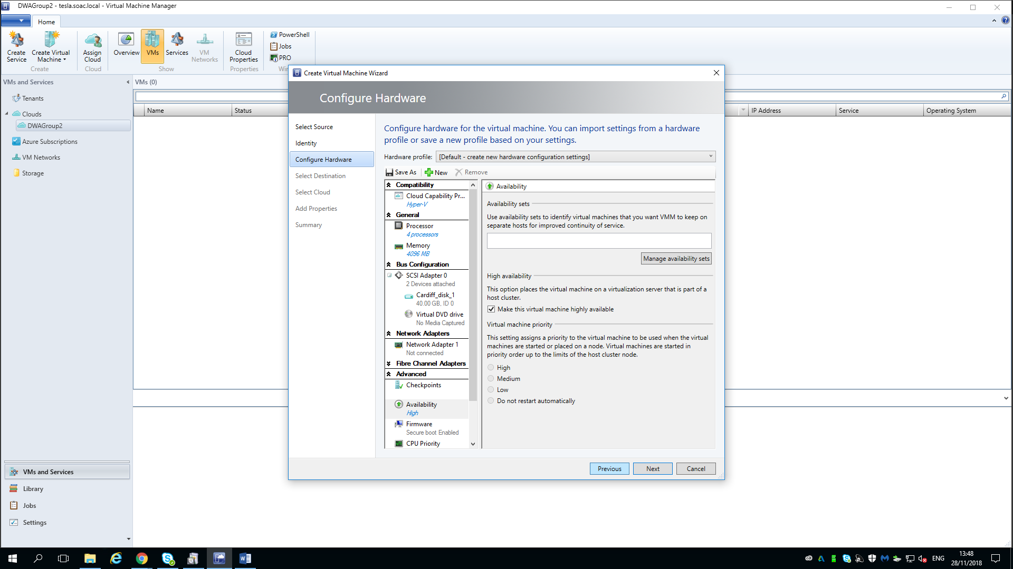
- Select the Destination of the virtual machine: at this step, we opted to deploy the virtual machine to a private cloud which created and managed on-premises by lecturer using the organization’s own hardware (of the school maybe that my lecturer knew exactly) to improve the performance of the cluster and some other advantages for example, the admins of this private cloud can delegate the management, the capacity and quotas for the clients, which means if clients want to request more capacity, they have to ask for the admins of this private cloud to carry out. In details, the private cloud is actually a specific model in the field of cloud computing, which comprises a quite secure cloud in which only some specified clients can access. In addition, compared to the other cloud models, the principle of private cloud is to provide computing service within a virtual condition by the underlying pool of physical storage and computing resources in order to realize the organization with better privacy and control issues.
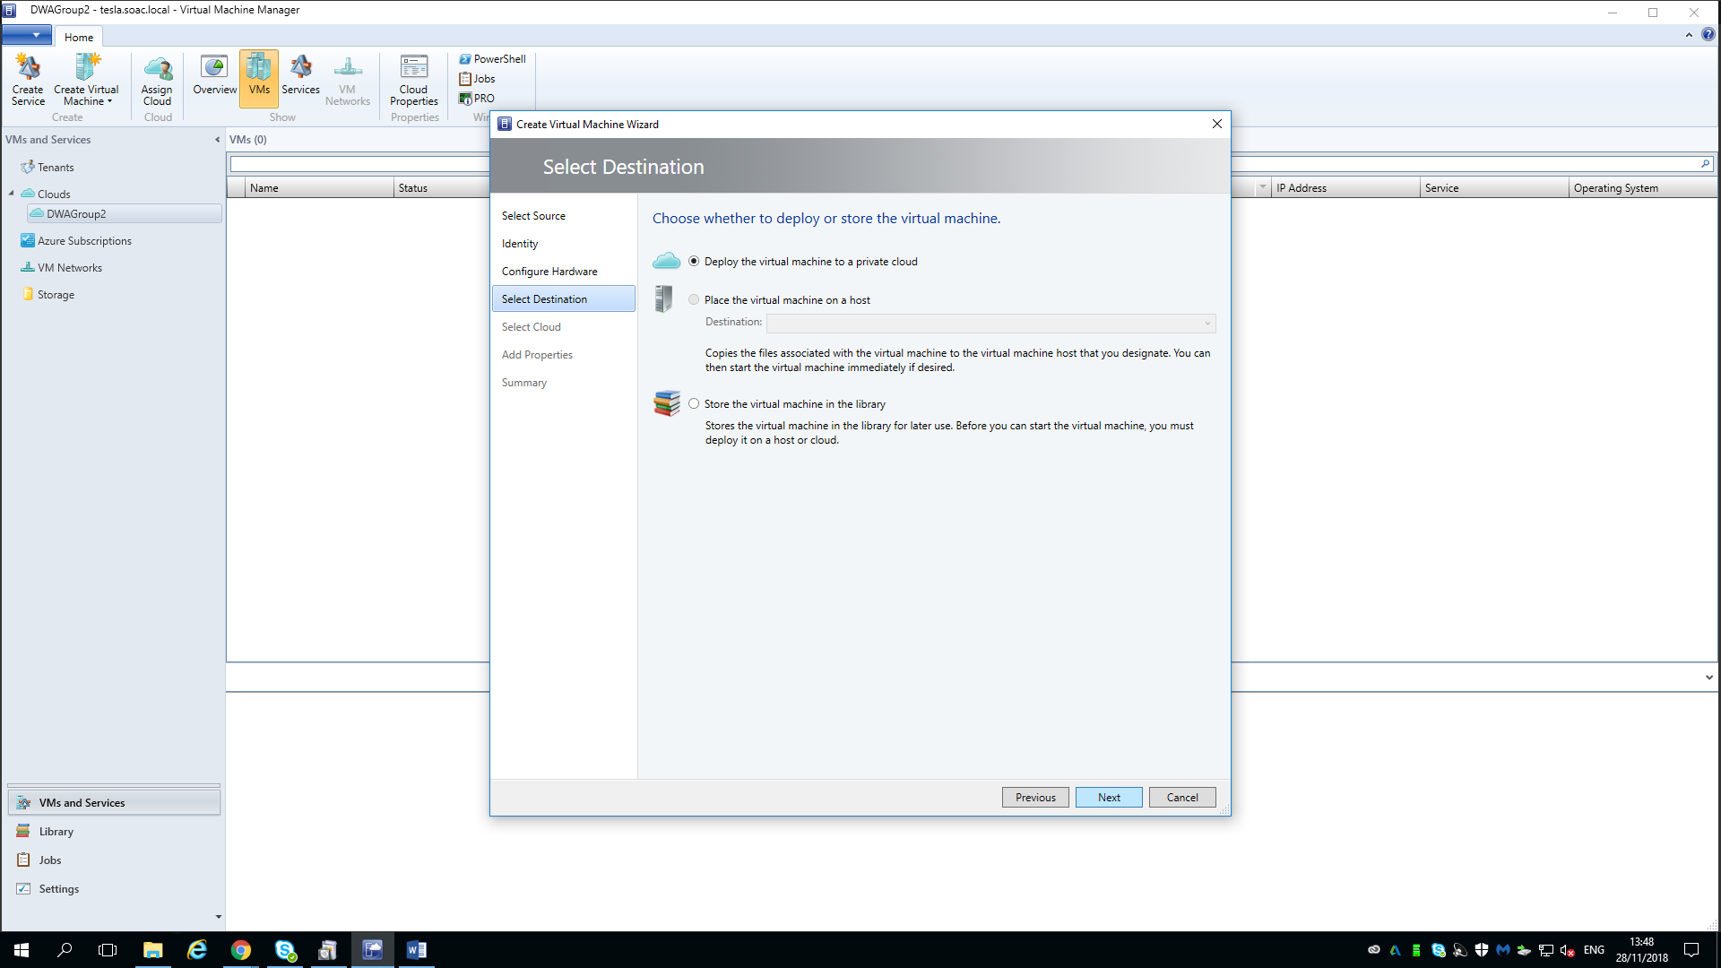
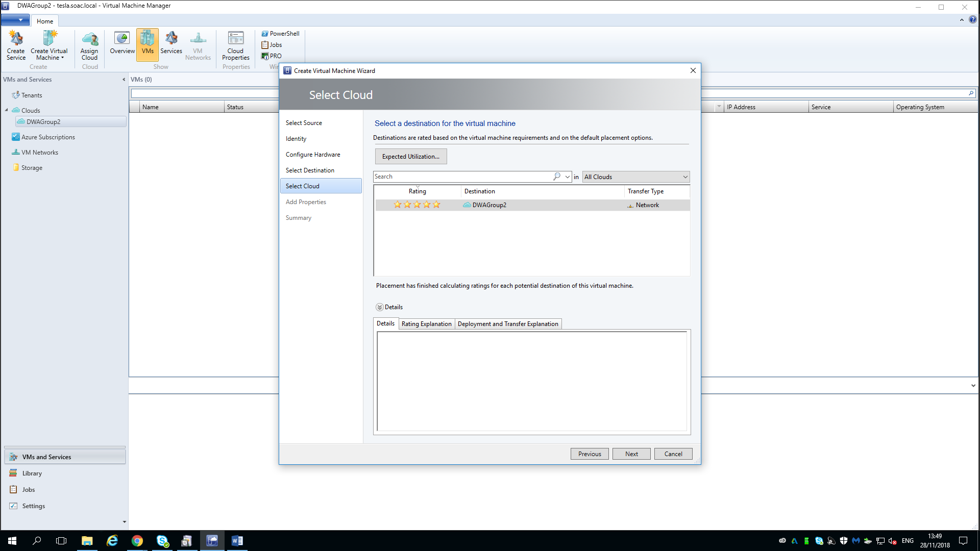
- Install operating system on the virtual machine: the operating system is Windows Server 2016.
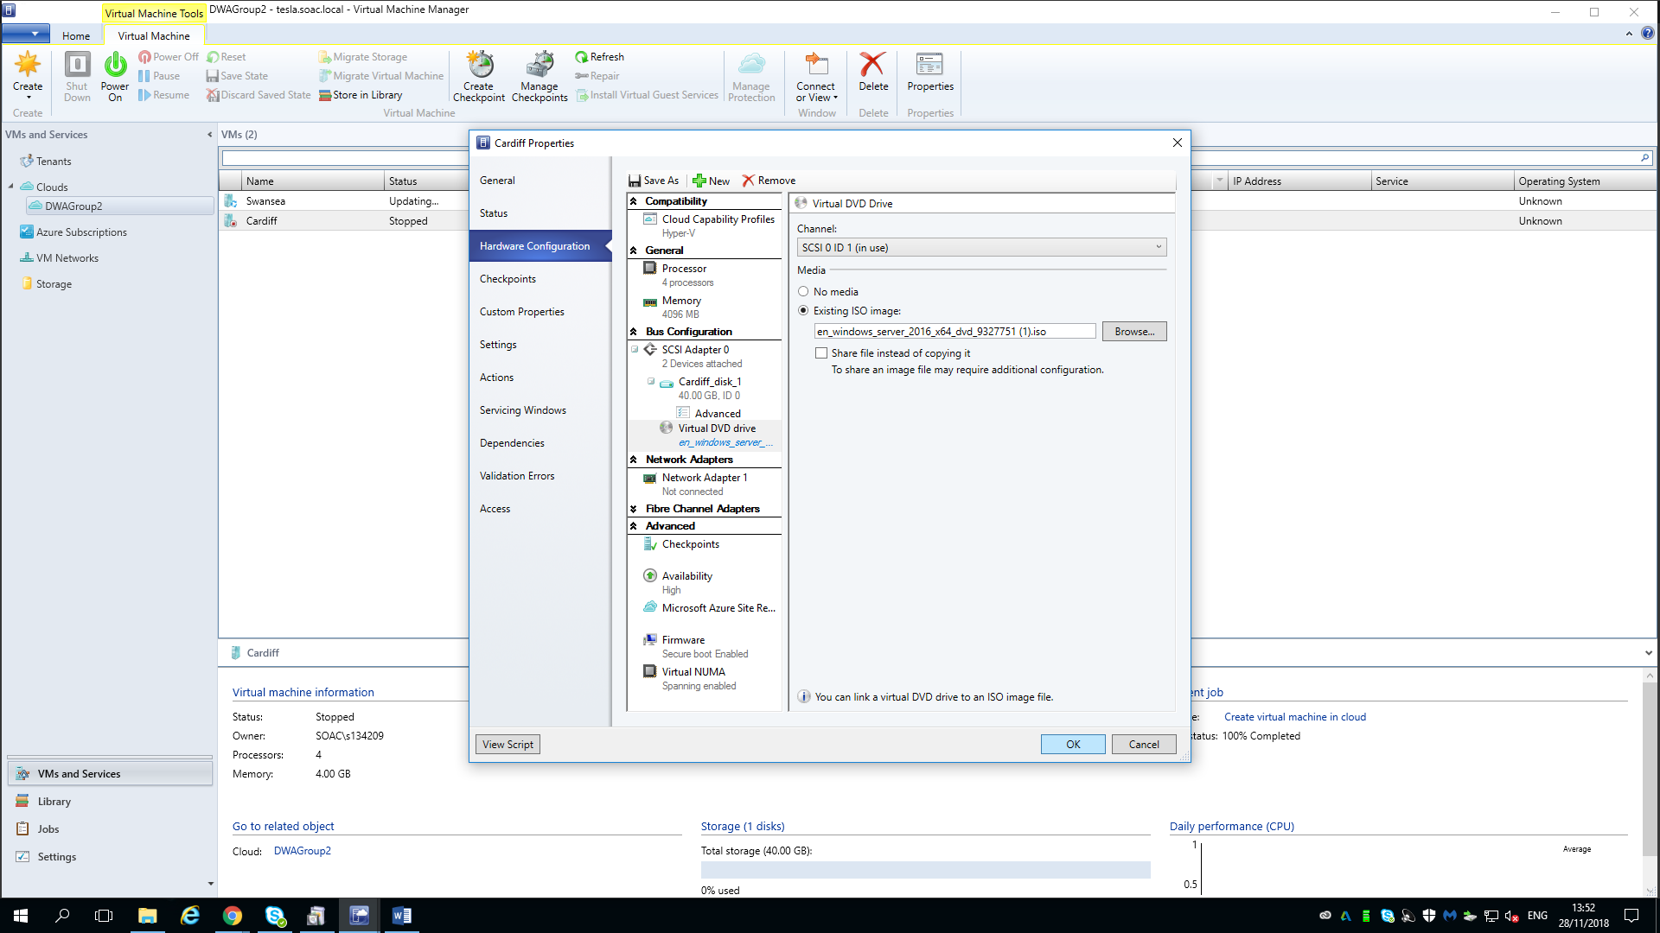
In details, according to Wikipedia [8]. Microsoft Windows comprises of some graphical operating system families which is developed by Microsoft, there are some active windows families of Microsoft Windows such as Windows NT and Windows Embedded, especially, the Windows Server is the subfamily of the Windows NT that is a family of operating system developed by Microsoft and is a multiprocessing, multi users and the processor independent operating system. In addition, in the recent years, the version of Windows for PCs, embedded devices and smartphones, is almost Windows 10 and the Windows Server 2019 and windows Server 2016 are also the most recent versions regarding to the server computers.
Turning to the Windows Server 2016 [9], developing with Windows 10, it was released on the 26th of September, 2016 and Windows Server 2019 is the successor of Windows Server 2016. In details, Windows Server 2016 operating system is used for server computers duo to its a variety of features such as Web Application Proxy, Windows Server Containers, Active Directory Federation Servers and so on. In terms of Networking features, it is also very powerful, including the features of DHCP, DNS, IP address management, Hyper-V Network virtualization and so on.
- Set the network of the virtual machine: using an existing VM network that is derive private cloud.
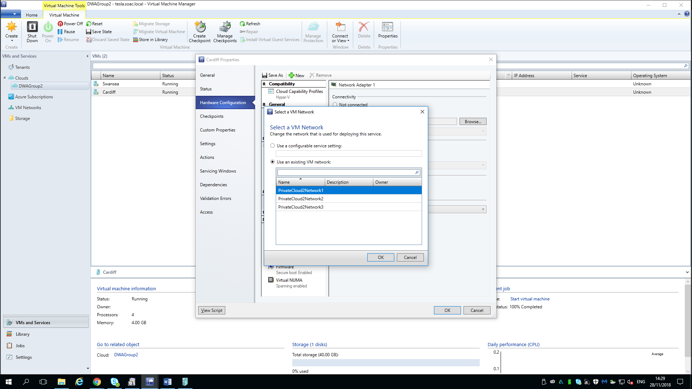
Create shared storage resources under the IP-SAN
The shared storage resources are on the domain controller (Cardiff) in order to provide shared storage to the failover cluster of Swansea and Bridgend using the iSCSI disk protocol to connect disks by internet.
In details, choosing a server computer Cardiff as the domain controller to create the ISCSI shared storage as the target to support storage for the other nodes of cluster. The steps are as following:
- Add new virtual hard disk on the domain controller Cardiff.
- Partition this disk and online.
- Add the iSCSI target role on the Cardiff and create virtual disks on E and F named ‘quorum’, ‘data’. The result is as following:
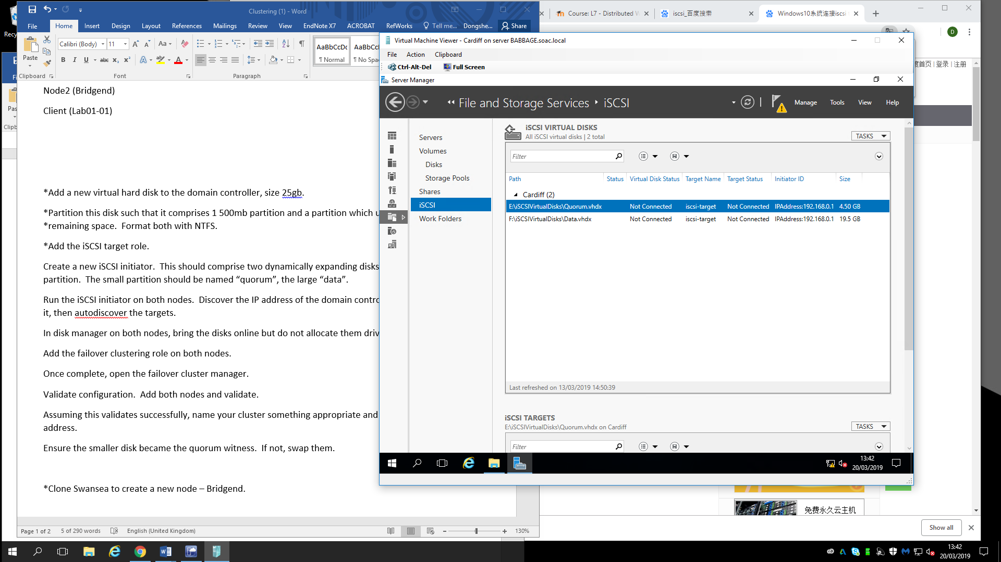
- Initiate the new iSCSI initiator on the Swansea and Bridgend to connect shared storage on the domain controller.
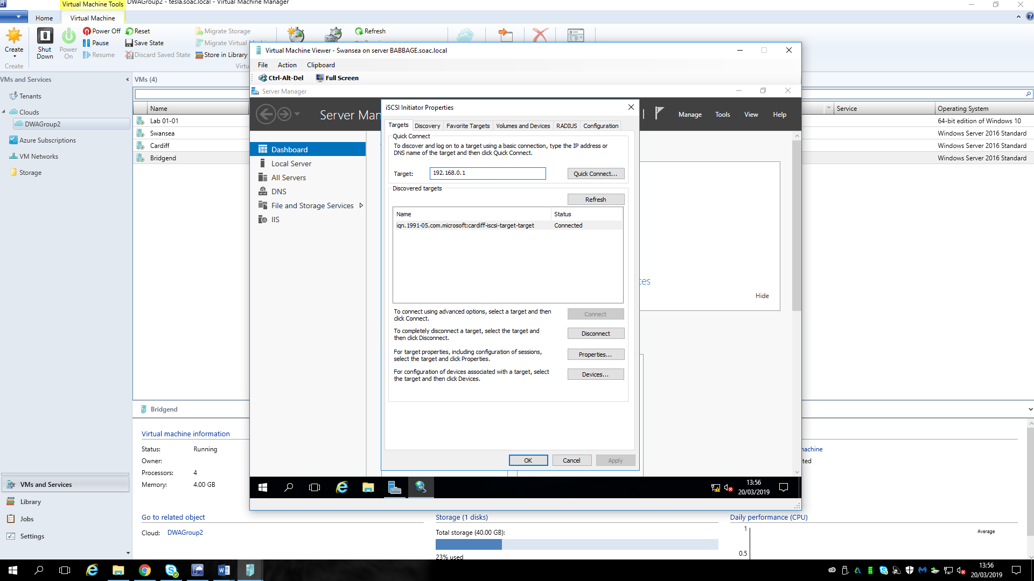
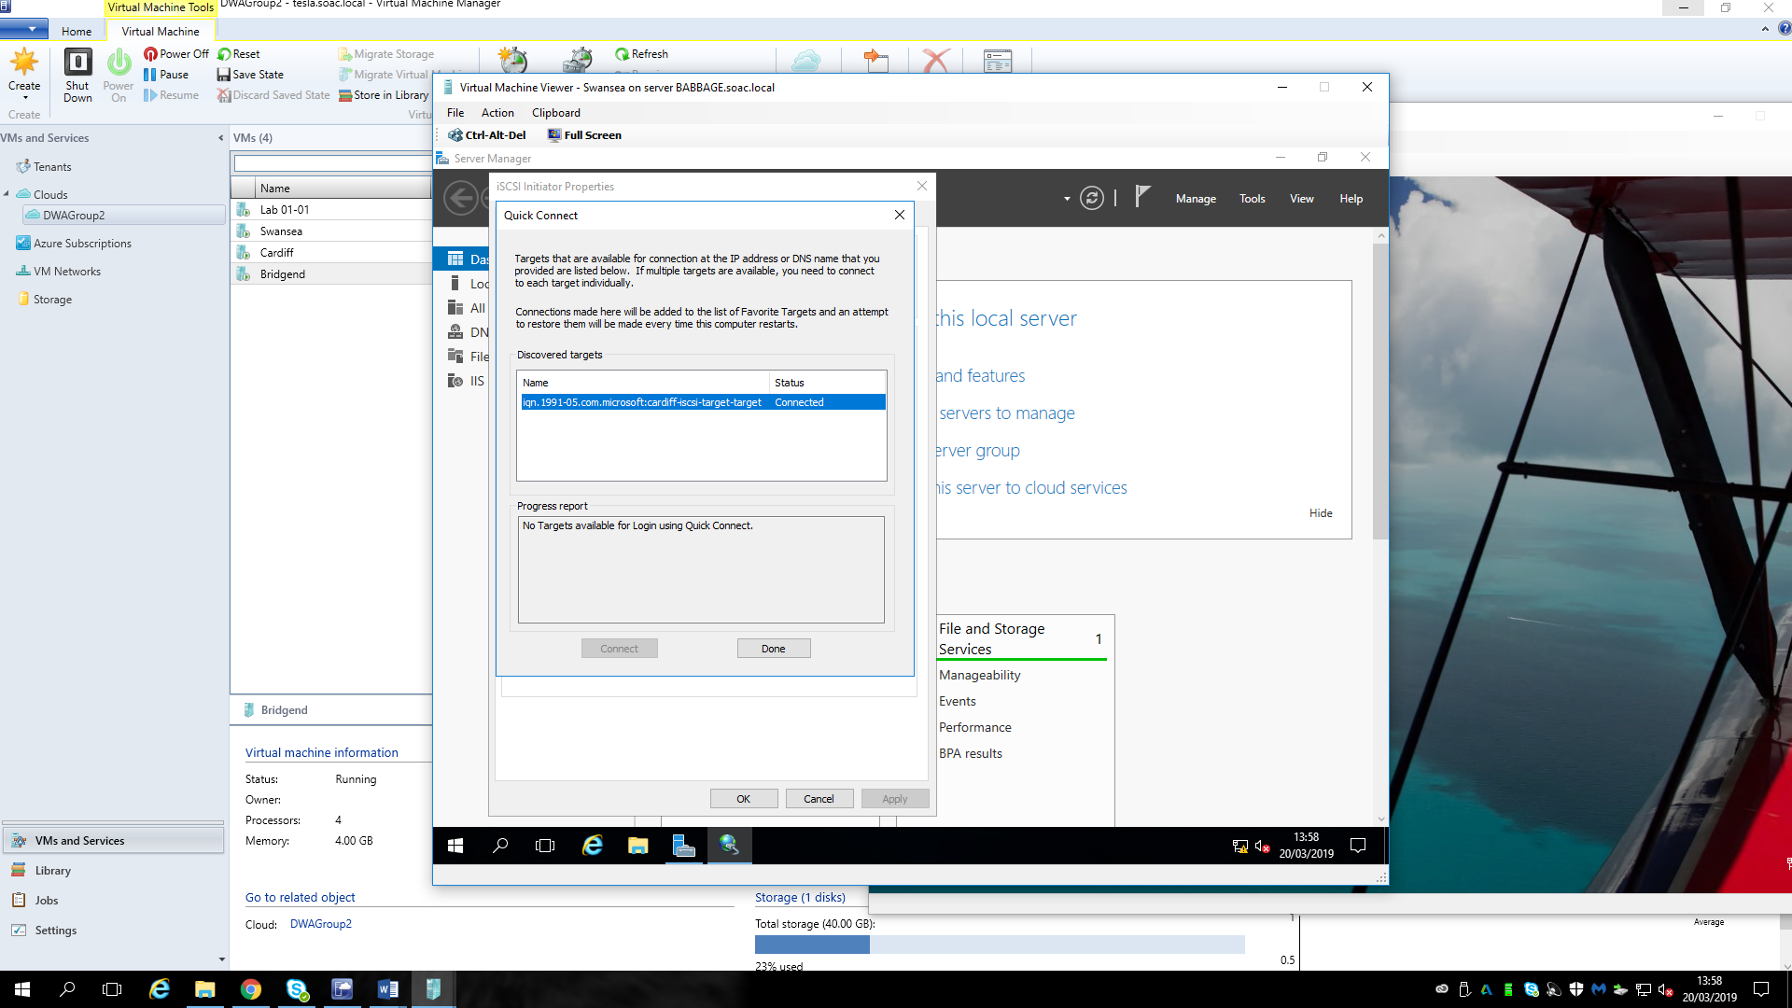
Add the failover cluster
Adding the failover cluster is to the both nodes Swansea and Bridgend using the iSCSI shared storage from domain controller Cardiff.
This step begins to configure the failover cluster of Swansea and Bridgend that means assuming the Swansea is the active server while the Bridgend is the standby server, if the Swansea shut down suddenly, the standby server Bridgend will take over it immediately to provide the service and the steps are as following:
- Add failover cluster features on the both nodes.
- Configure the failover cluster such as selecting servers in the cluster, testing options and so on.
- Create a cluster of the failover cluster manager by adding Swansea and Bridgend and named the cluster Wales (or something else). In addition, the result of created the cluster Wales is as following:
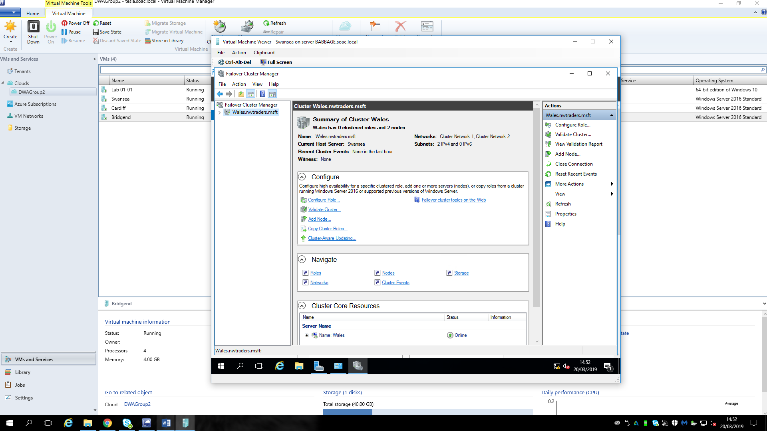
Adding DHCP role to both nodes (Swansea and Bridgend)
Configure a role on failover cluster
Configuring a role is for the high availability for Swansea including selecting the role to configure high availability, client access point and the storage. The summary information is as following:
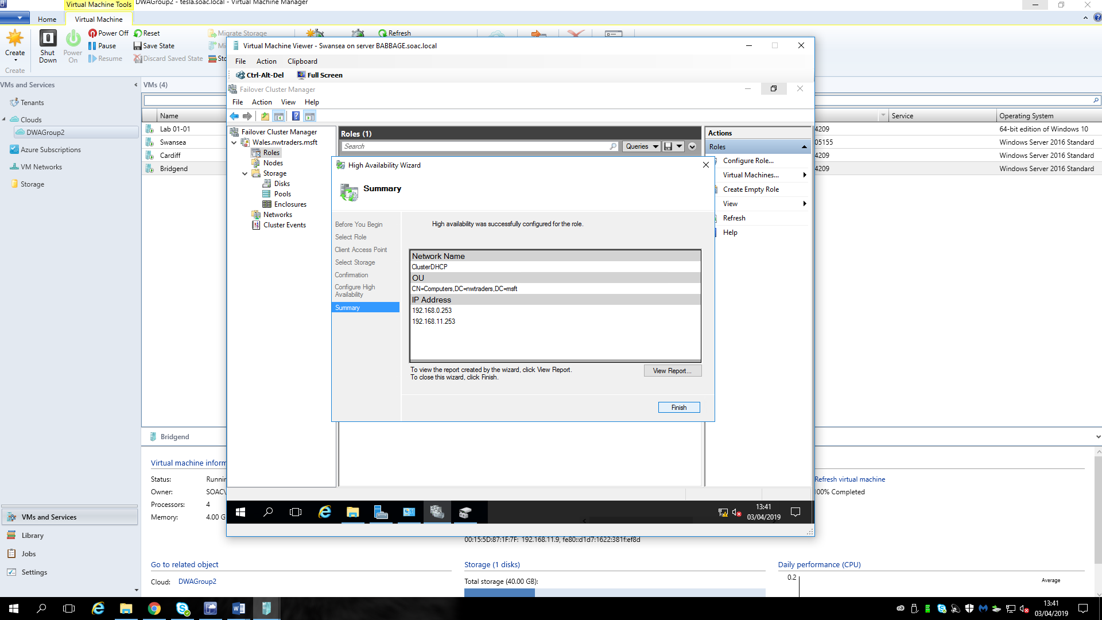
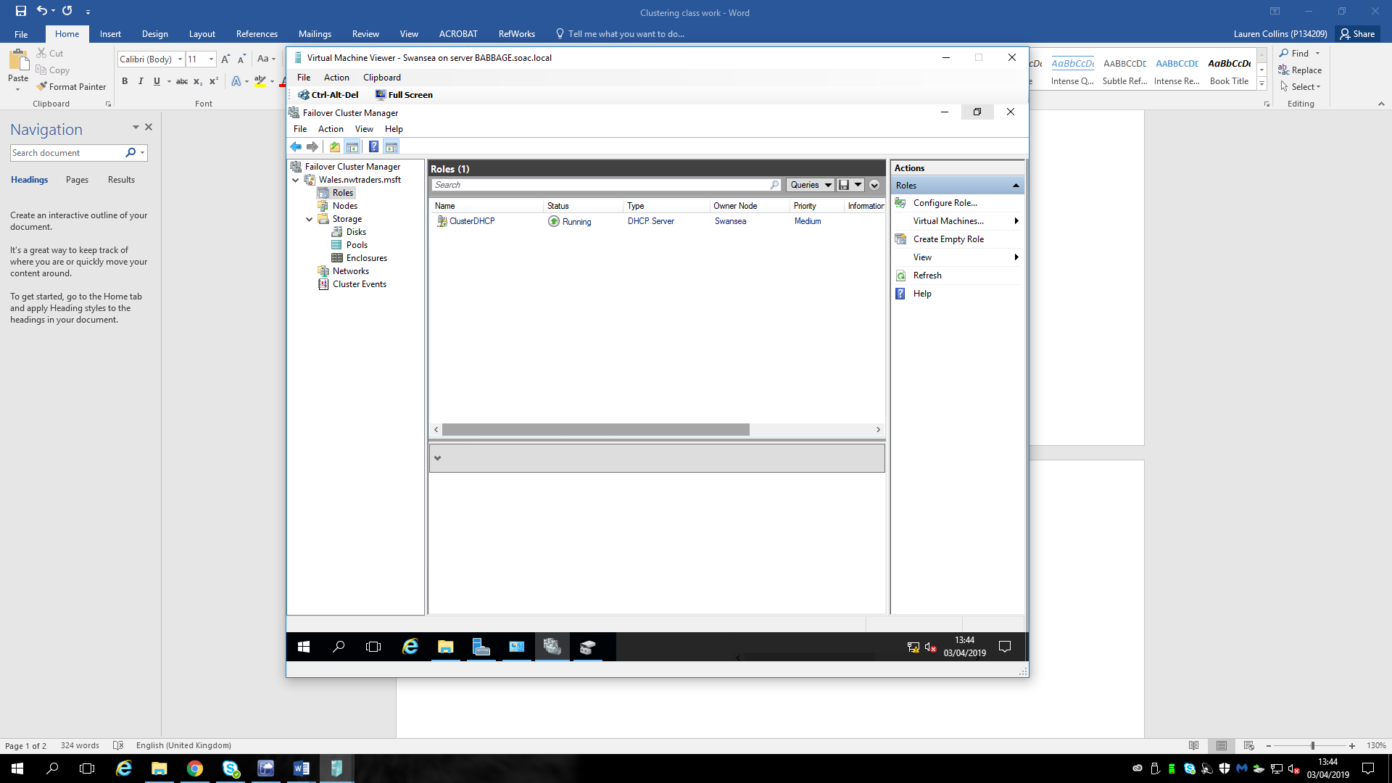

- Configure the failover DHCP servers to define a scope of IP on both nodes Swansea and Bridgend.
- Test the failover cluster of DHCP servers.
The picture above is shown that at this time, the DHCP server is Bridgend.
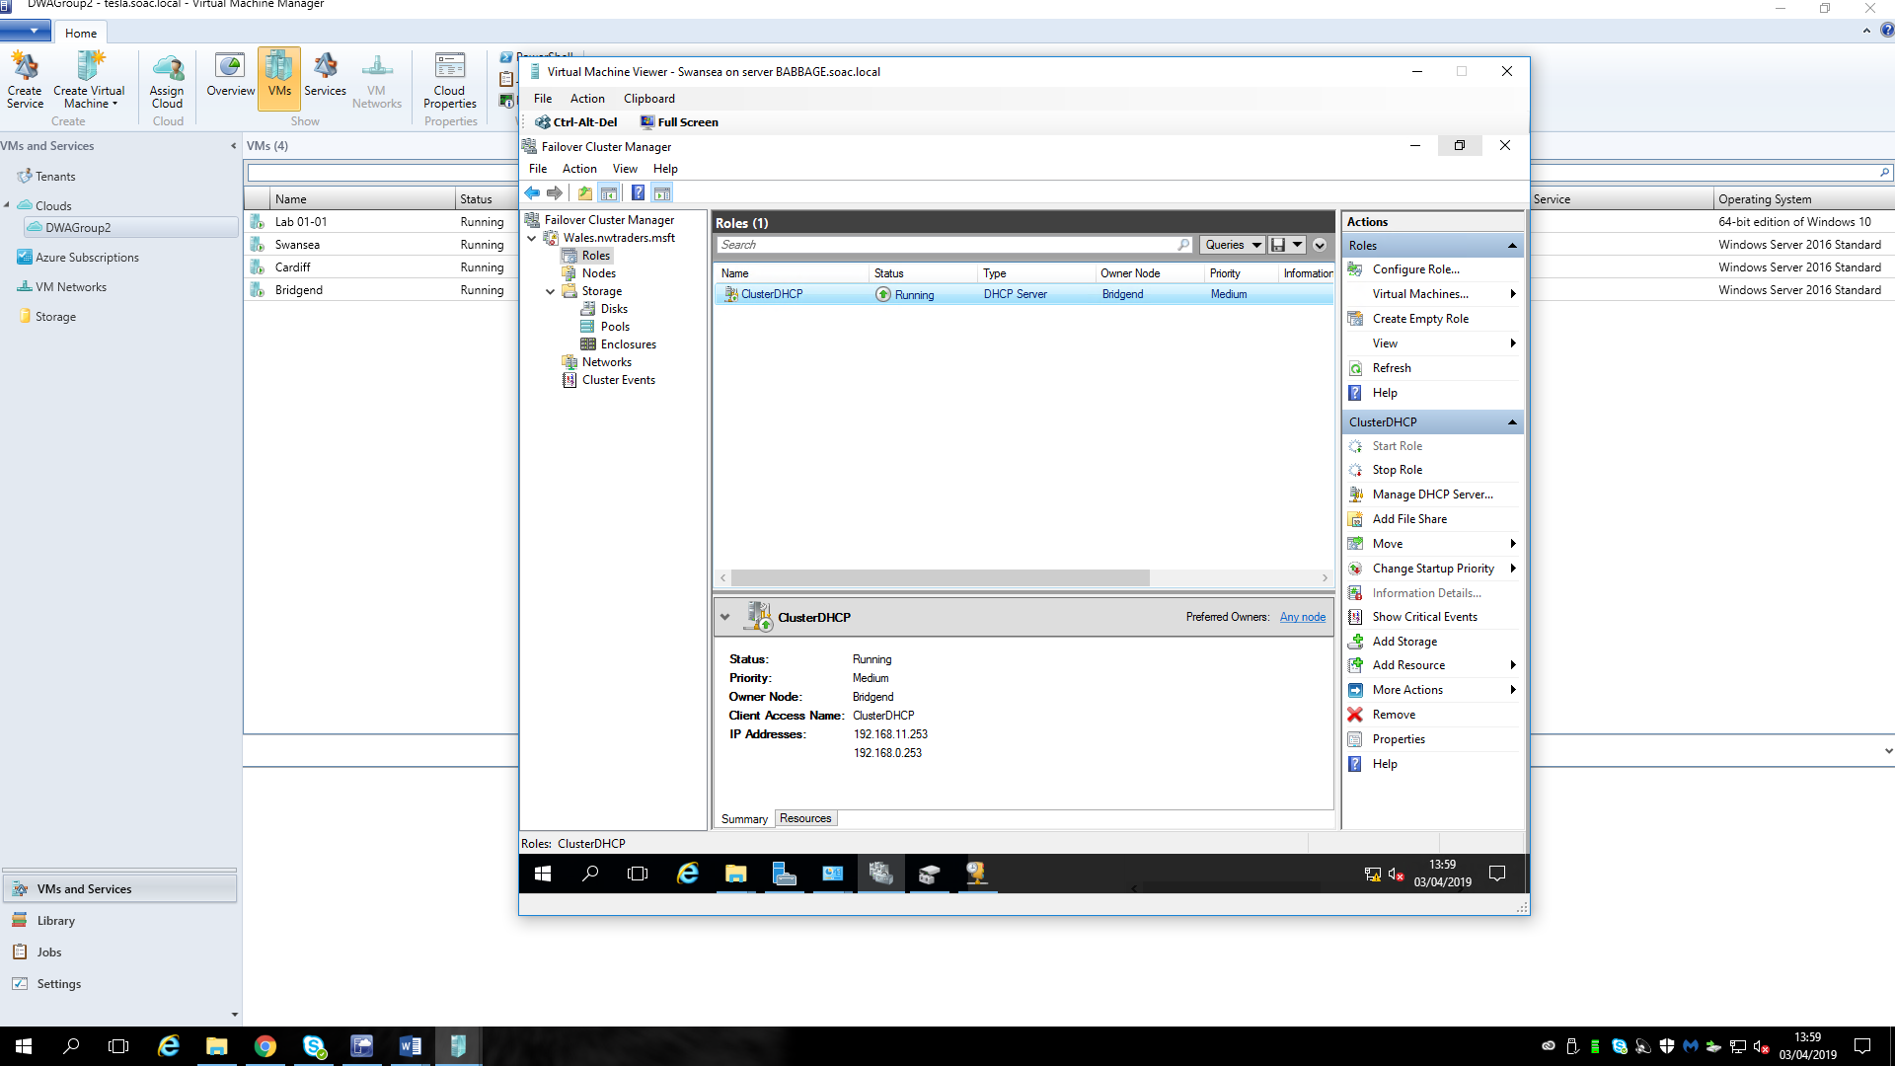
Then power off the Bridgend to emulate the server shuts down accidently.
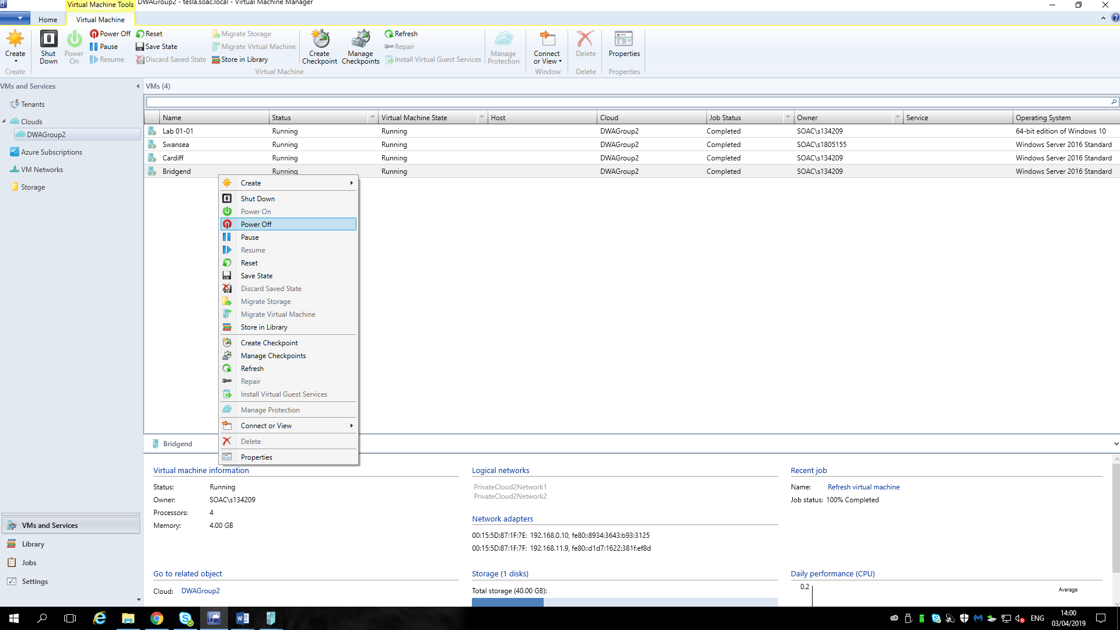
As the picture above shown, the DHCP server Swansea immediately takes over the Bridgend to provide service, which shows failover cluster configured successfully.
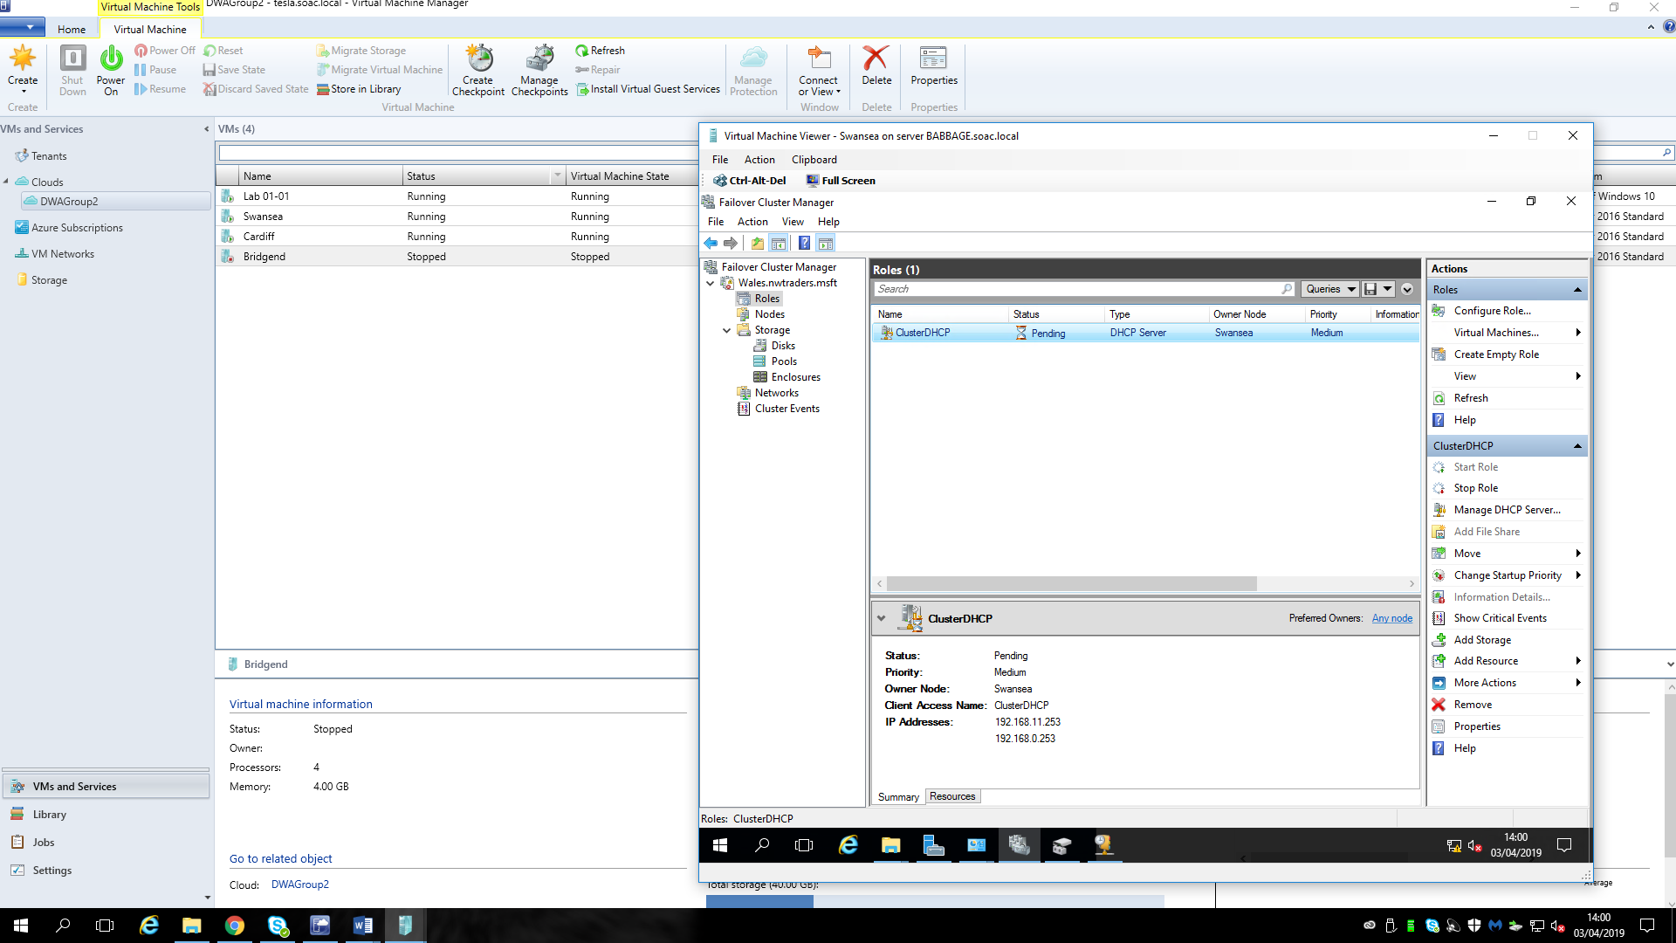

Some other principles

What is the difference between failover cluster and Network Load Balancing cluster?
First of all, the aims are different between failover and Network Load Balancing cluster. The aim of failover cluster is to make sure the performance of individual nodes or servers is uninterrupted without any accident or interruption of services. By contrast, the goal of Network Load Balancing is to distribute clients’ requests using the network while the servers are making the CPU, database IO rate or disks more available optimizing the use of various resources and minimizing the time to respond. On the other hand, as the pictures shown following, the structure of this two kind clusters are quite different as well. The left picture is the structure of Network Load Balancing cluster and the right one is the failover cluster structure, which shows the major difference is there is some devices fail in the failover cluster but the Network Load Balancing Cluster emphasizes the performance of the cluster to optimize capacity of the cluster.
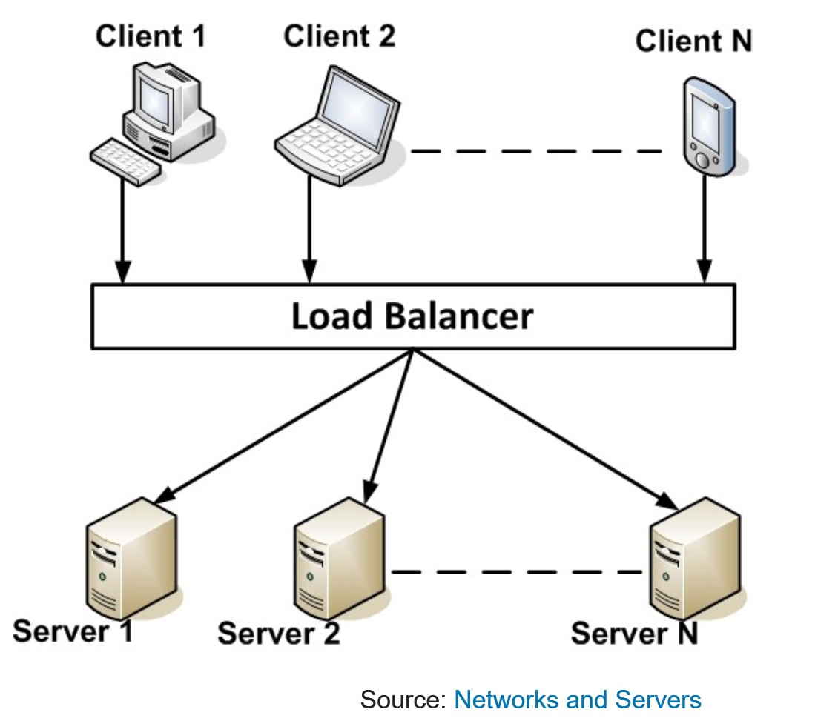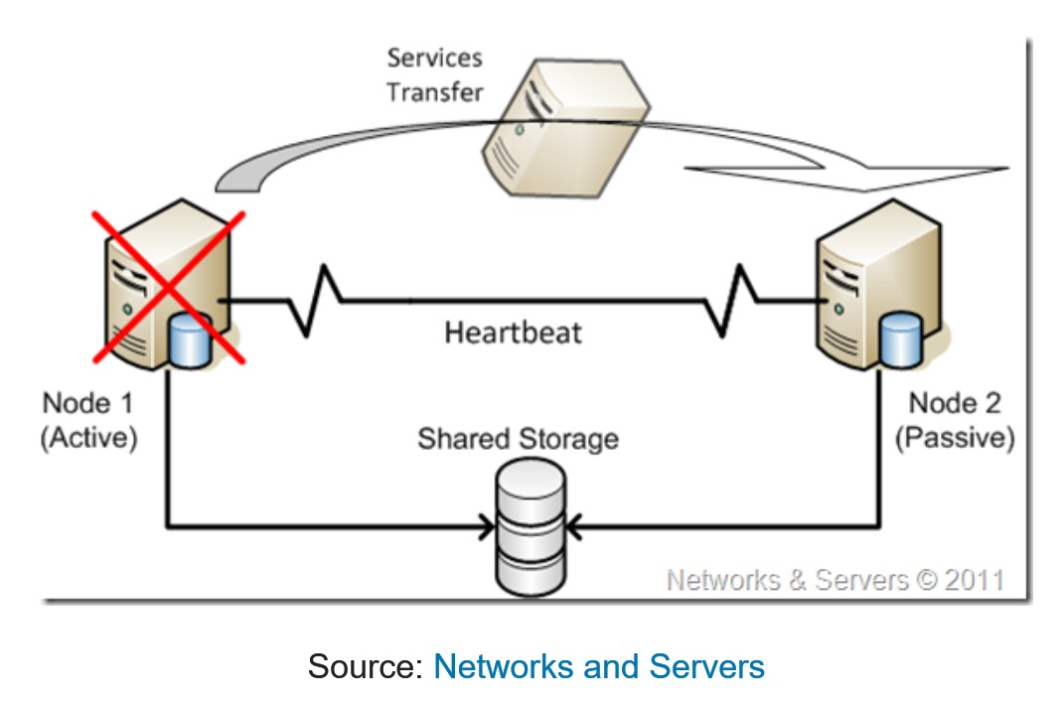
What is more, the failover cluster can be treated as stateful application, which means the servers in the failover are collecting the heartbeat packets in the several ways. On the contrary, the servers in the Network Load Balancing cluster don not collect the data like the heartbeat packets from each other, so it can be seen as stateless application.
Finally, the failover and Network Load Balancing cluster are usually work together to achieve the high availability of the cluster.

References

[1] | M. Documentary, “Failover Clustering in Windows Server,” [Online]. Available: https://docs.microsoft.com/en-us/windows-server/failover-clustering/failover-clustering-overview.
[2] | M. Rouse, “Windows Server Failover Clustering(WSFC),” Techtarget, july 2012. [Online]. Available: http://www.searchwindowsserver.com.
[3] | Fracy.Yin, “What Is the Purpose of a Switch in Networking,” 12 October 2018. [Online]. Available: http://www.fiberopticshare.com/what-is-the-purpose-of-a-switch-in-networking.html.
[4] | M. J. a. B. Posey, “Storage Area Network,” February 2018. [Online]. Available: https://searchstorage.techtarget.com/definition/storage-area-network-SAN.
[5] | RAID, 3rd ed., Oxford University Press, 2005.
[6] | R. H. Katz, “RAID: A Personal Recollection of How Storage Became a System,” IEEE Computer Society, 18 01 2015. [Online]. Available: eecs.umich.edu.
[7] | G. G. A. K. R. Patterson David, “A Case for Redundant Arrays of Inexpensive Disks (RAID),” in SIGMOD Conferences, 2016-12-31.
[8] | Wikipedia, “Microsoft Windows,” 26 4 2019. [Online]. Available: https://en.wikipedia.org/wiki/Microsoft_Windows.
[9] | Wikipedia, “Windows Server 2016,” 21 4 2019. [Online]. Available: https://en.wikipedia.org/wiki/Windows_Server_2016#Hyper-V.

