NAME: ANDREEA CRISTINA DUTA
STUDENT NUMBER: 1921953
LECTURER: GREGORY COWAN

INTRODUCING THE MODERN WORKPLACE
STRUCTURE AND CULTURE OF APPLE
ASSESSMENT 1



Organizational structure and culture have an important role in any organization. Mintzberg assumed that the structure of an organisation is that the sum of the ways during which it divides its labour into distinct tasks then achieves coordination among them. (Boddy D.,2011:296)
The aim of the structure is to divide the work tasks between the members of the organization and to coordinate their activities. Through the structure, the order and command within the organization's activities are managed and the tasks, responsibilities, work roles and communication channels are defined. Within the smaller organisations may be some problems of structure: the distribution of tasks, the definition of authority and responsibility, and also the relations between the members of the organisation have a more personal and informal basis. In the bigger organizations, there is a need for a formal organization structure and a continual review of the structure to make sure that it is the suitable form for the organisation and to keep with its growth and development. (Mullins L.,2016:395)
There are many ways to structure a business. The functional structure is used to group tasks into several sections based on similar skills and expertise. The divisional structure is used to group tasks according to their outputs, like products or the necessities of different customers. The matrix structure is used to report tasks to a functional and a project or divisional manager. A network structure is used when the tasks required by a company are performed by others who are experts in that field. (Boddy D.,2011:302-306)

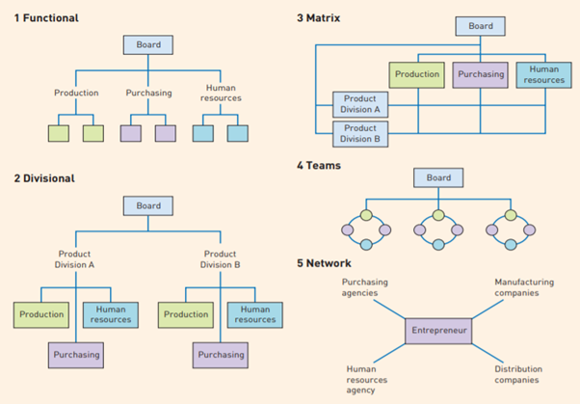

Fig.1- Five types of structure
(Boddy D.,2011:303)
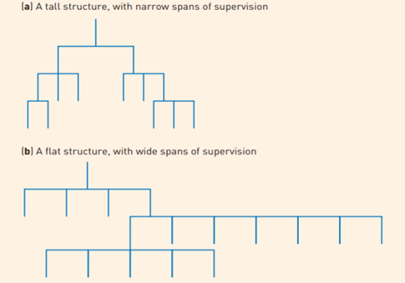
Two other types of structure are hierarchical and flat. Managers divide their work vertically and approve the decisions of others below them when an organization grows. In this situation, the hierarchy establishes the decisions of the people at each level and becomes more complex. There are usually three levels which are: operational, divisional and corporate. Most larger businesses will use this kind of structure. (Boddy D.,2011:300)
The span of control means a quantity of subordinates who report directly to a manager or supervisor. The chain of command establishes the vertical graduation of authority and responsibility, and therefore the framework for superior-subordinate relationships. (Mullins L.,2016:404)
Fig.2- Tall and flat organisation structures
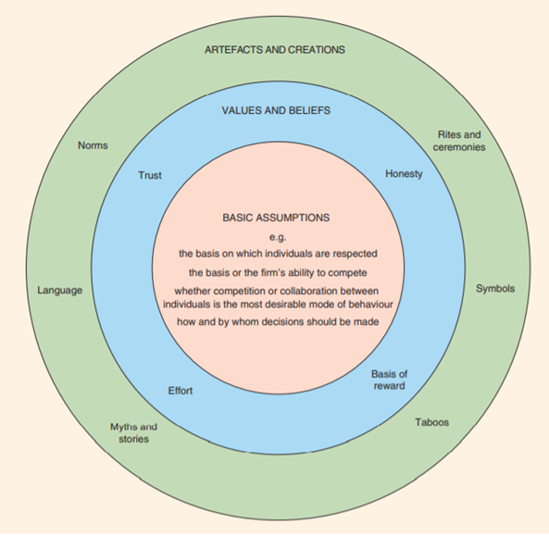
(Boddy D.,2011:300)

Organizational culture refers to the influence of beliefs, values ​​and norms on the way employees feel, think and behave among others both inside and outside the organization. The concept of culture has three layers: artefacts and attitudes, rules and values and assumption. (Huczynski A., Buchanan D.,2013:113)

Fig.3- Schein’s levels of culture
(Mullins L.,2016:539)

There are different types of organizational culture. The culture of power is one of them, and organizations that have this type of culture have a single dominant individual who imposes his will and is symbolically represented by an internet. The company is based on the individual, and the wishes of those at the centre are anticipated. The second type of culture is that of roles, symbolized by a Greek temple and characterized by the importance of rules, procedures and job description. Managers are serious, do their job properly and support their position in the hierarchy and their role. Person culture organizations are the third type of culture, symbolized by a cluster and focused on individuals. The organization is considered to be subordinate to individuals because control takes place only by mutual consent. Task cultures are represented by a network and are based on projects or jobs. An important thing they are focused on is getting the resources and the workers considering their enthusiasm and commitment. (Huczynski A., Buchanan D.,2013:132)
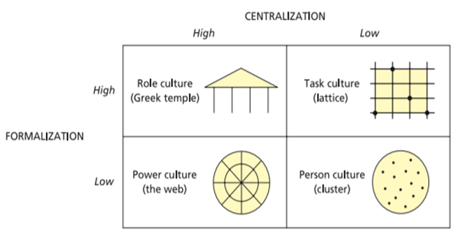

Fig.4- Handy’s culture typology
(Huczynski A., Buchanan D.,2013:132)

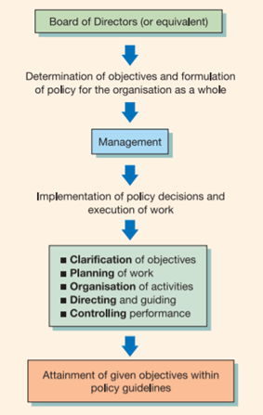
Drucker assumes that a popular way of defining management today is that the work is completed, through the efforts of people. Managers are judged, not just on their performance but on the results achieved by subordinate staff. If we glance at how people at work spend their time, we can distinguish between those whose main occupation is that the completing of discrete tasks and doing of work themselves, and other people who spend more of their time in determining the character of work to be undertaken by people, the planning and organising of their work, providing advices and checking their performance. Management is used to accomplish organizational goals and is described as a clarification of objectives, planning, organising, directing, and controlling. (Mullins L.,2016:356)
Fig.5- Summary of essential nature of managerial work
(Mullins L.,2016:357)

Leadership means inspiring people to try to do their best to attain a desired result. It involves developing and communicating a vision for the future, motivating people and securing their engagement. Dixon assumes that leadership is like an influence upon others that they have a tendency to act collectively towards achieving a goal which they could not have done so easily if they were left with their own devices. (Armstrong M., Taylor S.,2014:322)
There are three major variables that determine the favourability of things which affect the leader’s role and influence: leader-member relations, the task structure and position power. Judging by what Fiedler said, leadership effectiveness could also be improved by changing the leadership situation. Position power, task structure and leader-member relations may be changed to create matters more compatible with the characteristics of the leader. (Mullins L.,2016:332)
Management has often been defined as “getting things done through people”, but managers are liable for guiding and controlling the business or their part of it by managing their other resources (finance), work systems and technology. Management could, therefore, be defined as deciding what to do and how to get it done through the resources’ effectiveness.’ (Armstrong M., Taylor S.,2014:322)
There are many approaches to management such as: scientific management approach, the human relations approach, contingency approach, etc. Many classical writers were concerned with improving management, meaning accelerating productivity. Scientific management approach highlights the efficiency productivity by motivating workers with monetary rewards. F.W. Taylor was the creator of this approach. Taylor believed that while there is the best machine for every job, there is also the best working method by which individuals should undertake their jobs. All work processes can be analysed into discrete tasks which by methodology it was possible to seek out the ‘one best way’ to perform each task. Taylor’s principles were more rigid, which might help to keep up discipline among the workers. (Mullins L.,2016:38)
Elton Mayo was a management scientist who became famous for his theories on Human Relations and Hawthorne studies. In Mayo’s reflections on the Hawthorne studies, the attention to aspects of human behaviour was highlighted. The Hawthorne studies assumed that management should give at least as much attention to human factors, leading to the human relations approach. This means that employees will work more effectively if management shows some interest in their well-being, like by having more human supervision. This approach emphasises the importance of social processes at work. (Boddy D.,2011:54)

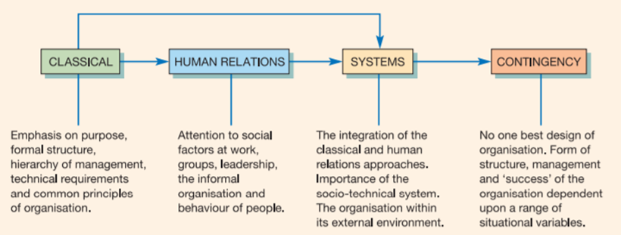

Fig.6- Main approaches to organisation, structure, and management
(Mullins L.,2016:36)

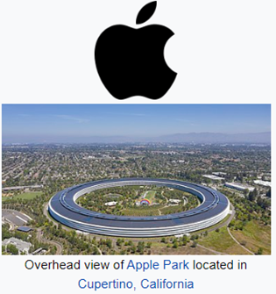
The organization I chose for my project is Apple which is an American multinational technology company based in Cupertino, US. It has been created in 1976 by Steve Jobs and Steven Wozniak. This company deals with the design, development and sale of electronics, computer software and online services to consumers. The first product ever launched by this company was called ‘Apple I’ and took place in the same year that the company was created. Since then, Apple has been very successful and has proven the effectiveness of its products on the market, so that it has grown exponentially in terms of products and services. (Wikipedia,2020)
Figure 7
(Wikipedia,2020)
Resources evidence shows that Apple Inc.’s organizational structure contributes to effective and rapid innovation, which could be a success factor of the business within the information technology, online services and consumer electronics industries. The organizational or corporate structure of a company is the combination of workforce, resources and interconnections between the groups and resources within the business. The organizational design shows how the organizational structure is managed and developed. Apple’s organizational structure is efficient in supporting business performance, keeping the company in the leading game, especially regarding competing against many companies like Microsoft and Google. The Porter’s Five Forces analysis of Apple determines that these competitors impose the strong force of competitive rivalry within the company’s external environment, but through efficient use and evolution of its corporate structure, Apple continues to improve its capabilities and competitive advantages. (Meyer P.,2019)
Apple Inc. includes a hierarchical organizational structure with divisional characteristics and a functional matrix which is week. The hierarchy is a traditional structural feature in business organizations. Divisional characteristics mean group up by-product and therefore the weak functional matrix involves inter-divisional collaboration, while the hierarchy is preserved. The most important characteristics of Apple’s corporate structure are spoke-and-wheel hierarchy, product-based divisions and weak functional matrix. The advantage of strong corporate control of Apple Inc.’s is allowing rapid and effective strategic management implementation and helps establish coherence across the organization. A disadvantage of Apple’s corporate structure is that the limited organizational flexibility. Hierarchy typically prevents lower levels of the structure to flexibly reply to current business needs and market demands. (Meyer P.,2019)
The corporate culture of Apple plays a crucial role in efficiently maintaining its operations within the global scale with 132,000 full-time equivalent employees. Apple's organizational culture had a reputation of being harsh, demanding and intimidating under the leadership of Steve Jobs. Within the last years, Tim Cook has invested great efforts to "humanize" the brand and talked about human rights, privacy, immigration reform and environmental issues. (Dudovskiy J.,2019)
Apple organizational culture includes some features such as creativity and innovativeness, working under pressure, a high level of secrecy and focus on diversity and inclusion. The company encourages its employees to be more innovative and creative by developing a relevant work environment. To illustrate this point, Apple Campus’s creative design, informal fashion codes and creatively designed workspace could be mentioned. An important skill for Apple employees is working under pressure, which means there are strict and challenging deadlines for the most project and long working hours in this company. High level of secrecy is a vital feature of Apple organizational culture. As an example, those who work on software do not have any idea what hardware is like and hardware people do not have any idea about the software. Apple is trying to integrate diversity and inclusion because of the strength of its organizational culture and contains a position of vice president for diversity and inclusion. (Dudovskiy J.,2019)
Apple has been a successful organization over the years. The structure and culture of the organization helped to attain it. Organizational culture could be a critical component in a company that dictates employee’s operations as Apple does. Any organization must make sure that incorporates a good structure that focuses on achieving the objectives and capacity of its employees and adopting a culture that ensures its productivity and profitability on the market. From my point of view, the hierarchical structure used in the organization must be adjusted so it becomes flexible and also the creation of an environment that ensures collaboration would correspond well to the company, the essence of collaboration being greatly reduced.

Bibliography:

- Armstrong M., Taylor S. (2017), Armstrong's Handbook of Human Resource Management Practice, 14th Edition, Kogan Page
- Boddy D. (2011), Management: An Introduction, 5th edition, Harlow: Pearson
- Dudovskiy J. (2019, April 5), Apple Organizational Culture – Secrecy and Maximum Benefit from Human Resources, Available at: https://research-methodology.net/apple-organizational-culture/#_ftnref1 , Accessed July 26, 2020
- Huczynski A., Buchanan D. (2013), Organisational Behaviour, 8th edition, Harlow: Pearson
- Meyer P. (2019, February 14), Apple Inc.’s Organizational Structure & Its Characteristics (An Analysis), Available at: http://panmore.com/apple-inc-organizational-structure-features-pros-cons , Accessed July 26,2020
- Mullins L. (2016), Management and Organizational Behaviour, 11th edition, Pearson
- Wikipedia contributors (2020, July 23), Apple Inc, Available at: https://en.wikipedia.org/w/index.php?title=Apple_Inc.&oldid=969068538 , Accessed July 26, 2020

