

Assessment 1 – Reading Task Template
PART 1: Upload your photo of your A3 in-class notes here:
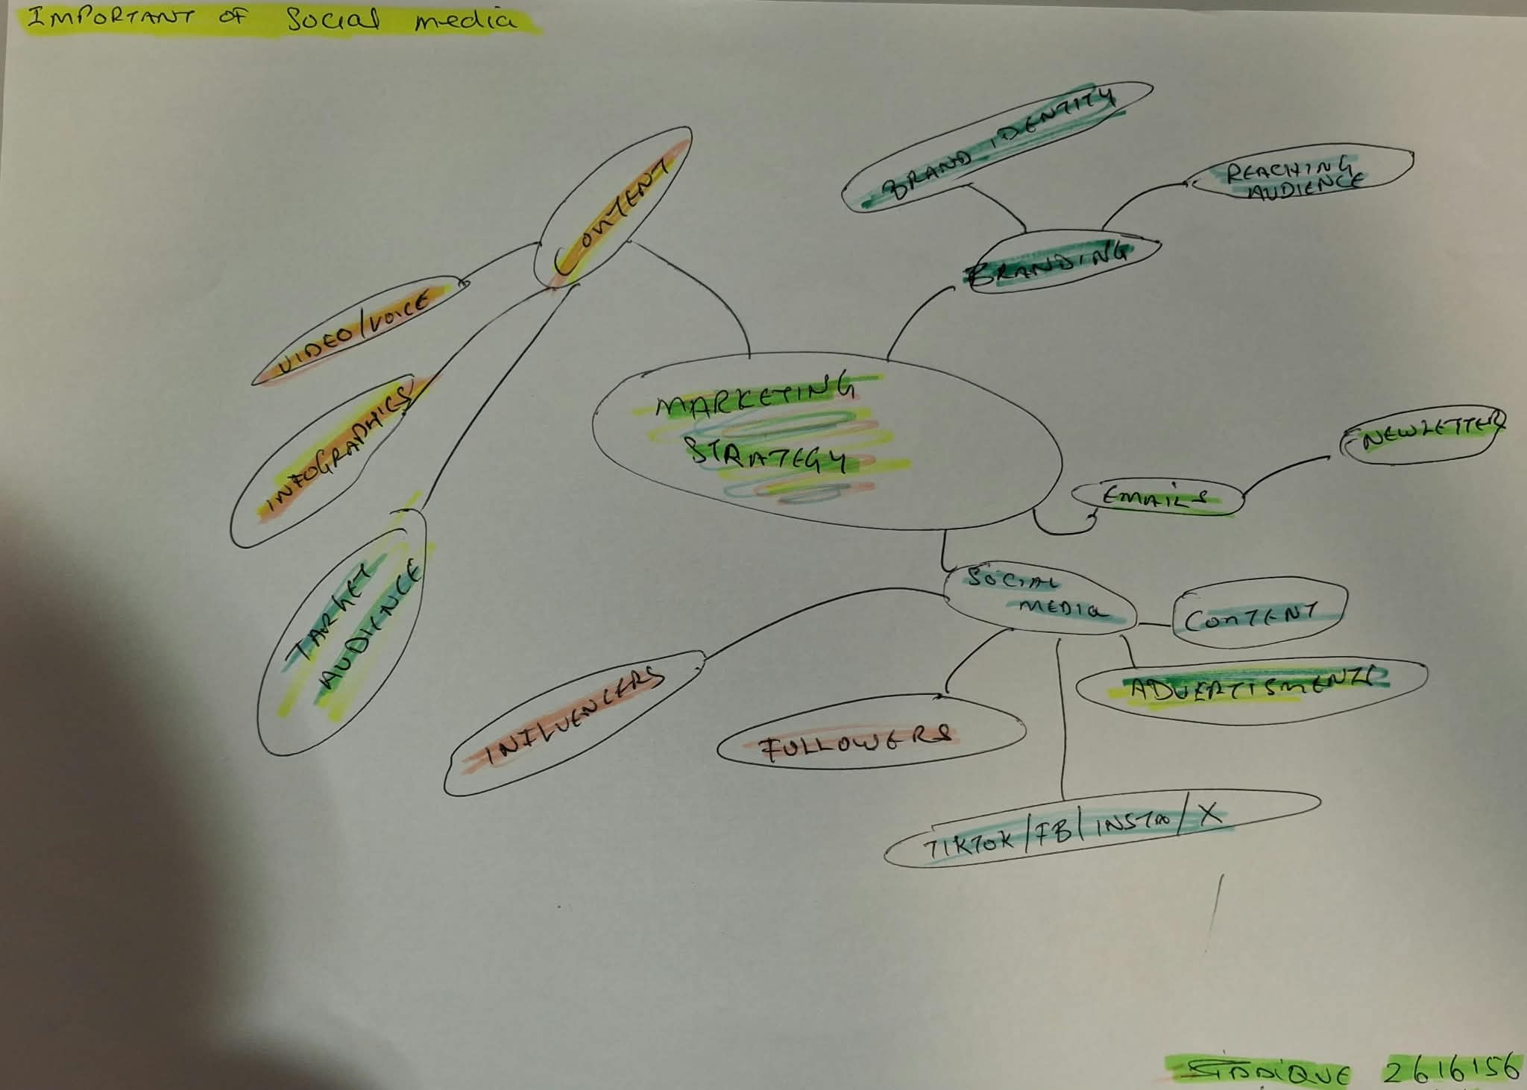

PART 2:
- Answer every question below in 1-3 full sentences.
- Use your own words. Do not use generative AI to answer these questions.
- Include a specific detail from the text when asked.
REMINDER
- The main idea is the overall message of the whole text.
- A key point helps to explain the main idea.
- A specific detail or example from the text shows that the key point is true.

- What is the main idea of the whole text?

The importance of social media and how it can boost a business and reach a target audience from different cities and countries. The main idea is social media can help businesses become more successful by reaching new customers and increasing sales.

- What is one key point that supports the main idea, and which specific example from the text shows this?

One key point is that social media can be an effective marketing strategy for businesses. For example, Bingley Mega Chippy saw its trade increase tenfold because of videos that went viral on social media.

- What is a different key point that supports the main idea, and which specific example from the text shows this?

One of the different key points is that social media can help reach customers from all over the world. For example, customers travelled for up to three hours to Honywood Sandwich shop to try its chicken burger, that was posted by a regular customer and unintentionally went viral.

- Which part of the text do you think is most important, and why?

I think the most important part is how social media can have such a huge effect on a small business because it can bring in many new customers and increase sales. It also gives the business a platform where they can continue to promote their business and potentially increase their customers.

Reflection:
- What did you find difficult in this task (including in-class components), and why was it difficult?
I found it difficult to identify the main idea and key points because there was a lot of information on the article and each one had a different approach to how social media was used to boost their businesses. For example, Bingley Mega Chippy went viral for videos that were posted from customers, whereas Spudman would post and promote his own videos.

- What helped you with this difficulty, and how did it help you?

Looking at the examples from the article helped me with this difficulty because I could compare how different businesses used social media to promote their business. It helped me understand the main idea and identify the key points more easily and I feel more confident in classroom.

