Liaqat Ali
Student ID: 2520512

LCHS4003 Introduction to Health and Social Care

Dr Helen Parsons
challenges faced by the pharmacy profession:

Medication Errors and patients' safety- Pharmacists must ensure the correct medication, dosage, and instructions are provided to patients. Mistakes can lead to serious health risks and patient harm. Medication errors remain a significant challenge for pharmacies because they can harm patients and reduce confidence in healthcare services. Errors can occur at any stage of the medication process, including prescribing, dispensing, labelling, or supplying medicines. Common causes include high workloads, staff shortages, distractions, fatigue, poor communication between healthcare professionals, and look-alike or sound-alike medicine names. As pharmacies take on more clinical responsibilities and handle increasing numbers of prescriptions, the risk of errors can rise if adequate staffing, training, and safety systems are not in place. To reduce these risks, pharmacies use measures such as double-checking procedures, staff training, technology, and incident reporting systems to improve patient safety. (Mistry, B., Patel, 2023)

Increasing Workload and Staff Shortages – Many pharmacies face high prescription volumes, administrative tasks, and limited staffing, which can increase stress and reduce the time available for patient counselling and care. Workforce shortages and increasing workload pharmacists and pharmacy teams are facing growing workloads due to rising prescription numbers, an ageing population etc. At the same time, many pharmacies struggle to recruit and retain pharmacists, pharmacy technicians, and support staff. These pressures can lead to stress, burnout, and difficulties maintaining service quality.(Al-Suwailem, A.K., 2021)

(Pharmacy health, 2026)
Introduction to pharmacy:
Pharmacy is the branch of health science that focuses on the preparation, dispensing, and proper use of medicines. It plays a vital role in healthcare by ensuring that patients receive safe, effective, and appropriate medications. Pharmacists are trained professionals who provide advice on drug therapy, dosage, side effects, and interactions. They work in hospitals, community pharmacies, research laboratories, and the pharmaceutical industry. Pharmacy combines scientific knowledge with patient care to improve health outcomes and prevent diseases. As healthcare continues to advance, pharmacy remains an essential profession dedicated to promoting the safe and responsible use of medicines.
(Hindi, A.M., Schafheutle, 2018)

Role of a pharmacist:
- Provide appropriate preventive medications
- Address medication access issues in the face of pandemic restrictions
- Patient education/ Educate patients about preventing infections and symptoms of the disease/ education on over-the-counter medications
- Increase patient self-efficacy and reduce adverse outcomes from medications
- Vaccinations
- Prevent outbreaks of vaccine-preventable diseases
- Blood pressure checks
- Increase patient self-efficacy and reduce adverse outcomes from medication
- Empower patients, increase pharmacist role in multidisciplinary team, and improve population health. (Strand, M.A., Bratberg, 2020)

Pharmacy services in the UK
History of pharmacy:
One of the earliest names for pharmacists was apothecary, from the Latin apotheca (storehouse). In medieval London, apothecaries were regulated by the Company of Grocers until they formed the Worshipful Society of Apothecaries.
1617: They oversaw medicines and required a seven-year apprenticeship. 1704: apothecaries gained the right to prescribe medicines, becoming more like today’s GPs. This created opportunities for chemists and druggists who opened shops selling medicines, chemicals, and everyday goods such as cosmetics and tobacco.
Recent pharmacy legislation in the Uk has strengthened patients safety by improving the regulation of medicines, pharmacy services and professional standards for pharmacists. (Worling, P.M., 2005)(Baale, L, 2025)
(My Tribe, 2026
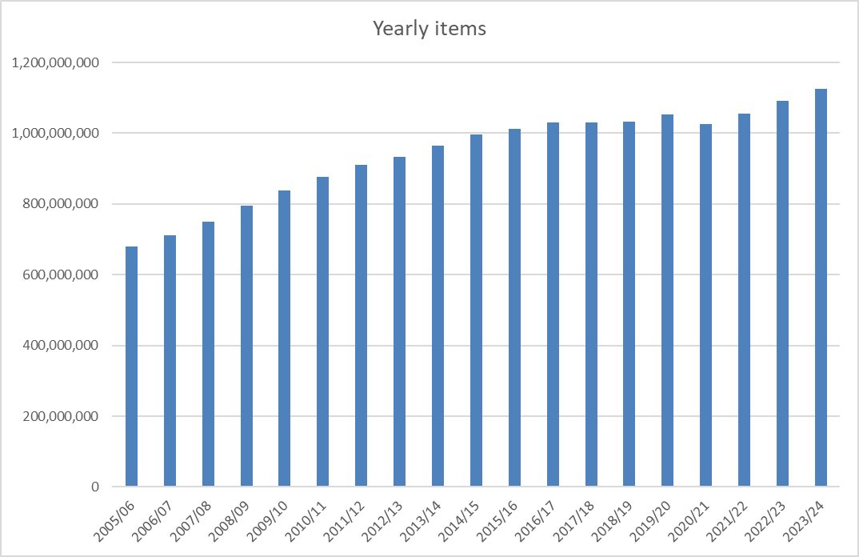
This graph shows the steady increase of prescription items over time expanding role of pharmacies to meet needs. (Community pharmacy England, 2024)

Community mental health care services

This assignment will explore the development of mental health services in the UK, examining their historical origins and the factors that shaped their development. It will critically evaluate how these services function today and discuss their importance in improving the quality of life and wellbeing of service users.
Community mental health care services help people maintain good mental health and provide support, treatment, and care for those experiencing mental health problems. These services help people cope with conditions such as anxiety, depression, stress, bipolar disorder, schizophrenia, and other mental health difficulties. Mental health care services can also assess a person's mental health needs, diagnose mental health conditions, provide counselling and therapy. They also Prescribe and manage medication when needed, offer crisis support during emergencies and help people recover and live independently whilst supporting families. (Thornicroft, G., Deb, T. and Henderson, et al, 2016)
History
Mental health services in the UK have changed a lot over time. In the past, people with mental health problems were misunderstood and treated badly. Today, services focus on treatment, support, recovery, and helping people live independently. Before the 1800s, there was little understanding of mental illness. Many people believed mental health problems were caused by evil spirits, bad behaviour, or personal weakness. People with mental illnesses were often cared for by family members, placed in workhouses, or kept in prisons (Farreras, I.G., 2019). During the 19th century, special hospitals called asylums were built for people with mental health problems. However, as more people were admitted, many asylums became overcrowded and focused on keeping people locked away rather than helping them recover. Later on, early 1900s medical knowledge improved, mental illness began to be seen as a health condition rather than a moral failing. In 1948, the National Health Service (NHS) was created. Mental health services became part of the NHS, meaning people could receive treatment without paying directly for it. This improved access to care across the country. From the 1950s onwards, there was growing concern about the conditions in large mental hospitals. New laws encouraged treatment in the community instead of long-term hospital. Today, mental health services in the UK aim to help people recover and live fulfilling lives. (Raeburn, T., Bradsha, et al, 2023)
General Practitioners are often the first point of contact for mental health concerns. NHS talking therapies provide treatments such as cognitive behavioural therapy (CBT) for anxiety and depression. Community Mental Health Teams. Support people with more complex mental health needs. Psychiatrists are medical doctors who specialise in mental health as well as psychologists and Counsellors who provide therapy and emotional support. Crisis Teams can help people experiencing severe mental health crises and Inpatient Mental Health Units provide hospital care when intensive support is needed. These mental health services in the UK play a significant role in supporting people with mental health conditions through assessment, treatment, therapy, crisis intervention, and ongoing care (NHS, 2024). While services have improved significantly over recent decades, they face multiple challenges that affect their effectiveness. Public awareness of mental health has increased. Mental health is now discussed more openly in schools, workplaces, and the media. Most people can now receive treatment while living at home rather than in long-term institutions. Community-based care promotes independence and helps individuals maintain family, work, and social relationships. (Hazell, C.M., Koc, et al,2021)
However, these services come with many challenges. One of the biggest criticisms of current mental health services is long waiting times. Many people wait weeks or months for therapy, specialist assessments, or treatment. Delays can cause symptoms to worsen and increase The NHS faces shortages of mental health professionals, including psychiatrists, nurses, psychologists, and therapists. High workloads can lead to staff burnout and affect the quality and continuity of care. (Lowther-Payne, H.J., et al, 2023)
Mental health services today are more person-centred, accessible, and focused on recovery than in the past. The move away from institutional care and the expansion of psychological therapies are major achievements. However, the challenges continue to limit the effectiveness of services. While the system provides valuable support to many people, further investment and improvements are needed to ensure timely and equal access to care for everyone (Grant, K.L., Simmons, et al, 2018).

REFRENCES

Al-Suwailem, A.K., 2021. Effect of the pharmacy staff shortage on the medication safety. Issues in Biological Sciences and Pharmaceutical Research. https://journalissues.org/wp-archive/wp-content/uploads/sites/6/2021/03/Al-Suwailem.pdf
Baale, L., 2025. The evolution of pharmacy: From Imhotep to the modern era. Archives of Biotechnology and Pharmaceutical Research, 1(1), pp.19-21. https://www.researchgate.net/profile/Lere-Baale/publication/405123015_The_Evolution_of_Pharmacy_From_Imhotep_to_the_Modern_Era_Archives_of_Biotechnology_and_Pharmaceutical_Research_1_Origins_of_Pharmacy_in_Ancient_Civilisations/links/6a0f72ede48e8125fa396dd7/The-Evolution-of-Pharmacy-From-Imhotep-to-the-Modern-Era-Archives-of-Biotechnology-and-Pharmaceutical-Research-1-Origins-of-Pharmacy-in-Ancient-Civilisations.pdf
Community pharmacy England, 2024, NHS statistics Dispesning statistics graph, available at: https://cpe.org.uk/funding-and-reimbursement/nhs-statistics/
Farreras, I.G., 2019. History of mental illness. General psychology: required reading, 244, Available at: https://d1wqtxts1xzle7.cloudfront.net/60283871/General_Psychology_-__Required_Reading20190813-110996-103829r-libre.pdf?1565739873=&response-content-disposition=inline%3B+filename%3DGeneral_Psychology_General_Psychology_Re.pdf&Expires=1781558518&Signature=bTCMfzePGA8fTiZ-OXj8DEFDoihc1GOBLt8Ac53~in9wxzuW3qh7UPxYfDccuaKlQKyjhpACL25wCp-vNdSi7JICqr5MjDLG-JLOJYTueIBa6J-3tCMFSRtW8YU17fa-ImN50nPn78yiHbC1qZ6k0BaVg-6Alb4fNAnIBWCqKL0oDN4ttBoFDMJ3l8nK3LGE9OiUP5Flz1Rju1mg7EIz2LQHI1s6xLxa0bedN36BEU87wre5ptblQtw6yPRAOkUm-mIPfrcYJ06Dz~guSrE6muAubjDJ9yJBdM43hLlooGzIWwuyed6SzUCDtfMYm6qUAB0qtw4mznR6F9NnR2bPUg__&Key-Pair-Id=APKAJLOHF5GGSLRBV4ZA#page=246
Grant, K.L., Simmons, M.B. and Davey, C.G., 2018. Three nontraditional approaches to improving the capacity, accessibility, and quality of mental health services: An overview. Psychiatric Services, 69(5), pp.508-516. https://psychiatryonline.org/doi/full/10.1176/appi.ps.201700292
Hazell, C.M., Koc, Y., O'Brien, S., Fielding-Smith, S. and Hayward, M., 2021. Enhancing mental health awareness in emergency services (the ENHANcE I project): cross-sectional survey on mental health stigma among emergency services staff. BJPsych open, 7(3), p.e77. https://www.cambridge.org/core/journals/bjpsych-open/article/enhancing-mental-health-awareness-in-emergency-services-the-enhance-i-project-crosssectional-survey-on-mental-health-stigma-among-emergency-services-staff/2A0D90963CF99D26898C82E811D42E3C
Hindi, A.M., Schafheutle, E.I. and Jacobs, S., 2018. Patient and public perspectives of community pharmacies in the United Kingdom: a systematic review. Health Expectations, 21(2), pp.409-428. Available at:
https://pmc.ncbi.nlm.nih.gov/articles/PMC5867331/
Lowther-Payne, H.J., Ushakova, A., Beckwith, A., Liberty, C., Edge, R. and Lobban, F., 2023. Understanding inequalities in access to adult mental health services in the UK: a systematic mapping review. BMC health services research, 23(1), p.1042 https://link.springer.com/article/10.1186/s12913-023-10030-8
Mistry, B., Patel, Z. and Prajapati, M., 2023. Medication errors: understanding the types, causes, and prevention, and the critical role of pharmacists. Int J Pharm Res App, 8(5), pp.1358-1370.https://www.researchgate.net/profile/Manthan-Prajapati/publication/375061800_Medication_Errors_Understanding_the_Types_Causes_and_Prevention_and_the_Critical_Role_of_Pharmacists/links/653e7cc60426ef6369e9b723/Medication-Errors-Understanding-the-Types-Causes-and-Prevention-and-the-Critical-Role-of-Pharmacists.pdf
My tribe, 2026, Can I buy antibiotics over the counter in the UK?, Available at: https://www.mytribeinsurance.co.uk/treatment/how-to-get-antibiotics-in-the-uk
National Health Services, 2024, Mental health support for serving personnel and reservists, Available at: https://www.nhs.uk/nhs-services/armed-forces-community/mental-health/serving-personnel-reservists/
Pharmacy health, 2026, vaccination service, Available at: https://pharmacyplushealth.co.uk/service/vaccination-service
Raeburn, T., Bradshaw, J. and Cleary, M., 2023. Mental health history–It matters. Issues in Mental Health Nursing, 44(1), pp.3-5. https://www.tandfonline.com/doi/full/10.1080/01612840.2022.2138437
Strand, M.A., Bratberg, J., Eukel, H., Hardy, M. and Williams, C., 2020. Community pharmacists’ contributions to disease management during the COVID-19 pandemic. Preventing chronic disease, 17, p.E69. https://pmc.ncbi.nlm.nih.gov/articles/PMC7380294/
Thornicroft, G., Deb, T. and Henderson, C., 2016.Community mental health care worldwide: current status and further developments. World Psychiatry, 15(3), pp.276-286. health care worldwide: current status and further developments. World Psychiatry, 15(3), pp.276-286. https://onlinelibrary.wiley.com/doi/full/10.1002/wps.20349
Worling, P.M., 2005. Pharmacy in the early modern world. Making Medicines: a brief history of pharmacy and pharmaceuticals, p.57. Available at: https://books.google.co.uk/books?hl=en&lr=&id=A6lWNwuO-f0C&oi=fnd&pg=PA57&dq=pharmacy+in+the+early+modern+world&ots=ltBYw4SfmH&sig=8eRmE0VUNzJXofJMurFYjR-M-7I&redir_esc=y#v=onepage&q=pharmacy%20in%20the%20early%20modern%20world&f=false

