Q1 The following table records the execution time of 3 C++ functions, Func1(), Func2() and Func3(). Each of these functions has been timed (in milliseconds) when processing a range of data arrays containing data of size 500 data elements, 1000 data elements, 2000 data elements, 4000 data elements and 8.000 data elements.

 | Data size in array elements
 | 500 | 1000 | 2000 | 4000 | 8,000
Func1() | 10.0ms | 39.5ms | 160.3ms | 642.0ms | 4001.5ms
Func2() | 10.0ms | 19.8ms | 41.0ms | 83.0ms | 160.0ms
Func3() | 10.1ms | 10.7ms | 9.9ms | 9.7ms | 10.3ms

Table Q1

For each function, sketch a graph in your answer book showing the relationship between time and data size. From this graph, or from the table Q1 above, estimate the time complexity of each function using Big Oh notation.
Func1() -> O(n²)
Func2() -> O(n)
Func3() -> O(c)

Graph of Data size vs Time func1(), followed by graph of func2 (in blue) and func3 in red.
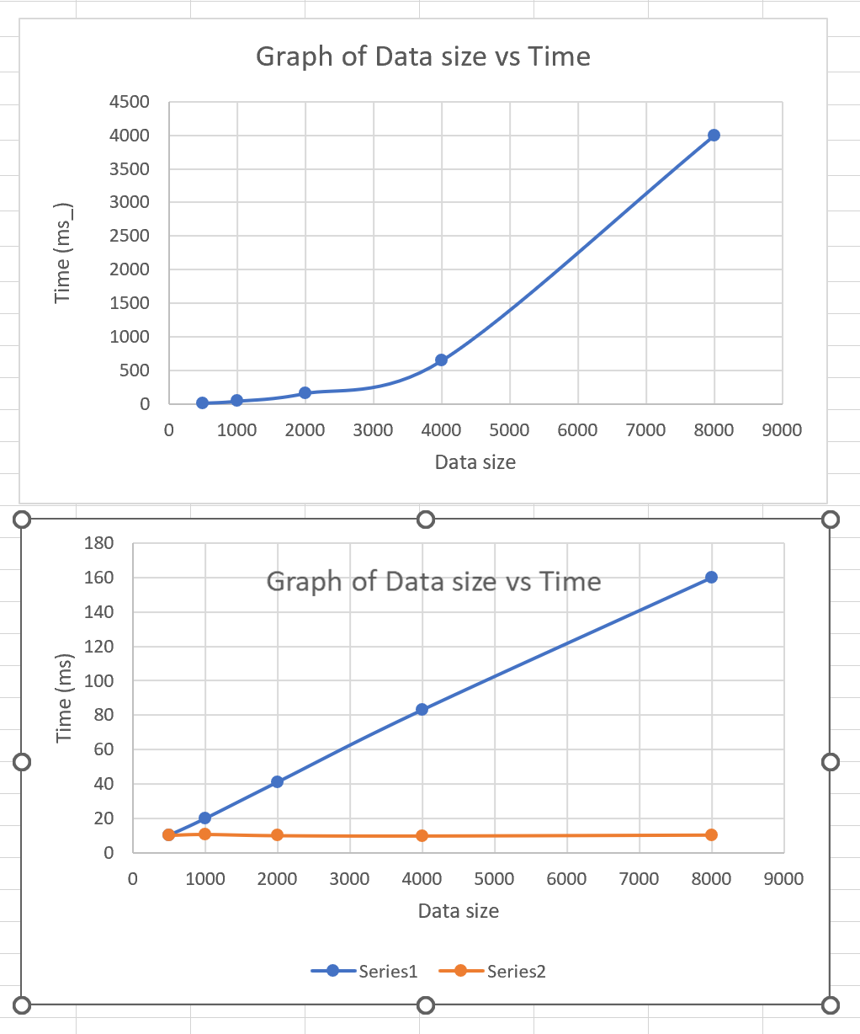
QUESTION

- Big “O” notation is often used to describe the computational complexity of an algorithm, for example sort algorithms may be categorized as either order n² or nlogn. Explain what is meant by these two terms and why it is useful to categorize sorts this way. Identify an algorithm for any sort that you have studied that is categorized as being of the order nlogn.
[5 marks]

- Use pseudocode to illustrate programming structures that have complexity O(1), O(n) and O(n²).
[6 marks]

- An algorithm has a running time,Rt given by:-
Rt = n² + n + log(n) + 15
where n is the number of items input into the algorithm.
Using “big-O notation,” state the computational complexity of this algorithm and explain your answer.

[4 Marks]

