Module Name : Change and Stability Management
Module # : BMMB7000
Student Name : Anushi Fernando
Student Number : 2222875
Submission Date : 05th May 2023
TOMMY HILFIGER
3D Virtual Sampling Process
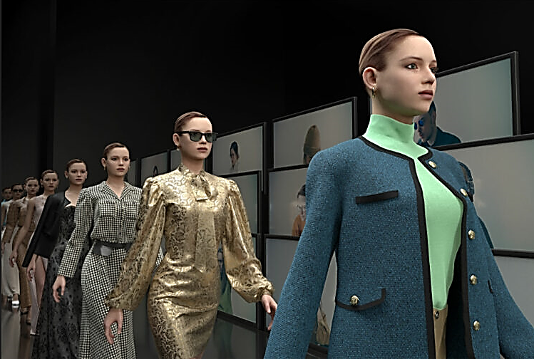

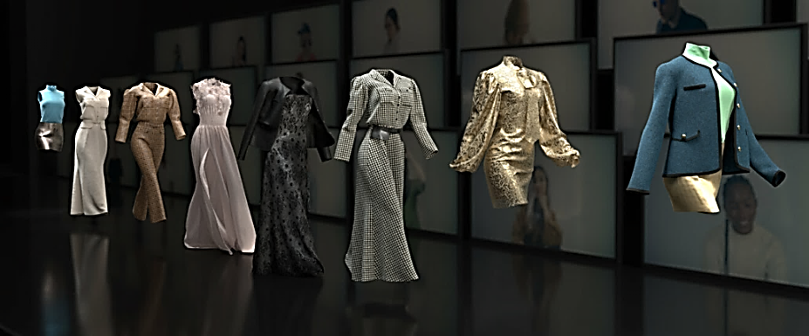

EXECUTIVE SUMMARY

Fashion is one of the world's most important industries, accounting for a significant share of the global economy with revenue between USD 1.7 trillion – USD 2.5 trillion per year (Fashion United, 2023). Also known as apparel and textile industry which consists of main two parts. One is manufacturing of textiles/fabrics and second is conversion of these fabrics in to clothes. This report is about, Tommy Hilfiger, a high end American clothing brand which falls to the second category of developing designer clothes. It started in 1985 and now a famous global brand with company headquarters in Amsterdam Netherlands.
The company has a valued supply chain for garment construction. Here the most important process is the sample development stage as without a proper sample it is unable to predict the final outcome of the product, either its physical properties or the market trends. The company had decided in using new technology to improve the process in order to get more befits for the company and to fulfill their social responsibilities too.
In this report, a background research has been done to identify the actual need for the company for the transformation of their traditional sampling process in to a 3D virtual sampling. Then a research is done to find out the triggers of change. A force field analysis is carried out to find the driving and resisting forces and the stakeholder analysis to identify positive and negative attitudes towards the change management process, so that the company can decide on how to minimize resistance to change and start on the change implementation.
During the change execution, Kurt Lewin’s three step model and John Kotter’s eight step model is used to successful application for the change overcoming resistance to change management process. Further, this report explains the post change experience for the company and few recommendations for improvements.

CONTENTS

1. EXECUTIVE SUMMARY 1
CONTENTS 2
TABLES AND FIGURES 2
2. INTRODUCTION 2
2.1 Company Overview 3
3. BACKGROUND FOR THE ORGANIZATIONAL PROCESS CHANGE 3
3.1 What is the Change 3
3.2 Traditional Sample development process 4
3.3 Issues with Traditional sample development process 5
3.4 3D Virtual Sampling 6
3.5 Benefits of 3D virtual sampling 6
4 RESEARCH AND ANALYSIS 7
4.1 McKinsey 7S Framework 7
4.2 Kurt Lewin’s Force field analysis 8
4.3 Stakeholder Analysis 10
5 CHANGE IMPLEMENTATION 13
5.1 Application of Kurt Lewin’s three step model 13
5.2 Application Of Kotter’s Eight Step Model 14
6 EVALUATION OF CHANGE 16
7 CONCLUSION 17
8 RECOMMONDATIONS 18
9 REFERENCES 18

TABLES AND FIGURES
Figure 01: Tommy Hilfiger Logo
Figure 02: Traditional Development Process
Figure 03: 3D Virtual Sample Process
Figure 04: McKinsey 7S Framework
Figure 05: Force Field Analysis
Figure 06: Stakeholder Analysis
Figure 07: Kurt Lewin’s 3 step model
Figure 08: John Kotter’s 8 step model
Figure 09: AR mirrors for virtual fit-on

INTRODUCTION

Apparel and textile is a very challenging and highly demanded industry where all the brands intention is on fulfilling customer needs in a timely manner. Here the brands need to focus on innovations and process improvements where appropriate to lead the fashion market and new market trends. In this report, a detailed process transformation took place at Tommy Hilfiger; a famous global brand is described step wise. First, it is the company management to decide on the change to take place and plan the future benefits the change would add to the company. Then a background research and a detail analysis carried out to explore how the change should occur, what is the resistance to change and how to overcome challenges to successful implementation of the change in the company.

2.1 Company Overview

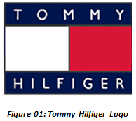
Tommy Hilfiger is a global, American clothing brand with its headquarters in Amsterdam, Netherlands. The company was initially formed in 1985 by Thomas Jacob Hilfiger, a talented designer, which was then sold to Phillips-Van Heusen Corporation (PVH) in 2010. The company started its European business in 1996. With its main business of manufacturing and retailing of designer clothes, it operates with more than 2000 retails stores across the globe over 100 countries including 46 stores in the UK. The brand is in the retail market under different labels as ‘Tommy Hilfiger’ , ‘Tommy Hilfiger Denim’ , ‘Tommy Hilfiger Tailored’ , Tommy Jeans’ with inspiring its customers with a range of luxury designer clothing for men’s, women’s, children’s, sportswear and denim including some licensed accessories too. (Kumar, 2022)

3. BACKGROUND FOR THE ORGANIZATIONAL PROCESS CHANGE

3.1 What is the Change

Tommy Hilfiger changed their traditional sample development process to a 3d virtual sampling process (Tafreschi, 2019). This took place with the need of using new technology after seeing the drawbacks of the traditional process and as an approach to sustainability while catering the best and quickest seasonal collections for its retailers.

3.2 Traditional Sample development process
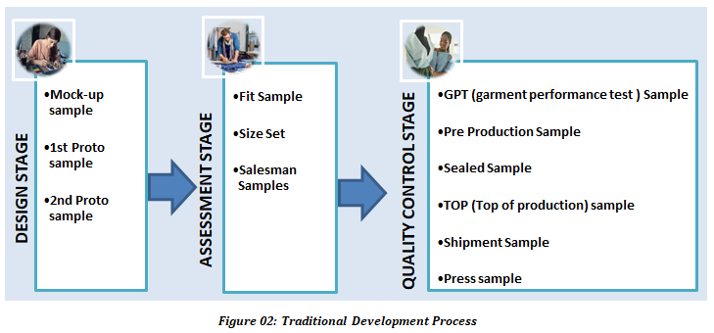

Before making the end product for retail, the garment manufacturing process passes three main sample stages. First comes the design stage where the very preliminary design to pattern finalization is done. Three sample types such as mock ups, 1st Proto samples, 2nd proto samples are done in this stage. Secondly, it is the product assessment stage where the actual design fit is finalizes together with the costing for the product. Sample types of fit samples, size set samples and salesman samples are completed in this stage. Finally, it is the quality control stage, where samples should be done to certify the product quality and consistency for the planned production. GPT (garment performance test) Sample, Pre Production Sample, Sealed Sample, TOP (Top of production) sample, Shipment Sample, Press sample are done during this stage. Almost twelve sample types are included for all these three stages, and for each sample type, there will be 1-5 garments being done with the purpose of keeping reference for each department involved for the development process such as designer team, technical team, buying office, construction team…etc (Kochar, 2021).

3.3 Issues with Traditional sample development process

(a) Huge sample waste
Manufacturers develop hundreds of styles for a season and only few will be selected to release to the market. Non selected styles may drop after few stages in the development and for selected styles, once the final production is completed and released to retail shops, all development samples will be disposed after keeping them as references for few months (James, Roberts and Kuznia, 2016)

(b) High cost
Most of the clothing construction is being done in Asia with involvement of few countries from where the raw material and accessories are sourced. So the development cost incurred sample processing charges, fabric cost, accessories cost, courier charges for samples sending for approvals and freight charges for imported raw materials. Finally, there is an added cost for fit models in order to see the actual styling of the product (Sharkar, 2015)

(c) Timely process
According to Senanayake (2015), the average time taken to complete a development process takes 1-3 months for new fashion designs and 3-4 weeks for basic designs.

(d) Stressful process
Fashion Industry is always to work on a critical path in order to release the latest clothing collection in time to the market. During the sample development process there is a lot of communication between designers, suppliers, factory construction staff and minor staff which involve in coordination and arranging samples for inspections, getting fit on comments passing them to factories and checking for sample construction timelines, updating of sample processing progress and so. Also if there needs a change for pattern and any improvement in styling, there is a long process to follow from starting to give instruction and to follow on the corrections (Birhan, Ambissa, Delele, and Dagne, 2022)

(e)Massive environmental impact
As per United Nation’s 17 sustainable goals to achieve by 2030, the fashion industry has a great responsibility, since it is known that the fashion industry has a huge impact against environment (Geneva Environment Network, 2023). Apparel industry is accused for wasting 20% of global water, 10% of global carbon emissions, 24% of air pollution due to the use of insect repellents in cotton farming which is the main raw material for clothing. Further, textile waste is 21 billion tons per year which are sent to landfills (UNECE, 2018). So it’s time to take corrective measures as much as possible to reduce environmental impact and one way of doing this is to reduce waste during the production and development process.

3.4 3D Virtual Sampling Process

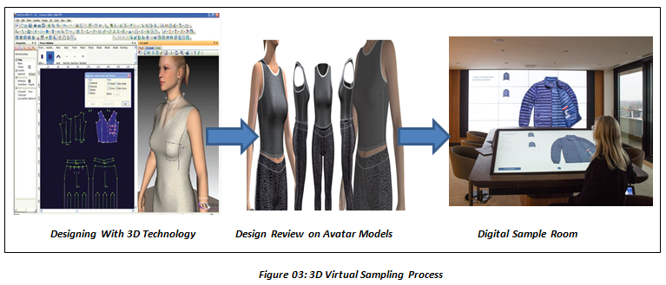
Tommy Hilfiger introduced 3D technology, so the designers can now sketch their designs on a 3D platform where they can implement a 3D sample as they desire, do changes as they require and construct the 3D product using input data of high resolution fabric/ accessories images. Once the product is ready, that could be dressed to an avatar body within the 3D system and see how the product will be on human body. The successfully completed digital collection is finally linked to a digital sample room where the product is first sold and then produced (Mcdowell, 2019)

3.5 Benefits of 3D virtual sampling

This is a very effective process where the owner of the design, mainly the designer gets the full responsibility of designing, developing, revising and finalizing the product. With elimination of physical samples during the development process, this has become an effective time saving approach as it avoids waiting in lines for sample stitching and sending them from one country to another for reviews. Further, it is very cost effective process since the development cost will not include the fabric/ accessories and courier costs, since the physical samples will be done only at the final stage where a bulk production commences. Moreover this is a sustainable approach with minimizing waste (Papahristou and Bilalis, 2017)

RESEARCH AND ANALYSIS

McKinsey 7S Framework
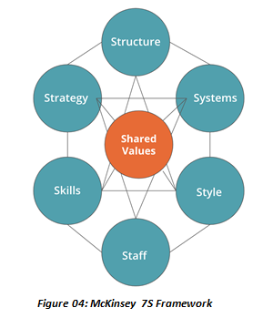
McKinsey 7S model is an effective framework to apply managing a change process. This is with 7 key elements based on organizational design where the company management can make their strategies to win the challenges facing during change management process (Gechkova & Kaleeva, 2020)
Structure, Strategy and Systems are the Hard features Skills, Style, Staff, Shared Values are the soft features (Malik, 2022)

Structure – Development department consists with designers/pattern makers/ buyers/ technicians and fit construction staff
Strategy – Use of new technology for process improvement
System – 3D Sample development process
Skills – Staff training with STITCH academy
Style – A unique way to approach sustainability and fastest route for developments
Staff – Main focus on internal staff involve in design and pattern making
Shared Values – to become the leading sustainable designer in the fashion industry

4.2 Kurt Lewin’s Force field analysis
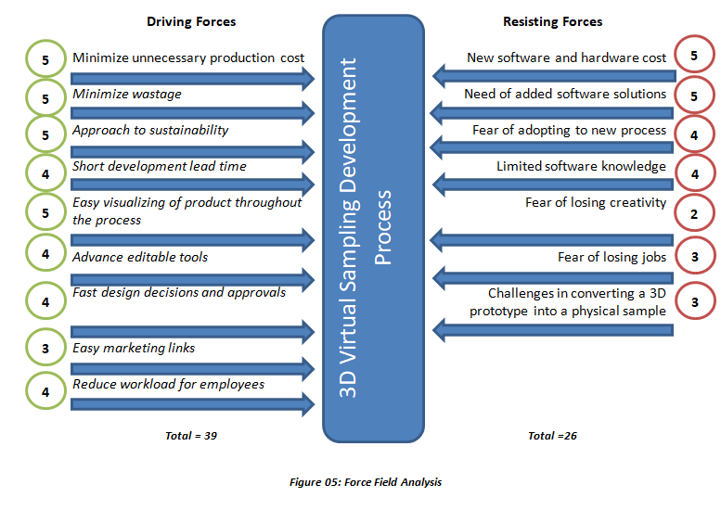
As per Kurt Lewin’s change management theory, there can be identified two categories of forces effecting the change as driver forces and resisting forces. An organization should carefully analyze both the forces and as long as the driver forces are more powerful than the resisting forces, the organization can proceed with the change. However, company managers should proactively involve in reducing resisting forces and improve drive forces to successfully implementing the change.

Above is the force field analysis done for the change and the driving forces have more than the resisting forces. Hence, the company proceed with the new change.

Driving Forces
These are the forces help to progress with the planned changing process. For Tommy Hilfiger, 3D sampling led the designer team continue product development and modifying process with powerful tools with trials on avatar bodies preventing physical samples in every step of designing. So this was a cost and time saving approach with easy visualizing of the product at each development stage which led to sustainability by controlling waste. It has the convenience of getting product approvals quickly as everybody had access to a common system where product approvals can be done and rejections can be modified and send for re-approvals with few clicks. Also, this led to easy marking approach since all the designs can be linked to the digital showroom easily for marketing activities.

Resisting forces
These are the forces which will prevent the change process. As long as the company management is well aware and well prepared to face the resisting forces successfully, the change process will be smooth and easy to implement. Below are the resisting forces and how company overcame the situation
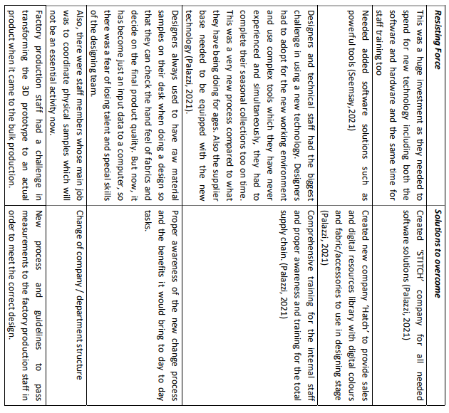

Stakeholder Analysis
According to (Production Plan, 2018) Stakeholders are the group of people the organization should examine thoroughly when it comes to do a change. They can be either internal or external but directly or indirectly participated or effected by the organizational change. Company management should analyze and group their stakeholders as per their involvement, power or interest on the project. This will help to identify the key players for the change, aligning them the best to reduce resistance to change and discuss and find solutions for any struggles. Early recognition of stakeholder resistance and finding solutions is a key success for any organization before commencing the change.
A stakeholder analysis is carried on here to get a deeper idea of the influence for the change in Tommy Hilfiger 3D virtual sampling process.
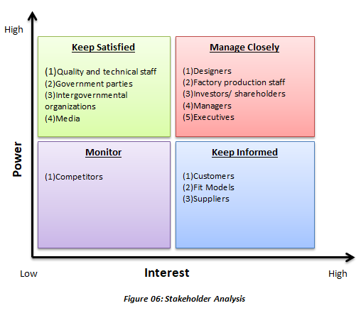

Stakeholders with High power and high interest
These stakeholders have the highest influence on the organizational change and they should be managed well in order to successful in the changing process (Smith, 2000) Designers/ Executives who will be using the new 3D software would be facing the main challenge, as they may not be able to get a learning curve, but on job training since the fashion industry is proceeding with a critical path with strict time lines to meet the new fashion trends for the upcoming season. Also, the factory production staff (mostly from Asian countries) who used to do the garment designing with 2D patterns and then construct the garment will be following a huge process change since the product is now fitted into 3D avatars and once the design is finalized only, it should be converted to a physical sample for production. This 3D virtual sampling is a high cost project where investors and shareholders anticipate for the benefits and see how their investment will be in future. Managers will be facing a huge challenge in order to make the change happen and they will be working hard together with the team in order find solutions for the laps in each stage.

Stakeholders with high power and low interest
These stakeholders should be kept well satisfied on the change taking place (Mind tools content team, 2022) Brand’s quality and technical staff will face changes in their working process as they may not receive physical samples for fitting sessions. However, as long as the quality and the technical aspects of the final product is maintained, they can be kept satisfied about the change. Also the change should process under government rules and regulations. Also, proper awareness can be done through social media to get comments and community ideas for the change.

Stakeholders with low power and high interest
These stakeholders may not be able to resist mush against the organizational change but to adapt for the new process. So they should be kept well aware about the new change and the benefits of the same (Gregoire, 2019). One of these stakeholders is customers who would like to experience a new era of fashion. Then the fit modelers who will eventually loose few sessions of their job as the fitting will be mostly done with 3D avatars and the physical fitting will be only at the final stage now. Another party is the suppliers who need to well aware on the change and make their supply accordingly. There won’t be any need of the physical samples of accessories and fabrics for the samples constructions, but all should be as high quality images which should be a main input data for the 3D virtual sampling.

Stakeholders with low power and low interest
These stakeholders must be well monitored as the fashion industry is a challenging trade and the organizational change should give more benefits to the brand to be more successful compared to its competitors (Chartered Management Institute, 2020)

CHANGE IMPLEMENTATION
After proper analysis of the forces and stakeholders, the change implementation is taken place.

Application of Kurt Lewin’s three step model
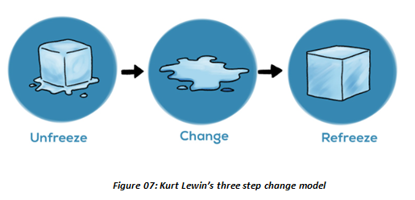

Kurt Lewin’s change theory consists of three main steps as unfreeze, change and refreeze.

Stage 1 : Unfreeze
In this stage, the management have gathered up the drive forces and resisting forces and done their best to minimize resistance to change. Also, Tommy Hilfiger had selected “Stitch” as a tech incubator to digitalize their development process and proper staff awareness of the new change was done thoroughly here with set targets on when the digitalized collections to be released to the market.

Stage 2 : Change
In this stage, Tommy Hilfiger had invested on the digital sample development project. Together with stitch academy, more than half of its employees were trained to use the new 3D design process. Also, they launched a supporting tool library including digital fabrics, digital patterns and colors. Apart for this, 3D presentation tools and execution technologies were implemented.

Stage 3 : Refreeze
Now the new development process is in use and Tommy Hilfiger released their very first capsule collection for Fall 2020 including a fully 3D designed men’s shirt collection. Apart for this, they released their fully 3D designed collection for spring 2022.

Application of Kotter’s eight step model

The 8-step change model developed by John Kotter is a change management methodology that enables to address organizational change and digital innovation by motivating their people to promote the rapid adoption and execution of a new change initiative.
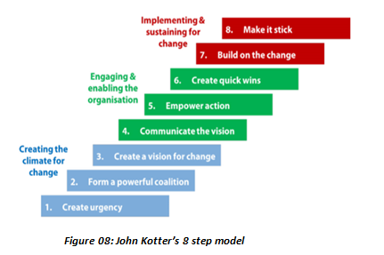

Creating the climate for change
Step 01 : Create urgency
This is the very initial stage to identify the need of change, identify and analyze threats and opportunities and make awareness among employees about the change to happen and the benefits the organization would gain. For Tommy Hilfiger, the adoption of new 3D virtual sampling process is an essential implementation in order to minimize sample waste, minimize sampling development time.
Step 02 : Form a powerful coalition
In this stage, the organization should plan to gather required skills and leaders to carry on the change for the company. Tommy Hilfiger has selected “Stitch” as a tech incubator for their organization to implement the change in to their sample development process.
Step 03 : Create a vision for change
This is the stage to form the vision pertaining to the change to take place and make mission to approach the desired change. According to (Lacombe, 2019), Daniel Grieder, the chief executive officer of Tommy Hilfiger Global and PVH Europe announced, “The potential of 3D design is limitless, allowing us to meet consumer needs faster and in a more sustainable way,”

Engaging and enabling the organization
Step 04 : Communicate the vision
This should be a formal stage to have proper discussions between management and the employees to understand, give feedbacks and get answers to their problems. Most important is to make employees understand the change benefits so the company can get the maximum support from the workforce to make the change process successful. Various methods such as e mail, awareness programs, newsletters can be used here to have a better communication inside the organization.
Step 05 : Empower action
In this stage, the organization should clearly identify the barriers for the change and remove them successfully. These barriers can be either employee resistance to change, technical issues, weaknesses in process or insufficient knowledge. Tommy Hilfiger successfully faced the challenge by giving staff training to use the new 3D sampling process with the support of stitch academy.
Step 06 : Create quick wins
This is to have short term goals as millstones in the change process. This will encourage the team with short term wins until reach the final goal. Tommy Hilfiger set target to release a capsule collection with 3D sample approach including fully digitalized men’s shirt collection. And it was a success in their winter collection for 2020.

Implementing and sustaining for change
Step 07 : Build on the change
In this stage, the total transformation should take place mapping all drawbacks and successfully overcoming them. Tommy Hilfiger could adapt the new change and target on releasing their very first fully digitalized collection in Spring 2022.
Step 08 : Make it stick
Step by step, the change leaders should attempt to create a new culture in the organization in which the new change can be sustained.

EVALUATION OF CHANGE

The new 3D sample development process helped the company to reduce its development cycle time by 35%, count of physical samples by 60% and fitting sessions by 40 – 50% compared to the traditional method they had been using before. Also, it was a cost effective process since there were no additional or hidden charges for sample transportation from on country to another and no raw material and accessories cost. 3D design could be directly used for virtual prototyping, digital showrooms and social media and made the marketing activities more efficient. Further, reducing of physical samples lead to environmental sustainability as it helped reducing textile waste, energy waste and CO2 emission (Metselaar, 2021).

PVH owned ‘STITCH’ Technology to outside brands
After achieving a great success, PVH Corporation, the parent company of Tommy Hilfiger was ready to give the 3D designing experience to outside brands who were willing to invest on 3D designing process. They were ready to sell ‘STITCH’ technology with access to ‘STITCH HUB’ including online training courses and a set of tools in beta version together with digital asset library including digital samples of fabrics / colours and accessories (Nast, 2021)

AR mirrors for virtual fit-on
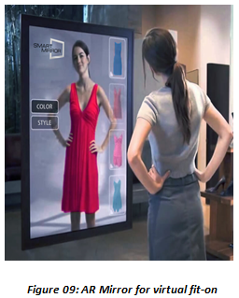
After few years using of 3D technology for the sample development process, Tommy Hilfiger has now stepped forward to give a new shopping experience for their retail customers by letting them do virtual fit-ons up to 28 digital designs in front of AR mirrors. The company has now installed AR mirrors in their stores which let the customers select their preferred outfit and see different looks with incorporating some changes as they prefer. Initially, each customer will be able to try on 10 digital designs in three Tommy Hilfiger stores in London, Berlin and Milan from 23rd March to 16th April, 2023 (Taylor, 2023)

CONCLUSION

Tommy Hilfiger is a leading global brand who had stepped forward with a digital transformation in their internal sample development process. As a responsible brand, Tommy Hilfiger analyzed the effectiveness of their traditional sample development method and could identify the areas they need to improve in order to make their trend collections in a fastest route while minimizing cost and reducing cycle time. The company had successfully faced the resistance during the change management process and implemented the desired changes and now experiencing the stability of the change with more benefits with brand recognition while giving a better experience for its customer base.

RECOMMONDATIONS

One of the main drawbacks in the change process of 3D sampling is the lack of knowledge of the staff and the fear of using an advanced technology for the day to day activities but, still working on the same critical path to meet the required seasonal collections for the market. So, it will take longer time for the designers to be competent in 3D designing. Though this 3D designing is new to apparel manufacturing, there are more experienced personals in different industries such as 3D Industry or gaming who really know the complexity and experienced in using advanced tools. So adding few technical 3D artists to the company will help the designing and technical staff to troubleshoot day to day software handling issues and improve knowledge. Further, brand should regularly participate in industrial consortiums such as ‘Khronos Group’ where new technological aspects are regularly discussed and introduced (Hackl, 2021).

REFERENCES

Birhan, T.A., Ambissa, M., Delele, T.G. and Dagne, H., 2022. Work-related stress and associated factors among garment workers in Bole Lemi Industrial Park of Addis Ababa, Ethiopia: a multi-center institution-based cross-sectional study. BMC psychiatry, 22(1), pp.1-9.
Chartered Management Institute (2020). Stakeholder Analysis and Management. [online] CMI. Available at: https://www.managers.org.uk/knowledge-and-insights/resource/stakeholder-analysis-and-management/.

Fashion United (2023). Global Fashion Industry Statistics. Fashion United. https://fashionunited.com/global-fashion-industry-statistics

Gechkova, T. and Kaleeva, T., 2020. The mckinsey 7s model in the airport system protection. KNOWLEDGE-International Journal, 42(5), pp.843-848.

Geneva Environment Network (2023). Environmental Sustainability in the Fashion Industry. [online] www.genevaenvironmentnetwork.org. Available at: https://www.genevaenvironmentnetwork.org/resources/updates/sustainable-fashion/.
Gregoire, P. (2019). Stakeholder Analysis: Definitions, Tools and Techniques. [online] Boréalis. Available at: https://www.boreal-is.com/blog/what-is-stakeholder-analysis/.

Hackl, C. (2021). Fashion In 3D: An Opportunity For Greater Innovation. [online] Forbes. Available at: https://www.forbes.com/sites/cathyhackl/2021/10/17/fashion-in-3d-an-opportunity-for-greater-innovation/?sh=7641c9937a5a [Accessed 30 Apr. 2023].
James, A.M., Roberts, B.M. and Kuznia, A., 2016. Transforming the sequential process of fashion production: Where zero-waste pattern cutting takes the lead in creative design. International Journal of Fashion Design, Technology and Education, 9(2), pp.142-152.
Kochar, S. (2021). Types of garment samples during apparel production. [online] Techpacker Blog. Available at: https://techpacker.com/blog/manufacturing/12-types-of-garment-samples-you-should-know-about-for-apparel-production/#types-of-garment-samples [Accessed 28 Apr. 2023].
Kumar, M. (2022). Tommy Hilfiger Creator of a Luxury Brand. [online] www.tutorialspoint.com. Available at: https://www.tutorialspoint.com/tommy-hilfiger-creator-of-a-luxury-brand#.
Lacombe, G. (2019). Tommy Hilfiger takes latest step toward fully digital design. [online] ww.fashionnetwork.com. Available at: https://ww.fashionnetwork.com/news/Tommy-hilfiger-takes-latest-step-toward-fully-digital-design,1156680.html.
Malik, P. (2022). The McKinsey 7-S Model Framework, Explained (2022) - Whatfix. [online] The Whatfix Blog | Drive Digital Adoption. Available at: https://whatfix.com/blog/mckinsey-7s-model/
Mcdonald, S. and Foster, R.A., 2013. The use of Johnson's Cultural Web to improve understanding of organisational culture: a critical review. International Journal of Management, 30(4), p.340.
Mcdowell, M. (2019). Tommy Hilfiger switches to 100% digital design. [online] Vogue Business. Available at: https://www.voguebusiness.com/technology/tommy-hilfiger-pvh-corp-3d-design-digital-clothing-innovation-sustainability.

Metselaar, T. (2021). 3D samples: the technology that will change the fashion industry for the better. [online] TNC. Available at: https://thenextcartel.com/discover/3d-samples-change-fashion-industry/.

Mind Tools Content Team (2022). Stakeholder Analysis. [online] www.mindtools.com. Available at: https://www.mindtools.com/aol0rms/stakeholder-analysis

Nast, C. (2021). Exclusive: Tommy Hilfiger parent opens 3D platform to outside brands. [online] Vogue Business. Available at: https://www.voguebusiness.com/technology/exclusive-tommy-hilfiger-parent-opens-3d-platform-to-outside-brands.
Palazzi, T. (2021). Tommy Hilfiger moves the digital frontier - MFFashion.com. [online] MFFashion.com. Available at: https://www.mffashion.com/news/tommy-hilfiger-moves-the-digital-frontier-202005042103475938 [Accessed 1 May 2023].

Papahristou, E. and Bilalis, N., 2017. 3D virtual prototyping traces new avenues for fashion design and product development: A qualitative study. J Textile Sci Eng, 6(297), p.2.

Pollack, J. and Pollack, R., 2015. Using Kotter’s eight stage process to manage an organisational change program: Presentation and practice. Systemic practice and action research, 28, pp.51-66.
Product Plan (2018). What is Stakeholder Analysis? | Definition and Overview. [online] Productplan.com. Available at: https://www.productplan.com/glossary/stakeholder-analysis/.
Sarkar, P. (2015). Product and Process Costing in Garment Manufacturing. [online] Online Clothing Study. Available at: https://www.onlineclothingstudy.com/2015/10/product-and-process-costing-in-garment.html [Accessed 30 Apr. 2023].
Seemsay,(2021) Transition from 2D Fashion Design to 3D Clothing Development. Available at: https://medium.com/@seemsay/transition-from-2d-fashion-design-to-3d-clothing-development-bf7df37c3dfb (Accessed on 19 February 2023)

Senanayake, M. (2015). Product Development Cycle - an overview | ScienceDirect Topics. [online] www.sciencedirect.com. Available at: https://www.sciencedirect.com/topics/engineering/product-development-cycle [Accessed 30 Apr. 2023].
Smith, L.W. (2000). Stakeholder analysis. [online] PMI. Available at: https://www.pmi.org/learning/library/stakeholder-analysis-pivotal-practice-projects-8905.

Tafreschi, J. (2019). Technology: Tommy Hilfiger implements 3D design technology. [online] the-spin-off.com. Available at: https://www.the-spin-off.com/news/stories/Technology-Tommy-Hilfiger-implements-3D-design-technology-14995
Taylor, N. (2023). Tommy Hilfiger uses AR tech in three key stores for Shawn Mendes launch. FAshion Network. https://uk.fashionnetwork.com/news/Tommy-hilfiger-uses-ar-tech-in-three-key-stores-for-shawn-mendes-launch,1499192.html
Thudium, T. (2020). Lewin’s Change Theory (Definition + Examples). [online] Practical Psychology. Available at: https://practicalpie.com/lewins-change-theory/.
UNECE (2018). Fashion and the SDGs: what role for the UN? The fashion industry in numbers. [online] Available at: https://unece.org/fileadmin/DAM/RCM_Website/RFSD_2018_Side_event_sustainable_fashion.pdf.

