

Student name: Kamwanya Kazadi
Student ID: 2531293
Module name: Introduction to Health and Social Care
Module code: LSCHS4003
Lecturer name: Sam Parker
Assignment title: Component 1
TASK 1
Elemen1

CREATING A ONE TO TWO PAGE POSTER FOR PHARMACY SERVICES
Pharmacy services are healthcare services provider by pharmacists’ and pharmacy teams to support the safe effective, and appropriate use of medicines, Pharmacists are highly trained healthcare professionals who work in community pharmacies, hospital, GP practice. care homes, and other healthcare settings
Their role extends beyond dispending medicines, and includes patient education, health promotion, disease prevention, and medication management (NHS, 2024).
The primary aim of pharmacy services is to improve patient health outcomes, ensure medicines are used safely, and support people in managing their health conditions effectively.
There are so many key roles and responsibilities of pharmacists, but I will state few in my report.
1, Dispensing medicines safely
One of the most important of Pharmacy Services is the accurate dispensing of prescribed medicines.
Pharmacists check prescriptions to ensure the medicines dose, and instructions are appropriate and safe for the patient.
This includes:
Verifying prescription errors
Checking correct dosage and quantity
Providing clear instructions on medicine use

2.Providing Advice and information
Pharmacists offer professional advice on:
Prescription medicines
Over-the counter treatment
Minor illness and injuries
Healthy life stile choices

3.Supporting Self-care
People visit pharmacies first when they have minor health concerns, pharmacists can advise on managing condition such as:
Colds and flu
Headaches
Hey fever
Skin conditions
Stomach problems
And, types of pharmacy services are:
- Community Pharmacy services
- Hospital Pharmacy Services
- Clinical Pharmacy services
- Person -centred Care in Pharmacy Services
Medication dispensing
Pharmacy services ensures that patients receive the correct medications safely and accurately.
Pharmacies reviews prescriptions, check for drug interactions, and provide instructions on proper medication use to improve treatment outcomes (world Health Organisation,2019)
Pharmacy Services 2531293@uwtsd.ac.uk
Kamwanya Kazadi
Health and Social Care

so
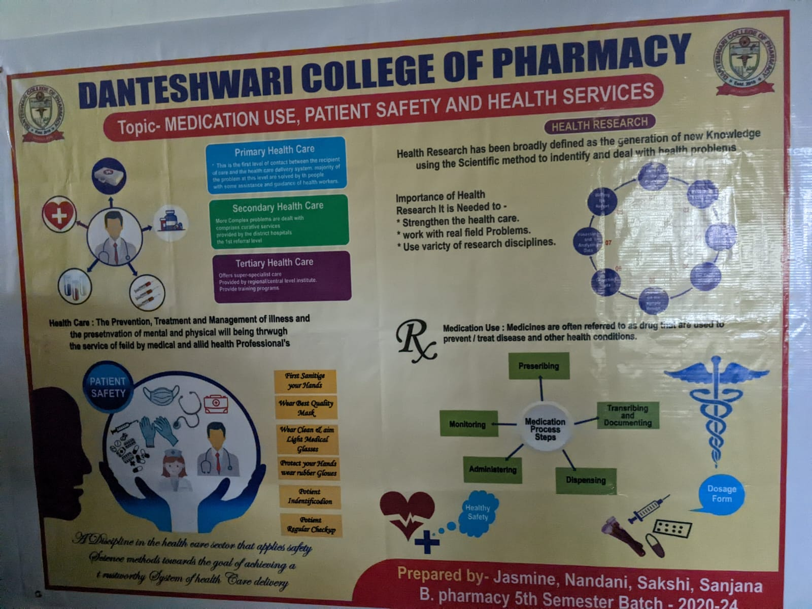
Patient Counselling
Patient counselling’s essential pharmacy service that helps patients understand how to take their medication correctly, recognise possible side effects, and improve adherence to medication errors and enhance patient safety(American Society of Health System Pharmacists,2023).
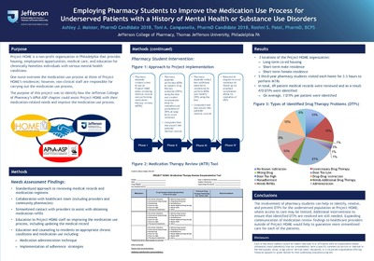
Immunisation Services
Pharmacists play an important role in providing immunisation services, including administering vaccines, educating patients about vaccine benefits, and increasing access to preventive healthcare. Pharmacy-based vaccination programs have been shown to improve immunisation rates and help protect communities from vaccine-preventable diseases(International Pharmaceutical Federation.2020).
Medication Therapy Management
Medication Therapy Management involves pharmacists reviewing a patient’s complete medication regimen to optimise therapeutic outcomes, prevent adverse drug events, and improve overall health. MTM services are especially beneficial for patients with chronic diseases who takes multiple medications (Centres for Diseases Control and Prevention,2022).
Element 2
TASK2
In my report, I choose the Community disability service
- Investigating the origine of the community disability services and exploring the historical context that shaped its development.
Community disability services originated from shift awa from institutional care toward community-based support for people with disabilities. Before the mid-20th century, many individuals with disabilities were placed in large institutions where they had limited independence and opportunities to participate in societies. During the 1960s and 1070s, disability rights movements, advocacy by families, and changing public attitude promoted the idea that people with disabilities should have the same rights, opportunities, and access to community life as everyone else (Worl Health Organisation,2011).
According to the United national,2006, the development of community disability services was shaped by the principles of normalisation, and person-centred care. Government and organisations began creating services such as community-based rehabilitation, supported employment independency living programs, and accessible health and social services. A major milestone was the adoption of the United Nations Convention on the rights of Persons with Disabilities in 2006, which emphasised equality, inclusion, accessibility, and the right of participate fully in their communities. Today, community disability services continue to focus on empowering, ensuring equal access to education, healthcare, emplacement and social participation.

- Evaluating how the service function today
The Gov.UK 2026 state, that the community disability provide essential support intendent to promote independence, safety, wellbeing and quality of life. However, their effectiveness is uneven.
Services are assessed through outcomes such as users ’control lover daily life, social contact, satisfaction, safety and experience barriers in accessing support, maintaining choice and independence, and navigating fragmented services. Recent evidence also suggests that access and support can vary significantly depending on local promoting individual circumstances. Therefore, community disability services can be viewed as essential but under pressre, with ongoing challenges relating to accessibilities, consistency, funding and person-centred support.

- Discussing the significant in enhancing the quality of community disability service its quality of life of service users.

Discussing the significance of enhancing the quality of community disability services is essential because high-quality services have a direct impact on quality of life of service users. Effective community disability services can promote independence, dignity, choice, activities, social inclusion and participation in everyday activities.
Person-centred support enables service users to have greater control over individual need, preferences and goals.
Therefore, improving the quality of community disability services is important for supporting service users to achieve greater wellbeing, independence and overall, quality of life(Care Quality Commission, 2023; Département of Heath a Social Care, 2024).
References

- Care Quality Commission — Care Quality Commission. (2023) Community learning disability services: regulatory guidance [online]. Available at: https://www.cqc.org.uk (Accessed: 20 July 2026).
- Department of Health and Social Care — Department of Health and Social Care. (2024) Community support for disabled adults: policy guidance [online]. Available at: https://www.gov.uk/government/publications (gov.uk in Bing) (Accessed: 20 July 2026).
- Disability Rights UK — Disability Rights UK. (2023) Independent living and community inclusion [online]. Available at: https://www.disabilityrightsuk.org (Accessed: 20 July 2026).
- Local Government Association — Local Government Association. (2022) Community-based disability services: best practice toolkit [online]. Available at: https://www.local.gov.uk (Accessed: 20 July 2026).
- NHS England — NHS England. (2024) Community learning disability services [online]. Available at: https://www.england.nhs.uk (Accessed: 20 July 2026).
- Scope — Scope. (2023) Support services for disabled people in the community [online]. Available at: https://www.scope.org.uk (Accessed: 20 July 2026).

