Business Plan for Peace Essentials

Submitted
By
Student Name: Muhammed Gulzar Hossain

Group Name: Muhammed Gulzar Hossain ssain (ID: 1604632)
Md Faisal Ahamed Rana (ID: 1604528)

Table of Contents
3.3 Market analysis 4
Market trends 4
Competitor analysis 5
3.4 Market plan 5
Product strategy 6
Pricing strategies 6
Promotion strategies 8
3.5 Location 8
3.6 Competition 9
3.7 Management and operation 9
Operation strategies 9
Manpower need in Peace Essentials 9
HR planning for Peace Essentials 10
Recruitment and selection strategies 11
Staff motivational strategies 11
Reference 13

3.3 Market analysis
The market and customer segments for Peace Essentials are outlined in the diagram below:
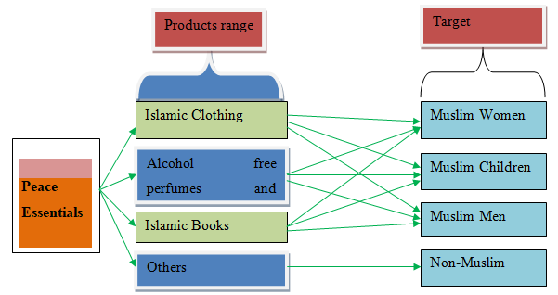
Diagram: Peace Essential’s target customer Source: Peace Essentials (2017)

Market trends
A survey shows that the proportion of Muslim people is growing quickly in Britain, in the main in London together with East London space. The study by Benson (2017) disclosed the Muslim people raised by double within the last ten years. On the other hand, the study shows that women are seen to wear more long and loose fit dresses nowadays than ever before. Other study by Hendrikzs (2017) shows that the worth of Muslim fashion is nearly 100 million, where the customer expenditure might be about £208 million by 2018These dramatic changes in the Muslim community and East London bring huge opportunities for new and existing entrepreneurs who want to do business in this sector. Therefore, the demand of Islamic books, clothing and alcohol free fragrance have been increasing day by day. Thus, Peace Essentials needs to do research and develop its products based on the customer changing needs and expectations that that would provide competitive advantages in the market.

Competitor analysis
It is a common phenomenon that every business firm has faced severe competitor at their beginning stage. So, the Peace Essentials’ Ltd is facing huge competition with their marketing system including Witney Street Markets. About 30 street shops like Peacock, Salma, Al-Baraka, Isha which sits in the street from Monday to Saturday are creating pressure on the business strategies of the Peace Essentials’. The main competitor of the Peace Essentials’ is shown in the graph:
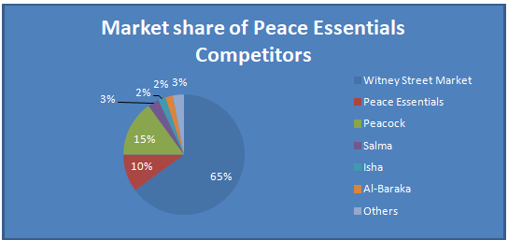
Chart: Market share of Peace Essentials Source: Peace Essentials (2017)
The chart shows that Witney Street Market is the main competitor of Peace Essentials’ Ltd which gained 65% local market shares. But Peace essentials’ didn’t gained due response by the customers locally whereas Peacock earned 15% shares (Peace Essentials, 2017).

3.4 Market plan
Marketing combine (4P's) strategies that refers to product, price, place and promotion (Kotler et al., 2014). Peace Essentials can use 4Ps strategies to promote its products and services to the target customers.

Product strategy
Strategy for any business organization ensures their products promotion. Peace Essentials’ has made its own business strategy. The authority should consider the views and feelings of the customers for their religion. Muslims all over the world have to maintain ‘Halal’ food code. As peace essentials’ prefer to sell their product to the Muslims, they try to sell alcohol free fragrances and ‘Jaaiz’ goods to consume. They offer the Islamic dress code maintain clothing to the Muslims community. Peace Essentials target the Muslims as their big customer segments. For this, they need to keep an eye to the religious festivals of the Muslims, Cultures of the Muslims, Norms and Customs of the Muslims.

Pricing strategies
The authority of the Peace Essentials’ always considers the ability of the customers for buying their products. They provide all kinds of products by remembering the means of the poor Muslims around the world.

Cost-plus pricing
The methodology of cost-plus pricing may be very helpful such a small business firm like Peace Essentials’. Following the suggestions provided by Kotler et al. (2014), Peace Essentials can apply this technique to create competitive advantages in the marketplace.

Customer (demand)-based pricing
The demand for a product varies from customer to customer. The Peace Essentials’ prefer to rate their products according to their demands and their means. This system helps the company to promote their products much more than ever.

Competition- based pricing
One company tries to sell their several products cheaper than another. So, Peace Essentials’ always considers this process of pricing. They offers same lines price though the price of the products gets higher to hold the marketplace. However, the success of these strategies depends on the supply and demand curve (Kotler et. al, 2014). Therefore, Peace Essentials needs to analyse the supply and demand curve very carefully.
Suggested pricing policies for Peace Essentials
Time scale (months) | Suggested pricing strategies | Proposed implementation
- 8 | Decoy pricing | Promoting their products keeping the price same as before to extend the customers.
9- 16 | Time-based pricing | This type of strategy can ensure the optimum revenue for the company.
17- 24 | Competitive pricing | By this Peace Essentials’ will be able to cope with the competitors in digital market place.
Table: Pricing strategy developed for Peach Essentials
The authority of Peace Essentials’ ensured happiness of the consumers but they need to research more to expand their business.
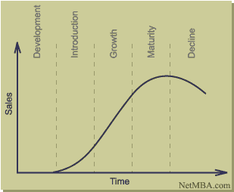

These Strategies in the following chart can be adopted by the Peace Essentials’ though they have accomplished their strategy plan scientifically.
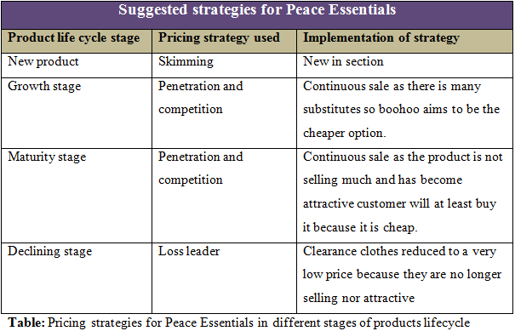

Promotion strategies
Peace Essentials’ can advertise their products by publishing leaflet, banner, Email forwarding, SMS sending and with other digital advertising procedures. Facebook, Whatsapp, Viber, Imo etc social media can play an important role for promoting Peace Essentials products. Sometimes, Peace Essentials’ authority offers various types of small gifts such as Pens, Notebook etc. They offer discount prices on sales to attract customer for the productions promotions.

3.5 Location
Easily finding and reachable location can promote a business within very short of time. Though Peace Essentials’ Ltd has limitations of investment, they should try to enlarge their branches in wide ranges. They can establish their business firm in local market place. They prefer to choose location basis on their customers segments. As their main portions of customers are the Muslims, they need to choose location near Muslims residential areas like East London (Peace Essentials’, 2017).

3.6 Competition
Competition is seen in every types of business sector. Peace Essentials’ Ltd faces unequal competition with some evil marketers in the East London. Many street shops also known as bunker hinder the progress of the business promotion of Peace Essentials’. More than the number of 30 shops is competing against Peace Essentials’. These competitors sometimes apply illegal approach to attract the customers before buy from Peace Essentials’. These stores sit on the street or footpath and people can easily reach to them. Especially Witney Street Markets is used to sell their products in Muslim populated areas which create unequal competition with Peace Essentials’. Beside this, Al-Baraka, Peacock, Isha, Salma etc street shops are giving extra pressures in the progress of the Peace Essentials’. Though there’s a huge range of obstacles on the way of promotions of Peace Essentials’ Ltd, they are trying to attract people by their sincerity and honesty. They supply quality maintained products. That’s why their business is increasing to reach top ranks but slowly and steadily (Peace Essentials, 2017).

3.7 Management and operation

Operation strategies
Peace Essentials adopted a scientific strategy for their operational purposes in the management. They apply four keys forms for their operation strategies. Firstly, they will apply Enterprise Resource Planning (ERP) to regulate standard form for well automated management methodology. Secondly, they will use the SME method for their managerial operation to get updated with newer technology. Peace Essentials will maintain direct connections and communications among the employees and expert decision makers for any purposes when need. Finally, the business firm always try to be dynamic in their operation for rapid development of globalization (Kotler et al, 2017).

Manpower need in Peace Essentials
As a growing business firm, the Peace Essentials’ may need to recruit employee for their well management of the customer services. But at this time they needn’t any staffs because they filled their employees recently. They are trying to establish their newer branches for the promotion of the business, and then the employees may be employed (Peace Essentials, 2017).

HR planning for Peace Essentials
According to Civil Service India (2017) suggestions, Peace Essentials’ follows various steps for their Human Resource (HR) management. The survey shows the business objectives and strategies for the betterment of the business. Secondly, they scan all the internal and external environmental factors related to the business. Thirdly, obviously they need employee for their well performances, they response on the public question for better HR managements.
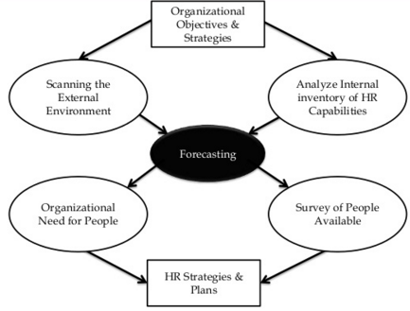
Diagram: Human Resource Planning process Source: Civil Service India (2017)

Recruitment and selection strategies
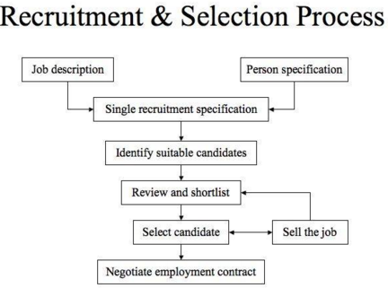
Diagram: Recruitment and selection process Source: Mullins (2014)
Peace Essentials’ Ltd has formed their recruitment and selection approaches by a scientific method. According to Mullins (2014) suggestion, Peace Essentials needs to do job description and person specification to recruit every individual staffs. Then, it should select suitable candidates and select the candidate to sell the jobs. Finally, a formal agreement should be done between employees and employers. This agreement should strictly maintained by both parties including employees and employers.

Staff motivational strategies
Employee relations play an important role for the betterment of any business organization. For this, Peace Essentials’ has adopted an effective strategy to motivate their staffs for better improvement of their products. Here in the pyramidal diagram showed the Maslow’s hierarchy of Needs theory in Mullins (2014) to motivate the staffs for business institution. Peace Essentials’ authority ensures the minimum privileges to their staffs. They provide safety and security for better workplace environment. The company offers various advantages during various festival moments. They also give bonus, small gifts to motivate the staffs for the better employee relations. Peace Essentials’ offers promotion to the employee according their sincerity and participation eagerness in the workplace.
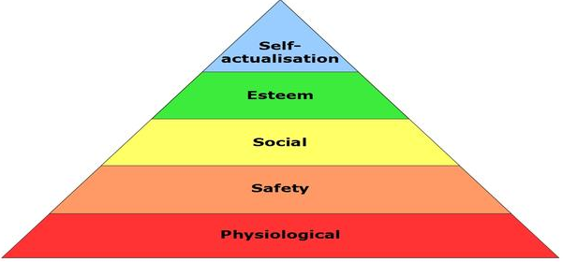

Diagram: Motivational Strategy by Peace Essentials Source: Mullins (2014)

Reference
- Cliffs Notes (2017) The Motivation strategy Available at: https://www.cliffsnotes.com/study-guides/principles-of-management/motivating-and-rewarding-employees/motivation-strategies. [Accessed on: 19 December 2017]
- Global Data (2017) Muslims fashion. Available at: https://www.globaldata.com/our-industries/retail/. [Accessed on: 19 December 2017]
- Benson, C. (2017) The growing demand for Muslim clothing in the UK. Available at: http://conlumino.com/?p=2067/. [Accessed on: 20 September 2017]
- Hendriksz, V. (2017) The demand for Muslim-fashion continues to growth. Available at: https://fashionunited.uk/news/fashion/the-demand-for-muslim-fashion-continues-to-grow/2017052017466/. [Accessed on: 20 December 2017]
- Attril, P. and McLaney, P. (2012) Accounting and finance for non-specialists. 4th Ed. Pearson Education Ltd: Harlow.

