

APPENDIX GA36c

LEVEL 6 ASSESSMENT SPECIFICATION

Student name: | Jamie Thomas | Student ID number: | 261948
Programme: | BSc Applied Computing
Module: | Big Data
Module code: |  | Contribution to Overall Module Assessment (%): | 50%
Lecturer: | John Williams | Internal Verifier: | Jeanette Adams
Assignment Title: | Big Data Report | Word count (or equivalent): | 3000
Submission deadline: | 19/04/2020 | Return date of provisional marks & written feedback: | 26/04/2020
Submission method: | All written assessments, where practical and possible, must be submitted via Turnitin unless otherwise instructed by the Lecturer. (Please DO NOT put this assessment specification into Turnitin or it will match many similarities with other students’ submissions.)  Alternative submission method (if applicable):  Late submission of the assessment will result in a late penalty mark. Penalties for late submission: Up to one week late, maximum mark of 40%. Over one week late, 0%. Only the Extenuating Circumstances Panel may approve a change to submission dates.
Academic honesty / referencing: | Academic honesty is required. In the main body of your submission you must give credit to authors on whose research and ideas your work is based. Append to your submission a reference list that indicates the books, articles, etc. that you have used, cited or quoted in order to complete this assessment.

Module Learning Outcomes
(from module syllabus)
Upon the successful completion of this module, the student should be able to demonstrate the ability to:

1. Develop a systematic understanding of the concepts, architecture and technologies required to manage and process Big Data.

2. Critically evaluate the technologies and applications of Big Data.

TASK DESCRIPTION

NPTC Power is a fast growing, welsh based power company. We are the leading provider of reliable, flexible and low carbon power units to the UK electricity market. With a portfolio of over 1GW of small-scale, local thermal power generation and battery storage units, we help keep the country’s electricity system running.
NPTC Power have a contract to supply 700 homes in the Neath Port Talbot area with electricity. The current project consists of three Bio fuelled units each providing 1GW of electricity per hour. Each home is fitted with smart meters that record power usage. Usage Data is calculated hourly and at the end of each day uploaded to the NPTC Power systems. Power demand varies considerably throughout the day and throughout the week, and in different weather conditions. All these elements have an effects on power usage and in-turn demand.
As it stands, all three power units are working to full capacity, irrespective of day, hour or weather conditions. As a consequence the power units often generate surplus power, incurring extra fuel costs and unnecessary were and tear on the units. In order to reduce costs the manager would like to analyse the data so that they can more accurately predict the days, times when power usage will be low, and therefore turn off some of the power units.
There are three systems used by NPTC power:
- Customer Database with customers address postcode, wards etc.
- Smart Meter Data: date address Id, 24 hourly data usage.
- Weather Data: Daily average temperature, Precipitation.
All three systems have very different data storage and data formats. As a result the Business analyst has requested that they develop a data warehouse to order to analyse the data and accurately predict times when units can be switched on and off.
Using this data you should do the following:
- Design and develop an appropriate data warehouse structure to store the data provided.
- You should justify all of your design decisions.
- Upload the data into your data warehouse, documenting the ETL process in a professional manner.
Design, develop and critically evaluate reports that can be run to retrieve and display the
Following data:
- Report: Power usage over time for each day of the week and by hour, highlighting peaks and troughs.
      - Tabular Data Report
      - Line graph
- Dashboard: Power usage
    - Ward,
    - District,
    - Postcode
- Report: The impact that weather has on power usage
    - Rain
    - Temperature
The reports should be appropriately referenced and should include the appropriate tables of contents, tables of figures and tables of tables. Any figures should have titles and identification labels. The document should also be spellchecked and grammar-checked.
The report should be submitted via Turnitin.

Student FEEDBACK FORM

This section details the extent to which the assessment criteria are demonstrated by you, which in turn determines your mark. The marks available for each category of skill are shown. Lecturers will use the space provided to comment on the achievement of the task(s), including those areas in which you have performed well and areas that would benefit from development/improvement.

Generic Assessment Criteria | Marks available | Marks  awarded
1. Engagement with Literature Skills  . | 0
2. Knowledge and Understanding Skills | 10 | 7
Knowledge is reasonably extensive coherent and detailed. Exhibits very good understanding of the breadth and depth of established views, and the work is, at least in part, well-informed by current research and scholarship.
3. Cognitive and Intellectual Skills | 20 | 13
Sound critical thinking, analysis, synthesis and evaluation demonstrating critical thinking. Ability to devise and sustain persuasive arguments, and to review the reliability, validity and significance of evidence to make mostly appropriate and valid judgements.

4. Practical Application Skills | 60 | 43
An advanced application of a range of methods, materials, tools and techniques. The context of the application is well considered, and insightful. Can identify complex problems and propose excellent solutions. Innovation and creativity evident
5. Transferable Skills for Life and Professional Practice | 10 | 7
Can communicate professionally confidently and consistently in a suitable format.
Work is coherent, very fluent and is presented professionally. Demonstrates excellent graduate employment skills and an appetite for further development

Assessment Mark (Assessment marks are subject to ratification at the Exam Board. These comments and marks are to give feedback on module work and are for guidance only until they are confirmed. ) | Late Submission Penalties (tick if appropriate) |  | 70%
 | Up to 1 week late (40% Max) |  | 70%
 | Over 1 week late (0%) |  | 70%



Big Data
Assignment 2

Jamie Thomas (261948)

Supervisor: John Williams

Project submitted as part of the requirements for the award of BSc (Hons) Applied Computing
April 2020


Introduction
NPTC Power is a power company based in Wales. NPTC Power is a leading provider of reliable, flexible, and low carbon power units to the United Kingdom electricity market. NPTC Power uses 1GQ small-scale, local thermal power generation and battery storage units.
This report will outline the process of developing a functional data warehouse for the storing of all essential and relevant data. This data warehouse will provide NPTC Power with the ability to generate reports and dashboards enabling proper data analysis to be undertaken.

Data Warehousing
A data warehouse is a read-only database that aims to combine information from separate systems, all into one, cohesive, easy to access location. A data warehouse focuses on determining the needs of the client or the user and then presenting the relevant data and reports. Data warehouses often have a “ROLES” database which determines the permissions that are assigned to each user [1].
Data Warehouses often use the entity-relationship data model and are used for storing data that is “transactional data”. Often, the data warehouse will consist of data which is relatively new or generally recent. [2]
The first and most important step in developing a useful and functional data warehouse is to determine the business needs of the client or user of the system.

NPTC Power Business Needs
NPTC Power supply over 700 homes in the Neath Port Talbot area. The current project uses three bio-fuelled power units which each produce 1GW of electricity per hours. All of the homes which are connected to the NPTC Power grid are fitted which smart meters which are capable of recording power usage.
Usage data is pulled from the installed smart meters at the end of each day and uploaded to NPTC Power systems. This data tracks each household’s usage on an hourly basis. Throughout the days and weeks, NPTC Power experiences differing levels of demand and usage on their network.
All three power units operated by NPTC Power currently run at full capacity, irrespective of the demand which is required by each household. As a result of this, power units often generate surplus power.
The management of NPTC Power would like to analyse the data produced from smart meter so that they can more accurately predict how much power should be generated by their bio-fuelled power unit. To do this, NPTC Power will require a Data Warehouse which contains all essential data and provides the ability to produce detailed reports for data analysis.
The business needs of NPTC Power will drive the functionality of the data warehouse.

Current System
NPTC Power currently deploys three systems which will be used to create a functioning data warehouse. The current system is not cohesive and does not work together to create a central location for the easier management and analysis of data. The implementation of a data warehouse will facilitate the process of generating useful and accurate analysis.
The current NPTC power system looks like this -
- Customer Database containing information like name, address, postcode, wards
- Smart Meter data containing information like hourly usage statistics, date, address, ID.
- Weather Data such as daily average temperature, precipitation, rainfall.

New System Requirements
- Develop a data warehouse which contains all relevant and useful information from the three main NPTC Power systems.
- Ensure that the data warehouse is capable of producing reports and dashboards based off SQL code.
Three main reports and dashboards should be created
- Report #1 - Power usage over time for each day of the week and by hour, highlighting the peaks and troughs using a tabular data report and a line graph.
- Report #2 - The impact that weather has on the usage of power on the network
- Dashboard - Power usage by ward, district and postcode.

Designs

This data warehouse design will follow a star schema. The star schema is one of the simpler ways to set up a data warehouse and is one of the most popular schemas for designing and developing data warehouses.
Data Warehouse Diagram
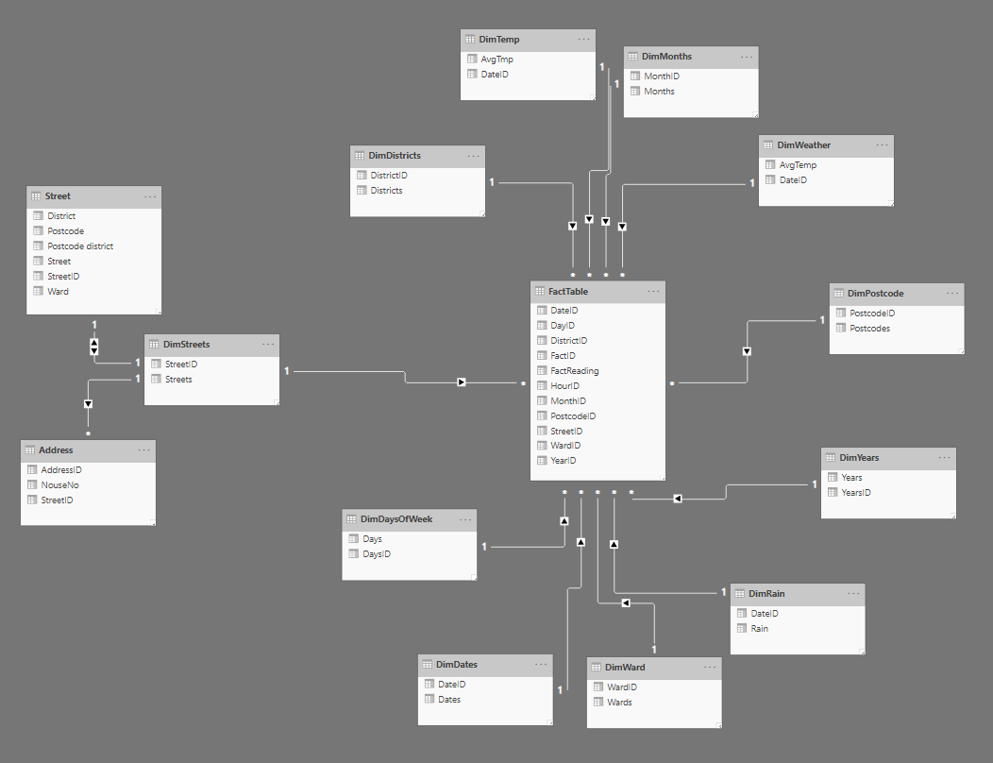

Data Definition
Application Name  Data Source Name  Primary Key |  | NPTC Power System  tempfact  Address
Connection | Details |  |  |  | Comments
Database Platform  Dataset  SQL  Access Method | Access  Address  Select * from Address  Select |  |  |  | The address tables hold all Uk addresses.
File Name | Type |  | Size | Format |  | Description | Validation | Key
StreetID# | AutoNumber |  | Integer | # |  | Primary Key | Must be Unique | P
Street | Text |  | 30
Postcode | Text |  | 30
Ward | Text |  | 20
District | Text |  | 20

Data Dictionary
Data Definition
Application Name  Data Source Name  Primary Key |  | NPTC Power System  Address  Address#
Connection | Details |  |  |  | Comments
Database Location  Database Platform  Dataset  SQL  Access Method | C:\Datawarehouse.mdb  Access  Address  Select * from Address  Select |  |  |  | The address tables hold all UK addresses.
File Name | Type |  | Size | Format |  | Description | Validation | Key
Address ID# | AutoNumber |  | Integer | # |  | Primary Key | Must be Unique | P
Street ID | Text |  | 30
House number | Text |  | 30

Data Definition
Application Name  Data Source Name  Primary Key |  | NPTC Power System  Address  Address
Connection | Details |  |  |  | Comments
Database Platform  Dataset  SQL  Access Method | Access  Address  Select * from Address  Select |  |  |  | The address tables hold all Uk addresses.
File Name | Type |  | Size | Format |  | Description | Validation | Key
StreetID# | AutoNumber |  | Integer | # |  | Primary Key | Must be Unique | P
Street | Text |  | 30
Postcode | Text |  | 30
Ward | Text |  | 20

Data Definition
Application Name  Data Source Name  Primary Key |  | NPTC Power System  Date-Year  Date
Connection | Details |  |  |  | Comments
Database Platform  Dataset  SQL  Access Method | Oracle  Dim-Date-Year  Select * from Dim-Date-Year  Select |  |  |  | Date Year Dimension
File Name | Type |  | Size | Format |  | Description | Validation | Key
Year ID# | Number |  | Integer | # |  | Primary Key | Must be Unique | P
Year | Short text |  | 15 | Dd/mm/yyyy

Data Definition
Application Name  Data Source Name  Primary Key |  | NPTC Power System  Date-day  DayID
Connection | Details |  |  |  | Comments
Database Location  Database Platform  Dataset  SQL  Access Method | Oracle  Dim-Date-Year  Select * from Dim-Date-day  Select |  |  |  | Date day Dimension
File Name | Type |  | Size | Format |  | Description | Validation | Key
DayID# | Number |  | Integer | # |  | Primary Key | Must be Unique | P
day | Number |  | 10 | ##

Data Definition
Application Name  Data Source Name  Primary Key |  | NPTC Power System  Date - month  monthID
Connection | Details |  |  |  | Comments
Database Platform  Dataset  SQL  Access Method | Oracle  Dim-Date-Year  Select * from DimDateYear  Select |  |  |  | Date Year Dimension
File Name | Type |  | Size | Format |  | Description | Validation | Key
MonthID# | Number |  | Integer | # |  | Primary Key | Must be Unique | P
month | Short text |  | 15

Data Definition
Application Name  Data Source Name  Primary Key |  | NPTC Power System  street  streetID
Connection | Details |  |  |  | Comments
Database Platform  Dataset  SQL  Access Method | Oracle  Dim-street  Select * from DimStreet  Select |  |  |  | street Dimension
File Name | Type |  | Size | Format |  | Description | Validation | Key
StreetID# | Number |  | Integer | # |  | Primary Key | Must be Unique | P
street | Short text |  | 45 | ####

Data Definition
Application Name  Data Source Name  Primary Key |  | NPTC Power System  Weather  Date
Connection | Details |  |  |  | Comments
Database Platform  Dataset  SQL  Access Method | Oracle  Dim- Weather  Select * from Dim- Weather  Select |  |  |  | Date Year Dimension
File Name | Type |  | Size | Format |  | Description | Validation | Key
WeatherID# | Number |  | Integer | # |  | Primary Key | Must be Unique | P
Weather | auto number |  | double | ###. ##
Data Definition
Application Name  Data Source Name  Primary Key |  | NPTC Power System  Weather  Date#
Connection | Details |  |  |  | Comments
Database Platform  Dataset  SQL  Access Method | Oracle  Dim-Date-Year  Select * from Dim-district  Select |  |  |  | Date Year Dimension
File Name | Type |  | Size | Format |  | Description | Validation | Key
districtID # | Number |  | Integer | # |  | Primary Key | Must be Unique | P
district | Short text |  | 50 | ####

Data Definition
Application Name  Data Source Name  Primary Key |  | NPTC Power System  Date-Year  Date#
Connection | Details |  |  |  | Comments
Database Platform  Dataset  SQL  Access Method | Oracle  Dim-Date-Year  Select * from Dim-Date-Year  Select |  |  |  | Date Year Dimension
File Name | Type |  | Size | Format |  | Description | Validation | Key
wardID | Number |  | Integer | # |  | Primary Key | Must be Unique | P
ward | Short text |  | 40 | ####
Data Definition
Application Name  Data Source Name  Primary Key |  | NPTC Power System  postcodes  Date#
Connection | Details |  |  |  | Comments
Database Platform  Dataset  SQL  Access Method | Oracle  Dim-Date-Year  Select * from Dim-postcodes  Select |  |  |  | Date Year Dimension
File Name | Type |  | Size | Format |  | Description | Validation | Key
postcodeID | Number |  | Integer | # |  | Primary Key | Must be Unique | P
postcode | Short text |  | 7 | ####

Data Definition
Application Name  Data Source Name  Primary Key |  | NPTC Power System  Date-Year  Date#
Connection | Details |  |  |  | Comments
Database Platform  Dataset  SQL  Access Method | Oracle  Dim-Date-Year  Select * from Dim-Date-Year  Select |  |  |  | Date Year Dimension
File Name | Type |  | Size | Format |  | Description | Validation | Key
factID # | Number |  | Integer | # |  | Primary Key | Must be Unique
postcodeID | Number |  | Integer | # |  | Foreign Key | Must be Unique
wardID# | Number |  | Integer | # |  | Foreign Key | Must be Unique
districtID | Number |  | Integer | # |  | Foreign Key | Must be Unique
weatherID | Number |  | Integer | # |  | Foreign Key | Must be Unique
streetID | Number |  | Integer | # |  | Foreign Key | Must be Unique
monthID | Number |  | Integer | # |  | Foreign Key | Must be Unique
dayID | Number |  | Integer | # |  | Foreign Key | Must be Unique
yearID | Number |  | Integer | # |  | Foreign Key | Must be Unique

Queries
Individual Household Usage
This query uses the AddressID of a record to display the power readings for one household over a 24 hour period.
SQL
SELECT TempFact.FactID, TempFact.AddressID, TempFact.ReadingDate, TempFact.ReadingHour, TempFact.Fact
FROM TempFact
WHERE (((TempFact.AddressID)=32715) AND ((TempFact.ReadingDate)="07/01/2019"));

Result
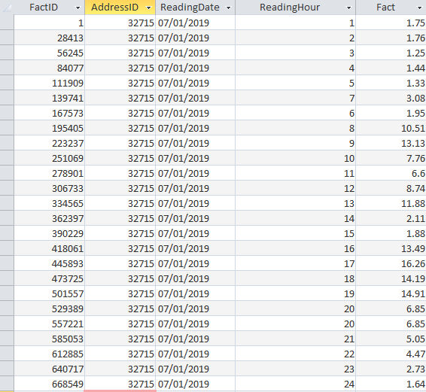

Graph
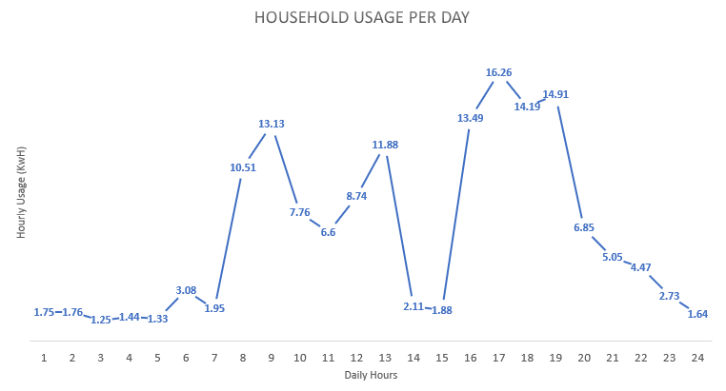
The results show the way in which a household uses electricity throughout the days. This can be used to draw conclusions, such as the usage throughout the night compaed to when people wake up. We can see through the night that power usage tends to stay under 2 kWh. When the household wakes up, around 8am in this instance, there is a huge increase in power consumption.

Total Household Usage Per Day
Power usage over time for each day of the week and by hour, highlighting the peaks and troughs using a tabular data report and a line graph.
SQL
SELECT
DIMDAYS.DAYS as DAY,
FACT.DAYID,
SUM(FACT.FACTREADING) AS "Total",
SUM(CASE FACT.HOURID WHEN 1 THEN FACT.FACTREADING END) AS "1",
SUM(CASE FACT.HOURID WHEN 2 THEN FACT.FACTREADING END) AS "2",
SUM(CASE FACT.HOURID WHEN 3 THEN FACT.FACTREADING END) AS "3",
SUM(CASE FACT.HOURID WHEN 4 THEN FACT.FACTREADING END) AS "4",
SUM(CASE FACT.HOURID WHEN 5 THEN FACT.FACTREADING END) AS "5",
SUM(CASE FACT.HOURID WHEN 6 THEN FACT.FACTREADING END) AS "6",
SUM(CASE FACT.HOURID WHEN 7 THEN FACT.FACTREADING END) AS "7",
SUM(CASE FACT.HOURID WHEN 8 THEN FACT.FACTREADING END) AS "8",
SUM(CASE FACT.HOURID WHEN 9 THEN FACT.FACTREADING END) AS "9",
SUM(CASE FACT.HOURID WHEN 10 THEN FACT.FACTREADING END) AS "10",
SUM(CASE FACT.HOURID WHEN 11 THEN FACT.FACTREADING END) AS "11",
SUM(CASE FACT.HOURID WHEN 12 THEN FACT.FACTREADING END) AS "12",
SUM(CASE FACT.HOURID WHEN 13 THEN FACT.FACTREADING END) AS "13",
SUM(CASE FACT.HOURID WHEN 14 THEN FACT.FACTREADING END) AS "14",
SUM(CASE FACT.HOURID WHEN 15 THEN FACT.FACTREADING END) AS "15",
SUM(CASE FACT.HOURID WHEN 16 THEN FACT.FACTREADING END) AS "16",
SUM(CASE FACT.HOURID WHEN 17 THEN FACT.FACTREADING END) AS "17",
SUM(CASE FACT.HOURID WHEN 18 THEN FACT.FACTREADING END) AS "18",
SUM(CASE FACT.HOURID WHEN 19 THEN FACT.FACTREADING END) AS "19",
SUM(CASE FACT.HOURID WHEN 20 THEN FACT.FACTREADING END) AS "20",
SUM(CASE FACT.HOURID WHEN 21 THEN FACT.FACTREADING END) AS "21",
SUM(CASE FACT.HOURID WHEN 22 THEN FACT.FACTREADING END) AS "22",
SUM(CASE FACT.HOURID WHEN 23 THEN FACT.FACTREADING END) AS "23",
SUM(CASE FACT.HOURID WHEN 24 THEN FACT.FACTREADING END) AS "24"

FROM DIMDAYS DIMDAYS, FACT FACT
WHERE FACT.DAYID=DIMDAYS.DAYSID
GROUP by FACT.DAYID, DIMDAYS.DAYS
ORDER BY FACT.DAYID

Result
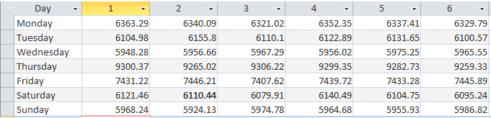
Continued (total included)
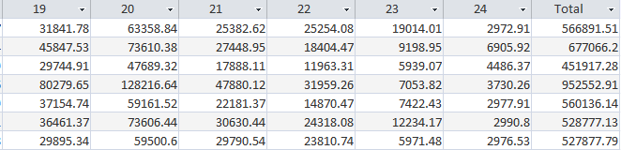

Graphs
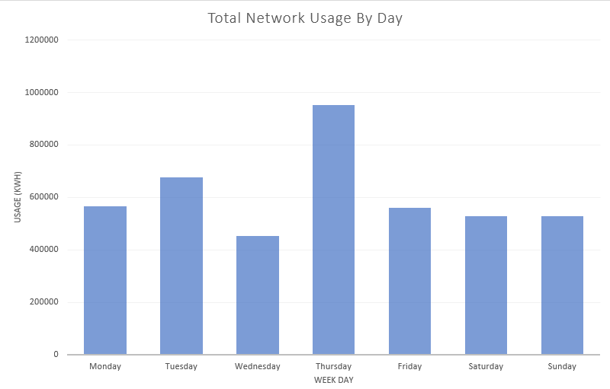
Usage Over One Particular Day
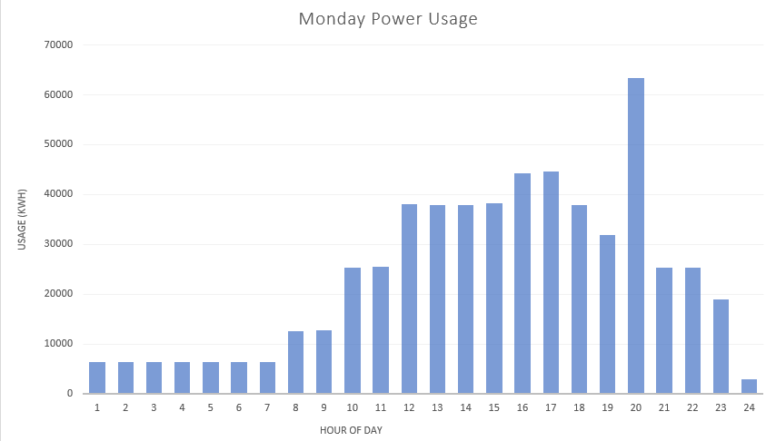

Dashboard
This dashboard contains powerful information that could be extremely useful to NPTC Power. There are three queries which have been represented in multiple formats. The first is the total network usage per day in the form of a bar graph and a line graph. The seconds is the daily usage across the whole network, separated by PostCode and plotted as a bar graph and a pie chart. The final reports is the total usage across the whole network separated by Ward and plotted on a bar graph and a pie chart.
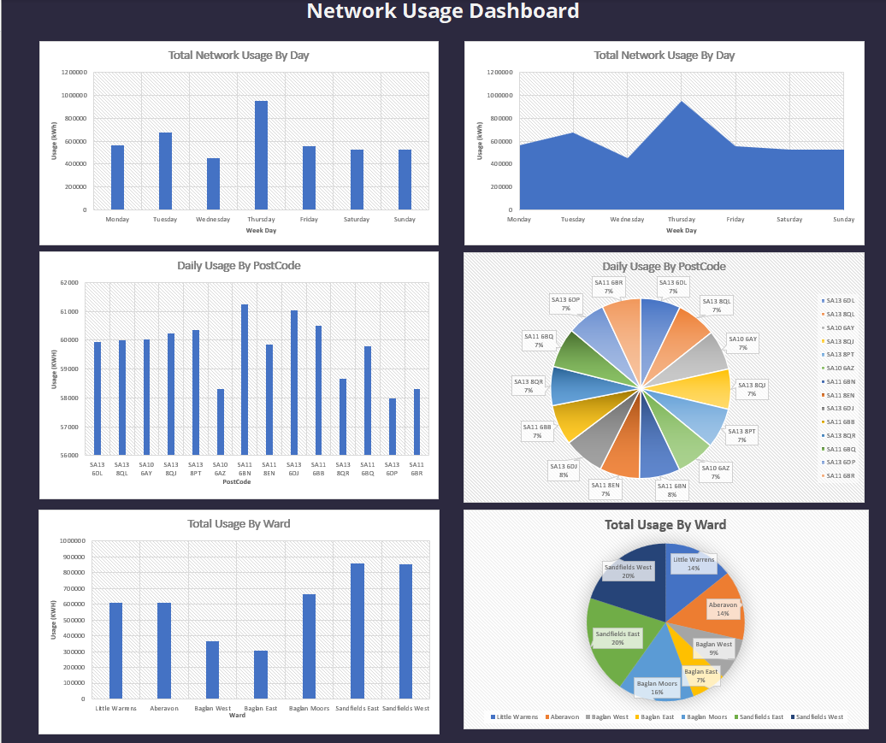

References
- Data Warehouse [Internet]. Information Systems & Technology. 2020 [cited 2020 Apr 15]. Available from: https://ist.mit.edu/warehouse
- ‌Data Warehousing Concepts [Internet]. Oracle.com. 2020 [cited 2020 Apr 19]. Available from: https://docs.oracle.com/cd/A87860_01/doc/server.817/a76994/concept.htm
‌

