
Human Resource Management
STUDENT NAME – KHUSHI JITESHBHAI DHOLA
STUDENT ID – 2240745
PROGRMME – MBA – Master Of Business Administration
MODULE – Human resources management
MODULE CODE - LCMB7000
LECTURER NAME – gladius david kulothungan
SUBMISSION DATE – 23 AUG 2023

Executive Summary
The report on the present situation of the UK labour market and the coming changes in human resource management techniques in the post-Covid and post-Brexit external environment is summarised in the Executive Summary. Brexit and the Covid-19 epidemic both significantly affected the UK labour market. The market was solid before the epidemic and before Brexit, with low unemployment rates and access to the talent pool in Europe. The epidemic, however, created disruptions that resulted in high unemployment rates, adjustments to work schedules, and changes in employee preferences. By altering immigration laws, Brexit has an even greater impact on the labour market, leading to skill gaps and labour shortages across a range of industries. Due to unpredictability in trade relations, foreign investment was also impacted. Organisations must modify their human resources strategies in response to these issues. Human resource strategies adopted after COVID place a strong emphasis on work-life balance, employee well-being, and digitization of HR procedures. The post-Brexit strategy emphasise workforce planning, diversity and inclusion, retaining talent, and conforming to new laws. It is advised that organisations embrace innovation and HR technology, invest in employee training and development, foster a diverse and inclusive workplace, and work with industry and government stakeholders in order to thrive in this changing environment. Organisations may effectively handle the challenges of the post-pandemic and post-Brexit business climate by putting this advice into practice. Organisations will be able to take advantage of opportunities and achieve long-term success in the changing business landscape by developing a competitive, adaptive, and sustainable workforce.
Table of Contents

1.0 Introduction 4
2.0 Overview of the UK Labor Market 4
2.1 Pre-Covid and Pre-Brexit Labor Market 4
2.2 Impact of Covid-19 on the Labor Market 4
2.3 Impact of Brexit on the Labor Market 6
3.0 Internal and External Factors Shaping the Current Labor Market 7
4.0 Emerging Changes in Human Resourcing Strategies 9
4.1 Post-Covid Human Resourcing Strategies 9
4.2 Post-Brexit Human Resourcing Strategies 10
5.0 Impact on Organisational Policies, Procedures, and Processes 10
7.0 Recommendations 11
8.0 Conclusion 13
References 14

1.0 Introduction
The Covid-19 pandemic and Brexit have made a significant impact on the business world and brought on many significant changes (Harvey, 2021). This report aims to analyse the UK labour market as it stands right now, taking into account the effects of COVID-19 and Brexit. In the post-pandemic, post-Brexit external context, it also examines the growing shifts in human resource strategy. In order to assess how internal and external variables affect organisational policies, procedures, and processes, the report will critically analyse pertinent research. The report's ultimate goal is to offer organisations advice and guidance on how to survive and prosper in the changing business environment.

2.0 Overview of the UK Labor Market

2.1 Pre-Covid and Pre-Brexit Labor Market
Before the Covid-19 outbreak broke out and the UK left the EU (Brexit), the labour market in the UK was rather stable. There were numerous work possibilities available in a variety of areas and industries, and unemployment rates were very low (Gupta et al. 2023). Organisations were able to profit from talented staff due to the UK's access to the European talent pool and the flexibility of movement (Gupta et al. 2023). The economy was expanding at a favourable rate, and foreign investment played a role in this growth.

2.2 Impact of Covid-19 on the Labor Market
The UK labour market saw substantial disruptions as a result of the Covid-19 outbreak. The rise in unemployment rates brought on by company closures, job losses, and a drop in economic activity was one of the most significant effects (Mayhew and Anand, 2020). Mass layoffs and redundancies resulted from the devastating impact on several industries, including hospitality, tourism, and retail. As remote work and flexible scheduling became vital for keeping operations running, work patterns drastically changed (Arthur, 2021). The tastes and expectations of employees have also evolved, with a stronger emphasis now being placed on health, safety, and work-life balance.
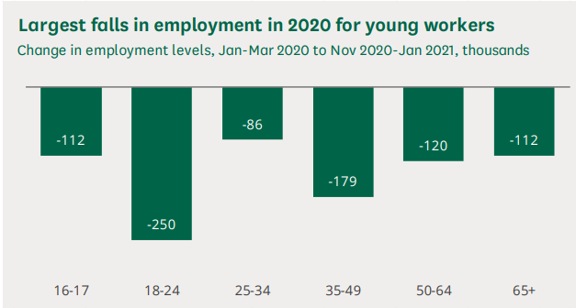
Figure: Covid-19 impact on young workers in the UK
Source: Powell (2022)
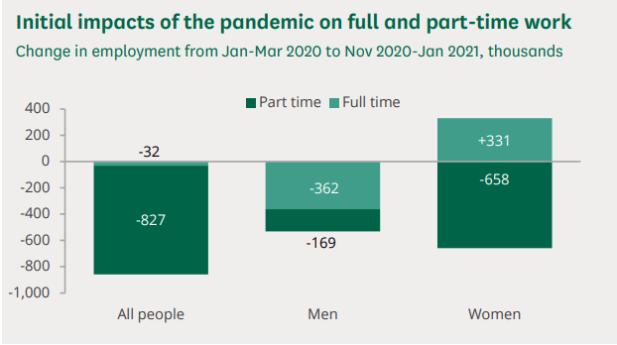
Figure: Covid-19 impact on full and part-time work
Source: Powell (2022)
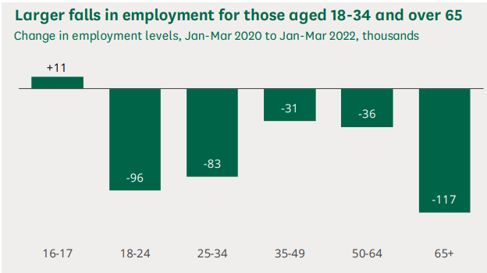
Figure: Covid-19 impact on older workers in the UK
Source: Powell (2022)

2.3 Impact of Brexit on the Labor Market
For the UK labour market, Brexit represented a significant turning point. There were noticeable changes in immigration laws and workforce composition with the termination of free movement between the UK and the EU (Sargent, 2023). EU immigration to the UK decreased, which had an effect on sectors including healthcare, construction, and agriculture that significantly depended on European labour. Many industries had a labour shortage, which resulted in skill gaps and difficulties filling particular posts. Foreign investment was also impacted by the ambiguity surrounding the EU's future relationship, and several businesses moved their operations outside of the UK as a result (Portes and Springford, 2023). Despite these difficulties, Brexit gave the UK fresh chances to create its own immigration regulations, potentially benefiting highly qualified employees from outside the EU. Concerns were raised regarding the effects on trade and economic expansion, though, since changes to trade agreements and tariffs might have an impact on the profitability and competitiveness of some industries.
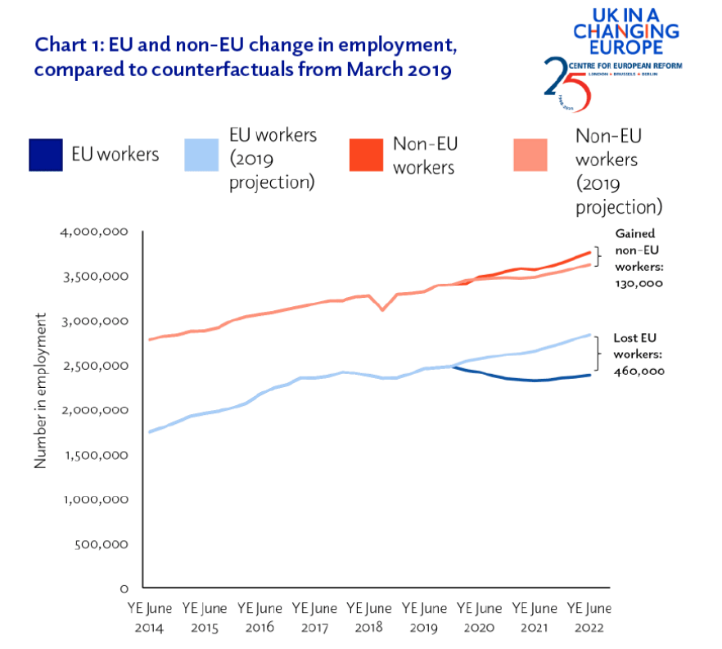
Figure: Brexit impact on labour market in the UK
Source: Walker (2023)
Overall, the combined effects of COVID-19 and Brexit led to considerable changes in the UK labour market (Harvey, 2021). Unprecedented difficulties were brought on by the epidemic, including skyrocketing unemployment rates and changes in labour habits. However, Brexit changed the working environment by modifying immigration laws and creating a labour shortage in a number of industries. Organisations had to adjust to these changes and put plans in place to deal with the changing dynamics of the workforce.

3.0 Internal and External Factors Shaping the Current Labor Market
Government Policies and Economic Conditions: The UK labour market is significantly impacted by both economic and governmental factors. The government launched assistance measures including furlough programmes to help companies and employees during the Covid-19 epidemic (Stuart et al. 2021). These regulations have an impact on workforce stability and employment patterns. Following Brexit, the UK government's immigration policy influenced the availability of labour, with adjustments to the work visa and residence restrictions having an impact on the inflow of foreign talent and the makeup of the various workforce sectors (Sumption, 2022). Trade agreements and tariff decisions also have an impact on an industry's competitiveness and capacity to recruit and retain people.
Technological Advancements and Automation: The UK labour market is changing as a result of automation and technological improvements. Businesses are utilising automation and AI technology more and more to increase efficiency (Christie, 2021). While automation may replace certain occupations, it also opens up new career prospects in cutting-edge industries like data analysis and artificial intelligence development. The Covid-19 epidemic has affected collaborative techniques and the abilities needed for virtual environments (Alnagrat, Ismail and Idrus, 2022). It has also hastened the digital transition and made remote work the norm.
Demographic Changes and Workforce Diversity: Demographic shifts have a significant impact on the labour market. An increasing number of retirees as a result of an ageing population might cause a skills gap (Martins Van Jaarsveld, 2020). To recruit and hold onto experienced people, organisations must modify their human resource management techniques. Businesses are realising the significance of diverse viewpoints in fostering creativity, which is why workforce diversity is becoming more and more important. Diversity-welcoming workplaces have emerged as a top priority.
Education and Skill Development Initiatives: Workforce flexibility is greatly influenced by education and skill development. In order to create a workforce with the necessary skills, the educational system must be matched with those of business. During the pandemic, upskilling and reskilling programmes were more popular since they helped employees move to other jobs or sectors (Jabbari et al. 2023). Enhancing resilience in response to shifting market needs is achieved by investing in personnel skill development.
Global Economic and Trade Trends: Global economic and trade movements have an impact on the UK labour market. Brexit has an effect on trade links, export potential, sectors, and job market circumstances (Latorre et al. 2020). Global economic downturns can affect worker demographics and cause changes in demand.

4.0 Emerging Changes in Human Resourcing Strategies

4.1 Post-Covid Human Resourcing Strategies
Remote and Hybrid Work Arrangements: The pandemic saw the emergence of remote work, which would influence human resource management in the post-Covid future. Organisations recognised its advantages, such as higher productivity and lower costs. A lot of businesses are probably going to use hybrid work arrangements that blend on-site and remote possibilities (Mefi and Asoba, 2021). It will be crucial for HR experts to develop flexible work practices that respect employee choices while maintaining efficiency.
Employee Well-being and Mental Health Support: The pandemic brought attention to the importance of employee wellbeing and mental health, which prompted a change in HR strategy to place a higher priority on extensive support networks (Bailey et al. 2023). Companies are implementing measures like wellness programmes and mental health counselling to foster a positive work environment that promotes workers' emotional wellbeing and increases productivity and job satisfaction.
Work-Life Balance and Flexibility: Work-life balance and flexibility are prioritised in the post-Covid human resource strategy (Gigauri, 2020). Traditional working hours are being reviewed by businesses, and more flexible scheduling methods are being used. Employees may successfully juggle personal and work demands with this strategy. Organisations may improve employee morale, engagement, and retention by recognising the different requirements of their staff.
Digitalisation of HR Processes: The digitisation of human resource procedures was hastened by the epidemic. Online platforms are being used for hiring, onboarding, performance management, and learning and development. Collaboration and HR software on the cloud is now crucial for effectively managing distant and hybrid workforces (Kuzior, Kettler and Rąb, 2021). By improving operational efficiency, this digital transformation frees HR professionals to devote more time to strategic projects.

4.2 Post-Brexit Human Resourcing Strategies
Talent Acquisition and Retention Strategies: Businesses face changes in the availability of foreign talent after Brexit as a result of the changed immigration laws. Human resource initiatives are increasingly centred on luring and keeping skilled individuals from the UK and beyond the EU (Kumodji, 2022). To attract top personnel, businesses are putting more of a focus on their employer brands, competitive compensation plans, and possibilities for professional advancement.
Workforce Planning and Succession Management: Effective staff planning and succession management are essential given the possibility of labour shortages in specific industries after Brexit (Taylor, Florisson and Wilkes, 2020). To guarantee a smooth transition when important people depart, organisations are proactively identifying vital jobs and building talent pipelines. Planning for succession reduces business risks and supports organisational stability.
Diverse and Inclusive Hiring Practices: Adopting diversity and inclusion in the workforce is crucial for promoting innovation and adjusting to changing markets as the UK aims to redefine its place on the global stage (Sánchez-Monedero, Dencik and Edwards, 2020). Human resource management tactics are changing to include diverse recruiting practices, eliminate prejudices, and foster an inclusive workplace that recognises each employee's individual opinions and experiences.
Compliance and Legal Considerations: Companies have to negotiate new legal frameworks and compliance standards relating to employment and immigration following Brexit (Radziwinowiczówna and Lewis, 2021). To guarantee that the organisation's activities continue to be legal and compliant with regulatory norms, human resource experts are concentrating on comprehending and complying with these developments.

5.0 Impact on Organisational Policies, Procedures, and Processes
Recruitment and Selection Practices: Organisations have modified their recruiting and selection practices to attract and evaluate qualified individuals in light of the dynamic changes in the labour market. The implementation of virtual interviewing and onboarding procedures was required by the transition to remote employment (Vuchkovskiet al. 2023). Companies today place more value on skills and flexibility than in the past, allowing them to recruit people with a high potential for growth and resilience in the face of unpredictability.
Training and Development Initiatives: Training and development efforts have become more well-known as a means of addressing skill shortages brought on by the shifting nature of the workforce. To provide employees with the skills needed for new positions or technology, organisations are investing in upskilling and reskilling programmes (Jabbari et al. 2023). Employees can maintain their competitiveness in the post-pandemic and post-Brexit business climate thanks to online learning platforms and customised training programmes that support ongoing learning.
Performance Management and Appraisal Systems: Systems for performance evaluation and management have developed to take into account remote work arrangements as well as new capabilities and criteria that reflect the changing character of the workplace (Aguinis and Burgi-Tian, 2021). In order to assist employee development, managers increasingly place a strong emphasis on regular feedback and evaluations that are outcome-based. These modifications encourage responsibility and guarantee compliance with organisational goals.
Compensation and Benefits Packages: Organisations have reviewed their compensation and benefits packages in an effort to keep top talent and preserve employee morale. To accommodate the various demands of employees, flexible benefits, well-being allowances, and performance-based incentives are becoming increasingly widespread (Shtembari, Kufo and Haxhinasto, 2022). In order to handle the economic effects of Brexit and maintain competitiveness in luring qualified people, compensation practices are also modified.
HR Technology and Data Management: The use of remote work has hastened the adoption of data management and HR technologies. Processes like payroll, attendance monitoring, and performance evaluations are streamlined by cloud-based HR applications (Kutieshat and Farmanesh, 2022). Data analytics enables organisations to optimise their human resource strategies and link them with business objectives by offering useful insights for strategic decision-making.

7.0 Recommendations
- Building Resilience and Adaptability in HR Practices: Organisations must give priority to incorporating resilience and adaptation into their HR practices in a business climate that is changing quickly due to the Covid-19 epidemic and Brexit. This entails encouraging a culture of adaptability and constant learning among personnel. Regular talent evaluations may be used by HR departments to spot possible skill gaps and proactively create training programmes to fill them (Bieńkowska et al. 2022). Employees' capacity for adaptation and successful navigating of uncertainty may be improved by fostering cross-functional teamwork and giving them the opportunity to take on varied responsibilities within the organisation.
- Investing in Employee Development and Training: For the workforce to prosper in the post-pandemic and post-Brexit scenario, it is essential to invest in employee development and training. Programmes for retraining and upskilling employees that fit the changing demands of the industry should be given top priority by organisations. Offering online learning resources, mentoring initiatives, and seminars are a few of the ways you may encourage lifelong learning and professional development (Urbancová et al. 2021). Organisations may boost their competitiveness and capacity to adjust to shifting market demands by providing staff with new skills and knowledge.
- Embracing Innovation and HR Technology: Organisations should embrace innovation and HR technology solutions to optimise workforce management and HR operations. HR workers may make data-driven choices by using cloud-based HR tools, which can improve data accessibility and accuracy. Automated recruiting platforms can increase the effectiveness of applicant sourcing and selection (Kutieshat and Farmanesh, 2022). Adopting AI-driven solutions for performance evaluation and people management may also offer useful insights for strategic decision-making. Organisations may improve operational effectiveness, lessen administrative duties, and concentrate more on strategic HR initiatives by utilising technology.
- Fostering a Diverse and Inclusive Workplace: Employing a diverse and inclusive workforce benefits organisations strategically as well as from a point of social obligation. Accepting diversity encourages innovation, problem-solving, and creativity among teams. Initiatives for diversity and inclusion that cover recruiting procedures, talent development, and leadership representation should be developed and implemented by HR departments (Chan et al. 2021). To eradicate prejudices and advance understanding, creating an inclusive culture calls for regular training and awareness programmes. To create a diverse and inviting workplace, organisations should actively solicit employee feedback and engage in open discussions.
- Collaborating with Government and Industry Stakeholders: Collaboration with stakeholders in the government and business may help organisations thrive in the post-Brexit scenario (Gupta et al. 2023). Speaking with government authorities may give firms insightful information about regulatory changes, allowing them to modify their HR practices as necessary. Organisations may keep updated about new trends and best practices by taking part in industry associations and networking events. Working together with other companies in the same sector might result in new solutions to shared problems.

8.0 Conclusion
Brexit and the Covid-19 epidemic have had a significant influence on the UK labour market and human resource practices. The labour market saw considerable disturbances, which resulted in rising unemployment rates, adjustments to work schedules, and a labour shortage. Changes in talent acquisition and workforce planning methods were required as a result of the issues that Brexit brought about for immigration laws and trade dynamics. Organisations need to concentrate on encouraging diversity and inclusion, investing in employee development, embracing innovation and HR technology, and working with stakeholders in order to adapt to these changes. Adopting these suggestions would help organisations effectively traverse the post-pandemic and post-Brexit business landscape, assuring long-term development and prosperity in the dynamic business climate.

References
Aguinis, H. and Burgi-Tian, J., 2021. Talent management challenges during COVID-19 and beyond: Performance management to the rescue. BRQ Business Research Quarterly, 24(3), pp.233-240. Available at: https://journals.sagepub.com/doi/abs/10.1177/23409444211009528 [Accessed 02 August 2023]
Alnagrat, A.J.A., Ismail, R.C. and Idrus, S.Z.S., 2022. The Effectiveness of Virtual Reality Technologies to Enhance Learning and Training Experience: During the Covid-19 Pandemic and Beyond. Journal of Creative Industry and Sustainable Culture, 1, pp.27-47. Available at: https://e-journal.uum.edu.my/index.php/jcisc/article/view/14605 [Accessed 02 August 2023]
Arthur, R., 2021. Studying the UK job market during the COVID-19 crisis with online job ads. PloS one, 16(5), p.e0251431. Available at: https://journals.plos.org/plosone/article?id=10.1371/journal.pone.0251431 [Accessed 02 August 2023]
Bailey, K., Scheutzow, J., Cooke, E., Taylor, K., Silvestrin, F., Naumenko, A., Hadley, R., Huxley, A. and Ponzo, S., 2023. Employees’ support strategies for mental wellbeing during and beyond the COVID-19 pandemic: Recommendations for employers in the UK workforce. Plos one, 18(5), p.e0285275. Available at: https://journals.plos.org/plosone/article?id=10.1371/journal.pone.0285275 [Accessed 02 August 2023]
Bieńkowska, A., Koszela, A., Sałamacha, A. and Tworek, K., 2022. COVID-19 oriented HRM strategies influence on job and organizational performance through job-related attitudes. Plos one, 17(4), p.e0266364. Available at: https://journals.plos.org/plosone/article?id=10.1371/journal.pone.0266364 [Accessed 02 August 2023]
Chan, F., Tansey, T.N., Iwanaga, K., Bezyak, J., Wehman, P., Phillips, B.N., Strauser, D.R. and Anderson, C., 2021. Company characteristics, disability inclusion practices, and employment of people with disabilities in the post COVID-19 job economy: A cross sectional survey study. Journal of Occupational Rehabilitation, 31, pp.463-473. Available at: https://link.springer.com/article/10.1007/s10926-020-09941-8 [Accessed 02 August 2023]
Christie, L. (2021) How technology is accelerating changes in the way we work, UK Parliament. Available at: https://post.parliament.uk/how-technology-is-accelerating-changes-in-the-way-we-work/ [Accessed 02 August 2023]
Gigauri, I., 2020. Effects of Covid-19 on Human Resource Management from the Perspective of Digitalization and Work-life-balance. International Journal of Innovative Technologies in Economy, 4(31). Available at: https://rsglobal.pl/index.php/ijite/article/view/1438 [Accessed 02 August 2023]
Gupta, R., Hasan, M.M., Islam, S.Z., Yasmin, T. and Uddin, J., 2023. Evaluating the Brexit and COVID-19’s influence on the UK economy: A data analysis. Plos one, 18(6), p.e0287342. Available at: https://journals.plos.org/plosone/article?id=10.1371/journal.pone.0287342 [Accessed 02 August 2023]
Harvey, D., 2021. Brexit and Covid-19. King's Law Journal, 32(1), pp.26-36. Available at: https://www.tandfonline.com/doi/full/10.1080/09615768.2021.1891617 [Accessed 02 August 2023]
Jabbari, J., Zheng, H., Roll, S., Auguste, D. and Heller, O., 2023. How Did Reskilling During the COVID-19 Pandemic Relate to Entrepreneurship and Optimism? Barriers, Opportunities, and Implications for Equity. Journal of Family and Economic Issues, pp.1-20. Available at: https://link.springer.com/article/10.1007/s10834-023-09906-y [Accessed 02 August 2023]
Kumodji, B.D., 2022. Exploring talent management practices in SMEs in a turbulent context: lessons from Brexit and Covid-19 (Doctoral dissertation, Birmingham City University). Available at: https://www.open-access.bcu.ac.uk/13601/ [Accessed 02 August 2023]
Kutieshat, R. and Farmanesh, P., 2022. The impact of new human resource management practices on innovation performance during the COVID 19 crisis: A new perception on enhancing the educational sector. Sustainability, 14(5), p.2872. Available at: https://www.mdpi.com/2071-1050/14/5/2872 [Accessed 02 August 2023]
Kuzior, A., Kettler, K. and Rąb, Ł., 2021. Digitalization of work and human resources processes as a way to create a sustainable and ethical organization. Energies, 15(1), p.172. Available at: https://www.mdpi.com/1996-1073/15/1/172 [Accessed 02 August 2023]
Latorre, M.C., Olekseyuk, Z. and Yonezawa, H., 2020. Trade and foreign direct investment‐related impacts of Brexit. The World Economy, 43(1), pp.2-32. Available at: https://onlinelibrary.wiley.com/doi/abs/10.1111/twec.12859 [Accessed 02 August 2023]
Martins Van Jaarsveld, G., 2020. The effects of COVID-19 among the elderly population: a case for closing the digital divide. Frontiers in psychiatry, 11, p.1211. Available at: https://www.frontiersin.org/articles/10.3389/fpsyt.2020.577427/full?fbclid=IwAR1AsSQQr7RhGiisqVIZ9jdbMJueuTbf7BC_RSazIuStRSJpBbi6k7P6lH8 [Accessed 02 August 2023]
Mayhew, K. and Anand, P., 2020. COVID-19 and the UK labour market. Oxford Review of Economic Policy, 36(Supplement_1), pp.S215-S224. Available at: https://academic.oup.com/oxrep/article-abstract/36/Supplement_1/S215/5850129 [Accessed 02 August 2023]
Mefi, N.P. and Asoba, S.N., 2021. Sustainable human resource practices for organizational competitiveness post the COVID-19 pandemic. Academy of Entrepreneurship Journal, 27(2), pp.1-7. Available at: https://www.researchgate.net/profile/Samson-Nambei-Asoba/publication/350603401_SUSTAINABLE_HUMAN_RESOURCE_PRACTICES_FOR_ORGANIZATIONAL_COMPETITIVENESS_POST_THE_COVID-19_PANDEMIC/links/60680e54a6fdccad3f69960d/SUSTAINABLE-HUMAN-RESOURCE-PRACTICES-FOR-ORGANIZATIONAL-COMPETITIVENESS-POST-THE-COVID-19-PANDEMIC.pdf [Accessed 02 August 2023]
Portes, J. and Springford, J., 2023. The impact of the post-Brexit migration system on the UK labour market. Contemporary Social Science, 18(2), pp.132-149. Available at: https://www.tandfonline.com/doi/abs/10.1080/21582041.2023.2192516 [Accessed 02 August 2023]
Powell, A. (2022) Coronavirus: Impact on the labour market. Available at: https://researchbriefings.files.parliament.uk/documents/CBP-8898/CBP-8898.pdf [Accessed 02 August 2023]
Radziwinowiczówna, A. and Lewis, O., 2021. The Post-Brexit Legal Framework for International Migration in the UK: Differentiated Deportability of Poor Europeans?. Available at SSRN 4335909. Available at: https://papers.ssrn.com/sol3/papers.cfm?abstract_id=4335909 [Accessed 02 August 2023]
Sánchez-Monedero, J., Dencik, L. and Edwards, L., 2020, January. What does it mean to'solve'the problem of discrimination in hiring? Social, technical and legal perspectives from the UK on automated hiring systems. In Proceedings of the 2020 conference on fairness, accountability, and transparency (pp. 458-468). Available at: https://dl.acm.org/doi/abs/10.1145/3351095.3372849 [Accessed 02 August 2023]
Sargent, K., 2023. The labor market impacts of Brexit: Migration and the European union. Economic Modelling, 121, p.106196. Available at: https://www.sciencedirect.com/science/article/pii/S0264999323000081 [Accessed 02 August 2023]
Shtembari, E., Kufo, A. and Haxhinasto, D., 2022. Employee compensation and benefits pre and post COVID-19. Administrative Sciences, 12(3), p.106. Available at: https://www.mdpi.com/2076-3387/12/3/106 [Accessed 02 August 2023]
Stuart, M., Spencer, D.A., McLachlan, C.J. and Forde, C., 2021. COVID‐19 and the uncertain future of HRM: Furlough, job retention and reform. Human Resource Management Journal, 31(4), pp.904-917. Available at: https://onlinelibrary.wiley.com/doi/abs/10.1111/1748-8583.12395 [Accessed 02 August 2023]
Sumption, M., 2022. Shortages, high-demand occupations, and the post-Brexit UK immigration system. Oxford Review of Economic Policy, 38(1), pp.97-111. Available at: https://academic.oup.com/oxrep/article-abstract/38/1/97/6514754 [Accessed 02 August 2023]
Taylor, H., Florisson, R. and Wilkes, M., 2020. Post-Brexit labour supply and workforce planning: key questions for policymakers. Available at: https://www.voced.edu.au/content/ngv:91466 [Accessed 02 August 2023]
Urbancová, H., Vrabcová, P., Hudáková, M. and Petrů, G.J., 2021. Effective training evaluation: The role of factors influencing the evaluation of effectiveness of employee training and development. Sustainability, 13(5), p.2721. Available at: https://www.mdpi.com/2071-1050/13/5/2721 [Accessed 02 August 2023]
Vuchkovski, D., Zalaznik, M., Mitręga, M. and Pfajfar, G., 2023. A look at the future of work: The digital transformation of teams from conventional to virtual. Journal of Business Research, 163, p.113912. Available at: https://www.sciencedirect.com/science/article/pii/S0148296323002709 [Accessed 02 August 2023]
Walker, A. (2023) The impact of Brexit on the UK labour market: An early assessment, UK in a changing Europe. Available at: https://ukandeu.ac.uk/the-impact-of-brexit-on-the-uk-labour-market-an-early-assessment/ [Accessed 02 August 2023]

