NAME: PRISCILLA OPPONG

STUDENT NUMBER: 2332573

MODULE CODE: BMHP5014-BIRM

MODULE TITLE: CHANGE MAKERS: CREATIVITY AND VALUE CREATION

ASSIGNMENT TITLE: COMPONENT 2: WRITEN (REPORT)

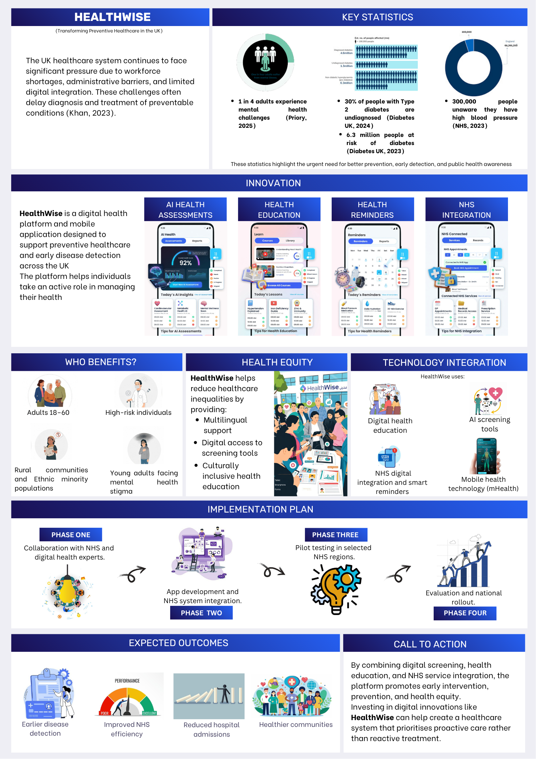

HealthWise
Transforming Preventive Healthcare in the UK

INTRODUCTION
As healthcare systems across the UK continue to face increasing pressure, one of the most significant challenges the National Health Service (NHS) has historically faced is retaining staff, bureaucratic hurdles, a lack of digital technology, and obstacles to sharing patient data, which lead to late diagnosis of preventable conditions (Khan, 2023) . Chronic illnesses such as diabetes and hypertension, as well as mental health disorders, continue to affect millions of individuals across the country. Yet many people remain unaware of their conditions until symptoms become severe. This not only affects patient well-being but also places a significant burden on National Health Service (NHS) resources (NHS, 2024)
To address this challenge, I propose HealthWise, a digital health platform designed to improve prevention, awareness, and early detection of common health conditions across the UK.
HealthWise is a mobile application that empowers individuals to take a proactive role in their health. Through digital risk assessments, personalised health insights, and direct connections to NHS services. This platform helps users identify potential health risks early and seek appropriate support before conditions worsen.
The need for such innovation is clear. Diabetes remains one of the most significant public health challenges in the UK. Research indicates that around 30% of individuals with type 2 diabetes remain undiagnosed, equating to nearly one million adults in England (Diabetes UK, 2024)
Furthermore, an estimated 1.3 million people may already be living with undiagnosed diabetes, while an additional 6.3 million people are at risk of developing the condition (Diabetes UK, 2023)
Without early intervention, these individuals face a higher risk of severe complications including cardiovascular disease and kidney failure.
Similarly, hypertension continues to go undetected among large segments of the population. Often referred to as the silent killer, high blood pressure can develop without noticeable symptoms. In South East England alone, over 300,000 individuals are unaware that they have high blood pressure(NHS, 2023). This lack of awareness prevents individuals from accessing early treatment and increases the risk of serious health complications.
Mental health challenges present another critical concern. In the UK, approximately one in four adults experiences mental health issues each year (Priory, 2025). However, stigma remains a major barrier to seeking help. Studies show that 35% of young adults aged 18–25 avoid seeking support due to stigma and fear of judgment (Citizen Advice, 2024). As a result, many individuals struggle in silence without accessing the services that could support their well-being.
HealthWise aims to address these challenges by making health awareness and screening more accessible and user-friendly.
- The platform includes several innovative features designed to support early detection and prevention.
- Users can complete quick AI-guided health assessments for conditions such as diabetes, hypertension, and mental health concerns. These assessments are based on recognised clinical screening tools and provide users with personalised feedback and recommendations.
- HealthWise includes interactive educational resources that help users understand symptoms, risk factors, and prevention strategies. This improves health literacy and empowers individuals to make informed decisions about their wellbeing.
- HealthWise provides personalised reminders for important health checks. Users receive prompts for NHS health screenings, blood pressure checks, and mental health self-assessments, ensuring that preventative care remains part of their routine.
Another key feature is its integration with NHS services. HealthWise directs users to local GP practices, community health centres, and mental health resources. By connecting individuals with available services, the platform helps bridge the gap between awareness and action.
HealthWise is designed primarily for:
- Adults aged 18–60
- High-risk populations
- Rural communities
- Ethnic minority populations
- Young adults experiencing mental health stigma
HealthWise is also designed to reduce health inequalities. Communities in rural areas, as well as ethnic minority and low-income populations, often face barriers to accessing preventative healthcare (Eberhardt et al., 2025). These barriers include limited transportation, language differences, and mistrust of healthcare systems (Corris et al., 2020) To address this, HealthWise will provide multilingual support and culturally inclusive health education resources.

- The implementation of HealthWise would follow a structured development plan.
IMPLEMENTATION OF HEALTHWISE
PHASE ONE | Involve collaboration with NHS leaders, digital health experts, and public health professionals to refine the platform’s design and ensure alignment with national healthcare priorities
PHASE TWO | involve application development and integration with existing NHS digital systems.

FOLLOWING DEVELOPMENT,
PHASE THREE | The platform would undergo pilot testing within selected NHS regions to evaluate user engagement, accessibility, and effectiveness.
PHASE FOUR | Feedback from healthcare professionals and users would be used to improve the platform before wider implementation

The potential benefits of HealthWise are significant. By increasing awareness and encouraging earlier detection of health conditions, the platform could help reduce preventable hospital admissions and support more efficient use of NHS resources.
Research shows that avoidable health issues and adverse events already place an estimated £98 million annual burden on the NHS (Elliott et al., 2018)
Digital health technology has already demonstrated its effectiveness in supporting public health interventions. For example, the NHS COVID-19 app successfully prevented approximately one million infections through digital exposure alerts(Kendall et al., 2023). This example highlights how technology can play a powerful role in supporting preventative healthcare strategies.
HealthWise builds upon this concept by focusing specifically on long-term disease prevention and health awareness. By combining digital screening tools, health education, and service integration, the platform offers a practical and scalable solution for improving population health outcomes.
In conclusion,
HealthWise represents a forward-thinking approach to healthcare innovation. It empowers individuals to take control of their health while supporting NHS goals related to prevention, digital transformation, and health equity (McNaughton et al., 2011)
By investing in solutions like HealthWise, we can move closer to a healthcare system that prioritises early detection, prevention, and community empowerment.
I urge healthcare leaders and policymakers to support the development and implementation of HealthWise so that we can build a healthier, more proactive future for communities across the UK.

REFERENCES
Citizen Advice (2024) “Health Awareness: Barriers to Cancer Screening in Crawley Community Participatory Action Research We are Citizens Advice.”
Corris, V. et al. (2020) “Health inequalities are worsening in the North East of England,” British Medical Bulletin, 134(1), pp. 63–72. Available at: https://doi.org/10.1093/bmb/ldaa008. (Accessed: 8 March 2026).
Diabetes UK (2023) How many people in the UK have diabetes? Available at: https://www.diabetes.org.uk/about-us/about-the-charity/our-strategy/statistics (Accessed: 8 March 2026).
Diabetes UK (2024) 30% of people living with type 2 diabetes in England are undiagnosed, ONS analysis shows | Diabetes UK. Available at: https://www.diabetes.org.uk/about-us/news-and-views/30-people-living-type-2-diabetes-england-are-undiagnosed-ons-analysis-shows (Accessed: 11 March 2026).
Elliott, R.A. et al. (2018) “PREVALENCE AND ECONOMIC BURDEN OF MEDICATION ERRORS IN THE NHS IN ENGLAND Rapid evidence synthesis and economic analysis of the prevalence and burden of medication error in the UK.”
Kendall, M. et al. (2023) “Epidemiological impacts of the NHS COVID-19 app in England and Wales throughout its first year,” Nature Communications, 14(1), p. 858. Available at: https://doi.org/10.1038/s41467-023-36495-z. (Accessed: 11 March 2026).
Khan, Z. (2023) “The Emerging Challenges and Strengths of the National Health Services: A Physician Perspective,” Cureus, 15(5), p. e38617. Available at: https://doi.org/10.7759/cureus.38617. (Accessed: 18 March 2026).
NHS (2023) NHS England — South East » An estimated 300,000 people unaware they have raised blood pressure. Available at: https://www.england.nhs.uk/south-east/2023/01/26/an-estimated-300000-people-unaware-they-have-raised-blood-pressure/ (Accessed: 18 March 2026).
NHS (2024) Health Survey for England 2024 Questionnaires, field documents and measurement protocols. Available at: www.natcen.ac.uk/ (Accessed: 20 March 2026).
Priory (2025) Mental health statistics UK 2026 - Priory. Available at: https://www.priorygroup.com/mental-health/mental-health-statistics (Accessed: 20 March 2026).

