  Component One:  What are the key skills required when working in the housekeeping team? 750 words (+/- 10%)  Contribution to Overall Module Assessment: 25% | Student No: | 2206171
 | Module Title: | Operating Hotel Facilities
 | Module Code: | BMIH4006
 | Lecturer: | Lola Villard
From ancient times people traveled and there was a need for hospitality and for housekeeping. Over the years the duties of the housekeepers were changing continuously from only cleaning the rooms to managing products, orders, and employees (Jones, 2008, p. 1).
As the job changed so much the required skills for the housekeeping employees have changed as well. Housekeepers are a very important part of the hospitality industry because they are maintaining the cleanliness of all the private facilities as well as the public ones and they are required to have several skills to be successful and effective in their job. (Indeed editorial team, 2022).
During my experience in work placement, I had the opportunity to be part of a great team at Premier Inn Weston Super Mare East and I learned that one important skill is the people skill. All the housekeepers must have good people skills if not they will have to develop it because even if they are back of house team, they have to deliver the best services for the guest and to work together with their team and other departments. (Executive housekeeping today, 1980, p. 1)
Another soft skill required to work in a housekeeping team is time management. Each team member has a set time required to finish all the duties during the day and good time management is required because sometimes the shift can become very busy, and this skill is required to finish all the jobs in the correct requested way.
To successfully perform their duties and to be effective at their job a housekeeper must be detailed-oriented. This skill will ensure that the windows and the mirrors are clean with no spots, the floor has no dirt on it and the beds, and the towels are spotless. Communication and customer service skills are important in the housekeeping job because the housekeepers communicate with guests and co-workers and supervisors. The housekeeper`s customer service skills must be strong because their job is based on the approval of the guests and many times they will interact with guests and respond to their requests and inquiries. My colleagues from housekeeping had to develop a series of hard skills as well to be successful at their job. The most used hard skills required for housekeeping are mopping, carpet cleaning, vacuuming, dusting, polishing, deep cleaning, infection control, and window treatment cleaning (Indeed Editorial Team, 2022).
When working with my colleagues from housekeeping I had the opportunity to assist to a theoretical knowledge learned in Hospitality and Guest Service Management applied in the industry, customer loyalty. It is very important for the hotel to gain and maintain its loyal guest and for that every time when a guest had a birthday or celebrated a special occasion the reception team informed the housekeeping team and they were making sure the guest`s room had something special in it, chocolate, flowers, extra towels, little touches that make a big difference.
Another skill learned in university classes and applied when working at housekeeping is positivity and flexibility. It is very important to stay calm in stressful situations and every time my colleagues were overwhelmed by many tasks and the short time left I stepped in, looked for solutions, and with my can-do attitude we finished all the tasks in time (National Careers Service, 2020).
Very important in the housekeeping job is that every employee uses his own strength and does the job in his own way to have the best results. Because everyone is different, we all have different ways to do things. For example, my colleagues have different ways of doing the beds but in the end, all the beds look the same, clean, tidy, and neat (Lombardi, 2003, p. 6).
Soft skills such as time management, people skills, customer service, positivity, and flexibility are only a few of the most important skills required to be part of a housekeeping department because the team will develop many other important soft skills during their time at the job but to do an effective and successful job the hard skills as dusting, vacuuming, window cleaning, and many other ones are a must.

References:
- Executive housekeeping today (1980). Gallipolis, Ohio: [Published for the Association by Zimmerman & Leonard].
- Indeed, (2022) Guide to Housekeeping Skills (With Tips and Examples). Available at: https://www.indeed.com/career-advice/career-development/housekeeping-skills (Accessed: 01 June 2023).
- Indeed editorial team, (2022), Guide to Housekeeping Skills (with Tips and Examples). Available at: https://www.indeed.com/career-advice/career-development/housekeeping-skills (Accessed: 02 June 2023).
- Jones, T.J.A. (2008) Professional management of housekeeping operations. 5th ed. Hoboken, N.J: John Wiley & Sons.
- Lombardi, V. Jr. (2003) The Lombardi Rules. United States of America: McGraw-Hill.
- National Careers Service, (2020) Developing your soft skills. Available at: https://nationalcareers.service.gov.uk/careers-advice/how-to-develop-your-soft-skills. (Accessed: 02 June 2023).

Word Count | 689

Component Two:
Contribution to Overall Module Assessment: 25%
In this scenario – You have just been promoted to team leader for a floor within the hotel. A guest complains that on their arrival, their room had not been properly cleaned. Create an action plan and answer the following questions.

Problem | Why did it happen? | What are you going to do? | How will you prevent this from happening in the future? | What measures would you introduce to improve team effectiveness?
Dirty mugs | The housekeeper did not check the mugs because the mugs looked clean. | Ask the team member to do the training again. | All the team members working for more than one year will have to redo all the training. | 10 minutes team briefings every morning.
Bed sheet stained | The housekeeper had too many rooms to clean and saw the bed sheet stained after was put on the bed and from lack of time decided not to change it. | Speak with the head of housekeeping and request to recruit more staff. | Try to have the right number of staff cleaning the right number of rooms. | Identify the right skills needed from new employees and try to hire the right person.
Empty plastic bottle under the bed | The housekeeper forgot to check under the bed for any items left over. | Explain the importance of checking every time under the bed. | Make sure all the team knows how important is to check under the beds. | Speak with the hotel manager to implement an incentive for the team so they can be motivated to check under beds.
Dusty table and tv frame | After the room was cleaned the maintenance team came to hang one picture on the wall with the drill. | Speak with the maintenance team and kindly ask them to make sure they are cleaning every time after they are conducting jobs in the rooms. | Speak with the housekeeping team to provide the right cleaning products to the maintenance if they request. | Make sure the housekeeping has enough cleaning supplies all the time.
Stained carpet | The housekeeper tried to clean the carpet but was still stained because professional cleaning was needed. | Speak with the Head Housekeeper and ask if is possible to have a carpet cleaning company professionally clean all the carpets in the rooms | Have someone professionally clean the carpets every six months. | Speak to all the team and ask them to clean the carpets every time when they see any small spot on it.

References:

- Academy Whitbread (2023) Bedroom Genie- Housekeeping Management via required learning program Housekeeping Management. Available at: https://academy.whitbread.co.uk/course/view.php?id=2888 (Accessed: 04 June 2023).
- Academy Whitbread (2023) Deep Cleaning and Job of the Day- Housekeeping Management. Available at: https://academy.whitbread.co.uk/course/view.php?id=2891 (Accessed: 04 June 2023).
- Lakena, W. (2017) Pre-opening Activities of an Executive Housekeeper. Available at: https://www.linkedin.com/pulse/pre-opening-activities-executive-housekeeper-winfred-lakena-mawa (Accessed: 05 June 2023).
- Rose, B. (2020) How to build a housekeeping team that improves guest satisfaction. Available at: https://www.hhs1.com/blog/how-to-build-a-housekeeping-team-that-improves-guest-satisfaction (Accessed: 05 June 2023).
- Trotto, S. (2015) 11 tips for effective workplace housekeeping. Available at: https://www.safetyandhealthmagazine.com/articles/12470-tips-for-effective-workplace-housekeeping (Accessed: 05 June 2023).

Component Three:
Contribution to Overall Module Assessment: 50%
Your task is to create and prepare a presentation following the detailed scenario provided below.

As the floor housekeeping manager and given the recent guest complaints you need to put together a basic training presentation for your colleagues within the housekeeping team to get the best out of them, ensure that brand standard is being achieved, and that Health and Safety procedures are also being followed.



Training Notes: Good afternoon, as a new floor Housekeeping Manager I put together a training presentation to help all the team learning and refreshing all the knowledge about cleaning the rooms, achieving the Brand Standard and make sure the Health and Safety Procedures are being followed.
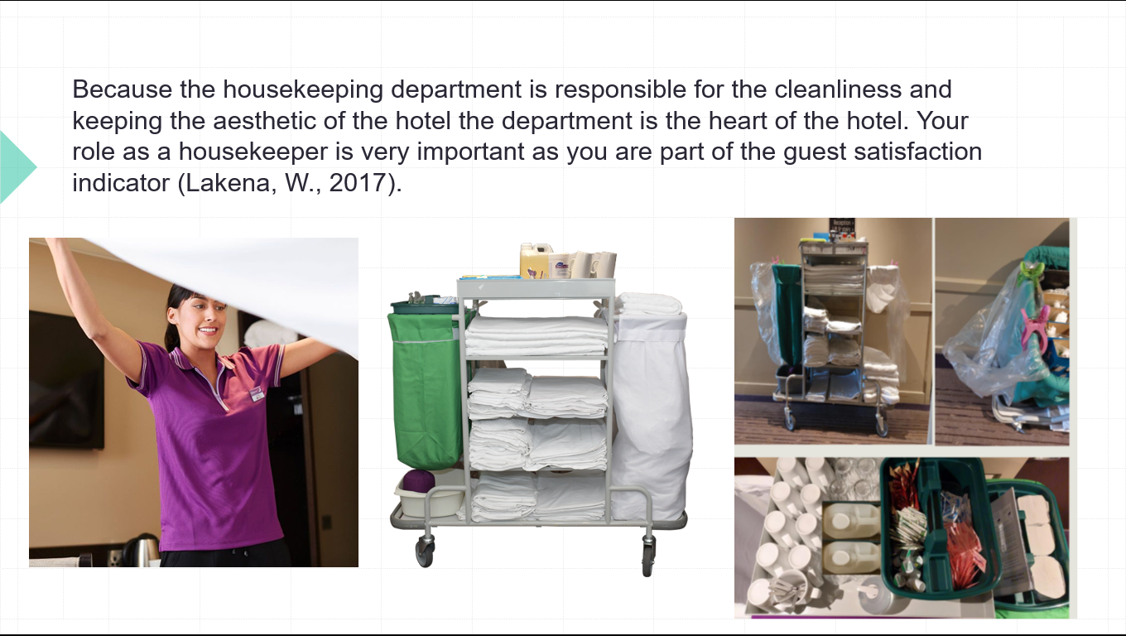

Training Notes: The housekeeping job is very important for a good and effective working hotel because the housekeeper is the person who guarantees a good night’s sleep for the guests and also, they are responsible for the aesthetic of the hotel.
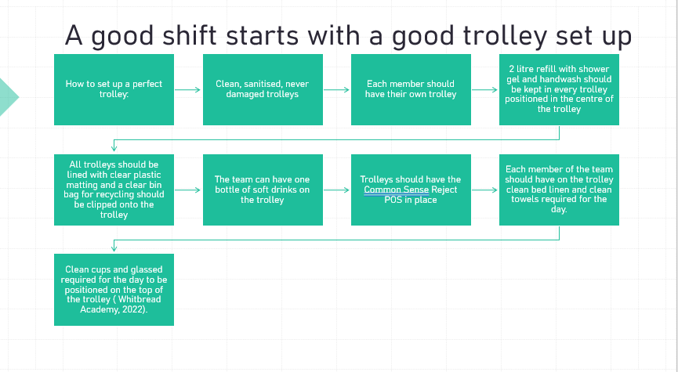

Training Notes: In this slide we can see a step-by-step preparation of the housekeeping trolley. Every housekeeper should have their own trolley because on the trolley they can put all the products they need to successfully complete their shift. Every trolley needs to be kept clean, all the products should be kept in the correct place and no personal belongings to be kept on it.
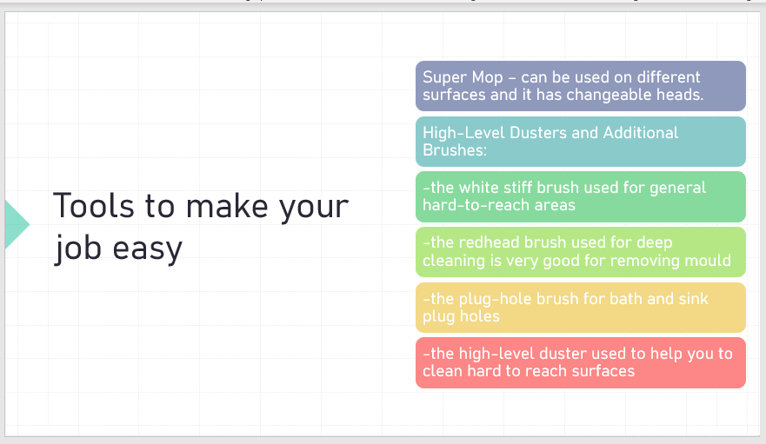

Training Notes: Because at Trinity Hotel we care about making the cleaning process as efficient as possible for you we provide you some tools to help with this. The Super Mop is a great tool to clean bathroom tiles and floor, bedroom and bathroom mirrors, and bathroom and bedroom doors. Mop heads must be changed between cleaning every room and must be washed separately from other cloths. For hard-to-reach areas in the bedroom and bathroom which needs to be cleaned frequently we provide you with a range of brushes and high-level dusters.
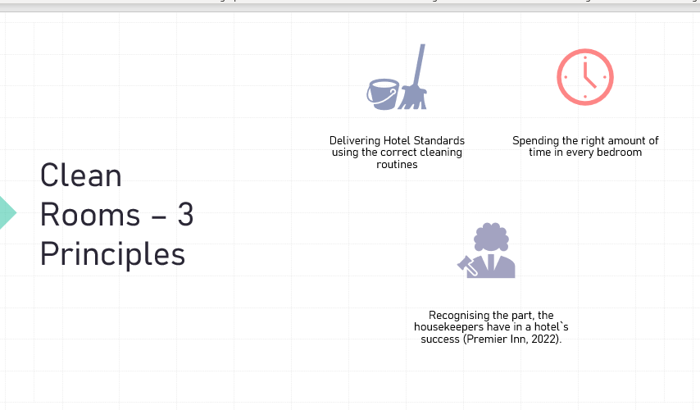

Training Notes: All the housekeeper team members should follow the 3 principles of the clean rooms to complete their daily tasks, Delivering Hotel Standards using the correct cleaning routines, Spending the right amount of time in every bedroom and recognizing the part the housekeepers have in a hotel`s success.

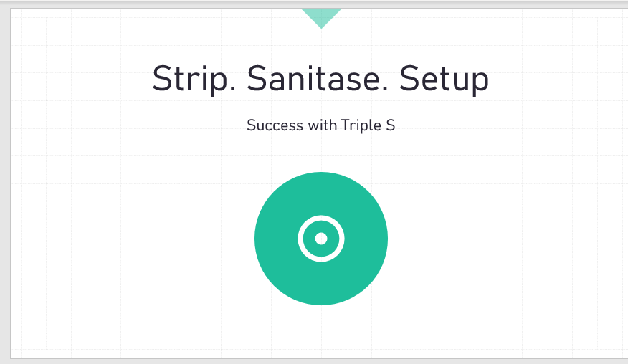

Training Notes: Here, at Trinity Hotel we use the triple S success method, we strip the room, sanitise it and set it up according to our Brand Standards.
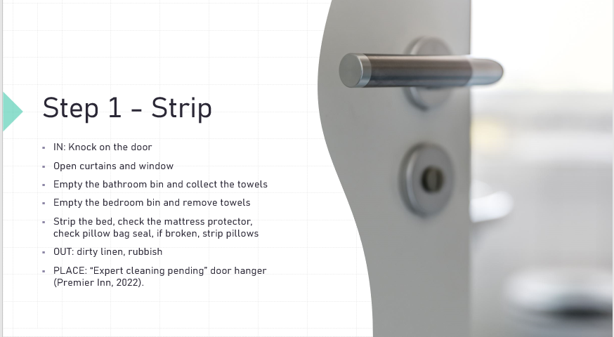

Training Notes: First step in cleaning a room is striping. On this stage we must make sure we collect all the rubbish from the room, all the dirty linen, and all the dirty towels. We have to make sure we check under the bed, checking the mattress and mattress protector, pillows protectors, and bed frames.
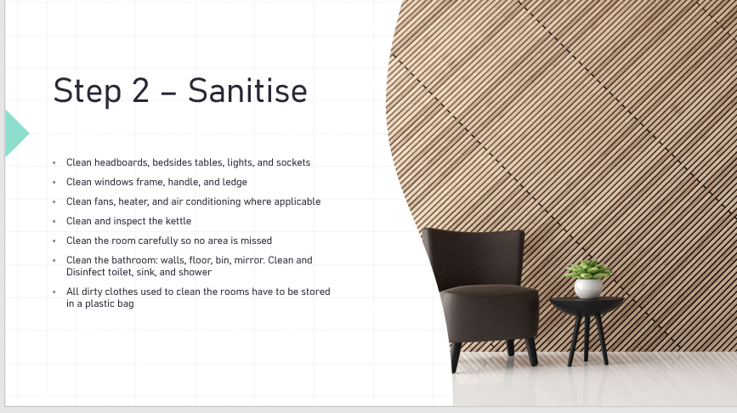

Training Notes: After we striped the room, we start sanitising all the required surfaces. We properly clean all the surfaces from the bedroom and after that we properly clean the bathroom making sure everything is cleaned with the proper product and we allocate enough time to clean it.
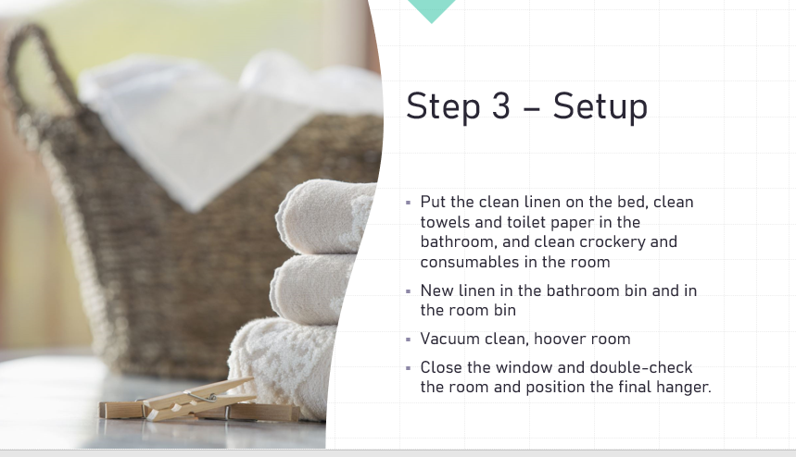

Training Notes: After striping, sanitising we must set up the room. We take all the clean linen and clean towels from the trolley positioned outside in front of the room and we start putting the linen on the bed, fold the clean towels and put them in the right places, new linen in the bins, and vacuum clean and hoover the room. When we finish, we must close the window, double-check the room and put the final hanger on the door.
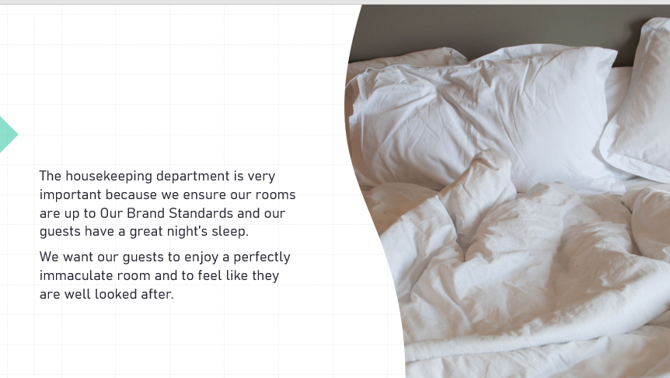

Training Notes: The safety of ourselves, our team and our guest are the most important thing. We will never do anything that is unsafe, and we must ensure we work according to Health and Safety procedures and we deliver the Hotel Trinity Brand Standards to our guests.

References
- Academy Whitbread (2023) Success- Sanitise Route. Availabe at: https://academy.whitbread.co.uk/course/view.php?id=2878 (Accessed: 05 June 2023)
- Academy Whitbread (2023) Success- Set up. Availabe at: https://academy.whitbread.co.uk/course/view.php?id=2880 (Accessed: 06 June 2023).
- Academy Whitbread (2023) Success – Strip Route. Availabe at: https://academy.whitbread.co.uk/pluginfile.php/451019/mod_scorm/content/1/index_lms.html (Accessed: 05 June 2023).
- Academy Withbread (2023) Trolley Set Up. Available at: https://academy.whitbread.co.uk/pluginfile.php/443433/mod_resource/content/2/Trolley%20Set%20Up.png (Accessed: 04 june 2023).
- Academy Withbread (2023) Tools to do your job- in the room. Available at: Course: Tools to do your job - In Room - Housekeeping (whitbread.co.uk) (Accessed: 04 June 2023).
- Academy Whitbread (2023) Bedroom Genie- Housekeeping Management via required learning program Housekeeping Management. Available at: https://academy.whitbread.co.uk/course/view.php?id=2888 (Accessed: 04 June 2023).
- Briefing pack (2020) CheckMate for Covid-19 Secure Test Hotels. Premier Inn Weston Super Mare East A370.
- Lakena, W. (2017) Pre-opening Activities of an Executive Housekeeper. Available at: https://www.linkedin.com/pulse/pre-opening-activities-executive-housekeeper-winfred-lakena-mawa (Accessed: 06 June 2023).
- Premier Inn (2022) Ensuring our guests Rest Easy. Premier Inn Weston Super Mare East A370
- Rose, B. (2020) How to build a housekeeping team that improves guest satisfaction. Available at: https://www.hhs1.com/blog/how-to-build-a-housekeeping-team-that-improves-guest-satisfaction (Accessed: 05 June 2023).

