

Assessment 1 – Reading Task Template
PART 1: Upload your photo of your A3 in-class notes here:
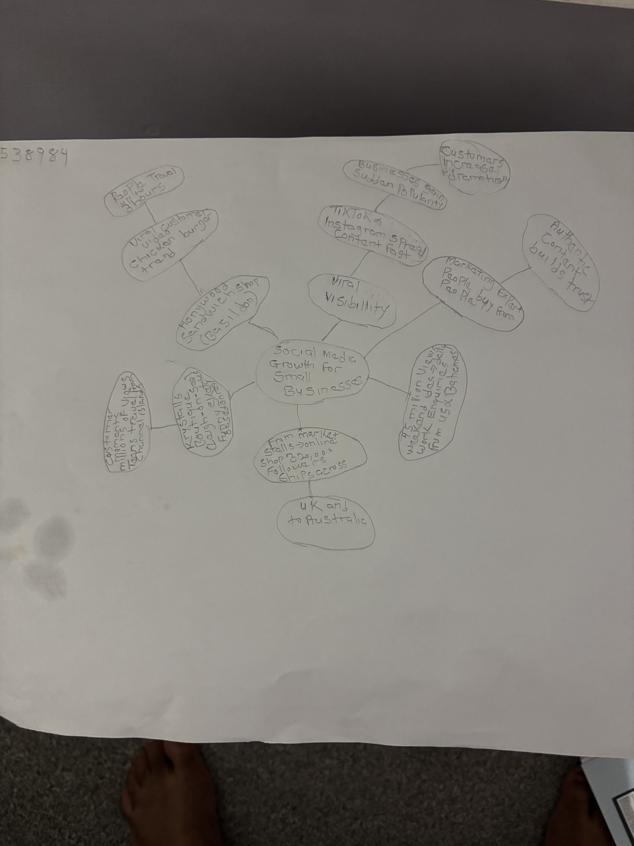

PART 2:
- Answer every question below in 1-3 full sentences.
- Use your own words. Do not use generative AI to answer these questions.
- Include a specific detail from the text when asked.
REMINDER
- The main idea is the overall message of the whole text.
- A key point helps to explain the main idea.
- A specific detail or example from the text shows that the key point is true.

- What is the main idea of the whole text?
The article explains how social media helps businesses become better known, attract new customers and increase sales.

- What is one key point that supports the main idea, and which specific example from the text shows this?
Customers posted videos about Honywood Sandwich Shop, and some people travelled three hours to try its chicken burger.

- What is a different key point that supports the main idea, and which specific example from the text shows this?
Linda Hunter moved her clothes business fully online and sends orders across the UK and to Australia.

- Which part of the text do you think is most important, and why?
Customers’ videos reach more people on social media. It helps businesses get more customers and increase revenue.

Reflection:
- What did you find difficult in this task (including in-class components), and why was it difficult?
Organising the mind map. Also struggled with the main idea.

- What helped you with this difficulty, and how did it help you?
Reading and checking word meanings again, and getting an explanation in class.

