Emily Brown (1900471)

Module Code - ECAD4008
Module Lead - Carys Jennings

Module Title - Cycle 1 Professional and Pedagogical Studies: Leading the Learning: what, how and why am I teaching?

Assessment Title:
Good teaching and learning means employing a blend of approaches including direct teaching

Good teaching and learning sets tasks and selects resources that build on previous knowledge and experience and engage interest

Good teaching and learning ranges within and across Areas of Learning and experience

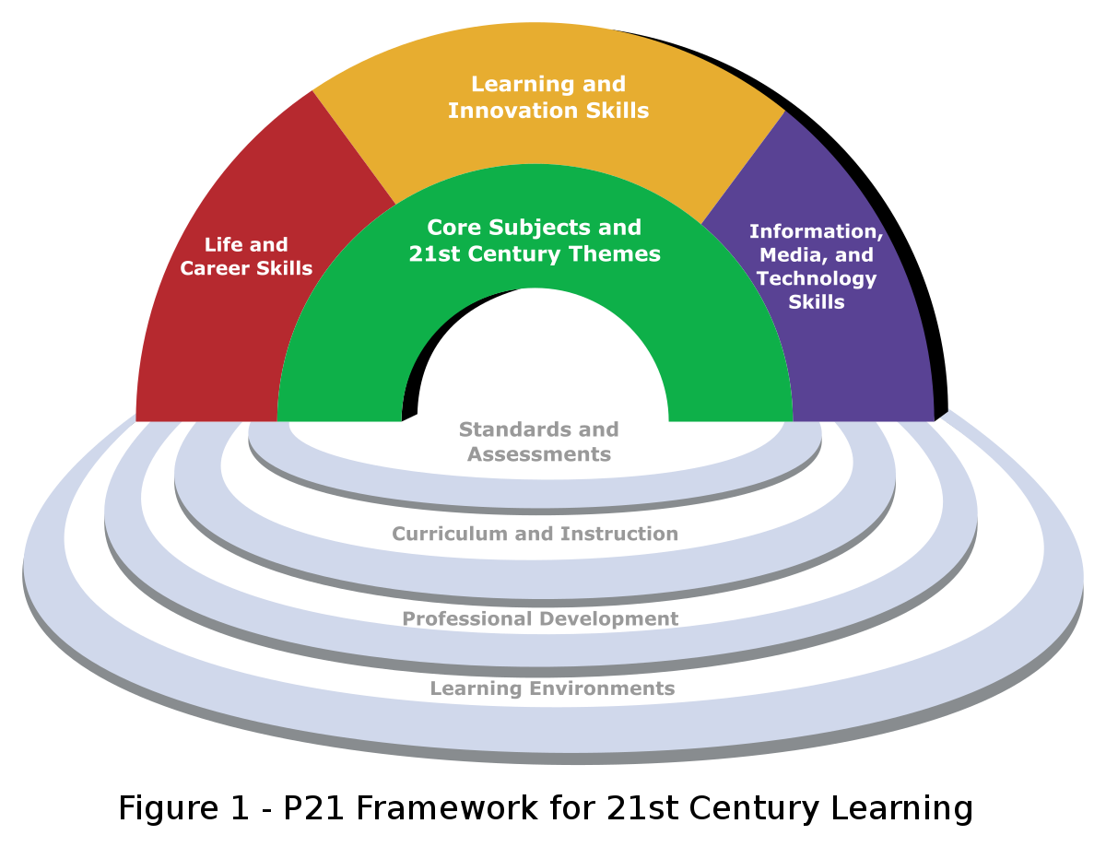

Targed/Target 1 | Check your referencing techniques as you should, for example; include references for what you are saying
Targed/Target 2 | Proof-read your work and use educational texts to model a more academic style of writing. Try to avoid contractions in academic essays.
Targed/Target 3 | Check you referencing technique as you should, for example; include page reference with direct quotes

The aim of this module is to increase knowledge of subjects, cross-curricular teaching and pedagogical principles as outlines in ‘Successful Futures’ and the new curriculum for Wales 2022. This module looks further into the roles and professional responsibilities of the teacher and the requirements to be a part of a professional working community.

Foundation Phase
“The Foundation Phase is a developmental curriculum for three-to-seven-year-old. It encourages children be creative, imaginative, investigative learners and to have fun whilst learning through play. Children will be challenged physically and cognitively through practical activities relevant to their developmental stage and develop their knowledge and understanding of subject areas accordingly.

“The Foundation Phase encompasses the developmental needs of children” with the holistic development of children and their skills, experiences and knowledge at the centre. Promoting values and opportunities and Donaldson’s Four Purposes refers to creating “ethical informed citizens, ready to be citizens of Wales and the World”. From my experiences in Primary School settings, I have seen first-hand the emphasis schools are placing on the Rights of the Child. My placement school displays children’s rights in all of the classrooms, toilets, staff room, dinner hall, and reception. A large display of the children’s rights is displayed in the schools “Learning Street” accompanied by illustrations by the children to depict each one.

The ‘National Curriculum’ is divided into 5 sections; Early Years (age 3-5), Key Stage 1 (5-7), Key Stage 2 (7-11) with Key Stage 3 and 4 being in Comprehensive school (age 11-16). The ‘Foundation Phase Profile Handbook’ supports the assessment of children’s learning and development throughout their time in the Foundation Phase. The ‘skills ladder’ refers to the Areas of Learning throughout the Foundation Phase; “Personal and Social Development, Well-being and Cultural Diversity, Language, Literacy and Communication Skills, Mathematical Development, and Physical Development” (Foundation Phase Profile, 2017. Welsh Government). In addition to these are the skills each child should possess including the ability to manage time, spell age appropriate words, and improve coordinated movement. Children will be assessed following a six-stage plan (see appendix 1) in order to support the children in developing further, this includes keeping record and evidence of the children’s skills from all Areas of Learning.

Play
The importance of play is recognised by Maria Montessori (Pound, 2006, 30) and the Welsh Government as documented in a 2014 document “Wales – a Play Friendly Country”. The Welsh Government like Montessori believes that play is an essential part of children’s cognitive, physical, social and emotional development.

In 2002 the Welsh Government alongside stakeholders created the “Play Policy” followed by the “Play Policy Implementation Plan” in 2006. These set out the Governments vision for educational play for children in Wales and the steps needed to instigate this in the classroom. Activities will be planned by teachers in conjunction with children based on what they would like to learn about specific topics identified by the teacher. In my placement school this is referred to as EPIC (Everyone Plans in Class), giving children autonomous learning opportunities. Teachers structure the activities and model them for the class monitoring them accordingly based on the teaching and learning model.

The National Literacy and Numeracy Framework
This statutory curriculum was introduced in 2013 to raise children’s literacy and numeracy skills by helping all practitioners to develop the children’s literacy and numeracy through the Foundation Phase AoLE through integrating these into continuous, enhance and focussed provision both in-and-outdoors whilst also creating cross-curricular learning experiences and an inclusive learning environment. The model is a ‘bottom up model’ that builds on what children can do/understand, thus putting the child sat the centre of the curriculum. The Framework aims to assist practitioners help the children by identifying those who may benefit from additional support and ways to help them progress their learning through self-assessment, monitoring and assessing children’s academic and social performance. (see appendix 2)

Curriculum for Wales
In a “WalesOnline” (2019) interview, Minister of Education Kirsty Williams described how the new curriculum moves away from a subject orientated structure and more so on the AoLE as set out by the Curriculum, and the well-being of the children. The four purposes; “ambitious, capable learners ready to learn throughout their lives, enterprising, creative contributors ready to play a full part in life and work, healthy, confident individuals ready to lead fulfilling lives as valued members of society, and ethical informed citizens ready to be citizens of Wales and the World”. The new curriculum marks the removal of “key stages” to be replaced with “progression steps” for each AoLE, setting out what learners should be achieving at specific age ranges rather than on a termly or annual basis thus releasing pressure on the children to perform at a certain level before they move up a year group. Teachers will have to follow the six-AoLEs; “mathematics and numeracy, science and technology, humanities, language, literacy and communication, health and wellbeing and expressive arts” however they will experience more autonomy in their roles. The curriculum will be introduced to all publicly funded nurseries and maintained schools from September 2022 on a phased basis, followed by Year 8 in 2023/24, Year 9 in 2024/25 consecutively meaning it will reach Year 11 in 2026/27. Teachers and stakeholders will receive the appropriate training during scheduled ‘inset days’ in 2019-2022 based on their level of teaching.

Pedagogy
Stemming back to Aristocratic times, pedagogy is defined as the method and implementation of teaching; encompassing teaching styles, theories, feedback and assessment. Referring to the interactions between teacher and students with the learning environment, pedagogy will differ depending on the age of the children, depth into research of theorists/theories, and available resources to inform their teaching practices. Each teacher will develop their own pedagogical principles over time. (Jennings, C. 2010) Foundation Phase Pedagogy – The holistic nature of learning, “All aspects of learning are interlinked for young children; they do not compartmentalise their learning and understanding into curriculum areas” (WG, 2008:5). Pedagogy links closely to Bronfenbrenner’s theories of understanding how, who, why, where and what we teach.

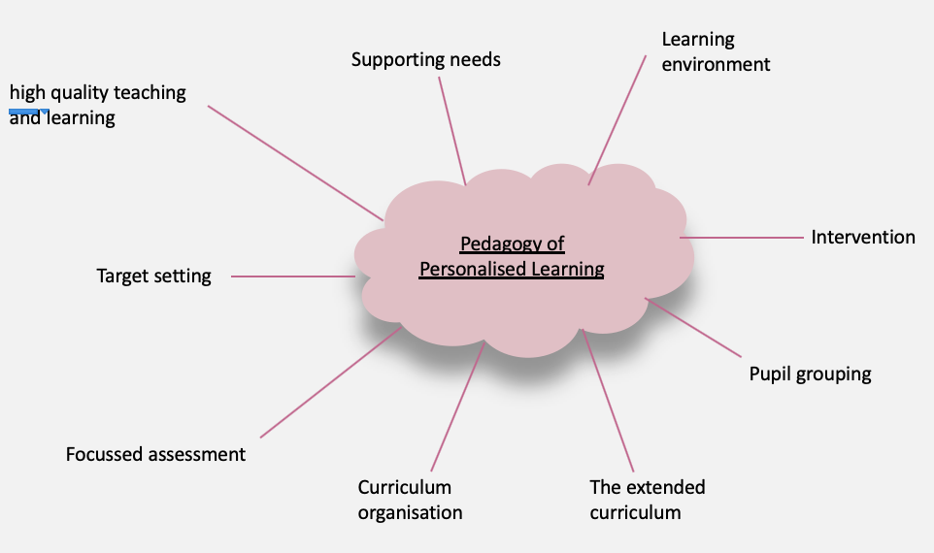
Schools should be offering children a rich and varied experiences. Exposure to the widest curriculum and the most powerful of experiences will be much more likely to help children discover their passions and identify their personal strengths. (Barnes, 2015, p.186)

Cross-Curricular Learning
Linkages between skills and language of more than one discipline is something the ancient Greeks and medieval Chinese view as an important part of education. The concept of a child-centred curriculum was investigated by twentieth-century theorist John Dewey (1859-1952) and Rudolf Steiner (1861-1925). Steiner’s views much like the holistic approach to the Foundation Phase Curriculum were more spiritual and personal to the child. More specifically, the Welsh Government have published a document stating their methods of achieving Donaldson’s 4 purposes for example; “Developing a shared vision centred on the learning of all learners” this refers to an inclusive aim to enhance the learning experiences of children and subsequently their academic outcomes. In my placement school’s improvement plan (SIP), it refers to the increase of focus on the children’s wellbeing alongside developing their cognitive and socio-emotional development through an inclusive learning environment and by inspiring and motivating the children in their education. In addition, enhancing the relationship between staff and children with the community and parents/guardians. (See appendix 3). Theorists Booth and Ainscow, (2011); McCauley and Rose, (2010); Raffo et al., (2010); and Wrigley et al., (2012) believe that the teachers role is to have an awareness of the growing gap between the educational experience or rich and poor children, argued for fundamental change to the curriculum rather than to resort to the more tried and tested methods ‘parrot’ style teaching methods (Barnes, 2015, p.186). As the new curriculum states, teachers will receive more independence in their classroom thus meaning that they can tailor their lessons to the ability and needs of the children, allowing for enhanced provision for those children who would benefit from a challenging task and focus provision – direct teaching using a ‘more knowledgeable other (MKO)’ technique as Vygotsky devised. Lucas et al (2013), observed schools as primarily narrowing their curriculum to accommodate demands for SATs achievements rather than exposing the children to the widest curriculum and the most enriching experiences to help children discover their passions, strength and develop their weaknesses. Disadvantages of cross-curricular learning experiences include a lack of resources. For example; expecting the children to be able to use a computer as a result of ever-evolving technology is unfair as poverty-stricken children may not have access to technology. As a result of this, children may not complete their work as they are unable to transfer computing skills from home to the classroom. From a teacher’s perspective, as they are used to set times for different subjects, the new curriculum will pose difficulties to them. However, many teachers may be bored of these methods and welcome the change.
Potentially the more experienced teachers will fight against the new curriculum will which harm the children’s education. The retention rates from (House of Commons Education Committee, 2012) demonstrates in both the UK and US half of teachers leave within the first five-years of joining the profession. This new curriculum will mean teachers will need professional support as all ‘Areas of Learning’ will have to be incorporated within a theme (Barnes, 2015, p.305-306).

Adult-led and Child-led Learning
Adult-led activities are based on a teachers’ own professional understanding of what children should experience and be taught by introducing new skills, ideas and opportunities to ensure they experience all ‘Areas of Learning’ in the Foundation Phase. Adult-led learning allows teachers to maintain control over what the children are learning however we cannot control what children learn from these experiences. Therefore, it is important to balance adult-led learning with child-led learning allowing children the opportunity and time to explore and play with resources using their imagination. Montessori believed in child-lead learning and allowing children autonomous learning experiences throughout education. In addition, “sustained shared thinking”, where the child initiates an activity with support from an adult. In the new curriculum, this is called a ‘focus task’. Montessori believed that children have specific “sensitive periods” for development and should be encouraged to develop their senses from an early age by self-learning. In contrast, Piaget believed children have specific periods of “cognitive” development with children not reaching their “concrete operational” stage until the age of 7. (Two development theories compared. The learning web). Piaget’s theory is based on a teacher-led approach to developing academics such as language skills.

The pedagogical principle “Good teaching and learning means employing a blend of approaches including direct teaching” links to the idea of “sustained shared thinking”; including both independent and directed learning by engaging in dialogue. Employing a blend of teaching approaches for example: behaviourism shows that learners will repeat desired behaviour if positive praise is given or demonstrated; this technique is called modelling (Skinner, 1947) and (Bandura, 1961). In my placement school they use a ‘my turn, your turn’ technique to model behaviour or pronunciation of words. Vygotsky’s (1978) constructivist theory refers to active learning by constructing knowledge independently rather than acquiring it. By using past experiences to link to their learning, it becomes more relevant to them and therefore more interesting. This is something outlined in ‘Donaldson’s Four Purposes’; “ethical, informed citizens ready to be citizens of Wales and the world” and “healthy confident individuals ready to lead fulfilling lives as valued members of society”. My placement school arranges local trips to allow the children physical and visual experiences linked to their theme. Also linking learning to popular children’s characters allows the children to make concrete links to things more relevant to them and therefore more interesting. Katz (2000) stated that “practitioners should have a good grasp of developmental theory so that they can check their working knowledge and understanding against theory” and therefore have an understanding of what they are teaching, why and how it will benefit the children’s development and academic experience (Pound, 2009, p.32). This theory, along with a blend of approaches to teaching demonstrates the importance of practitioner knowledge.

In relation to, “Good teaching and learning ranges within and across Areas of Learning and experience”, in my placement school there is constantly a focus on the six ‘Areas of Learning’. All of these are incorporated into the weekly activity planning. For example; a role-play area for the children to experience expressive arts linked to the classes theme. This encourages communication between the children and allows them to be imaginative and innovative. However, some children may mistreat this area and therefore have a negative impact on their learning and the learning of others. In addition, a lack of space or imagination from the teacher may hinder the children’s expressive arts experience. This is not something I have experienced in my placement school as the children understand show respect towards the area.

Planning
“Good teaching and learning sets tasks and selects resources that build on previous knowledge and experience and engage interest”. This pedagogical principle clearly states that building on children’s previous knowledge an understanding will engage interest in learning. Referring to popular children’s characters or linking to their local community will interest the children more than something they cannot relate to. For example, when studying Celts in Primary School, my class was taken to the local castle as it is a Celtic castle. This gave context to our learning and allowed us to ask role-play workers questions about the Celtic times therefore progressing our learning and engaging our interest.

Lesson planning is important as it gives the teacher and teaching staff a guided as to how best to support the lesson and the resources needed. Planning allows teachers so ensure that the ‘Areas of Learning’ and Foundation Phase Framework elements are incorporated efficiently and effectively.

“Herbartian’s” approach of teaching emphasised the key steps to lesson planning. At the introductory stage, the pupils are asked questions to ascertain their existing knowledge and areas of interest. During the statement of aim stage, the topic becomes clear to the pupils and the teachers writes the topic on the board for the children to learn to recognise and pronounce. Presentation; the lesson is developed alongside the children. In my placement school, this is referred to as “EPIC” meaning “Everyone Plans in Class” (see appendix 4); the children each write what they would like to learn about the theme. The teacher then incorporated these into the ‘Areas of Learning’ and to the lesson planning. The comparison and association stage refers to the facts, events and application relating to the theme for example; planning of class trips. This stage also includes cross-curricular learning and implementation. Generalisation/system comes after explaining the main lesson, where the children are given opportunities to think, and expand their knowledge and skillset. The final stage is application, “it is observed whether the acquired knowledge may be applied to the new situations”. The teacher verifies pupil understanding by asking questions about the theme or by providing opportunities to apply the acquired knowledge. Alternatively, a more modern approach begins with setting learning objectives (what do I want them to learn?), an introduction to the topic; perhaps by ascertaining existing knowledge. It is important to engage the children at this stage, making them interested in learning. This is referred to as the “hook”. Then specific learning activities are planned around that topic and the areas of learning, including any trips or visitors that may enhance the children’s learning over the course of a reasonable timeline. Finally reviewing the pupils understanding by asking questions and creating activities for them to apply their new-found knowledge.

Rights of the Child
Article 12: Respect for the views of the child
“Every child has the right to express their views, feelings and wishes in all matters affecting them, and to have their views considered and taken seriously. This right applies at all times, for example during immigration proceedings, housing decisions or the child’s day-to-day home life” Rights of the Child (UNICEF 2019).

With increasing emphasis on children’s rights been taught in schools in conjunction with increasing pupil wellbeing, many schools have pupil voice groups. According to Estyn (2016), “strong pupil participation can support school improvement by helping the school to identify future priorities and make more informed decisions on wellbeing, learning experiences and the quality of teaching”. Pupil voice groups help children to develop communication, evaluation, teamwork, critical thinking, confidence and self-esteem. In my placement school, the pupil voice groups feedback to the teachers and governors at a monthly meeting and work together to formulate an improvement plan. This links to pupil involvement with lesson planning. Allowing children, the opportunity to be involved in their own learning can have the opportunity to open doors for them. Allowing children to plan for their own learning links to this idea of listening to children’s views.

A downside to pupil voice groups would be a lack of understanding regarding school budgets. Perhaps their aspirations for the school may be out of reach and therefore disappoint them.

Respecting the wishes of “Looked After Children” and “Children with Adverse Childhood Experiences” is vital to ensuring their wellbeing. Most “LAC” and “ACE” children in care say their experiences were good and the right choice for them (Biehal et al, 2014) however more should be done to promote wellbeing and equal opportunities. Practitioners and stakeholders must have a depth of understanding regarding the appropriate provisions that should be in place for an “ACE” or “LAC”. For example; children with adverse childhood experiences may need counselling and therapy. This should be easily accessible through the school without affecting the child’s learning opportunities or making them feel different to their peers. This is linked to poor physical/mental health, negative behaviour and substance abuse therefore it is vital that children receive the appropriate support during their time in education.

Curriculum for Wales
Curriculum for Wales aims to help each school develop its own curriculum, enabling learners to develop towards Donaldson’s four purposes (below) as a point of aspiration for all learning and learner in Wales. Schools will be given guidance to adhere too with requirements set out in legislation for all learners aged 3-16 years old to ensure all schools teach the same core learning and to secure consistency among learners across. This will allow for simple comparisons between school performance levels. Expectations regarding assessment to support learner progression are also outlined. Other than this, practitioners and stakeholders will receive autonomy regarding their school’s curriculum and implementation methods.
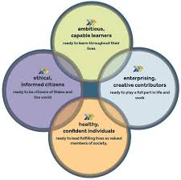
A greater emphasis will be placed on why and how we teacher; referring to the original theories and research undertaken by theorists Bronfenbrenner, Vygotsky and Montessori to name a few. The curriculum also aims to tackle the attainment gap and ensure the education system is a place where wellbeing is nourished, and pupils’ voices are listened too. Designed to develop a more integrated approach to learning, the new curriculum will encourage practitioners to pool together their skillsets and knowledge to create seamless education.

Good practice standards state that should set high, achievable standards to inspire, motivate and challenge pupils in the learning by remaining enthusiastic and positive about education. A safe and inclusive environment is paramount to this as it is important that pupils feel supported in the school environment especially as they may be experiencing difficulties at home. Therefore, teacher should be ready to listen and help in any way possible. Increasing confidence link to this. It is important to encourage pupils to step out of their comfort zone and build on their prior knowledge and interests.

Academically, teachers should demonstrate a clear understanding of pedagogy, teaching and support methods to support children by planning effective and inclusive lessons to promote a love of learning and discovery. The new curriculum allows teacher to adapt learning to suit the needs of their pupils according to developmental stage. Children with English as an Additional Language will be behind those with first language English meaning the language, literacy and oracy AoL will need to be adapted.

Teachers should have an understanding of different learning difficulties and the impact they may have on cognitive, socio-emotional and physical development. This links to inclusivity, as these children will still need to receive a rich education. An understanding of these medical conditions as well as the resources and equipment available to help the child is vital. For example; children on the autistic spectrum may need access to a multi-sensory room. Techniques to control behaviour of all children by setting out expectations and strategies will also need to be understood and established.

Schools offer Continuous Professional development to ensure all teaching methods and practices are updated regularly.

Conclusion
I agree with the three pedagogical principles (as highlighted in bold). I understand that including a blend of teaching approaches is vital creating an inclusive learning environment and aspire to include a blend of teaching approaches in my teaching practice. A huge emphasis is placed on this in my placement school, so I intend to take full advantage of the various resources available to me to achieve this. This links to involving all six Areas of Learning into lesson planning to help the children experience every opportunity. With regards to engaging the children, I will ensure to the children’s previous knowledge and interest by referring to toys and film they are familiar with.

.

Reference List:

Barnes, J. (2015) Cross-curricular Learning 3-14. 3rd edition. SAGE Publications

Bhoj Virtual University (2016) Lesson Plans
Available at: http://www.bhojvirtualuniversity.com/slm/B.Ed_SLM/bedteb3u4.pdf
Accessed on: 29th February 2020

Blog Optimus (2019) Getting the right balance between adult-led and child-initiated learning
Available at: https://blog.optimus-education.com/getting-right-balance-between-adult-led-and-child-initiated-learning
Accessed on 28th February 2020

Child Welfare (2019) Adverse Childhood Experiences (ACE’s)
Available at: https://www.childwelfare.gov/topics/preventing/preventionmonth/resources/ace/
Accessed on 27th February 2020

Donaldson, G (2018) Successful futures a summary
Available at: https://gov.wales/sites/default/files/publications/2018-03/succesful-futures-a-summary-of-professor-graham-donaldsons-report.pdf
Accessed on 21st February 2020

Estyn (2016)’Pupil voice’ benefits pupils and helps schools to improve
Available at: https://www.estyn.gov.wales/news/‘pupil-voice’-benefits-pupils-and-helps-schools-improve
Accessed on 24th February 2020

Jennings, C. 2020 “Foundation Phase Pedagogy”
Accessed on 26th of February 2020

National Assembly for Wales (2019) The Draft Curriculum for Wales 2022
Available at: https://seneddresearch.blog/2019/05/22/the-draft-curriculum-for-wales-2022/
Accessed on 19th February 2020

NSPCC (2019) Looked after children
Available at: https://learning.nspcc.org.uk/children-and-families-at-risk/looked-after-children/
Accessed on 25th February 2020

Pound L (2006) How children learn. 1st edition. Practical preschool books.

Pound, L. (2009) How children learn 3 Contemporary thinking and theorists. 3rd edition. Practical preschool books

Study.com (2020) Cross-curricular Teaching Advantages & Disadvantages
Available at: https://study.com/academy/lesson/cross-curricular-teaching-advantages-disadvantages.html
Accessed on 23rd February 2020

Simply Psychology (2019) Bandura
Available at: https://www.simplypsychology.org/bandura.html
Accessed on 22nd February 2020

The Learning Web (2018) Two theories compared
Available at: https://www.thelearningweb.net/chapter07/page264.html
Accessed on 23rd February 2020
Thornton, L (2015) Getting the right balance between adult-led and child-initiated learning

UNICEF (2019) Right of the Child
Available at: https://www.unicef.org.uk/wp-content/uploads/2010/05/UNCRC_summary-1.pdf
Accessed on 21st February 2020

Welsh Government (2017) Foundation Phase Profile
Available at:
https://hwb.gov.wales/storage/f9d85dba-85a4-4e87-bb58-a24730ad7e57/foundation-phase-profile-handbook-revised-september-2017.pdf
accessed on 24th February 2020

Welsh Government (2018) How is my child doing in the Foundation Phase – a guide for parents and carers
Available at: https://gov.wales/sites/default/files/publications/2018-06/how-is-my-child-doing-in-the-foundation-phase-a-guide-for-parents-and-carers.pdf
Accessed on 23rd February 2020

Welsh Government (2019) Wales a play friendly country
Available at: https://gov.wales/sites/default/files/publications/2019-07/wales-a-play-friendly-country.pdf
Accessed on 20th February 2020

Wightwick, A (2019) The first details of what Wales’ new school. Curriculum will look like have been published
Available at: https://www.walesonline.co.uk/news/education/first-details-what-wales-new-16197528
Accessed on 24th February 2020

Welsh Government (2019) Foundation Phase
Available at: https://s3-eu-west-1.amazonaws.com/csc-live-thinqi-storage/54/03/25/dc/8c2e456ca6ecc9d6c38d6155/Module-4-–-Play-and-Active-Learning-–-PowerPoint.pdf
Accessed on 27th February 2020

Welsh Government (2020) Curriculum for Wales: Overview
Available at: https://gov.wales/curriculum-wales-overview
Accessed on 19th February 2020

Appendix

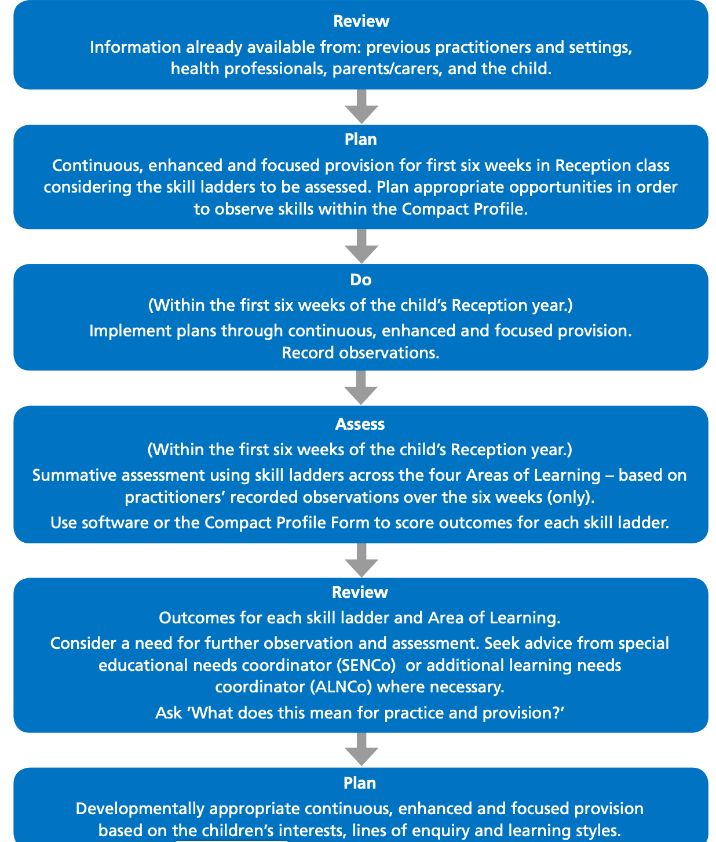

Appendix 2
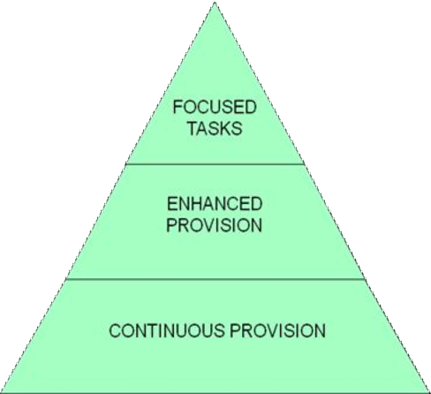

Appendix 3

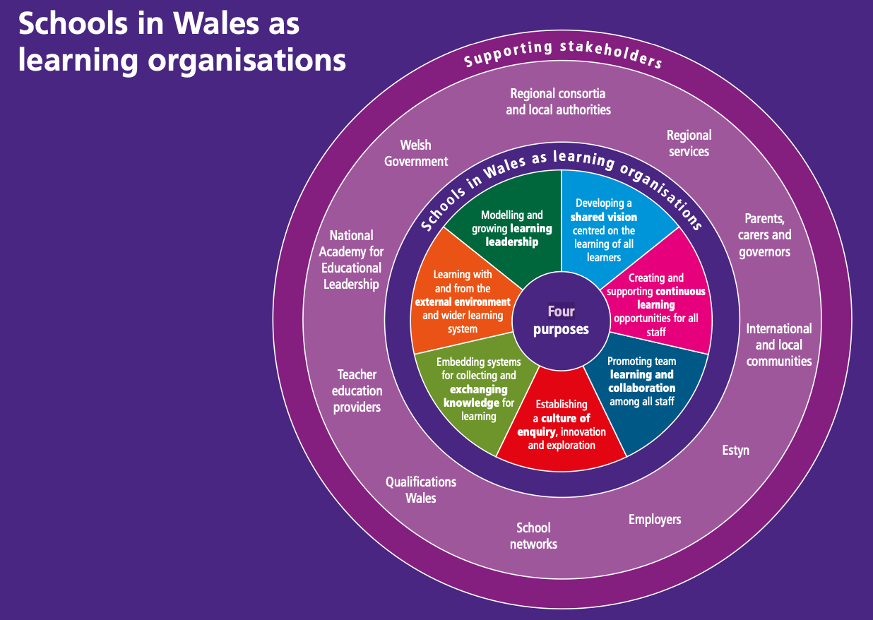

Appendix 4
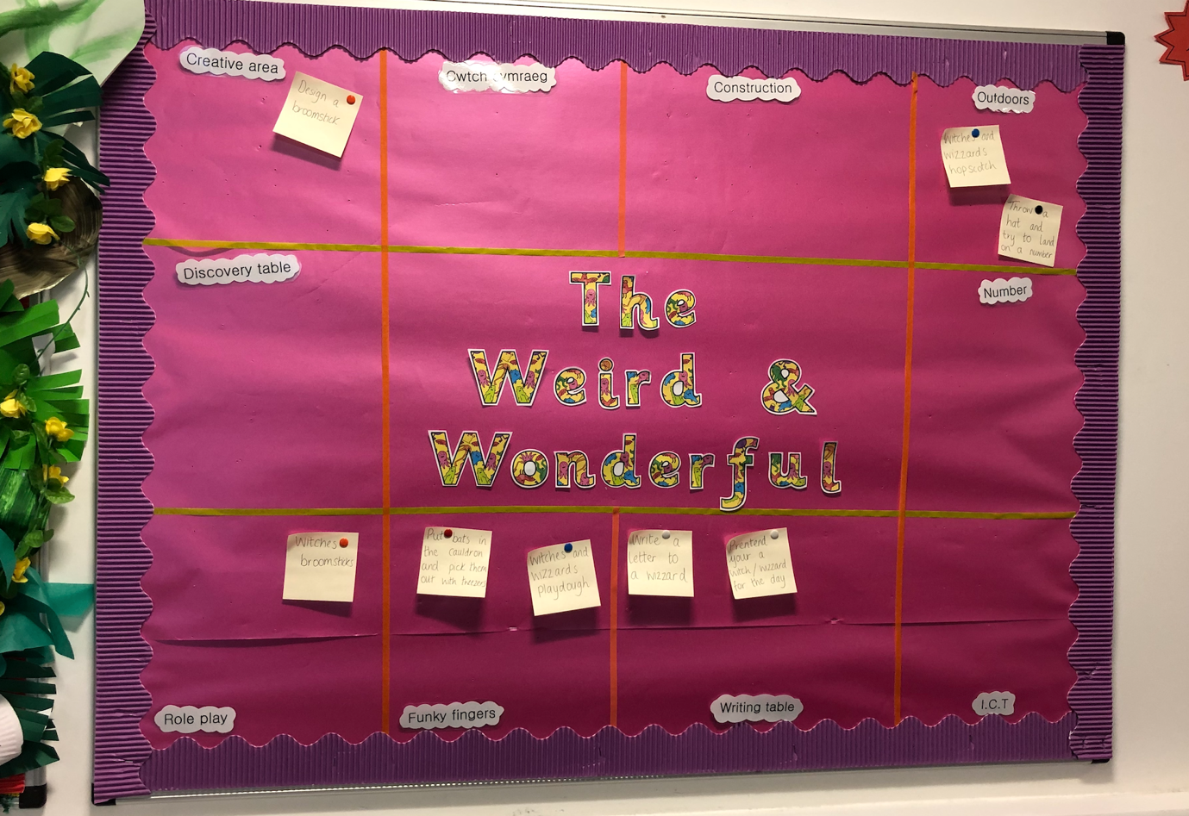
EPIC board examples


