

Student name: Marie France Aurelie Bodo Bodo
Student ID: 2426167
Module name: Introduction to Health and Social Care
Module code: LCHS 4003
Supervisor’s name: Jolly Nwankwo

TASK 1: Poster on Hospital Pharmacy

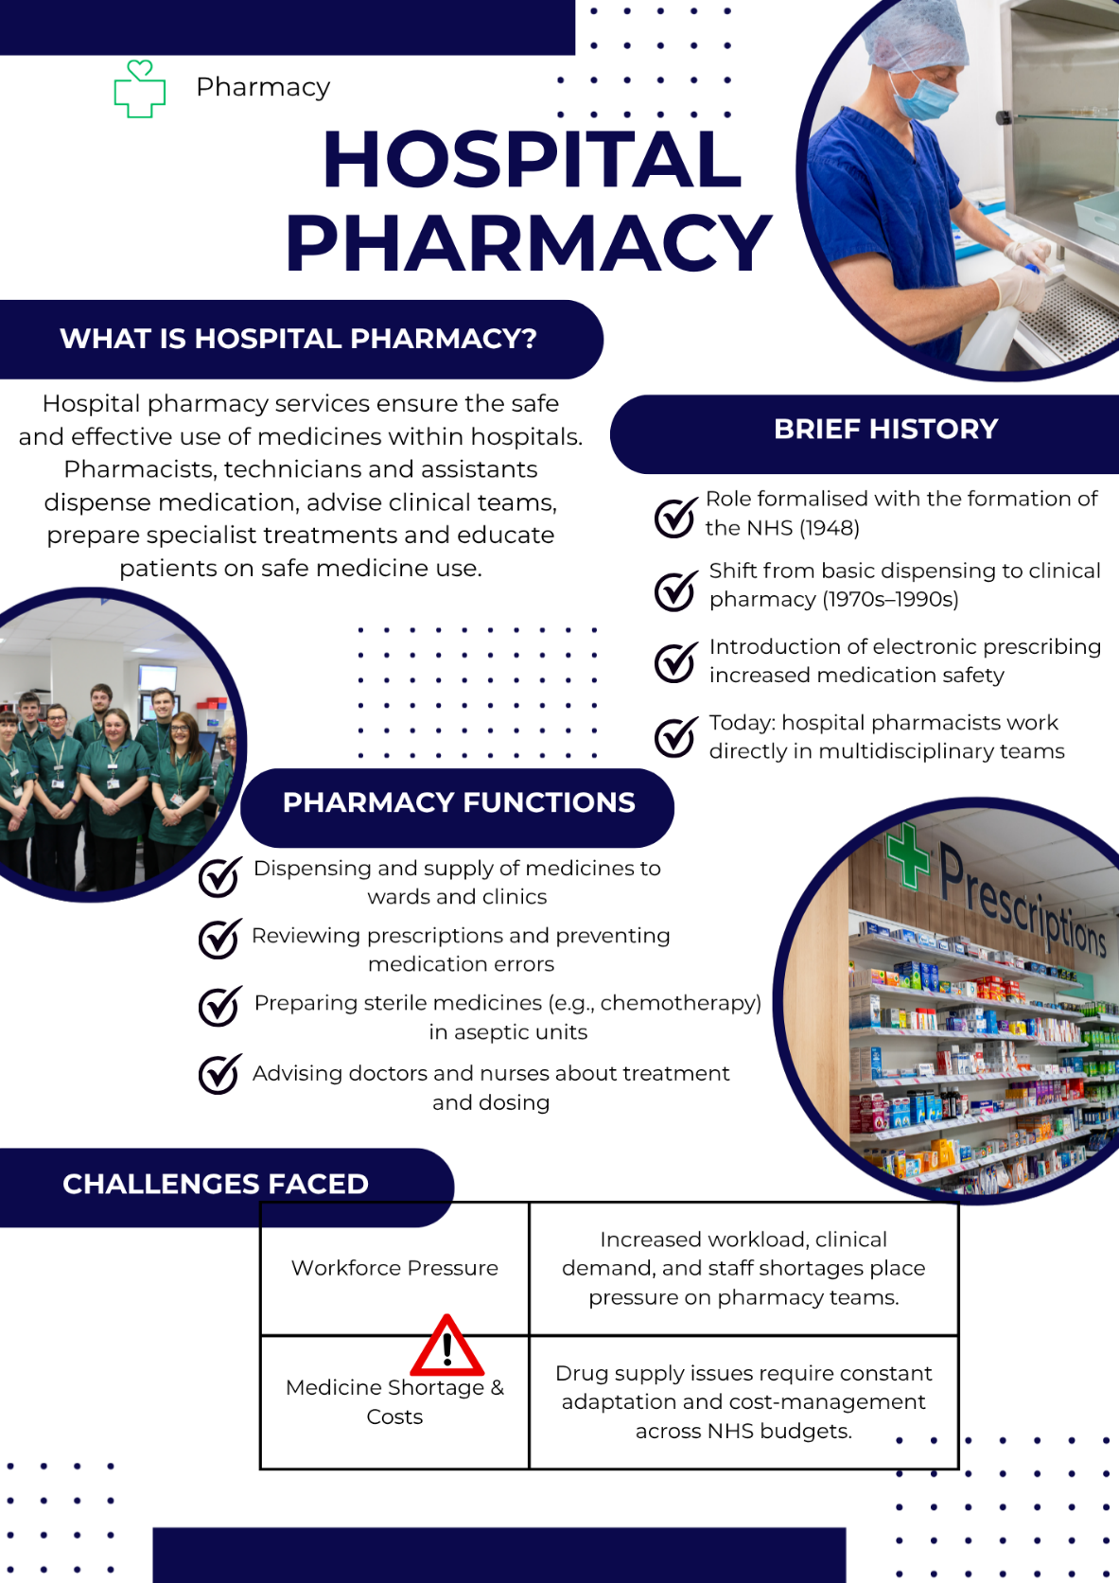
References
- Barnard, A. (2011) Key Themes in Health and Social Care. London: Routledge.
- Glasby, J. (2017). Understanding Health and Social Care. 3rd edn. Bristol: The Policy Press.
- Glasby, J. and Dickinson, H. (2014) Partnership Working in Health and Social Care. Bristol: The Policy Press.
- NHS England (2022) Transforming Pharmacy Services in Hospitals.
- Royal Pharmaceutical Society (2020) Hospital Pharmacy Standards.

Task 2: The Origins of the NHS and Its Current Structure

- Introduction
The National Health Service (NHS) was established in 1948 to provide healthcare that is free at the point of use, funded through taxation, and available to all. Before the NHS, many people could not afford medical treatment, and access to care often depended on income, charity, or local voluntary services. The creation of the NHS marked a significant shift towards a universal health system based on social welfare and equity in healthcare.

- Origins of the NHS
The origins of the NHS are closely linked to the Beveridge Report of 1942, which proposed a new welfare state to tackle “five giants”: want, disease, ignorance, squalor and idleness (Beveridge, 1942). This report highlighted the importance of accessible healthcare for the whole population.
Following the Second World War, there was strong public support for social reform. The post-war Labour government, led by Aneurin Bevan, introduced legislation to establish a national health system funded through taxation. Bevan argued that healthcare should not depend on the ability to pay.
On 5 July 1948, the NHS was officially launched. Its founding principles were:
- Universal access: Healthcare available to everyone
- Comprehensive services: A wide range of treatments included
- Free at the point of delivery: No direct charges to patients.
These principles remain central to the NHS today.
- Development and Evolution
Since 1948, the NHS has expanded to meet the needs of a changing population. Medical advances, an ageing demographic, and increasing expectations have influenced the development of new services and care models. The role of healthcare professionals has also evolved, with greater emphasis on multidisciplinary care and evidence-based practice.
The rise of technology has contributed to more efficient care, including electronic prescribing, telehealth consultations, and digital patient records. However, these developments present new challenges, including training needs and funding pressures.

- Current Structure of the NHS
Today, the NHS in England functions through several key organizations:
Structure | Role
Department of Health and Social Care (DHSC) | Sets policy direction and allocates funding.
NHS England | Oversees planning and ensures national quality standards.
Integrated Care Systems (ICSs) | Regional partnerships coordinating hospitals, GPs, mental health services, community services and local councils.
NHS Trusts and Foundation Trusts | Organisations that run hospitals and specialist services.
General Practices (GPs) | The primary point of contact for most patients and providers involved in long-term condition management.
Healthcare is delivered across multiple settings, including hospitals, community services, mental health services and primary care networks. Some private and voluntary organisations also deliver services under NHS contracts.
- Current Challenges
The NHS faces several major pressures:
- Funding and Demand
An ageing population and a rise in chronic illnesses increase demand for healthcare. At the same time, modern treatments and technology are costly. This can result in long waiting times and pressure on hospital beds (NHS England, 2019).
- Workforce Shortages
Many areas report shortages of doctors, nurses, and allied health professionals. High workloads and recruitment difficulties can affect staff wellbeing and patient safety.
- Health Inequalities
Some communities experience poorer health outcomes due to social, economic, and environmental factors, which the NHS continues to work on addressing.

- Conclusion
The NHS was created to ensure fair and universal access to healthcare, based on need rather than ability to pay. Although the structure and services of the NHS have evolved, the core principles established in 1948 continue to influence healthcare delivery today. Despite challenges such as funding pressures and workforce shortages, the NHS remains a central part of public life in the UK and continues to adapt to meet the changing needs of the population.

References
- Beveridge, W. (1942). Social Insurance and Allied Services. London: HMSO.
- Glasby, J. (2017). Understanding Health and Social Care. 3rd edn. Bristol: The Policy Press.
- NHS England (2019) The NHS Long Term Plan. Available at: https://www.longtermplan.nhs.uk
- Webster, C. (2002). The National Health Service: A Political History. Oxford: Oxford University Press. Department of Health and Social Care (2022)

