
APPENDIX GA36a

LEVEL 4 ASSESSMENT SPECIFICATION

Student name: | James Anthony Gladwin | Student ID number: | 1800150
Programme: | BA PRIMARY EDUCATION with Qualified Teacher Status
Module: | Pedagogy in Practice 1: Essential teaching skills
Module code: | ECAD4001/C | Contribution to Overall Module Assessment (%): | 100%
Lecturer: | Rachel Bendall | Internal Verifier: | Rachel Bendall
Assignment Title: | An individual reflective response to the Professional Teaching Experience | Word count (or equivalent): | 1,500 words
Submission deadline: | 22/03/19 (23:59) | Return date of provisional marks & written feedback: | 29/04/19 (17:00)
Submission method: | All written assessments, where practical and possible, must be submitted via Turnitin unless otherwise instructed by the Lecturer. (Please DO NOT put this assessment specification into Turnitin or it will match many similarities with other students’ submissions.)  Alternative submission method (if applicable):  Late submission of the assessment will result in a late penalty mark. Penalties for late submission: Up to one week late, maximum mark of 40%. Over one week late, 0%. Only the Extenuating Circumstances Panel may approve a change to submission dates.
Academic honesty / referencing: | Academic honesty is required. In the main body of your submission you must give credit to authors on whose research and ideas your work is based. Append to your submission a reference list that indicates the books, articles, etc. that you have used, cited or quoted in order to complete this assessment.

An individual reflective response to the Professional Teaching Experience

Over the course of my first teaching experience I have used my time in school to observe two different year group classes with a large range of abilities and from very different backgrounds. This has enabled me to gain an insight into how I would approach teaching different pupils to meet their educational needs to enable them to flourish academically and socially. My experiences in Professional Teaching Experience 1 can be used in future to demonstrate the required skills expected of a teacher both in classroom situations and out of classroom situations. From my experiences, I have given myself targets on how I believe I can improve to help me show progression in my skills as a teacher in training to aid in providing the best education for students in the future and to prepare me for any situation I can expect to face in the teaching profession.

During my first week of observations with a Year 3 class I personally believed that classroom management could’ve been an issue for me due to the mixture of characters and social groups and my lack of experience in the teaching profession. This refers to S3.3 and my target is to “begin to identify and support more able and talented learners, those who are working below age related expectations, those who are failing to achieve their potential in learning, and those who experience behavioral, emotional and social difficulties”. I addressed this target by having conversations and by working with small groups of children to give me an idea of who were more able and talented learners and who were performing below age related expectations which in turn gave me a great insight into the development of different students in the classroom. I chose an approach based on Piaget’s learning theory of cognitive development which relies on the idea that children can best learn by taking part in activities and exploring. The Plowden report emphasizes the importance of “individual learning, flexibility in the curriculum, the centrality of play in children's learning, the use of the environment, learning by discovery and the importance of the evaluation of children's progress - teachers should 'not assume that only what is measurable is valuable.'”. A similar stance is reflected by Donaldson in his Successful Futures report which details that the purpose of the curriculum should be that children develop as “ambitious, capable learners, ready to learn throughout their lives” and should develop as “enterprising, creative contributors, ready to play a full part in life and work”. The reason this is useful is that I found that when children were finding their work difficult or disinteresting, they can easily become distracted leading to issues arising due to a lack of confidence in classroom management. The next steps I took were to make sure that the children were actively exploring new information in all of their lessons and treating them like detectives where they had to put their “thinking caps” on and discover how they could solve any problems they came up against. This could work for both more talented and able learners and for students who may be performing below age related expectations as both groups of students will be greeted with praise or rewards if they complete their work which provides positive reinforcement from Skinner’s theory of Operant Conditioning. This method of allowing children to play the part of detective is that Skinners theory suggests that small amounts of information should be backed up with praise when correct behavior is displayed increasing the chance that this behavior is repeated in future which should help to promote learning taking place in the classroom. I have chosen these approaches to make sure I progress my skills as a teacher to make sure students can feel confident with their education by constantly promoting good behavior and asking questions tailored to certain abilities to try and install confidence in children who, at first, may be unwilling to answer questions. This can improve the atmosphere in the classroom and can lead to more confidence from all learners to answer questions and learn to not be afraid to answer something wrong.

For my next target I focused on making sure I was “aware of the need to select resources that show they value diversity and are sensitive to the needs of different groups”. I set this target due to high percentage of English as an additional language (EAL) students that were in the school I had been placed in. This factor could play a pivotal role in the educational development of children if the correct resources and support is not given to the correct individuals. I addressed this target by asking the teacher to inform me of who these children were and whether they would need any differences or extra support to complete any tasks I would set in the future. My teacher informed me that all students could work of the same/similar worksheets (depending on the difficulty of the task). However, some students would need extra support from a “more knowledgeable other” to be able to support their learning to push them further to allow them to complete more challenging tasks. I chose this approach to allow me to aid children who are more likely to struggle and to make sure that any issues any children could have are detailed before I set work that they may not be able to complete which could lead them to become demotivated which doesn’t promote Skinner’s theory of Operant Conditioning. My main aim was to implement Vygotsky’s theory of the Zone of Proximal Development (See Figure 1). This theory involves children being supported and given a “boost” to help them transition between the “what is known” zone to the “skills too difficult for a child to master on his/her own” zone which is where “guidance and encouragement” from the teacher should be implemented to allow them to transition across stages that they wouldn’t be able to without the help of a “more knowledgeable other”. The next steps involved in this approach is to see how much help this can provide to students and whether they react negatively to this approach due to the individual differences within the classroom. This could be linked to Kolb’s theory on different learning styles where students must progress through the whole of the cycle to truly learn new information. If this is to be true, students would only be travelling through the first phase of the experiential learning cycle. If the students were to react negatively to the initial lesson, then the teacher can use this information to plan more sessions around the experiential cycle to ground the information for the children to better understand what and why they are being taught this information. I have chosen this way forward to be able to monitor student’s progression especially those who may being held back due to circumstances out of their control, such as being an EAL student.

My time on my first Professional Teaching Experience has opened my eyes to the importance of teachers reflecting on their own practice on a regular basis to enable students get the best support and highest quality of teaching whilst keeping their progression in track with what is suggested by the Welsh government. Donaldson’s Successful Futures report also outlines this notion suggesting that “pedagogy that makes full use of wider skills” is more likely to allow for students to engage in “powerful learning”. Donaldson also mentions that “monitoring and reflecting” are very important to the progression of a child’s education and also suggests that engaging children in “self-assessment and peer assessment” is very important to help them “diagnose their own progress” and what they can do in future to improve their knowledge and skills. During my time on my first Professional Teaching Experience I have taken group work sessions with a teacher present to observe my progress to see how I could improve in future. I found this critical in helping me to improve my skills when leading lessons and giving me fresh ideas that could help me to improve my own lessons to better suit student’s abilities and needs. This was vital in making sure that I was promoting correct behavior and providing quality learning experiences where children felt confident and comfortable to complete the tasks I set.

Reference List:

- Central Advisory Council for Education (1967) Children and their Primary Schools (‘The Plowden Report’)

- Professor Graham Donaldson CB (2015) Successful Futures
Independent Review of Curriculum and Assessment Arrangements in Wales

- Saul McLeod (2018) Zone of Proximal Development
https://www.simplypsychology.org/Zone-of-Proximal-Development.html#scaff

- Saul McLeod (2017) Kolb's Learning Styles and Experiential Learning Cycle
https://www.simplypsychology.org/learning-kolb.html

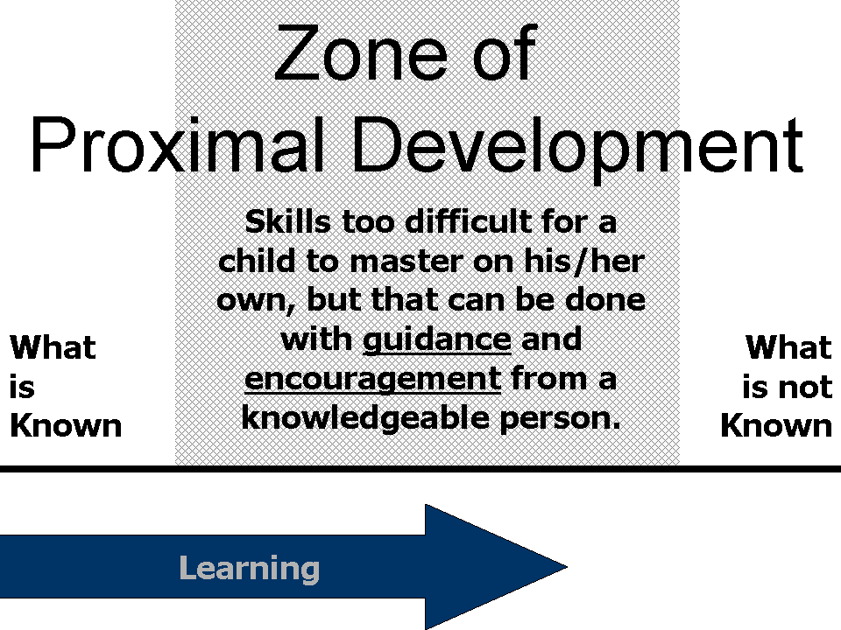
Figure 1

THIS DOCUMENT IS ALSO AVAILABLE IN WELSH

