

LCLM4005
Employability and Career Development
Portfolio of written tasks

Title: Portfolio of Employability Skills, Self-Assessment and Personal Development Planning for a Career in Restaurant Management

Table of Contents
Task 1: Comparison of Two Job Adverts 3
Comparison of Restaurant Supervisor Job Adverts 3
Task 2: Self-Assessment Using SWOT Analysis 4
SWOT Analysis 4
Evidence of Readiness for Employability 5
Task 3: Employment Goals and Personal Development Plan 7
Employment Goals 7
Short-Term Goals (Within 12 Months) 7
Long-Term Goals (3–5 Years) 7
Personal Development Plan 7
References 9

Task 1: Comparison of Two Job Adverts

Comparison of Restaurant Supervisor Job Adverts
The two job ads for restaurant supervisors were analysed as examples of hospitality organisations. The candidate will be required to run day-to-day restaurant operations, train staff, ensure customer satisfaction and maintain health and safety standards in both of these positions.
The following skills were needed for the initial placement at The Ivy Collection: leadership, customer service, communication, problem-solving skills and food safety regulations. Responsibilities involved staff supervision, customer complaints, staff training and organising the restaurant.
The second position at Pizza Express was for a job as a team player, leader, communicator, organiser and customer service specialist. Successful candidate will take responsibility for staff morale, quality service, performance tracking and be able to assist the management of the restaurant.
While each ad necessitates a specific skill set and understanding, there are a couple of commonalities. Both employers emphasised:
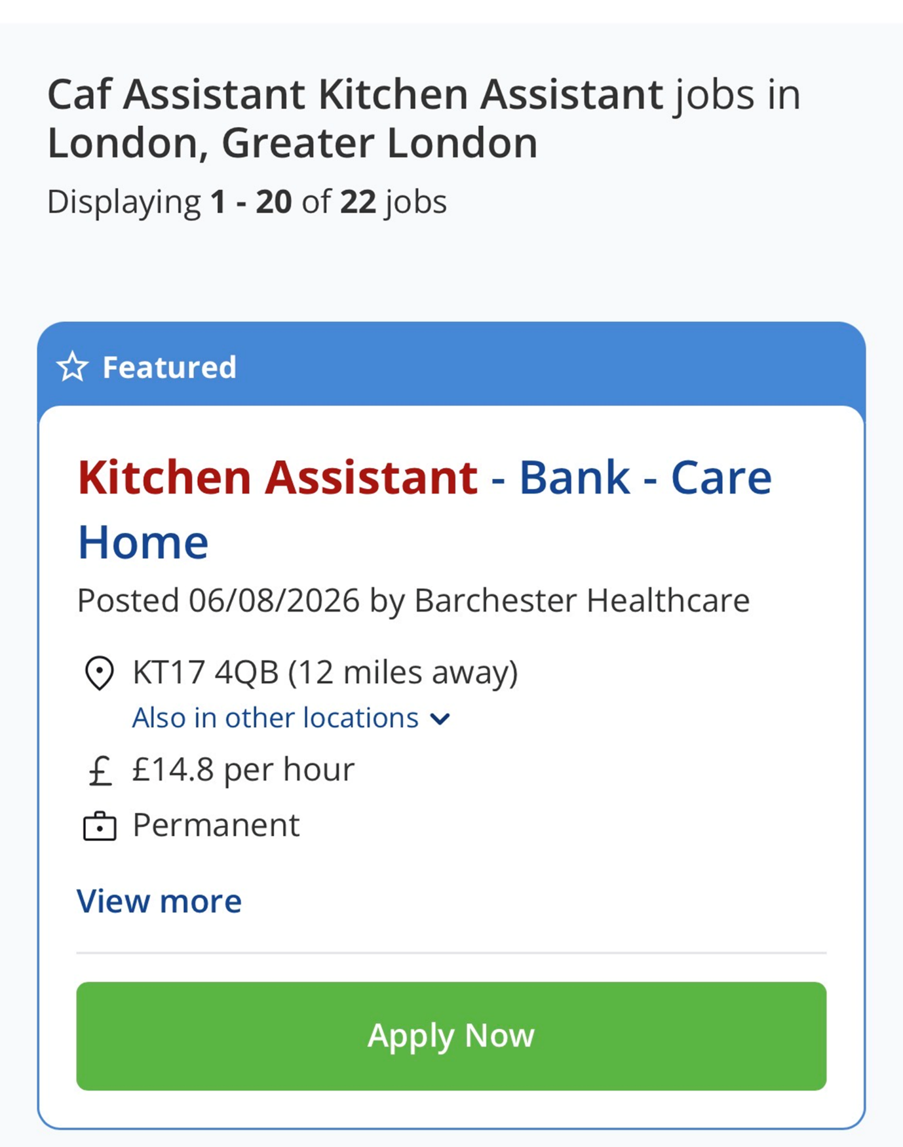

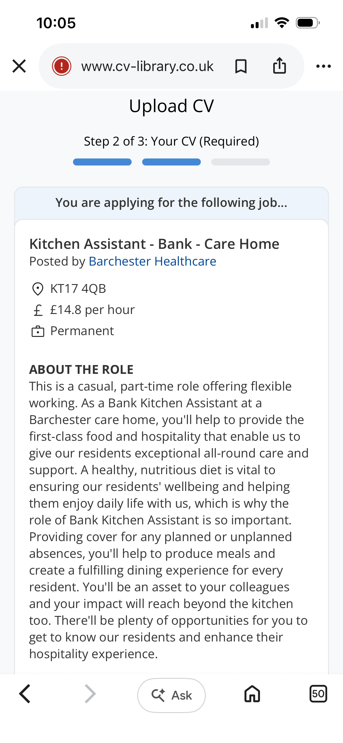
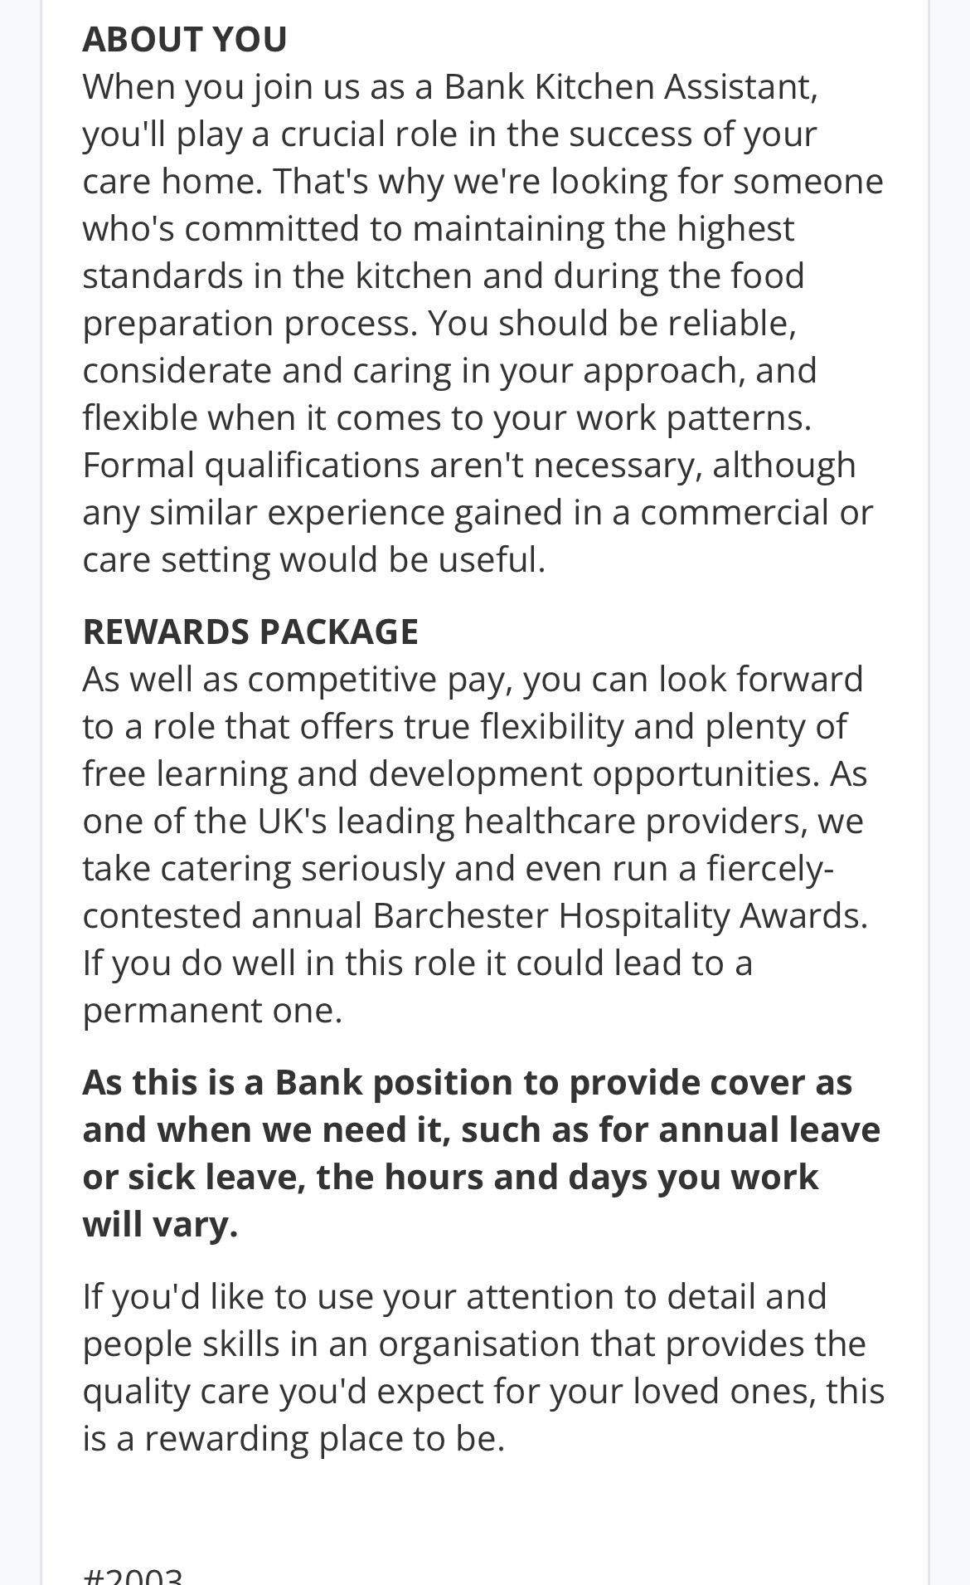
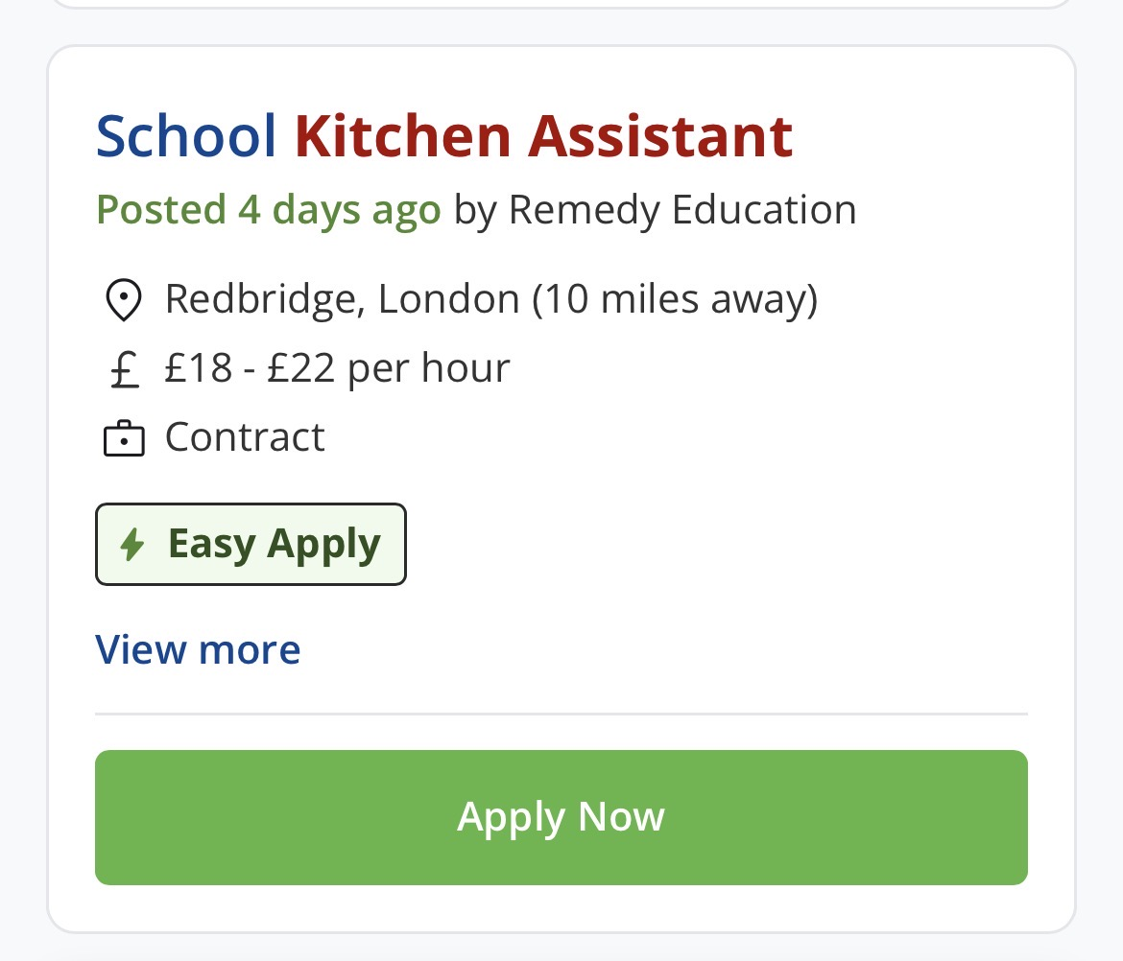
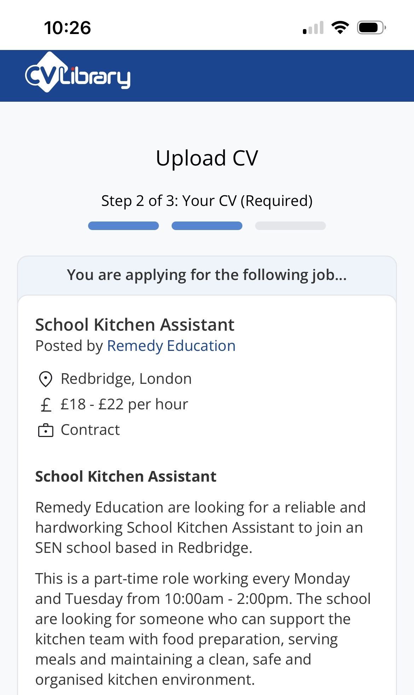
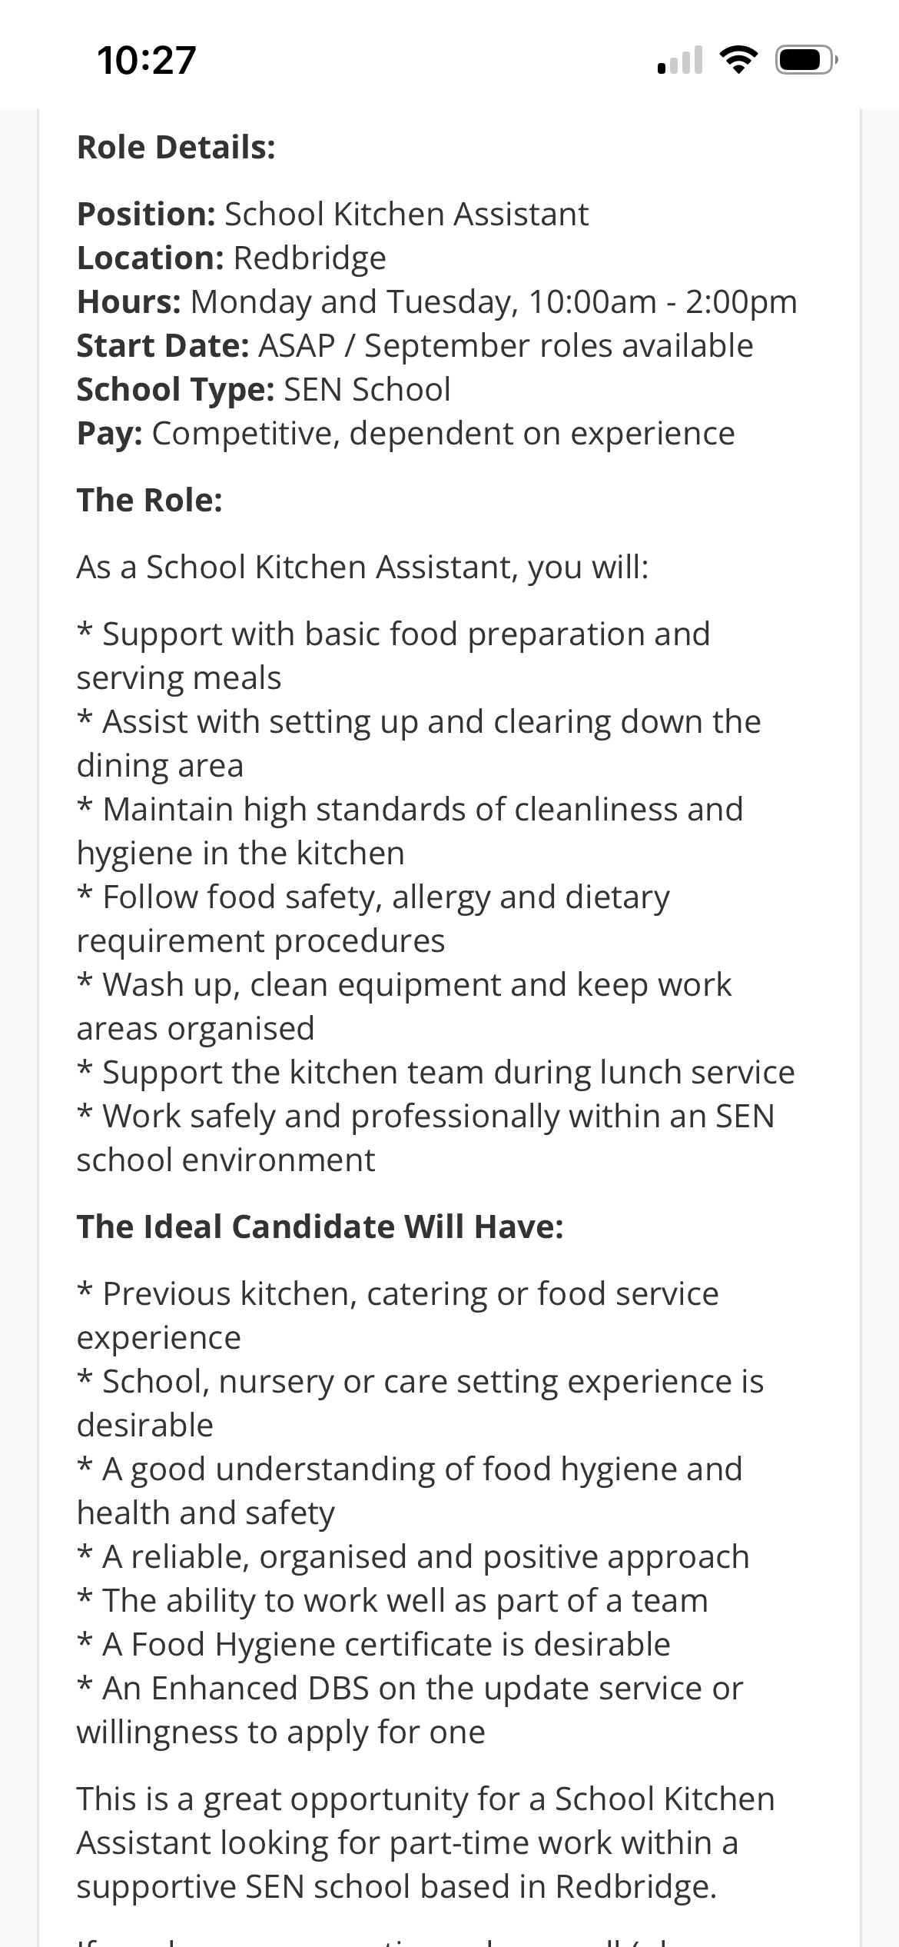

Common Skills | Common Knowledge Areas
Communication | Food safety regulations
Leadership | Restaurant operations
Teamwork | Customer service standards
Problem-solving | Health and safety procedures
Customer service | Staff supervision
Of these skills, communication is especially crucial for the position of Restaurant Supervisor. Clear communication to employees, handling customer complaints, communicating with kitchen staff and maintaining a positive relationship with employees are all things that supervisors can use that will allow them to effectively communicate with the rest of the team. Armstrong and Taylor (2023) feel that one of the key abilities required for successful management is communication, as it helps to improve teamwork and organisational performance.
Communication Skills will be needed on a daily basis as a Restaurant Supervisor to keep the restaurant running smoothly. If it was busy and/or there were any problems in the service, I would be able to communicate with the kitchen staff and let them know what the customers require, arrange the staffing, and work out the issues within the required time. Also, communicating well with the employees would make it easier to motivate and better to develop a positive working climate with the employees (Robert et al., 2020). Besides, effective communication can also improve customer satisfaction, as well as offer professional communication to customers.
By summarising the two job advertisements, the skills required for success in a hospitality management job can be deduced as being crucial: leadership, communication, customer service, and problem-solving. I will be more employable and will help advance myself in the restaurant world with these.

Task 2: Self-Assessment Using SWOT Analysis

SWOT Analysis
One employability tool which can be used is a SWOT analysis, which allows individuals to identify their strengths, weaknesses, opportunities and threats (Cottrell, 2023).
Strengths
I have an outstanding ability to provide customer service. In the restaurant, I've learned to be able to communicate and provide good service to customers. In addition, I'm a team player and perform well under pressure. The other is flexibility. Working in restaurants can be hectic and unpredictable, with staff members needing to react quickly to shifts in circumstances (Nickson, 2022). I can stay cool under pressure and be effective in challenging situations.
In addition, I have good time management skills. To be organised and responsible due to balancing work and study. The following strengths are beneficial for the future supervisory role, as supervisors must be able to coordinate their staff's work to ensure the quality of services.
Weaknesses
I have a number of strengths, but some things need to be improved. The downside is that it's not a program that has leadership experience. I back my colleagues, but I have not been a manager of a team yet. The other disadvantage is being heard in public. Sometimes also nervous when I am called on to speak in front of a large audience, like when conducting staff meetings or training staff.
Another disadvantage is the deficiency of knowledge in the field of financial management in restaurants (Robbins and Judge, 2022). Often the supervisors/managers are also involved in the budgeting, cost control and stock management. There is a need to develop knowledge and understanding of these areas in preparation for future leadership positions.
Opportunities
I have a couple of opportunities to further enhance my career. I'm currently at a restaurant where I have the experience to work hands-on and learn from the supervisor and manager. Opportunity to develop leadership skills and gain knowledge of the restaurant business (Simpson et al., 2025).
The other one is from an Academic programme. In Business Skills for the Workplace, I am building my knowledge of Business, communication skills, teamwork skills and problem-solving skills. Courses such as leadership, food safety and hospitality management are also available and can develop new skills in these courses (Bratton et al., 2021).
A good attitude and hard work in the hotel and hospitality industry still have a part to play in getting promoted. Continued training and experience will lead to advancement in my career with the goal of becoming a Supervisor and/or Manager.
Threats
One possible threat is competing candidates who might have more experience or qualifications in the field of management. The other challenge is the dynamic nature of the hospitality sector, such as modifications in the field of technology and customer expectations (Armstrong and Taylor, 2023). To stay competitive, staff need to continually develop their skills.
The economy is extremely fragile, and this could impact jobs in the hospitality industry. Reducing spending can impact various aspects of a restaurant, including its operations and hiring practices. So, the ability to learn through life and develop professionally is vital to employability.

Evidence of Readiness for Employability
I believe that I have the necessary skills and would be willing to work up to promotion and employment in the future, as I feel that I have learned from my experiences in school and the work that I have done.
I have gained knowledge of being a customer service employee, team player, communicator and problem solver from working in a restaurant. I help their clients and address problems with their services, troubleshoot, and work with the staff to ensure the restaurant runs smoothly, for instance (Robert et al., 2020). All these experiences have helped me to prove my capability to function in a professional setting.
But not just my work experience has made me more employable; my academic studies have made me more employable. Research, communication, and Organisation skills have been developed through coursework, presentations and group activities. On-time work delivery is an indication of responsibility and self-management.
My managers and peers have commented that I am dependable and have a positive attitude. Customer feedback on my services and professionalism has been positive, as well. This feedback shows that I have attributes that employers would seek in their employees.
In addition, I am more confident and conscious of what is expected in the job due to being involved in workshops to prepare me for employability and interview preparation. These experiences have enabled me to seek out areas of development and to expand my level of preparedness for future career opportunities (Cottrell, 2023).
In summary, my work experience, education and personal development were all factors that have prepared me for work and helped me to advance in my career within the hospitality industry.

Task 3: Employment Goals and Personal Development Plan

Employment Goals
My weakness, in my opinion, for SWOT analysis is limited experience in leadership, limited confidence in public speaking and little knowledge in financial management.

Short-Term Goals (Within 12 Months)
The first short-term objective that I have is to become a better leader, taking on more responsibilities at work and assisting supervisors as I can. My second aim will be to build up my confidence in speaking in public via class presentations and situations at work. Finally, I would like to attend the courses in food safety and hospitality management so as to enhance my skills and knowledge.

Long-Term Goals (3–5 Years)
My career objective is to become a Restaurant Supervisor, then transition to a Restaurant Manager in the long term. The goals are important because they play a major part in my career goal, which is to work in the hospitality industry and become successful in it. If I am able to get these jobs, then I will be able to apply those leadership skills to develop my team and to help my organisation achieve its goals.

Personal Development Plan
Development Area | Action Required | Timeline | Resources Needed | Success Measure
Leadership Skills | Assist supervisors and lead small tasks at work | 6–12 months | Manager guidance | Increased responsibilities
Public Speaking | Participate in presentations and workplace discussions | 6 months | University workshops | Improved confidence
Financial Knowledge | Study hospitality finance and cost control | 12 months | Online courses and textbooks | Better understanding of budgeting
Professional Qualifications | Complete food safety and hospitality training | 12 months | Training providers | Certification achieved
Career Progression | Apply for supervisory opportunities | 2–3 years | Work experience and mentoring | Promotion to supervisor
Through this development plan, I will be able to build on my weaknesses, enhance my employability and grow my career within the restaurant and hospitality industry.

References
Armstrong, M. and Taylor, S. (2023) Armstrong’s Handbook of Human Resource Management Practice. 16th edn. London: Kogan Page.
Bratton, J., Gold, J., Bratton, A. and Steele, L. (2021) Human Resource Management: Theory and Practice. 7th edn. London: Red Globe Press.
Cottrell, S. (2023). Skills for Success: Personal Development and Employability. 6th edn. London: Red Globe Press.
Nickson, D. (2022). Human Resource Management for the Hospitality and Tourism Industries. 4th edn. London: Routledge.
Robbins, S.P. and Judge, T.A. (2022) Organisational Behaviour. 19th edn. Harlow: Pearson.
Robert, L.P., Pierce, C., Morris, L., Kim, S. and Alahmad, R. (2020) ‘Designing Fair AI for Managing Employees in Organisations: A Review, Critique, and Design Agenda’, arXiv. Available at: https://arxiv.org/abs/2002.09054
Simpson, E., Ermovick, R. and Sloane, M. (2025) ‘Human Resource Management and AI: A Contextual Transparency Database’, arXiv. Available at: https://arxiv.org/abs/2511.03916.

