
MBA – Masters of Business Administration
Human Resource Management
LCMB7000
Assessment 1

Student name : Aparna sharath Ezhava
Student ID : 2210726

Executive Summary
Human resource management is considered one of the important aspects of any organization. This report mainly focuses on two sectors including the UK labor market and strategies used by HR after Brexit and during Post Covid period. The author first describes the UK's economy which includes the UK in the world place, cities, GDP per capita, growth, etc. under the labor market description, the author explains employment rate, gender-based participation, inflation, and the economic statistics after Brexit. The author identifies a few labor market issues as Covid-19, unemployment, and health issues. In task two, changes in human resources in the Post Covid period are explained that including human-centric culture, personalized rewards schemes, data-driven decision-making, health and safety, and digital transformation. The author further focuses on changes in Human Resourcing Strategies in the post-Brexit external environment that includes overseas recruitment, being transparent, workforce planning, attracting young UK workers, different approach to attracting EU workers, and methodology.

Contents

Executive Summary 2
Contents 3
List of Figures 5
1 The current state of the labor market in the UK 6
1.1 The UK’s economy 6
1.2 The UK’s labor market 6
1.2.1 Employment rate 7
1.2.2 Gender-based participation 8
1.2.3 Inflation 8
1.2.4 Economic statistics governance after EU exit 8
1.3 Labor market issues in the UK 8
1.3.1 Covid-19 pandemic impact 8
1.3.2 Unemployment 9
1.3.3 Health issues 9
2 The emerging changes in Human Resourcing Strategies in the post Covid-19 10
2.1 Human-centric culture 10
2.2 Personalized rewards schemes 10
2.3 Data-driven decision making 11
2.4 Health & safety the new priority 11
2.5 Digital transformation 11
3 The emerging changes in Human Resourcing Strategies in the post-Brexit external environment 12
3.1 Overseas Recruitment 12
3.2 Being transparent with employees 12
3.3 Workforce Planning 12
3.4 Taking different approaches to Attract EU Workers 13
3.5 Attracting young UK workers 13
3.6 Methodology 13
4 Conclusion 14
References 15

List of Figures
Figure 1: The UK's labor force 7
Figure 2: Employment rate Figure 3: Unemployment rate 7
Figure 4: Labor market in the UK 9

The current state of the labor market in the UK

The UK’s economy
The UK has the fifth-largest economy in the world Based on market exchange rates that emphasize the UK has a partially regulated market economy. London is considered one of the largest financial centers in the world that rank second place in the world according to the 2020 Global Financial Centers Index (Tiwasing, Clark & Gkartzios, 2022). The largest city GDP in Europe is London which is the capital of the UK and the most international visitors of city in the world. In the British economy, Tourism is very important with over 27 million tourists arriving per year (Upadhyay, Kumar & Akter, 2022). The United Kingdom Internal Market Act 2020 enshrines the UK's internal economic market to ensure the continuity of trade in services and goods without internal barriers in the UK’s four countries (Tiwasing, 2022). The minimum wage is 1,598.69 EUR per month and the GDP per capita is 47,334.36 USD by 2021. GDP growth rate is 7.4% based on the 2021 annual change (Mahato, Kumar & Jena, 2021). The core success behind the UK’s economy is its labor force.

The UK’s labor market
Over the past seven years, the labor market performance of the UK has been remarkably significant towards growth and productivity. Its Unemployment rate is 3.8% by 2021 (Fennell, 2022). In the UK, the total number of Workforce Jobs increased by 290,000 recording 35.8 million by 2022 June (Aldrick, 2022). After the Post Covid era, that was the first time. In regular pay, there was a 5.2% growth from May to July 2022 while the average total pay of employees was 5.5% (MCINTYRE, 2022). The UK's labor force increased by 0.04% in September 2022.
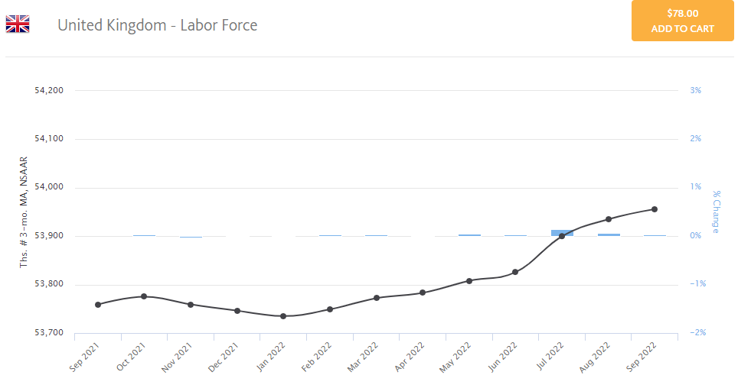
Figure 1: The UK's labor force
(Source: Mahato, 2021)

Employment rate
The unemployment rate has reduced to below 4% which is significantly considered the lowest since the mid-1970s. The employment rate is 75% for the 16 to the 64-year-old workforce which has reached historic highs (Allas, 2022). But, in September 2022, the aged of 16 to 64 years decreased by 0.2%. The Bank of England indicates longer-term analysis. A number of factors are reflected by the rise in UK employment rates. The many people unemployed over 12 months continued to decrease (Ellison, Blomqvist & Fleckenstein, 2022).
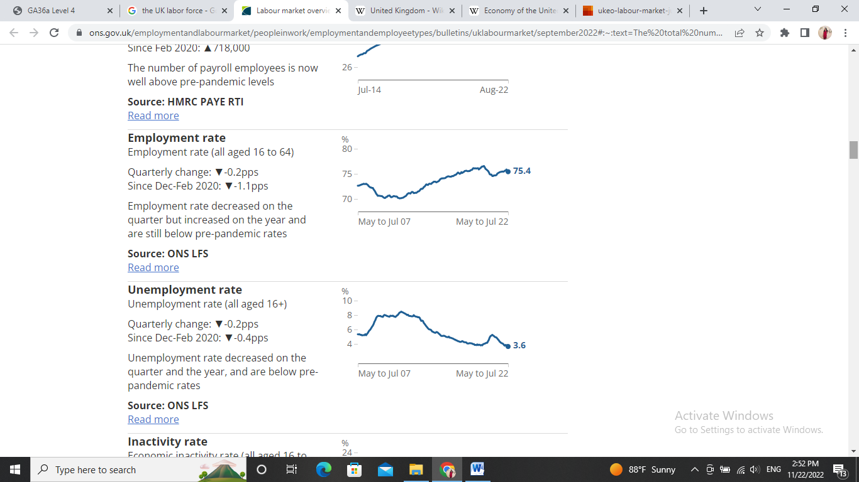
Figure 2: Employment rate Figure 3: Unemployment rate
(Source: Ellison, 2022)

Gender-based participation
Towards higher female participation in the workforce, there is a long-term trend. To retain in the workforce for longer, people are encouraged, especially women whose pension limit age has extended from 60 years to 65 years since 2011(Manning, 2021). Over the latest three-month time, both self-employed and Full-time employee’s workers increased while part-time employees decreased. A monthly increase for pay-rolled employees is indicated in August 2022.

Inflation
By 2.6%, total pay fell over the year and by 2.8%, regular pay fell (Pizzinelli & Shibata, 2022). For the private sector, there was average regular pay growth that was 6.0% from May to July 2022 and for the public sector, that was 2.0% which emphasizes the difference between the public sector and private sector (Pizzinelli, 2022). In the post-Covid period, the UK inflation hit 11.1% in October 2022 according to the consumer prices index that directly impacts the UK's labor market. When the prices of goods and services increase, people need more salaries in providing basic human needs (Manning, 2021).

Economic statistics governance after EU exit
New governance arrangements started following the UK's exit from the EU that supports the implementation and adoption of high-quality standards for UK economic statistics (Schnepf, 2017). International comparability is promoted by these governance arrangements. For Advice, the new National Statistician's Committee is appointed by this new governance framework.

Labor market issues in the UK

Covid-19 pandemic impact
The labor market is severely affected by the different forms of issues from time to time. The Covid-19 pandemic situation hit the employment opportunities in 2020 and 2021 as well. The first coronavirus lockdown in March 2020 had a huge impact on the labor market with economic inactivity (Bieńkowska, Koszela, Sałamacha & Tworek, 2022). Between January-December 2020, 825,000 people, many people in work fell. By almost 400,000, unemployment increased which resulted in creating 327,000 economically inactive people (Turner & Baker, 2022). Since 1994, working hours in the UK dropped to the lowest. But both employment and unemployment levels started improving by the start of 2021 and peaked in December 2021 (Bieńkowska, 2022). Two years after the start of the pandemic, employment levels are still 350,000. Redundancies are below pre-pandemic levels In January-March 2022 while job vacancies are at higher levels. The Coronavirus Job Retention Scheme is introduced for Over 11.7 million jobs. Self-Employment Income Support Scheme is introduced to over 1.3 million (Bieńkowska, 2022).

Unemployment
Unemployment rates for minority ethnic groups increase between January-March 2020 and 2022 as well. At the start of the pandemic, a loss of income is likely to experience by minority ethnic groups (Gupta, Pierdzioch & Salisu, 2022). Unemployment rates have also increased over the pandemic mainly due to decreases in economic inactivity rates. More than among women, Employment among men is decreased significantly over the pandemic. The economic inactivity for men is over 48% of the workforce as a high record that is between January-March 2022 (Gupta, 2022). At the start of the pandemic, the oldest and youngest employees were most likely to lose their jobs. By January-March 2022, pre-pandemic levels helped to recover Youth employment. Low-paying jobs also increased in 2021 and 2022 (Blundell, Costa Dias & Cribb, 2022). There are lesser unemployed people than vacancies for the first time.
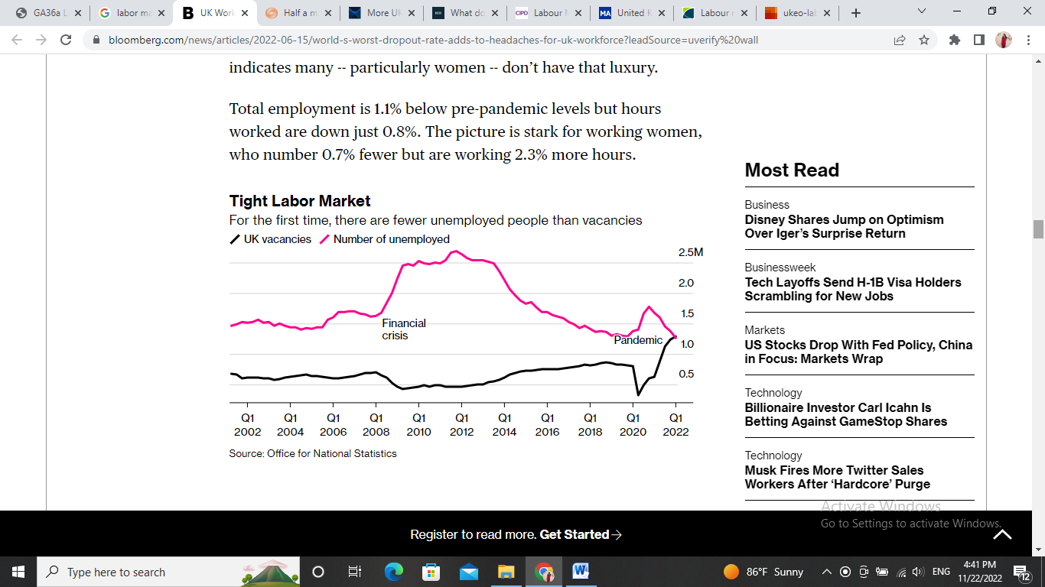
Figure 4: Labor market in the UK
(Source: Blundell, 2022)

Health issues
225,000, Aged between 16 to 64 are under "long-term sick" which that means for at least two years, 376,000 people have had Covid symptoms in relation to mental health issues according to ONS estimations (Abdulla, 2022).

The emerging changes in Human Resourcing Strategies in the post Covid-19
The success or failure simply depends on the level of human resource management of any organization that is improved by human resources strategies. The way of human resources strategies has changed significantly in the post-Covid era (He & Harris, 2020). The global economies and businesses have been disrupted by the Covid-pandemic situation. The role of HR is becoming even more important in occupational health and safety, remote working, employee engagement, and communication. Hence, emerging changes in Human Resourcing Strategies in the post-Covid are focused on in this discussion as follows.

Human-centric culture
By shifting towards a people-centric workplace, organizational culture is redefined that becomes a top priority for HR departments for the purpose of o adopting more flexible working arrangements (He, 2020). A major shift towards hybrid working models is highly encouraged in the UK working places. For example, 30% of the workforce is accounted by remote working in 2022 in the UK but somehow that is a 7% decrease from 2021 (Abdulla, 2022). 60% of people worked from home during the first lockdown in the UK. For UK companies in 2021, Over 20 million people worked remotely (Abdulla, 2022). In the UK, 1 in 5 office employees is currently working a hybrid model. For the whole of 2021, 8% of UK workers did not enter the office (Watermeyer, Knight, Crick & Borra, 2022). Although this hybrid model is considered a positive change, the existing organizational culture is threatened by this transition. Due to different working conditions, the social dynamic between employees is not the same. To establish a balanced structure, on and off check-ins are organized to manage relationships (Watermeyer, 2022). Their recommendations are needed to check on how best to transition to the new normal through satisfaction and pulse surveys. HSBC banks worldwide plan to shift to hybrid working to reduce physical space in the post-Covid era.

Personalized rewards schemes
Through personalized and adaptive compensation structures, the performance of the employees is changed. The pandemic opened the discussion regarding employee benefits and rewards in the long term although many organizations had short-term strategies (Donthu & Gustafsson, 2020). At a higher level, employee performance and productivity is improved through incentives. In the post-Covid era, the most expected personalized reward or incentive is flexible working conditions that help to have a work-life balance. The employees are allowed to design their own packages after the Covid-19 pandemic.

Data-driven decision making
To promote data-driven decision-making, workforce analytics are leveraged. Across all business sectors, industries, and organizations, a rise in data-driven decision-making is witnessed over years. HR is enabled to gauge employee engagement, experience, and satisfaction (Donthu, 2020). To forecast their workforce requirements, organizations should continue to leverage analytics as a result of COVID-19 that better reduce costs and optimize revenues. To monitor and measure workforce productivity and performance, more reliance on analytics is heavily taken into consideration (Hite & McDonald, 2020). The strategic development, talent acquisition, and management decisions are determined by HR by regularly monitoring and analyzing employee engagement metrics, and performance.

Health & safety the new priority
By focusing on mental and physical well-being, occupational health and safety are maximized. Throughout the workplace, installing sensor-based technologies, and social distancing measures are implemented to reduce the risk of spreading the Covid again (Hite, 2020). Due to the pandemic and disruption, high levels of anxiety and stress are endured. HR has a moral and ethical obligation to ensure the wellbeing of the employees including vaccination, wearing masks, using sanitizer, etc.

Digital transformation
Through disruptive technologies, the digital transformation agenda is accelerated. Reduction cost is aimed by the HR of organizations today to create more value with fewer resources. 59% of Europe CFOs and 62% of Middle East CFOs are seeking the establishing new ways of working and adopt automation (Dutta, Vedak & Sawant, 2022). Emerging technologies like VR, AI, and AR are allowed for different applications in the HR domain. To improve all HR functions including onboarding, recruitment, training, etc, these technologies are helpful (Dutta, 2022). The recruitment process is enhanced by data analytics and big data that can identify top talent.

The emerging changes in Human Resourcing Strategies in the post-Brexit external environment
On 31 January 2020, the UK officially left the EU which shaped emerging changes in Human Resourcing Strategies in the post-Brexit external environment as follows. Brexit influences many sectors in the country both positively and negatively.

Overseas Recruitment
With the post-Brexit immigration system, UK-based leaders and US leaders employ EU nationals. Incoming talent should be supported by HR professionals when they arrive in the UK (Abbot, 2019). Permission is needed to find UK nationals working in an EU country. By the European Commission, shared information is reviewed. There is no free movement between the EU and UK countries for people. When managing EU nationals in the UK, the correct documentation is needed to provide (Mahato, Kumar & Jena, 2021). When the UK left the EU, the HR departments had to prioritize the UK employees in recruitment. By reducing all forms of benefits in the UK being worked there as an EU member, the UK has to look for overseas recruitment.

Being transparent with employees
For businesses, Brexit creates different new rules and regulations that impact employee mental health. For many reasons, things are in flux across businesses (Blog, 2019). By developing a clear understanding of Brexit, this can be mitigated focusing on impacting many businesses, and then communications. The organizational leaders navigate them into a post-Brexit world (Lattice, 2021). All policies and regulations must clearly be communicated with existing employees and recruits to indicate being transparent. In addition, when a company is being transparent to its employees, there is no way of doing corruption or forms of illegal activities.

Workforce Planning
7% of the UK workforce left the country due to Brexit and those vacancies are needed to fill (Dutta, 2022). The UK candidates have little success recruiting because UK workers are unwilling, overqualified, disabilities. To attract skilled employees, the UK companies start providing different incentives such as work-life balance policies, Flexible working, holiday incentives, discounts, and fitness programs, etc that help employees feel valued, motivated and involved (Lattice, 2021). The employees are allowed autonomy, freedom, space, and time. Employee retention is increased through a positive company culture through recommendations, referrals, and a positive brand image.

Taking different approaches to Attract EU Workers
EU citizens have the right to work in the UK during the transition period till introducing a new immigration system which changes the working rights of EU citizens in the UK. New immigration rules might result in a lesser choice of EU citizens to work in the UK (Lattice, 2021). From the job advert, career and Job opportunities can be clearly communicated. Job adverts are used by HR departments and hiring managers for those who like to start the job in the UK with low-pay, low-skilled roles (Abbot, 2019). Successful mixed workplaces are maintained by facilitating voluntary English classes, regular communication, and ensuring management priorities. Such forms of job motivations engage, attract, and retain non-skilled and skilled EU workers across business functions (He & Harris, 2020). Lifelong learning concept is highly encouraged in the UK after Brexit prioritizing locals for the vacancies.

Attracting young UK workers
According to estimations, 1 in 3 graduate persons are not happy with their current job in the UK hence they are in urgent need of rewarding careers while UK businesses are in need of skilled workers. 8,000 new technology, engineering, and teachers are recruited by addressing the technical skills shortage by the UK government in the last year which invests £ 84 million into engineering education (He & Harris, 2020).

Methodology
The different aspects of labor market activity in the UK are reflected by Labor market statistics that cover unemployment, employment, the Claimant Count, redundancies, economic inactivity, earnings, vacancies, jobs, labor disputes, and labor productivity (Lattice, 2021). For the UK, a set of labor market statistics is published on a monthly basis by ONS. The Trade and Investment and Department of Enterprises in Northern Ireland publishes Data for Northern Ireland (Lattice, 2021). From different forms of sources, Labor Market estimates are to come. The main source of data is The Labor Force Survey which facilitates estimates of unemployment, employment, economic inactivity, activity hours worked, and redundancies (Lattice, 2021). To compile data on workforce vacancies, jobs, labor disputes, and average weekly earnings, Business surveys are also used. By using definitions and concepts set by the International Labor Organization, much data is produced. The Bank of England and government are the main users of labor market data that monitor and make government policies (Lattice, 2021). National, local government, businesses, the general public, and academia are other data users regarding the UK labor market.

Conclusion
The UK labor force is experienced different forms of challenges mainly due to inflation, the Covid-19 pandemic situation, Brexit, etc. The core success behind the UK’s economy is its labor force. The labor market is severely affected by the different forms of issues from time to time. The way of behaving and making decisions of the HR departments of the companies has changed significantly in the post-Covid period in the UK. The HR departments of the companies use different forms of strategies in the modern world with the support of advanced technology in the globalized business world.

References
A.Abbot. 2019. THOUGHT LEADERSHIP. https://blog.v-hr.com/blog/hiring-strategies-after-brexit
A.Fennell. 2022. StandOuts. https://standout-cv.com/remote-working-statistics-uk#:~:text=In%202022%20the%20amount%20of,a%207%25%20decrease%20from%202021.
Bieńkowska, A., Koszela, A., Sałamacha, A. and Tworek, K., 2022. COVID-19 oriented HRM strategies influence on job and organizational performance through job-related attitudes. Plos one, 17(4), p.e0266364.
Blog. 2019. MHR. https://mhrglobal.com/uk/en/blog/how-brexit-will-affect-hr
Blundell, R., Costa Dias, M., Cribb, J., Joyce, R., Waters, T., Wernham, T. and Xu, X., 2022. Inequality and the COVID-19 Crisis in the United Kingdom. Annual Review of Economics, 14, pp.607-636.
Donthu, N. and Gustafsson, A., 2020. Effects of COVID-19 on business and research. Journal of business research, 117, pp.284-289.
Gupta, R., Pierdzioch, C. and Salisu, A.A., 2022. Oil-price uncertainty and the UK unemployment rate: A forecasting experiment with random forests using 150 years of data. Resources Policy, 77, p.102662.
He, H. and Harris, L., 2020. The impact of Covid-19 pandemic on corporate social responsibility and marketing philosophy. Journal of business research, 116, pp.176-182.
Hite, L.M. and McDonald, K.S., 2020. Careers after COVID-19: Challenges and changes. Human Resource Development International, 23(4), pp.427-437.
J.Turner, M. Baker. 2022. Gartner. https://www.gartner.com/smarterwithgartner/9-future-of-work-trends-post-covid-19
Lattice Team. 2021. Resources for Humans. https://lattice.com/library/4-ways-hr-can-navigate-brexits-impact-on-uk-business
Mahato, M., Kumar, N. and Jena, L.K., 2021. Re-thinking gig economy in conventional workforce post-COVID-19: A blended approach for upholding fair balance. Journal of Work-Applied Management.
Manning, A., 2021. Monopsony in labor markets: A review. ILR Review, 74(1), pp.3-26. Pizzinelli, C. and Shibata, M.I., 2022. Has COVID-19 Induced Labor Market Mismatch? Evidence from the US and the UK. International Monetary Fund.
P. Aldrick. 2022. Bloomberg. https://www.bloomberg.com/news/articles/2022-06-15/world-s-worst-dropout-rate-adds-to-headaches-for-uk-workforce?leadSource=uverify%20wall
S. Aabdulla. 2022. Reuters. https://www.reuters.com/markets/europe/half-million-uk-workers-drop-out-workforce-citing-long-term-illness-2022-11-10/
S. MCINTYRE. 2022. Economics. https://www.economicsobservatory.com/what-do-the-latest-data-tell-us-about-the-uk-labour-market
Schnepf, S.V., 2017. How do tertiary dropouts fare in the labour market? A comparison between EU countries. Higher Education Quarterly, 71(1), pp.75-96.
T. Allas. 2022. McKinsney and Company. https://www.mckinsey.com/uk/our-insights/the-mckinsey-uk-blog/more-uk-employees-are-leaving-their-jobs-than-ever-how-businesses-can-respond
Tiwasing, P., Clark, B. and Gkartzios, M., 2022. How can rural businesses thrive in the digital economy? A UK perspective. Heliyon, 8(10), p.e10745.
Upadhyay, A., Kumar, A. and Akter, S., 2022. An analysis of UK retailers’ initiatives towards circular economy transition and policy-driven directions. Clean Technologies and Environmental Policy, 24(4), pp.1209-1217.
Watermeyer, R., Knight, C., Crick, T. and Borras, M., 2022. ‘Living at work’: COVID-19, remote-working and the spatio-relational reorganisation of professional services in UK universities. Higher Education, pp.1-20.

