The Sublime Landscape Essay

This essay will discuss the theories behind the show Shock and Awe and the sublime. The exhibition aims to bring about a collaboration of artists and art works of Ansel Adams, Peter McKinnon, Sonja Bullaty, Angelo Lemo and Steven C. Wilson and provoke an analytical response to their understanding of the sublime in their art, and seeks us to find a deeper connection between ourselves as lonely beings and that solitude and sublimity of the natural world as depicted in the artists’ works.

Firstly, the theories of Edmund Burke will be discussed and the definition of sublime. Secondly, the way that the sublime is connected to Landscape Photography will be looked at. Finally, the works of Landscape photographers Ansel Adams and Peter McKinnon’s show exhibits will be used for reviewing this topic. Artists like Ansel Adams and Peter McKinnon set out to enlighten us about our appreciation of their pieces that evoke in our deepest memories. This exhibition aims to show us a world of nature at its purest and isolating; it evokes our gratitude and acceptance of a world more sublime than it can possible be. These art works will also be related to Burkes Theories and the sublime.

The sublime has been an attractive and challenging concept for all creative artists and philosophers, for hundreds of years, since it was defined as something of a necessity if a piece of work was to have significance strive to engage and articulate the sublime through their work. The sublime could be defined as the natural phenomenon with can evoke awe and wonder. Many artist such as Ansel Adams, Peter McKinnon, Sonja Bullaty, Angelo Lemo and Steven C. Wilson, describe the word sublime as the shock and awe factor, such as infinite skies avalanches etc.

In the journal ‘The Fear of the Sublime’, they define the sublime as ‘sudden and over- whelming, vanquishing any incidental beauty.’ (VELDE, 2010). The Irish theorist and philosopher Edmund Burke said that there were experiences of nature, which had supplied a kind of thrill or shudder of perverse pleasure, mixing fear and delight.

The passion caused by the great and sublime in nature, when those causes operate most powerfully is Astonishment, and astonishment is that the state of the soul in which all its motions are suspended, with some degree of horror … No passion so effectually robs the mind of all its powers of acting and reasoning as fear. For fear, being an apprehension of pain or death, operates in a manner that resembles actual pain. Whatever therefore, either with regard to sight, is sublime to … Indeed terror is in all cases whatsoever, either more openly or latently the ruling principle of the sublime. (Morley, 2010)

The sublime is an awesome experience at first, and could be almost a religious experience. And this is the reason why artist such as Ansel Adams and Peter McKinnon have tried to capture the sublime. Landscape photography as a genre has been related to geography and links into a certain order. (Wells, 2011). This is one of many definitions of landscape photography but from a sublime perspective, this is another element to landscape photography on how we see it.

Landscape photography is concern with all different types of landscapes. Landscape photographers mainly capture the moment of the experience of nature, but can also capture man-made object that we implemented. Photographers mainly capture the moment of the experience that they have witness, but this can also be resolved with man-made landscapes.

Ansel Adams likes to capture the untouched raw landscape in his photography and the feeling of loneliness that the image creates. However, Adams has taken many good photographs that include a wide variety of subjects, and does not consider himself to be a landscape photographer “Like all good artists he distrusts categorise.” (Adams, 2006: 2). The image of Carter National Park expanse of the landscape with the scale of the mountains and the large lake, creates that feeling of the sublime to the viewer.

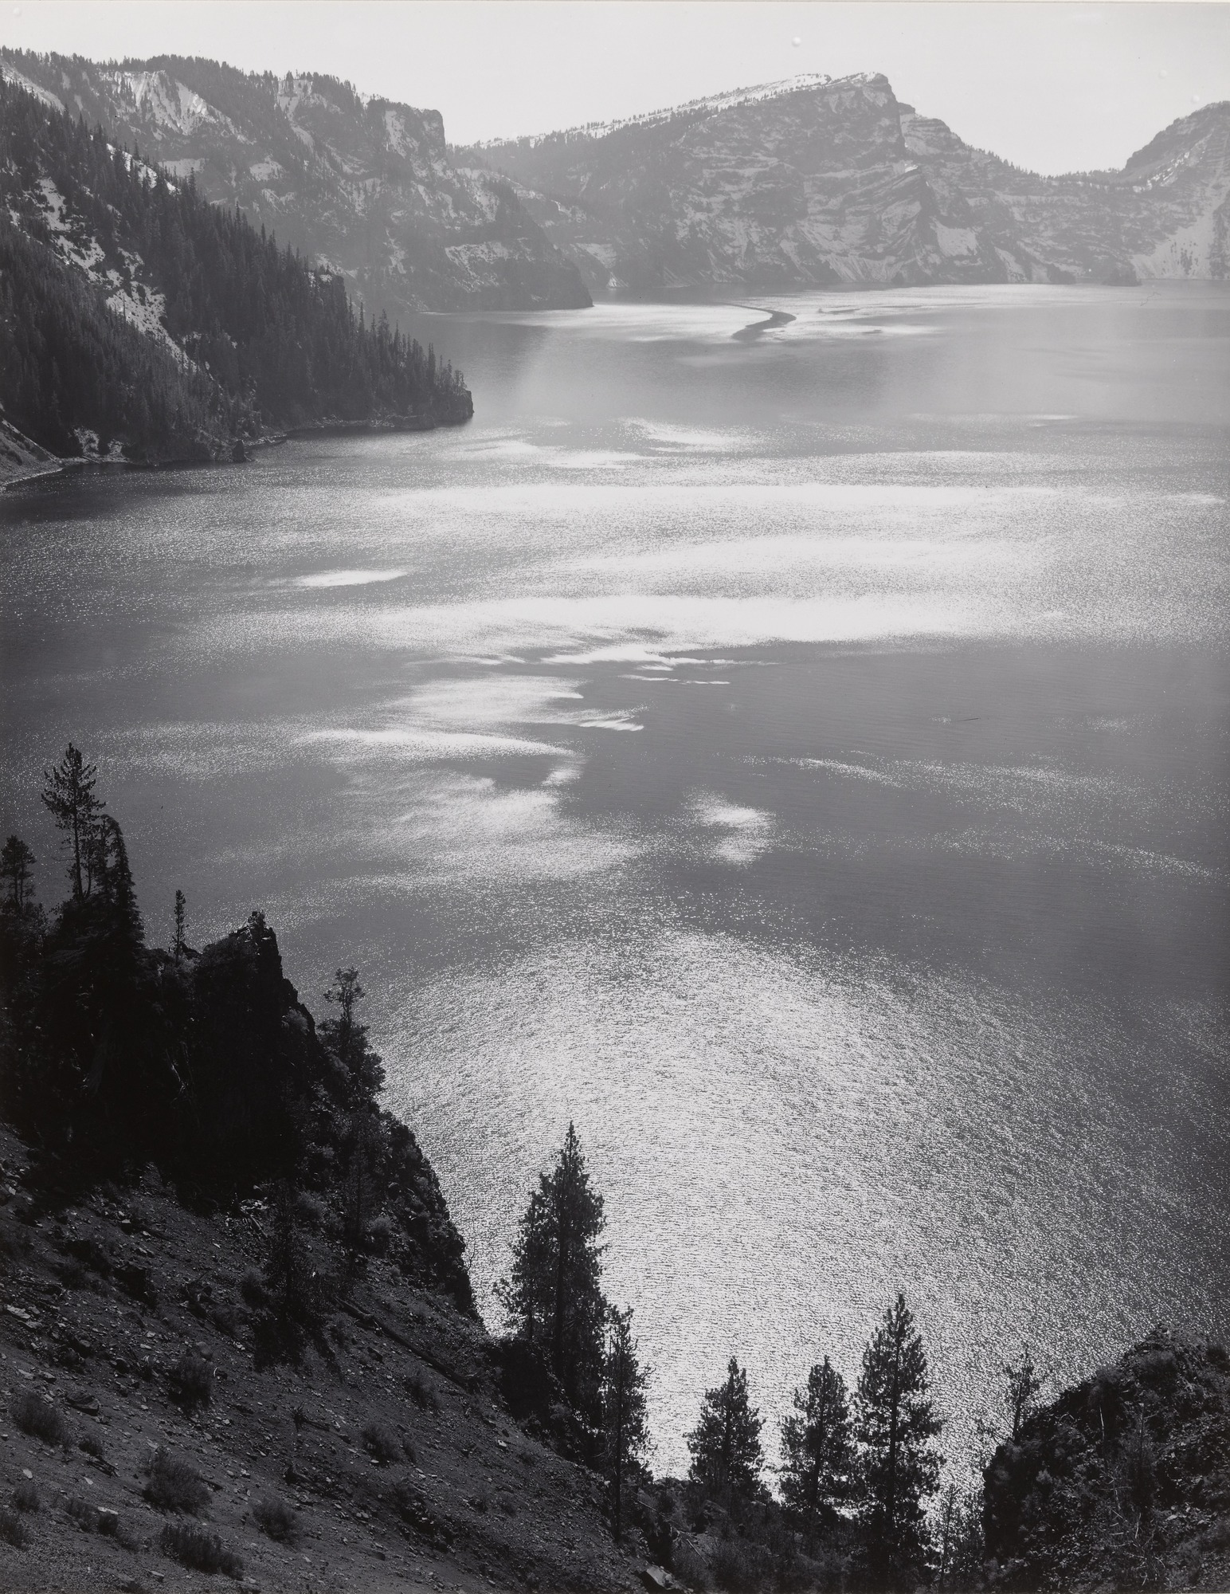“There were experiences of nature, which had supplied a kind of thrill or shudder of perverse pleasure, mixing fear and delight.” (Burke)

Figure 1
Oregon Adams. A, 1943. Crater
National Park, Oregon Manhattan: Museum of Modern Art
Available at: https://www.moma.org/collection/works/58256 Accessed: March 11th 2018

This image was taken by Peter McKinnon when he visited Narvick. The photograph that we see has the same principle as Ansel Adams by capturing the feeling of the loneliness of the landscape, which makes us feel isolated when we see the image for the first time.

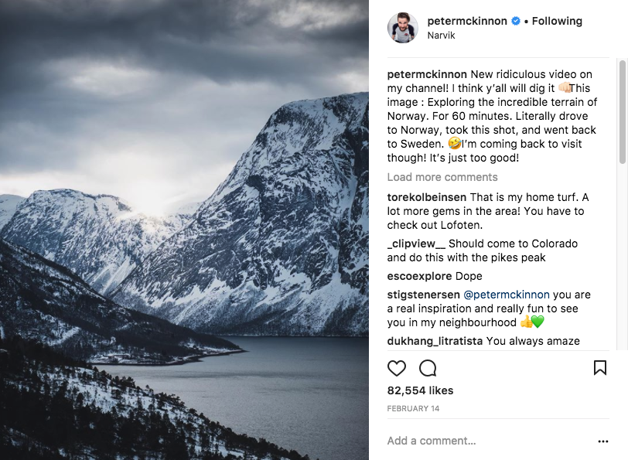
Like in Adams photography, Peter has taken a wide variety of urban landscapes and continues to explore more of the sublime to this day.

Figure 2
Peter McKinnon, B. 14th February 2017. Narvick, Norway
Available at:
https://www.instagram.com/p/BfMMHQ6BijL/?taken-by=petermckinnon Accessed: March 11th 2018
Spring Thaw, High Sierra

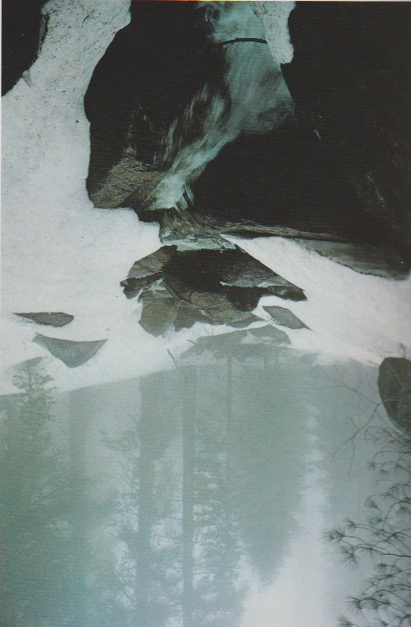
In the book Landscape photography, Sonja Bullaty say’s “A photographer should try to still symbols so that the picture represents universality as much as possible.” This photography of the Spring Thaw, High Sierra, is a fine illustration of what she was trying to achieve in this image.

This photograph expresses the words of Sonja Bullaty because like in Ansel Adam’s work, she has captured the loneliness of what it was like to be in an untouched environment by producing this classic photograph.

Figure 1
Sonja Bullaty. C, 1984. Spring Thaw. New York: American Photographic Book

Birch Trees, Acadia, Maine

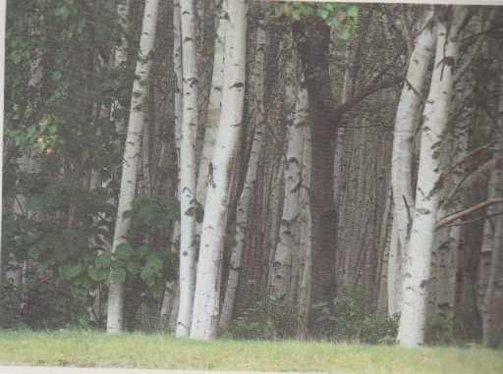
Birch Trees, Acadia, Maine Angelo Lemo photographs, show a different side of the sublime and how it can be viewed. Lemo, has a passion for birch trees which started when he was a child (landscape photography book). This is a different side to the sublime because instead of your typical photographs of mountain regions or grand landscapes.
Figure 2
Angelo Lemo, D. 1974. New York: American Photographic Book
Willow Trees, Akun Island, Aleutian Island

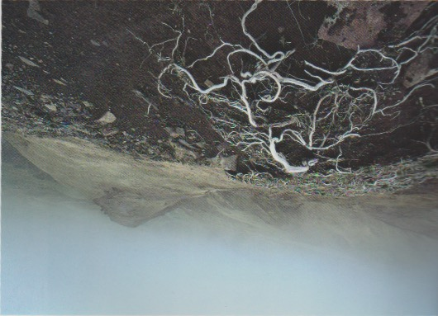
This image by Steven C. Wilson of the Willow Trees shows us the sublime of survival, and how they manged to live a long live. The way that these willow trees cling on to life is awesome in a different way than we normally see your normal grand landscape.

Figure 2
Steven C. Wilson, E. 1983. New York: American Photographic Book

The way that the sublime is manifests in landscape photography can be through the grand landscapes, but can also be shown in a small features of a landscape.

Bibliography

Books
Morley, S. (2010). The Sublime: Documents of Contemporary Art. London: The MIT Press.
Sund, H. (1984). Landscape Photography. New York: American Photographic Book .
Szarkowski, J. (1977). The Portfolio of Ansel Adams. London: Little, Brown and Company Bulfinch Press.
Wells, L. (2011). Land Matters: Landscape Photography, Culture and Identity. London: I.B. Tauris.

Jurnoals
VELDE, P. (2010). Fear of the Sublime. 68, 217-231.
Barbara Novak. (1972). American Landscape: Changing Concepts of the Sublime (Vol. 4). Kennedy Galleries, Inc.

