Checking your University Email
It is important you regularly monitor your University Email. Besides regularly logging in online, you can also choose to have emails come directly to a mobile device such as a tablet or mobile phone, or forward your emails to another account.

To add your University Email to a mobile device you should add a new ‘Exchange’ account with your user details (studentnumber@student.uwtsd.ac.uk).
More specific guidance can be found at http://www.uwtsd.ac.uk/ithelp/online-guides/email--calendar-guides/
~~~
To forward your email to another account, you need to log in to your Office 365 account. The quickest way to do that is follow the link from the “Quicklinks” page on the University website (http://www.uwtsd.ac.uk/quick-links/) or go direct to https://www.outlook.com/uwtsd.ac.uk

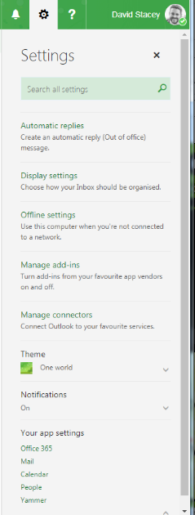  1. Click on the ‘Cog’ icon in the top right, and from the menu that appears, choose ‘Your app settings’ > ‘Mail’ | 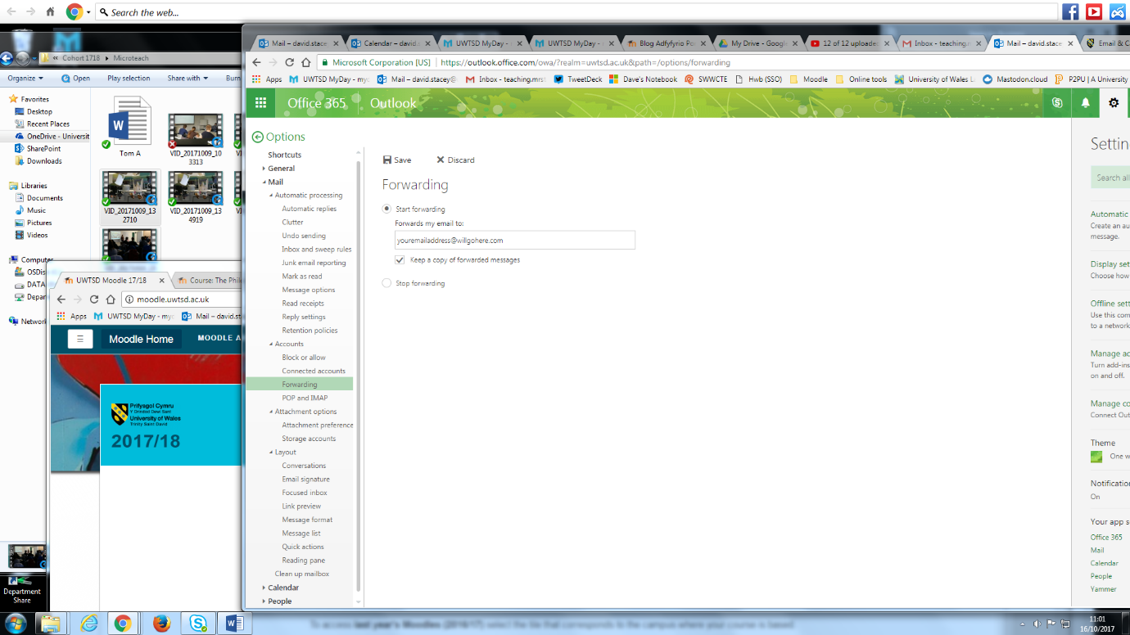  2. From the new menu on the left of the screen, choose ‘Forwarding’ (around half way down the screen).  Click ‘Start forwarding’ and add your usual email address in the space provided, and tick the ‘Keep a copy of forwarded messages’.  Click Save

