Embedded C Assignment

Henry Rennison
Student Number: 2218326

Introduction

The purpose of this report is to show the uses of programming in C to complete a set of tasks. The tasks were then completed using proteus and a CCS compiler. C is a general-purpose computer programming language that is simple and flexible to use. C is characterised by its structured programming approach.
The circuit used has 6 inputs which were the 4 switch positions, the potentiometer and a button. The circuited consists of 11 outputs. The tasks were set around using different switch positions to call a different routine of code.

Global

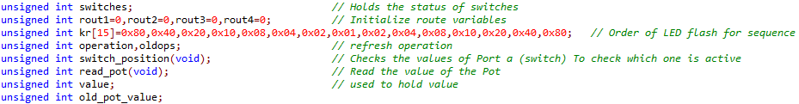
This is where all the global commands are set up. The first one (switches) will keep the status of a switch while it remains in the same spot. The second line is used to start route of variables for each routine. The third line (kr[15]) is where the order of led flashing is for task two. It will read from left to right.
The next line (operation,old ops) is used to refresh the current operation. The line (switch position) is used for checking that the position of the switch hasn’t changed so the programme knows when to change routine. The Read Pot line is for reading the value of the potentiometer.

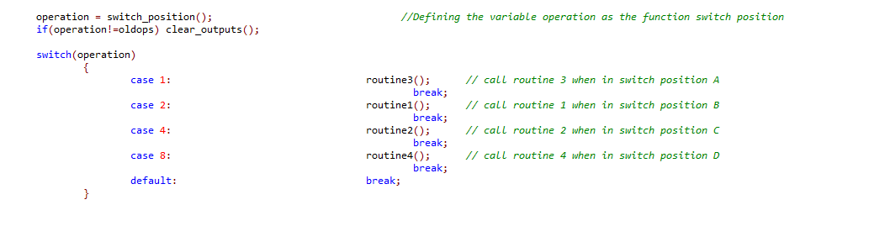
This part of the config is for checking what position the switch is in and directing it to the correct routine. This is also where the config for checking if the switch position has been changed is.

Task 1
This task involved spinning the motor clockwise when the pot value is below 75 or anti clockwise when the pot value is 175 and higher. The motor will not spin when the pot value is between 75 and 175. Part of the task was also to display the value of the pot on the LCD and the terminal.

This part of the routine is simply displaying the pot value on the console.
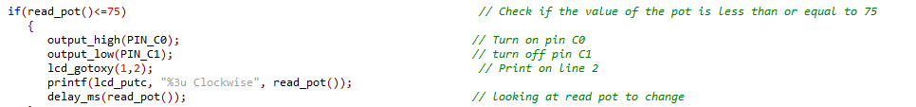
In this section it is checking that the pot value is less than 75 and if it is it then sets PIN C0 to on and C1 to off, this will then spin the motor clockwise. The next line (lcd_gotoxy) is setting the text to be displayed on the second line of the LCD. The (printf) is telling the LCD what data to display on the screen. Finally, the (dealy_ms) line is checking if the pot value has changed and if not continues to display the current pot.
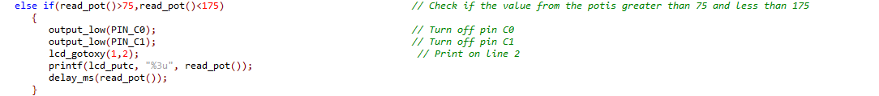
This section of code is for when the pot value is between 75-175. Both pins (C1/C2) are set to low which means that the motor will not spin. The text on the LCD is also se to be on line 2 as above. It will then check the pot value to see if there has been a change.
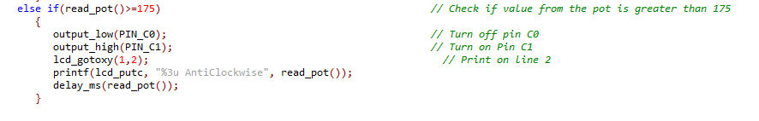
This section of code is for when the pot value is over 175. With only Pin C1 being set to high the motor will spin anticlockwise, it will also display anticlockwise on the terminal and on the LCD.

Task 2

This Task was to get all of the LEDs to flash in a sequence from left to right and then back the other way. It was also to have the word “Kit Mode” display in the centre of the 4th line of the LCD. This message should also be mirrored on the terminal. This sequence should be started when the switch is moved into switch position C.

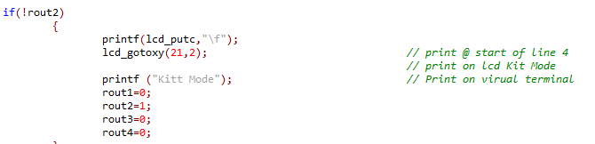
In this section once the correct routine has been selected by changing the switch position it will start the above. The (printf) and (gotxy) functions are setting the text on the LCD screen and what line it goes on.
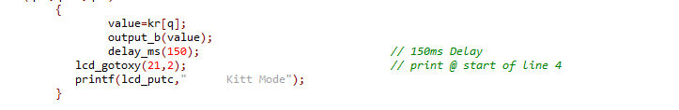
The first part of this text is beginning the sequence by calling (kr) which is where the sequence is stored for which order the lights should flash. The next part of the text is sending the command to output b which Is the LEDs and then it is setting the delay to 150ms (delay_ms). The print to LCD and terminal is doubled up here because there was an issue with the Led and terminal lights flickering so much they were unreadable.

Task 3

Task three was to display the value of the potentiometer on the LED and terminal. It also required the values to be converted to binary and displayed on the LEDs. This should be activated when the switch is in position A
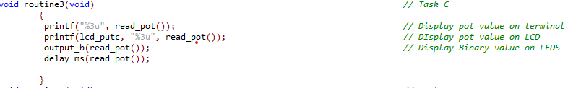
This shows on the first line of text the pot value is being sent to the terminal. The seconds line is displaying the same pot value to the LCD. It sends the value to the LEDs to be shown in binary. The Delay line is checking for a change in the pot value.

Task 4

Task four was for the LCD and terminal to show clockwise on the screen and for the motor to spin clockwise when the button is pressed and held. It should then stop once the button has been released and clear both the LCD and the terminal. The text should be displayed on line four of the LCD.

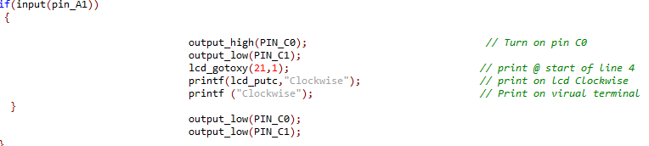
This line of code is all part of an if statement, meaning it will continue to run if the (if) criteria is met. In this section it is looking for an input from (pin_A1) which is the button on the circuit. This means as long as the button is pressed the sequence will keep looping.

Non-Task Code
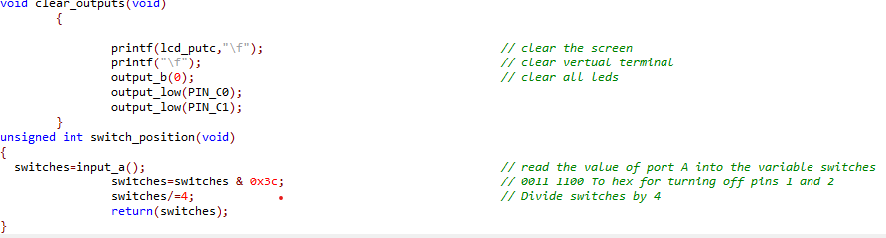
Void clear outputs task is to clear the LCD, terminal and LEDs. It clears the LCD and terminal by sending \f to them which clears all text on the screen. It then sets the output to LEDs to 0 which turns them all off. The final step of this part is setting both the pins to the motors to low which stops them from spinning. The second Part is the switch_position code which is essentially constantly checking the position of the switch and checking for it to change so it can then call a different routine to be run.

Conclusion

In conclusion looking back over all the code and how the programme works there is some duplicated lines of code especially around the LCD and terminals. If the code was to be re written it could be trimmed down by removing some duplications when needed. One of the other issues with code is that the text on the terminal and LCD flickers on some of the switch positions, this is due to the code looping and re running each section multiple times.

