Roxana Gherman
1920090
BMHP4019_BIRM
Psychology in Health and Social Care
Rebecca Kavanagh and Dr. Mark Gallagher-Read
Written Assignment (Case Study)

Table of content

Introduction……………………………………………………………………………………………3

1.Social Identity Theory………………………………………………………………………………4
2. Theory of Planned Behaviour……………………………………………………………………..5
3. Frustration Aggression Hypothesis……………………………………………………………….6

Conclusion…………………………………………………………………………………………….8

References…………………………………………………………………………………………….9

Introduction
This report is destined to the Youth Offending Team as it highlights all the possible theories related to Mason’s case. It will bring evidence not only to support the idea of understanding the possible causes for the adolescent’s behaviour, but also will support a plan that could bring solutions for this problem. There will be presented in detail psychological theories that could demonstrate some of the causes and possibly what could be done in order to help the boy pass this stage in his life. Therefore, it will be used the social identity theory by Tajfel (1978), the theory of panned behaviour stated by Ajzen (1991) and the hypothesis of frustration and aggression designed by Dollard et al. (1939).

1. Social Identity Theory
This theory has originated from an assumption that an individual is defining his own identity in regard with their social groups, which ultimately strengthen its own self-identity (Tajfel, 1978, Tajfel & Turner, 1979).
This theory is applied to explain bias and conflicts within the group (Hogg & Wiliams, 2000). It started from Tajfel’s idea on cognitive grouping, stereotyping, social comparison, and categorization. This theory is famous itself because of its key findings regarding intersocial conflicts within a group that can be applied to multiple categories of groups (Huddy, 2001).
What it means is that social identity is a person that self-categorizes itself based on a social group that they belong in. A social group is a gathering in which people have common identifications and can related to one another. If a person has a similar self with the group, then it is called ‘the in-group’. If a person’s self does not have that have similar attributes as the one the group has, it is called an ‘out-group’ (Stets& Burke, 2000), which in today’s climate, translates as ‘an outsider’.
The theory is focusing on two identities:
A) Personal Identity
-This identity is based on self-descriptions, meanings that are related only to the self of the individual
-an example: ‘I am a competent person’ (Stets& Burke, 2000)
B) Social Identity
- This identity is based on the views of a person’s identity related to the self-descriptions of the group which is a part of
- an example: ‘I am a student’ or people who behave at concerts as those who are a part of its group.

We can divide the Social Identity Theory in other 3 categories:
a) Social Categorisation
- assigning attributes to a person and describing them in terms of the group their in
b) Social Identification
- we take most characteristics of our group to ourselves and make them part of our self identity, to the level of which it creates an emotional attachement ot the group
c) Social Comparison
- we compare our group to other groups

Therefore, in Mason’s case, one of the most possible and plausible cause of his behaviour is related to this theory. He still views himself based on the identity of his group and still has an emotional attachement to his former associates. His identity still relies on the group’s one and is afraid that once he is out of the group, he could lose all his personality’s attributes and would be considered an outsider.
2. Theory of Planned Behaviour
One of the best theories to predict and analysie attitudes and behaviours is the Theory of Planned Behaviour.
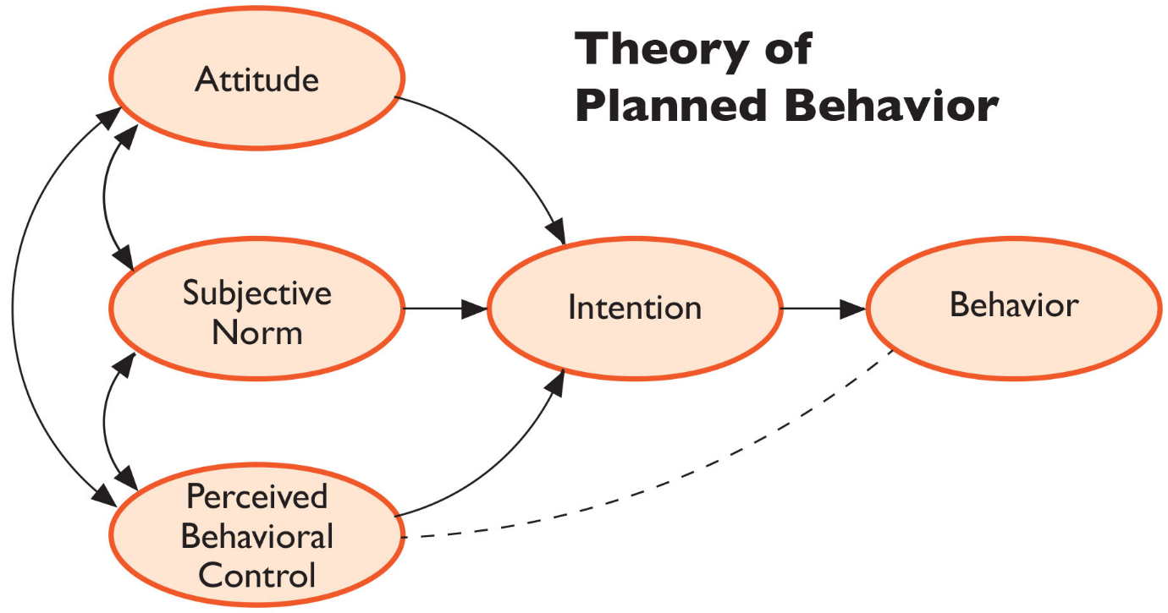
Conceptualized by Ajzen (1991), this theory highlights the importance of behaviour that forms from different factors.

Source: Martin, 2014

Intentions, which are easy to predict from attitudes, subjective norms, and perceived behavioural control, are highly important for the behaviour itself (Ajzen, 1991).
What links behaviour and intentions is that people tend to participate in behaviours they intend to do (Conner & Armitage, 1998).
Therefore, there are other 3 subsequential factors that determine intentions, and overall, behaviour:
1) Attitudes
-the individual’s attitude toward the behaviour is positive or negative (Norman & Conner, 2006).
-this is really important in terms of behaviour and engaging in behaviours
2) Subjective Norms
-the individual’s perception that is influenced by people that he considers important and the pressure that is put on him to engage in some types of behaviours (Norman & Conner, 2006).
-the beliefs of other people that matter to us (e.g., family and friends) and their attitude toward the behaviour
3) Perceived Behavioural Control
- the individual’s perception on how easy or difficult it is to perform the behaviour, which of course, is influenced by the internal (skills) and external (constraints) control considerations (Norman & Conner, 2006).
- it regards the person’s ability, opportunity, and resource to engage in this type of behaviour.

One of the most controversial attack brought to this theory is that it should not be based on cognitive beliefs ad has insufficient consideration on the affective aspects of behaviour (Bagozzi, 1992). But researchers say that, empirically speaking, attitude is a complex concept that includes both affective and cognitive components. Research has suggested that moral norms and obligations can be added to this model. The reason is that for example, moral obligations play an important role in, for example, stealing, cheating, and lying.
In Mason’s case, the behaviour that he adopted after he got out of the Institution can for sure be explained by using this theory. This theory can confirm that one of the possible causes that he is acting this was is because he still senses the influence that the group had on him. Because we know that attitude is affectional and cognitive, the chances that he still has this ongoing perception that the former associates (who it can be presumed, had a big influence on him) are right regarding his behaviour, are high.

3. Frustration Aggression Hypothesis
The theories of aggression are categorized in 2: Biological and Social theories of Aggression.
Frustration Aggression Hypothesis is, alongside Aggressive Cues Model and General Aggression Model, part of the Social Theories.
This hypothesis has been developed by Dollard et al. (1939) which have stated that aggression comes from frustration (p.1). This leads to two possibilities: everytime there is aggression, there always has to be frustration behind it, or that the existence of frustration will always lead to aggression.
The definition for the term ‘aggression’ is coming from Dollard et al. (1939) and it is basically defined by any sequences of behaviour, goal-response to which the injury of the individual is directed to.
It seems that some people who are frustrated cannot express it through aggression because they know that the behaviour will be punished. They are also reserved when it comes to express frustration because they think that their loved one can be harmed or that they are unable to do such an aggressive action (Berkowitz, 1989).
This theory has been applied in many fields: psychology, criminology, sociology etc. It is one of the most popular theory in the aggression research (Breuer & Elson, 2017).
Basically, this theory explains that when a person expects to be treated fairly, correctly, and that does not happen, and that person cannot confront the situation adequately, frustration happens and, in most cases, turns into anger. For example, an unfortunate case could be when a child has expectations to be treated with love and respect. When he does not receive that, is held from meeting his goals and dreams, or thinks that he is not loved and respected, his frustration is turned into anger. Until the frustration is not resolved, the anger will still linger and still affect the individual(Lewis & Bucher, 1992).
When a person cannot express their frustration through aggressive behavior, then the individual will redirect his aggression and anger towards other things-process which is called displaced aggression.
In Mason’s case, this theory is explaining really well his behaviour after he left the Institution. This defines his behaviour when the team approached him, and he became aggressive. The frustration that is build up in him and the fact that he is followed is briningun him anger. This is a possible cause of him storming out and it will not be solved until his bottled up feeling, his anger and therefore his frustration and aggression will disappear completely.

Conclusion
In conclusion, this report has been made for the Youth Offending Team to reflect the psychological theories that could be applied in Mason’s case and further up find solutions that could stop his apparently bad behaviour that could eventually ruin his future. By using appropriate theories such as the Social Identity Theory stated by Tajfel (1978), the Theory of Planned Behaviour reiterated by Ajzen (1991) and the Frustration Aggression Hypothesis by Dollard et al. (1939), the report highlights the most important factors that could potentially intervene and change an individual’s behaviour in worse. Therefore, this piece of work it could be considered a tool in understanding the causes for his problems and make use of the theories in order to help him solve his problems by finding solutions and develop in the future.

References
- Ajzen, I. (1991), ‘The theory of planned behaviour’, Organizational Behaviour and Human Decision Processes, 50(2), pp. 179-211.
- Bagozzi, R. P. (1992), ‘The self-regulation of attitudes, intentions and behaviour’, Social Psychology Quarterly, 55(1), pp. 178-204.
- Berkowitz, L. (1989), ‘Frustration-aggression hypothesis: Examination and Reformulation’, Psychological Bulletin, 106(1), pp. 59-73.
- Breuer, J., & Elson, M. (2017), ‘Frustration–aggression theory’, in The Wiley handbook of violence and aggression, 1st edn. NJ: John Wiley & Sons.
- Conner, M. & Armitage, C.J. (1998), ‘Extending the Theory of Planned Behavior: A Review and Avenues for Further Research’, Journal of Applied Social Psychology, 28(1), pp.1429-1464.
- Dollard, J., et al. (1939). Frustration and Aggression. 1st edn. New Haven, CT: Yale University Press.
- Hogg, M. A., & Williams, K. D. (2000), ‘From I To We: Social Identity and the Collective Self’, Group Dynamics: Theory, Research and Practice, 4(1), pp. 81–97.
- Huddy, L. (2001), ‘From Social to Political Identity: A Critical Examination of Social Identity Theory’, Political Psychology, 22(1), pp. 127-156.
- Lewis, W. A. & Bucher, A.M. (1992), ‘Anger, Catharsis, The Reformulated Frustration-Aggression Hypothesis, And Health Consequences’, Psychotherapy, 29(3), pp. 385-392.
- Martin, K. (2014) HC3 Research Primers Aid in SBCC Program Design [Image]. Available at: https://healthcommcapacity.org/hc3-research-primers-aid-in-sbcc-program-design/ (Accessed 20 March 2021).
- Norman, P. & Conner, M. (2006), ‘the theory of planned behaviour and binge drinking: assessing the moderating role of past behaviour within the theory of planned behaviour’, British Journal of Health Psychology, 11(1), pp. 55-70.
- Stets, J.E. & Burke, P.J. (2000), ‘Identity Theory and Social Identity Theory’, Social Psychology Quarterly, 63(3), pp. 224-237.
- Tajfel, H. (1978), ‘The Achievement of Inter-Group Differentiation’. In Tajfel, H. (ED). Differentiation between social groups. 1st edn. pp. 77–100. London: Academic Press.

