

Lowrie Proctor, 1903551

Lab: IPv4, Subnetting, VLSM and IPv6 Addressing

- Understanding IPv4 and IPv6 addressing (word count 1000)
This part of lab worksheet require you research and write a report on comparing IPv4 and IPv6 addressing. You may discuss but not limited to structure, address types, features and security.

Perset [1] reports a big challenge for the future of the internet is being able to connect to a large number of devices and people. An essential part of this is the Internet Protocol (IP). The IP stipulates how communication occurs between devices through an IP addressing system [1].
IPv4 (Internet Protocol version 4) was established in 1982 and considered the most commonly used addressing protocol, it is however seen as being in its final stage of its unallocated address space [2]. IPv4 is a 32 bit protocol and can address up to 2³² devices. The IPv4 addresses are written in decimal format, with each byte defined by a decimal point. i.e. 120.23.68.244 [3].

IPv6 (Internet Protocol version 6) was introduced in order to meet the requirement of the increasing demand, and to solve the exhaustion of addresses faced by IPv4.IPv6 is necessary in facilitating the growth of the internet [1] . IPv6 uses 128 bits and can be used to address 2¹²⁸ devices [2].
The address format differs from the IPv4 format, with the IPv6 addresses being written in hexadecimal with each four digit hex inter separated by a colon i.e. 67cf:9:2100:f2ef:241:2ffe:cb83:64ad [3]. IPv6 addresses often contain consecutive hexadecimal fields of zeros. In this case two colons can be used in their place [4]. The figure below demonstrates the various types of compressed IPv6 address formats, using the double colon method [4].

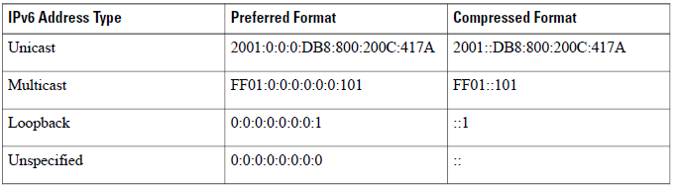

There are three IPv6 address types, which are: Unicast, one to one communication where the exact IP address of the destination is used for communication and the packets are consequently sent to the corresponding device [5]. ; Multicast, one to many where the IPv6 device will send a packet to the multicast IPv6 address and subsequently all subscribers will receive the packet [5]; Anycast is a new addressing type part of the IPv6 , where “if any system in the IPv6 network sends the packet to the anycast IPv6 address, the system which has less routing distance and anycast IPv6 address will receive it” [5] ; The broadcast address type previously available in IPv4 is no longer used in IPv6, [6] Hagen considers this to be a positive option due to broadcasts causing issues in most networks. Service providers are allocated IPv6 prefixes from their regional registry whilst consumer users would be allocated their IPv6 address from their service provider [7].

Along with the advantage of the increased addressing range there are other benefits of the IPv6, specified by some sources to include the security being greater than it was in IPv4.
Tri Nguyen, as cited in IPv6: Five Things you should know about the new protocol [8], states that features of the IPv6 protocol makes it more secure than the previous IPv4. This is considered due to increased encryption and techniques used to prevent packet spoofing to protect the authenticity of the IPv6 content Ngugen, as cited in IPv6: Five things you should know about the new protocol [8], adds that IPv6 is better at ensuring that “internet traffic gets to the correct destination without being intercepted” [8]. Bradley [8] states that IPv6 was developed with security in mind. In contradiction to Bradley, DeNardis [9] considers however that any “claims that IPv6 improves security are misleading”, and that these claimants are “under the assumption that a network would be entirely IPv6 end to end.” Deliberation and thought must also be given to the fact that whilst having a greater number of IP addresses is a benefit to many it will also benefit cyber criminals, they will be able to become difficult to trace due to frequently changing IP addresses and also many existing controls used to blacklist malicious IP address will no longer be effective [10].

In addition to the security variations IPv6 also allows plug and play; if a user has an IPv6 enabled host it will configure automatically to a valid IPv6 address [6, p. 4]. IPv6 also claims to have an improved adaption of multimedia applications, resulting in technologies such as streaming and conferencing will be more effective [11]. As a consequence to the increased address capacity provided by IPv6 there is no longer the requirement for Network Address Translation (NAT).

IPv6 has introduced a simplified header, in comparison with IPv4, with this header having a fixed length of 40 bytes. This simplification allows for faster processing [6, p. 5]. The improved IPv6 header eradicates fields that were rarely used and adds one to better support “real-time traffic” [12]. The altered IPv6 header structure also includes a more flexible extension header which allows for more inclusions and safeguards any future needs and capabilities [13].

The table below provides a comparison of the IPv6 and IPv4 addressing elements [5].

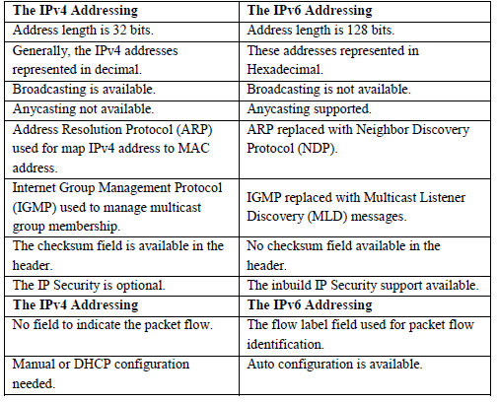

A difficulty confronted with the implementation of IPv6 is that it is not backward compatible; IPv6 only devices would not be able to communicate directly with devices that are IPv4 only [1, p. 40]. Due to this the conversion to IPv6 from IPv4 is considered complex [1, p. 6] An important feature to consider however is that IPv6 will coexist with IPv4 with numerous mechanisms in place to support the transition, including the tunneling, translation and dual-sack mechanism, however it is considered that some of these mechanisms may prohibit some of the services offered by IPv6 [14].

The conversion to IPv6 will take substantial effort and consideration [10] however it is something that all will have to transition too and businesses need to be proactive in their strategies to implement [10]. Perset [1, p. 5] considers that “IPv6 is not being deployed sufficiently rapidly to intercept the estimated IPv4 exhaustion date”.

NOTE: To complete this part you would need full understanding of Lab 10 to 14.



Using the Network address 172.16.2.0/24, VLSM the network to support the following requirements:
Subnet A: 12 hosts
Subnet B: 60 hosts
Subnet C: 120 hosts
Subnet D: 45 hosts
Subnet E: 6 hosts
Subnet F: 180 hosts and Serial links between routers

Table 1
Subnet | Network Address | Subnet mask | First Address | Last Address | Broadcast Address
F (180) | 172.16.2.0 | 255.255.255.0 | 172.16.2.1 | 172.16.2.254 | 172.16.2.255
C (120) | 172.16.3.0 | 255.255.255.128 | 172.16.3.1 | 172.16.2.126 | 172.16.3.127
B (60) | 172.16.3.128 | 255.255.255.192 | 172.16.3.129 | 172.16.3.190 | 172.16.3.191
D (45) | 172.16.3.192 | 255.255.255.192 | 172.16.3.193 | 172.16.3.254 | 172.16.3.255
A (12) | 172.16.4.0 | 255.255.255.240 | 172.16.4.1 | 172.16.4.14 | 172.16.4.15
E (6) | 172.16.4.16 | 255.255.255.248 | 172.16.4.17 | 172.16.4.22 | 172.16.4.23
Serial Link 1 | 172.16.4.24 | 255.255.255.252 | 172.16.4.25 | 172.16.4.26 | 172.16.4.27
Serial Link 2 | 172.16.4.28 | 255.255.255.252 | 172.16.4.29 | 172.16.4.30 | 172.16.4.31

References

[1] | K. Perset, “Internet Addressing: Measuring Deployment of IPV6,” OECD Digital Economy Papers, Paris, 2010.
[2] | V. Jain, D. Tiwari, S. Singh and S. Sharma, “Impact of IPv4, IPv6 and Dual Stack Interface over Wireless Networks,” International Journal of Computer Network and Information Security, vol. 10, no. 4, 2018.
[3] | IPv4 Imminent Depletion, Los Angeles: Anthem Media Group, 2011.
[4] | “IPv6 addressing and Basic Connectivity,” [Online]. Available: https://www.cisco.com/c/en/us/td/docs/ios-xml/ios/ipv6_basic/configuration/xe-3s/ip6b-xe-3s-book/ip6-add-basic-conn-xe.pdf. [Accessed 05 July 2019].
[5] | A. Dhanapal and P. Nithyanandam, “An overview of the IPv6 Addressing scheme,” International Journal of Mathematics, Game Theory, and Algebra, vol. 27, no. 1, pp. 81-92, 2018.
[6] | S. Hagen, IPv6 Essentials, Second Edition, O'Reilly Media, 2006.
[7] | “IPv6 Addressing,” [Online]. Available: https://www.cisco.com/en/US/technologies/tk648/tk872/technologies_white_paper0900aecd8026003d.pdf. [Accessed 05 July 2019].
[8] | T. Bradley, “IPv6: Five Things You Should Know About the New Protocol.,” PC World, vol. 30, no. 9, p. 34, September 2012.
[9] | L. DeNardis, “Questioning IPv6 Security,” Business Communications Review, vol. 36, no. 7, pp. 51-53, July 2006.
[10] | W. Ashford, “How to avoid the hazards of IPv6,” Computer Weekly, pp. 14-16, 23 August 2011.
[11] | D. Bird, “IPV6,” Inside NetWare, vol. 9, no. 4, pp. 18-19, April 2000.
[12] | J. Davies, Understanding IPv6, 3 ed., Pearson Education, 2012.
[13] | “Top 10 features that make IPv6 better than IPv4,” [Online]. Available: https://www.ipv6.com/general/top-10-features-that-make-ipv6-greater-than-ipv4/4/. [Accessed 05 July 2019].
[14] | M. Olsen and S. Anonsen, IPv6 : prospects and problems : a technical and management investigation into the deployment of IPv6, Agder University College, 2003.

