An examination of the hanging of William Cragh in 1287 at Swansea castle.

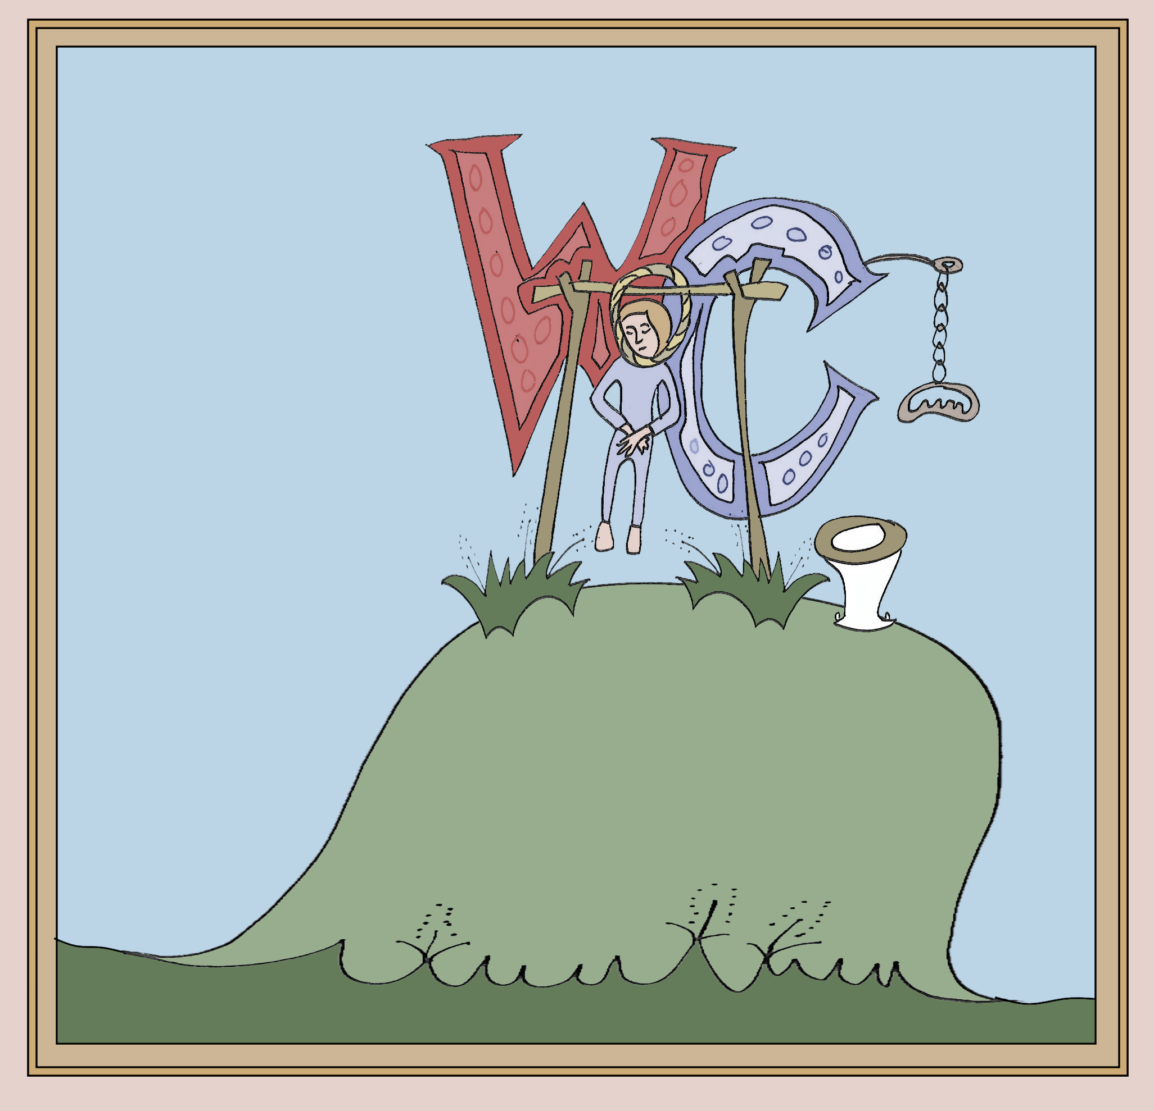

In this exercise we are working from Swansea ‘City Witness’ website. This website provides an examination of the hanging of William ap Rhys or ‘Cragh’ in 1287 at Swansea castle. William Cragh lived in medieval Swansea and in 1287 he was one of the invaders of the Anglo-Norman Oystermouth castle at Swansea when thirteen of the Lord’s men were killed. We are told in the document that the castle belonged to the Lords of the Gower. To pay for this action, William Cragh was sentenced to be hanged and the after events of the hanging were later reported as being miraculous.

The supposed miracle was that William Cragh was hung twice and lived to tell the tale with the miracle being linked to Thomas Cantilupe. Cantilupe had been a Bishop of Hereford and the miracle was that just before the planned burial of William Cragh was examined and pronounced to be still alive, although is a revolting physical condition with a black protruding tongue and eyes popped out of his head.

Twenty years later in 1307, it’s said a group acting for Pope Clement V was told this was a sign of a miracle being invoked and Cragh’s story contributed to the reasoning behind the canonisation application for Thomas Cantilupe. The Pope’s representatives heard nine witnesses give their accounts of the details they remembered on the double hanging of William Cragh and the miracle which followed.

From these witnesses, I have chosen to write about Lady Mary de Briouze. Lady Mary was the third wife of Lord William de Briouze and, in 1297 when the hanging of William Cragh occurred, she lived at Swansea castle. 33 Lady Mary is shown to be a woman of independent means before she married Lord de Briouze which may be why she was secure in speaking out with her beliefs as she was confident in her position in society and not afraid to disagree with her husband. Although the text does not provide a specific relationship between Lady Mary de Briouze and William Cragh, the 'hanged man'', it says that Lady Mary had tried to persuade her husband to pardon William Cragh and the account describes how Lady Mary had 'a mysterious interest in William Cragh's fate' and her appeal to her husband, for clemency, failed.
Lady Mary was involved in the events surrounding the miracle by pleading for the life of William Cragh before his execution and arranging the examination of his body following his hanging.

Lady Mary 'sent one of her household to 'measure' William's body. This was a common custom among the laity, which involved measuring the length and breadth of a person's injured part (in this case William's whole body) with string which was then covered in wax to form a votive candle. The candle would then be lit to attract the attention of a saint, who would hopefully intercede on the injured person's account and miraculously cure them. In this case, the measuring was intended to attract the attention of the late Bishop of Hereford, Thomas de Cantilupe, to whom many miracles were being attributed at the time. The measuring and accompanying prayers apparently worked, for soon William began to recover: he moved a foot, began to breathe, and his eyes withdrew into their sockets 'of their own accord'. Soon he was fully recovered,and visited Swansea Castle to tell the lord and lady of the miracle in the hope he would be pardoned. Accepting the miracle, and attributing it to Thomas de Cantilupe, the Lord and Lady de Briouze made the three day journey to Hereford accompanied by William Cragh on foot. At the bishop's tomb they gave thanks for the miracle, making an offering there of the noose with which William had been hanged and a wax model of a man on a gallows’.

The hanging place in medieval Swansea was outside the castle walls on Gallows Hill. People gathered there to witness the gory events, though rather than attend the hanging, some stayed inside the castle; the son of Lord de Brouize is said to have chosen to do this on the day and later he provided witness account to the Pope’s envoys, as did William Cragh himself. William’s own testimony was said to be significant. He was the first person to speak witness in the Welsh language. Translators reported his statement for him.

It is difficult to affirm how reliable or valuable was the testimony of Lady Mary de Brouize because we are considering a report of the time, but, if viewed from a current day perspective, the story may appear more nonsense than miracle?

The report on Medieval Swansea has a particularly interesting section which describes how a later Bishop of Hereford was keenly involved in promoting the resurrection of William Cragh to be miraculous and further that this maybe to encourage an increase in the pilgrims visiting the cathedral at Hereford. Could it be the account is hinting that current Bishop of Hereford was selling the idea of Cantilupe as a performer of miracles? In medieval times, this could give credence to the holiness of Hereford Cathedral and thereby attract more visitors. An increase in visitors would bolster the Cathedral coffers and the earnings of the then Bishop would increase, but that may not have been the case, perhaps there was genuine belief behind all the witness’s words.

A sceptical viewer of the proceeding in 1287 and 1307 may perhaps consider the whole double hangings and resurrection was either a hoax or a confidence trick or at least hopeful and entertaining story.

929 words
Author or organisation (if available), Title (Place: Publisher, year) (if available) <web address of document> [accessed day Month year] (page).

- (www.medievalswansea.ac.uk) ‘City Witness: Place and Perspective in Medieval Swansea’

