Introduction
This report will analyse the company's market hypothesis, dividend policy and investor appraisal and a critical analysis of Nestle S.A will be presented.
Nestlé is the world's largest and most diverse food and beverage company based in Vevey, Switzerland, and employs approximately 276,000 people globally. Nestlé, as a global corporation, serves a wide range of consumer markets with a 44.9 per cent regional share of global sales, with the Americas as a leading market accounting for 26.6 billion Swiss francs, followed by Europe, the Middle East, and Africa (Statista Research Department, 2022). The company's market capitalization is at 336.79 billion market value, with net sales of 93.6 billion USD and a net profit of 16.9 billion CHF. Nestle is currently the second largest worldwide food and beverage industry with 43,476 billion revenues coming from beverage sector and market leader in 2019 with 93.1 billion revenues (Wunsch, 2022). The food and beverage industry has a high competition and Nestle competitors are listed on the figures bellow.
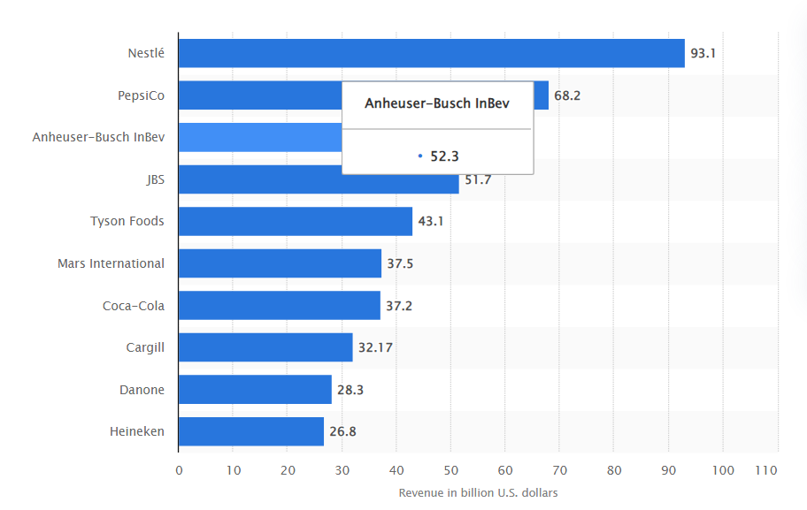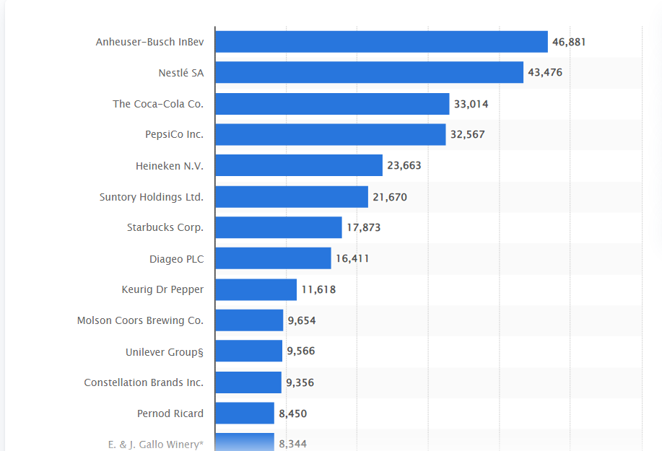
(Wunsch, 2022) (Ridder, 2022)
Nestlé owns and operates a diverse range of food and beverage brands. Nestlé Toll House, Gerber, and Nescafé are some of its most well-known brands. The powdered and liquid beverage categories account for most of the group's sales, followed by Pet Care products. In 2021, Nestle was the sixth largest confectionary company, divided into chocolate, sugar confectionary and biscuits. KitKat, Smarties, and Aero are a few of the confectionary brands owned by Nestle. The chocolate sector was the largest of these categories in 2021, with sales of more than 5.7 billion Swiss francs. (Wunsch, 2022). Nestle's most significant competitors in the food and beverage industry are Anheuser-Busch InBev, Coca Cola and PepsiCo, based on Statista research 2020 (Ridder, 2022).
The importance of International Financial Management
The world continues to develop, and globalisation is increasing accordingly. Every country depends on one another. Developed countries seek low-cost labour from developing countries while developing countries seek services and products. International finance is critical when multinational corporations (MNC) are trading deals between two countries to ensure no regulatory violations are present, and local government intervention ensures that both parties do not face competition (Hamdi, 2015). Multinational corporations are regional companies looking to expand internationally opening subsidiaries in different international markets. When MNC are trading their products or services internationally they face various risk as foreign exchange, market flaws, legal and political risks, and economical risks which can result in positive or negative challenges on international markets for any corporation worldwide (Bekaert, 2013). The advanced telecommunications and technology which improved accessibility and price fluctuation has driven the flames of globalisation even more. Financial developments like currency derivatives, global stock listings, multi-currency bonds, global mutual funds, and other global market instruments bring in more opportunities for multinational corporations. Therefore, the financial economics are responsible to deal with macroeconomic relationships and monetary transactions between two countries in a global corporate setting. Due to various national currencies, diverse opportunity sets, political contexts, and imperfect markets, every aspect of a business's operations impacts its financial performance, which implement the importance of financial managers and their decisions for the company financial wealth. (Arnold, 2013).
Challenges on International markets for Nestle
The international markets have significant impact on MNCs financial performance due to the foreign exchange, political risk factors, economical factors such as climate and inflation. The foreign exchange can affect the Multinational corporation financial performance because of the currency exchange rate fluctuation, which can result in a risk for the company financial health (Arnold, 2013). The exchange rate fluctuation can increase or decrease sales and company revenue.
Nestle's overall risk score is 3.62 according to Global Data’s in-house risk methodology, indicating a high-risk profile. The operational and country risk pillars of the organisation have increased its overall risk profile. The financial risk scores have been significantly influenced by low liquidity and an excessive reliance on equity (GlobalData, 2022). The firm is most exposed to the food industry, then the non-alcoholic beverage industry with 66 percent of Nestle's income comes from food, and the remaining 14 percent coming from non-alcoholic drinks. The food and non-alcoholic beverage industries have low profit margins and limited growth expectations, giving them an industry risk score of three on average (GlobalData, 2022).
As reported by the Nestle press release in June 2022, the foreign exchange rate decreases sales revenue by1.5 percent (Nestle, 2021) , CHF 41.8 billion for the first half-year 2021 and 1.3 percent for full year 2021 resulting on a total 2.9 percent, however an increase of 3.3 percent in sales CHF81.7 billion (Nestle, 2022). However, the firm increases profit in the first quarter of the year 2022 by 5.4 percent due to the organic growth increasing sales by 7.6 internal growth and the foreign exchange rate 0.8 percent resulting in1.3 percent negative impact (Nestle, 2022).
The political risk is another crucial factor for MNCs because of its uncertainty. Operating in multinational markets, firms can louse control over ownership and benefits caused by any political emergency or unexpected changes. Enterprise can face extra cost in export/import, restricted in financial operations as investment return, the corporation freedom to operate in that country and standards and legislation for service or products (Madura, 2021). Nestlé employed a number of CPA methods that may have affected public health policy, research, and practise in ways that benefited the infant food sector. In order to prevent commercial interests from taking precedence over objectives related to public health, these findings might be utilised to better recognise and anticipate the effect of companies on health (Hacer Tanrikulu, 2020). The Brexit affected the food and beverage industry and therefore Nestle face challenges causing disruption foe the supply chain and return in investment. The firm increased stockpile in UK to prevent any shortage (Belger, 2019).
Dividend policies
The dividend policy is part of the company strategy to pay out dividend. There are four types of dividend policy such as regular, irregular, stable and no dividend policy (Madura, 2021). The most current information available as of August 2022 shows that Nestlé paid dividends of 2.94 USD per share during the previous 12 months to a dividend yield of 2.40 percent at the stock's current price of USD 122.45. Nestle dividend policy is stable, as the firm is paynd dividend once a year in April. The chart below present Nestle dividend payment history from 2007 to 2022 (Dividend Stock, 2022).
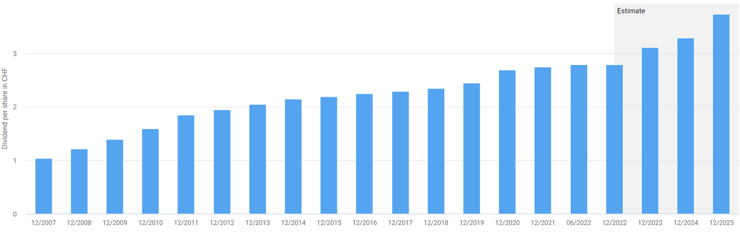
(Dividend Stock, 2022)
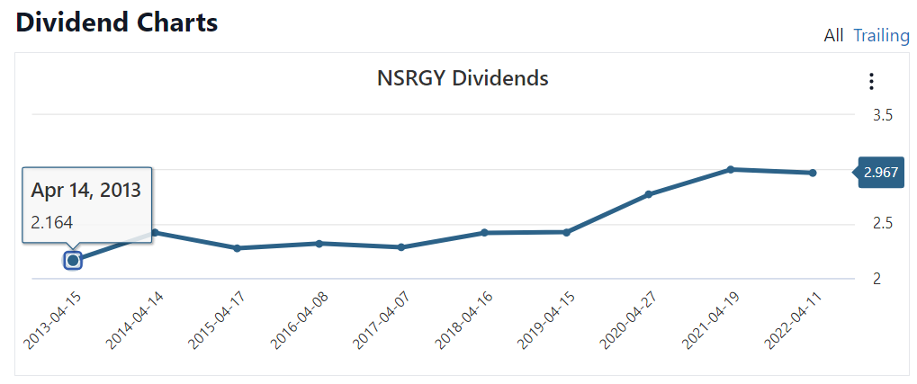
(Stock Analysis, 2022)
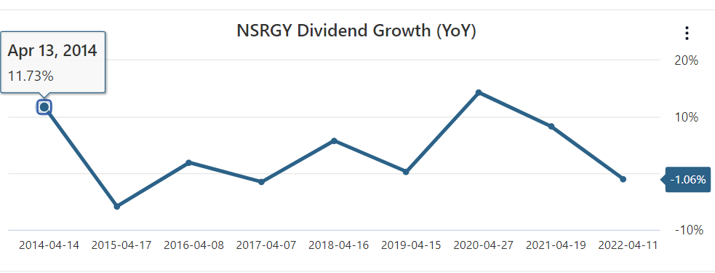
(Stock Analysis, 2022)
The corporation is maintaining a stable dividend policy for the past 62 year, with a constant increasing dividend per share. Between 2017 to 2021 the dividend pay-out is in constant increase, listed in the chart below (Nestle, 2021). Also, with the share buyback programs, Nestle gains 6.3 billions Swiss francs in Nestle shares.
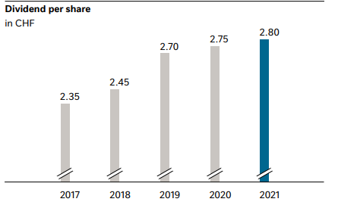
(Nestle, 2021)

Market hypothesis

