Dynamic Stress-Strain Investigation

Thomas Austin Diaper-Fox
Student ID: 2022125
Physics
Ordnances Munitions and Explosives (OME)
Level 4 Student

Abstract
This experiment was to test the performance of the L28A1 anti-tank Armour Piercing Fin Stabilized Disregarding Sabot (APFSDS) round when fired into a rolled harmonious steel (RHA) armour target at varying velocities. Trying to map the changeover point from ridged bodied penetration to hydrodynamic penetration and the effect of this on penetration performance. The result of this experiment was partly inconclusive due to errors when running the simulation in the Abaqus software. However, the results obtained indicate a penetration performance drop between 800ms⁻¹ and 1200ms⁻¹. The main cause for this decrease in performance being plastic deformation caused by tensile force below 800ms⁻¹ and compressive force above 1200ms⁻¹.

Table of Contents
Abstract 2
Introduction 4
What is ballistic impact? 4
Description of Problem 4
Simulated Model 4
Creating the model 5
Creating the projectile and target meshes 5
Material Models Description 6
Projectile performance against the target 6
Stress Waves 6
Shear Stress 7
Tensile Stress 8
Limitations and Approximations of Simulation 8
Approximations and Assumptions 8
Limitations 9
Improvements 9
Conclusion 9
References 10

Introduction

What is ballistic impact?
Ballistic impact is when one object with mass hits a second object with a collision velocity. One or both objects could be moving and the collision velocity is the sum of the projectile and the target’s velocities. For example, in a car crash the cars could be moving towards each other meaning the impact velocity is the sum of both vehicles velocity’s where as if the cars were moving in the same direction but at different speeds it would be velocity 1 minus velocity 2. During ballistic impact, the target object absorbs energy lost from the projectile through compression, shear stress, tensile deformation and friction. [1]

The reason we model these events is that running a simulation gives an indication of the real world out come without conducting full scale tests, saving time and money in development costs as less products need to be physically tested in trials. Modelling can differ from real world results for various reasons such as mesh density and material models so final products should still be tested in the real world however safety precautions can be put in place as we already know approximately what the result of the test will be.

Description of Problem
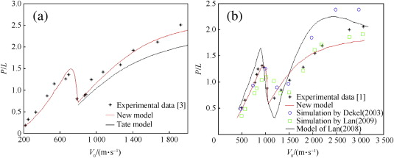
It is well documented that the tungsten long-rod penetrator fired by many modern tanks experiences a large decrease in performance when impacting aluminium targets at velocities between 800ms⁻¹ and 1200ms⁻¹. This is known as the transition zone where the penetration changes from ridged body to hydrodynamic. [2] [3]
Figure 1 – Showing tungsten long-rod penetration performance in aluminium target with change in impact velocity [2]
This experiment is to see if this transition zone transfers across into rolled harmonious armour (RHA) plating. In order to test this theory a tungsten projectile was simulated hitting a RHA target in Abaqus. The simulation was run using a range of starting velocities in order to compare the penetration depth at different collision rates and find out how the transition zone is affected by the RHA target.

Simulated Model
Penetration of a long-rod projectile into RHA armour target plate was modelled using Abaqus software. This software allows for forces to be applied to objects and see how the material reacts. This includes changing the velocity, material, object shape, and/or impact location.

Creating the model
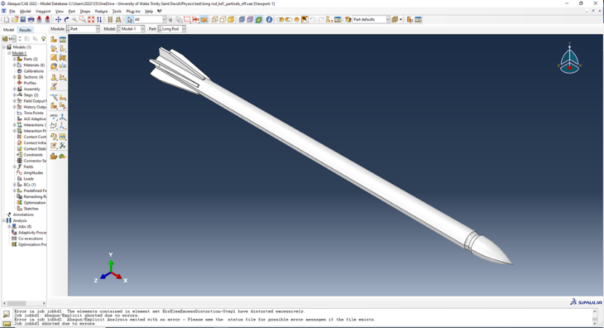
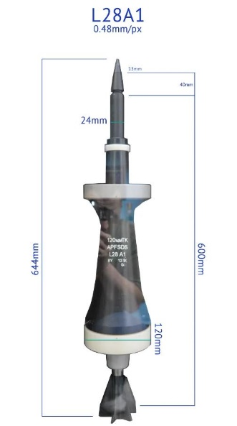
The projectile used was modelled on a L28A1 Armour Piercing Fin Stabilized Disregarding Sabot (APFSDS) round fired by the British Challenger 2 tank.
Figure 3 - L28A1 APFSDS model in Abaqus
Figure 2 - L28A1 APFSDS Dimensions [17]

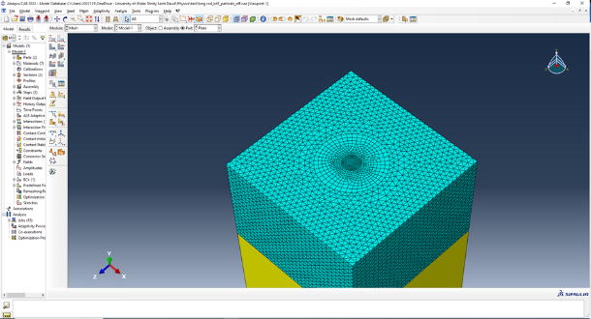
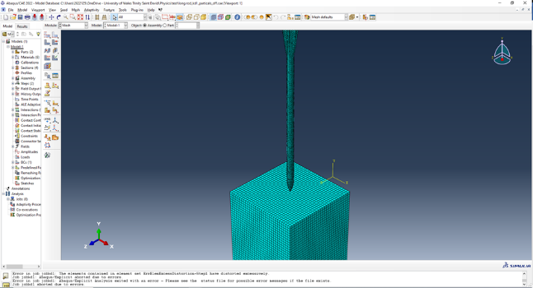
Creating the projectile and target meshes
Figure 5 – Showing target mesh sectioned
Figure 4 – Showing large target mesh and projectile mesh

The model originally started with a target mesh size of 10mm throughout the entire target block (figure 4), however, this caused errors when simulating due to the size of the elements created. Therefore to improve the simulation accuracy the mesh was changed to a 2mm element size in the centre of the target gradually increasing to 10mm at the edges (figure 5). This enabled for finer calculations in the area being hit without wasting nodes on the outer edges that weren’t being deformed by the projectile.

Material Models Description
The Johnson-Cook damage model was used for the target plate numbers for each specific material – getting material properties which specifies the hardening behaviour and strain-rate dependence of yield stress. [4]

RHA Material Model:
Density – 7850kg/m³ [5]
Young’s modulus – 2.18x10¹¹ Pa [6]
Poisson’s Ratio – 0.303 [7]
Plastic [8]
A | B | n | m | Melting Temp | Transition Temp
1.083x10⁹ | 5x10⁸ | 0.26 | 1 | 1800 | 273

Johnson-Cook Damage [8] [9]
D1 | D2 | D3 | D4 | D5 | Melting Temp | Transition temp | Reference strain rate
0.05 | 0.8 | 0.44 | -0.046 | -2.9 | 1800 | 273 | 0.001

Tungsten Material Model:
Density – 19450 kg/m³ [10]
Young’s Modulus – 4.11x10¹¹ Pa [11]
Poisson’s Ratio – 0.28

For the tungsten material properties, the Johnson-Cook damage model wasn’t used as including the damage model would have added complications to the simulation.

Projectile performance against the target

Stress Waves
There are three different types of stress waves. Longitudinal waves are created by the particles within the material moving in parallel with the direction of the wave. This in turn causes compressive and tensile forces within the material. Transverse waves are caused by particles within the material moving perpendicular to the wave direction. As a result of the particle motion shear forces are generated. Rayleigh waves move the particles in an elliptical counter clockwise direction as the wave propagates through the material. This type of wave has components of both longitudinal motion and transverse motion resulting in both tensile and shear stress being experienced. As the velocity of the projectile is increased the amplitude of the stress wave also increases. [12] [13]

Shear Stress
Figure 6 - Shear stress results A) 800ms⁻¹ B) 1000ms⁻¹ C) 1200ms⁻¹ D) 1500ms⁻¹
A) 7.7x10⁸ - -8.1x10⁸ Pa 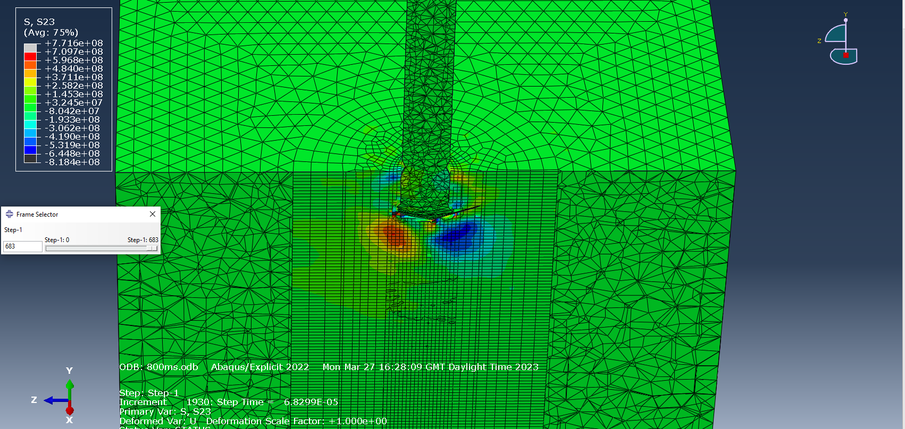 | B) 7.3x10⁸ - -7.9x10⁸ Pa 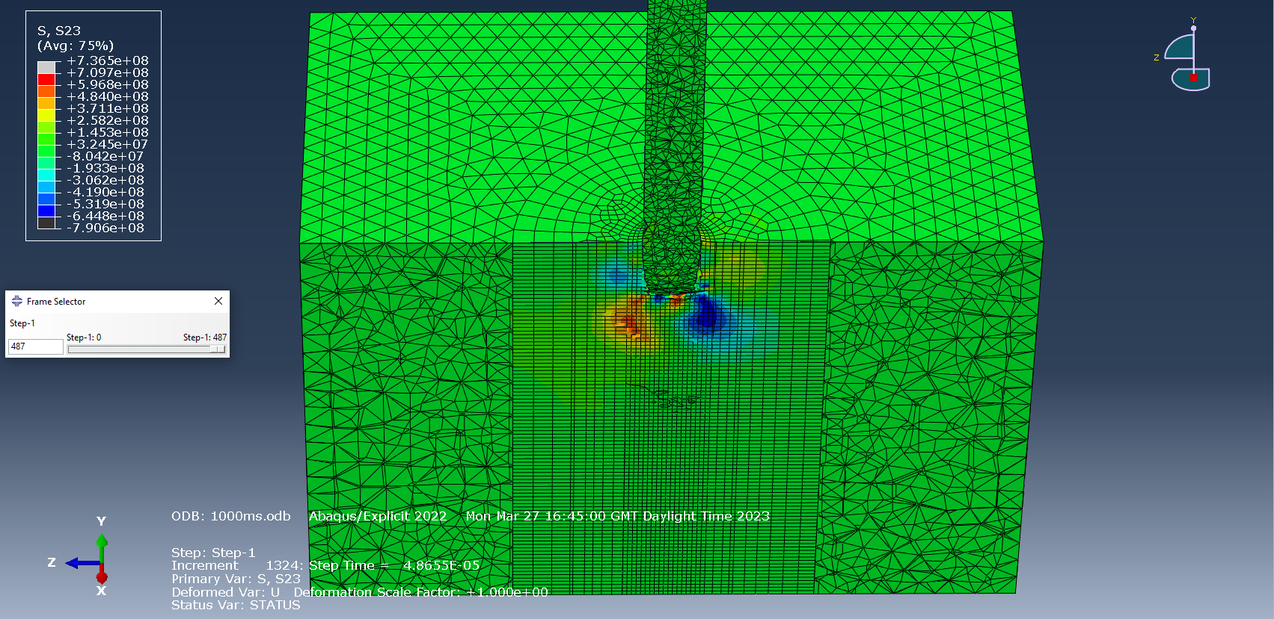
C) 8.0x10⁸ - -7.8x10⁸ Pa 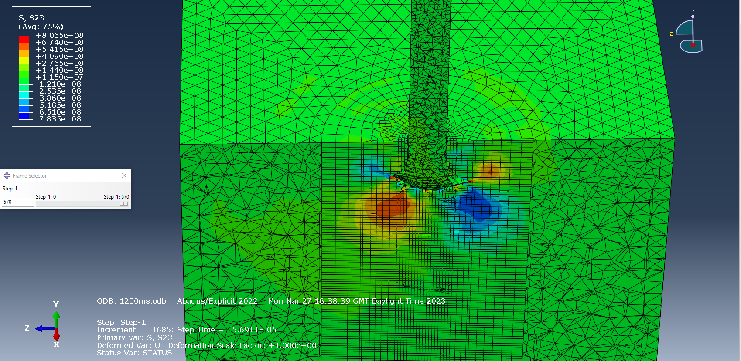 | D) 7.7x10⁸ - -7.7x10⁸ Pa 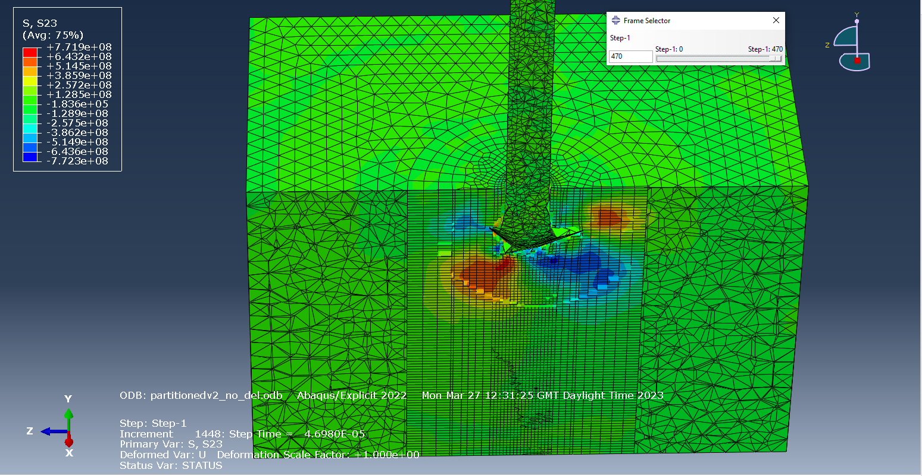

Shear stress which is when there are two forces acting in parallel but in opposite directions. This could be as a result of a transverse or Rayleigh wave generated by the impact of the projectile. Image D within figure 6 shows the wave propagating out ahead of the visible shear stressed particles within the target.

Between the four velocities tested the peak shear stress was comparatively unchanged however as can be seen in figure 6 the area experiencing the shear stress is dramatically increased. This is due to velocity increasing into the hydrodynamic region of penetration; the energy is being dispersed further out into the target which would indicate a larger damage hole at the end of the experiment due to plastic deformation.

Tensile Stress
Figures 7 - Tensile stress results A) 800ms⁻¹ B) 1000ms⁻¹ C) 1200ms⁻¹ D) 1500ms⁻¹
A) 3.7x10⁹ - -3.0x10¹⁰ Pa  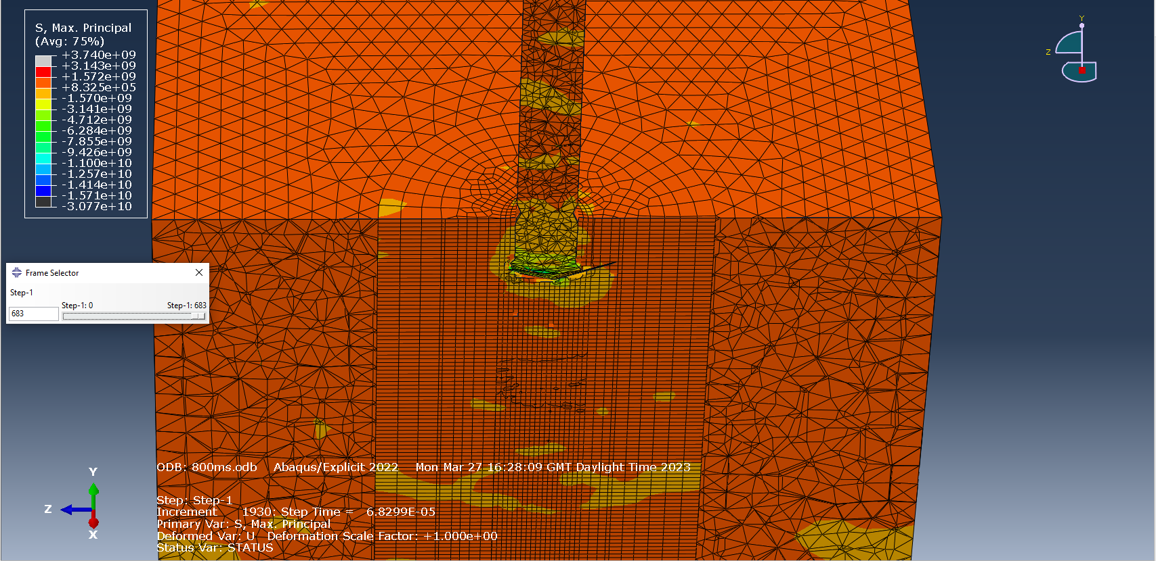 | B) 3.1 x10⁹ - -1.7x10¹⁰ Pa  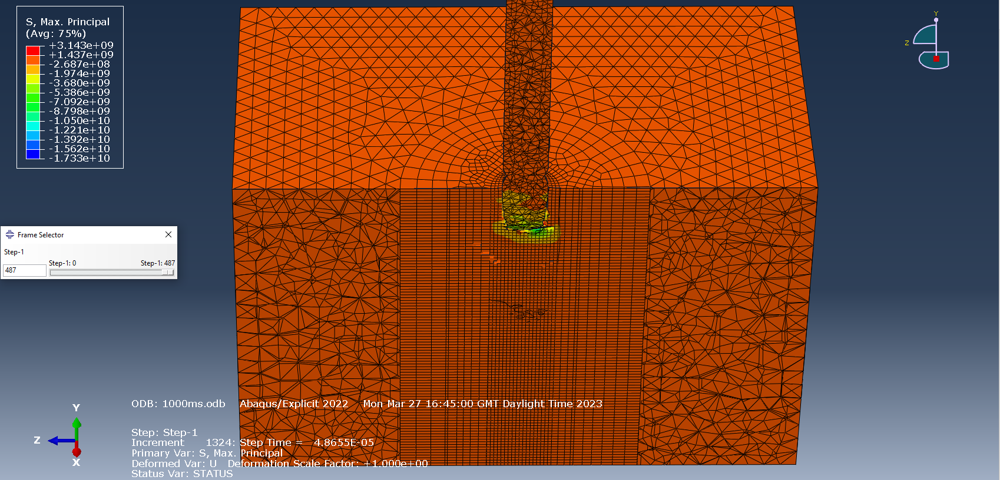
C) 3.1 x10⁹ - -1.4 x10¹⁰ Pa  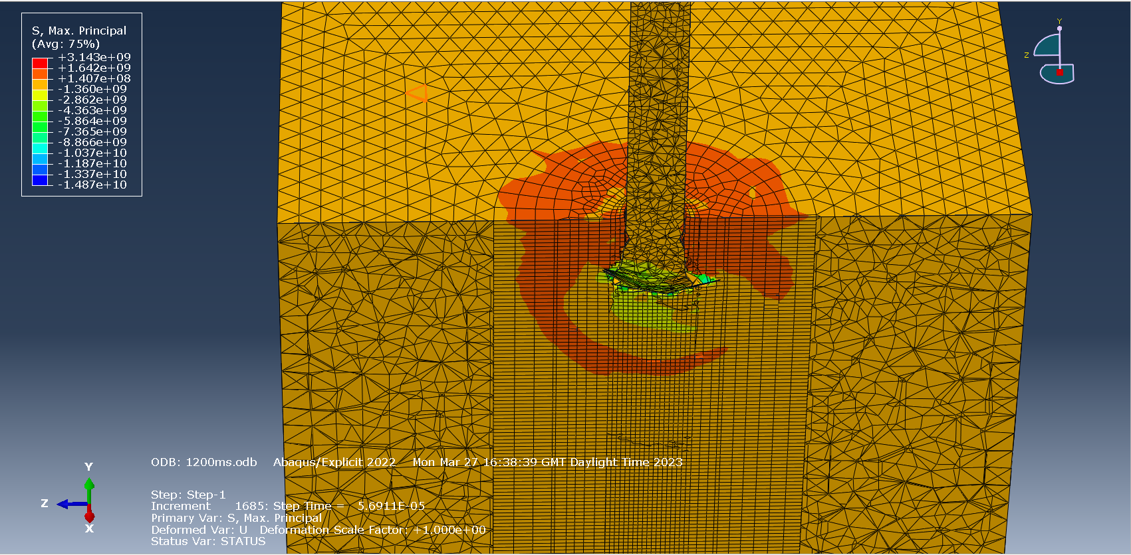 | D) 3.1 x10⁹ - -4.3x10¹¹ Pa  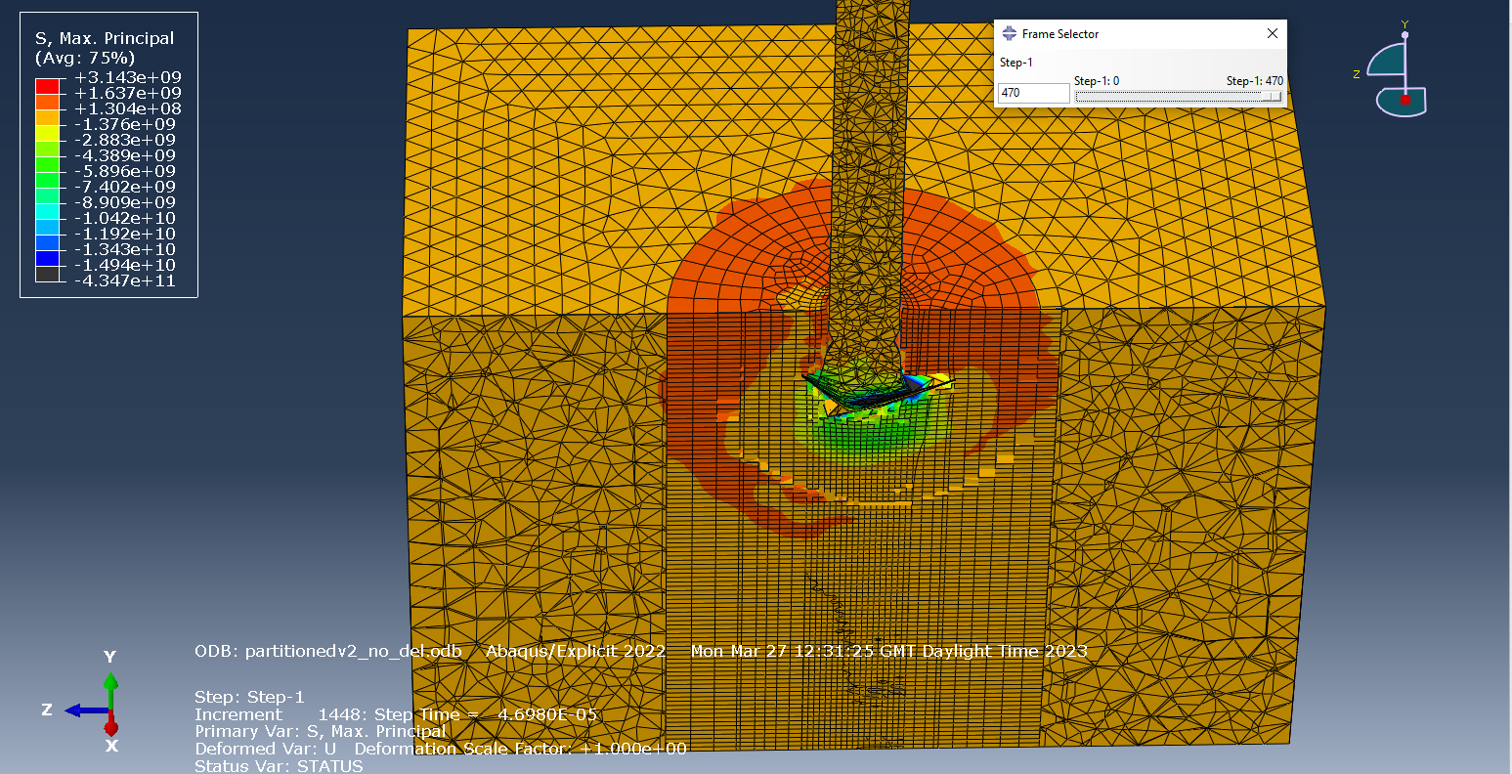

The target block in the 800ms⁻¹ and 1000ms⁻¹ (figures 7A and 7B) are experiencing tension whereas the target in the 1200ms⁻¹ and 1500ms⁻¹ is experiencing compression. This is shown by the target pictures in figures 7C and 7D. Figure 7A the target block is a dark orange indicating a tensile stress of approximately 8x10⁵ Pa where as in figure 7D the target is a light yellow indicating a compressive stress of approximately 1.3x10⁹ Pa.
The peak tensile stress measured at the impact point is significantly greater than the peak shear stress, therefore indicating the main stress wave acting upon the target block is a longitudinal wave. As a result of the longitudinal stress wave having a higher amplitude than the transitional wave it will be the tensile and compressive forces causing the majority of the plastic deformation. Failure within the target is likely to be star shaped cracking as a result of tensile failure instead of Hertzian cone shaped which would have resulted from a shear failure. [14]

Limitations and Approximations of Simulation

Approximations and Assumptions
The simulations were run with element deletion switched off. This will provide a more realistic and true to life result as mass was not lost from the simulation from highly deformed mesh particles not being deleted during simulation. Originally the simulation was run with element deletion on but it was removed due to simulation errors occurring.
One limitation to the simulation is the material models used due to not being able to consider things like how the target plate is constructed. For example, a billet machined component will be stronger than a cast component even if they are produced from the exact same material due to the differences in the grain structure. Another limitation of the material model is not accounting for things such as impurities in the metal as in real life it will never be 100% pure.

Limitations
Errors were occurring as a result of projectile erosion and mass loss, meaning that the computational surface contact mesh was removed. This resulted in the simulation never completing successfully. [15] In a real life experiment the dart would have completely penetrated the thickness of RHA being tested in the simulation.
Another factor not taken into consideration when simulating the ballistic problem is temperature. Materials act different at higher and lower temperature and the temperature the experiment was starting at was never specified. Steel at low temperature tends to fracture under load whereas at higher temperature the plastic deformation zone increases resulting in the material being more elastic and ductile. [16]

Improvements
Given more time and the ability to use more than the limit of 250,000 nodes it would have been possible to make polygon elements smaller, that way each node would see less deformation and give a more precise result and circumnavigate the error being experienced of too much damage. However this would increase the computing time as there would be a greater number of nodes to process.

Conclusion
The results are inconclusive from this experiment as to whether the penetration in RHA follows the same curve as in aluminium. However the initial results indicate there is a difference in the tensile stress waves forming between the velocities tested. This could be the starting indication as to the cause of the loss in performance between 800ms⁻¹ and 1200ms⁻¹ as the stress wave transitions from tensile deformation to compressive deformation. Around the hole in the target created by the projectile it would be expected to be able to observe cracks forming in a star-shaped pattern from the centre of the impact point and propagating out towards the edges of the target as this type of deformation is associated with tensile failure.

References

[1] | K. C. N. N. P. P. N. N. Pandya K, “Analytical and experimental studies on ballistic impact behavior of 2D woven fabric composites.,” International Journal of Damage Mechanics, vol. 24, no. 4, pp. 471-511, 2015.
[2] | Y.-g. Z. Z. W. T. H. X.-l. Z. S.-d. Z. Jian-feng Lou, “Long-rod penetration: the transition zone between rigid and hydrodynamic penetration modes,” Defence Technology, vol. 10, no. 2, pp. 239-244, 2014.
[3] | M. Wickert, “PENETRATION DATA FOR A MEDIUM CALIBER TUNGSTEN SINTER ALLOY PENETRATOR INTO ALUMINUM ALLOY 7020 IN THE VELOCITY REGIME FROM 250 M/S TO 1900 M/S,” in 23RD INTERNATIONAL SYMPOSIUM ON BALLISTICS , Tarragona, Spain, 2007.
[4] | J. S. Xuemei Wang, “Validation of Johnson-Cook plasticity and damage model using impact experiment,” International Journal of Impact Engineering, vol. 60, pp. 67-75, 2013.
[5] | K. Frank, “ARMOR-PENETRATOR PERFORMANCE MEASURES,” US ARMY ARMAMENT RESEARCH AND DEVELOPMENT COMMAND, ABERDEEN PROVING GROUND, MARYLAND, 1981.
[6] | S. Abdullah, “Mechanical properties and microstructures of steel panels for laminated composites in armoured vehicles,” International Journal of Automotive and Mechanical Engineering, vol. 13, no. 3, pp. 3741-3753, 2016.
[7] | Engineering ToolBox, “Poisson's Ratio,” [Online]. Available: https://www.engineeringtoolbox.com/poissons-ratio-d_1224.html. [Accessed 10 April 2023].
[8] | S. D. S. A. D. D. N. N. Arkadeb Banerjee*, “An Experimental Determination of Johnson Cook Material and Failure Model Constants for Armour Steel,” Applied Mechanics and Materials (Volumes 592-594), July 2014.
[9] | S. D. a. S. A. a. D. D. b. N. N. c. A. Banerjee a c, “Determination of Johnson cook material and failure model constants and numerical modelling of Charpy impact test of armour steel,” Materials Science and Engineering: A, vol. 640, pp. 200 - 209, 2015.
[10] | P. Evans, “Density of Metals,” The Engineering Mindset, 18 May 2015. [Online]. Available: https://theengineeringmindset.com/density-of-metals/. [Accessed 10 April 2023].
[11] | Mathematica's ElementData, “Young Modulus of the elements,” Wolfram Research, Inc., [Online]. Available: https://periodictable.com/Properties/A/YoungModulus.al.html. [Accessed 10 April 2023].
[12] | F. T. TIM SVENSSON, Stress Wave Propagation Between Different Materials, Gothenburg, Sweden: CHALMERS UNIVERSITY OF TECHNOLOGY, 2015.
[13] | D. F. G. D. C. K. J. P. George B. Arfken, International Edition University Physics, Miami University, Oxford, Ohio: Elsevier Inc, 1984, pp. 344-360.
[14] | A. K. V. M. Kindrachuk, “Phase Field Modeling of Hertzian Cone Cracks Under Spherical Indentation,” Strength of Materials, vol. 52, pp. 967-974, 2020.
[15] | Y. Q. J. L. Y. C. W. C. Tianhan Xu, “Mass Loss and Penetration Depth of Hypervelocity Projectiles,” Shock and Vibration, vol. 2021, no. 7320711, 2021.
[16] | B. P. M. G. H. W. John F. Chinella, “Processing, Mechanical Properties and Ballistic Impact Effects of Austempered Ductile Iron,” Army Reseach Laboratory, 1998.
[17] | [Online]. Available: https://arca.live/b/apfsdscharts/19442555. [Accessed 20 February 2023].

