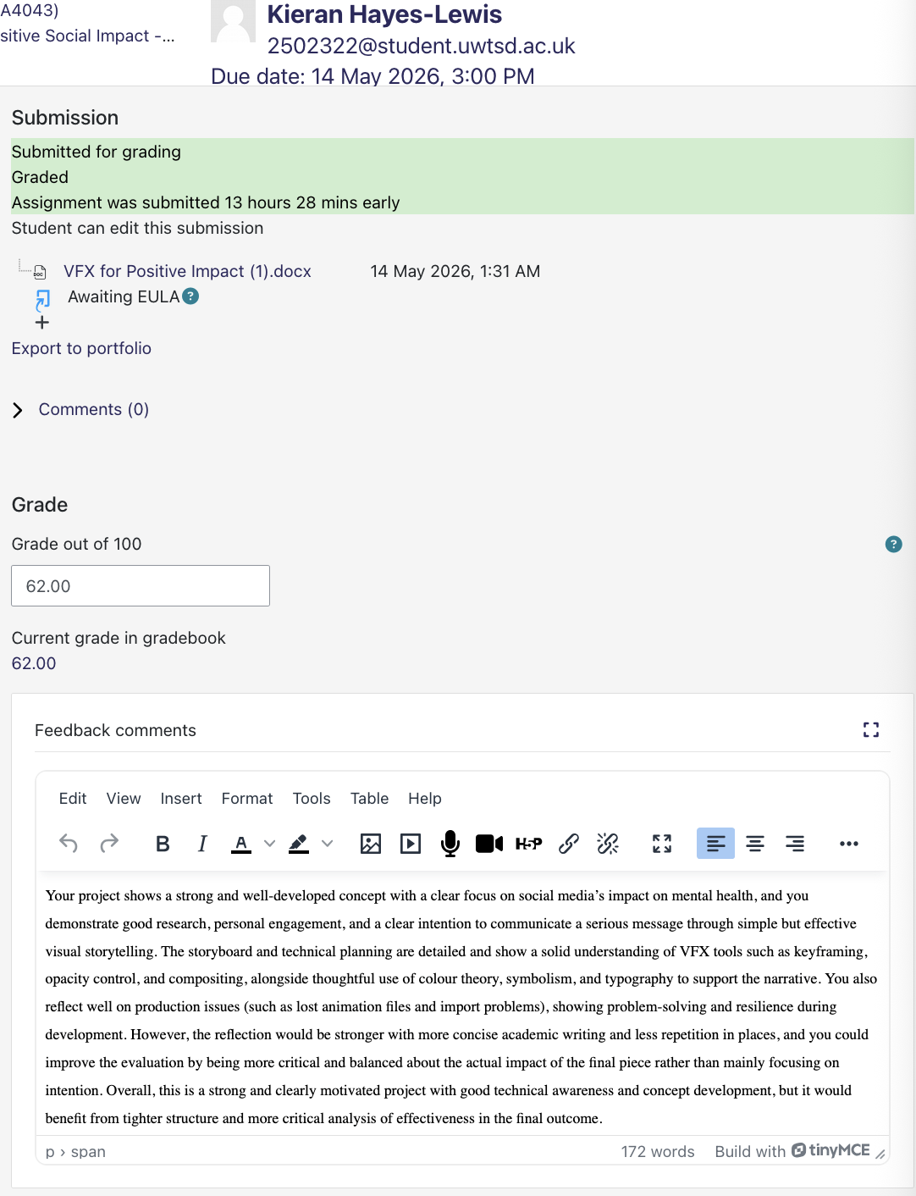

VFX for Positive Impact:
Task 1: Research and Concept development
- My chosen Issue:
Social Media: As of 2026, social media has increased developing mental health issues in vast amounts of the human population that have been steadily increasing to extreme numbers with each new year that passes and now with generative AI content, new issues like Social Media Fatigue have presented themselves. Existing problems that social media has accelerated in people are mental health problems like anxiety and depression which are already problems people start to endure from puberty to adult hood and as teens make up most social media users, the effects of social media causing these problems are doubled which has led to a global mental health decline.
According to the American health service, the number of adults who have reported having depression has risen by 8% since 2015 and while that doesn’t seem too big, you must consider the fact that this is 8% of 341.8 million people which is 27,344,000 people added to the 10% that existed before the rise which means 61,524,000 people in America suffer from depression caused by social media and that is just America.
Many types of people use the online world and among those people are those who fall under certain online labels like “trolls”, “Cyberbully”, “Flame Warrior”, “Doxxer”, “Groomer”, “Catfish” and many more and these people actively use social media for harming others in a variety of different ways from consistent harassment to sexual manipulation with the screen between them and their target giving them more confidence to act maliciously than a face to face situation which makes them act on it more. People like these cause many others to develop severe mental issues alone from the torment they cause and in more extreme situations, even drive the person they targeted to suicide which happens too often as shown through scientific research done over the years with data from 2025 showing that those who use social media 3 to 6 hours a day ae twice as likely to commit suicide.
- My VFX Concept:
I want to make a make a visual and text driven short of someone dealing with social media that is driven by music more than anything. The idea will simply be a simple design environment and characters that increasingly get darker visually as it shows in 60 seconds at most, the deterioration of a vulnerable teens mental state when exposed to social media for prolonged periods of time.
The narrative will be is that of following a nameless character within a VFX heavy animation, showing the character interacting with social media happily but as it progresses, the media start to become darker and more hostile and it affect the character negatively in a way that progressively worsens as it goes on with the color draining away as it does, making things seem more dull. It’s connection to the audience comes from how everyone deals with negative mental health even if it’s just anxiety and everyone uses social media and has likely had it negatively impact them or someone they know in some way at least once and i want to show that while they may have had a passing bad experience, with the worlds massive global population, many don’t have it pass as the internet can be a dark and hateful place if people aren’t careful and indulge in it too much.
- Brief:
The problem social media provides is that it gives the wrong people the confidence of being untouchable and the rest the anxiety of feeling like the entire world is monitoring them because, the entire world is watching as most the human population uses social media. I’ve always been one to never use social media that is open, so I only have WhatsApp and Discord to talk to those I want to and no one else which is what media like snapchat, Instagram, Facebook and all else does. Being connected around the world one on one is fine but being connected to millions of strangers simultaneously is terrible and its actively led to an increase in human lives lost that climbs higher each year which is something that needs to be addressed as its getting more people killed than most illegal substances and it's an easy access unsafe environment where elderly and children are being taken advantage of daily.
The issue I’ve chosen is the commonly overlooked negative mental health effects of social media as the statistics show it has been the cause for so many premature deaths via suicide and that is awful and needs to be spoken about.
The core message of my work is that people need to limit their connection to social media as it is too often filled with a lot of targeted and non-targeted negativity that can overwhelm people and cause anxiety, paranoia and depression in the minds of younger people who are still developing through the difficult times of being a teen were they are already dealing with stress from relationships, school and handling fluctuating hormones and such hence the nickname of ‘the awkward phase’ so the last thing they need is having the entire world on a small screen Infront of them for hours with all its good and bad.
The techniques I plan to use are animation which I'll likely do through Photoshop to create my own assets, VFX through AFter Effects to aid the movements and transitions as things go on like making two identical scenes but one in color and one in monochrome to make a gradual shift by layering them and slowly fading one through dropping the opacity to make the look of the color actually fading into dull shades, color theory which is the technique of displaying emotional meaning through color, symbolism by using things that aren’t verbal or written but understandable in conveying meaning, video editing by using Premiere to piece things together better and do some touch up work at the end and Typology by using text that fits the vibe through font style and color so it doesn’t seem out of place.
- Story Board/Visual Plan:
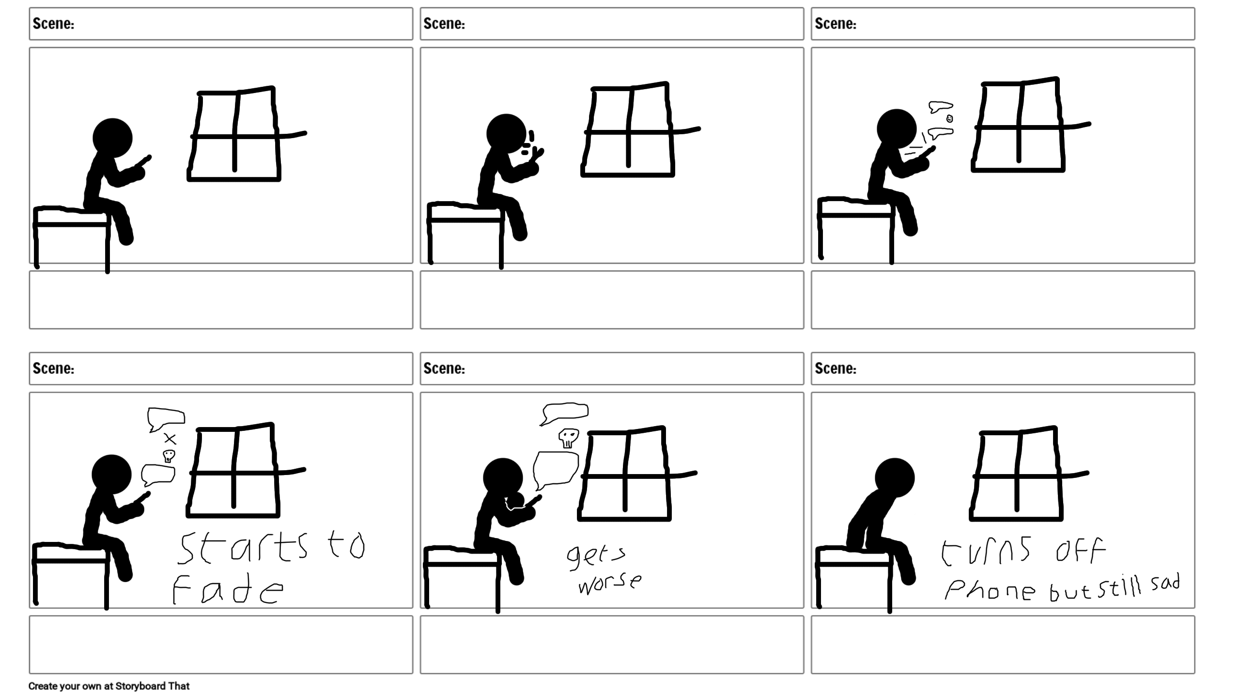
The first scene will be aided by VFX for animation to make the movement of taking out the phone with a semitransparent asset set to change opacity from 0 to 100 so it appears like the phone screen lights up suddenly when turned on. The second scene will have text fade in explaining how social media looks appealing and nice while there will be an audio queue of a notification pop up with little cartoony lines appearing from the screen with VFX like a visual representation. The third scene will have notifications of different types and emojis popping up like notifications, stacking up over the phone to show the nice and stuff on the phone by using VFX. The fourth scene will then start to fade to darker shades rather than color with an opacity effect in VFX all While the notifications continue, parts are now darker things and more text will come in, explaining the darker side of the media. The fifth scene will then have the notifications coming faster and worse while the text changes to explain more, and the scene continues to darken. The final scene will have the character put away their phone but will stay shaded rather than colors as text comes in and explains how the negative effects can linger long after a person disengages from social media.
Task 2: Production and Visual affects creation
Asset list:
- Self-Made Animation assets [Stick man, Bedroom scene in color, Bedroom scene in shades, Phone, Text, light effect]
- Gathered Animation Assets [Notification bubble, Emojis, Social Media Logos]
- Audio assets [Notification sound, Copyright Free Background music, bubble sound]
- Research tools [Google, YouTube, Books, E-Books]
Software:
- Adobe Photoshop
- Adobe After Effects
- Adobe Premiere

VFX:
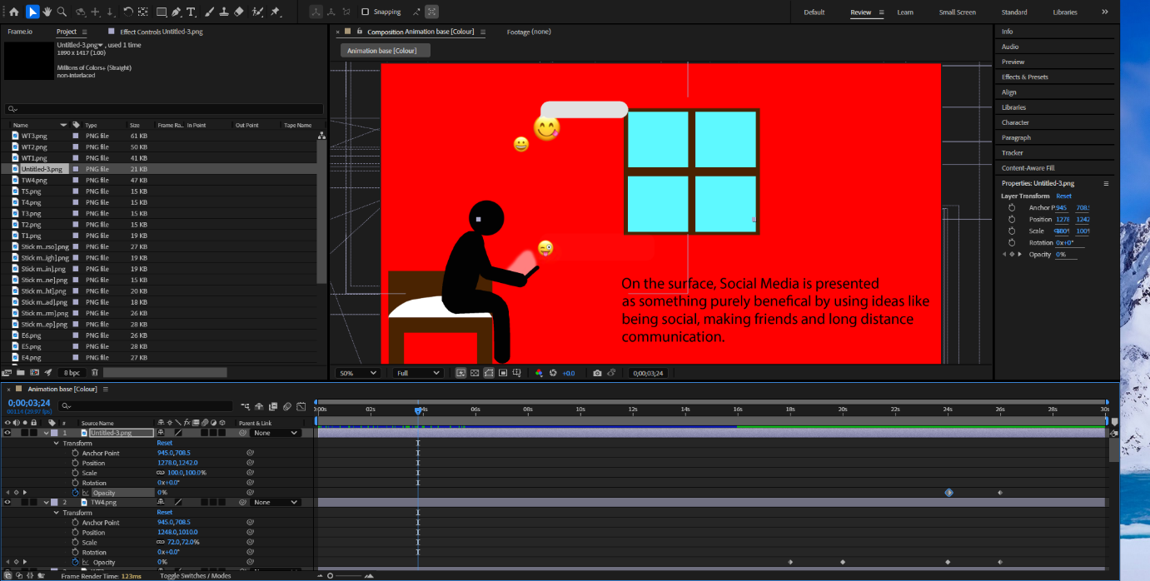
Post production:
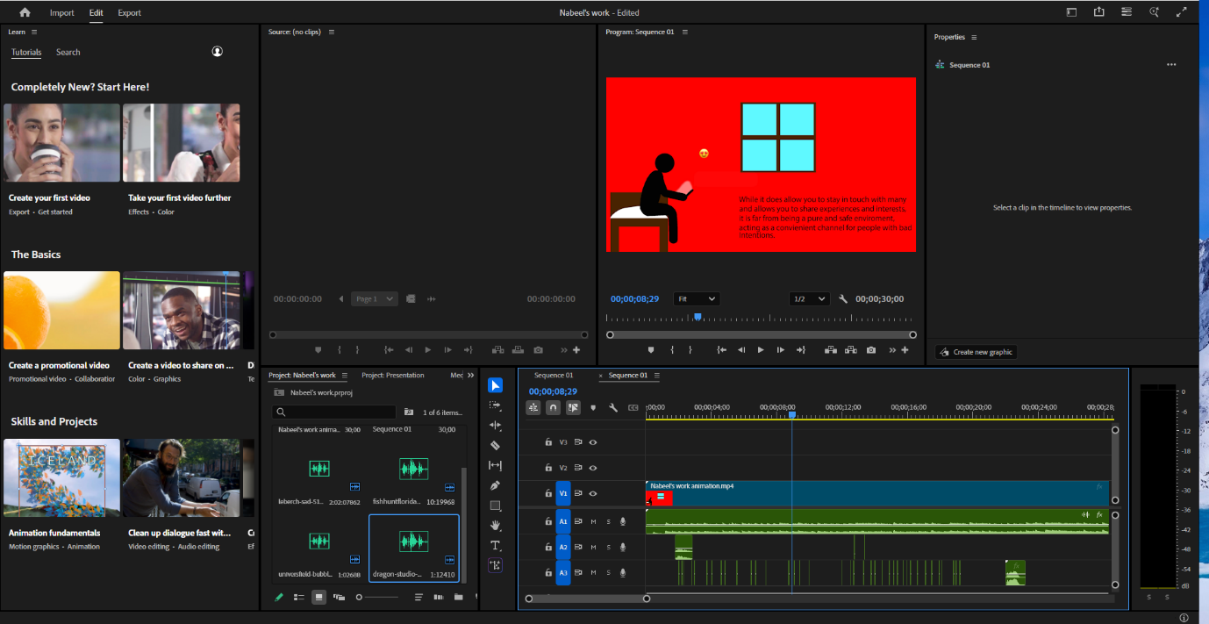
Task 3: Evaluate
Finished video:
https://youtu.be/p2HY7VLljvQ?si=Ezh_vzix7h9jNSkA
- Reflect and evaluate (500 to 750 words)
Concept choice:
I chose the issue of social media as I have always been an advocate against open social media like Snapchat, Instagram and Facebook. I do like more controlled medias such as Discord and WhatsApp as you can mediate what you see yourself quite easily while you can’t with others. I’ve always found it to be a massive issue with the world as many people misuse it and it puts people in danger. I developed my concept to address this by basing it’s styling on those informative animation videos they use to show in school to warn against dangers by showing the affects in a simplistic style to best get it across to all ages, so I decided to show the negative mental affects that come from overuse in a heavily visual manner with researched statistics. As someone who has known and current knows people being heavily affected by social media’s negative effect on the mind, I feel it’s something I am especially passionate about confronting as I’ve seen it drive people to anxiety, paranoia and depression with one person I know needing counseling. Social media has age ratings for a reason, but most people neglect this, willingly allowing children to use it and acknowledging that many of the people causing trouble online are kids who get overconfident with the belief that a screen keeps them safe from the consequences of what they do online.
Technical execution:
The techniques I use for the VFX is keyframing positions, opacity, rotation and more while altering the anchor points to make each part full articulated with its own movements to make it move more cleanly. The challenges I faced weren’t too many but still problematic such as how I lost all my animation work but not my assets, but I got around this by simply remaking it all as I knew what I wanted so the second time around, I had it done faster. Another issue I had was when importing some assets, it added them as their own sequences rather than simple PNGs which was making them unusable. I fixed this issue by saving them to a new place on the device then importing it again which worked.
Message impact
My messages impact I believe will be big as it’s a message that’s being presented more and more as technology advances. Technology is great and convenient but when open to everyone in the way it is, it is very dangerous and chaotic. If anything, I hope my message can have a major impact, but I don’t doubt it will have an impact as it is something important that needs to be addressed and is always swept under the rug so to speak. I’ve shown my work to a few of my friends, and they’ve told me it is compelling and that it reminds them of the videos they would be shown in school which is exactly what I wanted it to do so that made me proud of my work. They suggested that I add some noise and grain to the look of the background as it darkens and I liked that idea so I did, making it look more static and blurred but not too much as that would ruin it.
https://moodle.uwtsd.ac.uk/pluginfile.php/1026556/mod_resource/content/3/ACCA4043_VFX%20for%20Positive%20Impact.pdf

