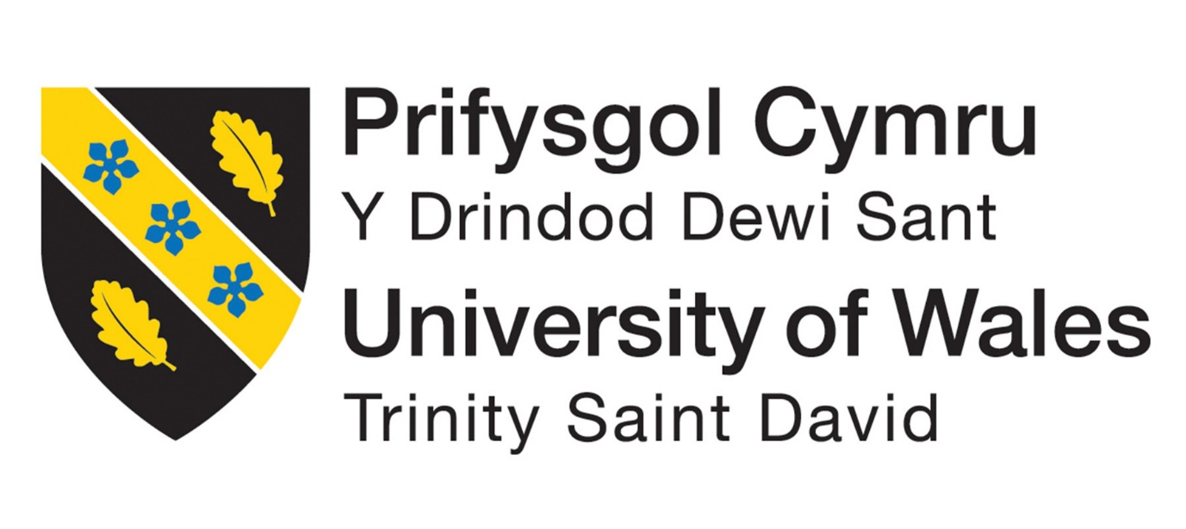
K

Module Name: Digital Skills Module Code: LCLM4002
Student Number: 2544270
Assessment 2
ARTEFACT
1. Why I choose my tool
I choose to work with Microsoft Word because I have experience in my life making poster or writing documents, additionally in the classroom the teacher teaches us how to improve our assessment using different tools to edit, to make clearer and more readable for the public.
2. What information I used
I read the scenario that I previously choose and look for the specific task that they ask me to do then I read the products that they sell which gave me an idea of how my menu more eye-catching for the public.
3. How I create my artefact
First, I made a draft of how I wanted my work to look and designed the presentation of the products on the menu. I arranged the items in a single column using bullet points to clearly distinguish between the products and food services. I set the text colour “Blue Accent 1” so the words would stand out against the white background, and I added logos to improve the overall appearance and bring a bit more colour and life to the menu.
4. What changes I made
At first, my menu looked very colourful and unprofessional, so I decided to change the colour scheme, I switched to a white background and incorporated green accents to catch the public’s eye. Additionally, I specified the ingredients for each dish listed on the menu, which gave customers more confidence when choosing their meals.
5. How I improve my work
I improved my work by adjusting the font, colour, and size to make it look clean an easier to read.
I also improved it by adding logos to make it look more eye-catching.
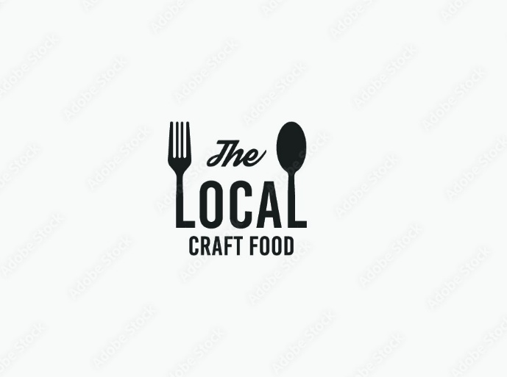
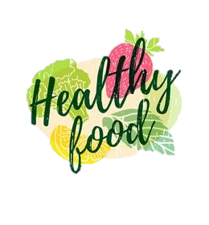
“FRESH BITES MEALS”

- BREAKFAST
Porridge Bowl …………… £3.80
(Oat Milk, Blueberries, Honey)
Breakfast Wrap…………. £4.20
(Chicken or Ham and Cheese, Salad, House Sauce)
Fresh Fruit Pot…………… £2.50
(Watermelon, Mango, Pineapple, Apple, Coconut)
- LUNCH
Chicken Salad Box……. £6.00
(Grilled Chicken, Avocado, Salad, Bolide Egg, Blue Cheese, Dressing)
Veggie Pasta Bowl……. £5.50
(Tomato Sauce, Courgette, Grilled Swet Potatoes, Parmesan Cheese, Olive Oil)
Soup of the Day………… £3.90
(Lentils or Tomato Soup)
- SNACKS
Granola Bar……………… £1.80
Greek Yoghurt Cup…… £2.20
Banana Bread Slice…... £2.50
(Flour, Eggs, Milk, Nuts)
- DRINKS
Fresh Orange Juice…... £2.80 Iced Coffee………… £3.20
Herbal Tea…. £2.00

