
L4 - Introduction to Web and Database Concepts
HTML & CSS Web Development


AMIR REZA TAMADDONI JAHROMI
2413014

Contents
Requirements’ section: 2
‘Implementation’ section: 3
Validation 5
'Evaluation’ section: 8
Website usability 8
Accessibility 8
SEO 9
Evaluation of the completed website: 9
in my HTML code, the following parts are SEO-focused: 10
Contract Checker 11
References: 12
Appendices 13
CSS 13
Index 15
Team Page 16
History Page 18
Stadium 21
Matches & Fixtures Page 23

Requirements’ section:
For this assignment, I designed and hand-coded a responsive website with at least five pages, using raw HTML and CSS. The site is dedicated to Real Madrid, one of the most successful football clubs in history, and serves as a platform to share information about the club’s history, players, fixtures, and the Santiago Bernabéu Stadium.
The website consists of five pages:
- Home Page – An introduction to Real Madrid, highlighting the club’s major achievements.
- Team Page – Details about the current team, including player profiles and roles.
- History Page – A timeline covering the club's history and key milestones.
- Stadium Page – Information about the Santiago Bernabéu Stadium, its importance, and ongoing renovations.
- Fixtures Page – A list of upcoming fixtures and match details.
The site is fully responsive, ensuring a smooth experience on both desktop and mobile devices. I used a custom CSS layout.

‘Implementation’ section:
- Screen grabs of all the pages of the completed website.
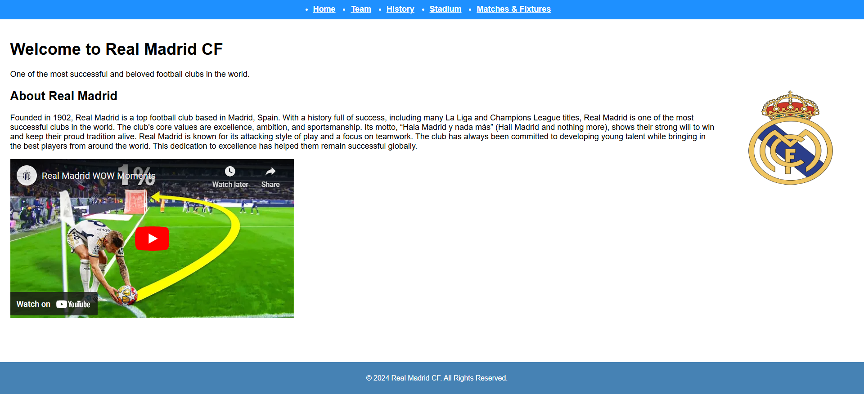
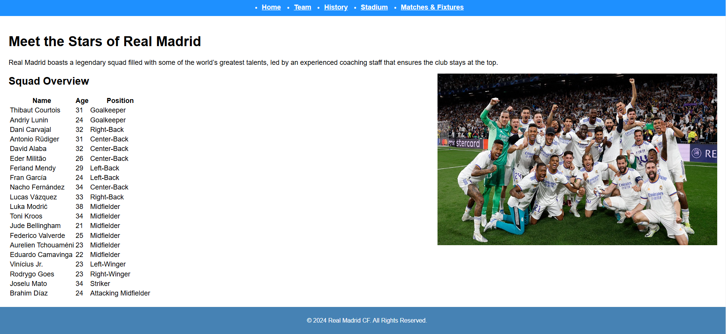
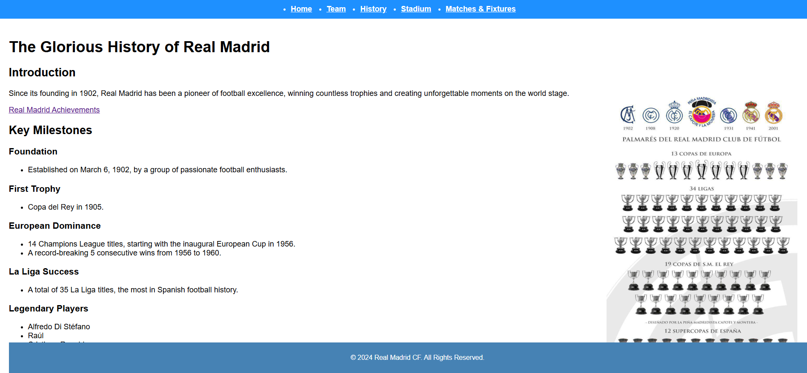
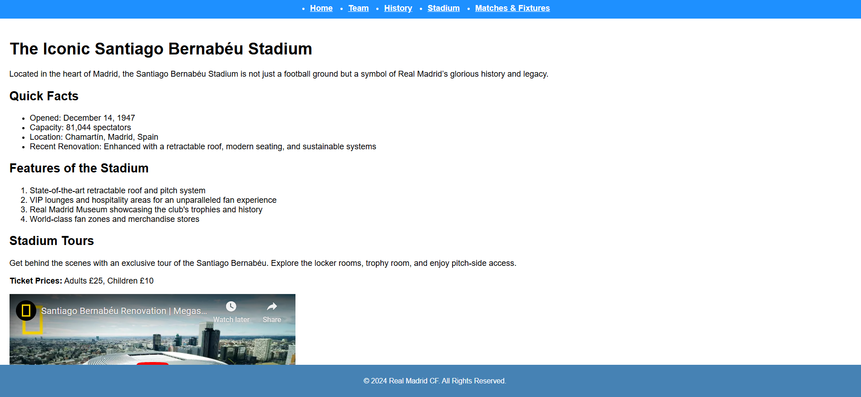
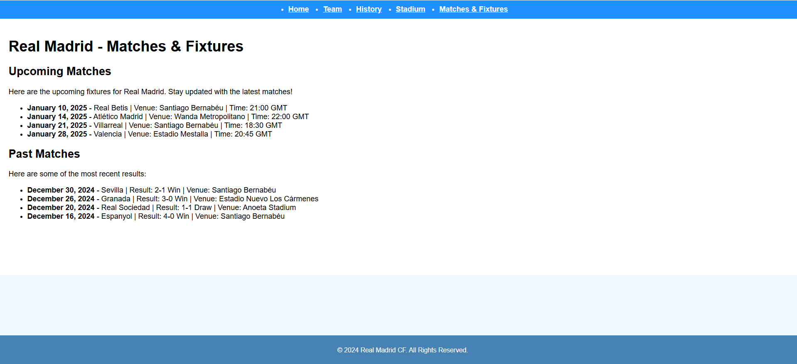

Validation
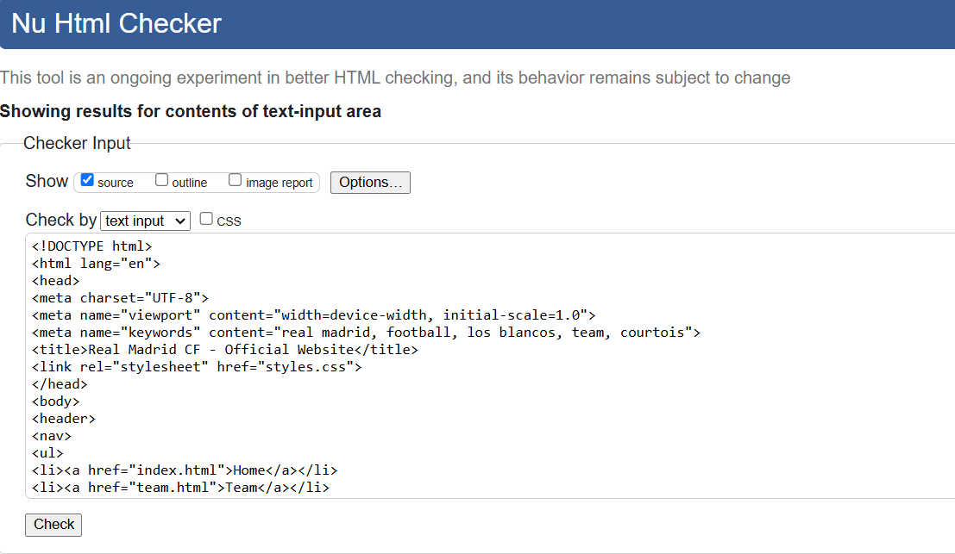
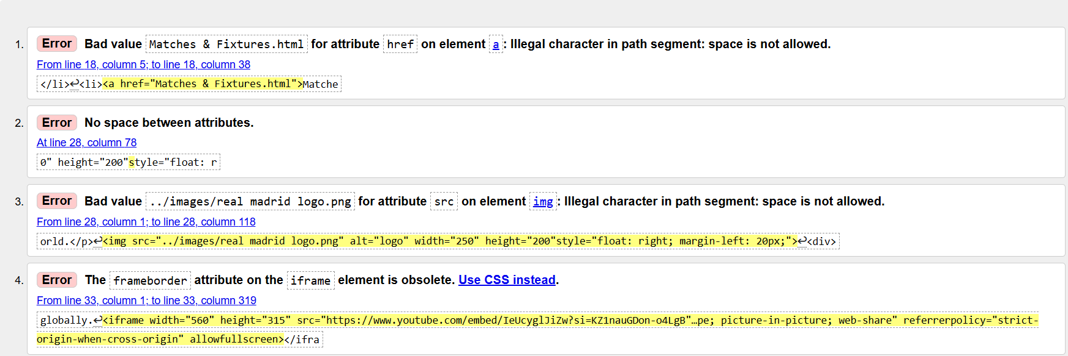
1.The error you're seeing happens because spaces aren't allowed in URLs or file paths. In this case, the space in Matches & Fixtures.html is causing the problem. The action that was taken to resolve issue was removing the spaces and changing it to “matches&fixtures.html”.
2.The error you're seeing specifies that there's a missing space between two attributes in an HTML tag. In this case, it looks like the height and style attributes are written together without the required space. The code that was inputted was ‘height=”200” style=”float: r’.
3. I ran into an issue where the image source ‘path, ../images/real madrid logo.png’, was causing an error due to the space in the file name. Spaces aren’t allowed in URLs or file paths, which is why the error occurred.
To fix it, the image file to is renamed as realmadridlogo.png (removing the space) and updated the src attribute in the code.
4. I encountered an issue where the frameborder attribute on the <iframe> element was considered outdated. The error message indicated that this attribute is no longer recommended.

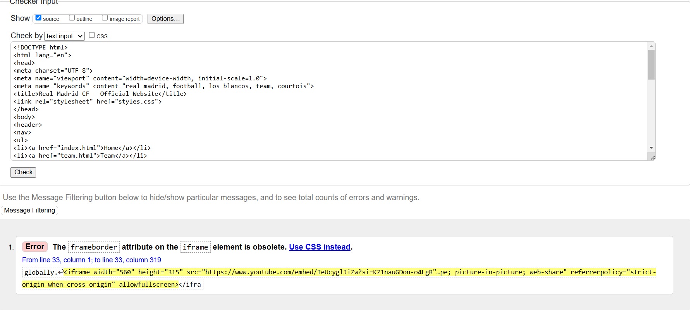
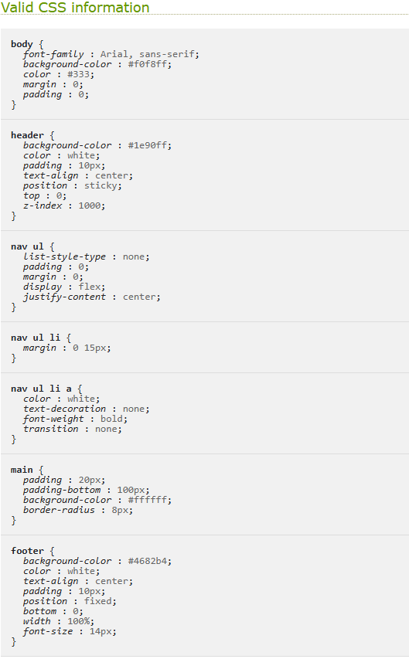
The CSS code provided has been validated and found to be error-free. All the styles adhere to standard CSS syntax and are correctly structured, ensuring compatibility and proper functionality in web development.

'Evaluation’ section:

Website usability
Website usability is about how straightforward it is for users to interact with and navigate throughout a website. It’s a key part of creating a good user experience and can have a massive impact on how visitors feel about the site. Usability comes down to a few main things:
- Clarity: Can users easily understand how the website is organized and what it offers? A clear structure makes it simple for people to find what they need.
- Simplicity: Is the site easy to use, even for someone visiting for the first time? A straightforward design is crucial for keeping users engaged.
- Efficiency: How quickly can someone find what they’re looking for? A good site gets users to their goals with minimal effort.
- Accessibility: Does navigating the site feel natural? Websites should run in a way that feels smooth and familiar [1]
- Control: Do users feel in charge of their experience? This includes features like clear buttons, the ability to undo actions, and easy correct errors. [1]
A poorly designed website can put off users and leave them with a bad impression, while a well-designed website creates a positive experience. When a site is easy to use, people are more likely to stick around and even come back in the future.
Usability is essential for a website’s success. It affects everything from how long people stay on a page to whether they make a purchase or sign up for a service. [1]

Accessibility
Web accessibility means designing and developing websites and online tools so that everyone, including people with disabilities can use them.
Accessibility makes sure that websites are user-friendly. International standards, like those from the World Wide Web Consortium (W3C), provide guidance on how to make websites accessible by removing barriers and improving usability for everyone. [2]
As Tim Berners-Lee, the inventor of the Web, said, “The power of the Web is in its universality. Access by everyone regardless of disability is an essential aspect.” [2]
Accessibility helps people with disabilities, such as those with hearing, vision or movement to understand, and interact with the Web better. However, accessibility doesn’t just benefit people with disabilities. It can also help people using mobile devices like phones or tablets, older adults with different abilities, or even those with temporary challenges. [2]
By making the Web accessible, developers and organizations can create better experiences for everyone while making sure that no one is missing out.

SEO
Search Engine Optimization focuses on making your website more visible on search engines like Google. It helps your site appear higher on search results, so its accessible to more people. SEO focuses on improving the quality and amount of traffic coming to your site.[3]
There are several key parts to SEO:
- Keyword Research: Figuring out what words or phrases people are likely to use when searching and using them strategically in your content.
- On-Page Optimization: Making sure things like titles, meta descriptions, headers, and images on your website are optimized for those keywords. [3]
- Technical SEO: Ensuring your site runs smoothly, loads quickly, is mobile-friendly, and is safe (using HTTPS). [3]
- User Experience: Making your website easy to use with clear navigation, so visitors stay longer and engage with the information provided on the website.
SEO is important due to the majority of users start their online experience with a search engine, and usually the top results are the ones that get the most attention. By optimizing your site, you boost your rankings and in result of that, attract more visitors.

Evaluation of the completed website:
1. Utility (Functionality)
Strengths:
- The website provides clear navigation links at the top (Home, Team, History, Stadium, Matches & Fixtures), making it easy for users to explore different sections.
- The inclusion of a YouTube video is engaging, adding appeal for visitors looking for highlights or key moments.
Recommendations:
- Add interactive features, such as a search bar or live match updates, to enhance functionality.

2. Usability (Look and Feel, Ease of Use)
Strengths:
- The layout is clean, with sufficient white space for readability.
- The colour scheme aligns with Real Madrid’s branding, reinforcing the club’s identity.
Recommendations:
- Change font sizes and styles for better readability, especially for the main body text.
3. Content (Information)
Strengths:
- The content is concise and informative, providing a brief overview of Real Madrid’s history, values, and achievements.
- Including the club’s motto, "Hala Madrid y nada más," adds emotional connection for fans.
Recommendations:
- Expand the "About Real Madrid" section to include recent achievements or notable players.
- Add links to purchase tickets, visit the fan store, or join a newsletter.
- Include a section for recent news or updates to keep the website dynamic and engaging.
Future Improvements
- Add interactive features like live chat support, social media integration, or a match calendar.
- Consider inserting image galleries or highlight reels to provide a richer experience.
- Improve page loading speed, especially for video and image

in my HTML code, the following parts are SEO-focused:
- Meta Tags:
  - <meta charset="UTF-8"> confirms proper character encoding.
  - <meta name="viewport" content="width=device-width, initial-scale=1.0"> makes the site mobile-friendly.
  - <meta name="keywords" content="real madrid, football, los blancos, team, courtois"> includes keywords relevant to the club for search engines.
- Alt Attribute: <img> includes an alt description ("logo") to improve accessibility and SEO.
- Header Structure: <h1> and <h2> tags in place for key information for SEO ranking.
- External Links: Linking CSS (styles.css) and video content improve site usability and engagement.

Contract Checker
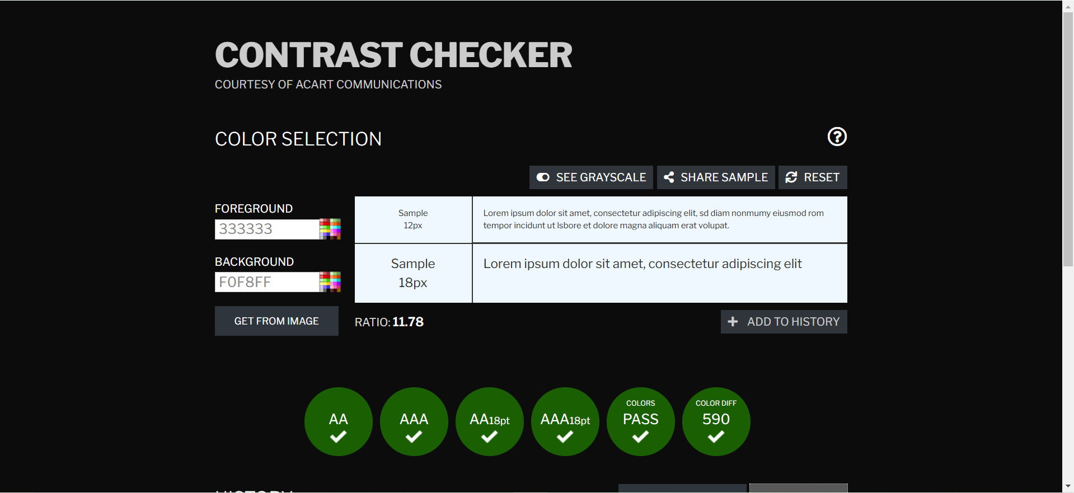
Using this tool, I checked the contrast between the foreground color (#333333) and the background color (#F0F8FF), and it passed with flying colors. The contrast ratio is 11.78, which is well above the minimum requirements. It meets both WCAG AA and AAA standards for normal and large text, so it’s great for readability and accessibility

References:
[1] Ramotion, “Website Usability 101: Definition, Principles and Methods | Ramotion Branding Agency,” Web Design, UI/UX, Branding, and App Development Blog, Apr. 17, 2023. https://www.ramotion.com/blog/website-usability/
[2] w3c_wai, “Introduction to Web Accessibility,” Web Accessibility Initiative (WAI), 2019. https://www.w3.org/WAI/fundamentals/accessibility-intro/#what
[3] Moz, “The Beginner’s Guide to SEO,” Moz, 2020. https://moz.com/beginners-guide-to-seo
‌

‌

‌

Appendices

CSS
/* General body styling */
body {
font-family: Arial, sans-serif;
background-color: #f0f8ff; /
color: #333;
margin: 0;
padding: 0;
}

/* Header styling */
header {
background-color: #1e90ff;
color: white;
padding: 10px;
text-align: center;
position: sticky;
top: 0;

}

/* Navigation Menu */
nav ul {
padding: 0;
margin: 0;
display: flex;
justify-content: center;
}
nav ul li {
margin: 0 15px;
}
nav ul li a {
color: white; /
text-decoration: none;
font-weight: bold;

}

/* Main Content Styling */
main {
padding: 20px;
padding-bottom: 100px;
background-color: #ffffff;

}

/* Footer styling */
footer {
background-color: #4682b4;
color: white;
text-align: center;
padding: 10px;
position: fixed;
bottom: 0;
width: 100%;
font-size: 14px;
}

Index
<!DOCTYPE html>
<html lang="en">
<head>
<meta charset="UTF-8">
<meta name="viewport" content="width=device-width, initial-scale=1.0">
<meta name="keywords" content="real madrid, football, los blancos, team, courtois">
<title>Real Madrid CF - Official Website</title>
<link rel="stylesheet" href="styles.css">
</head>
<body>
<header>
<nav>
<ul>
<li><a href="index.html">Home</a></li>
<li><a href="team.html">Team</a></li>
<li><a href="history.html">History</a></li>
<li><a href="stadium.html">Stadium</a></li>
<li><a href="Matches&Fixtures.html">Matches & Fixtures</a></li>
</ul>
</nav>
</header>

<main>

<h1>Welcome to Real Madrid CF</h1>

<p>One of the most successful and beloved football clubs in the world.</p>
<img src="../images/realmadridlogo.png" alt="logo" width="250" height="200"style="float: right; margin-left: 20px;">
<div>

<h2>About Real Madrid</h2>
<p>Founded in 1902, Real Madrid is a top football club based in Madrid, Spain. With a history full of success, including many La Liga and Champions League titles, Real Madrid is one of the most successful clubs in the world. The club's core values are excellence, ambition, and sportsmanship. Its motto, “Hala Madrid y nada más” (Hail Madrid and nothing more), shows their strong will to win and keep their proud tradition alive. Real Madrid is known for its attacking style of play and a focus on teamwork. The club has always been committed to developing young talent while bringing in the best players from around the world. This dedication to excellence has helped them remain successful globally.
</p>
<p> <iframe width="560" height="315" src="https://www.youtube.com/embed/IeUcyglJiZw?si=KZ1nauGDon-o4LgB" title="YouTube video player" frameborder="0" allow="accelerometer; autoplay; clipboard-write; encrypted-media; gyroscope; picture-in-picture; web-share" referrerpolicy="strict-origin-when-cross-origin" allowfullscreen></iframe>
</p>
</div>
</main>

<footer>
<p>&copy; 2024 Real Madrid CF. All Rights Reserved.</p>
</footer>
</body>
</html>

Team Page
<!DOCTYPE html>
<html lang="en">
<head>
<meta charset="UTF-8">
<meta name="viewport" content="width=device-width, initial-scale=1.0">
<meta name="keywords" content="real madrid, football, los blancos, team, courtois">
<title>Real Madrid CF - Official Website</title>
<link rel="stylesheet" href="styles.css">
</head>
<body>
<header>
<nav>
<ul>
<li><a href="index.html">Home</a></li>
<li><a href="team.html">Team</a></li>
<li><a href="history.html">History</a></li>
<li><a href="stadium.html">Stadium</a></li>
<li><a href="Matches&Fixtures.html">Matches & Fixtures</a></li>
</ul>
</nav>
</header>

<main>

<h1>Welcome to Real Madrid CF</h1>

<p>One of the most successful and beloved football clubs in the world.</p>
<img src="../images/realmadridlogo.png" alt="logo" width="250" height="200"style="float: right; margin-left: 20px;">
<div>

<h2>About Real Madrid</h2>
<p>Founded in 1902, Real Madrid is a top football club based in Madrid, Spain. With a history full of success, including many La Liga and Champions League titles, Real Madrid is one of the most successful clubs in the world. The club's core values are excellence, ambition, and sportsmanship. Its motto, “Hala Madrid y nada más” (Hail Madrid and nothing more), shows their strong will to win and keep their proud tradition alive. Real Madrid is known for its attacking style of play and a focus on teamwork. The club has always been committed to developing young talent while bringing in the best players from around the world. This dedication to excellence has helped them remain successful globally.
</p>
<p> <iframe width="560" height="315" src="https://www.youtube.com/embed/IeUcyglJiZw?si=KZ1nauGDon-o4LgB" title="YouTube video player" frameborder="0" allow="accelerometer; autoplay; clipboard-write; encrypted-media; gyroscope; picture-in-picture; web-share" referrerpolicy="strict-origin-when-cross-origin" allowfullscreen></iframe>
</p>
</div>
</main>

<footer>
<p>&copy; 2024 Real Madrid CF. All Rights Reserved.</p>
</footer>
</body>
</html>

History Page
<!DOCTYPE html>
<html lang="en">
<head>
<meta charset="UTF-8">
<meta name="viewport" content="width=device-width, initial-scale=1.0">
<meta name="keywords" content="real madrid, football, los blancos, modric, team, courtois">
<title>Real Madrid CF - Official Website</title>
<link rel="stylesheet" href="styles.css">
</head>
<body>
<header>
<nav>
<ul>
<li><a href="index.html">Home</a></li>
<li><a href="team.html">Team</a></li>
<li><a href="history.html">History</a></li>
<li><a href="stadium.html">Stadium</a></li>
<li><a href="Matches&Fixtures.html">Matches & Fixtures</a></li>
</ul>
</nav>
</header>

<main>
<body>
<div>
<h1>The Glorious History of Real Madrid</h1>
<h2>Introduction</h2>
<img src="../images/awards.jpg" alt="logo" width="400" height="800" style="float: right; margin-left: -60px;">
<p>Since its founding in 1902, Real Madrid has been a pioneer of football excellence, winning countless trophies and creating unforgettable moments on the world stage.</p>

<a href="https://www.transfermarkt.us/real-madrid/erfolge/verein/418" target="_blank">Real Madrid Achievements</a>
<h2>Key Milestones</h2>
<h3>Foundation</h3>
<ul>
<li>Established on March 6, 1902, by a group of passionate football enthusiasts.</li>
</ul>
<h3>First Trophy</h3>
<ul>
<li>Copa del Rey in 1905.</li>
</ul>
<h3>European Dominance</h3>
<ul>
<li>14 Champions League titles, starting with the inaugural European Cup in 1956.</li>
<li>A record-breaking 5 consecutive wins from 1956 to 1960.</li>
</ul>
<h3>La Liga Success</h3>
<ul>
<li>A total of 35 La Liga titles, the most in Spanish football history.</li>
</ul>
<h3>Legendary Players</h3>
<ul>
<li>Alfredo Di Stéfano</li>
<li>Raúl</li>
<li>Cristiano Ronaldo</li>
<li>Zinedine Zidane</li>
</ul>
<h3>Club Philosophy</h3>
<ul>
<li><strong>Motto:</strong> “Hala Madrid y nada más!”</li>
<li>Known for attacking football, a winning mentality, and nurturing world-class talents.</li>
</ul>
<h3>Historic Achievements</h3>
<ul>
<li>First Club World Cup winners.</li>
<li>Named the Best Club of the 20th Century by FIFA.</li>
</ul>
</div>

<footer>
<p>&copy; 2024 Real Madrid CF. All Rights Reserved.</p>
</footer>
</body>
</html>

Stadium
<!DOCTYPE html>
<html lang="en">
<head>
<meta charset="UTF-8">
<meta name="viewport" content="width=device-width, initial-scale=1.0">
<meta name="keywords" content="real madrid, football, los blancos, modric, team, courtois">
<title>Real Madrid CF - Official Website</title>
<link rel="stylesheet" href="styles.css">
</head>
<body>
<header>
<nav>
<ul>
<li><a href="index.html">Home</a></li>
<li><a href="team.html">Team</a></li>
<li><a href="history.html">History</a></li>
<li><a href="stadium.html">Stadium</a></li>
<li><a href="Matches&Fixtures.html">Matches & Fixtures</a></li>
</ul>
</nav>
</header>

<main>

<h1>The Iconic Santiago Bernabéu Stadium</h1>
<p>Located in the heart of Madrid, the Santiago Bernabéu Stadium is not just a football ground but a symbol of Real Madrid’s glorious history and legacy.</p>
<h2>Quick Facts</h2>
<ul>
<li>Opened: December 14, 1947</li>
<li>Capacity: 81,044 spectators</li>
<li>Location: Chamartín, Madrid, Spain</li>
<li>Recent Renovation: Enhanced with a retractable roof, modern seating, and sustainable systems</li>
</ul>

<h2>Features of the Stadium</h2>
<ol>
<li>State-of-the-art retractable roof and pitch system</li>
<li>VIP lounges and hospitality areas for an unparalleled fan experience</li>
<li>Real Madrid Museum showcasing the club's trophies and history</li>
<li>World-class fan zones and merchandise stores</li>
</ol>

<h2>Stadium Tours</h2>
<p>Get behind the scenes with an exclusive tour of the Santiago Bernabéu. Explore the locker rooms, trophy room, and enjoy pitch-side access.</p>
<p><strong>Ticket Prices:</strong> Adults £25, Children £10</p>

<iframe width="560" height="315" src="https://www.youtube.com/embed/GPwzHoibzSA?si=bPv92cx9PWeUGqjl" title="YouTube video player" frameborder="0" allow="accelerometer; autoplay; clipboard-write; encrypted-media; gyroscope; picture-in-picture; web-share" referrerpolicy="strict-origin-when-cross-origin" allowfullscreen></iframe>

</div>

</main>

<footer>
<p>&copy; 2024 Real Madrid CF. All Rights Reserved.</p>
</footer>
</body>
</html>

Matches & Fixtures Page
<!DOCTYPE html>
<html lang="en">
<head>
<meta charset="UTF-8">
<meta name="viewport" content="width=device-width, initial-scale=1.0">
<meta name="keywords" content="real madrid, football, los blancos, modric, team, courtois">
<title>Real Madrid CF - Official Website</title>
<link rel="stylesheet" href="styles.css">
</head>
<body>
<header>
<nav>
<ul>
<li><a href="index.html">Home</a></li>
<li><a href="team.html">Team</a></li>
<li><a href="history.html">History</a></li>
<li><a href="stadium.html">Stadium</a></li>
<li><a href="Matches&Fixtures.html">Matches & Fixtures</a></li>
</ul>
</nav>
</header>

<main>
<div>

<h1>Real Madrid - Matches & Fixtures</h1>

</div>
<div>
<h2>Upcoming Matches</h2>
<p>Here are the upcoming fixtures for Real Madrid. Stay updated with the latest matches!</p>

<ul>
<li><strong>January 10, 2025</strong> - Real Betis | Venue: Santiago Bernabéu | Time: 21:00 GMT</li>
<li><strong>January 14, 2025</strong> - Atlético Madrid | Venue: Wanda Metropolitano | Time: 22:00 GMT</li>
<li><strong>January 21, 2025</strong> - Villarreal | Venue: Santiago Bernabéu | Time: 18:30 GMT</li>
<li><strong>January 28, 2025</strong> - Valencia | Venue: Estadio Mestalla | Time: 20:45 GMT</li>
</ul>

<h2>Past Matches</h2>
<p>Here are some of the most recent results:</p>

<ul>
<li><strong>December 30, 2024</strong> - Sevilla | Result: 2-1 Win | Venue: Santiago Bernabéu</li>
<li><strong>December 26, 2024</strong> - Granada | Result: 3-0 Win | Venue: Estadio Nuevo Los Cármenes</li>
<li><strong>December 20, 2024</strong> - Real Sociedad | Result: 1-1 Draw | Venue: Anoeta Stadium</li>
<li><strong>December 16, 2024</strong> - Espanyol | Result: 4-0 Win | Venue: Santiago Bernabéu</li>
</ul>

</main>

<footer>
<p>&copy; 2024 Real Madrid CF. All Rights Reserved.</p>
</footer>
</body>
</html>

