Module Code : LCHS 4009

Assignment Title :Personal Portofolio

Student name : Ioana Bianca Cristiana

Student number : 2434786

Lecture’s Name :

Date: 24.03.2026

Contents
Task 1 3
Task 2 8
Task 3 10
Task 3 11
Task 4 12
References 14

Task 1
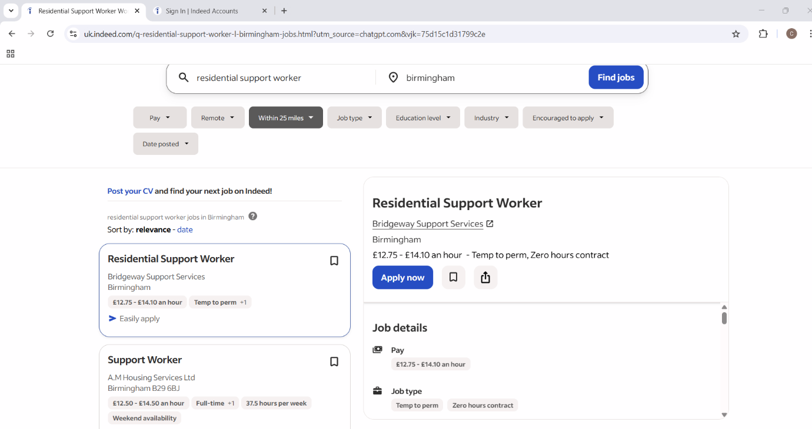
Job Details
Pay
- £12.75 - £14.10 an hour*
Job type
- Temp to perm
- Zero hours contract
Location
Birmingham
Full job description
Residential Support Workers – Zero Hour Contracts Available.
Bridgeway Support Services is currently recruiting Residential Support Workers to join our growing agency team supporting residential homes across the West Midlands.
Homes are located in:
- Birmingham
- West Bromwich
- Walsall
- Sutton Coldfield
If you are passionate about supporting vulnerable young people and want flexible work that fits around your schedule, we would love to hear from you.
About the Role
As a Residential Support Worker, you will support young people within residential settings, helping them develop independence, confidence, and life skills in a safe and supportive environment.
Key Responsibilities
- Supporting young people with daily routines and activities
- Promoting independence and life skills development
- Providing emotional support and guidance
- Maintaining a safe and nurturing environment
- Completing accurate records and reports
- Following safeguarding policies and procedures
What We Offer
✅ Zero-hour contracts with flexible shifts
✅ Competitive hourly rates
✅ Opportunities to work across multiple services
✅ Ongoing training and development
✅ Support from an experienced agency team
Requirements
✔ Previous experience in residential care or support work (preferred)
✔ Passion for supporting young people and vulnerable individuals
✔ Good communication and teamwork skills
✔ Understanding of safeguarding and professional boundaries
This is a great opportunity for experienced Support Workers looking for flexible agency work within residential care settings.
Apply today or message Bridgeway Support Services to find out more.
Pay: £12.75-£14.10 per hour
Work Location: In person

CV
Bianca-Cristiana Ioana
Birmingham
Telephone number 07491066358
Biancaioana210@gmail.com

I am currently studying on obtaining a degree in Health and Social Care. In the future, I want to work with kids and teens. I'm kind, motivated, patient, and good at talking to people. I've worked in a lot of various locations such as hotels, factories, and warehouses.These jobs taught me how to be flexible, work as part of a team, and handle stress well. I don't have any experience in social care at the moment, but attending college after having a baby was the biggest choice I've done for me so far. This experience demonstrated to me how strong, determined, and dedicated I am to making the present better.
As a Residential Support Worker, I want to help children become more confident and independent by taking care of them, giving them emotional support, and pushing them to do their best.As a Residential Support Worker, I want to help teens and young adults become more self-sufficient and sure of themselves by taking care of them, giving them emotional support, and pushing them to do their best.
Education & Qualifications
University of Wales Trinity Saint David, Birmingham
Bachelor of Science – Health and Social Care (Currently studying)
- Developing knowledge in safeguarding, child development, communication in care settings and community health.
- Learning about professional practice in health and social care environments.
Mihai Viteazul College, Romania
High School Diploma – 2014
Key subjects:
- Mathematics
- Romanian Language
- English
- Italian
Developed strong analytical, organisational and communication skills during my studies.
Work Experience
Production Operative – Salts Healthcare
July 2018 – June 2019
Put together medical stoma products that met strict quality standards.
• Checked equipment regularly and did small maintenance tasks.
• Followed rules for cleanliness, safety, and quality control.
• Finished daily paperwork and production reports.
• Kept a high level of accuracy and attention to detail.
• Always met or beat daily production goals.
Ocado, Dordon: Warehouse Operative (Picker & Packer) from January 2016 to July 2018
• Quickly and correctly picked and packed customer orders.
• Kept up high standards for quality control and safety at work.
• Worked well with others to meet daily productivity goals.
• Helped with managing stock and checking the inventory.
• Followed the rules and procedures set by the company.
Supported new team members by explaining work procedures.
Key Skills
- Communication and interpersonal skills
- Teamwork and collaboration
- Time management and organisation
- Ability to work under pressure
- Adaptability in fast-paced environments
- Attention to detail
- Cultural awareness and empathy
Languages
- Romanian – Native
- English – Intermediate
- Italian – Fluent
- German – Basic

Technical Skills
- Experience with warehouse operations and inventory systems
- Product assembly and quality control procedures
- Knowledge of hygiene and health & safety regulations
- Basic administrative and reporting skills

Interests
- Travelling and learning about new cultures
- Cooking and preparing healthy meals
- Personal development and education in health and social care

Task 2

I am Bianca-Cristiana Ioana and I am getting my Bachelor of Science in Health and Social Care at the University of Wales Trinity Saint David in Birmingham right now. I want to be a Residential Support Worker because I love helping young people who need care, support, and guidance. I think this job is a great way to start a long-term career in health and social care while also working toward my goal of becoming a midwife.
I've always wanted to help other people, but after I became a mother, that desire grew even stronger. Taking care of my kid while also going to school has helped me become more resilient, better at managing my time, and more understanding of other people. These attributes are very important when helping young people who may be going through hard times. One of my greatest successes is going back to school after having a child. This experience shows how determined I am to better myself as a person and as a worker, while also making a better future for my family.
I learned a lot about health and social care while I was in college, including how to keep people safe, how to promote community health, how to help children grow, and how to communicate well in care settings. These topics have helped me understand what vulnerable young people, especially those who live in residential care, have to deal with. I have learned how important it is to make a safe, supportive, and caring space where kids feel respected, valued, and encouraged to grow in confidence and independence. My studies have also made me more patient, aware of other cultures, and responsible when working with people from different backgrounds.
I haven't worked directly in social care yet, but my past jobs in hotels, factories, and warehouses have helped me learn a lot of skills that I can use in other jobs. Working in fast-paced settings and with people from different backgrounds has made me more adaptable, better at working with others, and better at staying calm under stress. I've also learned how to communicate well and have an excellent attitude towards work. My bosses and colleagues often say that I am honest, work hard, and am open to help others. I think that these qualities would make me a good member of a residential care team.

Being able to speak more than one language is one of my best skills. I can talk to people from a lot of different cultures because I speak English, Romanian, German, and Italian. This skill can help make the school, home, and workplace more friendly and open to everyone, including children, friends, and colleagues. I am also very focused on following professional standards, like keeping things private, following safety rules, and giving professional treatment.

I really want this job because I think that every child should have the chance to grow up in a safe and supportive place, especially children who are having a hard time. I want to learn from people who have been doing this for a long time, take part in training opportunities, and help make the lives of young people in residential care better.

I think my kindness, determination, and strong desire to grow as a person and in my career would help me do well in this position. Thank you so much for taking the time to review my application.

Strengths
Empathy and patience developed through motherhood and my studies in health and social care.
Can speak English, Romanian, German, and Italian fluently.
In past jobs, I learned how to work well with others and talk to them.

Opportunities
There are chances to receive specialised guidance and instruction in residential childcare.
Chance to work with kids and teens in real life.
Chance to make professional connections in the social care area.Chance to gain practical experience with children and young people.
Opportunity to build professional networks within the social care sector.
Weaknesses
No direct experience in social care settings.
Still building confidence in how to deal with challenging behaviours
Need more training in UK social care and safeguarding requirements.
Threats
Stress from work and the chance of burnout.Competition from applicants with more experience.
Adapting to shift work, including nights and weekends.

Task 3
Personal SWOT analysis

Task 3

Goals | List the actions to complete to achieve the goal | Support/resources needed | Target date | Review date
Gain practical experience working with children and young people in residential care | Take part in workplace introductions and follow closely experienced support workers. Help young people with their daily routines, activities, and emotional needs. Write down my thoughts and feelings about my experiences in a journal. | Support from supervisors and experienced colleagues. Workplace training and guidance. | Within 12 months
Learn about how to keep people safe and how to manage behaviour. | Complete safeguarding training and behaviour management courses. Study organisational safeguarding policies and observe experienced staff dealing with challenging situations. | Training courses on how to keep people safe, online learning materials. | Within 12–18  months
Improve communication skills with children, families and professionals | Attend communication skills training and practise active listening and empathy in daily interactions. Observe experienced staff communicating with young people and families. | Communication workshops, feedback from supervisors and colleagues. | Within 24 months

Task 4

For my LCHS4009 Component 1 assessment, I prepared a PowerPoint presentation about the importance of teamwork in health and social care. The presentation was delivered individually to my teacher and was expected to last five minutes. I had completed extensive reading on the topic and felt confident that I understood the theoretical concepts and case study information very well. However, when it was time to present, I experienced a high level of nervousness and anxiety (Febryantika & Sulistyani, 2025; Marinho et al., 2017).
At the beginning of the presentation, I felt very anxious and uncertain. Even though I had practised the presentation at home and understood the content, standing in front of my teacher made me feel overwhelmed. I struggled to organise my thoughts clearly and felt that my anxiety was affecting my performance. This situation made me feel disappointed in myself because I had prepared carefully but still did not feel confident during the presentation. I hoped that my teacher would understand that I had worked hard to prepare, even if my nervousness affected my delivery (Marinho et al., 2017).
When evaluating the experience, there were both positive and negative aspects. One positive outcome was that I successfully completed the presentation and demonstrated my understanding of the topic. I was able to explain the basic principles of teamwork in health and social care and highlight its importance in professional practice. Effective teamwork is essential in health and social care environments because it improves communication, enhances patient safety and supports better outcomes for individuals receiving care (Reeves et al., 2017; WHO, 2010).
However, there were also some weaknesses in my presentation. Due to my nervousness, I relied heavily on reading directly from the PowerPoint slides rather than speaking more naturally. This reduced the level of interaction and engagement in my presentation. Additionally, because I was speaking quickly due to anxiety, the presentation lasted only three minutes instead of the required five minutes. As a result, I missed the opportunity to expand on my ideas and demonstrate a deeper understanding of the topic (Febryantika & Sulistyani, 2025).
After thinking about it, I realised that anxiety was is most important thing that made my performance poor. It's important to get ready, but it's also important to practise giving presentations in real life. When I trained at home, I felt relaxed and sure of myself. But when I spoke in front of someone else, I felt more pressure. Reading from the slides helped me relax but it also made it harder for me to show what I knew and communicate clearly. I also learned that time management is an important presentation skill. If i am nervous, i might speak too quickly, which can make the presentation shorter and less good. A structured reflective model like the Gibbs Reflective Cycle can help me find these problems and help me grow as a professional (Ingham Broomfield, 2021).
In conclusion, the most important thing I learned from this is that I need to find ways to deal with my anxiety and feel more confident when I talk to people.
Although I understood the content well, my delivery did not fully reflect my knowledge and preparation. I also realised the importance of communicating ideas in my own words instead of relying heavily on written slides.Also, it's necessary to speak at the right speed so that i can easily and efficiently present information. These abilities are especially important in health and social care areas, where safe and effective care needs good communication and teamwork (Meng et al., 2025; Reeves et al., 2017).
For future presentations, I plan to practise speaking in front of other people, such as friends or family members, to build my confidenc. I might also record myself while I practise so I can evaluate how I speak and find ways to improve. To make communication more natural, I will use necessary words and short phrases instead of full paragraphs on my slides.. To manage anxiety before presenting, I will use breathing exercises and relaxation techniques that can help reduce stress and improve focus (Febryantika & Sulistyani, 2025). I will also ask my teachers feedback after I give a presentation so that I can keep getting better at giving presentations. I want to give clear, interesting, and professional presentations that show what I know and can do (Ingham Broomfield, 2025). I work on my confidence and learning new information all the time to do this.

References

Reeves, S., Pelone, F., Harrison, R., Goldman, J. and Zwarenstein, M. (2017). Interprofessional Collaboration to Improve Professional Practice and Healthcare Outcomes. Cochrane Database of Systematic Reviews, 6(6). doi:https://doi.org/10.1002/14651858.cd000072.pub3.

World Health Organization (2010). Framework for action on interprofessional education & collaborative practice. [online] World Health Organization. Available at: https://www.who.int/publications/i/item/framework-for-action-on-interprofessional-education-collaborative-practice.
‌

Febryantika Kustyandari and Sulistyani, L. (2025). Speaking Anxiety in Oral Presentation-based Assessment: Factors and Strategies. Jurnal Penelitian Pendidikan/Jurnal penelitian pendidikan, 42(2), pp.155–162. doi:https://doi.org/10.15294/jpp.v42i2.28968.
‌

Ocampo, F.A., McIntyre, B.G., Massey, D. and Saunders, R. (2025). Nursing Student Reflections on a Research internship: a Reflective Discussion following the Gibbs’ Reflective Cycle. Nurse Education Today, [online] 145(1), p.106481. doi:https://doi.org/10.1016/j.nedt.2024.106481.

Ferreira Marinho, A.C., Mesquita de Medeiros, A., Côrtes Gama, A.C. and Caldas Teixeira, L. (2017). Fear of Public Speaking: Perception of College Students and Correlates. Journal of Voice, [online] 31(1), pp.127.e7–127.e11. doi:https://doi.org/10.1016/j.jvoice.2015.12.012.
‌

Meng, Z., Tang, J., Yang, J., Wu, H., Cui, L., Zhu, S., Wang, X. and Huang, X. (2025). Fostering participation motivation and multidisciplinary teamwork collaboration through hospital culture and team leadership in Chinese tertiary public hospitals—A cross-sectional study. PLoS ONE, 20(11), pp.e0334831–e0334831. doi:https://doi.org/10.1371/journal.pone.0334831.
‌

