An Assessment of Coastal change along the Tenby South Sands, Pembrokeshire Coastline

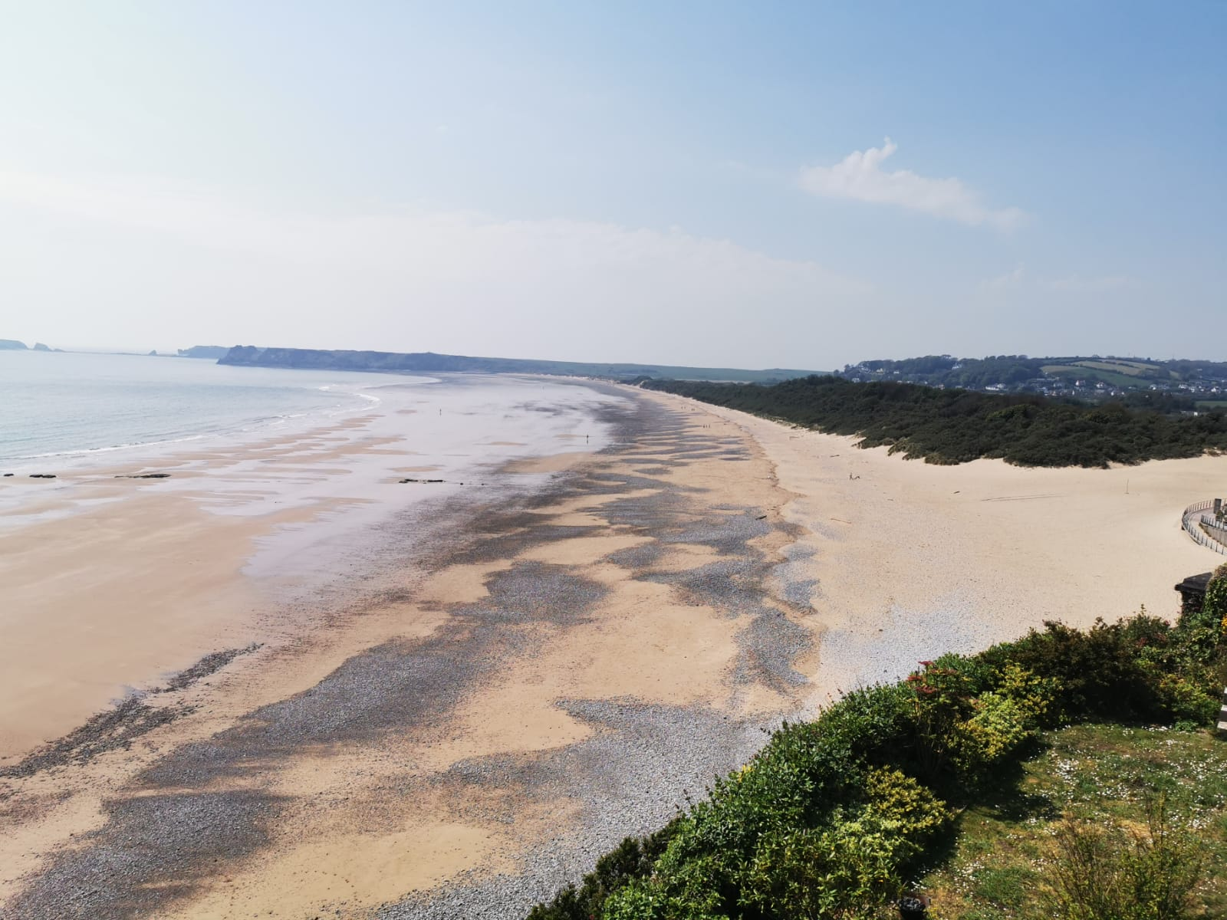

Abstract
Global warming has significant effects, particularly on dune backed embayed beaches, and Tenby South Sands, Pembrokeshire is one such beach. At medium-and short timescales, beach level change was assessed and between 1996 and 2019 beach levels mostly fell, confirmed by both t tests and regression modelling. Morphostat assessments using 1996-2013 data and more recent 2019 data, highlighted southern erosion, central stability (albeit with falling beach levels) and upper tidal accretion with lower tidal erosion in the north. However, overall beach erosion outweighed accretion and the profile was allocated a red decrease status. Short-term results using 2008-2010 monthly data and the 2019 survey, showed variable profile change confirmed by t tests and regression models with almost negligible correlation. However, Morphostat assessments using beach profiles averaged to represent each beach sector did show that, with the exception of the northern upper tidal area, beach levels in 2019 fell outside the 2008-2010 envelope and when all 13 profiles were assessed all but one were allocated an overall red status. Strategically, beach management, based upon medium term results would trigger further investigation, including assessments of external influences as well as additional profile data collection over shorter or project timescales. Depending on the trigger level framework, these investigations would prompt an agreed action.
This research has demonstrated the efficacy of the Morphostat programme for coastal zone management in providing a strategic assessment of beach health. Categorising whether a beach falls within or outside survey trends enables not only high-level strategic decision making, but implementation at project level to assess beach change and inform design, or as a monitoring tool during and after construction.

Acknowledgements

Contents
Abstract 2
list of Figures 5
List of Tables 6
Chapter 1 Introduction 7
Chapter 2 Literature Review 9
2.1 Introduction 9
2.2 Embayed beaches and beach rotation 9
2.3 The importance of the beach profile 11
2.4 Beach Profiling methods and technologies 12
2.5 Evaluating change 15
2.6 Shoreline Management Plan 15
Chapter 3 Physical Background 19
3.1 Introduction 19
3.2 Geological setting 21
3.3 Geomorphological Setting 22
3.4 Anthropogenic Influences 24
Chapter 4 Methodology 25
4.1 introduction 25
4.2 Beach profiling programme 26
4.3 Medium Scale profile analysis 26
4.4 Short term profile analysis 27
4.5 Evaluation of topographic data 28
4.6 Statistical Analysis 31
4.6.1 Kolmogorov-Smirnov test 32
4.6.2 Paired t tests 32
4.6.3 Linear Regression 32
4.7 Summary 33
Chapter 5 Results and Discussion 34
5.1 Medium Timescale data analysis 34
5.1.1 Qualitative assessment 34
5.1.2 Quantitative assessment 40
5.1.3 Morphostat Assessment 44
5.2 Short Timescale data analysis 47
5.2.1 Qualitative analysis 47
5.2.2 Quantitative assessment 53
5.2.3 Morphostat Assessment 56
5.3 Summary 60
Chapter 7 Conclusions and Recommendations 61
References 63
Appendix A 69
Medium timescale beach profile data sheets 69
APPENDIX B 73
SHORT TIMESCALE BEACH PROFILE DATA SHEETS 73
APPENDIX C 77
MORPHOSTAT TABLES 77
Appendix D 81
Statistical equations used for the computation of dependent t tests and regression models 81
Dependent t tests 82
Linear Regression models 83
Appendix E 86
Morphostat Results short-term data 86

List of Figures
Figure 1. 1: a) Carmarthen Bay and b) Tenby South Sands Study Area. 6

Figure 2. 1: A simple model of rotation, a) waves from one direction create erosion updrift and accretion downdrift and b) a reversal in wave direction reverses this process. Reproduced from Harley et al., (2011) 7
Figure 3. 1: Study area location A) UK, B) Bristol Channel and C) Carmarthen Bay showing studies littoral highlighted with black border, reproduced from Thomas et al., (2012) 15
Figure 3. 2: Tenby South Sands, study area 16
Figure 3. 3: Geological Map of Pembrokeshire, Source John (2019) 18
Figure 3. 4: Limits of the Sites of Special Scientific Interest. Source, Thomas (2012) 20
Figure 4. 1:Profile locations for short (white line) and medium (red line) timescale analyses. 26
Figure 4. 2: A definition sketch showing the morphological zones from which comparative beach levels used for characterising profile change within the Morphostat programme were computed. 28
Figure 4. 3: Illustration detailing how the percentage of green values allocated to trigger exceedance was determined, a) initial analysis from which the value of 74.43% was calculated and b) trigger value revised for subsequent analysis. 30

Figure 5. 1:a) T09 (south sector) profiles 1996-2019 inset and successively offset by 0.5m, b) photograph from Control Marker and c) Profile envelop with autumn 2019 profile (red dotted line). 34
Figure 5. 2: a) T10 profiles (central sector) 1996-2019 inset and successively offset by 0.5m, b) photograph taken from the control point c) confidence intervals (solid lines) and Autumn 2019 profile (red dotted line). 36
Figure 5. 3: a) T11 profiles 1996-2019 inset and successively offset by 0.5m, b) photograph taken from the control point c) confidence intervals (solid lines) and Autumn 2019 profile (red dotted line). 37
Figure 5. 4: Regression analysis results for Inter-survey cumulative average beach level change, a) T09, b) T10 and c) T11. 41
Figure 5. 5: a) South sector profiles 2008-2019 inset and successively offset by 0.5m, b) photograph taken from the South sector c) confidence intervals (solid lines) and Autumn 2019 profile (red dotted line). 46
Figure 5. 6: a) Central sector profiles 2008-2019 inset and successively offset by 0.5m, b) photograph taken from the Central sector c) confidence intervals (solid lines) and Autumn 2019 profile (red dotted line). 47
Figure 5. 7: a) North sector profiles 2008-2019 inset and successively offset by 0.5m, b) photograph take from the North sector c) confidence intervals (solid lines) and Autumn 2019 profile (red dotted line). 48
Figure 5. 8: Regression analysis results for Inter-survey cumulative average beach level change, a) south, b) central and c) north sectors. 51

List of Tables
Table 3. 1: Tide levels in relation to Ordnance Datum, reproduced from Thomas (2012) 19

Table 4. 1: Zones for beach change confidence intervals, reproduced from Thomas et al., 2018. 26

Table 5. 1: Kolmogorov-Smirnov test results. 41
Table 5. 2: Results of paired t tests. 43
Table 5. 3: Autumn 2019 colour coded results taken from Morphostat for T09. 47
Table 5. 4:Autumn 2019 colour coded results taken from Morphostat for T10. 47
Table 5. 5: Autumn 2019 colour coded results taken from Morphostat for T11. 48
Table 5. 6: Kolmogorov-Smirnov test results. 54
Table 5. 7: Results of Paired t tests. 55
Table 5. 8: Dec 2019 colour coded results taken from Morphostat for the southern (TR01-TR05) sector 57
Table 5. 9: Dec 2019 colour coded results taken from Morphostat for the central (TR05-TR09) sector. 59
Table 5. 10: Dec 2019 colour coded results taken from Morphostat for the northern (TR09-TR13) sector. 60
Table 5. 11: Morphostat results for all short term profiles 60
Table 5. 12: Trigger Level Framework, produced for a dune backed embayed beach, based upon Thomas et al. (2018). 61

Chapter 1 Introduction
Global sea-level rise as a result of climate change is a major threat to the coastal environment and is expected to accelerate (Papadopoulos and Tsimplis 2006). Large parts of Great Britain’s coasts already experience several problems, including sediment starvation and erosion (de la Vega-Leinert and Nicholls 2008). Carmarthen Bay, West Wales, is a large embayment and Tenby South Sands, Pembrokeshire, (ordnance Survey Reference: 212200, 198500) is located on its western fringe (Thomas 2012). A classic embayment backed by dunes and developed between two erosion resistant headlands that structurally control the evolution of the bay (Short and Masselink, 1999, Thomas et al., 2010). A dearth of worldwide macro tidal embayed beach studies existed prior Thomas et al’s (2012) work within the present study area. There works established beach rotation influenced by several forcing variables, at multiple temporal scales (for example Thomas et al, 2010, 2011b, 2011d, 2015 and 2016). They established links between offshore island and spit diminution and teleconnection and wave variations (Thomas et al 2011a and 2011c).

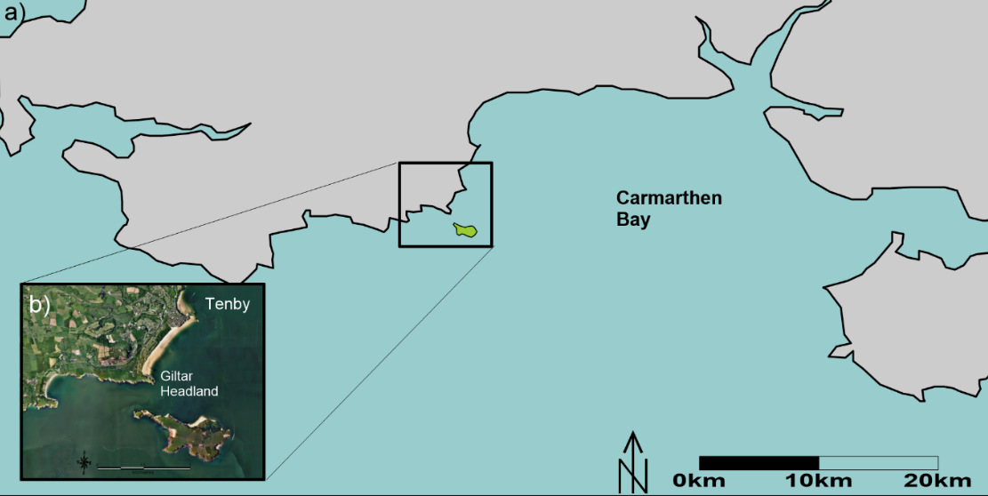
Figure 1. 1: a) Carmarthen Bay and b) Tenby South Sands Study Area.

To fill important research gaps and inform future management strategies, it was important that their work was assessed and updated. Previously, short-term data analysis was completed in November 2010 and the medium-term data was last collected in Spring 2013. Consequently, the main aims of this study are to:
- Evaluate existing embayed literature at a local and international level.
- Examine shoreline evolution at medium and short timescales to identify spatial change (based upon beach level variation).
- Propose beach management strategies based upon a statistically derived methodology.
To achieve research aims the following objectives were established:
- Collect data using dGPS technology at the predetermined beach profile locations set out in previous research.
- Analyse intertidal shoreface dynamics as expressed by cross shore profile variability for both medium and short timescales.
- Quantitatively analyse data using the “Winstat” statistical programme to assess profile variability
- Assess the extent of profile variability using “Morphostat” semi-automated programme and set results for medium and short timescale against a predetermined framework.
Ordinarily the results of the assessments would be set against the variables that influence these changes, such as, wind, waves, their directional components and teleconnection patterns, as well as physical influences, such as, bathymetry and offshore Islands that effect refraction and diffraction patterns inter alia. However, this project only analyses the physical changes and does not attribute causation, which would be the subject of continued research at this littoral.

Chapter 2 Literature Review

2.1 Introduction

There is a growing realisation that many of the world’s coastlines are under threat due to the impacts of climate change. Assessments of acceptable risk based on ongoing costs to defend, requires that suitable choices are made that reduce difficult and costly decisions for the future (Phillips et al, 2018). Seasonal changes in beach profiles constitute an important aspect of the adaptability of the coastal environment which is paramount for urban beaches (Benavente et al., 2014). Studies carried out on southern California beaches in the late 1940’s and the early work of Shepard (1950) discovered that seasonal beaches generally transport sand towards the beach during the spring and summer causing a steeper gradient on the beach face and a well-developed berm at the end of the summer, with a wider dry beach (Benavente et al., 2014). Assessment of the current condition of a coastline provides vital information in deciding whether to step in and mange physically or to refrain from intervention (Phillips et al., 2018).
Monitoring beach changes through varying temporal periods is a common and effective way of measuring erosion and accretion rates (Taveira-Pinto et al, 2009) and the ability of a beach to shift between these two different morphodynamic states shows the health of that particular beach (Benavente et al., 2000, Benavente et al., 2002). These changes are often depicted conceptually, however, generic models for coastal monitoring are difficult to achieve outside a local environment (see for example, Taveira-Pinto et al., 2009; Thomas et al., 2015; Griffiths et al., 2018 inter alia). Healthy beaches can adapt to changes in energy conditions, meaning its absence could be an indicator of erosion trends (Benavente et al., 2000, Benavente et al., 2002).

2.2 Embayed beaches and beach rotation
In nature, many coastline settings are in the lee of natural or artiﬁcial headlands that control beach evolution and feature curved shoreline geometry, best described as a zeta log spiral or parabolic curve (Thomas et al., 2016). Over 50% of the world’s coastlines are representative of this morphology (Short and Masselink, 1999). Headland impact complexities often mean that embayed beaches receive less attention than unconstrained beaches (Klein et al., 2002; Thomas et al., 2011a).
Beach rotation is a phenomenon in embayed beaches that are generally exposed to variable directional wave climate. A shift in incident wave direction would result in a shoreline realignment as a response but may not necessarily result in an overall change in sediment budget (Klein et al., 2002; Thomas et al., 2011b). This process is shown schematically in Figure 2.1. Incident wave approach the beach at an angle to the shore, resulting in updrift erosion and down drift accretion Figure 2.1a and vice versa when wave directional processes are reversed. (Figure 2.1b).
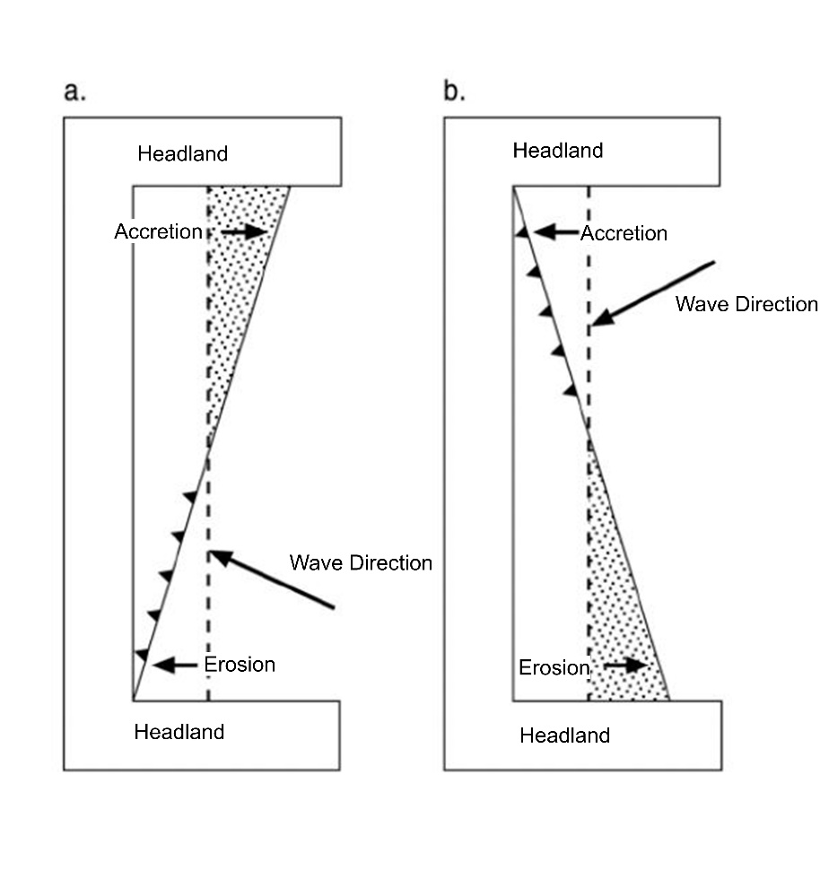
Figure 2. 1: A simple model of rotation, a) waves from one direction create erosion updrift and accretion downdrift and b) a reversal in wave direction reverses this process. Reproduced from Harley et al. (2011).

Figure 2.1 A simple model of beach rotation, a) waves from one direction create erosion updrift and accretion downdrift and b) a reversal in wave direction reverses this process. Based upon Short and Masselink (1999) and reproduced from Harley et al. (2011)
Often short term beach rotation processes generally follow erosive events that realignment of the beach shoreline and this is more often than not as a result of a shift in incident wave direction (Klein et al., 2002).Incident waves are not the only mechanism that may influence rotation for example, Anthony and Dolique (2004) and Dolique and Anthony (2005) showed that the migration of a mudbank was the cause on rotation in Cayenne, French Guiana. In the present area of study Thomas et al. (2011c) showed that the diminution of sediment within a sandbank caused the beach to rotate at historic timescales. But also showed that variations in wave directional components influences by teleconnection patterns also influenced rotation at short (Thomas et al., 2011b) and medium (Thomas et al., 2011d) timescales. But waves are the main cause of erosion, impacting the headlands then dispersing and filling the nearby bays (Boashash, 2015), eroded sediment is deposited along the beach and will eventually relocate back to its original location when a new shift in wave direction occurs.
Most beach research has been centred within mesotidal or microtidal environments, and as a result, tidal effects associated with macrotidal environments have received comparatively little attention in the literature (Masselink and Turner, 1999). But there has been a notable resurgence within the region study since the seminal works carried out on Pendine Beach, Carmarthenshire.by Jago and Hardisty (1984) and the Carmarthen bay work by Barber and Thomas (1989). With more recent studies carried out at historic, medium and short temporal period by Thomas et al. (2012 and 2015), Griffiths et al. (2018) and within the present study littoral for example Thomas et al. (2015) and (2016).

2.3 The importance of the beach profile

Evolution of cross-shore beach morphology in the medium- to long-term time scale entails large scale coastal topographical changes that are important for long term planning and management of the coastal zone (Karunarathna et al., 2011). The beach profile is important in that it can be viewed as a natural mechanism that causes waves to break and dissipate energy (Komar, 1998, Thomas et al., 2010). Therefore, the simplest expression of a beach is its cross-sectional profile, which reveals heights, width, slope and volume (m³/m²) of the beach through time or longshore (Short, 1999). Even though, they can be complex morphological features mainly due to the existence of bars and troughs but in overall form they tend to be steepest at the shoreline, with the slope decreasing in the offshore direction (Komar and Dougal 1994). Exposure to energetic wave conditions is responsible for driving sediment transport and can lead to a rapid profile response and influence its cross-shore shape (Komar, 1998). Because most beaches are characterised by a concave-upward intertidal and subtidal profile. the shoreface is wider at low tide than at high tide, especially over larger tidal ranges (Masselink and Turner, 1999). Most sandy beaches shoreline profile worldwide tend to progressively advance or retreat over the longer term (decades), and this pattern is a product of multiple factors, which may be of natural or anthropic origin (Jaramillo et al., 2020). In addition to this, beaches usually suffer from specific alterations at a shorter time scale, which are reflected by a representative sediment deficit or surplus (Mentaschi et al., 2018)
Ideally, management operations require knowledge of tidal elevations and extent of wave run-up under normal conditions and during storms. If data from a local tide gauge is available astronomical tidal characteristics can be established (i.e. Highest Astronomical Tide, High Water Mark Ordinary Spring Tide, etc.) (Thomas 2012). These can be related to an Ordnance Survey benchmark and used to establish beach profile positions (SNH, 2000).

2.4 Beach Profiling methods and technologies

The conceptional description and mathematical expression of beach profiles is fundamental in modern coastal geomorphology and morphodynamics (Huang et al., 2010). Beach profile data can be used to quantitatively establish beach response to storm events, beach recovery rates, long-term volume changes, areas of potential flood or erosion risk and the potential envelope of cross shore elevations (Rogers et al., 2010). Collected data may be used to establish direct sediment movement measurements and beach profile change over both time and sample frequency (Komar, 1998; Pilkey et al., 2002).
Emery (1961) devised a simple method to measure cross shore profiles comprising two graduated boards and a length of rope. Differences in board height in conjunction with the horizon provide profile measurements. Short and Trembanis (2004) utilised the method to establish one of the longest records (circa 46 yrs.) of monthly profile data at Narabeen Beach, Australia. Although since 2004 data has been collected using RTK-GPS, an Argus coastal imaging station (Harley et al., 2011) and Airborne scanning laser technology (Middleton et al., 2013; Turner et al., 2016). Andrade and Ferreira (2006) justified the use of a water level, comprising flexible tube filled with water and two graduated poles for data collection accuracy equal to the Emery method.
The use of a surveyor’s dumpy or quickset level and tape is a more traditional and accurate (vertical accuracy 10mm) method of performing beach profile surveys (Rogers et al., 2010; 1996; Sorensen, 2006), but horizontal accuracy may be as much as 3m depending on profile length (Parson, 1997). The introduction of an Electronic Distance Measure (EDM) or total station, instead of a level dramatically improves horizontal accuracy to 5mm ± 3ppm x distance (Huang et al., 2002). Its measurement in 3-dimensional space employs sophisticated angle components, laser beam emitting and mirror reflecting procedures, to determine target position via its azimuth (Huang et al., 2002). Both methods required a minimum team of (Rogers et al., 2010., Komar, 1998) and for repetitive surveys, it is important to establish a permanent benchmark, reduced to a datum that will survive any significant erosion (Sorensen, 2006). The introduction of robotic total stations that survey to similar accuracy can now be deployed and used by one man.
Global Positioning Systems (GPS) are now extensively used for field data collection (Huang et al., 2002; Pilkey et al., 2002;), early systems being suitable for measurements to the low tide mark which provided an accuracy of 150mm vertically and 5 to 10 m horizontally (Parson, 1997). However, the introduction of real time kinematics (RTK) and radio waves to correct readings between base station and rover, improves root mean square accuracy to 20 mm ±1ppm vertically and 10mm ± 1ppm horizontally (Thomas et al., 2010; Thomas et al., 2018; Huang et al., 2002). Further improvement in point accuracy was achieved by taking multiple observations; however, this is time consuming. Early equipment RTK typically involved two GPS receivers (a base station and a rover unit) lots of batteries and cables, two radios, a tripod and a pole, together with a backpack to carry all equipment (Thomas 2012).
Survey control is essential in order to repeat the accuracy of subsequent surveys. Here, a range of methodologies from local coordinate systems using existing features as a baseline (Huang et al., 2002) using the services online positioning user service to determine exact positions in relationship to a national co-ordinate system (Camann and Wells 2008). Thomas (2007) employed a base station set up on a tri-pod, orientated to Ordnance Datum using GPS resection (line lengths and sub-tended angles), control point coordinates were observed 200 times to ensure accuracy, and referenced to the British coordinate system using RTK network technology.
The growing availability of internet and telephone networks enabled development of a differential Global Navigation Satellite System (Thomas 2012). Consequently, RTK networks were developed to allow accurate surveys without a base station, saving valuable time in set up and use and similar to the use of robotic total station technology the surveys cab be conducted with just one operative see Thomas et al. (2015) and (2018) for practical applications.

2.5 Evaluating change

The prediction of shoreline variability along sandy coastlines is a valuable skill for a broad range of coastal engineering applications (Jaramillo et al., 2020). In terms of beach profile analysis, Fenster et al. (1993) argued that analysts often compromise between accuracy with complex models and robustness of simpler ones. According to Thomas et al. (2018), statistical methodologies abound in the study of coastal morphological change. Reeve et al. (2012) professed the use of multivariate statistics to identify principle components representing major changes along a beach profile. Douglas and Crowel (2000) argued that analysis begins with finding associations between variables and regression analysis is the basic tool. These basic tools (linear regression) where successfully used by Phillips and Williams, 2007 and Phillips (2008) to model shoreline change on the Penarth, South Wales, coastline, the R² value or coefficient of determination was used to assess the accuracy of the model. In the present area of study Thomas et al, (2010) and (2016) successfully applied linear regression to theoretical profiles spaced evenly alongshore, to determine planform changes and estimate beach equilibrium (i.e. zero longshore drift). This methodology was also successfully applied by Thomas et al. (2014) at Ginst Spit, Laugharne, West Wales and Griffiths et al. (2018) at Port Eynon on the south Gower peninsula. Using a method like that developed by Short and Trembanis (2004), Thomas et al. (2011a and 2011b) successfully applied cross-correlation analysis establishing time lag relationships between profiles within short and medium temporal periods. This methodology was also successfully applied to beach profiles at Pendine and Cefn Cedan Sands within Carmarthenshire Bay and Mumbles to Kenfig Sands in Swansea bay.

2.6 Shoreline Management Plan
Motyka and Brampton (1993) identified 11 main sediment cells from which England and Wales have based their shoreline management plans. A sediment cell has been defined as ‘a length of coastline which is relatively self-contained as far as the movement of sand or shingle is concerned and where interruption such as movement should not have significant effects on adjacent sediment cells’ (MAFF, 1995:1).
Shoreline management plans, aimed at a strategic level sets out a coastal defence approach for a stated coastal length, using the knowledge of both human and natural activities, essentially; defence and coastal processes; built environment and land use; the natural environment, particularly in the UK when considering the special areas of conservation (SAC) and special protected areas (SPAs) (Williams and Micallef, 2011). The risk management strategies include the following: (information gathered from SMP guidance, 2016)
- Avoiding development in vulnerable areas – planning control the land use
- Damage prevention work through managing beach, cliffs, dues, saltmarshes
- Implementing secondary defence systems such as tidal defence
- Providing early warnings to reduce the consequences of risks (flood warning system operated by the Environment Agency)
- Developing flood and coastal defence schemes or changing buildings to lower the risk of flood damage
The most suitable measures will be based upon the severity of the situation including, technical, economic, social and environmental circumstances (SMP guidance, 2016).
To enable efficient beach management, a reliable data source including baseline data of the beach system, cliff and dune environments and the beach sediment and erosion processes. Data collection on beach processes are used to recognise trends, their implications and origins, and provide a foundation to design beach management plans, subsequent evaluation and a strategic change in design (Williams and Micallef, 2011).
The Welsh Assembly Government has defined a policy of Integrated Coastal Zone Management which encourages organisations that have an interest in the coastline of Wales to come together and formulate policies and plans that will lead to vibrant, economically, successful and sustainable communities around the coastline of Wales (SMPs 2012).
Second generation Shoreline Management Plans (SMP) consider how a designated area of coastline is to be handled over epochs, e.g. 25 years, 50 years, and 100 years to address common arising issues such as flooding and/or erosion (Phillips et al., 2018). Changes in climate change effect the decisions made when analysing SMPs, which considers the socio-economic use, e.g. coastal tourism, etc. (EA, 2015). There are four policies under which management options are assessed under: (information gathered from Phillips et al., 2018)
- Managed realignment – An area of the coastline that will be neglected for a period of time and socio-economic assets will be moved or lost to the sea.
- Hold the line – This section of coastline will be defended or modify the types of coastal defence by constructing artificial defences to uphold the shoreline position.
- Advance the line – Constructing new coastal defences on the seaward side of the current shoreline or coastal defence system.
- No active intervention – Defence against flooding and erosion at particular locations on the coast will have no planned investment. This also covers the areas where coastal defences exist.
Despite the management options, the rise in conflict between human activities and natural processes result in difficulties. Simm et al. 1996, stated that a coastline’s present-day status is fundamental in deciding whether to actively manage or refrain from intervention.
However, before assigning management options, thorough examinations of the impacts of these decisions need to be conducted, these include detailed studies of hydrographical, geomorphological and the external forces such as waves, tides and their directional components as well as physical and economic studies in terms of indices. Regional studies have been performed in the former, by Thomas et al. (2010, 2011a, 2015 and 2016 respectively), Griffiths et al. (2018), Phillips and Williams (2007) and Phillips (2008) inter-alia. In the later, by Denner et al. (2015) who studied aspects of physical vulnerability and produced indices to evaluate the risk. Kantamaneni et al. (2018) extended this by developing an integrated physical and socio-economic vulnerability index.

Chapter 3 Physical Background

3.1 Introduction

The Bristol Channel is an inlet of the Atlantic Ocean located on the southwest of the British Isles (Thomas 2012: Figure 3.1A). The outer Bristol Channel lies at its western end from where it merges into the Celtic sea (Rangel et al., 2016: Figure 3.1B). There are several large embayment’s that fringe the margins of the Bristol Channel one of which is Carmarthen Bay (Thomas et al., 2015: Figure 3.1C). The studied littoral is located at the southwestern extremity of this wide (> 30km) but shallow (< 30m) embayment. The coastline that fringe Carmarthen Bay range from sea cliffs, sedimentary embayment’s and estuaries (Williams, 1996) and most coastal communities along this fringe rely on tourism which is a major contributor to their economy.
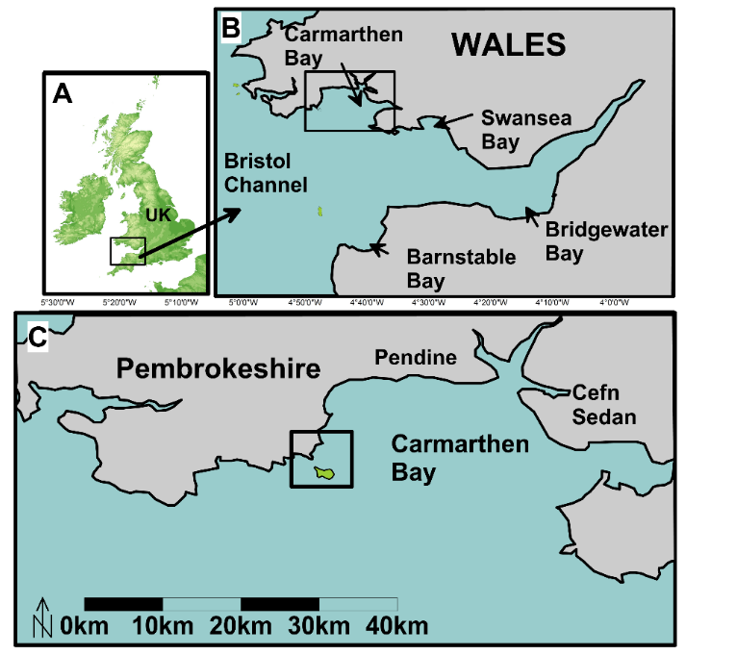
Figure 3. 1: Study area location A) UK, B) Bristol Channel and C) Carmarthen Bay showing studies littoral highlighted with black border, reproduced from Thomas et al., (2012)
However, coastal landscapes are degraded by economic pursuits of a modern society (Clark, 1998) and unconsolidated beach sediments with this respect are most at risk (Bird, 2000). South Sands, Tenby, Pembrokeshire, (Grid Reference SN 212200, 198500; Figure 3.2) falls specifically into this category and has recently suffered near-shore and dune erosion.

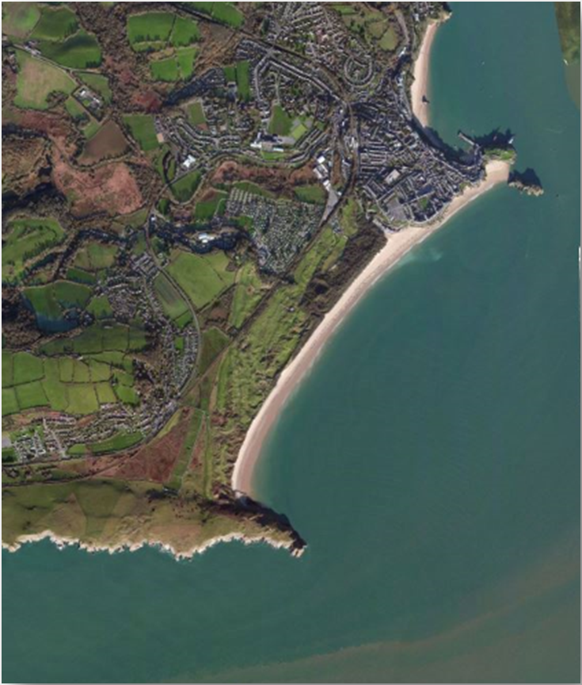
Figure 3. 2: Tenby South Sands, study area

3.2 Geological setting
Tenby and its surrounding environment were formed by intense folding during the Variscan Orogony (Hunter and Easterbrook, 2004), defined in SW Pembrokeshire, by the Ritec and Benton faults (Hillier and Williams, 2007)). These thrusts dominate the structure of south Pembrokeshire, as high-level, thin-skinned Variscan features, and the trace of the Ritec Thrust subsequently influenced the erosion of Milford Haven (Howells, 2007). The Ritec fault formed a shallow valley that extends through the River Cleddau and continues as far as Skomer Island on the north west approaches to Milford Haven (Toghill, 2000). The area of high ground upon which Tenby and Giltar Point is situated is composed of Limestone outcrops laid down during the Carboniferous period with an elevation above ordnance datum of between 30m and 90 m (Halcrow, 2010). Carboniferous Limestone and to a lesser extent Old Red Sandstone laid down during the Devonian period at a lower level is overlain by sand and shingle. The northern most limit of the Old Red Sandstone follows the trace of the Ritec Fault (Figure 3.3).
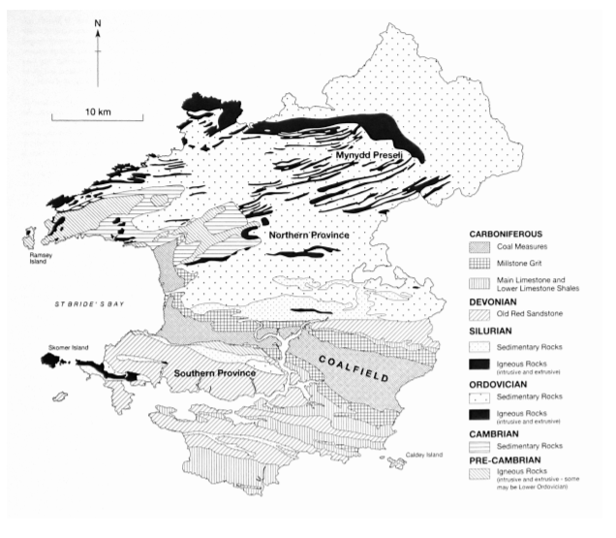
Figure 3. 3: Geological Map of Pembrokeshire, Source John (2019)

3.3 Geomorphological Setting
The Ritec River is aligned along the fault line, close to the southwest of the Carboniferous Limestone promontory on which Tenby town is formed (Posford, 1998; Toghill, 2000). The river once outflowed through an estuary but was closed to tidal influence following construction of a road and railway embankments between Penally and Tenby in the mid to late 1800’s (Thomas et al., 2011). The was River Ritec substantially trained and the flows diverted to a culvert which outlaws below the lowest astronomical tide level (Thomas et al., 2010; Thomas et al., 2011). There followed the development of a bar across the estuary mouth, and the subsequent development of the present-day configuration of South Sands, Tenby (Posford Duvivier, 1993; Halcrow, 2010).
Between the two Carboniferous Limestone promontories of Gilter and Tenby, South Sands, is backed by a 50m to 300m wide dune barrier (Owen, 1973; BGS, 1994; Hillier and Williams, 2006; Halcrow 2010), that overlays shingle that is periodically exposed during storms and high spring tides (Gibbard, 2005;Thomas et al., 2012). A classic embayment, with a shallow concave profile, wide sandy inter-tidal zone, and a ridge and runnel structure (Carter, 1988; SMP, 2000; Brown et al., 1999: Thomas et al., 2012). The distance between headlands, is approximately two kilometres, tides are semi-diurnal and macro-tidal. The relationship between respective tidal contours is given in Table 3.1.
Table 3. 1: Tide levels in relation to Ordnance Datum, reproduced from Thomas (2012)

The littoral presents varying level of human occupation, Tenby to the north is heavily urbanised and important to the regional economy, To the south headland, Marshes and dunes are ecologically important conservation areas (Thomas, 2012). Inland of the dune system lies golf links, a MOD firing range and Penally Cors, a Site of Special Scientific Interest (SSSI) enclosing an area of around 11 hectares (Thomas et al., 2010). Coastal sand dunes, perceived as areas worthy of sustainable development, they provide cost effective natural means of coastal defence, and are habitats for communities of highly specialised animal, and plant species (Carter, 1988). As a consequence, South Sands foreshore, dune system, cliffs and hinterland is designated SSSI status (except for the MOD shooting range), enclosing an area of approximately 110 hectares (Thomas et al., 2010) Figure 3.4.
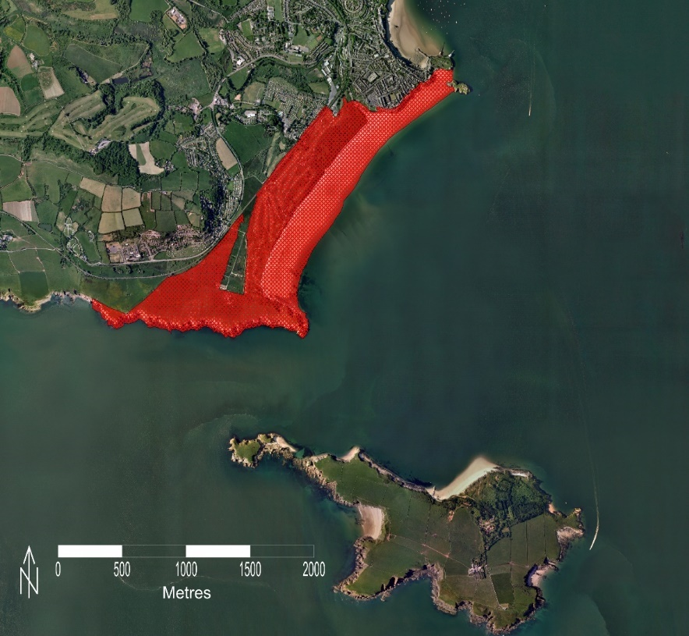
Figure 3. 4: Limits of the Sites of Special Scientific Interest. Source, Thomas (2012)

3.4 Anthropogenic Influences

It has been argued that Ritec Estuary closure in the mid 1800’s was a catalyst for the recent evolution of the bay (section 3.3). However, Thomas et al. (2012) suggested that changes in wind direction, wave heights and their directional components influenced by variations in the North Atlantic Oscillation (Large scale teleconnection patterns that dictate weather conditions over the UK) also had influence. There is a record of recent erosion in the southern section of the beach (near Gilter Headland), and Thomas et al. (2010) maintained that this has been exasperated by attempts to stabilise the shoreline by constructing concrete groynes and installing gabion walling that subsequently failed. More recently concern has been raised about the aesthetic quality of the beach close to Tenby
  a) |   b)
Figure 3. 5: Photographs of South Sands taken from the Tenby Headland looking south a) April 2013, and b) April 2020, Supplied by Dr Tony Thomas.

Chapter 4 Methodology

4.1 introduction

The review of literature (Chapter 2) identified that extensive research had been carried out with respect to headland embayed beaches in the general sense, but also within the current area of study (South Sands, Tenby Pembrokeshire). Within this environment, Thomas et al. (2010, 2011 and 2012) studied morphodynamical variability using both beach profile data at medium (6 monthly) and short (monthly) temporal scales but also planform variability at historic timescales. In an embayed beach environment (Swansea, southwest Wales) Thomas et al. (2018) utilised medium timescale profile data introducing to develop the “Morphostat” programme. Even though originally designed as a monitoring tool for a proposed tidal lagoon, Thomas et al. (1018) suggested that “Morphostat” may be applied to any tidal range, tidal ladder conﬁguration and disparate profile length. Despite extensive research being conducted at South Sands Tenby, three key areas have been identified to enhance current knowledge of the morphological change at Tenby South Sands, namely:

- Utilising additional more recent data and build upon Thomas et al.’s medium and short-term work on morphological change and proposed possible management outcomes.
- Utilise “Morphostat” statistical approach to maximise scale proﬁle length and identify or otherwise areas of concern based upon tidal ladder configuration at medium timescales.
- Utilise “Morphostat” statistical approach to maximise proﬁle length and identify or otherwise areas of concern based upon tidal ladder configuration at short timescales.

4.2 Beach profiling programme

Beach profile surveys have long provided a source of information on beach morphology (Short and Trembanis, 2004; Sorensen, 2006). They provide accurate information used to characterise beach height, width and volume fluctuation, and are essential in order to observe beach response to changing wave/tide conditions (Ruggiero et al., 2003; Short and Trembanis, 2004). A standard method of monitoring that provides consistent data, and is reduced to a datum, is important (Reeve et al., 2004). Two separate programmes have been designed to characterise beach profile variations along visually active profiles, as opposed to the total active profile. The first was surveyed annually between 1997 and 2013, with the second at monthly intervals between November 2008 and April 2010.

4.3 Medium Scale profile analysis
Between 1997 and 2013, the Shoreline Management Partnership through Carmarthenshire County Council provided annual and some at 6 monthly survey data. These data extend along the visually active beach profile and South Sands morphological variation was characterised by three cross shore profiles (≈ 250 m). Spaced 580 m apart, the profiles represented the south (T09), central (T10) and northern sectors (T11; Figure 4.1; see also Thomas et al., 2015). The data used in this work was supplied and checked for anomalies with thanks by Thomas et al. (2015). They also truncated each profile to a standard length based upon the shortest profile. It is important to note that this work makes no attempt to reduce the length of each profile and the intention is to maximise profile length to enable a better understanding of the temporal variability of each profile. Early data were gathered using a total station technology set up over the control marker located at the shoreward origin of the profile, but a GPS base station set up using the resection method that utilises several markers to establish its position and a GPS rover to guide the surveyor along the pre-defined bearing in order to record points at regular intervals and at any changes in surface type, was used for more recent data collection (from around 2006). In all 66 beach profiles are presented for analysis.
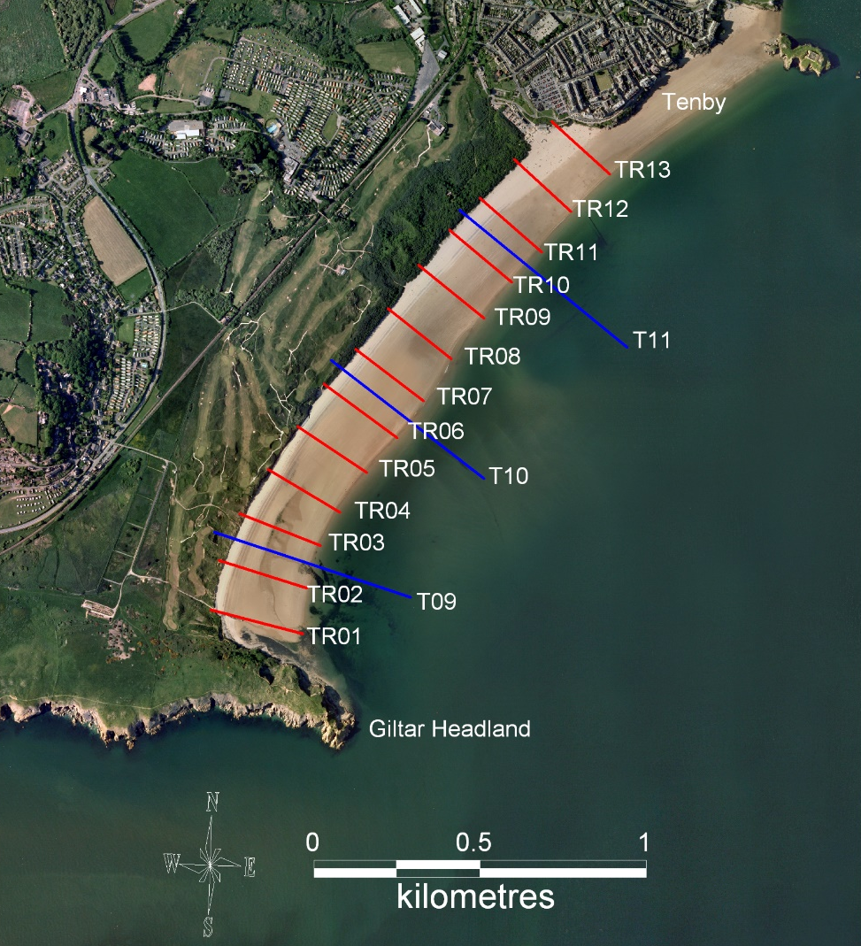
Figure 4. 1:Profile locations for short (white line) and medium (red line) timescale analyses.

4.4 Short term profile analysis

A programme of beach profiling was established in the study area. In order to produce monthly beach profile characteristics, 25 surveys conducted between October 2008 and November 2010, by Dr Tony Thomas and these data have been made available for analysis. Surveys of morphological variations of shore normal profiles. Each profile extended from the dune system or rock outcrop (close out), to the low water mark on the day of the survey (≈ 300 m). A single manned surveying technique was utilised to accurately map 13 transects (TR01-TR13, Figure 4.1; see also Thomas et al., 2015), spaced 150m apart and represent short- term cross-shore profile variability. In order to align with the medium scale analysis these profile data were subsequently considered in representative beach sectors, once again referred to as south (TR01-TR05), central (TR05-TR09) and north (TR09-TR13).
In addition, an updated survey was carried out along all profiles during the winter of 2019, a single manned surveying technique was also used. Here, horizontal and vertical control was achieved using GNSS with data derived directly from the OS Net. Equipment comprised a Geomax Zenith 25 receiver, capable of acquiring data horizontally at ±10 mm 1 ppm (rms) and vertically at 20 mm ±1 ppm (rms), and a Panasonic touchpad tablet containing X-Pad surveying software was used to acquire data. The Zenith receiver, housing a SIM card and employing Q-lock satellite tracking technology was mounted on top of a 2 m pole, for further methodologic and practical details see Thomas et al. (2015 and 2018), respectively.

4.5 Evaluation of topographic data

The Regional Morphology Analysis Programme (RMAP) will be utilised to evaluate medium-term and short-term profile change and determine beach level variation (see Morang et al., 2009). The disparate data will be transformed to reflect a standard spacing and downloaded in a csv or txt format. These data will be input into the Morphostat programme, a semi-automated set of tools designed to identify changes inside and outside-recorded historic variation and to maximise baseline data use. Essentially, the beach profile envelope is utilised to develop a statistical approach using the following steps (Reproduced from Thomas et al., 2015):
- Individual profile data was interpolated at 5m or 10m intervals within the RMP software and downloaded in an excel format. Once checked and adjusted, these data were input directly into the “Morphostat” programme.
- Within Morphostat, Average, maximum, minimum and standard deviation (SD) are calculated for each transect.
- Morphostat also determines the confidence intervals, 95%ile (+/- 1.96 SD) and 99%ile (+/- 2.33 SD) on either side of average.
- Identified Confidence Intervals are colour coded (Green, Amber, Red) within Morphostat for ease of reference, as shown in Table 4.1.

Table 4. 1: Zones for beach change confidence intervals, reproduced from Thomas et al. (2018).
Profile Number | Green | Amber | Red
 | <95%ile | >95%ile but  < 99%ile | >99%ile

- Data related to tidal contours input, to provide an overview of change along each profile within the different zones and these zones were tabulated in Table 2.1 and graphically illustrated here, in Figure 4.2.
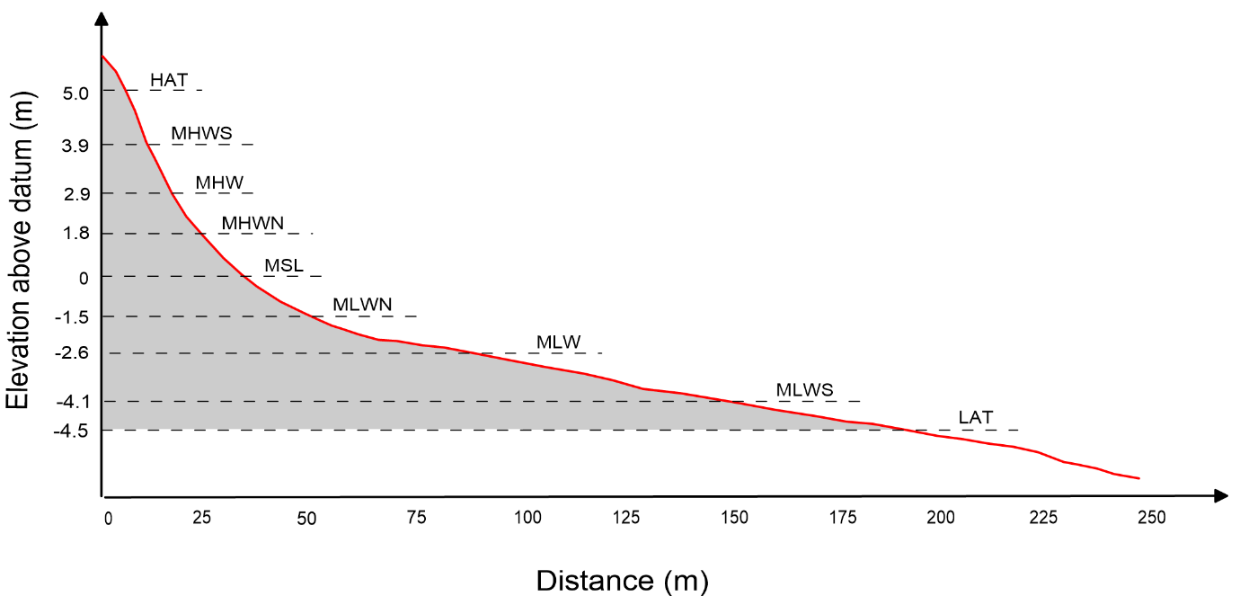
Figure 4. 2: A definition sketch showing the morphological zones from which comparative beach levels used for characterising profile change within the Morphostat programme were computed.

- Within each tidal contour the programme calculates the percentage beach levels within each confidence interval.
- Each tidal contour zone is allocated a Green, Amber or Red, with the Green being applied to any tidal ladder zone based on the 'profile stability' for the transect (see point 8 below). Where Green status was not achieved, a Red or Amber (increasing or decreasing) is applied depending on whichever had the greatest number of recordings. If the percentage of Reds and Amber are equal, Red status is allocated. However, the researcher may change this status depending on other circumstances.
- To assess the profile as a whole and to take into consideration each transects natural variability, the 'profile stability' or 'green percentage trigger' value is determined. This percentage is based on a comparison of the last set of survey data (2013 medium timescale and November 2010 short timescale) against the confidence intervals for each profile developed from each of the overall data sets (1998- 2012 and Nov 2008-Oct 2010). As such, the 'green percentage trigger' is the actual percentage of levels in the 2013 and Oct 2010 data sets that were classified as green for that profile (see figure 4.3 for further clarification).

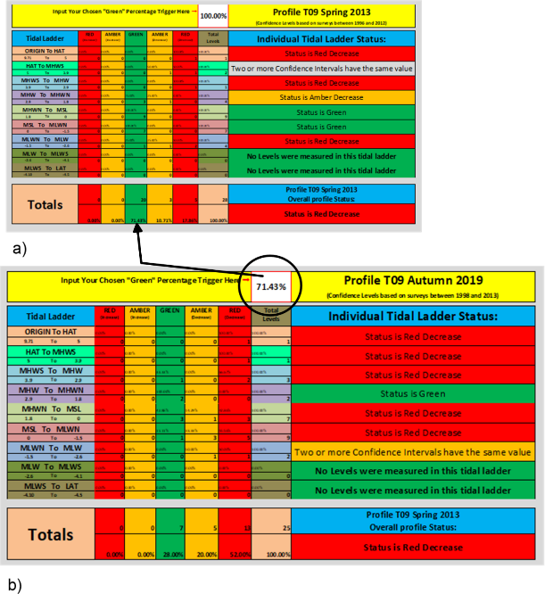
Figure 4. 3: Illustration detailing how the percentage of green values allocated to trigger exceedance was determined, a) initial analysis from which the value of 74.43% was calculated and b) trigger value revised for subsequent analysis.

4.6 Statistical Analysis

Many statistical methods, the so-called parametric methods, assume that the distribution of data within a given variable conforms to certain prerequisites. It is usually necessary to show that the distribution does not differ significantly from a normal distribution Finch (2006). According to Wheater and Cook (2000), variables measured on continuous scales are often normally distributed. As data in this research was measured on continuous scales, standard parametric tests were used to support the assumption that given data is normally distributed.

4.6.1 Kolmogorov-Smirnov test

Data will be directly input to the WinSTAT® statistical analysis programme and Kolmogorov-Smirnov test performed to test normal distribution. The test calculates the maximum distance between the cumulative frequency curve of data and the best fit normal curve, and then determines the significance (p) of this distance. A low p-value (p<0.05) would indicate significant results and therefore it is concluded that the data is not normally distributed. With a high p-value (p>0.05) the difference between the two curves is not significant, suggesting data are normally distributed.

4.6.2 Paired t tests
Profile data was collected at the interval level (set spacing) and each survey measured the same thing but under different circumstances, then dependent (or correlated) t tests are most appropriate (Fitch 2013). In this test, a pair of variables is analysed, and for each case, the difference of the two variables is computed. These differences are assumed to have a normal distribution. Then, the mean and standard deviation of these differences over the entire sample are computed. The t-test determines to what extent the differences are significant and the equations used for the determination of these tests are given in Appendix D (Fitch 2013).

4.6.3 Linear Regression

Attempts to model relationships between a given dependent variable ( in this research = cumulative beach level change) to a single independent variable ( in this research = temporal period or survey numbers). R is the correlation coefficient and ahigh value indicates a good fitand R² is the percentage of variance in the dependent variable which can be explained by the given equation.

4.7 Summary

The literature review (Chapter 2) discussed embayed beach research at local, regional and international scales, and evaluated beach monitoring techniques and coastal zone management. The physical background (Chapter 3) contextualised this research in geological, morphological and human geographical frameworks, andthe research framework set out in this chapter was partially determined by the abundance of coastal location research with a need to review and update previous findings. There is also a need to categorise beach change as being within or outside defined temporal trends. Consequently, results of medium and short term temporal scale monitoring will be discussed and evaluated in Chapter 5.

Chapter 5 Results and Discussion

Beaches change continually over event timescales and in response to tidal, diurnal, seasonal, medium-term and short-term cycles (Thomas et al., 2011a). Often, shorelines adjust to a time-arranged profile that may be relatively constant over time (Woodroffe, 2002; Thomas 2012). A literature review (Chapter 2) identified that a beaches cross shore profile is important since this natural mechanism causes waves to break and dissipate their energy (Komar, 1998: Thomas et al., 2010).

5.1 Medium Timescale data analysis

Results of medium-term changes based on the monitoring programme (Section 4.3) begins with a qualitative assessment of profile variation, and a quantitative assessment using statistical approaches described in Sections 4.5 and 4.6 respectively. In line with previous research (e.g. Thomas et al., 2015, inter-alia), data represents southern (T09), central (T10) and northern (T11) beach sectors.

5.1.1 Qualitative assessment

Assessment of variations in morphological formation used three shore normal profiles that characterised the active beach profile (dune system to low water, ≈250 m). From these data two-dimensional profile plots that detail individual survey results, cross shore profile envelopes based upon 95%ile and 99%ile confidence intervals (determined within “Morphostat”) and comparative plots detailing profiles used for statistical analysis.
Between 1996 and 2013, the southern profile (T09) has varied significantly along its entire length. The Autumn 2019 survey revealed that in the intervening period from 2013 to 2019 the back shore had eroded beyond the control point location. Therefore, future surveys will have to establish a new control point set back behind the dune system (Figure 5.1a). All previous survey data needed to be transformed and adjusted to enable comparison using the procedure adopted by Thomas et al (2015).

The beach generally maintained its concave shape, indicative of two beach states: a dissipative/intermediate around and below MSL and intermediate/reflective above but varied significantly along its entire length (Figure 5.1a inset). Figure 5.1a shows T09 beach profile data successively offset by 0.5m, from this data, it can be seen that there has been a significant change in the upper profile when S2013 and A2019 profiles are compared the dune system has been reduced in level around the position of the control marker and this sediment appears to have been deposited on the beach below the mean high water mark and a bank has developed at the profile extremity. There appears to be a pattern near shore erosion, and a gradual migration of sediment offshore throughout the record. Descriptive statistics (see Appendix A Sheet A), show that the maximum standard deviation occurred, at the shoreward boundary (0.81m and 0.96m respectively). Standard deviations also increase towards the seaward boundary of this profile with values ranging between 0.36m and 0.41m. The least standard deviation(s) were observed around MSL (0 m) where the minimum value of 0.17m existed.
The photograph given in Figure 5.1b provides an indication of the southern beach morphology and Figure 5.1c shows the 95%ile and 99%ile values above and below the average beach level alongside the A2019 profile. This Figure shows that levels fell below the 99%ile at the land ward extremity and around MSL but remained close to the lower 95%ile values in between these boundaries. The profile also dipped below the 99%ile values at the seaward extremity of the profile.
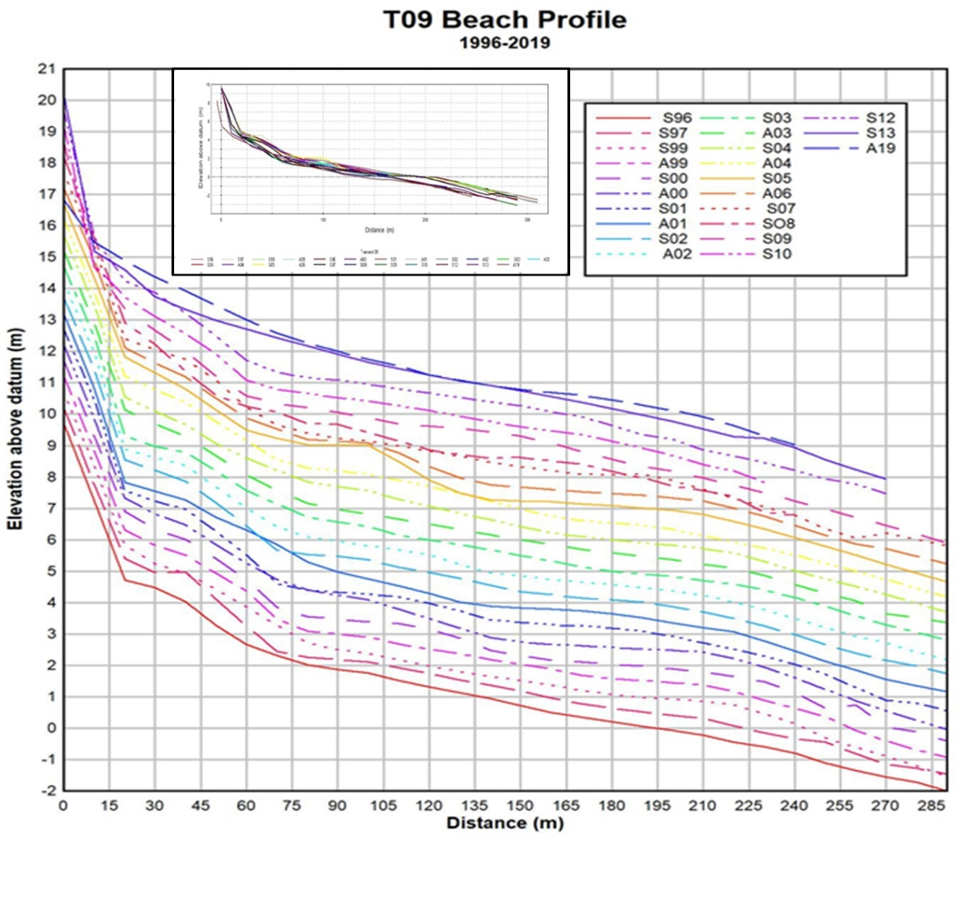
a)

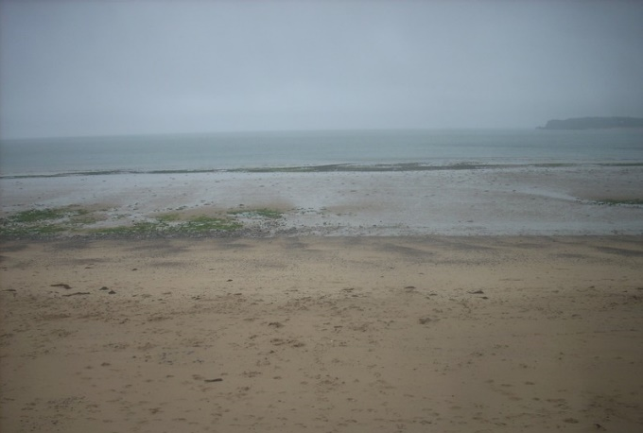  b) | 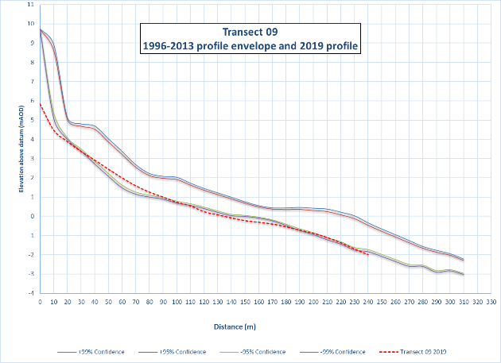  c)
Figure 5. 1:a) T09 (south sector) profiles 1996-2019 inset and successively offset by 0.5m, b) photograph from Control Marker and c) Profile envelop with autumn 2019 profile (red dotted line).

Similar to profile 09 profile T10 maintained a concave shape but beach levels showed less variation throughout the period of assessment (Figure 5.2a inset). Figure 5.2a also shows T10 beach profile data successively offset by 0.5m, from this data, in contrast to T09, beach levels have either remained stable or increased when comparisons are made between profiles S2013 and A2019. In the past a bar and trough morphology existed as is clearly visible toward the seaward extremity on profiles S96, A01 and S05 with the bar migrating shoreward/seaward or reducing in elevation between surveys.
Descriptive statistics (see Appendix A Sheet B), show that the maximum standard deviation occurred, 20m seaward of the control marker (0.61m). Standard deviations decrease in the offshore direction to their minimum value 120m from the landward control marker and then a gradual increase to the end of the profile where the standard deviations reached a maximum of 0.22m. The photograph given in Figure 5.2b provides an indication of the central beach morphology and Figure 5.2c shows the 95%ile and 99%ile values above and below the average beach level alongside the A2019 profile. This Figure shows that the beach profile remained within the boundaries of the 95%ile values along its entire length. Located near the lower boundary near control marker position, rising toward the upper boundary near the mean highwater mark, possibly benefitting from the reduction seen near the control marker. The profile dips back toward the lower boundary towards mean low water neap tide and rising to the upper boundary again before dipping toward the seaward extremity of the profile.
Similar to previous, profile T11 also maintained a concave shape. Beach levels showed a significant variation throughout the period of assessment (Figure 5.3a inset). Figure 5.3a shows T11 beach profile data successively offset by 0.5m, from this data, similarities between T10 and T11 can be seen, but T11 beach levels appeared to increase at a consistent rate between control marker and approximately MHW. This northern accretion, central profile stability and southern profile erosion, finds agreement with Thomas et al., (2011d) beach rotation work and illustrated in figure 2.1 of chapter 2.

Descriptive statistics (see Appendix A Sheet C), show that the maximum standard deviation occurred at the same interval as T10 (20m) with a figure of 1.14m. Again, showing a similar trend to T10 the standard deviation decreases in the offshore direction to their minimum value at chainage 90m (0.18m SD) from the landward control marker then showing a gradual increase to the end of the profile where the standard deviations increase back up to 0.29m. The photograph given in Figure 5.3b provides an indication of the central beach morphology and Figure 5.3c shows the 95%ile and 99%ile values above and below the average beach level alongside the A2019 profile. As seen in the Figure, the beach profile stayed within boundaries of the 95%ile but then dropped below the 99%ile at around 85m from the control marker. The profile remained under the 99%ile to the seaward extremity.

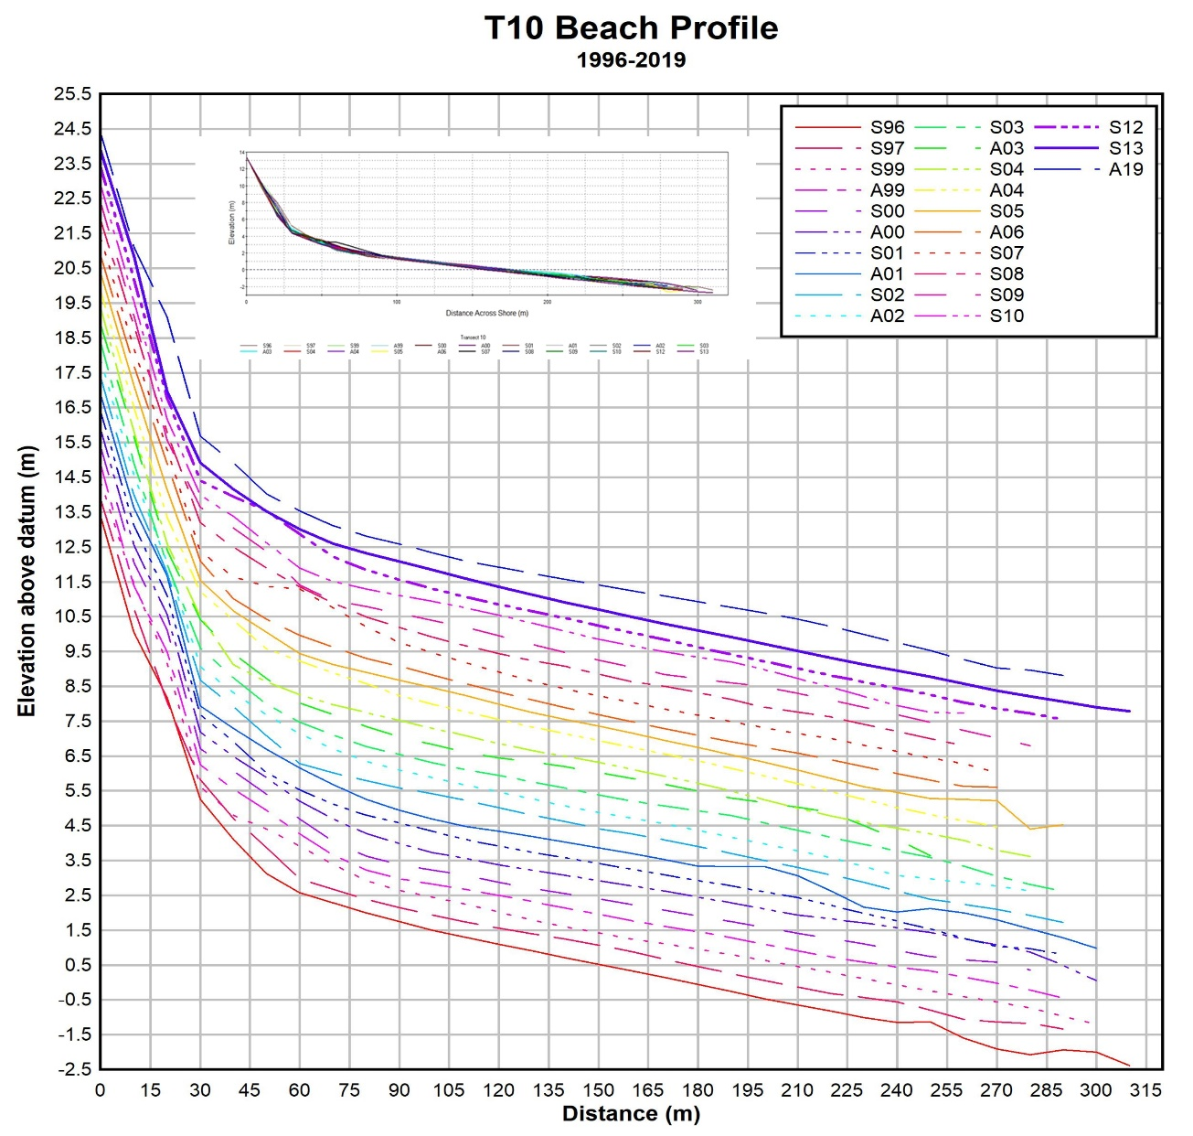
a)
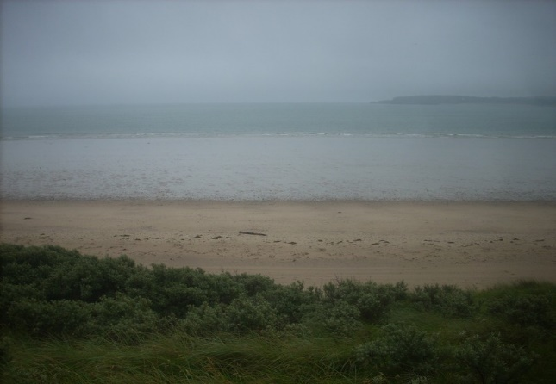  b) | 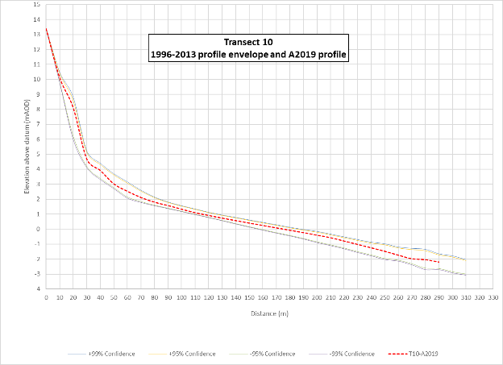  c)
Figure 5. 2: a) T10 profiles (central sector) 1996-2019 inset and successively offset by 0.5m, b) photograph taken from the control point c) confidence intervals (solid lines) and Autumn 2019 profile (red dotted line).

a)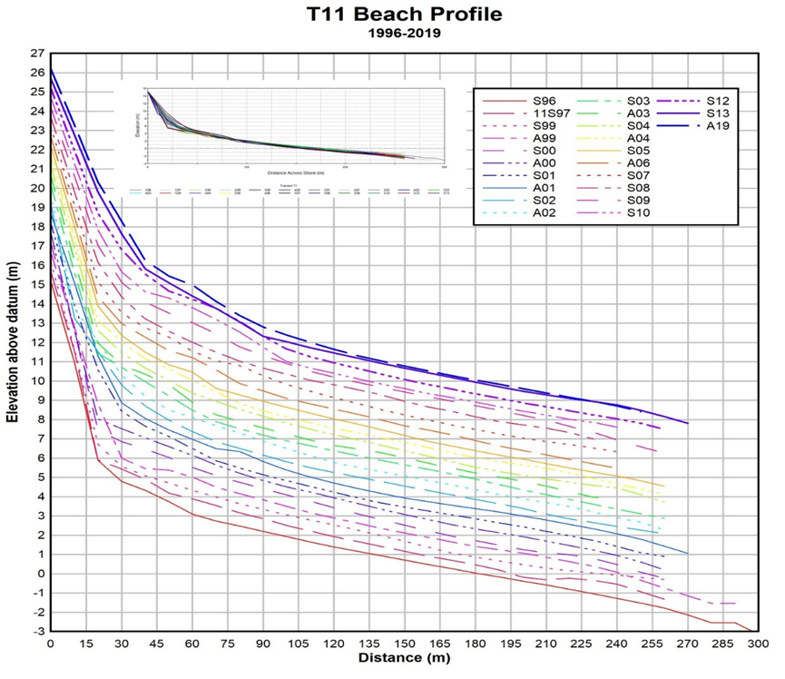

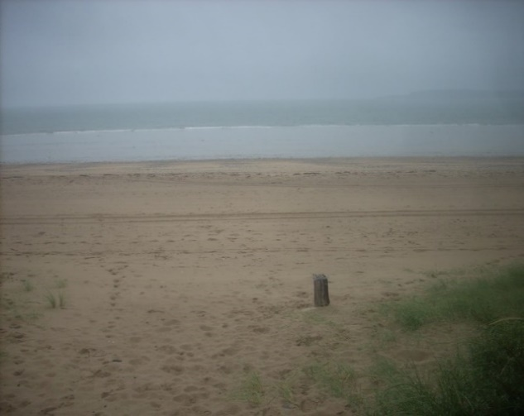  b) | 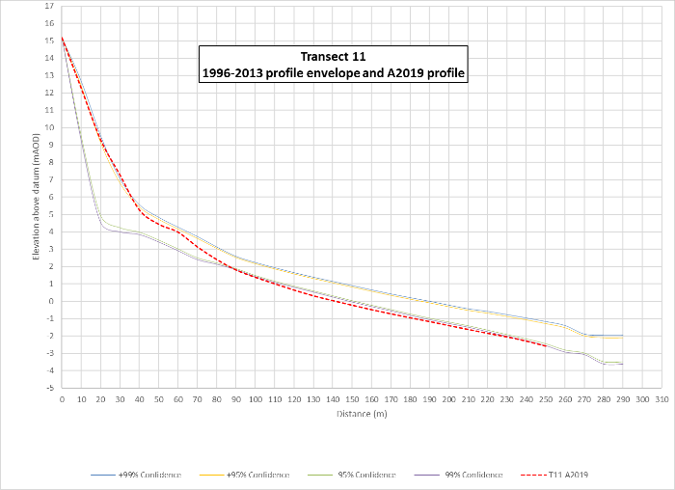  c)
Figure 5. 3: a) T11 profiles 1996-2019 inset and successively offset by 0.5m, b) photograph taken from the control point c) confidence intervals (solid lines) and Autumn 2019 profile (red dotted line).

5.1.2 Quantitative assessment
This research utilises a Shoreline Management Partnership (SMP) dataset consisting of 22 surveys representing 17 years of data (1996–2013), as well as an Autumn 2019 survey undertaken to provide a more recent assessment of change. Data are quantitatively assessed, using “t tests” using comparisons between surveys 1(Apr-96) and 22 (Apr-13), i.e. the “start and end” of both original SMP dataset and more recent data. However, for “t tests” to be used to compare differences, datasets were truncated to correspond to Autumn 2019.

5.1.2.1 Normal Distribution
Therefore, prior to conducting analysis, the assumption of normally distributed data was examined by conducting Kolmogorov-Smirnov tests. The results of tests carried out using Winstat statistical programme show that P values for each profile were > 0.05, ranging between 0.21 and 0.86 and therefore, we conclude that the data is normally distributed and suitable for parametric tests While indicative, the D value given here is the maximum distance measured between the curve of the actual distribution and the best-fit normal distribution (Table 5.1).
Table 5. 1: Kolmogorov-Smirnov test results.

5.1.2.2 Student t tests

Table 5.1 results showed that all data conformed to the requirements of a normal distribution and t tests would be most appropriate and the results are given in Table 5.2. In this Table the calculated t statistic (t_{calc}) is compared with the tabulated t-values (t_{tab}), according to the degrees of freedom (df) in a test for significance.
In Profile T09, t_{calc} > t_{tab} in all three cases the null hypothesis was rejected and there was a significant difference in beach level between first and last surveys at the 99% confidence level and the negative sign for t_{calc} indicated that beach levels had fallen between surveys.
In Profile T10, t_{calc} > t_{tab} in all three cases the null hypothesis was rejected and there was a significant difference in beach level between first and last surveys at the 99% confidence level. However, the negative values indicative of falling beach levels observed in the assessment for periods 1996-2013 and 1996-2019, was permeated by a positive value indicative of a period of increasing beach level between 2013 and 2019.
In Profile T11, t_{calc} > t_{tab} in the 2013-2019 assessment the null hypothesis was rejected and there was a significant difference in beach level between first and last surveys at the 99% confidence level and the negative value was indicative of a fall in beach level. Conversely, t_{calc} < t_{tab} in the 1996-2013 (p = 0.778) and 1996-2019 (p = 0.414) assessment the null hypothesis was accepted and there was no significant difference in beach level between first and last surveys. However, the negative values indicative of falling beach levels were observed between 1996-2013 and 2013-2019 surveys. A positive value between 1996 and 2013 was indicative of increasing beach level.
The mean difference between survey assessments is of most interest as this between 1996 and 2019 beach levels fell in each sector, most notably in the southern sector where more than a meter was lost.
Table 5. 2: Results of paired t tests.

5.1.2.3 Regression analysis

Regression models constructed using table 5.3 cumulative data showed that a statistically high negative correlation and a marked relationship existed when T09 profile was analysed (Figure 5.4a). The regression model demonstrated that between 1996 and 2019, a linear trend given by the equation y = -0.0381x+ 0.0972 explained well over half of the overall inter-survey beach level change (R² = 69%) and suggested that the beach level loss highlighted by Thomas et al, (2015) continued on the southern side of the beach (T09).
A negative relationship also existed in the regression model constructed around profile T10 data (Figure 5.4b) this was given by the equation y = -0.00101x – 0.0458 and coefficient of determination (R²) that explained around half the data variation( R² = 44%). Results show that the linear trend of beach level loss was associated with the centrally placed profile and once again this correlates with Thomas et al’s (2015) work but with less significance and suggesting a decrease in the sediment loss between their 2013 data set and the present study.
a negligible negative correlation existed at profile T11 with the regression model explaining virtually none of the data variation (R² =1%). The regression line gradient indicated a decreasing beach level trend (Figure 5.4c). Table 5.3 showed a general lowering beach levels occurred between Spring 1996 and Spring 2005, followed by increase until Autumn 2019. Therefore, the analysis was repeated, but this time truncated to align with these temporal periods. A high negative correlation existed, indicating beach level loss between Spring 1996 and Spring 2005, given by the regression equation y = 0.0123x + 0.0679 and an R ² value that explained 37% the variation in beach level through time. In contrast, between Spring 2005 and Autumn 2019 a positive correlation was indicative of rising beach levels given by the regression equation y = 0.0288x – 0.5436 and R² that explained 32% of the variation in beach level through time.

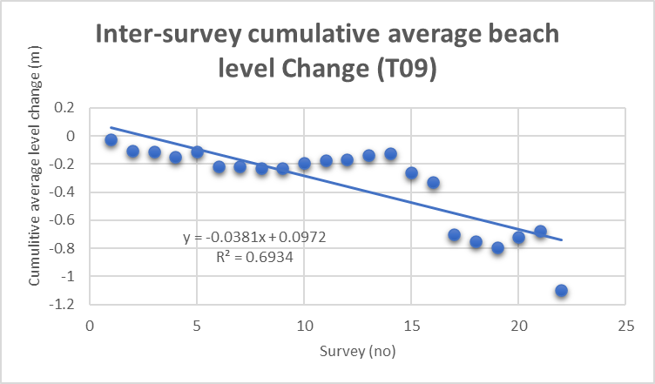  a) | 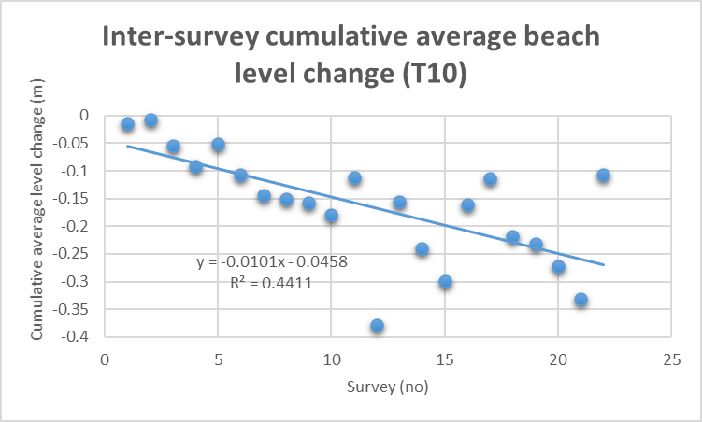  b)
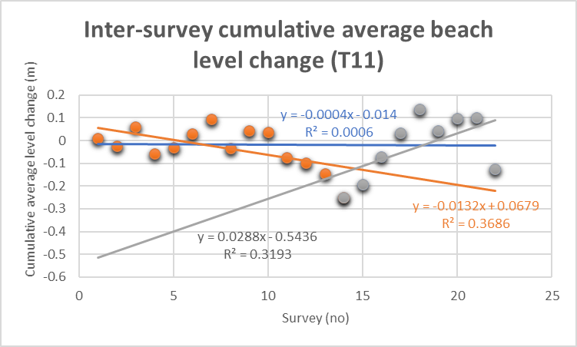
c)
Figure 5. 4: Regression analysis results for Inter-survey cumulative average beach level change, a) T09, b) T10 and c) T11.

5.1.3 Morphostat Assessment

Intertidal and overall profile change is assessed here, using appropriate quantiﬁable trigger levels established from the historic survey dataset and these assessments are given for each profile in Appendix C. From this, any change to proﬁle levels that exceed those identiﬁed through analysis of 1996–2013 data (i.e. the historic baseline) are considered to have fallen outside normal natural variation for that proﬁle. Results are reported by means of a traﬃc light system of red, amber and green, changes will act as a trigger for further action and the associated action required will be is set out at the end of this chapter.

5.1.3.1 Transect T 09

Table 5.3 shows the results from the Morphostat assessment described in Chapter 4 (section 4.5). Appendix C contains morphostat assessments used to establish the green percentage exceedance value of 71.43%. In this Table, the tidal ladder zone MHW to MHWN 100% of the levels remained within green status. For the upper tidal ladder zones (Origin to MHW), there was a resultant higher percentage in the ‘Red decrease’ section (ranged between 66.67% and 100%) and so these zones were allocated a status of ‘Red decrease’. Similarly, in the zones MHWN – MSL and MSL - MLWN several Amber and Red decreasing values were recorded (alongside some values that remained within the green exceedance limits, but the percentage was lower than the given exceedance level of 71.43%). A greater percentage of values exceeded the red threshold than the Amber as such, a Red decreasing status was allocated to these zones. Between MLWM and MLW, equal amber and red values were recorded, and an amber decreasing status was allocated to this zone (by the researcher).
Only 28% of values remained Green which was well below the allocated exceedance value of 71.43%. Twenty percent were allocated Amber decrease status but most beach levels fell into Red decrease status (52%) and as such, the overall profile was allocated a Red decreasing status.
On further examination of the shape of the historic beach proﬁle change (Figure 5.1a) and the conﬁdence intervals (Figure 5.1c) it is evident that 2019 beach levels have fallen significantly between 2013 and 2019 particularly, at the dune/ beach interface. The results find agreement with the research conducted by Thomas et al., (2011 and 2015 respectively). In their research the southern beach levels fell significantly in the first decade of the 21st century and this trend has continued into the 2nd decade.

5.1.3.2 Transect T10

Table 5.4 shows the results from the Morphostat assessment and Appendix C contains morphostat assessments used to establish the green percentage exceedance value of 93.33%. In this Table, it can be seen that 100% of beach levels remained within green exceedance level. Consequently the 'overall proﬁle was allocated Green status. On further examination of the shape of the historic beach proﬁle change (Figure 5.2a) and the conﬁdence intervals (Figure 5.2c) it is evident that 2019 beach levels were close to the upper exceedance limit between the control marker and mean high water, was close to the average levels near MSL and fell towards the minimum exceedance levels below. Rising again towards the upper exceedance limit at the profile’s seaward extremity. These results also found agreement Thomas et al’s. (2011) subaerial rotational work but not with their separated subaerial and intertidal work (e.g. Thomas et al., 2015) they suggested that the profile was located near the pivot point from which the beach rotated.

Table 5. 3: Autumn 2019 colour coded results taken from Morphostat for T09.

Table 5. 4:Autumn 2019 colour coded results taken from Morphostat for T10.

5.1.3.3 Transect T11

Table 5.5 shows the results from the Morphostat assessment and Appendix C contains morphostat assessments used to establish the green percentage exceedance value of 85.19%. The tidal ladders between HAT and MHW, exceeded the allocated exceedance limit and was allocated a Green status. In the zones between MHW and MLW, there was a resultant percentage in the ‘Red decrease’ section and so these zones were allocated a status of ‘Red Decrease’. Overall, the percentage of levels that remained within the green exceedance limit was just 26.92%, with the remaining values being, amber 3.85% and red 69.23%. Consequently, the proﬁle was allocated a status of Red decrease.
On further examination of the shape of the historic beach proﬁle change (Figure 5.2a) and the conﬁdence intervals (Figure 5.2c) it is evident that 2019 beach levels remained close to and above the upper exceedance limits near the control point marker and gradually dipped below the lower exceedance limits around MHWN to the extremity of the profile.
Table 5. 5: Autumn 2019 colour coded results taken from Morphostat for T11.

5.2 Short Timescale data analysis

Similar to the previous section 5.1, this section begins with a qualitative assessment of profile variation, followed by a quantitative assessment. Each beach sector is represented by averaging the beach levels of the profile contained within each sector. Namely, southern sector (TR01-TR05), central sector (TR05-TR09) and northern sector (TR09-TR13).

5.2.1 Qualitative analysis

Figure 5.5a shows the South sector beach profile data successively offset by 0.5m, the Autumn 2019 survey showed that since 2010, back shore/dune system had eroded beyond the control point locations and new markers will have to be established for future surveys.
The shape of southern beach profile is a relatively consistent concave shape, until the seaward extremity where levels show significant variation consistent with sand bank migration. The beach profile data collected in Dec 2019 highlight significant shoreward migration of this sand bank (Figure 5.5a Inset). Descriptive statistics (see Appendix B, Sheet A), show that the maximum and minimum standard deviation ranged between 0.498m and 0.019.
The photograph given in Figure 5.5b provides an indication of the southern beach morphology and Figure 5.5c shows the 95%ile and 99%ile values above and below the average beach level alongside the A2019 profile. This Figure shows that levels fell below the 99%ile at the land ward extremity and around MSL but remained close to the lower 95%ile values in between these boundaries. The profile also increased above the 99%ile values at the seaward extremity of the profile.

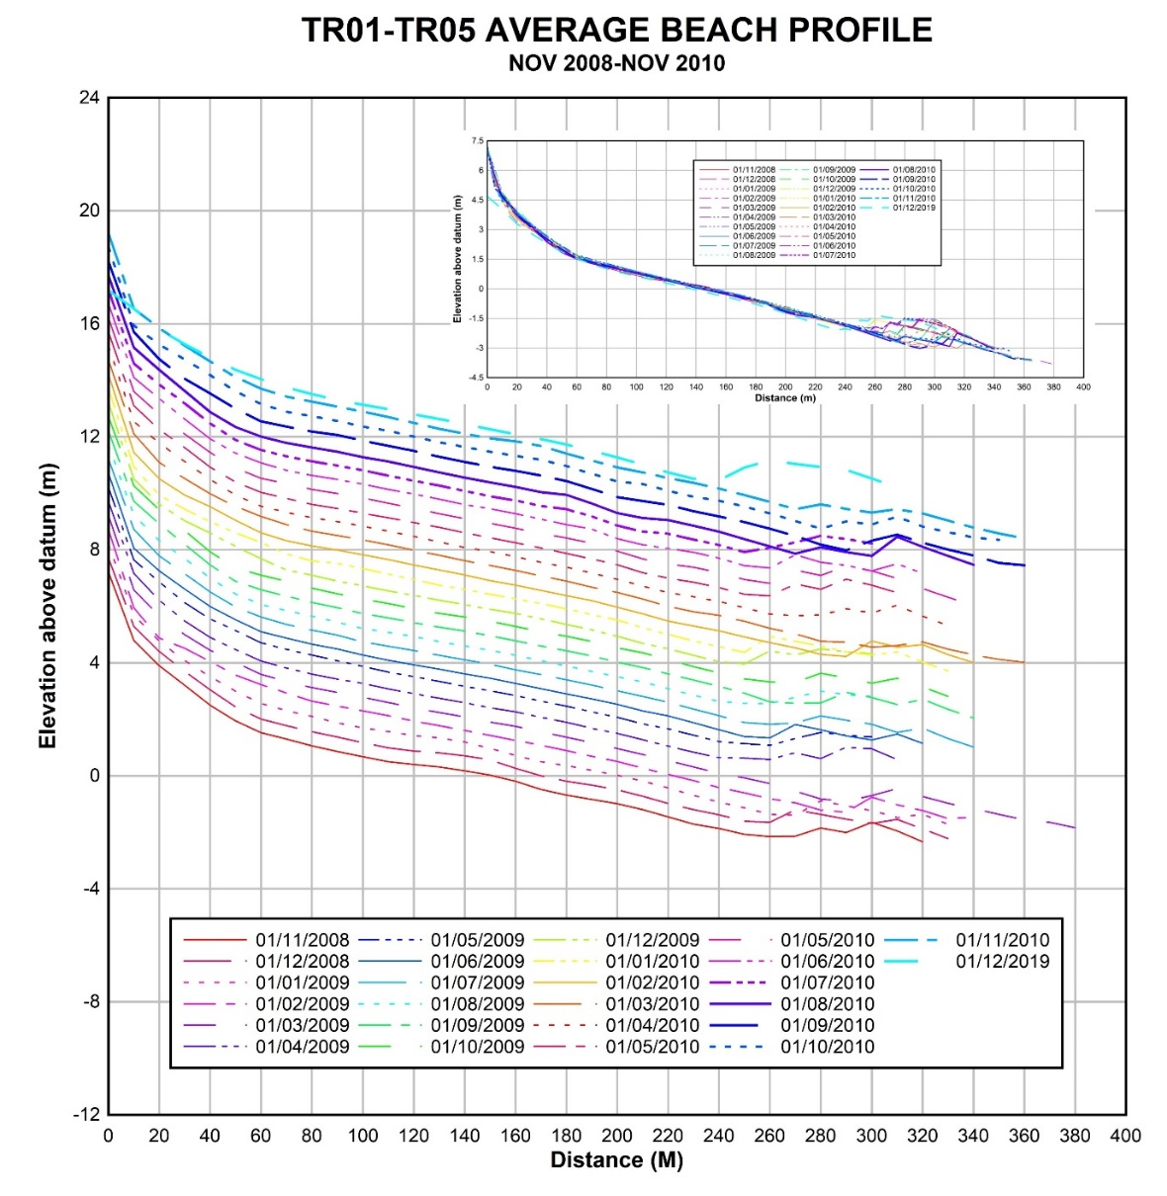
a)
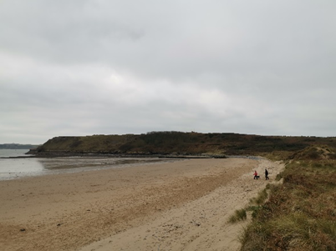  b) | 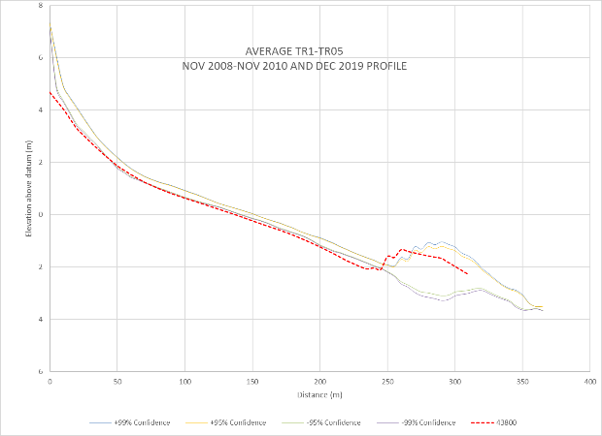  c)
Figure 5. 5: a) South sector profiles 2008-2019 inset and successively offset by 0.5m, b) photograph taken from the South sector c) confidence intervals (solid lines) and Autumn 2019 profile (red dotted line).

Central sector beach levels showed less variation throughout the assessment period (Figure 5.6a inset). The beach profile also showed back shore/dune erosion in 2019, also, beach levels have either remained stable or increased when comparisons are made between profiles 2008-2010 and A2019. Descriptive statistics (see Appendix B, Sheet B), show that the maximum standard deviation occurred, the profile origin (0.4929m). Standard deviations varied in the offshore direction, decreasing to a minimum value of 0.038m close to the profile extremity.
The photograph given in Figure 5.6b provides an indication of the central beach morphology, and Figure 5.6c shows the 95%ile and 99%ile values above and below the average beach level alongside the A2019 profile. This figure shows that 2019 beach levels fell below the 99%ile value at the control point and remained below for around 220m seaward of the control marker, then rises above the 95%ile values, before falling between the upper and lower 95%ile values at extremity of the profile.
Similar to previous, the North sector also maintained a concave shape The North sector beach profile data successively offset by 0.5m, from this data (Figure 5.7a). Beach levels appeared to increase at a consistent rate between control marker and approximately MHW. The maximum standard deviation (0.348) occurred 280m seaward of the control marker, the minimum value of 0.038 was located towards the profile extremity. The subaerial accretion, central profile stability and southern erosion highlights beach rotation and concurs with th Thomas et al. (2011b) beach rotation work and illustrated in figure 2.1 of chapter 2.
The photograph given in Figure 5.7b provides an indication of the northern beach morphology and Figure 5.7c shows the 95%ile and 99%ile values above and below the average beach level alongside the A2019 profile. As seen in the Figure, the beach profile stayed within boundaries of the 95%ile but then dropped below the 99%ile at around 75m from the control marker. The profile entered the boundary at 200m then exited above the 99%ile and almost immediately dropped back between the boundaries at the seaward extremity.

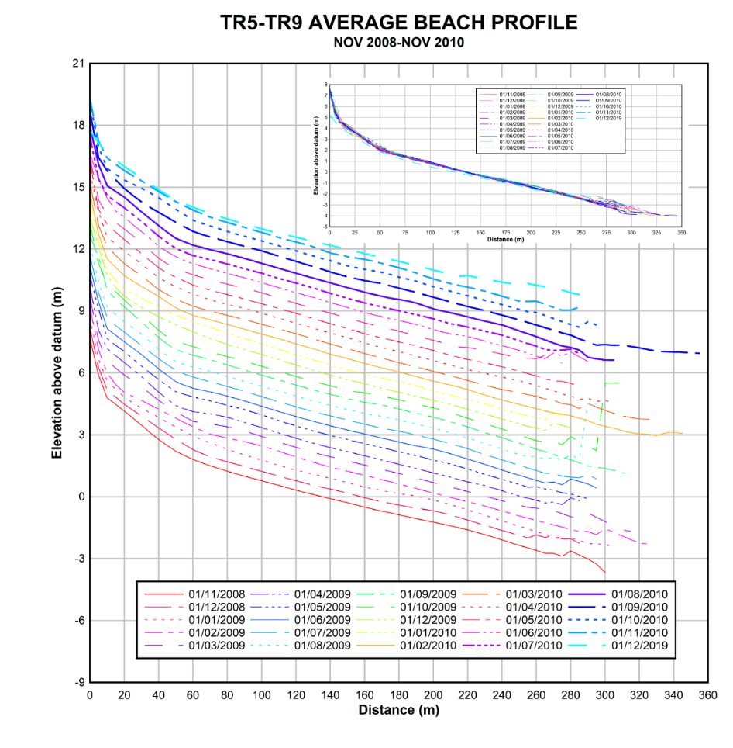
a)
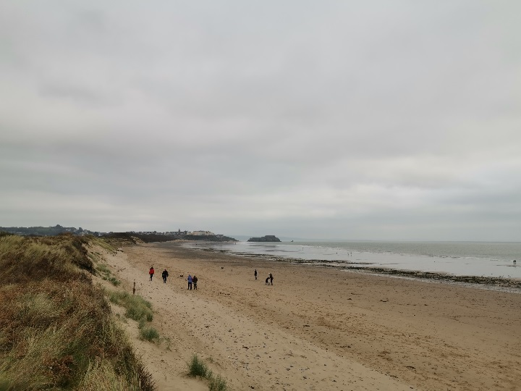  b) | 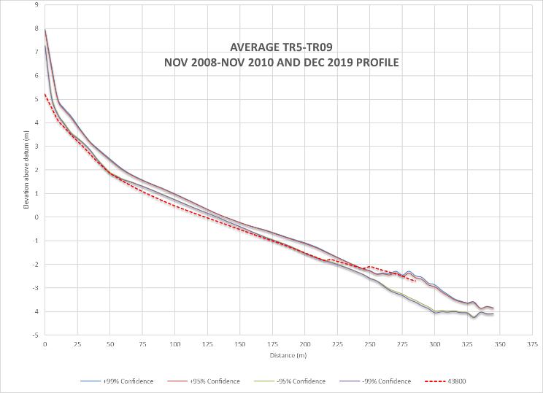  c)
Figure 5. 6: a) Central sector profiles 2008-2019 inset and successively offset by 0.5m, b) photograph taken from the Central sector c) confidence intervals (solid lines) and Autumn 2019 profile (red dotted line).

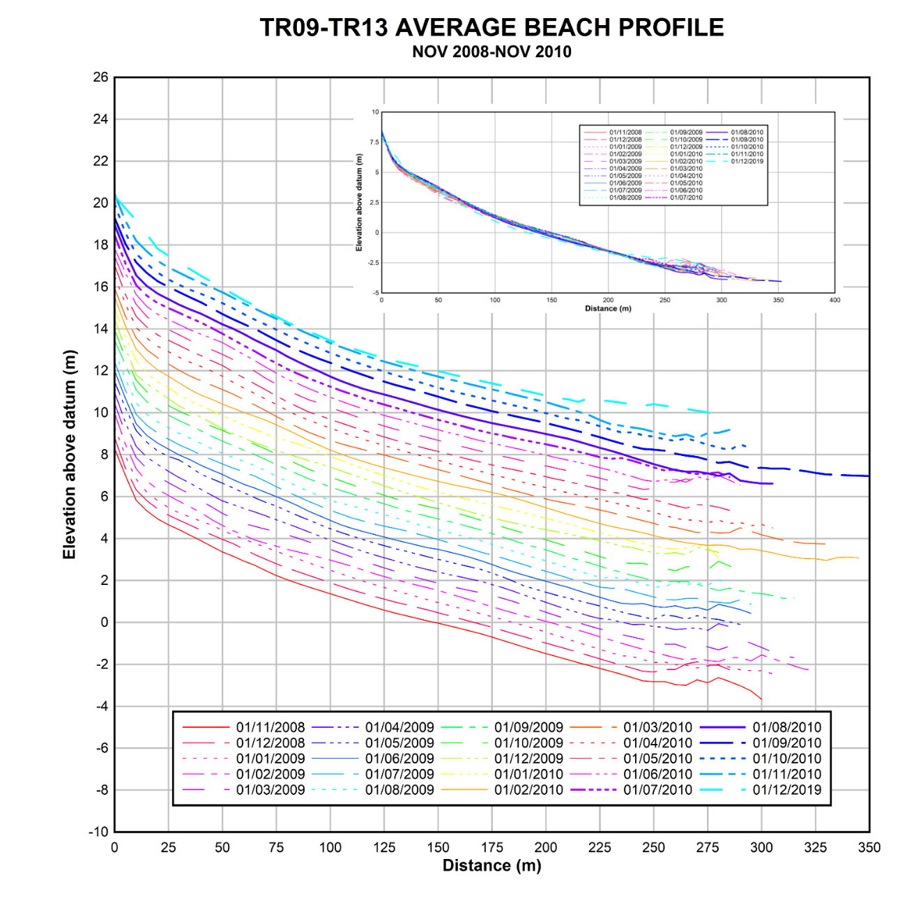
a)
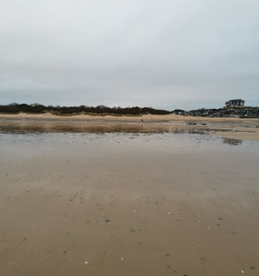  b) | 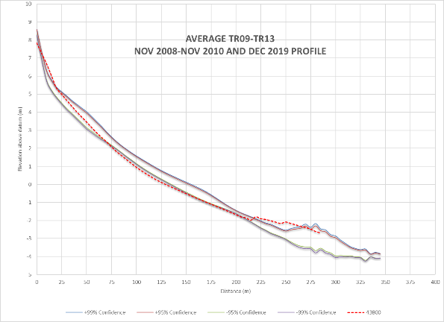  C)
Figure 5. 7: a) North sector profiles 2008-2019 inset and successively offset by 0.5m, b) photograph take from the North sector c) confidence intervals (solid lines) and Autumn 2019 profile (red dotted line).

5.2.2 Quantitative assessment
Profile data collected at monthly intervals between November 2008 and November 2010 and a more recent survey conducted in December 2019, These data are quantitatively assessed, using “t tests” by comparisons between surveys 1(Nov-2008) and 24 (Nov-2010), i.e. the “start and end” of original dataset and more recent data. However, for “t tests” to be used to compare differences dataset was truncated to correspond to the Autumn 2019 dataset.

5.2.2.1 Normal Distribution
Similar to section 5.1.2.1, Prior to conducting the analysis, the assumption of normally distributed data was examined by conducting Kolmogorov-Smirnov tests, The results of tests carried out using Winstat statistical programme show that P values for each profile were > 0.05, ranging between 0.26 and 0.74 and therefore, we conclude that the data is normally distributed and suitable for parametric tests. While indicative, the D value given here is the maximum distance measured between the curve of the actual distribution and the best-fit normal distribution (Table 5.7).
Table 5. 6: Kolmogorov-Smirnov test results.

5.2.2.2 Student t tests

Table 5.7 results showed that all data conformed to the requirements of a normal distribution and t tests would be most appropriate and the results are given in Table 5.8. In this table, the calculated t statistic (t_{calc}) is compared with the tabulated t-values (t_{tab}), according to the degrees of freedom (df) in a test for significance.
In the southern sector, t_{calc} < t_{tab} in all three cases the null hypothesis was accepted and there was no significant difference in beach level between first and last surveys at the 99% confidence level but negative signs for t_{calc} indicate falling beach levels.
In the central sector, t_{calc} > t_{tab} in all three cases the null hypothesis was rejected and there was a significant difference in beach level between first and last surveys at the 99% confidence level and negative values are indicative of falling beach levels.
In the northern sector, t_{calc} < t_{tab} in all three cases the null hypothesis was accepted and there was no significant difference in beach level between first and last surveys at the 99% confidence level A positive sign for t_{calc} between Nov 2008 and Nov 2010 was indicative of increasing beach level and negative signs indicate falling beach levels in the remining assessments.
Once again it is the mean difference between survey assessments that is of most interest, as this highlights that between Nov 2008 and Dec 2019 beach levels fell in each sector, most notably in the southern sector where level fell by almost half a metre.
Table 5. 7: Results of Paired t tests.

5.2.2.3 Regression analysis
Regression models constructed using table 5.9 cumulative data showed that a negligible negative correlation and almost non-existent relationship existed when the southern sector profile was analysed (Figure 5.4a). The regression model demonstrated that between Nov 2008 and Dec 2019, a linear trend given by the equation y = -0.0.0017x- 0.0008 explained just 3% of overall inter-survey beach level change.
A negative relationship also existed in the regression model constructed around the centrally placed profile data (Figure 5.4b) this was given by the equation y = -0.0045x + 0.0128 and coefficient of determination (R²) that explained around a third of the data variation( R² = 30%). a negligible negative correlation existed in the north sector with the regression model explaining virtually none of the data variation (R² =<1%). However, the regression line gradient indicated a decreasing beach level trend (Figure 5.4c).

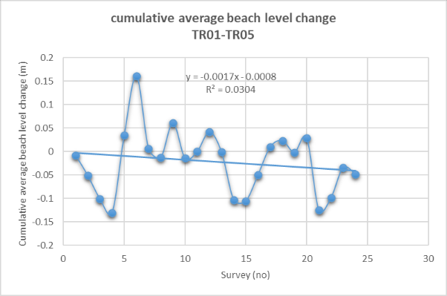  a) | 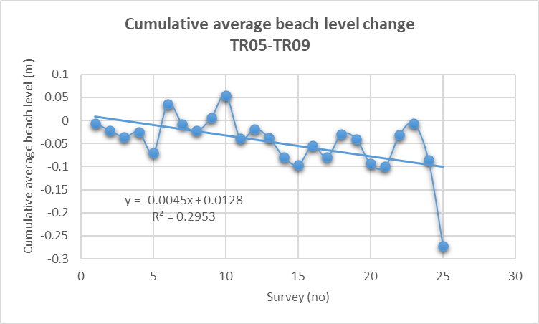  b)
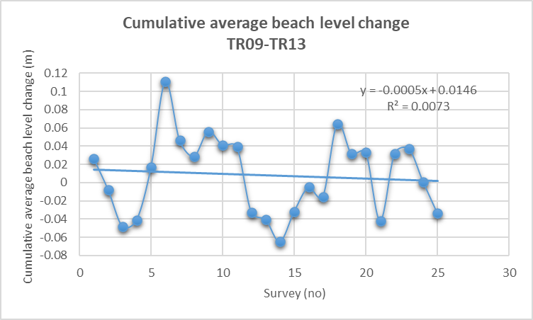
c)

Figure 5. 8: Regression analysis results for Inter-survey cumulative average beach level change, a) south, b) central and c) north sectors.

5.2.3 Morphostat Assessment

5.2.3.1 Southern sector

Table 5.8 shows the results from the Morphostat assessment described in Chapter 4 (section 4.5). Green percentage exceedance allocation for this sector was 87.67% (Appendix C). In this table, the tidal ladder zone Origin – HAT showed no measures due to the sand dune eroding back beyond the control point and dropping below the 5m ordinance datum level. Tidal ladder zones HAT-MLW were all allocated a status of ‘Red decrease’ with percentage exceedance ranging between 41.18% and 100%. Overall, only 22.22% of beach level remained where allocated a Green status, well below the allocated value of 87.67%. Almost 2%% were allocated Amber decrease status, whereas almost 70% was allocated to the status of ‘Red Decrease’. On further examination of the shape of the historic beach proﬁle change (Figure 5.5a) and the conﬁdence intervals (Figure 5.5c) the decrease in beach level is evident between 2008-10 and 2019, most notable at dune/ beach interface. The results find agreement with both Thomas et al., (2012) and the results given in section5.1.3.1.
Table 5. 8: Dec 2019 colour coded results taken from Morphostat for the southern (TR01-TR05) sector

5.2.3.2 Central sector
Table 5.9 shows the results from the Morphostat assessment and Appendix C contains morphostat assessments used to establish the green percentage exceedance value of 93.10%. As shown in the table, majority of the beach levels have a ‘Red Decrease’ status, from Origin-MLWN ranging between 75% and 100%, resulting in a status of ‘Red Decrease’ for the central sector profiles. Tidal ladder MLWN-MLW was awarded a status of red increase, despite the highest percentage of 37.5% in green, it did not reach the allocated exceedance value of 93.10%. A status of green was given to the MLW-MLWS tidal ladder where 100% of the levels were maintained. On further examination of the shape of the historic beach proﬁle change (Figure 5.6a) and the conﬁdence intervals (Figure 5.6c) similar to the southern sector, the decrease in beach level is evident between 2008-10 and 2019, most notable at the dune/ beach interface. The status of red increase shown at MLWN-MLW, can be seen in Figure 5.6c where the 2019 profile rises above the 99% and 95%ile, and then drops within the boundary showing a status of green at MLW-MLWS. These results differ somewhat from Thomas et al’s., (2011b and 2012) beach rotation work but can be explained. They used beach volumes (m³m⁻¹) which enabled them to remove the cross-shore sediment component.

Table 5. 9: Dec 2019 colour coded results taken from Morphostat for the central (TR05-TR09) sector.

5.2.3.3 North sector

Table 5.10 shows the results from the Morphostat assessment and Appendix C contains morphostat assessments used to establish the green percentage exceedance value of 98.25%. The first tidal ladder zone in this Figure (Origin-HAT), showed a red status of increase (50%), which may suggest that longshore drift southern toward north. In tidal ladder zones HAT-MHW and MLW-MLLWS, the percentage that remained within green status was 100% ,above the exceedance limit of 98.25%. In the tidal zones between MHW and MLWN, have a status of ‘Red Decrease’ with percentages varying between 40%-100%. The tidal ladder MLWN-MLW, shows a percentage of 58.82% in the ‘Red Increase’, and was also allocated this status. Overall, the percentage of levels that remained within the green exceedance limit was just 29.82%, with the remaining values being, amber 7.02% and red 63.16%. Consequently, the proﬁle was allocated a status of Red decrease. On further examination of the shape of the historic beach proﬁle change (Figure 5.7a) and the conﬁdence intervals (Figure 5.7c) it is evident that 2019 beach levels were within the exceedance limits near the control point marker and then dropped below the limits at MHW, but then re-entered the boundary around the extremity of the profile.
Table 5. 10: Dec 2019 colour coded results taken from Morphostat for the northern (TR09-TR13) sector.

In a final step Morphostat assessments were conducted on all short term profiles (Tables shown in Appendix E) and the results are given in Table 5.11. The table shows that 11 of the assessed profile were allocated a red decrease status, with just one being allocated green (TR08) and two allcated red increase (TR12 and TR 13 respectively).

Table 5. 11: Morphostat results for all short term profiles

5.3 Summary
In the medium-term evaluation of 23 years of beach profile data there was overall trend of beach level loss in each of the assessed areas. This loss was more pronounced more within south sector, where 2019 data showed that the dune frontage has been significantly affected. Centrally, beach levels were more stable with the 2019 levels largely remaining within the 1996-2013 profile envelope. However, the northern profile changes are of most interest, beach levels within the upper intertidal increased, as sediments built against the northern headland. In contrast, intertidal beach levels fell increasingly towards the profile extremity as headland influence diminished. Quantitatively, dependent t tests confirmed that beach levels had changed significantly since surveys began in 1996. Knowledge of temporal changes enabled three regression models to be developed and these can be used to predict morphological change by beach sector.
Morphostat allocated colour codes to each of the profiles and results assessed against the trigger level framework shown in Table 5.11. Centrally, changes remained within the boundaries of historic change (i.e. green status) and no further action would be required. However, southern and northern sector were allocated “Red Decrease” status. In this case the profile response is at a magnitude outside baseline variation and would trigger further action.

Table 5. 12: Trigger Level Framework, produced for a dune backed embayed beach, based upon Thomas et al. (2018).

Evaluation of 24 monthly profile surveys collected between 2008 and 2010 and a more recent survey conducted in 2019 also showed a trend of beach level loss. The evaluation showed no cyclic or seasonal behavioural patterns throughout the assessment period. Paired t tests subsequently applied to the first and last surveys showed with 95% confidence, no discernible beach level change in all three averaged sectors. Regression provided confirmation but low correlation meant models are not suitable for predicting future changes. Morphostat allocated a “Red Decrease” status to each of the three sectors. the profile response is at a magnitude outside baseline variation and would trigger further action. This highlighted that based upon short term data beach levels had continued to fall and that further action should be taken. When individual profiles were assessed all, but one would require further action to be taken and that all but one profile was allocated red status when all thirteen profiles were assessed.

Chapter 7 Conclusions and Recommendations

Many of the world’s coastlines are eroding, influenced by global warming, and dune backed embayed beaches can be most at risk. Tenby South Sands, Pembrokeshire is one such case. By utilising a series of medium-term and short-term beach profiles, beach level change was assessed. In the medium term between 1996 and 2019 beach levels have mostly fallen and this was confirmed by t tests and regression analyses. Morphostat assessment conducted on 2019 data using the 1996-2013 historic data envelope, suggested that southern erosion continued, centrally the beach remained stable and northern beach varied between accretion on the landward and erosion of the seaward side of the profile but was allocated a red decrease status. Unsurprisingly, short-term results using 2008-2010 monthly data and the 2019 survey results, showed variable profile change confirmed by t tests and regression models. These suggested that little change had occurred or there was almost negligible correlation. However, beach profiles averaged to represent each beach sector did show that, with the exception of the northern upper tidal area, that beach levels fell outside the 2008-2010 envelope and when individual profiles were assessed all but one fell into the red status overall.
Strategically, beach management, based upon medium term results would trigger further investigation including assessments of external influences, as well as additional data collection over shorter timescales. In this respect, short-term data highlighted the need for further investigation and: possible stabilisation works to the southern dune system and upper foreshore; recycling of large pebble and gravel accumulations for aesthetic reasons on the northern shores; and deposition in proposed stabilisation.
Research showed the efficacy of the Morphostat programme for strategic assessment of beach health, but it can also be used at a project level either to assess beach change and inform design or monitor during and after construction.

References
Andrade, F., Ferreira, M.A., 2006. A Simple Method of Measuring Beach Profiles. Journal of Coastal Research, 22(4), 995-999.
Anthony, E.J. and Dolique, F., 2004. The influence of Amazon-derived mud banks on the morphology of sandy headland-bound beaches in Cayenne, French Guiana: a short-to long-term perspective. Marine Geology, 208(2-4), pp.249-264.
Barber, P.C. and R Thomas, R., 1989. Case study at Carmarthen Bay. In Coastal management (pp. 243-262). Thomas Telford Publishing.
Barber, P.C., 2007. Shoreline Monitoring- Beach Profile Analysis, Report to the Swansea Bay and Carmarthen Bay Coastal Engineering Group.
Benavente, J., Del Río, L., Anfuso, G., Gracia, F.J. and Reyes, J.L., 2002. Utility of morphodynamic characterisation in the prediction of beach damage by storms. Journal of Coastal Research, 36(sp1), pp.56-64.
Benavente, J., Gracia, F.J. and López-Aguayo, F., 2000. Empirical model of morphodynamic beachface behaviour for low energy mesotidal environments. Marine Geology,167(3-4), pp.375-390.
Benavente, J., Plomaritis, T.A., del Río, L., Puig, M., Valenzuela, C. and Minuzzi, B., 2014. Differential short-and medium-term behaviour of two sections of an urban beach. Journal of Coastal Research, 70(sp1), pp.621-626.
Bird, E., 2000. Coastal Geomorphology: An introduction. Wiley and Sons, Chichester. pp 322.
Boashash, B., 2015. Time-frequency signal analysis and processing: a comprehensive reference. Academic Press.
Brown, E. Colling, A., Park, D., Phillips. J., Rothery, D., Wright, J., 1999. Waves, Tides and Shallow-Water Processes. Butterworth Heinemann. Oxford. pp 227.
Bryan, K.R., Foster, R. and MacDonald, I., 2013. Beach rotation at two adjacent headland-enclosed beaches. Journal of Coastal Research,65(sp2), pp.2095-2100.
Camann, E., Wells, J., 2008. Two-Component Methodology for detailed beach surveying with RTK-GPS. Shore and Beach, 76(1), 3-7.
Carter, R.W.G. and Environments, G.C., 1988. An introduction to the physical, ecological and cultural systems of coastlines. Coastal Environments, p. 617.
Clark, J.R., 1998. Coastal Seas. The Conservation Challenge. Blackwell Science Limited. London. pp 134.
Denner, K., Phillips, M.R., Jenkins, R.E. and Thomas, T., 2015. A coastal vulnerability and environmental risk assessment of Loughor Estuary, South Wales. Ocean & Coastal Management, 116, pp.478-490.
de la Vega-Leinert, A.C. and Nicholls, R.J., 2008. Potential implications of sea-level rise for Great Britain. Journal of Coastal Research, pp.342-357.

Dolique, F. and Anthony, E.J., 2005. Short-term profile changes of sandy pocket beaches affected by Amazon-derived mud, Cayenne, French Guiana. Journal of Coastal Research, pp.1195-1202.
Douglas, B.C. and Crowell, M., 2000. Long-term shoreline position prediction and error propagation. Journal of Coastal Research, pp.145-152.
Douglas, B.C., Crowell, M., 2000. Long-term Shoreline position Predictions and Error Propagation. Journal of Coastal Research, 16(1), 145-152.
Duvivier, P., 1993. Easington coast protection, environmental statement. Posford Duvivier, Peterborough.
EA (Environmental Agency), 2015. Shoreline Management Plan policies – What do they mean? Environment Agency. Available at: https://www.gov.uk/government/publications/shoreline-management-plans-smps (accessed 10th April 2020).
Emery, K.O., 1961. A simple method of measuring beach profiles. Limnology and oceanography, 6(1), pp.90-93.
Fenster, M.S., Dolan, R., Elder, J.F., 1993. A New Method for Predicting Shoreline Positions from Historic Data. Journal of Coastal Research, 9(1), 147-171.
Gibbard, B., 2005. Tenby South Beach erosion: Review of wind/wave data, beach monitoring and Modelling. Royal Haskoning. Peterborough. pp 39.
GOV.UK. 2012. Shoreline Management Plans (Smps). [online] Available at: <https://www.gov.uk/government/publications/shoreline-management-plans-smps/shoreline-management-plans-smps> [Accessed 8 April 2020].
Griffiths, D., House, C., Rangel-Buitrago, N. and Thomas, T., 2019. An assessment of areal and transect-based historic shoreline changes in the context of coastal planning. Journal of coastal conservation,23(2), pp.315-330.
Halcrow, 2010. Lavernock Point to St Ann’s Head SMP2. http://www.southwalescoast.org/contents.asp?id=55#SMP2MainDocument.
Date Accessed 15/04/2020.
Harley, M.D., Turner, I.L., Short, A.D. and Ranasinghe, R., 2011. A re-evaluation of coastal embayment rotation: The dominance of cross‐shore versus alongshore sediment transport processes, Collaroy Narrabeen Beach, southeast Australia. Journal of Geophysical Research: Earth Surface, 116(F4).
Howells, M F. 2007. British regional geology: Wales. Keyworth, Nottingham: British Geological Survey. http://earthwise.bgs.ac.uk/index.php/British_regional_geology:_Wales
Huang, J.D., Jackson, D.W. and Cooper, J.A.G., 2010. Piecewise polynomial expression of beach profiles. Journal of Coastal Research, pp.851-859.
Huang, J.D., Jackson, D.W.T., Cooper, J.A.G., 2002. Morphological monitoring of high energy beach systems using GPS and Total station techniques, Runkerry, Co Antrim, Northern Ireland. Journal of Coastal Research, SI36, 390-398.
Hunter, A., Easterbrook, G., 2004. The Geological History of the British Isles. The Alden Group. Oxford. pp 143.
Jago, C.F., Hardisty, J., 1984. Sedimentology and morphodynamics of a macrotidal beach, Pendine Sands, SW Wales. Marine Geology, 60, 123-154.
Jaramillo, C., Jara, M.S., González, M. and Medina, R., 2020. A shoreline evolution model considering the temporal variability of the beach profile sediment volume (sediment gain/loss). Coastal Engineering, 156, p.103612.
John, B. S.., 2019. An Historical Atlas of Pembrokeshire (Volume 5 of the Pembrokeshire County History). Howell, D.W. (ed) 2019, Haverfordwest, Pembrokeshire County History Trust, 205 pp,
Karunarathna, H., Horrillo-Caraballo, J.M., Spivack, M. and Reeve, D.E., 2011. On Modelling Cross-shore Beach Morphology. Journal of Coastal Research, pp.671-675.
Kantamaneni, K., Phillips, M., Thomas, T. and Jenkins, R., 2018. Assessing coastal vulnerability: Development of a combined physical and economic index. Ocean & Coastal Management, 158, pp.164-175.
Klein, A.H.F., Benedet Filho, L., Schumacher, D.H., 2002. Short-term Beach Rotation Processes in Distinct Headland Bay Systems. Journal of Coastal Research, 18(3), 442-458.
Komar, P.D., 1998. Beach Processes and Sedimentation (2nd edition). Prentice Hall. New Jersey. pp 544.
L. Cherns., L. R. M. Cocks., J. Robin Davies., Jeremy Robin 2006. Silurian: The influence of extensional tectonics and sea-level changes on sedimentation in the Welsh Basin and on the Midland Platform, In, the Geology of England and Wales, Editors: P. J. Brenchley, P. R. Rawson, The Geological Society London
MAFF (Ministry of Agriculture, Fisheries and Food), 1995. Shoreline Management Plans: A Guide for Coastal Defence Authorities. London, MAFF.
Masselink, G., Turner, I.L., 1999. The effect of tides on beach morphodynamics. I n: Short, A.D, (ed), Handbook of Beach and Shoreface Morphodynamics. Chichester. Wiley. pp 204-229.
Mentaschi, L., Vousdoukas, M.I., Pekel, J.F., Voukouvalas, E. and Feyen, L., 2018. Global long-term observations of coastal erosion and accretion. Scientific reports, 8(1), pp.1-11.
Middleton, J.H., Cooke, C.G., Kearney, E.T., Mumford, P.J., Mole, M.A., Nippard, G.J., Rizos, C., Splinter, K.D. and Turner, I.L., 2013. Resolution and accuracy of an airborne scanning laser system for beach surveys. Journal of Atmospheric and Oceanic Technology, 30(10), pp.2452-2464.
Morang, A., Batten, B. K., Connell, K. J., Tanner, W., Larson, M., & Kraus, N. C. 2009. Regional Morphology Analysis Package (RMAP), Version 3: User's Guide and Tutorial (No. ERDC/CHL CHETN-XIV-9). Engineer Research and Development Center, Vicksburg MS Coastal and Hydraulics Lab.
Motyka, J.M. and Brampton, A., 1993. Coastal management: mapping of littoral cells.
Ojeda, E. and Guillén, J., 2008. Shoreline dynamics and beach rotation of artificial embayed beaches. Marine Geology, 253(1-2), pp.51-62.
Papadopoulos, A. and Tsimplis, M.N., 2006. Coherent coastal sea-level variability at interdecadal and interannual scales from tide gauges. Journal of Coastal Research, pp.625-639.
Parson, L.E., 1997. Coastal Engineering Technical Note. Beach and Nearshore Survey Technology. http://chl.erdc.army.mil/library/publication/cheta/pdf/cetn. Date Accessed 11/11/06.
Phillips, M.R. and Williams, A.T., 2007. Depth of closure and shoreline indicators: empirical formulae for beach management. Journal of Coastal Research, pp.487-500.
Phillips, M.R., 2008. Consequences of short‐term changes in coastal processes: a case study. Earth Surface Processes and Landforms: The Journal of the British Geomorphological Research Group, 33(13), pp.2094-2107.
Phillips, M.R., Jones, A.L. and Thomas, T., 2018. Climate change, coastal management and acceptable risk: Consequences for tourism. Journal of Coastal Research, pp.1411-1415.
Pilkey,O.H., Andrew, J., Cooper, G., 2002. Longshore transport volumes: A critical view. Journal of Coastal Research, SI36, 572-580.
Posford Duvivier, 1998. South Beach, Tenby. Posford Duvivier., Peterborough. pp 19.
Rangel-Buitrago, N. G., Thomas, T., Phillips, M. R., Anfuso, G., & Williams, A. T. 2016. Wave Climate, Storminess, and Northern Hemisphere Teleconnection Patterns Influences: The Outer Bristol Channel, South Wales, UK. Journal of Coastal Research. 32(6), 1262–1276.
Reeve, D., Chadwick, A. and Fleming, C., 2012. Coastal engineering: processes, theory and design practice. CRC Press.
Rogers, J., Hamer, B., Brampton, A., Challinor, S., Glennerster, M., Brenton, P., Bradbury, A., 2010. Beach Management Manual (2nd edition). CIRIA, London, pp 915.
Ruggiero, P., Kaminsky, G.M., Gelfenbawn, G., 2003. Linking Proxy-based and Datum based Shorelines on a High Energy Coastline. Journal of Coastal Research, SI38, 57-82.
Scottish National Heritage (SNH), 2000. A guide to managing coastal erosion in beach/dune systems. Scottish National Heritage. https://www.nature.scot/sites/default/files/2017-07/Publication%202000%20-%20Beach%20Dunes%20-%20a%20guide%20to%20managing%20coastal%20erosion%20in%20beach%20dune%20systems.pdf Date accessed 03/04/2020.
Short, A.D. and Masselink, G., 1999. Embayed and structurally controlled beaches. Handbook of beach and shoreface morphodynamics, 1(999), pp.230-249.
Short, A.D., Trembanis, A.C., 2004. Decadal Scale Patterns of Beach Oscillation and Rotation: Narabeen Beach, Australia. Time Series PCA and Wavelet Analysis. Journal of Coastal Research, 20(2), 523-532.
Silva, A.N., Taborda, R., Antunes, C., Catalão, J. and Duarte, J., 2013. Understanding the coastal variability at Norte beach, Portugal. Journal of Coastal Research, 65(sp2), pp.2173-2178.
Simm, J.D., Brampton, A.H., Beech, N.W. and Brooke, J.S. eds., 1996. Beach management manual (Vol. 153). Construction Industry Research and Information Association.
Sorensen, R.M., 2006. Basic Coastal Engineering (3rd edition). Springer. New York. pp 319.
Taveira-Pinto, C.A., Taborda, R., Andrade, C., Teixeira, S.B., 2009. Seasonal and Mesoscale variations at an Embayed Beach (Armacao De Pera, Portugal). Journal of Coastal Research, SI56, 118-122.
Thomas, T., 2012. Coastal processes and morphological change along the Tenby, Pembrokeshire coastline (Doctoral dissertation, Swansea Metropolitan University.).
Thomas, T., Phillips, M.R. and Williams A.T. 2010. “Mesoscale evolution of a headland bay: Beach rotation Process”, Geomorphology, 123, 129-141.
Thomas, T., Phillips, M.R. and Williams, A.T. 2011 (a). “Sheltering effects of an offshore island: short-term morphological response of a macro-tidal beach”, Journal of Coastal Research, SI64, 1204-1208.
Thomas, T., Phillips, M.R., Williams, A.T. and Jenkins, R.E. 2011 (b). Short-term beach rotation, wave climate and the North Atlantic Oscillation (NAO)”, Progress in Physical Geography, 35(3), 333-352.
Thomas, T., Phillips, M.R., Williams, A.T. and Jenkins, R.E. 2011 (c). A Multi century record of linked nearshore and coastal change, Earth Surface Processes and Landforms, 36, 995-1006.
Thomas, T., Phillips, M.R., Williams, A.T. and Jenkins, R.E. 2011 (d). Medium timescale beach rotation: Gale climate and offshore island influences, Geomorphology, 135, 97-107.
Thomas, T., Phillips, M.R., Williams, A.T. and Jenkins, R.E. 2012. “Rotation on two adjacent open coast macrotidal beaches”, Applied Geography, 35, 363-276.
Thomas, T., Rangel-Buitrago, N., Phillips, M.R., Anfuso, G. and Williams, A.T., 2015. Mesoscale morphological change, beach rotation and storm climate influences along a macrotidal embayed beach. Journal of Marine Science and Engineering, 3(3), pp.1006-1026.
Thomas, T., Williams, A., Rangel-Buitrago, N., Phillips, M. and Anfuso, G., 2016. Assessing embayed equilibrium state, beach rotation and environmental forcing influences; Tenby southwest wales, UK. Journal of Marine Science and Engineering,4(2), p.30.
Toghill, P., 2000. The Geology of Britain: An Introduction. Crowhill Press Ltd. Wiltshire. pp 192.
Turner, I.L., Harley, M.D. and Drummond, C.D., 2016. UAVs for coastal surveying. Coastal Engineering, 114, pp.19-24.
Wheater, C.P., Cooke, A.C., 2000. Using Statistics to Understand the Environment, Routledge. Oxford. pp 245.
Williams, A. and Micallef, A., 2011. Beach management: principles and practice. Routledge.
Williams, A.T., 1996. An Introduction to the Coastline of South Wales. In; Jones, P. S., Healy, M. G., and Williams, A. T., (eds.), Studies in European Coastal Management. Samara Publishing, Cardigan. pp. 249-254.
Woodroffe, C.D., 2002. Coasts, Form, Processes and evolution. Cambridge University Press. Cambridge. pp 623.

Appendix A

Medium timescale beach profile data sheets

- Survey data and descriptive statistics Profile T09

- Survey data and descriptive statistics Profile T10

- Survey data and descriptive statistics Profile T11
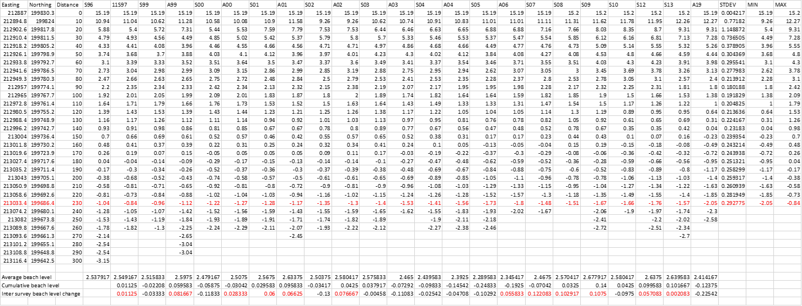

APPENDIX B

SHORT TIMESCALE BEACH PROFILE DATA SHEETS

- Survey data and descriptive statistics AVERAGE TR01-TR05
- Survey data and descriptive statistics AVERAGE TR05-TR09

- Survey data and descriptive statistics AVERAGE TR09-TR13

APPENDIX C

MORPHOSTAT TABLES

Colour-coded results for the relevant tidal contour zones of each of the assessed transects, i.e. initial assessment and the percentage that remained Green was then used for subsequent analysis.

Appendix D

Statistical equations used for the computation of dependent t tests and regression models

Dependent t tests
The t statistic for paired t tests was determined from:
 | d¯= | ∑d | .................................................(equation 4.1)
 | d¯= | n
Where d is the difference between each pair of data points.

The standard error of the mean difference (SEd) was then found by:
 | SE_{d} = √ | ∑d²- | (∑d)² | .............(equation 4.2)
 | SE_{d} = √ | ∑d²- | n | .............(equation 4.2)
 | SE_{d} = √ | n(n-1) |  | .............(equation 4.2)
The t statistic was determined from:
 | t_{calc} = | d¯ | ...............................................(equation 4.3)
 | t_{calc} = | SE_{d}
Finally, the calculated t statistic (t_{calc}) for both independent and paired t tests was compared with tabulated t values (t_{tab}) according to the degrees of freedom (d_{f}) in a test for significance. If t_{calc} < t_{tab} the null hypothesis was accepted and there was no significant difference but if t_{calc} > t_{tab} the null hypothesis was rejected and there was a significant difference.

Linear Regression models

y = (c + mx) + ε)

where y is the independent variable; c is a constant; m₁, m₂ and m_{n} regression coefficients; and x₁, x₂, and x_{n} are dependant variables; and ε is the error beteween model and actual results (Field, 2005: 157). Variables c and m are calculated from the following:

m = | ∑xy | -∑x∑y
m = | ∑xy | n
m = | ∑x² | -(∑x)²
m = | ∑x² | n

c = | y | -m | x
c = | n |  | n

Proportional dataset variability is explained by the statistical model determined from the coefficient of determination, which is simply the square of the sample Pearson correlation moment coefficients. Pearson’s product moment correlation coefficient (r) is determined from:

Correlation Coeficient (r_{calc}) = | n∑xy - ∑x∑y
Correlation Coeficient (r_{calc}) = | √(n∑x² – (∑x)²)( n∑y² – (∑y)²)

The significance of the regression line is given by the following formulae:.

SS_{total} = | ∑y² | – (∑y)²
SS_{total} = |  | n

SS_{regression} = | ∑xy | -(∑x∑y)²
SS_{regression} = |  | n
SS_{regression} = | ∑x² | -(∑x)²
SS_{regression} = |  | n

SS_{residual} = SS_{total} – SS _{regression}

Finally, the calculated F values are compared with a table of critical values according to degrees of freedom (d_{f}). If F_{calc} < F_{tab,} the null hypothesis is accepted and it is concluded that an insignifcent amount of variation in y is accounted for by the variation in x. However, if F_{calc} > F_{tab}, the null hypothesis was rejected and it is concluded that a highly significant amount of the variation in y is accounted for by the variation in x.

Inter-survey cumulative beach level changes Profiles T09, T10 and T11

Inter-survey cumulative beach level changes for south, central and north sectors.

Appendix E

Morphostat Results short-term data

