

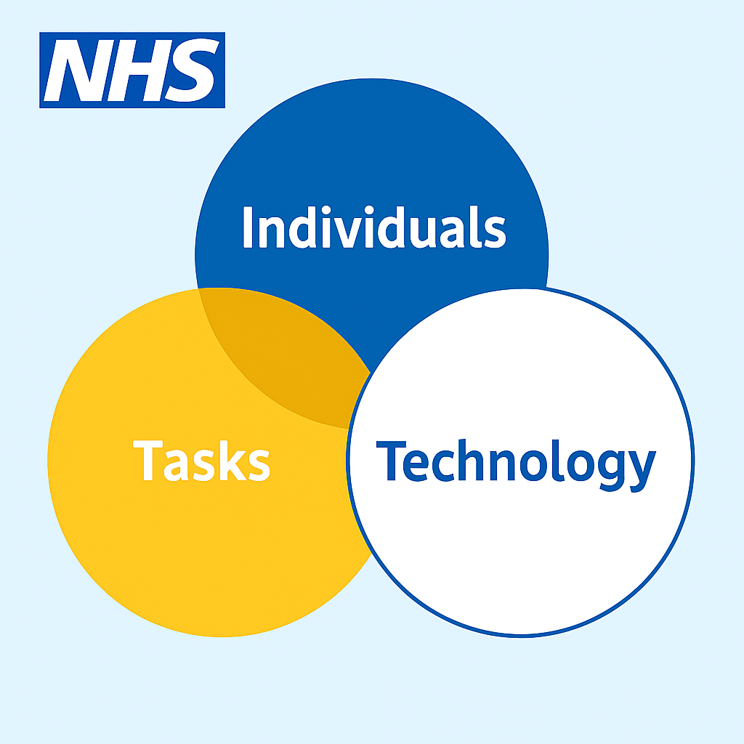

Critically analysing the Welsh community care information system using the socio-technical FITT model
Abstract
Using the FITT framework to complete a critical analysis of the ABUHB delivery of WCCIS.
Grant Healey (2517190)

Contents
Introduction 2
Methods 3
Technology-Task 4
Technology-Individual 4
Individual-Task 4
Results 5
Technology-Task 5
Technology-Individual 6
Individual-Task 7
Discussion 7
Technology-Individual 8
Technology-Task 8
Individual-Task 8
References 9

Introduction
The digital transformation of health and social care is increasingly dependent on effective implementation of complex software systems capable of supporting multidisciplinary pathways, enhancing data quality, and improving coordination of care (Sujan, 2023)
This critical evaluation concerns a large, multidisciplinary programme of digital transformation within a NHS service in Wales, specifically the mental health and learning difficulties (MHLD) directorate of Aneurin Bevan University Health Board (ABUHB) (Price, 2017) The service spans both hospital and community care and includes; Primary care mental health support services, community mental health teams, crisis resolution team, home treatment team, psychological therapies, learning difficulties services and mental health inpatient wards (Pask, McDonald and James, 2024)
Prior to system change, care delivery and management were constrained by the legacy ePEX application and a patchwork of paper and electronic processes (Price, 2017; Pask, McDonald and James, 2024) These conditions limited mobile working in the community, impeded safe and timely information sharing with local authority partners, and required time consuming work arounds to meet statutory and national reporting obligations, including the mental health measure, outpatient and admitted patient datasets, and waiting time returns (James, Pask and McDonald, 2021; Pask, McDonald and James, 2021a). Collectively, these circumstances generated avoidable risks to data quality, timeliness, and operational visibility (Price, 2017)
The software selected to address these problems was the Welsh Community Care Information System (WCCIS), delivered on the commercial CareDirector version 5 platform as part of a nationally provisioned “Once for Wales” ecosystem (Price, 2017) The system was intended to replace ePEX and to support core clinical processes, such as; referrals, assessments, care planning, mental health act records, and bed management. Whilst also offering administrative processes such as; diaries, scheduling, document and letter management. It also provides analytical and reporting functions including dashboards and statutory submissions, while laying the foundations for decision support through data capture (Pask, McDonald and James, 2021b, 2024) The stated programme aims were to improve care quality, streamline administration, strengthen data accuracy, secure timely and compliant reporting, enable mobile practice, and facilitate integrated information sharing across health and social care boundaries (Price, 2017)

Implementation at ABUHB formed part of a wider national digital transformation programme and was governed through explicit investment objectives and performance indicators (Price, 2017) These included day-one parity or better with ePEX, a controlled and safe go-live, delivery of priority integrations with national services, migration of active records, and demonstratable progress on mandated reporting (James, Pask and McDonald, 2021; Pask, McDonald and James, 2024) Change management activities comprised of the establishment of super-user networks, large scale training for more than 1,300 staff, structured operational acceptance, on-site support during the early adoption period, and targeted communications and micro-learning resources (Pask, McDonald and James, 2021b, 2021a, 2024).

To analyse the value and limitations of the implementation across this complex service landscape, the FITT framework will be utilised (Ammenwerth, Iller and Mahler, 2006) This approach will assess the extent to which the technology aligns with the priority tasks undertaken across mental health and learning disabilities pathways and is usable and acceptable for the individuals expected to operate it within their organisational and inter-organisational contexts (Ammenwerth, Iller and Mahler, 2006).The analyses will distinguish issues that are principally attributed to product design and platform constraints from those that arise from programme governance and change management execution, thereby providing an academically grounded account of socio-technical fit and its consequences for quality, safety, operational efficiency, and compliance.

Methods
The FITT framework was used as an analytical tool, which conceptualises effective adoption as a product of alignment across the three fits, technology-task, technology-individual, and task-individual, as shown in Figure 1. The FITT framework will allow the evaluation of socio-technical determinants of success or failure and to separate issues intrinsic to the product from those arising through the programme’s execution. (Ammenwerth, Iller and Mahler, 2006).

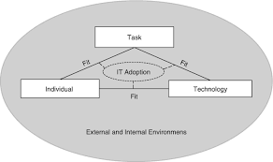
Figure 1; A visual representation of the socio technological FITT framework, illustrating the relationship between task, the individual, and technology. Alongside overall IT adoption. (Ammenwerth, Iller and Mahler, 2006)

Technology-Task
The fit between technology and task was examined through structured cross mapping of priority workflows against delivered capabilities. Task requirements were identified through programme documents describing capabilities such as; referral and waiting list management, assessment and care planning, mental health act administration, bed management, multidisciplinary scheduling, document generation, and statutory reporting. These were documented as either being delivered or not by the new system to evidence shortcomings in the technology (Price, 2017; James, Pask and McDonald, 2021; Pask, McDonald and James, 2024).

Technology-Individual
The technology and individual fit was explored through the discussions of user training, super user arrangements, and support plans captured in the closure documentation, lessons learned log, user acceptance testing. Identifying signals of preparedness, cognitive burden, perceived usability and the safety of core functions (Pask, 2021; Pask, McDonald and James, 2021a, 2024)

Individual-Task

Task and Individual fit was analysed by testing whether redesigned processes and standardised reference data remained compatible with role expectations and time constraints across impatient and community teams. Programme documents state where workflow design, form builds, and reporting processes were examined for the extent to which staff could enact required tasks within WCCIS without reliance on parallel or paper processes (McDonald, Pask and James, 2021; Pask, McDonald and James, 2024).
Data sources for the analyses combined organisational documentation and scholarly literature. Academic sources were used to justify the framework and interpret patterns of adoption and change. (Michie, van Stralen and West, 2011; Cresswell, Bates and Sheikh, 2013; Venkatesh, Thong and Xu, 2016; Greenhalgh et al., 2017; Proctor et al., 2023).
Methodological limitations include no direct observation of staff using the system was undertaken, and no conversations with users were conducted; the evaluation therefore relied exclusively on the documentary record. While this avoids the bias associated with small, self-selected interview samples, it limits insight into tacit practices and real time cognitive workload (Ammenwerth, Iller and Mahler, 2006; Greenhalgh et al., 2017). There is also potential personal analytical bias (Cresswell, Bates and Sheikh, 2013). which is likely mitigated through utilising a range of programme documents and explicit reporting (Price, 2017; James, Pask and McDonald, 2021; McDonald, Pask and James, 2021; Pask, McDonald and James, 2021b, 2021a, 2024). Another limitation was the constraints of time and access that precluded review of live environments and raw audit trails (Cresswell, Bates and Sheikh, 2013; Greenhalgh et al., 2017). Despite these limitations, the method remains proportionate and academically defensible for retrospective socio technical evaluation: FITT offers rigorous structure for judging alignment, the varied documentation provides credible evidence of practice, and the attribution step highlights distinctions between product constraints and programme level determinants of success (Ammenwerth, Iller and Mahler, 2006; Proctor et al., 2023).

Results
The implementation of WCCIS across mental health and learning disabilities generated a complex pattern of outcomes by interactions between users, task, and the technological environment they were required to adopt. Users represented a broad multidisciplinary community, including inpatient and community clinical staff, therapists, administrative teams, and local authority partners. This variation in role types meant that WCCIS had to support highly heterogeneous workflows, ranging from structured care planning and assessments to ad hoc communication, high-frequency observations, national dataset reporting, and multi-organisational information sharing. The system attempted to consolidate these workflows through functions such as referrals, assessments, case management, scheduling, bed management, form-based documentation, dashboards, and reporting; however, the extent to which these features aligned with real-world requirements varied significantly across the services (James, Pask and McDonald, 2021; Lane and James, 2021; Robinson and Kelly Griffiths, 2023; Pask, McDonald and James, 2024).

Technology-Task

The extent to which WCCIS supported or constrained the fit between technology and task was highly dependent on the specificity and stability of the workflows It was intended to support. Core functional components such as referrals, assessments, care planning, bed management, document generation, and dashboards were technically delivered, and substantial local configuration was undertaken with 196 electronic forms and 245 templates built to mirror MHLD and therapy processes. These elements modernised several administrative tasks and supported more consistent data capture, particularly where reference data had been standardised. Some tasks, such as scheduling across multidisciplinary teams, improved through shared diaries that enabled visibility of colleague’s commitments. However, misalignments were widespread in areas where real-world workflows diverged from system assumptions. Waiting list management, for example, was not supported consistently across mental health and sub-specialties, leading teams to create parallel referrals or maintain external spreadsheets when the system ended waiting times after the patient had received a single appointment by default. Staff also reported uncertainty in performing high-frequency inpatient observations, because the systems’ hourly structure did not align with the 15- or 30-minute cadence used clinically, and mandatory field logic often contradicted screening information labelled as “non-mandatory”. UAT feedback further highlighted confusion around leave processes, mental health assessment sequences, and consent workflows where signatures where required in practice but were absent in the digital model. Integration gaps also disrupted core tasks; although a small set of interfaces: national address exchange, local and national land and property gazetteer, master patient index and patient demographic query were available, others critical for clinical correspondence, alerts, and interoperability remained undelivered. These constraints, combined with performance instability in the platform and persistent referral to treatment time (RTT) calculation defects that forced local audits, meant that despite improvements in consistency, the system frequently required workarounds and manual reconciliation for tasks central to clinical and statutory reporting workflows (James, Pask and McDonald, 2021; Lane and James, 2021; Robinson and Kelly Griffiths, 2023; Pask, McDonald and James, 2024).

Technology-Individual

The fit between technology and individual was similarly mixed, shaped by both the volume of training delivered and the usability challenges that surfaced when staff attempted to put what they had learned into their operations. Training was significant with over 1,300 staff trained by trainers, more than 330 classroom sessions, 100 plus super users providing trickle down training, and 25 short “how-to” support videos widely accessed. Even so delays between training and Go-Live undermined knowledge retention, leaving many users feeling unprepared once the system became live. Reports from user acceptance testing sessions by both inpatient and community users, emphasised difficulties in navigating the system, they struggled with mandatory fields, hyperlinks, and inconsistent behaviour when saving forms or recording involvement. These issues increased cognitive load, particularly where clinical staff had to reconcile contradictory prompts or were system logic presented options that did not reflect the clinical sequence being undertaken, such as section 3 being allowed before section 2 was closed. Performance issues, such as slow page loads, system crashes and the need for manual diary refresh, further eroded confidence. While some users recognised value in having access to digital records across sites and considered the system functional if “glitches” were reduced, others described substantial frustration with reliability, citing excessive time spent navigating or correcting errors. Mobile working, initially anticipated to enhance individual usability and autonomy, did not materialise due to non-deployment of the mobile app and significant under-utilisation of issued devices, contributing to user scepticism about the systems promised benefits. These issues collectively shaped user attitudes, producing a spectrum from cautious optimism to pronounced frustration depending on role, task complexity, and reliance on the system responsiveness (Lane and James, 2021; McDonald, Pask and James, 2021; Pask, McDonald and James, 2021a, 2024; Robinson and Kelly Griffiths, 2023) .

Individual-Task

The relationship between the individual and tasks they were required to perform using WCCIS also demonstrated a pattern of uneven fit, with several tasks demanding higher levels of digital literacy, data validation, or workaround creation than originally anticipated. Staff were often required to compensate for limitations in the system design through additional administrative activity, such as; manual audits for national datasets, including mental health measure part 1 and 2, assessment of function in crisis resolution and home treatment, corrections to migrated data, and reconciliation of diary and referral inconsistencies. Workload shifted especially toward community and reporting teams who had to maintain duplicated spreadsheets to compensate for waiting list and RTT defects, or who performed repeated “fix on next appointment” workarounds to correct system-generated RTT timelines. Inpatient teams faced increased workload where system structures did not support the frequency of clinical observation or where legal workflows lacked appropriate stages, prompting staff to seek clarification from system trainers of business change facilitators. The mobility task domain also reflected a poor individual-task fit although 965 devices were scoped, 163 remained uncollected and usage data indicated limited integration into daily workflow, suggesting tasks were not aligned with device capabilities or staff preferences. As a result, many clinical and administrative tasks continued to rely on hybrid systems such as emails, spreadsheets, whiteboards and local logs, reducing the intended unity of digital workflow. Even with large-scale business change support, the mismatch between the system contributed to an ongoing dependence on manual, parallel processes. This outcome reflects a partial but incomplete alignment of individual capability, system competence and task design across implementation (James, Pask and McDonald, 2021; Lane and James, 2021; McDonald, Pask and James, 2021; Pask, McDonald and James, 2021b, 2021a, 2024; Robinson and Kelly Griffiths, 2023).

Discussion

The FITT analysis indicates that ABUHB established a credible technical base with WCCIS but realised only partial operational gains because fit broke down at multiple socio-technical interfaces. Where configuration could localise stable processes, benefits were visible; where benefits depended on upstream dependencies, misalignments multiplied and staff reverted to manual reconciliation. This pattern is consistent with FITT’s central claim that effective adoption arises from the interaction of technology, tasks and individuals, not any component in isolation (Ammenwerth, Iller and Mahler, 2006). The programmes constraints were less the software and more the timing and coupling between national product constraints, local workflow needs, and user readiness (Lane and James, 2021; Robinson and Kelly Griffiths, 2023; Pask, McDonald and James, 2024). A well-described risk in large-scale health informatic system programmes when workflows outpace technical dependencies (Cresswell, Bates and Sheikh, 2013).

Technology-Individual

Regarding the technology-Individual fit, substantial training activity did not fully translate into confident use because content and timing were misaligned with go-live, raising effort expectancy and lowering performance expectancy, which (Venkatesh, Thong and Xu, 2016) state are classic predictors of wavering acceptance in their unified theory of acceptance and use of technology. Evidence shows that documentation burden tied to workflow misalignment and navigation redundancy, reinforcing the role of usability beyond training volume (Cho et al., 2024).

Technology-Task

The strengths for technology-task fit clustered where coupling was tight, such as local configuration for documentation and scheduling. While weaknesses arose around interoperability and time-critical logic, A well-described risk in large-scale health informatic system (HIS) programmes (Cresswell, Bates and Sheikh, 2013).

Individual-Task

For the fit between individual-task, staff absorbed reconciliation work, consistent with the systems engineering initiative for patient safety warning that when organisational processes and tools are out of sync, workloads proliferate and load shifts to the frontline. (Carayon et al., 2006)

Improvements could have been made by firstly, treating interfaces and high-risk workflows as explicit dependencies for go-live and sequence them in “stabilise-before-scale” milestones (Cresswell, Bates and Sheikh, 2013). Second align enablement to behaviour science: provide just-in-time, role-specific scripts and test environments to build capability and opportunity (Michie, van Stralen and West, 2011). Third, anticipate scale-up and sustainability risks using the non-adoption, abandonment, and challenges to scale-up, spread, and sustainability framework to address system-level factors beyond software (Greenhalgh et al., 2017).
My evaluation is limited by the fact that it draws upon programme documentation rather than ethnographic observation or prospective measurement, which constrains casual inference and generalisability. Limitations common in retrospective HIS assessments (Cresswell, Bates and Sheikh, 2013). Implementation-science reviews also warn that links between strategies and outcomes are often under-tested (Proctor et al., 2023).

In conclusion, in real world terms, WCCIS advanced the digital transformation aim of a shared, auditable record and more consistent data capture, but unresolved interoperability, usability and timing gaps entrenched manual overheads. FITT therefore supports the verdict or partial success: strong fit for configurable, bound tasks; weak where cross-organisational flows and reliability were pivotal; and mixed for users due to training-time and usability burdens. Targeted fit-engineering such as sequencing dependencies, designing for behaviour, and planning for scale, offers the most direct path to realising the intended safety, efficiency, and integration gains.
I confirm this essay is my own original work and does not include text created by a generative artificial intelligence tool

References

Ammenwerth, E., Iller, C. and Mahler, C. (2006) ‘IT-adoption and the interaction of task, technology and individuals: a fit framework and a case study’, BMC Medical Informatics and Decision Making, 6(1), p. 3. Available at: https://doi.org/10.1186/1472-6947-6-3.
Carayon, P. et al. (2006) ‘Work system design for patient safety: the SEIPS model’, Quality in Health Care, 15(suppl 1), pp. i50–i58. Available at: https://doi.org/10.1136/qshc.2005.015842.
Cho, H. et al. (2024) ‘Electronic health record system use and documentation burden of acute and critical care nurse clinicians: a mixed-methods study’, Journal of the American Medical Informatics Association, 31(11), pp. 2540–2549. Available at: https://doi.org/10.1093/jamia/ocae239.
Cresswell, K.M., Bates, D.W. and Sheikh, A. (2013) ‘Ten key considerations for the successful implementation and adoption of large-scale health information technology’, Journal of the American Medical Informatics Association, 20(e1), pp. e9–e13. Available at: https://doi.org/10.1136/amiajnl-2013-001684.
Greenhalgh, T. et al. (2017) ‘Beyond Adoption: A New Framework for Theorizing and Evaluating Nonadoption, Abandonment, and Challenges to the Scale-Up, Spread, and Sustainability of Health and Care Technologies’, Journal of Medical Internet Research, 19(11), p. e367. Available at: https://doi.org/10.2196/jmir.8775.
James, J., Pask, E. and McDonald, P. (2021) WCCIS reporting status.
Lane, S. and James, J. (2021) WCCIS UAT tester comments.
McDonald, P., Pask, E. and James, J. (2021) WCCIS Problem, Change and Issue Log.
Michie, S., van Stralen, M.M. and West, R. (2011) ‘The behaviour change wheel: A new method for characterising and designing behaviour change interventions’, Implementation Science, 6(1), p. 42. Available at: https://doi.org/10.1186/1748-5908-6-42.
Pask, E. (2021) WCCIS closure checklist.
Pask, E., McDonald, P. and James, J. (2021a) WCCIS lessons learned log.
Pask, E., McDonald, P. and James, J. (2021b) WCCIS operational acceptance .
Pask, E., McDonald, P. and James, J. (2024) WCCIS closure report.
Price, L. (2017) Implementation of the National Welsh Community Care Information System (WCCIS) Business Case.
Proctor, E.K. et al. (2023) ‘Ten years of implementation outcomes research: a scoping review’, Implementation Science, 18(1), p. 31. Available at: https://doi.org/10.1186/s13012-023-01286-z.
Robinson, B. and Kelly Griffiths (2023) WCCIS business change plan.
Sujan, M. (2023) ‘Integrating digital health technologies into complex clinical systems’, BMJ Health & Care Informatics, 30(1), p. e100885. Available at: https://doi.org/10.1136/bmjhci-2023-100885.
Venkatesh, V., Thong, J. and Xu, X. (2016) ‘Unified Theory of Acceptance and Use of Technology: A Synthesis and the Road Ahead’, Journal of the Association for Information Systems, 17(5), pp. 328–376. Available at: https://doi.org/10.17705/1jais.00428.

