Section B, Question 1: Kenneth Morgan’s Peace Movements in Wales 1899-1945 and Rebirth of a Nation.

As one of the ‘little five-foot-five nations’ that shaped the coming of wars, the Welsh were deeply engrained within politics and industry of the late nineteenth century. There resides an overarching belief within history that the Welsh were largely pro-war in reference to the Boer and First World War, and such is coined within Kenneth Morgan’s Wales at War and Rebirth of a Nation. Within this essay, the jingoism of the Welsh will be discussed, along with contrasting views on the matter. War enthusiasm was often uplifted by politic opinion and newspaper coverage, which too shall be dissected in order to ascertain whether the Welsh as a nation were pro or anti-war.
This concept of Welsh jingoism is furthered by Kenneth Morgan’s writings. He is vehement in his belief that Wales, as a nation, were largely pro-war in their roots—their loyalties largely relied upon religion and state. He uses this example in reference to the history that encapsulates the Welsh patriotism, such as the feats faced during the early and later medieval periods. Within Modern Wales Morgan elaborates that the Welsh rejected the aggressive elements of war but claims that this perspective is usually upheld by historians of English origin, and uses A.J.P Taylor as an example. Taylor suggests that in terms of attitudes to the Boer War the Welsh were generally moderate in comparison to the Irish. Within Rebirth of a Nation, Morgan refers to the Welsh as being ‘Men of Harlech’, the reference being one of strong national identification of the Welsh efforts during wartime. Morgan explains that previous attitudes that were upheld by certain parts of Wales during the build up to 1899, primarily anti-war sentiments, had been reversed. He analyses the enthusiasm that the Welsh had for war through enlistment numbers, statistics that display that able-bodied Welshmen outnumbered the recruiting figures that were seen within Scotland and England. This idea of Welsh identity blurred the lines between duty to ones’ country and all out nationalism. Morgan reiterates said enthusiasm for war could be seen within literature, primarily poetry that stemmed from the Eisteddfod that had profound effects on the Welsh spirits. The Boer War was not forgotten, but anti-war opinions that had fuelled campaigns against the South African war had certainly changed. ‘Patriotic fervour reached heights of hysteria in Wales’, and Morgan concludes that this hysteria was due to the belligerent nature that David Lloyd George possessed. Despite this, Morgan does allude to the negative connotations that were created against the backdrop of renewed national identity. This came in the form of public condemnation of anti-war radicals, such as Thomas Rees. Coronwy Jones further discusses the mobbing of Thomas Rees within Wales and a Quest for Peace, an event that shaped the anti-pacifist approach that was upheld by many of the Welsh people. Xenophobia was present in the case of Hermann Ethé, a man of German origins whom was socially and physically persecuted by the Welsh. Morgan writes that those that sympathised with Ethé were too the subject of such confrontations, solidifying the argument that with such feeling of nationalism generated by the Great War came present hostilities towards ones’ neighbour.
Arthur Davey discusses how one would identify a pro-Boer and stated that Chamberlain was the embodiment of such imperialist opinions. Imperialism was at the heart of the Boer War, and within Modern Wales Morgan presents the argument of English historian Henry Pelling, whom reiterates pro-Boer sentiments in Wales by discussing how they were influenced as a result of ‘electoral swings’. The Welsh were largely associated with being opposed to the South African war, and such an inherent belief had been dissected by Pelling. Through considering Pelling’s statistical argument Morgan concludes that Wales were ‘a nation of pro-Boers’, as within predominately industrialised areas of Wales whose inhabitants included English speakers, sympathies for imperialist causes were pronounced. However, east and west Wales juxtaposed this and were instead sympathetic towards the Boers, as Morgan furthers within his own research.
Adrian Gregory alludes to Morgan’s’ argument regarding the Welsh throwing themselves into the war with gusto, and Gregory underlined his analysis of Welsh enthusiasm for the war being influenced by the mining issues that were circulating Wales at the time. Gregory discusses the jingoism of the Welsh by referring to the heckling of Keir Hardie in 1914, whom was a strong objector to the First World War. As an anecdote to Hardie, it is interesting to mention that he was pro-Boer, and like Lloyd George the switching of sides in regards to war stances was not just limited to the Liberal party, but the Labour too.
Davey, within his discussion of The British Pro-Boers claims that ‘the British had a sentimental feeling for small people’. Davey elaborates his argument further by alluding to the anti-war stance of Welsh liberal politics, spearheaded by figures such as Keir Hardie and Philip Snowden, both of whom believed that the Boers were victims of a ‘stock-jobbing operation.’ Davey notes that this perspective was widely shared by radical liberals and would soon see religious institutions taking the same opinion. The non-conformists, fundamentalists and Quakers are a few of the spiritual establishments to name. In terms of the politics that shaped the coming of wars, David Lloyd George played a significant role as Wales’ radical political party leader. Largely anti-war prior to the conflict of 1914, Lloyd George was the face of the liberal ideologies that the Welsh seemed to favour. The Black Week of December 1899 led to the dwindling of enthusiasm for the war, and so came the emergence of David Lloyd George. Lloyd George, the first Welsh Prime Minister ‘was no pacifist’, and this can be seen within his political endeavours. He held the interests of the British close, and tended to swing in the favour of British sentiments of the time. This is apparent within his initial condemnation of the Boer War, until he ultimately proved to be in favour of the Great War upon its outbreak. It is worth noting that Lloyd George didn’t uphold the primary precepts of pacifism yet believed that the 1899 conflict would just prove to be detrimental to the social reforms that would soon be cast aside.
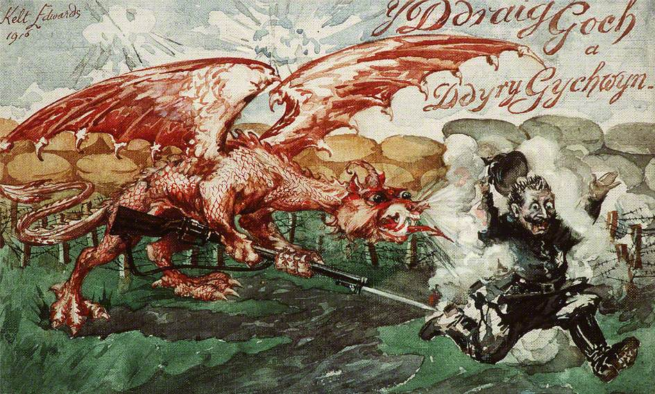
It is thought that generally, German life was a source of admiration for the Welsh and this was not just limited to politics. The German culture—specifically within the realm of music and philosophy—was held in a favourable light. This lends the belief that in the build up to World War One, Wales would have generally been opposed to the outbreak of war, especially with a country that was held with such great esteem. Wales at this stage were at the helm of social change, as can be seen within the Miner’s Next Step and Cymru Fydd, thus comes the conclusion that Wales may have sympathised against the ‘bullying of the Hun’, and saw a kindred spirit within socialist ideas. This ideology changed during the build up to World War One, in which David Lloyd George urged the Welsh to sympathise with the Belgians against their German aggressors and displays quite distinctly how public opinion could be switched. Such political stances led to various reactions of Welsh newspapers, and the creation of images depicting the wrath of the Welsh against the ‘German Hun’ as can be seen below.
Fig. 1: Kelt Edwards painting that depicts German soldier running from Welsh Dragon. Above translation reads: the red dragon inspires action, 1916.

The aforementioned points may prove Morgan’s statements within Rebirth of a Nation to be relevant. In considering the image curated by Kelt Edwards, along with how the influence of political leaders would have on public opinion. The above image could also be related to Lloyd George’s speech at Queen’s Hall, advising the Welsh to embrace the war with the same fervour as their ancestors. The same ideology can be likened to the Welsh experience with Rourke’s drift, in which the Welsh saw substantial success. The militaristic feats of the past may have rekindled the Welsh passions, such as the legend that the Welsh had held strong against 2,000-3,000 Zulus. Lieutenant Wilfred Heaton’s personal diaries from the Zulu conflict are reminiscent of how the Welsh may remember such feats, as Heaton’s successor provides a heartfelt message of Heaton’s war experiences within Heaton’s memoirs of the Boer War.
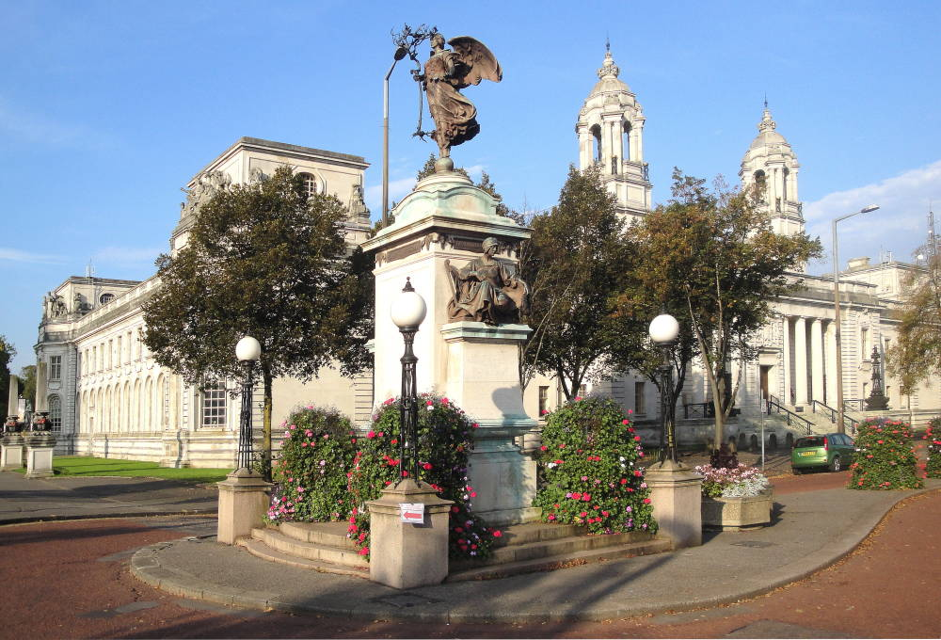
The Boer War memorial in Cardiff is reminiscent of the grief that amassed communities after the war. Below the angel atop of the memorial a man and women are situated—the female is the archetypal portrayal of the grieving mother, sweetheart, or sister. The male is the hero, depicting his role within the conflict and courage that he may have displayed. Names are included within the memorial, 817 in total. Upon studying this memorial, is it representative of the statements made by Morgan that suggest that the Welsh were largely pro-Boer war? To some extent, yes. However, this memorial is reflective of the lives that had been lost and commemorations for the war dead were erected across the country, as can be seen with the unveiling of a ‘handsome brass tablet’ in St David’s Cathedral by Lord Penrhyn. The tablet documents the lives of those who had fought in the Boer War, and Lord Penrhyn commends their bravery, as they had ‘at heart the future interests of the Welsh nation’. From within the Manchester Courier and Lancashire General the attitudes towards the war can be seen within Lord Penrhyn’s commendation of the Welsh that had fought, and in some regard his words may shape how pro-war feeling could be generated in due course, upon the arrival of the First World War.
Fig. 2: Jacqueline Banerjee’s photograph of the Boer War Memorial created by Albert Toft in 1909, Cardiff.
Were a majority of the Welsh pro-war for the African conflict? As Arthur Davey states, the British seemed to have an affinity for ‘small peoples’, and this is furthered by Kenneth Morgan’s discussion that Welsh language press presented anti-Boer sentiments to the public on the basis that like the Boers, the Welsh too were victims of the colonialism perpetrated by the English. The concentration camps that were constructed due to the commands of Kitchener were a source of great agitation. Herbert Asquith however commended Kitchener within a House of Commons sitting in 1901, in which the recent administrations and situations regarding the Boer war were discussed.
No praise, I think, can be too high, no appreciation can be too warm of the great work which Lord Kitchener has done in South Africa. He has displayed, under conditions of almost unexampled difficulty, a combination of energy and patience, of zeal and moderation which will always entitle him to a high place among the great soldiers of this country.

However, the attitude of Asquith was not one that correlated with the anti-Boer stances of the liberal Welsh. Davey writes that the pro-Boers would publicise war atrocities by reporting allegations of abuse, martial law injustices and the occurrences of farm burning. The concentration camps designed to ‘flush out guerrillas’ were administered poorly, and it became a centre for disease. The scale of people whom were sent to ‘perish in these concentration camps’ was huge, with Wessel claiming that 26,000 women and children were to succumb to the tragic repercussions created by the British during the Boer War. Such humanitarian issues would have resonated with the public, leading to the anti-Boer agenda to be exaggerated even more so by emotive events perpetrated by the British.
In regards to the First World War, Lloyd George was an avid supporter. He made attempts to persuade Lord Kitchener to create an army corps specifically for the Welsh and this sense of nationalism curated to establish a recognition of ‘Welshness’ is reiterated within his speech presented at Queens Hall in London.
Wales must continue doing her duty… I should like to see a Welsh Army in the field. I should like to see the race that faced the Normans for hundreds of years in a struggle for freedom, the race that helped to win Crecy…. Give a good taste of its quality in this struggle in Europe.
The North Wales Chronicle reports the reactions of the crowds that stemmed from Lloyd George’s war cry. Cheers, long and loud, followed Lloyd George’s words. The Nonconformists, Wales’ men of peace, ‘stand in line with all the sons of the Empire in their stern resolve to put an end to the Prussian Junker’. The Carmarthen Journal too documents reactions to the speech, stating that the Welsh as a people had lived sheltered lives, and that a descent into a great war would serve to fuel the passions of duty and patriotism. The article itself is steeped with religious connotations, and the phrasing is strong. Such can be seen with the statement: ‘the great pinnacle of sacrifice pointing like a rugged finger to heaven’. This coincides with Morgan’s conclusion that in terms of war, the Welsh were a nation that had jingoism rooted firmly within their society.
However, such reports of enthusiasm did not resonate with those that chose to take pacifist stances following the 1914 outbreak. Jones writes that pacifists in North and South Wales continued in their endeavours to promote anti-war propaganda as a means to oppose militarism in its entirety. He used the Independent Labour Party as an example of such outlooks, whom held meetings regularly to act open their public opposition to militarism. Even so, Jones established that said opposition was only seen from a minority within South Wales and that like the rest of Britain, Wales rejected ‘extreme pacifism’. The outbreak of First World War had a disastrous effect on peace societies, as mobs stormed peace meetings. The Labour Party at this time had flipped their previous agenda and were now of a pro-war stance due to adhering to the needs of the nation. For supporters of peace, this would have been a form of agitation. Another lies in the form of the church, such as the Rev. John Williams appealing to the Welshmen to serve their King and country. As previously mentioned, Davey discusses how the church took an anti-Boer stance. The religious stance undertaken by institutions during the First World War differed from the Boer War and is a clear display of how the religious institutions had switched in terms of their initial principles.
Within Wales and a Quest for Peace, which includes a nod to Morgan’s’ work, Jones discusses the connection of peace movements in Wales to the growth of political nonconformity. He creates this argument with the inclusion of the Swansea and Neath Peace Society, which was vehement in its belief that the war was immoral and juxtaposed Christian standards. This is yet another strand of pacifism that stems from the Boer War, and the popularisation of the conflict within British press furthered the agitation of the Peace Society.
Justification for the Boer War came as a conflict between religious and moral dynamics, furthering the agenda that war in Africa would be just on the grounds that it could be reinforced with spiritual connotations, thus making religion a key element of the anti-Boer argument. Dr. Thomas Rees condemns how the Church had succumbed so easily to serving the nation’s needs, as the Herald of Peace writes that religious institutions had become hubs of recruiting stations. As a man who held an extreme pacifist stance, Rees was attacked within his denomination for protesting against how the Church had gone against the primary principles of Christianity and was keen to pursue the state needs of war efforts.
In conclusion, it is evident that the writings of Kenneth Morgan ring true in many regards. The reports of the Welshmen present at David Lloyd George’s speeches present a feeling of nationalism, pride in ones’ own history and militaristic achievements. However, the pro-war stance in terms of the Boer and Great War was not all what it seems. In certain sectors of society, a conflict resided between religious and moral frameworks. The extreme pacifist became a symbol of opposition towards the war, deeming it so that suggesting that the ‘welsh threw themselves into the war with gusto’ is not a statement that would have applied to the majority of Welsh people. In all, war enthusiasm in Wales was related to the dominant issue of the day and differed between regions of the country.
Bibliography
Images
Fig. 1: Edwards, K. ‘Y Draig Goch a Ddyry Gychwyen’, (1914). Held by National Library of Wales, catalogue number: PZ03914.

Fig. 2: Jacqueline Banerjee, Cardiff Boer War Memorial by Albert Toft (2009), [online]. Available at: http://www.victorianweb.org/sculpture/toft/14.html. (Accessed 20th March 2018).
Primary Sources
CC 978-1051, Houses of Parliament. ‘South Africa—Conduct of the War: Present Situation; Recent Proclamations; Concentration Camps; Civil Administration’, 15th August 1901, vol. 99.
IWM 2133, For Remembrance and in Honour of Those Who Lost Their Lives in the South African War 1899-1902, Cardiff, [online]. Available at: https://www.iwm.org.uk/memorials/item/memorial/2133. (Accessed 14th March 2018).

J. Daniel, ‘The Carmarthen Journal and South Wales weekly advertiser’ (September 1914) held by National Library of Wales, [online]. Available at: http://www.cymru1914.org/en/view/newspaper/3678363/6/ART79/. (Accessed: 18th March 2018).

Kenmuir Whitworth Douglas, ‘North Wales Chronicle and Advertiser for the Principality, (September 1914), held by National Library of Wales, [online]. Available at: http://cymru1914.org/en/view/newspaper/4242682/1/ART20. (Accessed: 18th March 2018).
Lloyd George, D. The Great War speech delivered at the Queen's Hall, London, on 19th September 1914, published by Toronto Hodder and Stoughton.

The British Newspaper Archive, Manchester Courier and Lancashire General Advertiser Friday 15th August 1902, British Library, [online]. Available at: https://www.britishnewspaperarchive.co.uk/viewer/bl/0000206/19020815/034/0004. (Accessed 14th March 2018).

Secondary Sources
Ashwood, R., For Queen and Country: The Zulu War Diary of Lieutenant Wilfred Heaton (Darlington: Serendipity, 2005).
Davey, A., The British Pro-Boers 1877-1902 (Capetown: Tafelberg, 1978).
Davies, J., A History of Wales (London: Penguin Books Ltd., 1994)
Gregory, A., The Last Great War (Cambridge: Cambridge University Press, 2008).
Jones, G.J., Wales and a Quest for Peace (Cowbridge: University of Wales Press, 1969).
Morgan, K.O., Rebirth of a Nation (Oxford: Oxford University Press, 1998).
Morgan, K.O., Modern Wales: Politics, Places and People (Cardiff: Cardiff University Press, 1995).
Morgan, K.O., ‘The Boer War and the Media (1899-1902)’, Twentieth Century British History, vol. 13, Issue 1 (2002), pp. 1-16.
Wessels, A. The Anglo-Boer War 1889–1902: White Man's War, Black Man's War, Traumatic War (Stellenbosch: African Sun Media, 2011).
Williams, G.A., The Welsh in their History (London: Crook Helm, 1982).

K.O. Morgan, Rebirth of a Nation (Oxford: Oxford University Press, 1998), p. 160.
Morgan, Peace Movements in Wales, pp. 399-400 (NLW)
Ibid.
K.O. Morgan, Modern Wales: Politics, Places and People (Cardiff: Cardiff University Press, 1995), pp. 47.
Morgan, Rebirth of a Nation, p. 160.
Morgan, Rebirth of a Nation, p. 162.
Morgan, Rebirth of a Nation, pp. 161-3.
Ibid.
A. Davey, The British Pro-Boers 1877-1902 (Capetown: Tafelberg, 1978), p. 11.
Morgan, Modern Wales: Politics, Places and People, p. 48
Morgan, Modern Wales: Politics, Places and People, pp. 46-7.
A. Gregory, The Last Great War (Cambridge: Cambridge University Press, 2008), p. 11.
Ibid.
Davey, The British Pro-Boers 1877-1902. p. 11.
Ibid.
Ibid.
J. Davies, A History of Wales (London: Penguin Books Ltd., 1994), pp. 495-500.
Ibid.
Davies, A History of Wales, p. 499.
R. Ashwood, For Queen and Country: The Zulu War Diary of Lieutenant Wilfred Heaton (Darlington: Serendipity, 2005).
IWM 2133, For Remembrance and in Honour of Those Who Lost Their Lives in the South African War 1899-1902, Cardiff, [online].
The British Newspaper Archive, Manchester Courier and Lancashire General Advertiser Friday 15th August 1902, British Library, [online].
The British Newspaper Archive, Manchester Courier and Lancashire General Advertiser Friday 15th August 1902, British Library, [online].
Kenneth O Morgan, ‘The Boer War and the media (1899-1902)’, Twentieth century British history 13:1 (2000) 1-16 (p.10).
CC 978-1051, Houses of Parliament. ‘South Africa—Conduct of the War: Present Situation; Recent Proclamations; Concentration Camps; Civil Administration’, 15th August 1901, vol. 99.
A. Davey, The British Pro-Boers 1877-1902, p. 189
A. Wessels, The Anglo-Boer War 1889–1902: White Man's War, Black Man's War, Traumatic War. (Stellenbosch: African Sun Media, 2011), p. 79
Ibid.
D. Lloyd George, The Great War speech delivered at the Queen's Hall, London, on 19th September 1914, published by Toronto Hodder and Stoughton.
Kenmuir Whitworth Douglas, ‘North Wales Chronicle and Advertiser for the Principality, (September 1914), held by National Library of Wales, [online].
J. Daniel, ‘The Carmarthen Journal and South Wales weekly advertiser’ (September 1914) held by National Library of Wales, [online].
G.J. Jones, Wales and a Quest for Peace (Cowbridge: University of Wales Press, 1969), p. 89.
Ibid.
Excerpt from Y Tyst, published 30th September 1914 and can be found in G.J. Jones, Wales and a Quest for Peace, p. 91.
Jones, Wales and a Quest for Peace, p. xvi
G Jones, Wales and a Quest for Peace, pp. 29-31.
Wales and a Quest for Peace, p. 91
Ibid.
K.O. Morgan, Modern Wales: Politics, Places and People, p. 160.

