
Assessment Title: Programming
Assignment with Associated
Documentation

ACCA5036.
Koushik Modak (Lecturer)
University of Wales Trinity Saint David
(London Campus)

Student Name: PAUL CYRUS ABODERIN
Student Number: 2423978
Group: 01
Team: 01
Date: 16/08/26

Smart Home Device Manager
A Device Register for Bright Minds Academy
Software Design and Development Report
Detail | Value
Name | Paul Cyrus Aboderin
Student number | 2423798
Course | Computing Portfolio
Module | Scripting And Programming Concepts

Link to the source code repository
https://github.com/kinsflow/paul-cyrus-smart-home-dev-manager
The repository holds the complete, fully functional program (device_manager.py).

Table of Contents
Right-click here and choose “Update Field” to build the table of contents with page numbers.
1. Analysis .................................................. 3
1.1 Introduction .......................................... 3
1.2 Requirements Analysis ................................. 3
1.3 Abstraction and Problem Decomposition ................. 3
1.4 Software Development Life Cycle ....................... 4
2. Software Design and Development ........................... 5
2.1 Design ................................................ 5
2.1.1 Flowcharts ...................................... 5
2.1.2 Pseudocode ..................................... 12
2.2 Implementation Decisions ............................. 14
2.2.1 Data Structures ................................ 14
2.2.2 Variables Used ................................. 14
2.2.3 Programming Constructs ......................... 14
2.2.4 Python Modules and Libraries ................... 15
2.3 Source Code .......................................... 16
3. Testing and Debugging Report .............................. 19
3.1 The Importance of Programme Testing .................. 19
3.2 Types of Error in Programming ........................ 19
3.3 Test Cases ........................................... 19
3.4 Test Evidence ........................................ 21
3.5 Debugging: Defects and Limitations Found ............. 31
4. Evaluation ................................................ 32
4.1 Challenges Faced ..................................... 32
4.2 Future Improvements .................................. 32
4.3 Self-Reflection ...................................... 32

References ................................................... 34

Appendices ................................................... 35
Appendix A – How to Run the Program ...................... 35
Appendix B – Inputs Used for Each Test Session ........... 35

The table of contents above is a Word field: click inside it and press F9 to generate the headings and page numbers.

1. Analysis

1.1 Introduction
Bright Minds Academy has begun piloting smart classrooms fitted with smart lights, thermostats and projectors, but the equipment is still managed by hand. No single place records which devices exist, which room each one is in, or whether a device is working, so staff rely on memory and on asking colleagues. The result is wasted teaching time, faults that go unreported, and lessons planned around a projector that turns out to be broken.
The problem is therefore one of record-keeping rather than control. What the centre needs is a shared register that any member of staff can read and update without technical training. The solution is a menu-driven console application in Python that holds this register in memory and protects it with input validation. It must let staff do four things: record a new device and its room; mark that device online, offline or under maintenance; list every device with its location and status; and look up a single device by name. In line with the brief, real-time control and automation are out of scope - the program records what staff know about the devices, it does not talk to them.

1.2 Requirements Analysis
Each statement in the brief describing something staff cannot currently do was turned into a functional requirement, and each requirement was then examined for how it could go wrong in daily use: a name left blank, the same projector entered twice under different spellings, a status word nobody recognises. That second pass produced FR2, FR3 and FR5, which is why validation accounts for much of the finished program. A requirement counts as met only when a test case demonstrates it for both valid and invalid input.
ID | Functional requirement | Test
FR1 | Add a device by entering its name and room. | TC-01
FR2 | Reject a blank name or blank room. | TC-02, TC-03
FR3 | Reject a duplicate name, ignoring capitalisation. | TC-04
FR4 | Start every new device at status “offline”. | TC-01
FR5 | Accept only online, offline or maintenance as a status. | TC-07, TC-08
FR6 | List all devices with room and status in aligned columns. | TC-05, TC-06
FR7 | Search by name and show the room and status. | TC-11, TC-12
FR8 | Repeat a menu that rejects invalid choices and exits cleanly. | TC-13, TC-14

Three further capabilities were considered and deferred: saving the register between sessions, recording when a device was last used, and deleting or renaming a device. The second is worth noting, because the scenario mentions staff cannot tell “when it was last used,” yet it is absent from the four required features. It is recorded as a known gap and revisited in Section 4.2.

1.3 Abstraction and Problem Decomposition
Abstraction decided what a “device” is for this problem. A real projector has an IP address, firmware and a warranty date, but none of those help a tutor find it or know whether it works, so the model was reduced to the three attributes staff act on: a name, a room and a status.
Decomposition split the system into six routines with one responsibility each - add_device(), update_status(), view_devices() and search_device(), coordinated by main() - plus find_device(), the shared lookup used by both update and search. Extracting that lookup is the most important decomposition decision in the design: it removes duplicated code and guarantees that if the matching rule changes, both features change together.

1.4 Software Development Life Cycle
A Waterfall life cycle was chosen, with a short iterative loop between implementation and testing. Waterfall suits this project because the requirements were fixed and fully known before coding. The phases map onto this report: analysis (Section 1), design (2.1), implementation (2.2–2.3), testing (3) and evaluation (4). The iteration mattered in practice: test TC-15 exposed a defect the design had not anticipated, reported in Section 3.5.

2. Software Design and Development

2.1 Design

2.1.1 Flowcharts
The flowcharts use the conventional symbols [7]: a rounded box for start and stop, a rectangle for a process, a parallelogram for input and output, a diamond for a decision, and a rectangle with double side bars for a call to a routine charted separately.
Figure 1 shows the controlling menu loop. Only option 5 leaves it; any other unrecognised input produces a message and returns to the menu rather than ending the program.
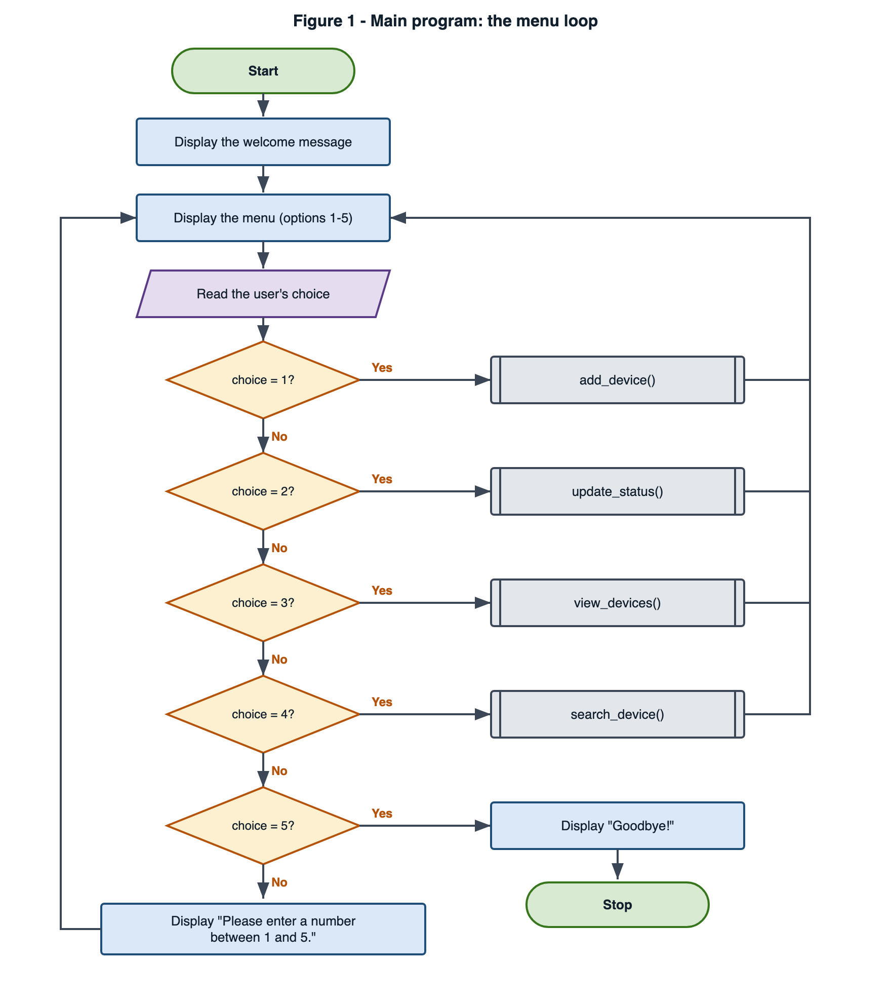
Figure 1 – Main program: the repeating menu loop.
Figure 2 charts the shared lookup. It walks the list one device at a time, compares names with capitalisation ignored, and returns either the matching device or None.
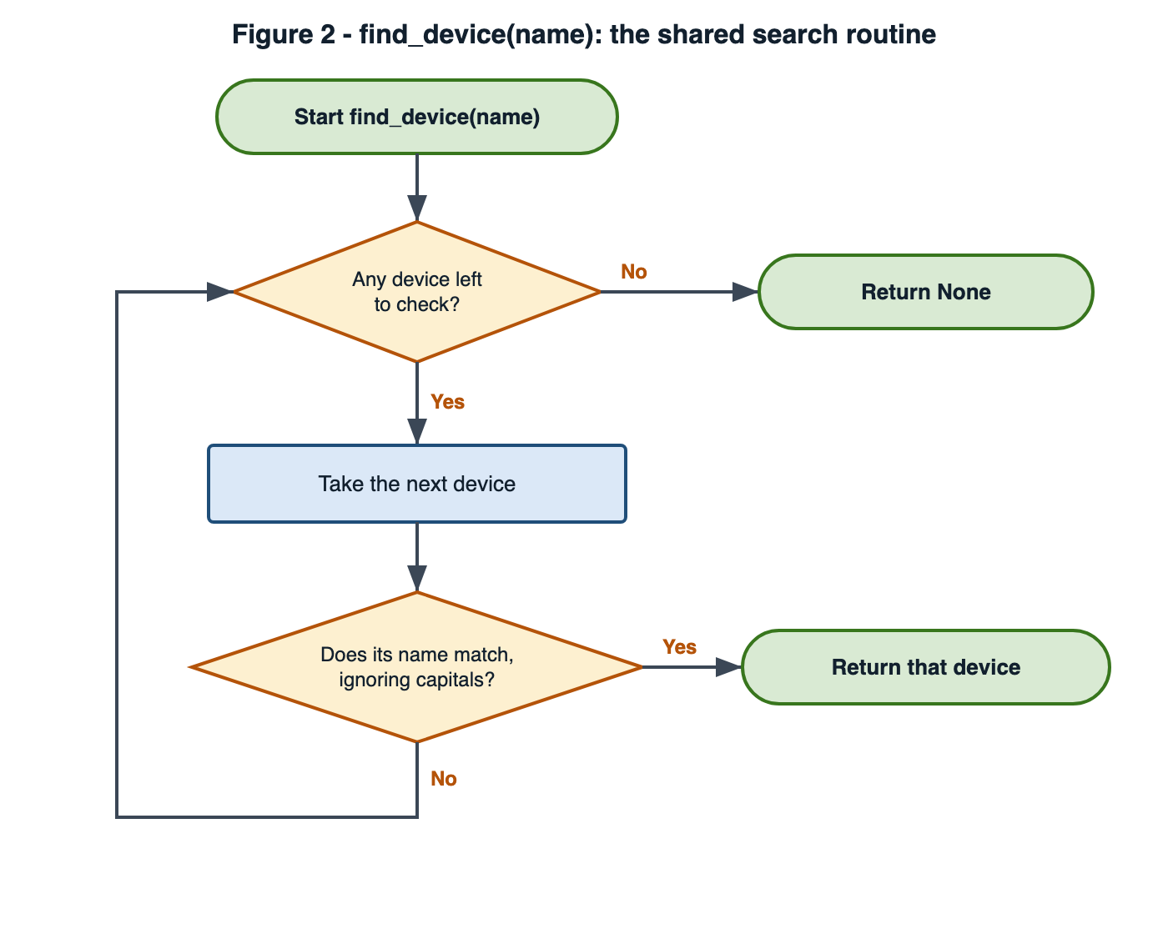
Figure 2 – find_device(name): the shared search routine.

Figure 3 charts adding a device. The three validation checks act as successive gates: the record is only created once the name is present, unique and paired with a room.
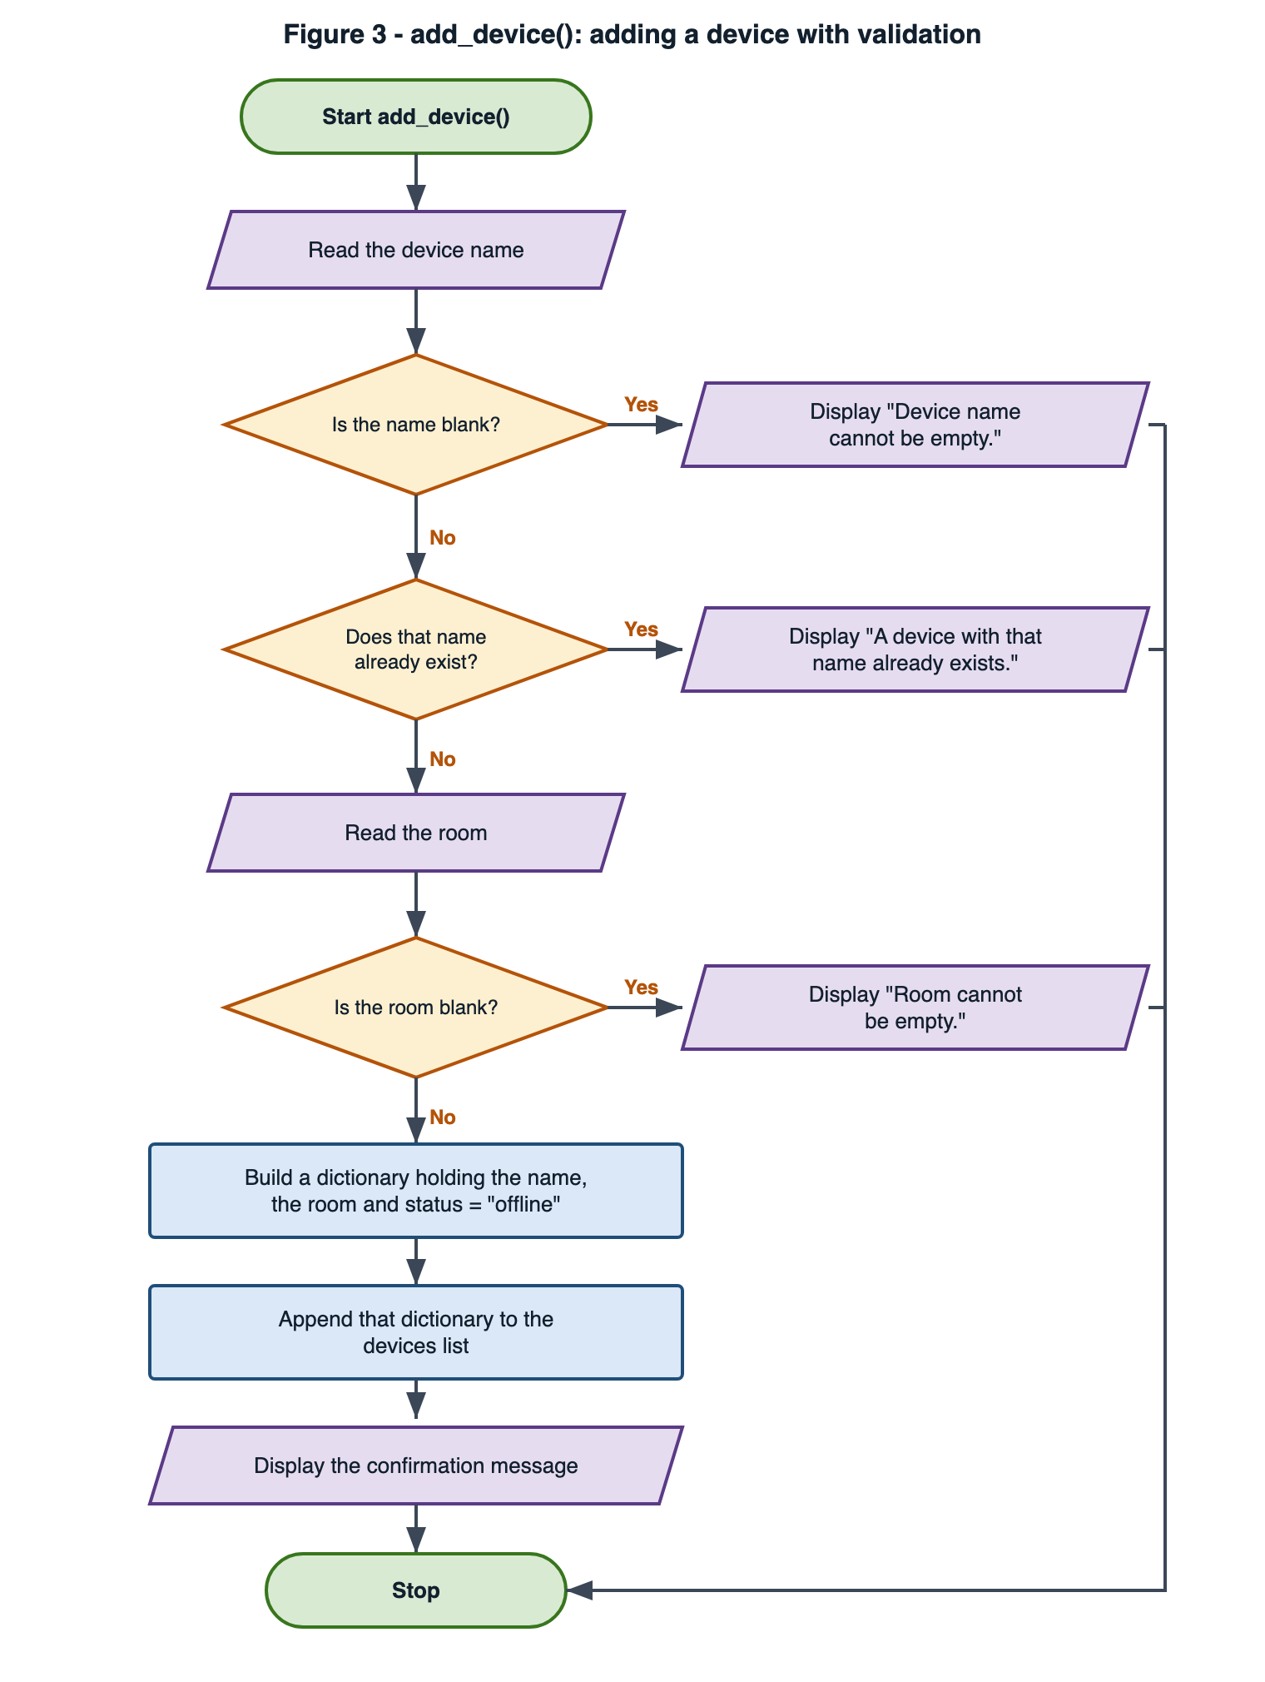
Figure 3 – add_device(): adding a device with validation.

Figure 4 charts the status update, which has four exits: three validation failures and one success. The status typed by the user is converted to lower case before it is checked, so “ONLINE” and “online” are the same answer.
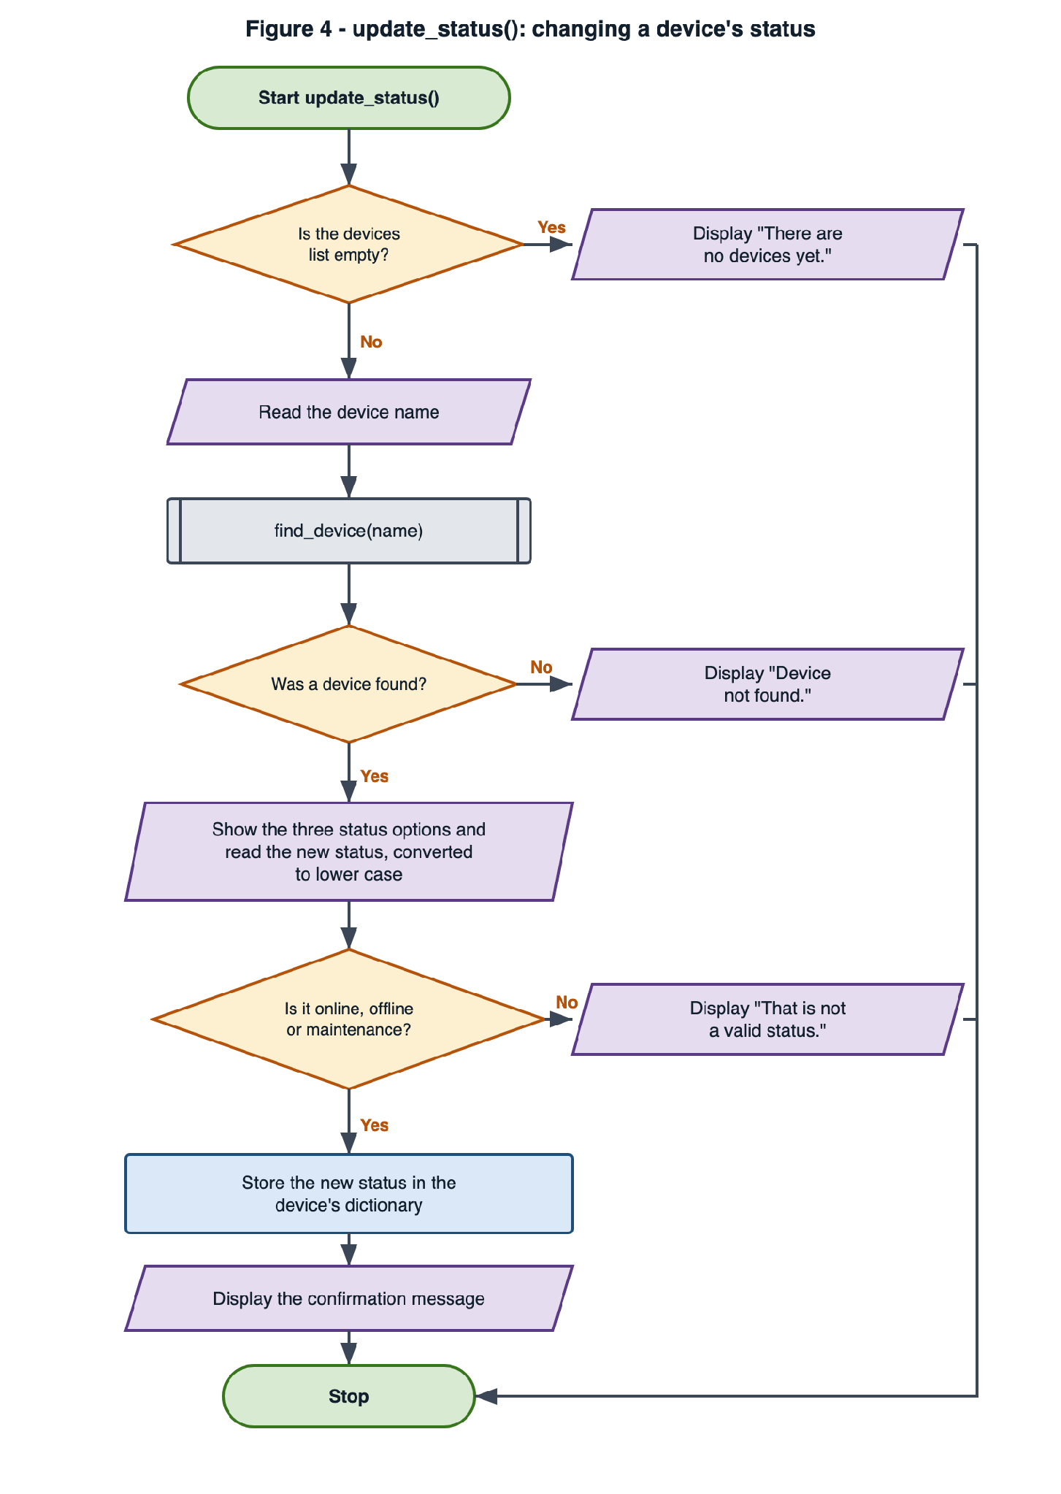
Figure 4 – update_status(): changing a device's status.

Figure 5 charts the listing routine, the only place a loop is used purely for output.
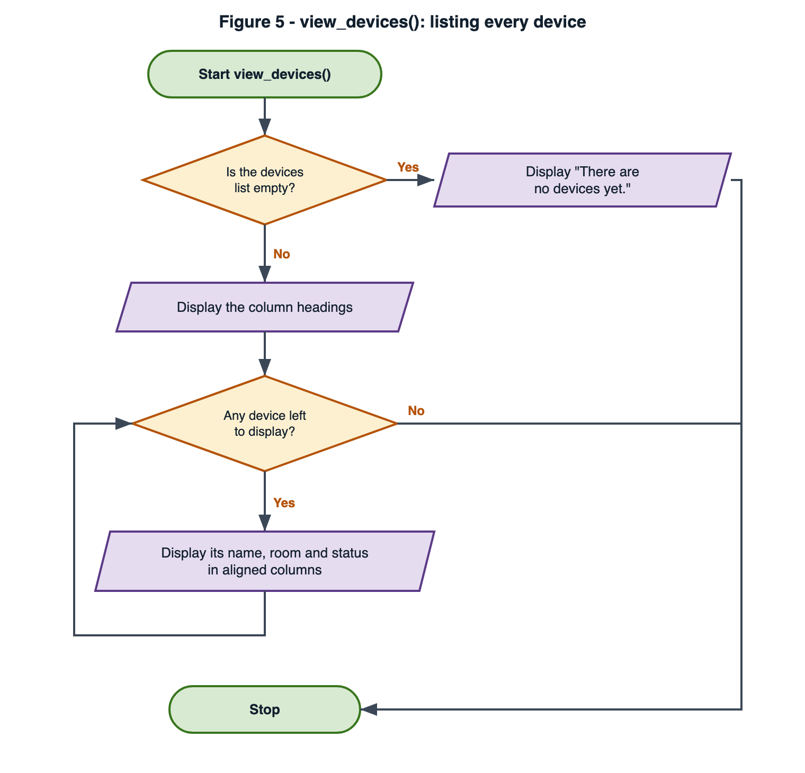
Figure 5 – view_devices(): listing every device.

Figure 6 charts the single-device search. It is the shortest routine in the program because the difficult part - finding the device - is delegated to find_device().
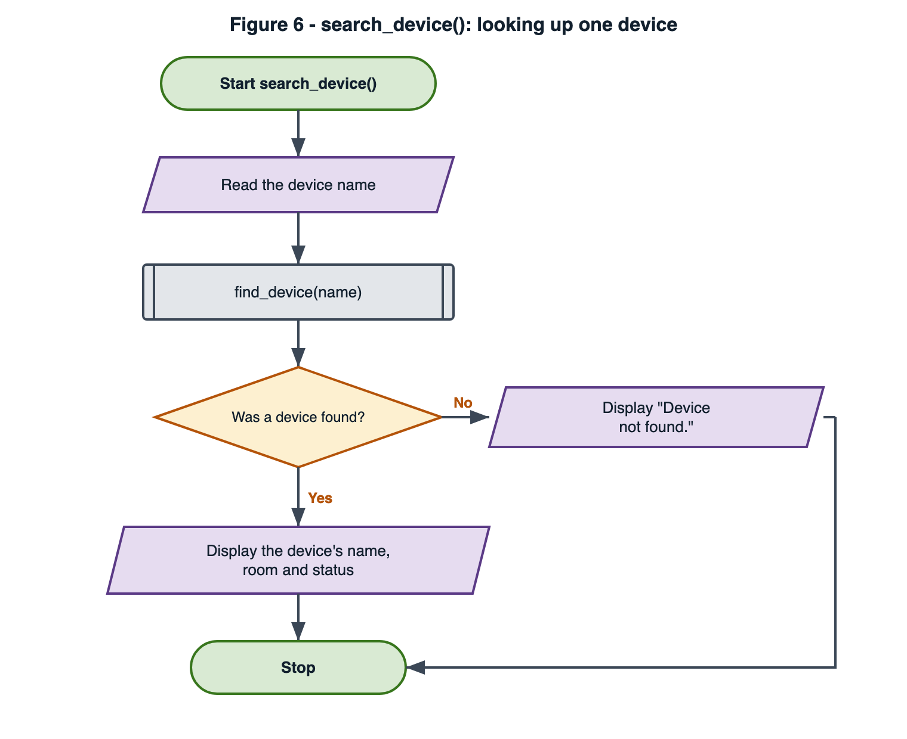
Figure 6 – search_device(): looking up one device.

2.1.2 Pseudocode
Pseudocode for each core routine is given below. It was written before the Python code, so the logic could be checked independently of the language.
Main controller
BEGIN main
DISPLAY "Welcome to the Smart Home Device Manager"
WHILE TRUE
DISPLAY the five menu options
READ choice
IF choice = "1" THEN
CALL add_device
ELSE IF choice = "2" THEN
CALL update_status
ELSE IF choice = "3" THEN
CALL view_devices
ELSE IF choice = "4" THEN
CALL search_device
ELSE IF choice = "5" THEN
DISPLAY "Goodbye!"
EXIT WHILE
ELSE
DISPLAY "Please enter a number between 1 and 5."
END IF
END WHILE
END main

Shared lookup
BEGIN find_device (name)
FOR EACH device IN devices
IF LOWERCASE(device.name) = LOWERCASE(name) THEN
RETURN device
END IF
END FOR
RETURN None
END find_device

Add a device
BEGIN add_device
READ name
REMOVE surrounding spaces FROM name
IF name IS EMPTY THEN
DISPLAY "Device name cannot be empty."
RETURN
END IF
IF find_device(name) IS NOT None THEN
DISPLAY "A device with that name already exists."
RETURN
END IF
READ room
REMOVE surrounding spaces FROM room
IF room IS EMPTY THEN
DISPLAY "Room cannot be empty."
RETURN
END IF
SET device TO a record holding name, room, status = "offline"
APPEND device TO devices
DISPLAY name + " was added to " + room + " (status: offline)."
END add_device

Update a status
BEGIN update_status
IF devices IS EMPTY THEN
DISPLAY "There are no devices yet."
RETURN
END IF
READ name
SET device TO find_device(name)
IF device IS None THEN
DISPLAY "Device not found."
RETURN
END IF
DISPLAY "Status options: online / offline / maintenance"
READ new_status
CONVERT new_status TO lower case
IF new_status IS NOT IN ("online", "offline", "maintenance") THEN
DISPLAY "That is not a valid status."
RETURN
END IF
SET device.status TO new_status
DISPLAY device.name + " is now " + new_status + "."
END update_status

View all devices
BEGIN view_devices
IF devices IS EMPTY THEN
DISPLAY "There are no devices yet."
RETURN
END IF
DISPLAY the column headings and a separator line
FOR EACH device IN devices
DISPLAY device.name padded to 20 characters,
device.room padded to 15 characters,
device.status
END FOR
END view_devices

Search for a device
BEGIN search_device
READ name
SET device TO find_device(name)
IF device IS None THEN
DISPLAY "Device not found."
ELSE
DISPLAY "Name: " + device.name
DISPLAY "Room: " + device.room
DISPLAY "Status: " + device.status
END IF
END search_device

2.2 Implementation Decisions

2.2.1 Data Structures
The register is a list of dictionaries. Each dictionary is one device record with three keys - for example {"name": "Smart Light A1", "room": "Room 3", "status": "online"} - and the list holds them in the order staff added them, which is the order the listing should display. A dictionary labels each field by name, so device["room"] states its own meaning, whereas a tuple or parallel-list design would rely on remembering that position 1 happens to be the room, a common source of logic errors [2].
A single dictionary keyed by device name was considered and rejected. It would make lookups instant and duplicates impossible, but keys would have to be normalised to lower case to keep matching case-insensitive, so the capitalisation the user typed would need storing separately anyway. At a few dozen devices the speed difference is not measurable, so the simpler structure was the better choice; Section 4.2 revisits this if the register grows. A second structure supports validation: VALID_STATUSES holds the three permitted status words in one place, so the rule is displayed and checked from the same source.

2.2.2 Variables Used
Variable | Type | Scope | Purpose
devices | list of dict | Module-level | The register itself; the single source of truth.
VALID_STATUSES | list of str | Module constant | The only three statuses accepted. Capitals signal it must not change at run time.
device | dict | Local / loop | One device record; the loop variable in find_device() and view_devices().
name | str | Local | The device name typed by the user, trimmed of surrounding spaces.
room | str | Local | The room typed by the user, trimmed.
new_status | str | Local | The replacement status, trimmed and lower-cased before validation.
choice | str | Local | The menu selection, kept as text - which is what stops non-numeric input crashing the program.

2.2.3 Programming Constructs
- Functions. Each menu option has its own function, plus the shared lookup - the decomposition of Section 1.3 expressed in code, so each routine can be read and tested alone.
- An indefinite loop (while True). The menu repeats an unknown number of times, so a condition-controlled loop is correct where a counted loop is not; break gives option 5 a single explicit exit.
- A definite loop (for each). find_device() and view_devices() visit every device exactly once, so a for loop over the list fits and removes any manual index handling.
- if / elif / else. The menu dispatch is a chain of mutually exclusive cases with a catch-all else, so every possible input is answered - including ones nobody anticipated.
- Guard clauses with early return. Each validation failure prints a message and returns at once rather than nesting the remaining work, keeping the successful path at one level of indentation.
- The membership operator. new_status not in VALID_STATUSES states the whole status rule in one line that needs no editing if a fourth status is added.
- String methods. strip() removes stray spaces, lower() makes name and status matching case-insensitive, and ljust() pads the listing columns.
The absence of try / except is deliberate. Exceptions are prevented rather than caught: input() always returns a string [1], and because the menu choice is compared as text (choice == "1") rather than converted with int(), there is no conversion that could raise ValueError when a user types “abc”. That is why TC-13 passes with no exception handling at all. The one input the program cannot survive is Ctrl+D, discussed in Section 3.5.

2.2.4 Python Modules and Libraries
No modules are imported and no third-party libraries are used, because everything needed is a Python built-in.
Built-in | Where | Why it is sufficient
input() | Every prompt | Reads a line and always returns a string - the type the validation works with [1].
print() | All output | Concatenation is enough for the short confirmation messages.
len() | Empty-list guards | len(devices) == 0 states the empty-register test plainly.
str.strip()`, `str.lower()`, `str.ljust() | Validation and listing | Trimming, case-insensitive comparison and column padding are standard string operations [1].

Avoiding imports keeps the program dependency-free: it runs anywhere Python 3 is installed, with nothing to download. The json module would be the natural first import if saving the register were added.

2.3 Source Code
The complete program is reproduced below as text so it can be copied and run directly, and is identical to the version in the repository linked on the title page. Line numbers appear in the annotation table that follows rather than in the listing, so the listing stays copy-and-paste ready.
File: device_manager.py
# Smart Home Device Manager for Bright Minds Academy
# Stores devices in a list of dictionaries (no database needed)

# each device looks like: {"name": "Smart Light A1", "room": "Room 3", "status": "online"}
devices = []

VALID_STATUSES = ["online", "offline", "maintenance"]

def find_device(name):
# returns the device dictionary if it exists, otherwise None
for device in devices:
if device["name"].lower() == name.lower():
return device
return None

def add_device():
name = input("Enter device name: ").strip()
if name == "":
print("Device name cannot be empty.")
return

if find_device(name) is not None:
print("A device with that name already exists.")
return

room = input("Enter the room it is located in: ").strip()
if room == "":
print("Room cannot be empty.")
return

device = {"name": name, "room": room, "status": "offline"}
devices.append(device)
print(name + " was added to " + room + " (status: offline).")

def update_status():
if len(devices) == 0:
print("There are no devices yet.")
return

name = input("Enter the device name to update: ").strip()
device = find_device(name)
if device is None:
print("Device not found.")
return

print("Status options: online / offline / maintenance")
new_status = input("Enter the new status: ").strip().lower()
if new_status not in VALID_STATUSES:
print("That is not a valid status.")
return

device["status"] = new_status
print(device["name"] + " is now " + new_status + ".")

def view_devices():
if len(devices) == 0:
print("There are no devices yet.")
return

print("\nName Room Status")
print("-" * 45)
for device in devices:
print(device["name"].ljust(20), device["room"].ljust(15), device["status"])
print()

def search_device():
name = input("Enter the device name to search for: ").strip()
device = find_device(name)
if device is None:
print("Device not found.")
else:
print("Name: " + device["name"])
print("Room: " + device["room"])
print("Status: " + device["status"])

def main():
print("Welcome to the Smart Home Device Manager")

while True:
print("\n----- MENU -----")
print("1. Add a new device")
print("2. Update device status")
print("3. View all devices")
print("4. Search for a device")
print("5. Exit")

choice = input("Enter your choice (1-5): ").strip()

if choice == "1":
add_device()
elif choice == "2":
update_status()
elif choice == "3":
view_devices()
elif choice == "4":
search_device()
elif choice == "5":
print("Goodbye!")
break
else:
print("Please enter a number between 1 and 5.")

main()

Annotated walkthrough
Lines | What the code does | Why it is written this way
1–4 | Header comments naming the program and the shape of a device record. | States the data structure before any logic.
5 | devices = [] creates the empty register. | One module-level list is the only place device data lives.
7 | VALID_STATUSES lists the three permitted statuses. | Defined once, so the rule cannot drift from the message shown.
10–15 | find_device() scans the list, returning the match or None. | Both sides are lowered, which is what makes “smart light a1” match “Smart Light A1”.
19–22 | Reads the name, rejecting it if blank after strip(). | First guard: no empty records enter the register (FR2).
24–26 | Rejects a name find_device() already finds. | Second guard: unique names without a separate matching rule (FR3).
28–31 | Reads the room, rejecting a blank one. | Third guard. The room is only asked for once the name is valid.
33–35 | Builds the dictionary with status "offline" and appends it. | Every device starts in a known state (FR4), in insertion order.
39–41 | Refuses to run when the register is empty. | Avoids prompting for a name that could not match anything.
43–47 | Reads a name and looks it up. | Reuses find_device() rather than repeating the loop.
49–53 | Shows the options, rejecting anything outside VALID_STATUSES. | strip().lower() on line 50 lets “ONLINE” through; line 51 is the whole rule (FR5).
55–56 | Writes the new status and confirms it. | find_device() returned the dictionary itself, not a copy, so the register updates directly.
59–68 | Prints headings, a rule, then one padded row per device. | ljust() aligns the columns (FR6). The fixed widths cause defect D1 in Section 3.5.
71–79 | search_device() looks up a device and prints its three fields. | The second consumer of find_device(), so search and update always agree (FR7).
82–107 | main() prints the menu in a while True loop and dispatches on the choice. | Comparing choice as text makes TC-13 safe; else catches every unexpected input (FR8).
110 | main() is called to start the program. | Section 3.5 notes why guarding this call would be preferable.

3. Testing and Debugging Report

3.1 The Importance of Programme Testing
Running a program once with sensible input proves only that one path through it works. Testing matters for three reasons. Cost: a defect found while coding is trivial to fix, while the same defect found in use is expensive and damages confidence in the data [4] - and for this centre a register staff do not trust is worse than none. Evidence: documented cases with expected and actual results show which requirements have actually been demonstrated. Regression: the same cases can be re-run after any change. Testing shows the presence of defects, never their absence [8], so the cases below cover valid input, invalid input and the boundaries between them.

3.2 Types of Error in Programming
Type | What happens | Example here | How it is found and fixed
Syntax | The code breaks the rules of the language, so nothing runs. | Writing if name == "" print(...) on line 20, with no colon. | Python reports SyntaxError with the line and a caret before execution. Fix the punctuation at that line.
Runtime (exception) | The syntax is legal but an operation fails mid-run, stopping with a traceback. | int(choice) would raise ValueError the moment a user typed “abc”. | Read the traceback upwards: the last line names the exception. Fixed here by prevention - the choice is compared as text, so the conversion never exists.
Logic | The program runs and reports nothing, but the result is wrong. The most dangerous kind. | Without lower() in find_device(), “smart light a1” would silently report “Device not found” and duplicates could slip in. | Only testing exposes it - TC-04 and TC-11 exist for this. Fixed by tracing values through the comparison until the faulty assumption shows.

3.3 Test Cases
Fifteen cases were designed before evidence was captured, covering every functional requirement with both valid and invalid input, plus three boundaries: an empty register, an empty string, and a name longer than the column reserved for it.
ID | What is tested | Input | Expected | Actual | Result | Fig.
TC-01 | Add a valid device (FR1, FR4) | 1, Smart Light A1, Room 3 | Stored, status offline | “…added to Room 3 (status: offline).” | Pass | 7
TC-02 | Blank name (FR2) | 1, Enter | Rejected, nothing stored | “Device name cannot be empty.” | Pass | 8
TC-03 | Blank room (FR2) | 1, Thermostat C1, Enter | Rejected, nothing stored | “Room cannot be empty.” | Pass | 8
TC-04 | Duplicate name, different capitals (FR3) | 1, smart light a1 | Rejected as duplicate | “A device with that name already exists.” | Pass | 9
TC-05 | View a populated register (FR6) | 3 | Aligned columns | Two devices listed correctly | Pass | 7
TC-06 | View an empty register (boundary) | 3 | A message, not empty headings | “There are no devices yet.” | Pass | 10
TC-07 | Valid status typed in capitals (FR5) | 2, smart light a1, ONLINE | Accepted, stored lower case | “…is now online.”; listing confirms | Pass | 11
TC-08 | Word that is not a status (FR5) | 2, Projector B2, sleeping | Rejected, old status kept | “That is not a valid status.” | Pass | 12
TC-09 | Update a device that does not exist (FR5) | 2, Ghost Device | Rejected | “Device not found.” | Pass | 12
TC-10 | Update with an empty register (boundary) | 2 | A message, no name prompt | “There are no devices yet.” | Pass | 10
TC-11 | Search lower case for a mixed-case device (FR7) | 4, projector b2 | Found; details shown | Name, Room and Status printed | Pass | 13
TC-12 | Search for an unknown device (FR7) | 4, Unknown Device | A message, no crash | “Device not found.” | Pass | 14
TC-13 | Invalid menu choices (FR8) | abc, 0, 9, Enter | Each rejected, menu redisplays | “Please enter a number between 1 and 5.” ×4 | Pass | 15
TC-14 | Exit (FR8) | 5 | Farewell and a clean end | “Goodbye!”, program ends | Pass | 15
TC-15 | Name longer than the 20-character column (boundary) | 1, Interactive Whiteboard Projector D4, Science Lab | Listing stays aligned | Long name pushes Room and Status out of line | Fail | 16

Fourteen of fifteen passed. The failure, TC-15, is a genuine defect and is analysed in Section 3.5 rather than presented as acceptable.

3.4 Test Evidence
Each screenshot is a terminal capture of the program running with the inputs listed above. The exact keystrokes for every session are in Appendix B, so any result can be reproduced.
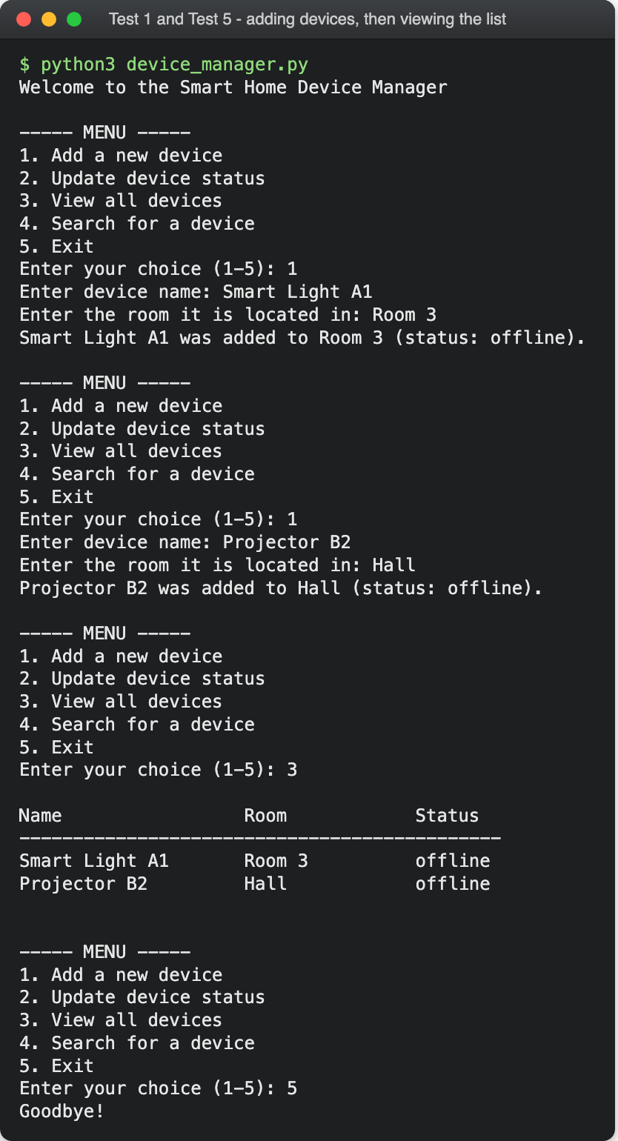
Figure 7 – TC-01 and TC-05.
Two devices are added, each confirmed with the default status offline (FR1, FR4). Option 3 lists them under aligned headings, in the order they were added (FR6).

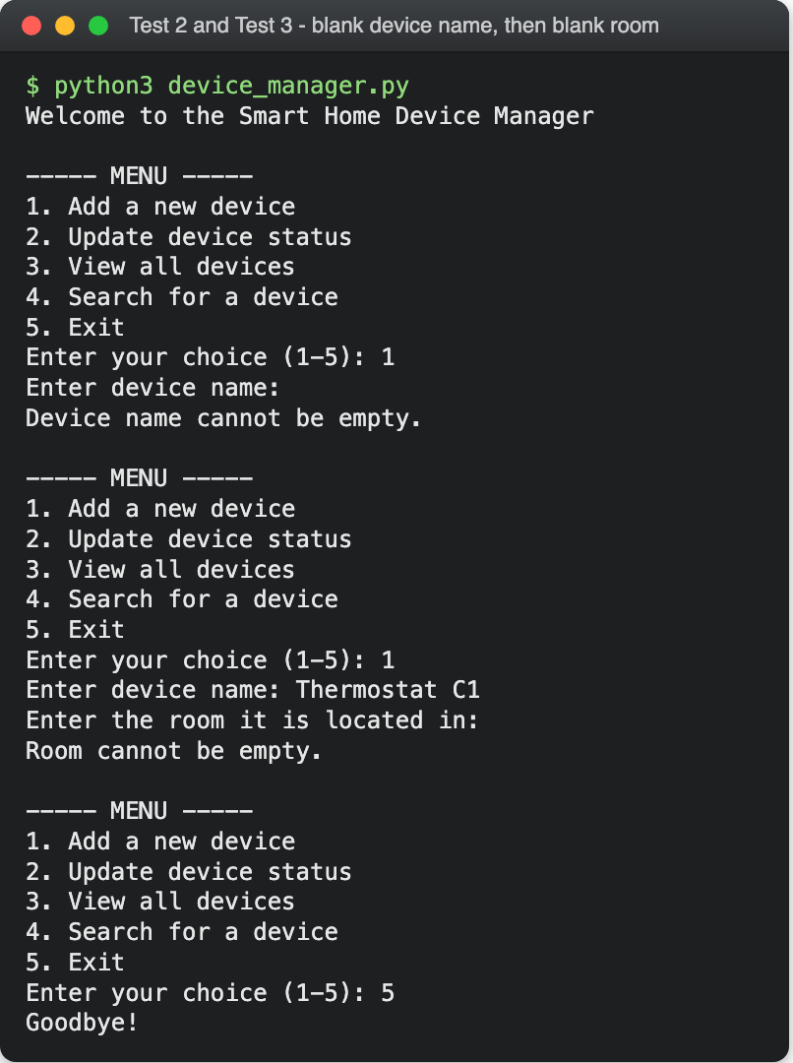
Figure 8 – TC-02 and TC-03.
A blank name and then a blank room are each rejected and the program returns to the menu. Neither failure leaves a partial record: nothing is appended until every check passes.

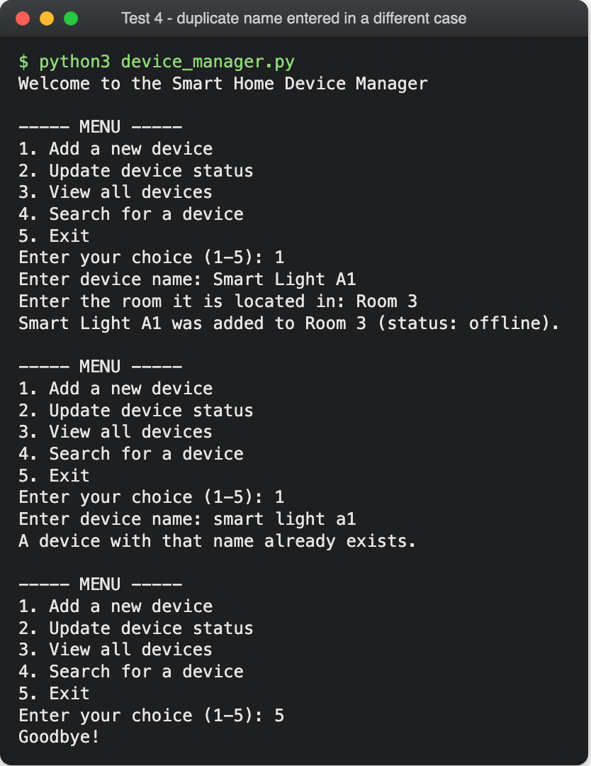
Figure 9 – TC-04.
“smart light a1” is refused as a duplicate of “Smart Light A1”, confirming the lower() comparison in find_device(). Without it the register would hold the same device twice under two spellings.

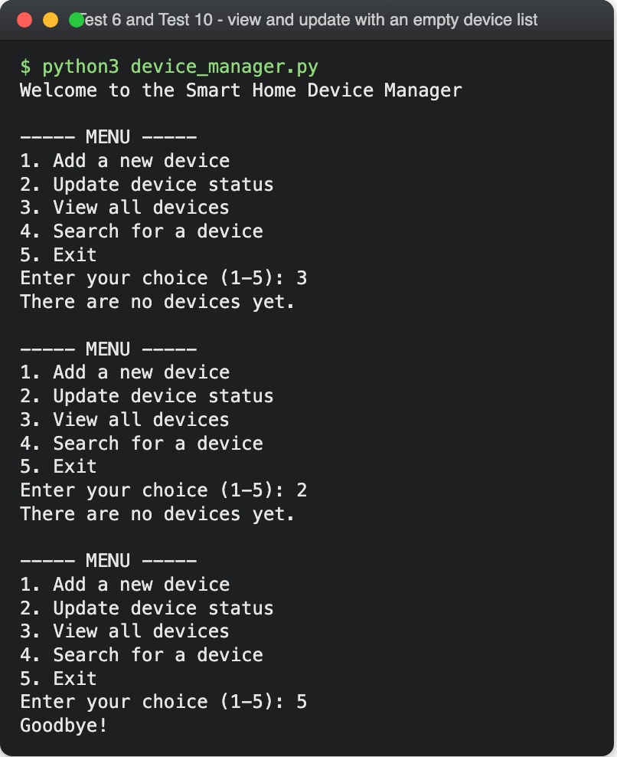
Figure 10 – TC-06 and TC-10.
Both boundary cases on an empty register. Viewing prints a message rather than bare headings, and updating stops instead of asking for a name that could not match.

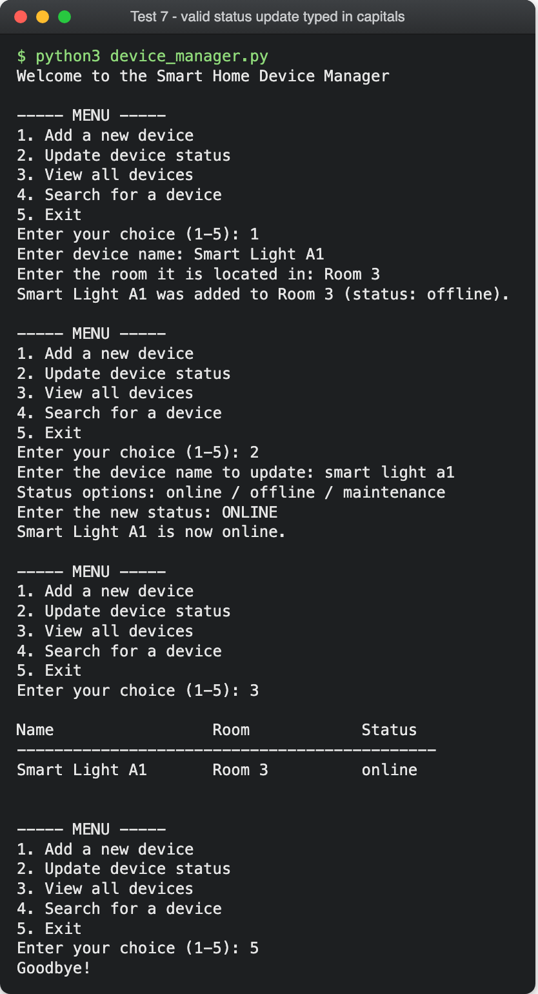
Figure 11 – TC-07.
The device is found using lower case and the status is typed as “ONLINE”; both are accepted and the status is stored lower case. Option 3 confirms the stored value rather than trusting the confirmation message.

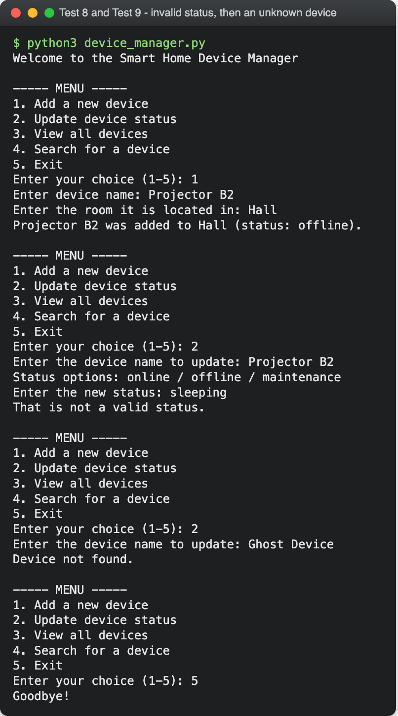
Figure 12 – TC-08 and TC-09.
“sleeping” is rejected as it is not in VALID_STATUSES, and an unknown device name is rejected too. Both failures leave the register untouched.

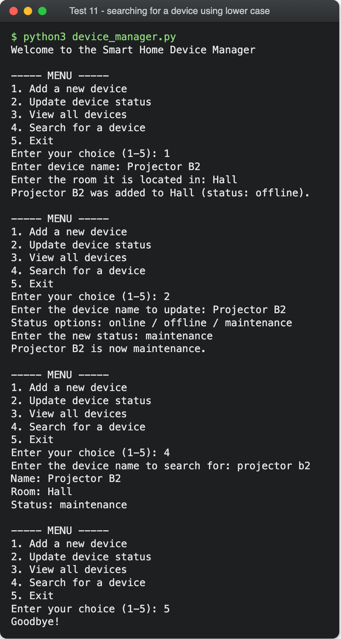
Figure 13 – TC-11.
Searching for “projector b2” returns the record stored as “Projector B2” and reports its current status, not the one it was created with - confirming update_status() wrote to the stored dictionary, not a copy.

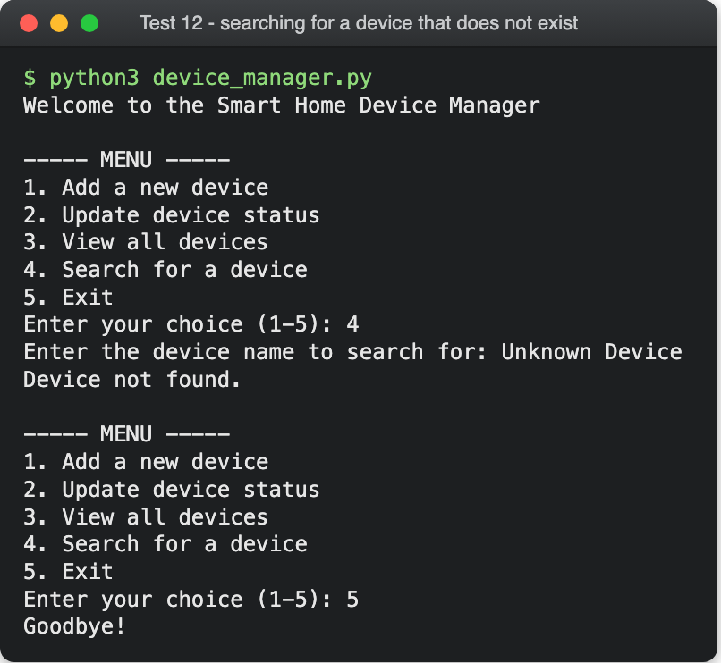
Figure 14 – TC-12.
Searching for a device that does not exist gives a plain message and returns to the menu. Run against an empty register, the harshest version of the test.

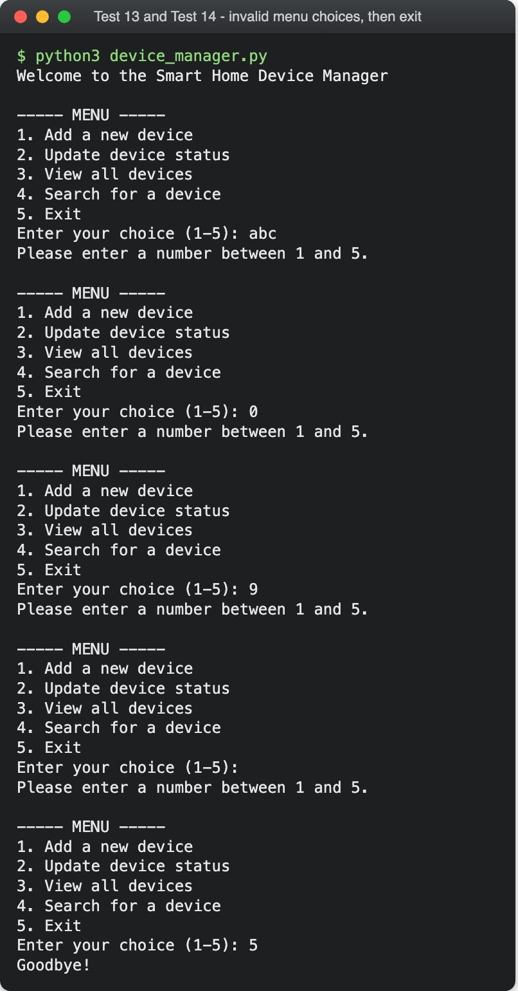
Figure 15 – TC-13 and TC-14.
Letters, a number below range, one above, and an empty line are all rejected without an exception - the practical proof of comparing the choice as text rather than converting it. Option 5 then ends the program cleanly.

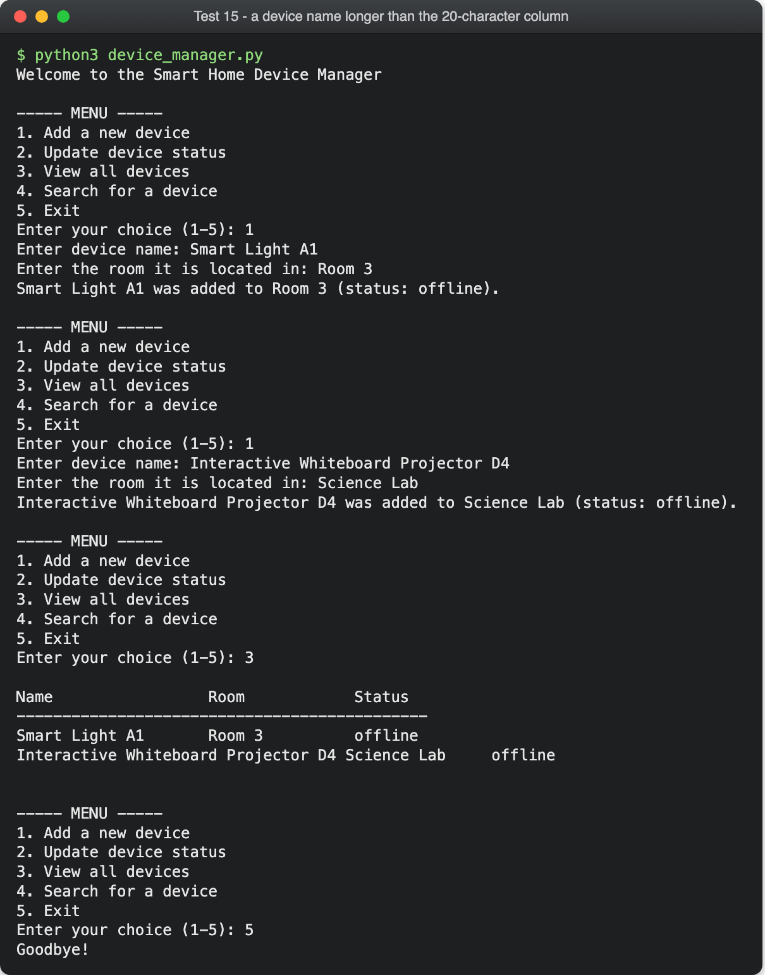
Figure 16 – TC-15 (the failing case).
A 35-character name overflows the 20-character column and pushes Room and Status out of line. The data is stored correctly, so this is a presentation defect - but it is a real failure against FR6, recorded as D1 below.

3.5 Debugging: Defects and Limitations Found
Testing produced one outright failure, and code inspection alongside the results produced several limitations. All are listed with an honest severity.
ID | Finding | Found by | Severity | Proposed fix
D1 | view_devices() pads the name to 20 characters and the room to 15, so longer values break the alignment. | TC-15 - a failing test | Low; cosmetic, data is correct | Measure the longest name and room first, so the table adapts to its contents.
D2 | The register is in memory only, so all data is lost on exit. | Observed across the test sessions | Medium; accepted, as the brief requires no database | Save to a JSON file on exit and reload on start-up.
D3 | search_device() has no empty-register guard, unlike the other two routines. | Code inspection | Very low; output is still correct | Add the same len(devices) == 0 guard for consistency.
D4 | main() is called at the end of the file, not from an if __name__ == "__main__" guard. | Code inspection | Low; blocks importing the module, so it cannot be unit tested | Wrap the call in the standard guard [3].
D5 | Ctrl+D at a prompt ends input and raises EOFError. | Exploratory testing | Low; not reachable by normal typing | Catch EOFError around input() and treat it as an exit.
D6 | Room names are free text, so “Room 3” and “room3” count as different rooms. | Requirements review | Low; acceptable while the pilot is small | Offer a list of known rooms once the set is fixed.

D1 is the only finding that caused a test to fail. It was left in place so the reported result matches the code in the linked repository; the fix is the first item in Section 4.2.

4. Evaluation

4.1 Challenges Faced
Choosing the data structure was the first challenge. A dictionary keyed by device name is tempting because lookups become instant, and it took some working through to see why it would complicate this program: keys would need normalising for case-insensitive matching, so the user's capitalisation would have to be stored separately anyway.
Keeping the validation readable was the second. An early draft of add_device() nested each check inside the last, pushing the line that stores the device three levels deep. Guard clauses - check, report, return - kept the successful path flat and made Figure 3 almost a direct translation of the code.
The third was making the program impossible to crash from the keyboard. Converting the choice with int() and catching ValueError is the obvious route, but comparing it as text removes the failure instead of handling it. The fourth was accepting a failing test: TC-15 was written expecting a pass, and reporting it was more useful than a clean sheet of results.

4.2 Future Improvements
- Adapt the column widths. Fix D1 by measuring the longest name and room before printing. The first change worth making.
- Save the register between sessions. Write the list to a JSON file on exit and read it back on start-up, removing D2. This is what would make the tool usable day to day.
- Record when a device was last used. The scenario raises this, but it is absent from the four required features. A last_used key stamped with the datetime module on each status change would close the gap.
- Add delete and rename. Devices get retired and relabelled; without these the only way to correct a mistyped name is to restart the program.
- Filter and sort the listing. Show one room, or only devices under maintenance - quickly more useful than the full list.
- Index the register. A dictionary keyed on the lower-cased name alongside the list. Unnecessary now, but it would matter at hundreds of devices.
- Add automated unit tests. Fixing D4 would allow the module to be imported, so find_device() and the validation rules could be tested with unittest. The fifteen cases in Section 3.3 are the specification for those tests.

4.3 Self-Reflection
The clearest lesson was that most of the value comes before the code is written. Once the problem was decomposed into six routines and drawn as flowcharts, the Python was close to mechanical; where I skipped the design, the logic came out tangled and had to be untangled anyway. Writing pseudocode first also made it obvious that the same lookup was needed twice, which is how find_device() came to exist rather than the same loop being written into two functions.
I also changed how I think about validation. I used to treat it as something added at the end to stop crashes; here it became clear that it protects the meaning of the data. Rejecting a blank name is not about avoiding an error message; it is about ensuring the register never holds a record nobody can identify.
Finally, testing became a source of information rather than a formality. Fourteen passing cases told me less than the one that failed. TC-15 was a boundary I only wrote because I was working systematically through valid and invalid input, and it found a real defect in code I had assumed was finished.

References
- Python Software Foundation, “Built-in Functions - Python 3 Documentation.” [Online]. Available: https://docs.python.org/3/library/functions.html [Accessed: Aug. 10, 2026].
- Python Software Foundation, “Data Structures - The Python Tutorial.” [Online]. Available: https://docs.python.org/3/tutorial/datastructures.html [Accessed: Aug. 10, 2026].
- G. van Rossum, B. Warsaw, and A. Coghlan, “PEP 8 – Style Guide for Python Code,” Python Enhancement Proposals, 2001. [Online]. Available: https://peps.python.org/pep-0008/ [Accessed: Aug. 10, 2026].
- I. Sommerville, Software Engineering, 10th ed. Harlow, U.K.: Pearson Education, 2016.
- R. S. Pressman and B. R. Maxim, Software Engineering: A Practitioner's Approach, 9th ed. New York, NY, USA: McGraw-Hill Education, 2020.
- ISO/IEC/IEEE 29119-1:2022, Software and Systems Engineering - Software Testing - Part 1: General Concepts, International Organization for Standardization, Geneva, Switzerland, 2022.
- ISO 5807:1985, Information Processing - Documentation Symbols and Conventions for Data, Program and System Flowcharts, Program Network Charts and System Resources Charts, International Organization for Standardization, Geneva, Switzerland, 1985.
- G. J. Myers, C. Sandler, and T. Badgett, The Art of Software Testing, 3rd ed. Hoboken, NJ, USA: John Wiley & Sons, 2011.

Appendices

Appendix A – How to Run the Program
The program needs Python 3 and nothing else. Download device_manager.py from the repository linked on the title page, open a terminal in the folder containing it, and run:
python3 device_manager.py

Choose an option by typing its number and pressing Enter; option 5 ends the program. Because the register is held in memory (D2), each run starts empty.

Appendix B – Inputs Used for Each Test Session
Every screenshot in Section 3.4 can be reproduced by entering the values below in order. “(blank)” means pressing Enter without typing anything.
Figure | Test cases | Values entered, in order
Figure 7 | TC-01, TC-05 | 1 / Smart Light A1 / Room 3 / 1 / Projector B2 / Hall / 3 / 5
Figure 8 | TC-02, TC-03 | 1 / (blank) / 1 / Thermostat C1 / (blank) / 5
Figure 9 | TC-04 | 1 / Smart Light A1 / Room 3 / 1 / smart light a1 / 5
Figure 10 | TC-06, TC-10 | 3 / 2 / 5
Figure 11 | TC-07 | 1 / Smart Light A1 / Room 3 / 2 / smart light a1 / ONLINE / 3 / 5
Figure 12 | TC-08, TC-09 | 1 / Projector B2 / Hall / 2 / Projector B2 / sleeping / 2 / Ghost Device / 5
Figure 13 | TC-11 | 1 / Projector B2 / Hall / 2 / Projector B2 / maintenance / 4 / projector b2 / 5
Figure 14 | TC-12 | 4 / Unknown Device / 5
Figure 15 | TC-13, TC-14 | abc / 0 / 9 / (blank) / 5
Figure 16 | TC-15 | 1 / Smart Light A1 / Room 3 / 1 / Interactive Whiteboard Projector D4 / Science Lab / 3 / 5

