Target 1 | To follow Harvard Referencing Guidance and not to become too reliant on the text.
Target 2 | To become more critical in your writing, to support your choices/judgements with supportive and counter arguments throughout your response.

Demonstrate how cross-curricular teaching and learning can influence in-depth skills and understanding. Underpin this with reference to relevant research, a detailed lesson plan and an enhanced provision material.

Throughout the new curriculum for Wales, it is evident that the curriculum had developed miraculously to better children’s learning outcomes. Cross-curricular teaching is the use of a variety of academic subjects during each lesson (Welsh Government, 2022). The framework includes literacy, numeracy and digital competence which are crucial skills within the curriculum for Wales (Welsh Government, 2022). Within the new curriculum for Wales, the cross-curricular framework has become a main focus because it is an innovative style of teaching that strives for students to learn through creative ways of interconnected topics (Barnes, 2015). When applying cross-curricular approaches to teaching and learning, it comes with many opportunities and challenges. (Sphero, 2023) Children can find numerous subjects challenging and boring which can often create a dislike to certain subjects. Using a cross-curricular approach to learning can frequently enhance the children’s motivation to learn by building connections through subjects they may enjoy and the subjects the children dislike. Cross-curricular teaching enhances the engagement for the children by interlinking subjects they love with other subjects to intensify their passion for all subjects (Sphero, 2023). This will encourage the children to progress their learning through every subject to their best ability. Cross-curricular education can also be a challenge because without the correct observation and reflection could negatively impact the children’s learning outcomes (Welsh Government, Unknown). Throughout my bridging experience, cross-curricular activities were introduced throughout the day in most lessons. It was evident to see that children’s engagement and understanding would increase if the lesson was linked to a subject that they highly enjoyed. Whereas, in the lessons that children found more challenging and were uninterested in, the children were easily distracted and would not complete the task. Within my bridging experience, it was also evident that budget was a key problem when teaching cross-circularly. The teacher planned a lesson that included plastic clocks for the children to use to understand new works that included half past, quarter past and quarter too. However, the class that used the clocks previously had broken 6 of the hands. There were then not enough clocks for the class to use and the school also did not have enough budget to replace the clocks. This then affected the lesson the teacher had planned.

The cross-curricular responsibilities include literacy, numeracy, and digital competence. To allow successful outcomes for children’s learning, there are a number of necessary skills (Welsh Government, 2022). On January 28th, 2020, the Literacy and Numeracy Framework

and Digital Competence were introduced with the new Curriculum for Wales Framework. It is required by all teachers to establish how the children progress in each skill. However, this will differ depending on the approach each school takes to cross-curricular teaching and learning (Welsh Government, 2022). There is a framework put in place for each skill including Literacy and Numeracy Framework (LNF) and Digital Competence Framework (DCF) to guide schools when advancing the skills to teaching across the 6 areas of learning (Welsh Government, 2022). The Literacy and Numeracy Framework and Digital Competence Framework are separated into two sections which are English and Welsh Mediums. Within the LNF and DCF, there are various areas which all have 5 progression steps (Welsh Government, 2022). Progression steps allow the educator to understand the progression of each child that links to the What Matters Statements. These steps are at the ages of 5, 8, 11, and 14 (Welsh Government, 2022). The progression steps 1-3, ages 5, 8 and 11 are essential to primary school teaching because they allow the teacher to have an understanding of where the child is, where they need to be and how they get there. Using LNF and DCF in a primary school setting will guide the children to be hitting their expected targets (Central South Consortium, 2023). The LNF and DCF are used consistently in primary school ages to ensure children are developing essential skills to be able to work at their best ability and use the skills in day-to-day life. Developing their digital competence skills it will allow children to become more creative within their work and become critical thinkers while engaging in the digital world (Equal Education Partners, 2024). The Cross-curricular approach to education combines serval subjects into one lesson by creating connections between each subject. There are numerous opportunities and challenges when taking this approach that can affect the learning outcomes of a child (Barnes, 2015). A benefit to cross-curricular teaching is that the approach encourages children to think critically by understanding the range of concepts and ideas that combine from each subject. Linking subjects that combine with one another can help children advance their knowledge by incorporating the knowledge they already know with new content (Barnes, 2015). Similarly, cross-curricular learning can promote a holistic approach to education by merging the subjects together to gain an understanding of the similarities between the concepts and ideas to develop a deeper understanding of the content of each subject (Chiangpradit, 2022). This could then allow the children to think critically when problem-solving. Contrastingly, taking the cross-curricular approach to education requires time for regular observations to ensure it is impacting the children positively and regular reflections (Welsh Government, Unknown). Without these two it may become complicated to understand whether cross-curricular learning is advancing the children’s knowledge rather than affecting their learning negatively (Welsh Government, Unknown). Additionally, it is apparent that two thirds of teachers in Wales and England are thinking about changing professions due to being overworked with workload (The Teachers’ Union, 2024). This can affect cross-curricular teaching in schools because of the lack of staff. However, (Welsh Government, 2023) emphasise that they have made progress in helping teachers with staff workload by performing regular assessments. Furthermore, when teachers are implementing cross-curricular activities.
into their lessons, it is important to ensure their own knowledge is as advanced as possible because during research in 2014, it was proven that teachers’ knowledge on a subject and their understanding have the biggest impact on how the children learn and what their learning outcomes are (Enser, 2014). During my bridging experience, the teacher was teaching a lesson about adding and subtracting big numbers. The lower ability group in the

class was easily distracted and was not engaging throughout the task. However, when the teacher introduced health and well-being into the lesson by taking a group at a time to go outside and use chalk to write the sum on the floor while being outside, it increased the engagement levels, and all of the children then completed the task.

The enhanced provision material I have created required the children to look at the different pictures and identify what animal belongs to each habitat. There is also an advanced activity sheet that is for children who finished the first worksheet and need another task. This task requires the children to label the name of each animal they see, along with tallying how many of each animal they see at the nature reserve. The lesson plan I have created is for children in year two going to the nature reserve. The area of learning the lesson focuses on is science and technology because the children are going to be learning about the different types of animals and their homes. The What Matters Statement that the lesson focuses on in science and technology is ‘The world around us is full of living things which depend on each other for survival’ (Welsh Government, 2022). This statement identifies that the centre of the task will be learning about living things, animals, and the environment they are learning in. Throughout my lesson plan I have ensured to include cross-curricular links across the curriculum. The lesson links to health and well-being because the children will be running around outside trying to find each animal and habitat which develops their physical development, and the children are also outdoors receiving fresh air. Another link is expressive arts because if the children are finding it difficult to identify the animal and the habitat, they could roleplay what sounds and movements the animal makes to jog their memory. There is also a link to mathematics because in the advanced activity, the children are required to count and tally how many of each animal they have spotted throughout the trip. Humanities is also linked within the lesson plan because the children are outside learning about the environment they live in and what materials make up their environment which is linked to geography. Languages, literacy, and communication are linked within the lesson because the children will be communicating with their team members to identify what animals they have seen, and their habitats and they are also learning how to pronounce the names of each animal. It is crucial to include cross-curricular links within the lesson because cross-curricular strategies encourage engagement from the children by linking subjects they find interesting with other subjects to advance their motivation for all subjects (Sphero, 2023). After the children have completed their tasks, I will mark the worksheets and use the progression steps within the Literacy and Numeracy Framework and the Digital Competence Framework to identify where the children are at, where they need to be and how they can get there.

Overall, throughout this assignment, it has significantly enhanced my knowledge about the cross-curricular framework and how it can be used in a primary school setting. The cross-curricular framework has proven to be beneficial when creating lesson plans. However, there are some challenges that affect it being carried out. These include budget, student engagement, staff numbers, the number of children in the class, old teacher style and the knowledge of each teacher. I will overcome this by creating solutions that work around each challenge. For example, teachers can recycle materials to overcome budget problems and regularly research about certain subjects and lessons to ensure my knowledge is always progressing. When completing my placement, I will ensure that I include cross-curricular

links within all my lessons because I believe it will have the best outcome for my students by increasing motivation and engagement for subjects they dislike. To ensure my teaching is to
my best ability I will relate to the Professional Standards of Teaching and Leadership because it will allow me to set expectations for each lesson, reflect on my teaching effectively, identify which areas of much teaching need to develop and to manage my progress (Welsh Government, 2020).

Reference list

Barnes, J. (2015) The Primary Curriculum. 2nd rev. edn. Unknown: Sage.

Central South Consortium (2023) Curriculum for Wales. [online] Available at: https://www.cscjes-cronfa.co.uk/api/storage/9ffbf024-20be-43f2-b168-213da1ebe3ac/27-11-2017English.pdf (Accessed: 4th April 2024).

Chiangpradit, L. (2022) The benefits of Cross-curricular. [online] Available at: https://stemsports.com/the-benefits-of-cross-curricular-instruction/ (Accessed: 5th April 2024).

Enser, M. (2014) Maintaining your subject knowledge. [online] Available at: https://my.chartered.college/early-career-hub/maintaining-your-subject-knowledge/#:~:text=In%20a%20review%20of%20research,of%20impact%20on%20student%20outcomes. (Accessed: 7th April 2024).

Equal Education Partners (2024). Curriculum for Wales: The Three Cross-curricular Skills. [online] Available at: https://equaleducationpartners.com/blog/curriculum-for-wales-the-three-cross-curricular-skills/ (Accessed: 4th April 2024).

Sphero (2023) Cross-Curricular Teaching: Helping Students Make Connections. [online] Available at: https://sphero.com/blogs/news/cross-curricular-teaching#:~:text=Cross%2Dcurricular%20teaching%20is%20an,a%20single%20course%20of%20teaching (Accessed: 4th April 2024).

The Teachers’ Union (2024) Tackling Excessive Teacher Workload. [online] Available at: https://www.nasuwt.org.uk/advice/conditions-of-service/workload/tackling-excessive-teacher-workload-england-wales.html#:~:text=Two%20thirds%20of%20teachers%20tell,of%20concerns%20about%20excessive%20workload. (Accessed: 6th April 2024).

Welsh Government (2022) Cross-curricular skills framework. [online] Available at: https://hwb.gov.wales/curriculum-for-wales/cross-curricular-skills-frameworks/ (Accessed: 4th April 2024).

Welsh Government (2023) Navigating the Curriculum Guidance. [video] Available at: https://www.youtube.com/watch?v=KvSvQpb0PM8 (Accessed: 4th April 2024).

Welsh Government (Unknown) Observing Children. [online] Available at: https://hwb.gov.wales/api/storage/74f7c7cc-d337-4fd0-9604-27b3d1a5746d/observing-children.pdf (Accessed: 5th April 2024).

Welsh Government (2020) Professional standards. [online] Available at: https://hwb.gov.wales/professional-learning/identifying-professional-learning-needs/professional-standards (Accessed: 7th April 2024)

Welsh Government (2022) Science and Technology. [online] Available at: https://hwb.gov.wales/curriculum-for-wales/science-and-technology/statements-of-what-matters (Accessed: 7th April 2024).

Welsh Government (2023) Update – reducing workload and bureaucracy for school staff. [online] Available at: https://www.gov.wales/written-statement-update-reducing-workload-and-bureaucracy-school-staff (Accessed: 5th April 2024).

Appendix

Enhanced provision material

Nature hunt!

In groups of 5, work as a team to find what habitats belong to what animals. Be careful and do not touch! Take photos of the animals and habitats you are able to find.

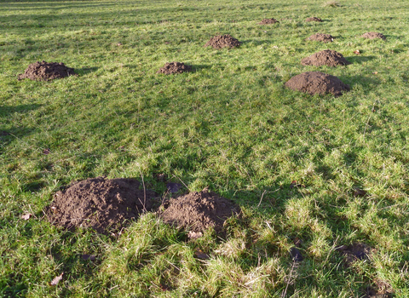 | 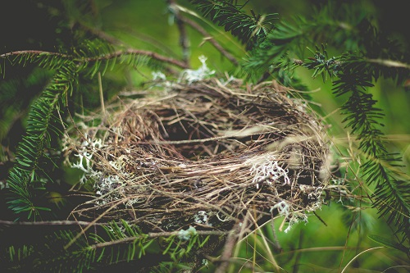 | 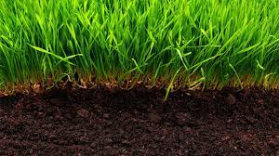
What animal lives in this habitat: | What animal lives in this habitat: | What animal lives in this habitat:
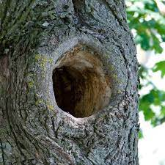 |  | 
What animal lives in this habitat: | What animal lives in this habitat: | What animal lives in this habitat:
 |  | 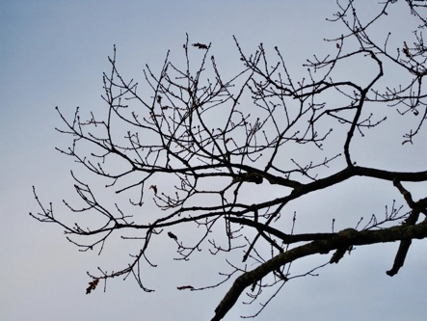
What animal lives in this habitat: | What animal lives in this habitat: | What animal lives in this habitat:

Advanced activity

After you have identified what animal belongs to each habitat, can you label the name of each animal and tally how many you have seen.

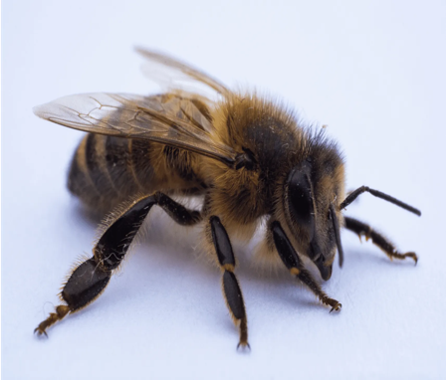 | 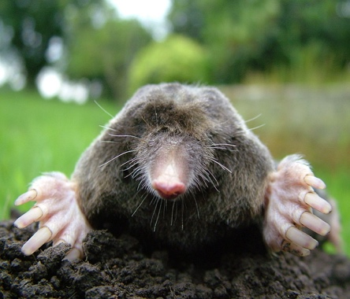 | 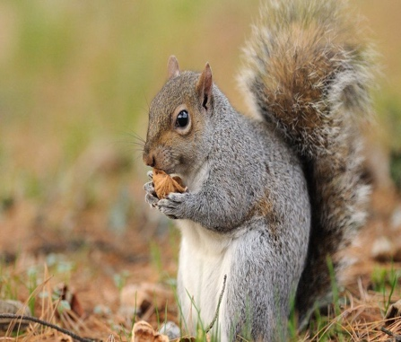
What is the name of this animal: | What is the name of this animal: | What is the name of this animal:
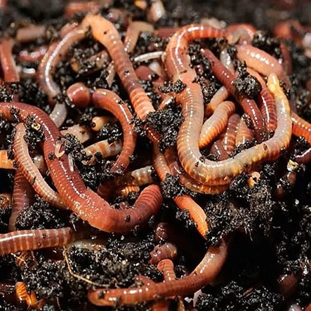 | 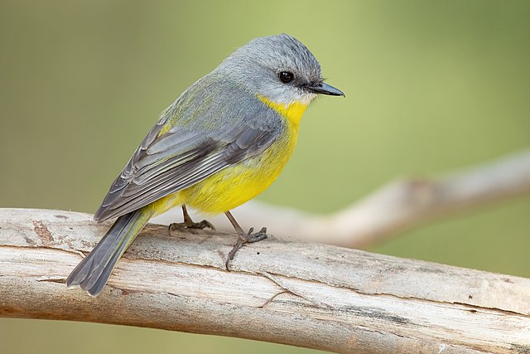 | 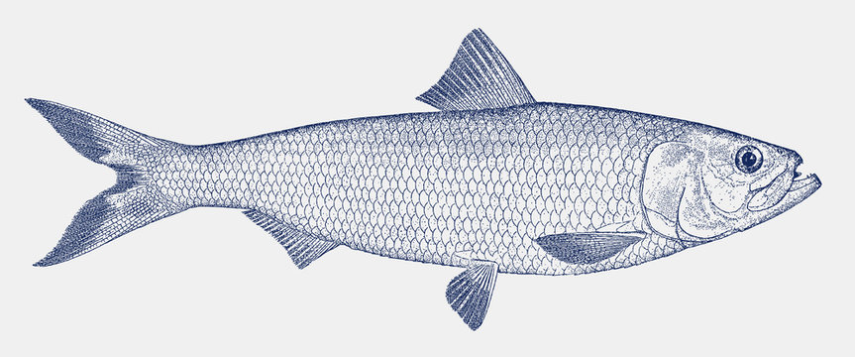
What is the name of this animal: | What is the name of this animal: | What is the name of this animal:
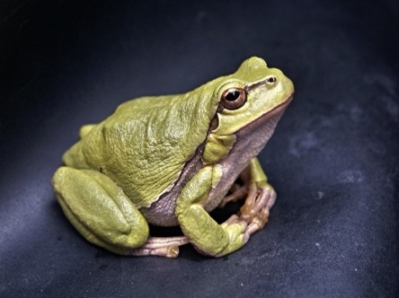 | 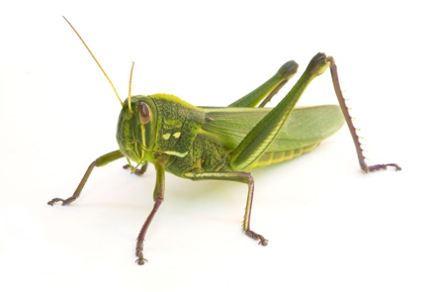 | 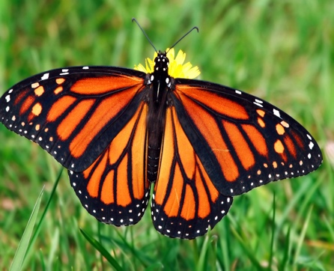
What is the name of this animal: | What is the name of this animal: | What is the name of this animal:

Lesson plan
Student-teacher: | Stella Griffiths | Class / Group: | Year two
AoLE or Subject: | Science and technology. | Date (please note that this may be a continuous session): | May 4th April 2024
Meaningful links to Curriculum (What Matters Statements, Descriptions of learning, ‘previous’ curriculum...) | What Matters Statement- The world around us is full of living things which depend on each other for survival.
Meaningful links across the curriculum  Links to other AoLEs or the Cross-curricular skills frameworks) | Health and well-being – the children are outdoors in the fresh air, running around finding each habitat.  Expressive arts- the children can roleplay what sounds the animals make to identify the animal.  Mathematics- the children can count how many of the same animal they have seen and count how many they have left to find.  Humanities- geography, the children are learning about their environment and what animals live in their environment.  Language, literacy and communication- the child are required to work as a team to communicate and identify the animal and habitat, and they are learning to pronounce the names of each animals.
Personal Targets (targets and consequent impact on learning - refer to any targets that have been identified in learning journal or weekly reflection meeting and describe the desired impact on learning)

-To ensure my knowledge is the best it can be to help the children develop their understanding.
-To ensure the children have fun while developing their knowledge.
-To ensure I ask the children a lot of questions to think out of the box.
-To ensure the enhanced provision material is easy to use and effective.

Learning Intention
‘This should focus on the pupils’ learning during the lesson, rather than what they will be doing, and should be short, achievable and measurable.’ (Crichton, H., and Mcdaid, A. 2016 p. 196)
LI- To identify the animals and the different habitats for each animal.

Success Criteria
What the pupils need to demonstrate to successfully meet the Learning Intention.
-I can identify the different animals.
-I can name each animal.

-I can identify what habitats belong to each animal.
-I can identify what the habitats are made from.
Planning for misconceptions:
Use this section to anticipate pupil errors and misunderstandings and your planned responses to them.
-The children may not see all the habitats for all the animals on the worksheet. They could take a photo of the animal and the look the habitat up online when they get back to the classroom. Organise another trip to the nature reserve.
-The children may not see all the animals on the worksheet. They could take a photo of the habitat and the look the animal up online when they get back to the classroom. Organise another trip to the nature reserve.
-The weather may not be appropriate. Warn the children/parents in advance to bring waterproofs and wellies on the day of the trip.
-The habitats may have been destroyed by other members of the public. Talk to the children and see if they know what materials the animal would need to rebuild their home to help identify what animals’ habitat it is.



