

Applied Leadership and Management in the Workplace
Module Assignment Submission
Student Name: | Jeraldine Derrick
Student Number: | 2525457
Module No: | BMSK4013
Module Title: | Management Communication

Statement of Confirmation of Authenticity
By the act of making this submission, the student declares that this is the work of the student named above. The work has not, in whole or in part, been knowingly presented elsewhere for assessment, or where assessment has been built on a previous assessment, this has been identified. Where materials have been used from other sources it has been properly acknowledged. If this statement is untrue, the student acknowledges that an assessment offence has been committed.
Attention is drawn to the plagiarism and unfair practice policies of both the University and of ILM.

Table of contents
Contents
Table of contents 2
1. Introduction 3
2. Communication 3
2.1 The Basic Communication Cycle 4
2.2 (Shannon & Weaver, 1949) 5
2.3 (Berlo’s SMCR, 1960) 6
2.4 (Schramm,1954) 7
2.5 Conclusion of models 8
2.6 Barriers to communication 9
2.7 Methods of Communication 10
2.8 Tone, Language and Formality 10
3. Conflict 13
4. Motivation 14
4.1 Intrinsic and Extrinsic 14
4.2 (Maslow,1943) 14
4.4 (McGregor, 1960) 15
4.5 (McClelland, 1961) 15
4.6 Applying Theories to my workplace 16
5. Colleague and Self-evaluation of Communication 17
6. GAP analysis. 18
7. PDP 18
8. Conclusion 19
Appendix A – Communication Feedback Form 20
Appendix B – PDP 20
References 22

1. Introduction
Effective communication and motivation are central to high-quality practice in health and social care, particularly in environments supporting individuals with complex needs and Acquired Brain Injury (ABI). Communication in management is not simply the exchange of information but a transactional process in which meaning is co-constructed through interaction, feedback and shared understanding. Using communication models helps explain how messages are encoded, transmitted and interpreted, and why misunderstandings occur in busy, emotionally demanding settings. Motivation is equally important, as staff performance, teamwork and consistency of care are shaped by both individual needs and organisational conditions. First, this report evaluates key communication models, examines tone, language and formality in management communication, and assesses the effectiveness of verbal, written and digital communication methods within my workplace. Then it will analyse theories of motivation and apply them to my role supporting a child with ABI. Finally, the report evaluates my own communication skills using feedback and theory, identifies development needs and presents a SMART Personal Development Plan to strengthen my practice as a support worker and effective team leader.

2. Communication
Communication within the workplace is essential and is important to recognise that it operates as a transactional process, where meaning is created jointly rather than passed in a simple one-way flow. This is relevant in my role supporting a child with an Acquired Brain Injury (ABI) and leading a care team, where communication with staff and MDT professionals is continuous and shaped by shared understanding. Effective communication also contributes to improved staff performance and organisational outcomes, as clear, consistent information supports confidence, accuracy and teamwork (Bates, 2018).

2.1 The Basic Communication Cycle
Figure 1 - Basic Communication Cycle diagram
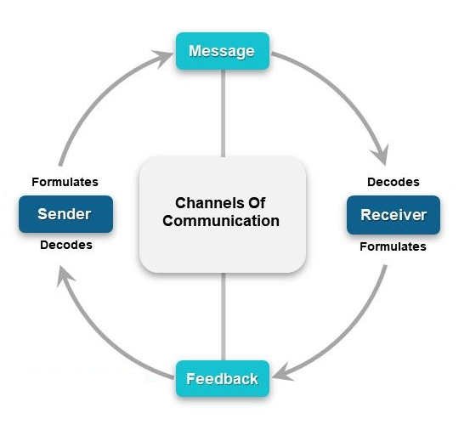
The Basic Communication Cycle helps explain how messages are created, shared and understood. Encoding involves the sender selecting words, tone and format to express their intended meaning, while the channel refers to the medium used, such as verbal handovers, written notes, or digital messages. The receiver is the person who receives the information, while decoding is the process of interpreting it based on their knowledge, experience and context. Feedback completes the cycle by confirming whether the message has been understood as intended. Communication failures often occur when decoding does not match the sender’s meaning, making feedback essential. In my role supporting individuals with ABI the cycle is visible during handovers and MDT meetings, where clarifying questions ensure shared understanding. Although the model can oversimplify real interactions, structured prompts and written summaries can strengthen accuracy and safeguarding.

2.2 (Shannon & Weaver, 1949)

Figure 2 - Shannon and Weaver’s (1949) linear model of communication.
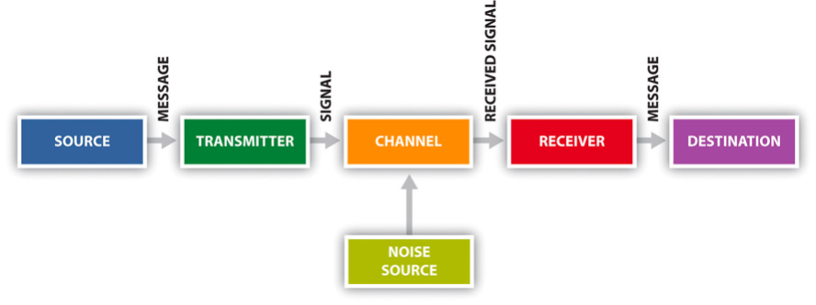
Shannon and Weaver (1949) linear model enhances understanding of workplace communication by emphasising the impact of noise, which refers to any factor that distorts or interferes with a message. Noise can be physical, like background sounds or environmental distractions, psychological which may be viewed as stress, fatigue. Noise can also be viewed as the use of unclear language, jargon, or unfamiliar terminology. In my workplace where time pressures, emotional demands and busy routines frequently disrupt communication. Within care with an ABI client, physical noise is common during morning routines, making it harder for staff to hear or process essential information about medication or risk behaviours. Semantic noise often arises in MDT meetings when solicitors or therapists use professional jargon that support workers may not fully understand. Psychological noise is evident during rushed handovers caused by staffing pressures, where reduced concentration increases the likelihood of errors. Although the Shannon and Weaver model is effective for identifying these barriers, its linear structure overlooks feedback and relational dynamics, limiting its usefulness in collaborative care settings. To improve the barriers, holding handovers in quieter spaces, using plain-English summaries in MDT discussions and promoting active listening, can reduce noise, improve clarity and enhance workplace performance by supporting accuracy, reducing risk and preventing conflict.

2.3 (Berlo’s SMCR, 1960)
Figure 3 Berlo’s (1960) SMCR model.
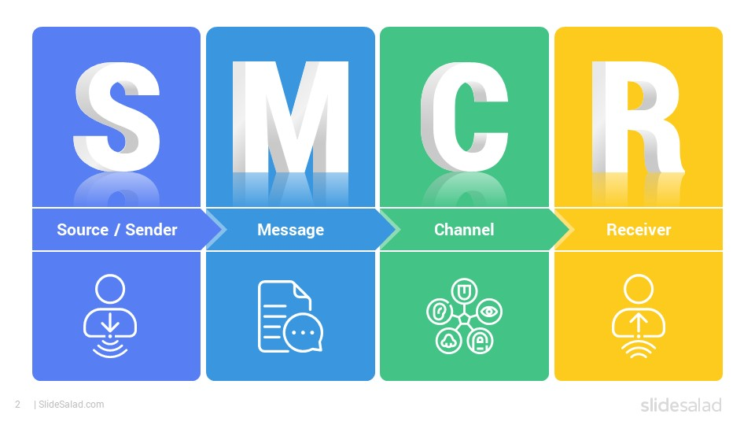
Berlo’s SMCR model (Source, Message, Channel, Receiver) offers a more detailed understanding of communication by emphasising how individual characteristics influence both the sending and interpretation of information. The Source is the person initiating the communication whose skills, attitudes, knowledge and background shape how effectively they encode the message. The Message refers to the content being communicated, including its structure, clarity and emotional tone. The Channel is the medium used for example, spoken handovers, written reports or digital communication, which affects how easily the message can be processed. The Receiver is the person interpreting the information and their experience, training and background influence how they decode it. Berlo (1960) argues that these personal factors heavily determine communication effectiveness, making the model particularly relevant in diverse care and MDT environments.
In my workplace differences in staff experience significantly affect interpretation. New support workers may struggle to understand risk assessments due to limited knowledge, while experienced staff decode them more accurately. In MDT meetings, SALT and OT practitioners often use clinical terminology, while solicitors focus on legal risk, leading to varied interpretations of the same message. Although SMCR helps explain these differences, there is a lack of feedback, limiting its practical application. Strategies such as training and tailored communication can reduce misinterpretation and strengthen collaboration. With clarity of communication, it may improve decision-making, reduces safeguarding risks and ensures that all professionals contribute effectively to care planning. It also enhances team cohesion, minimises conflict arising from misunderstanding and supports more consistent, person-centred approach to the client. It will then have a greater impact on improving alignment between sources and receivers, leading to safer, more coordinated care and better outcomes for the client.

2.4 (Schramm,1954)
Figure 4 - Schramm’s (1954) interactive communication model.
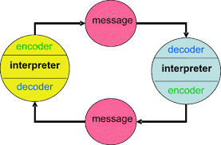
Schramm’s model of communication provides a more interactive and realistic explanation of workplace communication by emphasising shared meaning, continuous feedback and the importance of experience between communicators. Schramm (1954) suggests that communication is most effective when individuals share similar experiences, knowledge and contextual understanding, as this increases the likelihood that messages will be interpreted accurately. This is relevant in care and MDT settings, where communication is circular rather than linear and relies heavily on ongoing clarification. In my workplace, the idea of a shared field of experience is evident during MDT meetings, where occupational therapists, physiotherapists, speech and language therapists and solicitors contribute different forms of expertise. When these fields overlap, to ensure appropriate planning around risk management or rehabilitation, communication is smoother and decisions are reached more efficiently. However, when professional backgrounds differ significantly, misunderstandings can arise. Legal terminology used by solicitors may not align with the clinical language used by therapists and support workers may interpret information differently based on their hands-on experience with ABI clients.

2.5 Conclusion of models

When comparing the Communication Cycle, Shannon and Weaver, Berlo’s SMCR and Schramm’s models, it becomes clear that each contributes differently to understanding workplace communication.
The Communication Cycle provides the clearest explanation of feedback, making it highly relevant in my role where staff must confirm understanding during handovers and MDT discussions to prevent errors and ensure consistent support. Shannon and Weaver’s model is most effective for explaining barriers, as its concept of noise directly reflects the physical, psychological and semantic disruptions common when supporting a child with an ABI, for example, background activity, time pressure and professional jargon. Berlo’s SMCR model is particularly useful in MDT settings because it highlights how individual differences in knowledge, experience and attitudes shape interpretation, mirroring the varied professional backgrounds of solicitors, therapists and support workers. Schramm’s model adds value by emphasising shared meaning and fields of experience, which supports collaborative decision-making in MDT meetings but also exposes gaps when professionals do not share the same understanding.
However, Shannon and Weaver’s model is the most limited because it is overly linear and does not account for relational or emotional dynamics. Overall, the Communication Cycle and Schramm’s model have the greatest practical impact in my workplace because they reflect the interactive, feedback-driven nature of care communication.

2.6 Barriers to communication

Below is a table identifying barriers to communication within an ABI setting. It highlights the advantages, disadvantages and impact of care and performance. Additionally, there are recommendations on ways to improve.
Barrier | Example in my workplace | Advantages | Disadvantages | Impact on Communication & Care | Recommendations
Physical Noise | Busy morning routine.  Multiple conversations | Busy morning routine. Multiple conversations | Misheard instructions.  Increased stress | Missed updates.  Child may become overwhelmed | Use quieter handover spaces.  Reduce background noise.  Stagger tasks
Semantic Noise (Jargon / unclear language) | Staff using clinical terms unfamiliar to others | Useful with professionals | Confusion.  Incorrect strategies | Misinterpreted needs.  Inconsistent support.  Reduced confidence | Use plain English.  Provide glossary.  Offer ABI-specific training
Emotional Barriers | Staff stressed, tired, or overwhelmed | Can prompt reflection | Escalates conflict.  Lowers morale | Abrupt tone; reduced teamwork.  Child senses tension | Promote reflective practice.  Use PACE approach  Build supportive culture
Digital Barriers | Poor Wi-Fi  Incomplete online notes | Quick updates when working | Over-reliance.  Risk of missed info | Delayed updates.  Medication errors.  Inconsistent routines | Improve Wi-Fi.  Provide training.  Keep backup written notes
Non-verbal Misinterpretation | Misreading child’s fatigue or behaviour | Helps understand emotional state when accurate | Incorrect responses.  Inconsistent support | Child becomes distressed or overstimulated | Provide ABI behaviour training.  Use visual tools

2.7 Methods of Communication
The communication methods used in my workplace vary in effectiveness depending on the context and the level of detail required. Verbal handovers are highly effective for rapid decision-making and allow immediate clarification, but their reliance on memory means important details can be lost unless followed by written documentation. Written communication, including care plans and DCRs, is effective for accuracy, safeguarding and MDT coordination, although its time-consuming nature can reduce consistency when staff are under pressure. Digital systems such as EMAR improve efficiency and reduce medication errors, but technical failures can compromise reliability. Informal communication supports teamwork and quick problem-solving, yet its lack of structure increases the risk of missed information. A blended approach is therefore most effective, with verbal updates supported by written and digital records to ensure clarity, accountability and consistent care for the child.

2.8 Tone, Language and Formality

Tone, language and formality are central to effective communication in a care environment, as they shape how messages are interpreted and how confidently staff, families and professionals respond.
Tone refers to the emotional quality of communication and is especially important in ABI care, where children may experience cognitive fatigue, emotional dysregulation, or communication difficulties. A calm, collaborative tone encourages staff openness and reduces anxiety, while a reassuring and empathetic tone helps parents feel supported. A confident, factual tone with senior leaders and external professionals ensures information is taken seriously. However, an abrupt or stressed tone can create defensiveness, misunderstandings and reduced motivation, directly affecting the consistency of care.

Language choice also plays a crucial role. Using plain English with staff, families and young people avoids jargon and increases clarity, particularly when discussing routines, behavioural changes, or safety needs. Technical language is necessary when communicating with professionals or completing formal documentation, as it provides precision and supports accurate multidisciplinary decision-making. Adapting language to each audience ensures information is accessible and understood.

Formality further influences communication, incident reports, safeguarding documentation and professional emails provide accuracy, accountability and a clear record. Informal communication, including quick verbal updates or team chats, supports daily coordination. Balancing both ensures clarity, reduces errors and promotes safe, consistent care for a child with ABI.

Below is a table showing the models of communication used in care, outlining the advantages, limitations and impact of each method.

Communication Mode | Method Used | Advantages | Limitations | Impact
Verbal Communication | Shift handovers | Immediate.  Allows quick clarification | No written record unless documented | Essential for real-time decisions about the child’s fatigue, behaviour, and sensory needs; missed information risks inconsistent support
Written Communication | Care Plans | Permanent reference.  Supports consistency | Time-consuming to update | Ensures all staff follow the same strategies, risks, and therapeutic approaches
Written Communication | Daily Care Records (DCRs) | Prevents forgetting key details.  Supports safeguarding | Time-consuming.  Quality varies.  Can be misinterpreted | Supports MDT coordination and helps managers identify when plans or risks need updating
Digital Communication | Electronic Medication Administration  Record  (EMAR) | Fast, real-time medication updates | Technical issues (Wi-Fi/device failure) | Technical failures may delay medication information and increase risk of errors
Formal Communication | Supervisions | Dedicated time for structured check-ins | Formality may limit openness | Supports reflection, but staff may feel scrutinised and less willing to share concerns
Informal Communication | Team chats | Encourages teamwork and quick problem-solving | Information may not be recorded | Risk of important details being lost, which may affect the child’s safety

3. Conflict

Conflict in the workplace occurs when individuals experience incompatible goals, expectations, or interpretations of events. In care environments, conflict is common due to emotional demands, differing professional priorities and the need for consistent communication across multidisciplinary teams. While some conflict can encourage reflection, unmanaged conflict undermines performance, motivation and team cohesion.
Several factors contribute to conflict, role ambiguity is a major issue particularly when staff receive inconsistent instructions from MDT members or are unclear about expectations. This creates frustration and uncertainty, especially in ABI support, where routines and therapy plans must be followed precisely. Workload pressure also increases conflict, when staffing levels are low or routines are rushed, staff may become reactive or less patient. Differences in communication styles further contribute, particularly when staff vary in confidence or experience.
Poor communication can both trigger and intensify conflict. Shannon and Weaver’s (1949) concept of noise explains how meaning becomes distorted when messages are unclear. In my workplace, two staff members interpreted a SAL therapy instruction differently due to a rushed verbal handover, leading to disagreement about how to support the child. This shows how unclear encoding and decoding can damage trust and collaboration. Low motivation can worsen conflict by reducing emotional resilience, making staff more sensitive to criticism and less able to manage interpersonal challenges constructively.
Collaborative problem-solving provides a practical way to resolve conflict. This involves bringing staff together in a calm space, allowing each person to share their perspective, identifying the exact point of misunderstanding, agreeing on the correct procedure using the care plan or MDT guidance and confirming shared actions moving forward. Restorative communication can then repair relationships by acknowledging the emotional impact of the disagreement and agreeing on how to rebuild trust. This approach aligns with the Thomas–Kilmann Conflict Mode Instrument (1974), which focuses on joint problem-solving, shared ownership and mutually agreed solutions.
Both strategies strengthen teamwork by improving transparency, reducing defensiveness and restoring psychological safety. This leads to clearer communication, fewer mistakes and more consistent, coordinated support for the child.

4. Motivation

4.1 Intrinsic and Extrinsic
Motivation in the workplace can be understood through two key elements, intrinsic and extrinsic. Intrinsic motivation comes from internal satisfaction, for example feeling purposeful, developing skills, or taking pride in supporting a child with ABI. It is strengthened through methods of meaningful responsibilities and opportunities for learning. In contrast, extrinsic motivation is driven by external factors, including praise, recognition, supervision feedback and organisational expectations. Methods such as rewards, clear goals, and structured performance monitoring help reinforce this type of motivation. It is suggested both forms are essential in care settings, where intrinsic motivation encourages long-term commitment and emotional investment, while extrinsic motivation supports consistency, accountability and routine.
Managers can use these approaches by offering specific praise, involving staff in decision-making, providing training and setting clear expectations. When used effectively, motivation improves teamwork, reduces turnover, enhances staff confidence and leads to more consistent, high-quality care for a child with ABI.

4.2 (Maslow,1943)

Maslow’s Hierarchy of Needs explains motivation as a progression through five levels of human needs, from basic physiological and safety needs to higher-level psychological needs such as belonging, esteem and self-actualisation. This theory provides a useful starting point for understanding how staff engagement is influenced by the fulfilment of both basic and higher-order needs (Maslow, 1943). In my workplace, safety needs, predictable rotas, adequate staffing and clear behaviour-support protocols form the foundation for staff motivation. When these needs are unmet, anxiety and emotional fatigue increase, reducing the capacity for effective communication. As staff progress through belonging and esteem needs, team cohesion, recognition and trust become key drivers of motivation. However, Maslow’s linear hierarchy does not fully account for the emotional labour inherent in ABI support work, where staff may experience high stress even when lower-level needs are met .
4.3 (Herzberg, 1959)
Herzberg’s Two-Factor Theory explains that motivation is influenced by two separate sets of factors, hygiene factors, which prevent dissatisfaction and motivators, which actively increase job satisfaction and performance. The theory offers a more complex explanation of staff satisfaction. Hygiene factors, including rota stability, staffing levels and organisational communication prevent dissatisfaction but do not actively motivate staff (Herzberg, 1959). In contrast, motivators like recognition and opportunities to contribute to MDT discussions enhance job satisfaction and performance. This is relevant in ABI care, where meaningful work and professional trust strongly influence morale. Herzberg’s model has limitations, it underestimates the emotional intensity of care work and the impact of trauma exposure, which can disintegrate motivation even when motivators are present.

4.4 (McGregor, 1960)

According to McGregor, managers operate from two contrasting assumptions, Theory X sees employees as unmotivated and requiring control, while Theory Y views them as self-driven and thriving with autonomy. McGregor’s Theory X and Theory Y show how managerial assumptions shape staff behaviour (McGregor, 1960). In my team, a predominantly Theory Y approach based on trust and collaborative problem-solving, supports staff confidence and encourages reflective communication. However, during safeguarding incidents or behavioural crises, a temporary shift towards Theory X becomes necessary to ensure safety and compliance. This demonstrates that leadership styles in care settings must be flexible rather than fixed, aligning with research showing that adaptive leadership improves performance in high-pressure environments.

4.5 (McClelland, 1961)
McClelland’s Three Needs Theory argues that individuals are motivated by varying levels of three core needs, achievement, affiliation and power, which influence their behaviour and preferred roles at work. The theory further explains individual differences in motivation. Many staff in ABI care exhibit a strong need for affiliation, valuing teamwork and emotional support, while others are driven by achievement, seeking opportunities to develop specialist skills, including SALT strategies or positive-behaviour-support techniques. A smaller number are motivated by power, often progressing into senior or team leading roles. While McClelland’s model captures these variations, it does not fully address systemic factors such as workload, burnout, or organisational culture, which significantly influence motivation in care settings. These theories provide a comprehensive framework for understanding motivation in ABI care, but each has limitations when applied to emotionally demanding environments.

4.6 Applying Theories to my workplace

Motivation in my workplace is strongly shaped by recognition, psychological safety and opportunities for development. When staff feel valued and supported, they tend to communicate more effectively, engage in reflective practice and maintain high standards of care. However, when recognition is limited or progression feels restricted, motivation drops and performance can suffer. Conflict also plays a role, especially when miscommunication during handovers, differences in experience or inconsistent interpretations of care plans create tension. Emotional strain after challenging incidents can further weaken team cohesion and communication quality, which reflects Herzberg’s view that unclear expectations and poor working conditions contribute to dissatisfaction.
Staffing shortages, rota instability and unclear documentation also influence motivation and communication. In ABI care, where clients rely heavily on consistent routines and predictable support, these pressures directly affect both staff performance and client outcomes. Maslow and McGregor explain how unmet needs and leadership styles shape these dynamics.
Herzberg’s Two-Factor Theory provides the clearest fit for understanding motivation in my team. Meeting hygiene factors for example, rota stability, adequate staffing and clear communication help prevent dissatisfaction, while motivators like recognition and involvement in MDT discussions actively support engagement. However, Herzberg does not fully account for the emotional intensity of ABI care, where burnout can occur even when motivators are present. Integrating McClelland’s emphasis on social connection offers a greater understanding of what drives performance in my team. Strengthening these areas would likely improve performance by reducing errors, supporting better teamwork and helping staff maintain consistency and quality in their practice.

5. Colleague and Self-evaluation of Communication

Effective communication in ABI care requires clarity, emotional regulation, active listening, accurate written documentation and the ability to adapt tone and language to different audiences, including families, MDT professionals and colleagues. These criteria were informed by communication theory, workplace policies and the core skills required for safe, consistent care.
Evaluating my communication using colleague feedback and self-assessment quizzes showed strengths across verbal, non-verbal and written communication. The feedback included both quantitative Likert-scale ratings and qualitative comments, providing a balanced and credible assessment. Quantitative results were consistently high with colleagues selecting Agree or Strongly Agree for verbal clarity, calm tone, active listening and professional communication, indicating reliability and consistency across contexts.
Qualitative comments highlighted strengths in empathy, de-escalation, clarity and reliability during challenging situations. Colleagues also noted that my open body language and appropriate eye contact supported rapport, reflecting Schramm’s emphasis on shared understanding and non-verbal cues.
Self-evaluation quizzes reinforced these findings, identifying that I am an assertive communicator reflected confidence, clarity, empathy and respect, this was echoed in colleague feedback. The quizzes also highlighted strengths in emotional regulation, active listening and maintaining professional boundaries, aligning with the Communication Cycle’s focus on tone, feedback and mutual understanding. Non-verbal communication, including posture and facial expression, emerged as a key strength contributing to trust and psychological safety within the team.
The data identified written communication scored slightly lower due to delays in completing documentation, indicating a need to improve efficiency rather than accuracy. Another area for improvement was checking understanding in group discussions, linking to Shannon and Weaver’s concept of noise, where meaning can be distorted unless clarity is actively confirmed. Colleagues also encouraged me to seek support earlier during complex situations, reflecting McClelland’s emphasis on affiliation and collaborative communication.
Overall, combining quantitative ratings, qualitative feedback and self-evaluation results suggests strengths and weaknesses of my communication skills and highlights clear, achievable development goals addressed in my PDP.

6. GAP analysis.
Below is a GAP analysis, which highlights three key areas for development based on colleague feedback and my own self-assessment.

Skill | Current Level | Gap Identified | Expected Level
Timeliness of written documentation | Accurate but sometimes delayed | Improve efficiency and confidence in written communication | Complete documentation promptly while maintaining accuracy
Checking understanding in groups | Strong one-to-one clarity | Confirm shared understanding more consistently in group settings | Ensure all team members interpret instructions consistently
Seeking support during complex situations | Calm and capable but tends to manage alone | Reach out earlier for support when needed | Use team support to maintain resilience and clarity

The first relates to written communication, particularly completing documentation more efficiently during busy shifts. Although the accuracy of my written work is strong, the timing can be improved. The second gap concerns checking understanding in group discussions, as feedback suggested that taking a little extra time to confirm shared meaning would strengthen clarity. The final gap involves seeking support more proactively during complex or emotionally demanding situations. Addressing these gaps will strengthen my overall communication and support more consistent teamwork.

7. PDP

The feedback collected from colleagues, combined with my self-evaluation, highlighted clear strengths in verbal clarity, emotional regulation and non-verbal communication, but also identified areas requiring development. The main areas for improvement include increasing the timeliness of written documentation, improving confidence when seeking clarification in group discussions and strengthening consistency when checking understanding during busy or complex situations. These development needs directly influence communication quality, team coordination and the child’s safety. To address these gaps, I have created a SMART Personal Development Plan focused on building efficiency in written communication, enhancing assertiveness in MDT settings and embedding structured communication habits into daily practice. This PDP provides a clear, achievable pathway for improving my effectiveness as a support worker and team leader.

8. Conclusion
Effective communication and motivation are essential for maintaining safe, consistent and high-quality practice in ABI care, and this report has demonstrated how both areas directly influence staff performance, teamwork and the child’s outcomes. Communication models such as the Communication Cycle, Shannon and Weaver, Berlo’s SMCR and Schramm highlight how messages are encoded, interpreted and affected by noise, shared experience and feedback. Assessing verbal, written and digital communication methods within my workplace shows the importance of selecting appropriate tone, language and formality to ensure clarity, accuracy and professional accountability.
Motivation theories further explain how staff engagement is shaped by organisational conditions, psychological needs and leadership approaches. Herzberg’s Two-Factor Theory provides the strongest fit for my workplace, but integrating ideas from Maslow, McGregor and McClelland offers a more complete understanding of how emotional labour, safety needs and social connection influence performance.
Evaluating my own communication skills using feedback and theory has enabled me to identify clear strengths and realistic development needs. The PDP provides a structured plan to improve documentation efficiency, strengthen group communication and seek support more proactively. Continued development in these areas will support my growth as a reflective practitioner and contribute to safer, more coordinated and person-centred care.

Appendix A – Communication Feedback Form

Communication Feedback – Fill in form
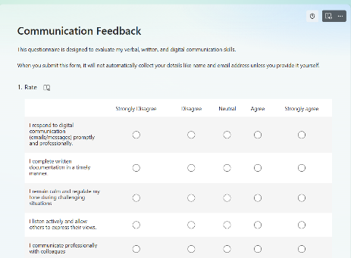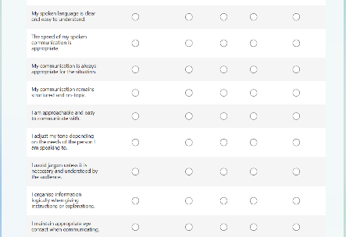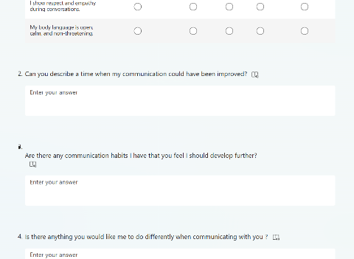

Appendix B – PDP

Goal | Actions | Indicators of Success | Timescale | Review
Within eight weeks, I will complete daily care records before the end of each shift on at least four out of five shifts, using a structured note template and requesting monthly feedback from my case manager. | Use structured templates  write notes during natural pauses  Verbal recordings | Documentation completed within expected timeframes.  Fewer delays noted by colleagues | 8 weeks | Monthly with case manager
Strengthen clarity in group communication.  Within six weeks, I will summarise key points and check understanding at the end of every group discussion I lead, evidenced by colleagues reporting clearer shared understanding in monthly supervision. | Check understanding at the end of discussions  Summarise key points  Ask clarifying questions | Colleagues report clearer shared understanding.  Fewer misinterpretations | 8 weeks | Monthly
Seek support earlier during complex or emotionally demanding situations.  Over the next 10 weeks, I will contact a senior or colleague for support during complex or emotionally demanding situations at least once per week, recording this in reflective notes reviewed monthly. | Contact senior staff or peers when unsure.  Debrief after incidents.  Use reflective practice | Increased use of team support.  Reduced stress.  Improved confidence | 10 weeks | Monthly
Build confidence in written communication.  Within 12 weeks, I will request feedback on two written records per month and review examples of high-quality documentation, aiming for improved confidence reported in supervision. | Practise writing DCRs.  Ask for feedback on written work.  Review examples of high-quality documentation | Increased confidence.  Fewer hesitations.  Positive feedback from colleagues | 12 weeks | Monthly

References

Bates, A. (2018). Effective communication in health and social care. Routledge.
Berlo, D. K. (1960). The process of communication. Holt, Rinehart and Winston.
Herzberg, F. (1959). The motivation to work (2nd ed.). John Wiley & Sons.
Maslow, A. H. (1943). A theory of human motivation. Psychological Review, 50(4), 370–396.
McClelland, D. C. (1961). The achieving society. Van Nostrand.
McGregor, D. (1960). The human side of enterprise. McGraw-Hill.
Schramm, W. (1954). How communication works. University of Illinois Press.
Shannon, C. E., & Weaver, W. (1949). The mathematical theory of communication. University of Illinois Press.
Thomas, K. W., & Kilmann, R. H. (1974). Thomas-Kilmann Conflict Mode Instrument [Assessment]. The Myers-Briggs Company. [1, 2]

