

Hotel Research Project.
To Brand or Not to Brand: Navigating the Hotel Franchise Dilemma.

Student Name: Anat Dranciuc Georgescu
Student Number: 2125394
Module: Hotel Placement Research Project
Module Code: BMIH6008
Lecturer: Dr Ernest Balutie Wavei
Word Count:

I acknowledge using Grammarly (https://www.grammarly.com/) on 20 May 2025 to check my work using the prompt(s): Please check the following text for readability, grammar, and syntax. I confirm that I have not presented any AI-generated text as my work. I confirm I have copies of my drafts, notes, and other resources I used before and after using AI tools, which I may be asked to provide as evidence.

Acknowledgement: I need to thank first of all to University Saint Trinity Davis, for allowing me to learn and study with them for these past three years, also to all the tutors I had and that had patience with me and thought me all I know today and last but not least I would like to thank my placement Hotels from year one and year three for the opportunity that they offered me to be part of their team even for a brief period and learn so much.

Abstract

The hospitality industry is shaped by branding, financial strategy, and guest experience innovations. As businesses navigate the complexities of franchising versus independent hotel operations, their ability to balance corporate-backed stability with personalised service flexibility becomes crucial in determining long-term success. This study explores these dynamics through a comparative analysis of Hilton Garden Inn Doncaster, a franchised model, and The Crown Hotel Bawtry, an independent luxury hotel, evaluating their pricing strategies, financial sustainability, and competitive positioning within the same regional market.
Franchised hotels such as Hilton benefit from structured financial security, standardised pricing frameworks, and brand-driven marketing initiatives. These attributes foster consumer trust and revenue predictability, ensuring a scalable and reliable business model. However, while this stability guarantees consistency, it inherently restricts local adaptability, limiting the ability to tailor services to evolving consumer expectations. In contrast, independent hotels thrive on customisation and direct guest engagement, crafting unique service experiences that resonate with niche markets. The Crown Hotel, operating outside corporate oversight, enjoys greater flexibility in pricing adjustments, responding dynamically to seasonal demand shifts and localised business opportunities. Despite these advantages, independent operators face heightened financial exposure, requiring diversified revenue streams to sustain long-term profitability.
The findings reveal that Hilton’s corporate-backed pricing mechanisms provide predictability across online travel platforms, ensuring stable revenue flow and brand integrity. Meanwhile, The Crown Hotel’s demand-sensitive pricing approach allows for competitive positioning in fluctuating markets, yet introduces challenges related to booking inconsistency and financial volatility. Guest experience analysis underscores Hilton’s standardised service, reinforcing global brand loyalty through uniform hospitality practices, while The Crown Hotel differentiates itself with high-touch, event-driven personalisation, establishing a niche within luxury hospitality. However, service inconsistencies and resource limitations remain critical factors affecting guest retention in independent hotels.
Based on these insights, several strategic recommendations have been developed to optimise operational models for both Hilton Garden Inn Doncaster and The Crown Hotel Bawtry. For Hilton, enhancing AI-driven personalisation, adopting micro-adjustments in pricing, and expanding tech-driven operational efficiencies can significantly improve guest engagement and market responsiveness. On the other hand, The Crown Hotel must focus on leveraging AI-powered service enhancements, strengthening partnerships with regional tourism networks, and diversifying revenue streams through high-value hospitality offerings.
Overall, this research reinforces the importance of adaptive business strategies, highlighting the need for financial resilience, service innovation, and evolving consumer engagement in the hospitality sector. Franchise-backed hotels should explore localised flexibility, while independent hotels must develop structured financial buffers to maintain market competitiveness. By integrating hybrid models, sustainability-driven initiatives, and AI optimisation, hotel operators can future-proof their strategies, ensuring both profitability and guest satisfaction in an increasingly brand-conscious industry.

Contents
Chapter 1 Introduction: 4
1.1 Overview of the Hospitality Industry 4
1.2 Franchising in Hospitality 5
1.2 Independent Hotel Operations: A Contrasting Model 5
1.3 Branding as a Strategic Competitive Advantage 6
1.4 Research Aim and Significance 6
Chapter 2 Literature Review: 7
2.1 Understanding Franchising as a Business Model 7
2.2 The Financial & Strategic Incentives Behind Franchising 8
2.3 Trust, Loyalty & Franchisee Satisfaction 9
2.4 SWOT Analysis: Hilton Garden Inn vs. The Crown Hotel Bawtry 11
2.5 PESTEL Analysis: External Influences on Hotel Strategies 13
2.6 Bowman’s Strategy Clock: Competitive Positioning in Hospitality 14
Final Reflections on Franchising as a Growth Model 15
Chapter 3: Methodology 16
3.1 Comparative Case Study Approach 16
3.2 Case Study Selection: Hilton Garden Inn Doncaster & The Crown Hotel Bawtry 16
3.3 Netnography & Digital Market Analysis 17
3.4 Theoretical Framework Integration 17
Application to Case Study Findings: 18
Chapter 4: Findings 18
4.1 Introduction 18
4.2 Pricing Analysis: Hilton vs. The Crown Hotel 19
Multi-Platform Rate Comparisons 19
Revenue Optimisation & Dynamic Pricing 22
4.3 Guest Experience Analysis: Hilton vs. The Crown Hotel 22
Review Ratings Overview 22
Guest Experience Themes 24

Financial Performance & Competitive Positioning 26
Market Analysis 27
Future Outlook 29
Final Summary of Findings 30
Discussions: 30
4.5 Critical Analysis of Key Findings 30
Pricing Strategies: Structured vs. Adaptive 30
Guest Satisfaction & Personalisation 31
Financial Sustainability: Franchise Support vs. Independent Risk 32
4.6 Implications for Hotel Operations 33
Hilton Garden Inn Doncaster (Franchised Model) 33
The Crown Hotel Bawtry (Independent Model) 33
4.7 Limitations & Future Considerations 33
Market Trends & Evolving Consumer Expectations 34
Financial Stability & Risk Mitigation 34
Changing Consumer Behaviour & Economic Pressures 34
Future Research Directions 34
Final Thoughts on Competitive Positioning 35
Chapter 5: Conclusion and Recommendations: 35
5.1 Summary of Key Findings 35
5.2 Financial Sustainability & Competitive Positioning 36
5.3 Guest Experience & Emerging Trends 36
5.4 Strategic Implications for Hotel Operators 36
5.5 Final Reflections 37
Recommendations & Practical Strategies 37
6.1 Strategic Recommendations for Hilton Garden Inn Doncaster 37
6.2 Strategic Recommendations for The Crown Hotel Bawtry 37
6.3 Industry-Wide Recommendations & Practical Strategies 38
Final Thoughts 39
References: 40

Chapter 1 Introduction:

Overview of the Hospitality Industry
The hospitality industry is an intensely competitive and rapidly evolving sector, where branding plays a crucial role in determining business success (The Brand Hopper, 2023). Hotel owners must navigate the strategic choice between operating independently or affiliating with a globally recognised franchise, balancing factors such as brand loyalty, financial stability, and market adaptability.
This research investigates the branding dynamics in hospitality through a comparative case study of two distinct hotel models within the same regional market:
- Hilton Garden Inn Doncaster—a franchise hotel leveraging corporate-backed resources (Hilton Garden Inn, 2025).
- The Crown Hotel Bawtry—an independent establishment that prioritises autonomy and personalised service (The Crown Hotel Bawtry, 2025).
The study explores whether franchising offers long-term competitive advantages or if an independent model provides superior adaptability in an increasingly brand-driven industry.

1.2 Franchising in Hospitality
Franchising has emerged as a dominant business model in the hotel sector, allowing companies to scale operations while mitigating financial risks. Under this structure, franchisees gain access to:
- Established brand recognition.
- Corporate marketing support
- Standardised service models
However, franchise agreements often come with substantial financial commitments, operational constraints, and an inherent dependency on corporate policies (Radiiplanetgroup.com, 2025).
The Hilton Garden Inn Doncaster exemplifies this model, benefiting from Hilton’s global presence, loyalty programs, and streamlined operational procedures. Yet, franchisees must adhere to strict branding and pricing guidelines, limiting their autonomy in decision-making (Doncaster Racecourse, 2018).

Independent Hotel Operations: A Contrasting Model
Unlike franchise hotels, independent establishments operate without external corporate oversight, allowing for:
- Greater strategic flexibility
- Tailored guest experiences
- Localised marketing initiatives
The Crown Hotel Bawtry, positioned as a luxury boutique hotel, takes full control of its branding, pricing strategies, and customer engagement. This independence enables customised service offerings, enhancing the hotel's differentiation within the regional hospitality market (Keyhole Creative, 2025).
However, independent hotels face challenges such as:
- Higher operational costs
- Limited brand recognition
- Lack of corporate marketing support
Despite these hurdles, independent hotels often leverage unique service innovations to maintain their competitive edge (Brandfetch, 2023).

Branding as a Strategic Competitive Advantage
Branding serves as a critical component of success in hospitality. Team TBH (2023) highlights Hilton’s branding strategy, which integrates:
- Loyalty-driven marketing campaigns
- Consistent service standards across locations
- Technology-driven guest experience improvements.
Franchised hotels, such as Hilton Garden Inn Doncaster, benefit from corporate-backed branding initiatives, reinforcing customer retention and global recognition. In contrast, independent hotels like The Crown Hotel Bawtry rely on localised branding efforts to carve out a niche within their market.

Research Aim and Significance
This study aims to evaluate the advantages and limitations of franchising versus independent hotel operations, using Hilton Garden Inn Doncaster and The Crown Hotel Bawtry as real-world exemplars.
Key areas of investigation include:
- Profitability and financial sustainability
- Brand loyalty and market positioning
- Operational flexibility and long-term viability
By integrating industry reports, financial data, guest reviews, and academic research, this study will offer critical insights to hotel proprietors seeking strategic guidance on branding, franchising, and market competitiveness.

Chapter 2 Literature Review:

2.1 Understanding Franchising as a Business Model
Franchising establishes a cooperative relationship between two independent entities:
The franchisor - Develops and refines a standardised business framework.
The franchisee - Implements and adapts this model within a specific market (Foote, 2025).
Franchising provides essential resources, including branding, marketing strategies, operational procedures, and staff training, ensuring business replication and consistency (Aliouche & Schlentrich, 2007).
Franchising is classified into two categories:
- Business format franchising: Franchisees operate under a standardised business system (e.g., McDonald's, Marriott).
- Product distribution franchising: Franchisees use the franchisor’s trademark but do not receive an integrated business system (e.g., Ford dealerships, Shell gas stations).
This model enables entrepreneurs to leverage an established brand, enhancing expandability and operational efficiency in varied market environments.

2.2 The Financial & Strategic Incentives Behind Franchising
Franchisees have strong financial stakes in business success, as they invest their capital, unlike salaried corporate managers (Aliouche, 2005). This model naturally motivates franchise operators toward efficiency and profitability.
Additionally, franchising plays a critical role in global expansion, helping businesses navigate cultural, legal, and operational complexities (Alon et al., 2012). Franchisees benefit from:
- Established brand recognition.
- Cost efficiencies
- Operational guidance
Gary F. Smith (2025) explores Malik’s Franchising Model, demonstrating how strategic standardisation enhances brand expansion and profitability while creating a structured yet adaptable framework.
Expanding this further, financial performance plays a crucial role in franchising models, influencing profitability, scalability, and risk management:
- Russo (2024) provides a hotel profitability analysis framework, covering dynamic pricing, inventory control, and demand forecasting to improve financial performance.
- Hampton (2024) forecasts UK hotel industry trends, highlighting RevPAR growth, occupancy rates, and cost pressures that impact financial sustainability.
- International Hospitality Institute (2022) discusses key financial ratios, including ADR, RevPAR, and occupancy percentage, which are essential for evaluating hotel performance.
Additionally, pricing strategies influence profitability:
- Elphick (2025) explains how real-time market conditions affect hotel dynamic pricing and revenue optimisation.
- Lacalle (2024) explores how smart algorithms, demand forecasting, and competitor-based pricing models refine pricing strategies.
- Campbell (2022) details static vs. dynamic pricing, demand-based pricing, and revenue management strategies.

These financial indicators provide a critical foundation for comparing franchised vs. independent hotels, highlighting how corporate-backed hotels maintain financial stability, while independent hotels must self-manage financial risks.

2.3 Trust, Loyalty & Franchisee Satisfaction
A critical factor in franchising success is trust development between franchisors and franchisees. Altinay et al. (2014) conducted a study on franchisee satisfaction, revealing key insights:
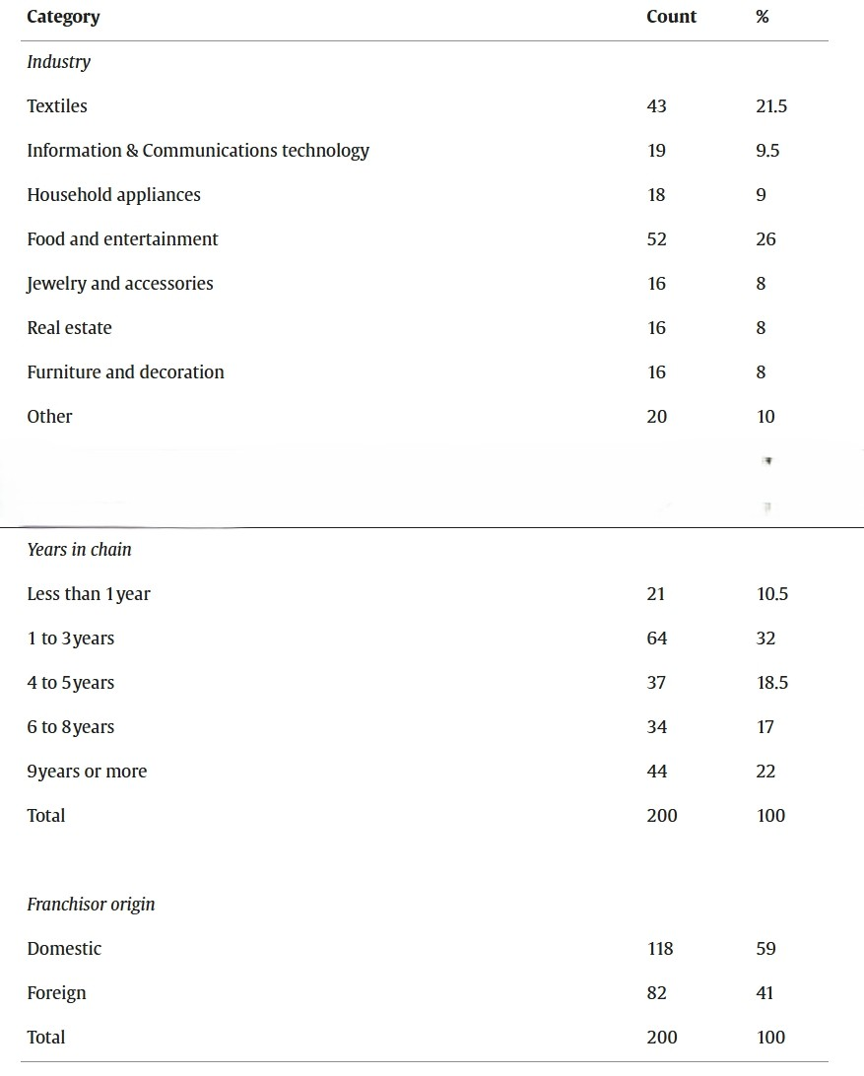(Altinay et al, 2014) Sample Characteristics-Franchisees' trust in and satisfaction with franchise partnerships.

- 47% of franchisees operate in the textiles, food, or entertainment sector, reflecting franchising’s dominance in consumer industries.
- 40% of franchisees remain in their franchise for 6–8 years, indicating strong early-stage commitment.
- The hospitality industry, including restaurants and hotels, accounts for 50% of the total franchise market share, reinforcing the strategic importance of branding and franchise satisfaction.
Building on this, guest perception directly impacts brand trust and repeat business:
- National Hotels (2024) explores how customer reviews influence hotel choices, emphasising trust-building, purchase decisions, and reputation management. Positive reviews enhance a hotel’s credibility, while negative reviews can significantly deter bookings.
- Crudu (2025) analyses how guest feedback transforms hotel experiences, showing that positive responses to reviews increase occupancy rates by up to 20%. It highlights that 86% of travellers consider reviews a decisive factor, and hotels that engage with guest feedback see higher booking confidence.
Additionally, service quality metrics are essential in guest experience evaluation:
- HotelMarketingWorks (2025) outlines key guest satisfaction indicators, such as Net Promoter Score (NPS), problem resolution rate, and review sentiment analysis.
- Hollander (2023) explains how hotels measure repeat guest rate, online reviews, and customer satisfaction scores (CSAT) to improve service.
- Pieszko (2019) highlights the importance of pre-stay engagement, real-time feedback collection, and service optimisation in hospitality.
This reinforces that customer trust and online reputation management are key success factors for both franchised and independent hotels.

2.4 SWOT Analysis: Hilton Garden Inn vs. The Crown Hotel Bawtry
SWOT analysis evaluates competitive positioning by identifying strengths, weaknesses, opportunities, and threats in franchised vs. independent hotels (CIPD Factsheet, 2025).

Hilton Garden Inn Doncaster (Franchise Model):
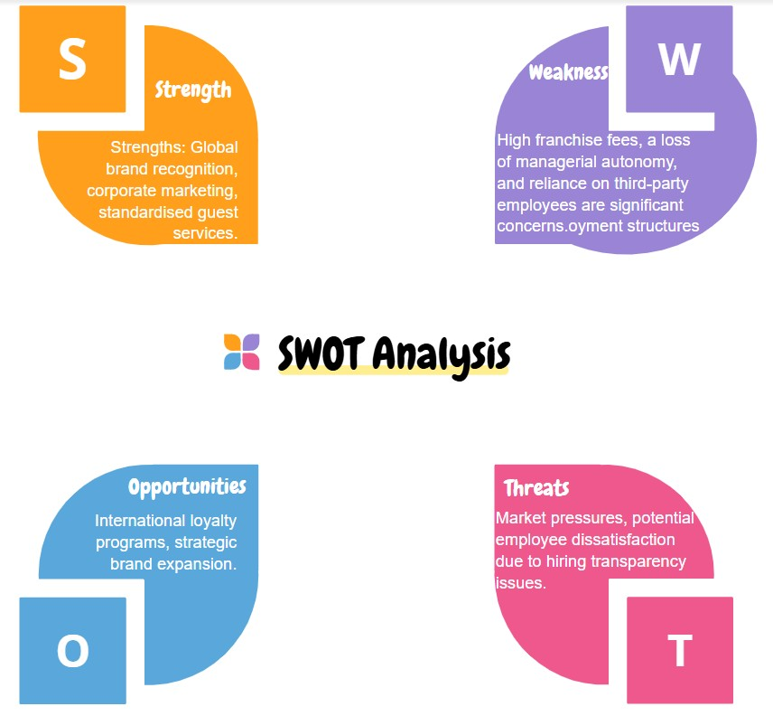(ConceptBoard, 2025a). Swot Analyses for Hilton Garden Inn Doncaster (Franchised Model).
- Strengths: Corporate-backed marketing, standardised guest services, global brand loyalty.
- Weaknesses: High franchise fees, restricted decision-making, third-party employment structures.
- Opportunities: International brand expansion, scalable customer outreach.
- Threats: Market saturation, employee dissatisfaction due to hiring transparency issues.

The Crown Hotel Bawtry (Independent Model)
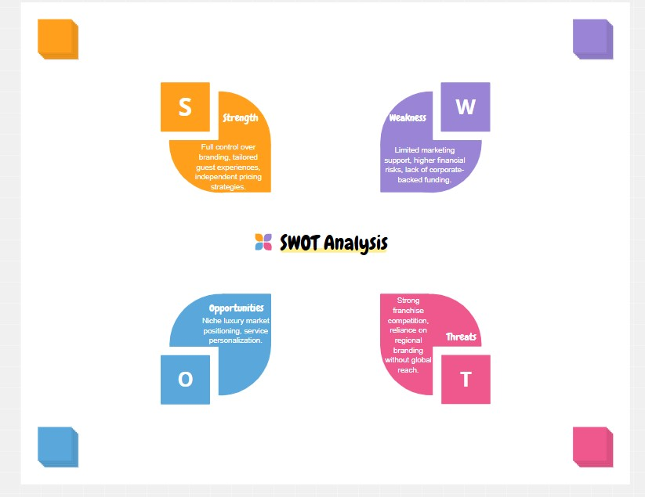(ConceptBoard, 2025b). Swot Analyses for The Crown Hotel Bawtry (Independent Model).
- Strengths: Full control over branding, service customisation, and independent pricing strategies.
- Weaknesses: Higher financial risk, limited marketing resources, absence of franchise-backed funding.
- Opportunities: Niche market targeting, boutique luxury experience.
- Threats: Competitive pressure from franchise chains, reliance on local consumer loyalty.
SWOT analysis underscores the trade-offs between financial security in franchising and strategic flexibility in independent hotels.
This analysis highlights the financial limitations of independent hotels, reinforces the previous findings on financial risk management in hospitality.

2.5 PESTEL Analysis: External Influences on Hotel Strategies
PESTEL analysis examines macro-environmental factors shaping franchising and independent hotel operations (PESTLE Analysis Website, 2025).
- Political & Legal:
- Franchisees must comply with corporate policies and labour laws (Tsai, Kuo & Lin, 2020).
- Independent hotels benefit from greater autonomy in governance structures.
- Economic:
- Franchise hotels ensure financial stability through brand backing but incur high fees (Silva, Gerwe & Becerra, 2023).
- Independent hotels rely on self-managed funding and market adaptability.
- Social:
Franchised hotels leverage corporate branding to foster stronger consumer trust (Team TBH, 2023).
- Independent hotels focus on localised guest relationships and personalised service (Keyhole Creative, 2025).
- Technological:
- Franchise chains use corporate-driven digital tools for operations.
- Independent hotels customise innovative guest engagement methods.
- Environmental:
- Global franchise chains implement standardised sustainability initiatives.
- Independent hotels tailor eco-friendly practices to regional needs.
PESTEL analysis reinforces that market pressures, legal restrictions, and technological advancements shape franchising and independent hotel strategies (PESTLE Analysis Website, 2025).

2.6 Bowman’s Strategy Clock: Competitive Positioning in Hospitality
Bowman’s Strategy Clock is included in Chapter 2 as a key framework for evaluating business strategies based on price and perceived value (Product Mindset, 2022).
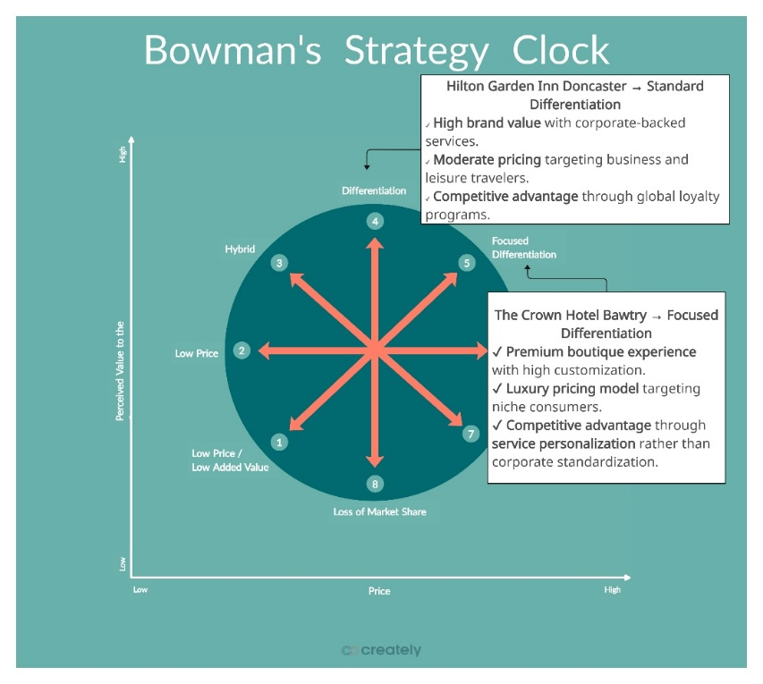(Creately, 2025). Bowman’s Strategy Clock: Competitive Positioning in Hospitality.
- Hilton Garden Inn Doncaster aligns with Standard Differentiation, leveraging corporate branding, loyalty programs, and competitive pricing.
- The Crown Hotel Bawtry follows Focused Differentiation, offering high-end boutique experiences with premium service customisation.
Bowman’s Strategy Clock complements SWOT and PESTEL analysis, ensuring a holistic assessment of competitive positioning in hospitality markets (Product Mindset, 2022).

Final Reflections on Franchising as a Growth Model
Franchising remains a dominant expansion strategy, balancing brand consistency, financial stability, and operational efficiency. However, challenges persist, including:
- Employment transparency—misalignment between franchise branding and third-party workforce management.
- High franchise fees—impacting profitability for franchise owners.
- Strategic limitations—franchise agreements restrict operational flexibility compared to independent business models.
Hotel operators must evaluate whether franchising supports their long-term business goals or whether independent branding provides greater adaptability within a competitive hospitality landscape.

Chapter 3: Methodology

3.1 Comparative Case Study Approach
This study adopts a comparative case study methodology to analyse franchising vs. independent hotel operations within the hospitality industry.
Case studies provide contextual insights into real-world business practices, allowing an in-depth examination of strategic, operational, and financial dynamics influencing hotel owners’ decisions (Brookes & Altinay, 2016). While case studies lack broad generalizability, they effectively capture intricate business perspectives, making them valuable for assessing franchising models vs. independent brand management.
Additionally, this study integrates Bowman’s Strategy Clock, SWOT, and PESTEL analyses (established in Chapter 2) to enhance competitive evaluation, ensuring a structured approach to understanding market positioning and external influences.

3.2 Case Study Selection: Hilton Garden Inn Doncaster & The Crown Hotel Bawtry
This study examines Hilton Garden Inn Doncaster and The Crown Hotel Bawtry, two distinct hotel models in the same regional market.
- Hilton Garden Inn Doncaster: Selected due to its role in placement practice experience, making it a strong representation of a franchised hotel model with corporate-backed branding and operational procedures.
- The Crown Hotel Bawtry: Chosen for its strategic location and status as a luxury brand, which mirrors elements of Hilton’s positioning while remaining fully independent.
Competitive Positioning Using Bowman’s Strategy Clock
- Hilton Garden Inn Doncaster follows Standard Differentiation, ensuring corporate-backed services and brand consistency.
- The Crown Hotel Bawtry adopts Focused Differentiation, emphasising niche market appeal and exclusive service experiences.
This comparative case study evaluates brand-driven advantages, operational flexibility, and financial sustainability, guided by Bowman’s Strategy Clock framework.

3.3 Netnography & Digital Market Analysis
To complement the comparative case study approach, this research employs netnography, a qualitative method for analysing online consumer interactions, brand sentiment, and franchisee perceptions (Shaw, 2020).
- Expanded Scope: Since Bowman’s Strategy Clock assesses price vs. perceived value, netnography investigates consumer expectations, brand loyalty, and perceived service differentiation in franchised vs. independent hotels.
- Data Sources:
- Customer reviews: Insights into service quality & guest preferences.
- Industry forums: Franchisee discussions on branding, pricing, and long-term strategy.
- Social media platforms: Market sentiment regarding hotel loyalty programs, boutique service appeal, and corporate marketing strategies.
Netnographic Analysis Implementation:
Guest feedback will be classified into recurring themes, reflecting trust, loyalty, service customisation, and market adaptability, ensuring data is linked to SWOT and PESTEL frameworks.

3.4 Theoretical Framework Integration
This study integrates Resource-Based Theory (RBT), Transaction Cost Economics (TCE), SWOT Analysis, PESTEL Analysis, and Bowman’s Strategy Clock, ensuring a robust methodological approach.
- RBT: Examines how franchisors leverage brand equity, operational expertise, and economies of scale to secure a competitive advantage (Marks, 2020).
- TCE: Evaluates how franchising minimises financial uncertainty while decentralising ownership (Ketokivi & Mahoney, 2020).
- SWOT Analysis: Identifies key strengths, weaknesses, opportunities, and threats affecting franchised vs. independent hotel models (CIPD Factsheet, 2025).
- PESTEL Analysis: Assesses macro-environmental influences, including legal, technological, and economic factors impacting hotel strategies (PESTLE Analysis Website, 2025).
- Bowman’s Strategy Clock: Defines each hotel’s competitive positioning, pricing strategy, and differentiation approach (Product Mindset, 2022).

Application to Case Study Findings:
Each framework will be systematically applied to the case studies, ensuring that the analysis considers operational structures, competitive strategies, guest perceptions, and long-term market viability.
By incorporating The Crown Hotel Bawtry as a contrasting case study, this research provides a balanced evaluation of branding strategies, operational flexibility, financial risk management, and long-term sustainability.

Chapter 4: Findings

4.1 Introduction
This section presents the comparative findings between Hilton Garden Inn Doncaster and The Crown Hotel Bawtry, focusing on
Pricing strategies (dynamic pricing vs. independent rate flexibility)
Guest experiences (corporate-standardised service vs. personalised engagement)
Competitive positioning (global franchise expansion vs. local market differentiation.
By analysing multi-platform rate variations, customer reviews, and industry trends, this chapter highlights key advantages and challenges in franchised versus independent hotel operations.

4.2 Pricing Analysis: Hilton vs. The Crown Hotel

Multi-Platform Rate Comparisons
A comparative pricing analysis was conducted using Booking.com, TripAdvisor, and Expedia. Findings indicate Hilton’s corporate-backed pricing strategy maintains consistency across major OTAs, while The Crown Hotel demonstrates more variation due to its independent status.
- Hilton Garden Inn Doncaster maintains consistent pricing across platforms, ranging from £598 to £1,198 for a six-night stay, reinforcing its standardized corporate pricing model (Booking.com, 2025a; TripAdvisor, 2025a; Expedia, 2025a)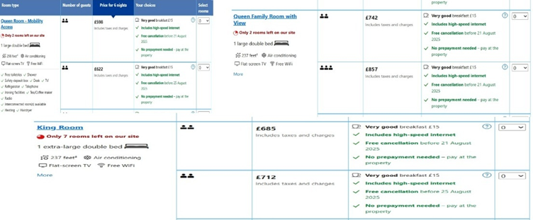(Prices range per room size for the Hilton Garden Inn Doncaster destination. Booking.com, 2025a).
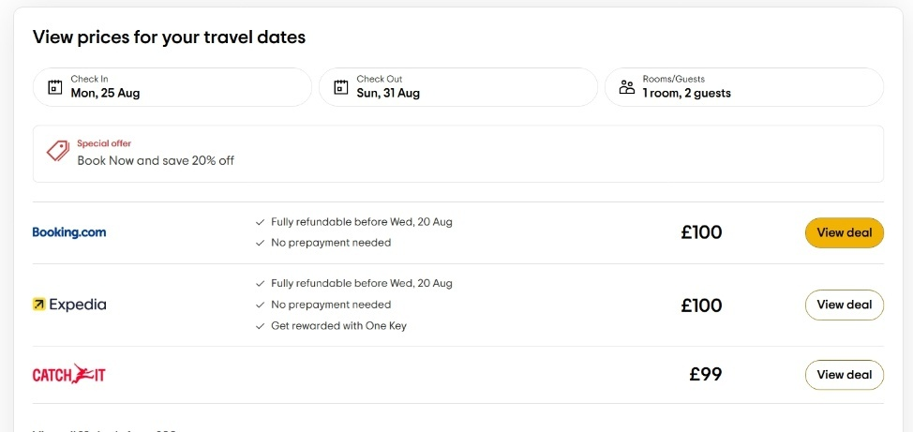Prices average range per holiday on different travel platforms for the Hilton Garden Inn Doncaster destination. (TripAdvisor, 2025a)
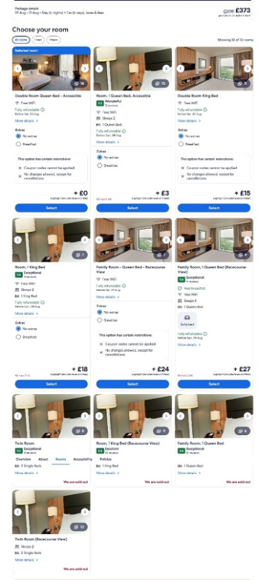Prices range per room size for the Hilton Garden Inn Doncaster destination. (Expedia, 2025a).

- The Crown Hotel Bawtry exhibits pricing fluctuations between £750 and £1,260, indicating seasonal adjustments and rate differentiation as an independent property (Booking.com, 2025b; TripAdvisor, 2025b; Expedia, 2025b). 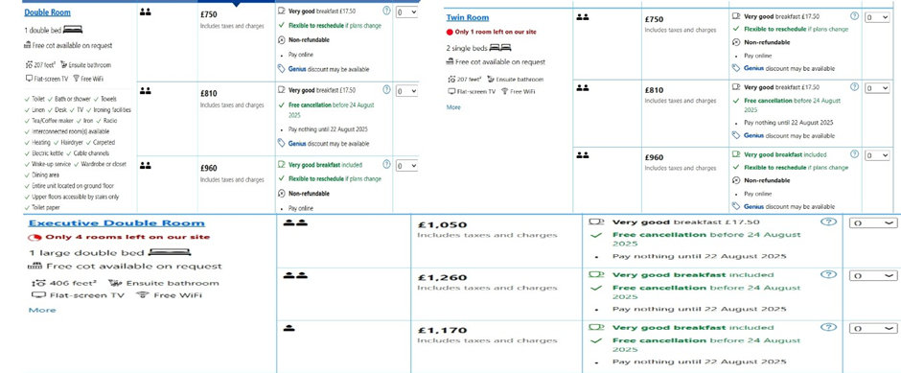(Prices range per room size for the Crown Hotel Doncaster/Bawtry destination. Booking.com, 2025b).
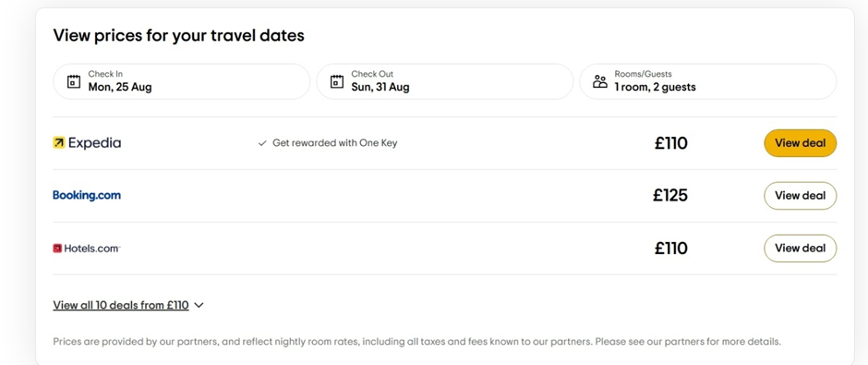Prices average range per holiday on different travel platforms for the Crown Hotel Doncaster/Bawtry destination. (TripAdvisor, 2025b)
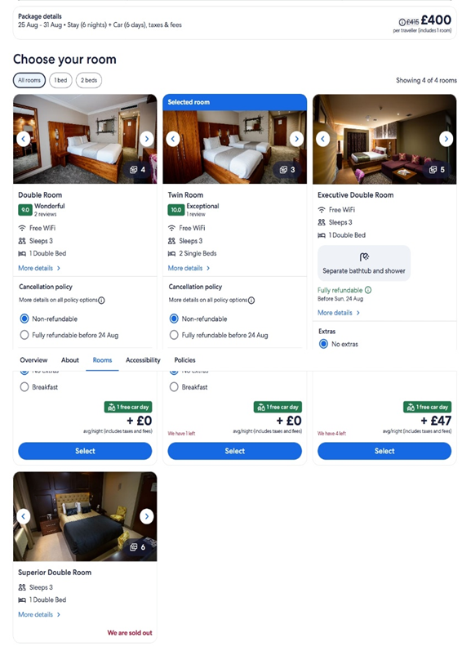Prices range per room size for the Crown Hotel in Doncaster/ Bawtry. (Expedia, 2025b).

Revenue Optimisation & Dynamic Pricing
Hilton’s corporate-backed dynamic pricing algorithms ensure:
- Predictability for travellers with minimal price variations.
- Market-driven rate updates without exceeding brand pricing guidelines.
In contrast, independent hotels like The Crown Hotel adapt pricing based on demand shifts rather than pre-set corporate strategies.
The hospitality industry increasingly leverages dynamic pricing models to maximize revenue:
- Hotels using automated pricing see a 12–18% revenue boost compared to those with static pricing (Mayfield, 2025).
- AI-driven forecasting helps franchises optimise rates based on occupancy, competitor pricing, and demand fluctuations (Jangid, 2025).
These findings underscore Hilton's structured pricing stability and The Crown Hotel's reactive pricing flexibility—two distinct strategies shaping consumer decision-making.

4.3 Guest Experience Analysis: Hilton vs. The Crown Hotel

Review Ratings Overview
A synthesis of guest reviews reveals Hilton’s superior consistency in service quality and brand engagement, while The Crown Hotel thrives on personalised guest interactions but faces maintenance concerns.
- Hilton: Scores 8.8 (“Fabulous”) on Booking.com, with guests praising staff friendliness (9.2) and cleanliness (9.1) (Booking.com, 2025c).
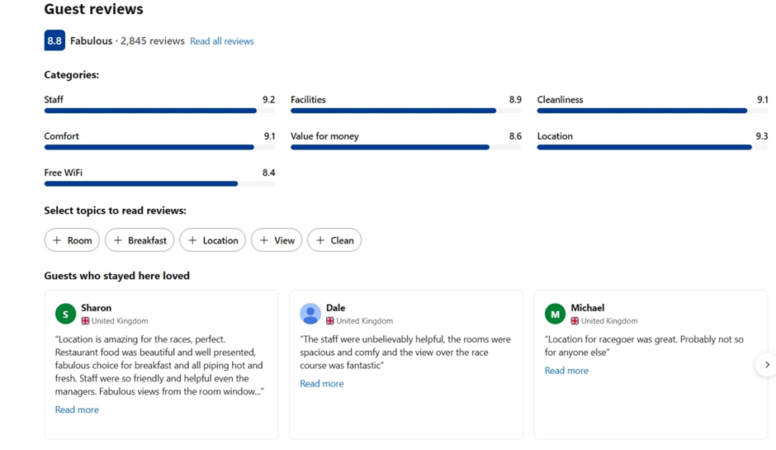(Hilton reviews. Booking.com, 2025c)

- The Crown Hotel: Scores 7.0 (“Good”), with mixed reviews highlighting great service but ageing facilities (Booking.com, 2025d).
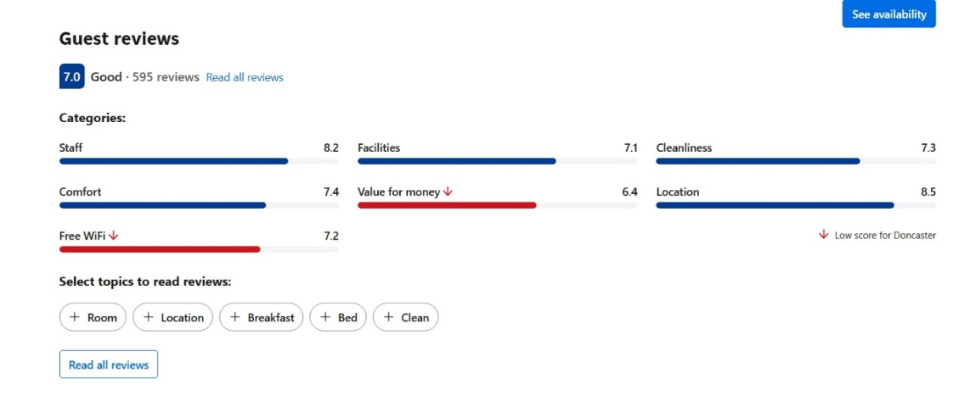(The Crown Hotel review. Booking.com, 2025d)
Trust & Reputation Management
Hilton’s corporate-backed hospitality standards ensure:
- Predictable service experiences across multiple locations.
- Strong brand reputation reinforces guest loyalty.
Independent hotels like The Crown Hotel rely on guest personalisation & local engagement, leading to higher variability in guest satisfaction (Shiji, 2025).
Recent guest sentiment trends reveal:
- 86% of travellers cite online reviews as a primary decision factor.
- Hotels actively responding to guest feedback see a 30% increase in repeat bookings.
- Corporate-backed hotels maintain more structured review management, while independent hotels struggle with consistency in service recovery.
These findings confirm Hilton's reputation stability, while The Crown Hotel thrives on localised engagement but faces service consistency challenges.
Hilton’s corporate-backed hospitality standards ensure predictability, whereas independent hotels like The Crown must differentiate through personal engagement, often leading to greater variability in guest feedback (Altinay et al., 2014).

Guest Experience Themes

Key themes emerging from guest feedback across platforms include:
- Hilton: Guests praise location convenience, standardised service, and loyalty incentives (TripAdvisor, 2025c; Expedia, 2025c).
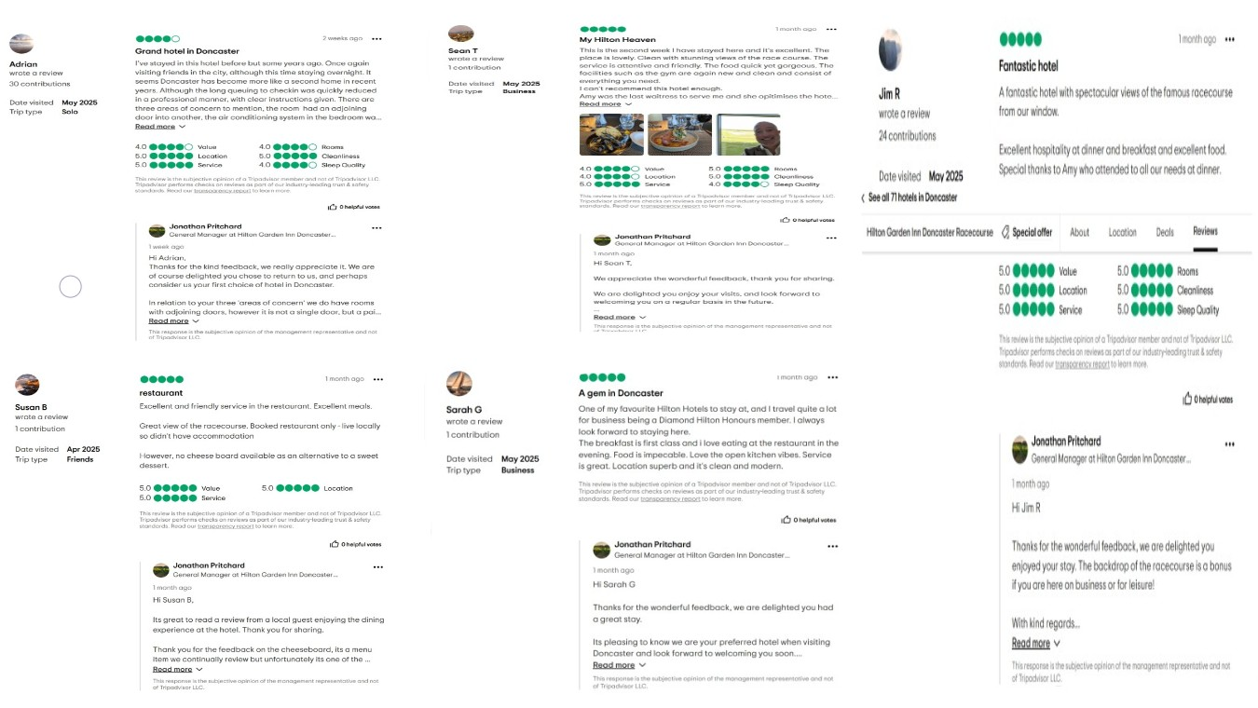(HILTON GARDEN INN DONCASTER RACECOURSE. TripAdvisor, 2025c)
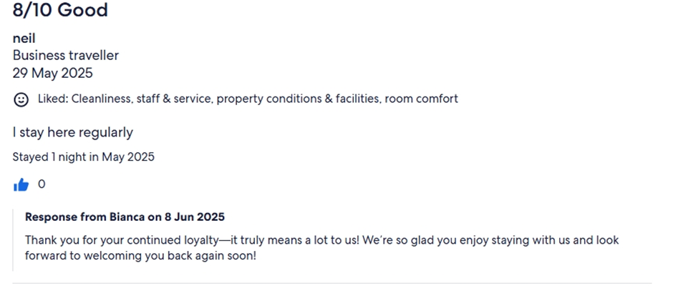
(Hilton Garden Inn Doncaster Racecourse. Expedia, 2025c)

- The Crown Hotel: Guests highlight wedding venue appeal, personalised attention, and local engagement, but maintenance concerns impact repeat bookings (TripAdvisor, 2025d; Expedia, 2025d).
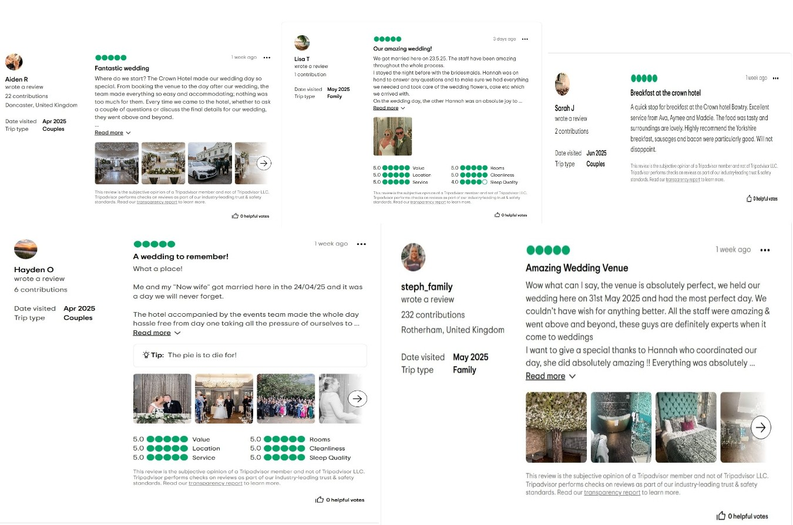
(THE CROWN HOTEL. TripAdvisor, 2025d)
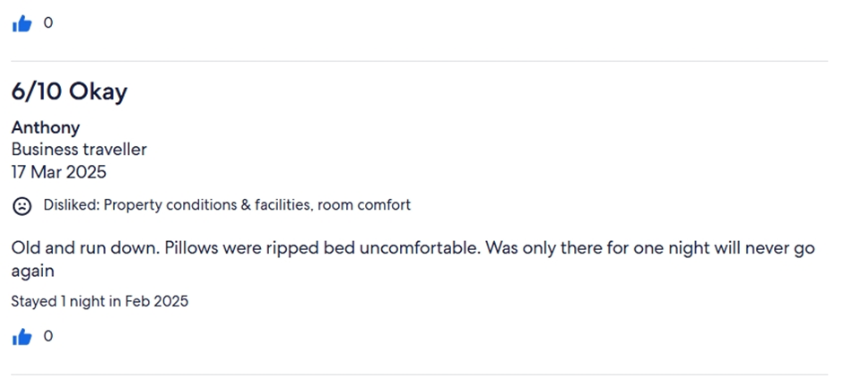
(Verified traveller. The Crown Hotel Bawtry, Doncaster. Expedia, 2025d)

4.4 Industry Trends & Competitive Strategies

Financial Performance & Competitive Positioning
A financial review of Accor and Corinthia Group provides valuable benchmarks for understanding the financial sustainability of franchised versus independent hotels, reinforcing Hilton and The Crown Hotel’s market positioning.
Accor Group Financial Highlights (2023):
- Revenue: €5.056 billion, marking a 20% increase from 2022.
- EBITDA: €1.003 billion, surpassing the €1 billion milestone.
- RevPAR Growth: +23% compared to 2022, reflecting strong pricing power and demand resilience.
- Expansion: Accor added 290 hotels, totalling 822,000 rooms globally (Accor, 2023).
Corinthia Group Financial Highlights (2023):
- Total Assets: €1.77 billion, reinforcing its luxury hotel investment strategy.
- Portfolio: Owns 12 luxury hotels in key global cities, including London, Lisbon, and Budapest.
- Revenue Streams: Operates hotels, commercial properties, and real estate developments, diversifying income sources.
- Financial Stability: Listed on the Malta Stock Exchange, ensuring public investment backing (Corinthia Group, 2023).
These figures demonstrate how corporate-backed hotel chains (like Hilton and Accor) maintain structured revenue streams, whereas independent brands (like The Crown Hotel and Corinthia) rely on diversified investments and market agility for financial security.

Market Analysis
Hilton’s global expansion strategy ensures financial stability, as demonstrated by record-breaking development milestones and shareholder confidence (Stories from Hilton, 2025a).
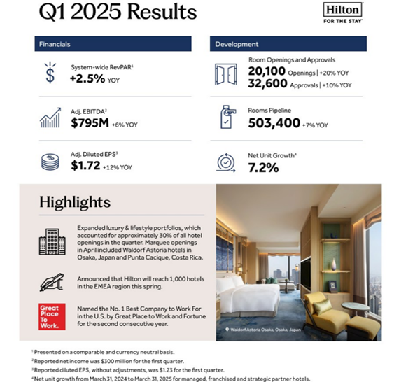 (Hilton Reports First Quarter Results. Stories From Hilton, 2025a).

Hilton’s market presence is reinforced by corporate-backed branding and digital innovations, ensuring long-term profitability.
Conversely, the Crown Hotel operates on a localised competitive strategy, relying on event-driven hospitality and sports sponsorships to attract guests (Allie Dransfield, 2025). Its financial limitations and regional focus pose scalability challenges compared to corporate-backed franchise models (Company Check, 2024).
A financial review of The Crown Hotel (Bawtry) Limited reveals ongoing fiscal constraints:
- Net Assets (2024): £105.6K (↓ 23% from the previous year)
- Total Liabilities: £1.69M (↑ 2%)
- Total Assets: £1.8M (slight decline from 2023)
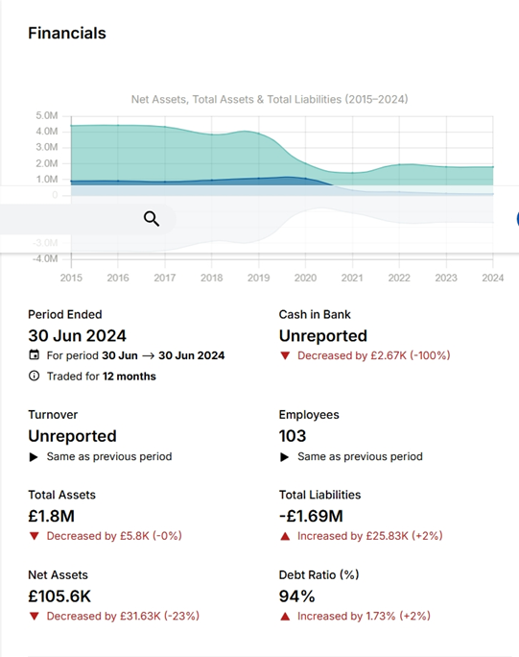(The Crown Hotel (Bawtry) Limited. Endole, 2024)
This reflects The Crown’s high financial leverage and restricted expansion potential, requiring targeted market strategies to sustain profitability (Endole, 2024).

Outlook
Hilton continues aggressive expansion, adding 973 hotels and 100,000 rooms in 2024 (Stories from Hilton, 2025b).
In contrast, independent hotels like The Crown focus on niche markets, using localised branding efforts such as Doncaster Rovers sponsorship to sustain visibility (Katey Dent, 2024; Bdaily Business News, 2025). However, given the financial data from 2024, its current financial status in 2025 remains uncertain.
Financial sustainability remains a challenge for independent hotels facing market pressures and cash flow risks (Bakker and Finney, 2025)
Key resilience factors in hospitality include:
- Building financial buffers—hotels with strong liquidity reserves withstand economic downturns better.
- Revenue diversification—franchises benefit from multiple income streams, reducing risk exposure.
- Operational efficiency—profitability depends on balancing staffing costs, marketing investments, and long-term capital strategies.
Hilton’s corporate security ensures stability, while The Crown Hotel must navigate financial vulnerabilities strategically.

Final Summary of Findings
- Hilton Garden Inn Doncaster maintains pricing stability, ensuring consistent guest expectations.
- The Crown Hotel Bawtry leverages flexible pricing, but financial constraints may limit large-scale adaptability.
- Hilton ensures predictable service standards, while The Crown Hotel thrives on personalised guest experiences.
- Hilton’s corporate-backed expansion fuels global growth, while The Crown Hotel relies on regional partnerships for competitive positioning.
These findings establish the foundations for the Discussion section, where implications, comparisons, and strategic interpretations will be explored.

Discussions:

4.5 Critical Analysis of Key Findings
The comparison between Hilton Garden Inn Doncaster and The Crown Hotel Bawtry underscores essential contrasts between franchised and independent hospitality models, particularly in the realms of pricing strategy, guest experience, and financial resilience.

Pricing Strategies: Structured vs. Adaptive
Franchised hotels prioritise rate stability, ensuring predictable revenue streams and reinforcing consumer trust. By maintaining uniform pricing across platforms, they safeguard profitability while benefiting from large-scale corporate backing. However, this structured approach limits flexibility, preventing adjustments based on regional demand fluctuations.
Independent hotels, on the other hand, rely on dynamic pricing strategies, adjusting rates based on seasonal trends and occupancy levels. While this flexibility enhances responsiveness to market shifts, it also introduces financial volatility. The challenge lies in balancing competitive pricing with long-term revenue predictability, particularly in luxury-driven markets where customer demand can be highly variable.
Hilton’s centralised pricing structure promotes rate consistency and predictable revenue flow. This is a hallmark of top-performing franchises, with standardised pricing mechanisms ensuring brand trust and streamlined yield management across multiple properties (Smereczniak, 2025). However, this level of control can restrict responsiveness to local demand fluctuations.
The Crown Hotel, operating independently, uses more flexible and demand-sensitive pricing. While this allows tailored offerings to niche market trends, it increases exposure to inconsistencies in booking patterns and potential revenue volatility—an ongoing risk for boutique operators without franchise-level infrastructure.

Guest Satisfaction & Personalisation
Brand-backed hotels emphasise consistency in service delivery, ensuring guests receive familiar experiences across locations. While this strengthens loyalty, it can reduce the ability to tailor offerings to local preferences. Independent hotels, however, build their reputation through personalised guest interactions, creating more intimate and memorable experiences.
Advancements in AI-driven personalisation tools are reshaping customer expectations, allowing hotels to customise everything from room preferences to curated experiences. This strategic use of technology helps smaller operators enhance service quality while maintaining their distinct identity. Personalised hospitality remains a key differentiator for independent establishments, providing them with a competitive edge despite lacking corporate standardisation.
Hilton relies on standardised guest service protocols, ensuring consistent experiences aligned with the brand promise. This builds consumer trust but may limit emotional personalisation.
In contrast, The Crown Hotel thrives on high-touch engagement, crafting individualised service that resonates with guests on a personal level (Taylor Hospitality, 2025). However, such customisation varies depending on staff capabilities, training, and available resources.
Modern technologies are now empowering even smaller operators. Triquell (2025) notes the rise of hyper-personalisation through AI, which allows hotels, especially independents—to tailor experiences based on guest data. From bespoke welcome amenities to real-time in-stay feedback adaptations, this trend enables The Crown Hotel to leverage innovation as a competitive differentiator, if implemented strategically.

Financial Sustainability: Franchise Support vs. Independent Risk
Corporate-backed hotels benefit from structured financial models, ensuring liquidity reserves and long-term stability. Their ability to withstand economic fluctuations is strengthened by diversified revenue streams, franchise royalties, and large-scale brand partnerships.
Independent hotels operate with greater financial exposure, requiring initiative-taking cash flow management and strategic diversification. By expanding revenue sources beyond accommodation, such as events, dining, and exclusive memberships, they can mitigate financial risk while maintaining market relevance. The key to long-term sustainability lies in adopting investment strategies that balance independent ownership with adaptive business models, ensuring resilience amid shifting economic conditions.
Hilton enjoys the strength of networked financial backing, brand equity, and centrally funded marketing initiatives. Top-tier hotel franchises benefit from well-established frameworks that allow smoother navigation through economic turbulence (Smereczniak, 2025).
By contrast, The Crown Hotel operates within a financially constrained environment, shouldering full risk on investments, staffing, and strategic decisions. Without the brand-level protections or shared infrastructure of a franchise system, it must continuously balance cost control with service delivery—an inherently more fragile model.

4.6 Implications for Hotel Operations
The differentiated strengths and vulnerabilities of Hilton and The Crown Hotel suggest distinct operational roadmaps.

Hilton Garden Inn Doncaster (Franchised Model)
- Advantage: Stability in pricing, operational consistency, and access to franchise systems ensure scalable growth and customer trust (Smereczniak, 2025).
- Challenge: Reduced local agility—corporate oversight may limit quick adaptation to specific market conditions or guest preferences.
- Strategic Application: Like Accor, Hilton could introduce regional micro-adjustments in pricing to increase market responsiveness.

The Crown Hotel Bawtry (Independent Model)
- Advantage: Greater room for service innovation and personalised experiences, especially as consumer demand shifts toward experiential and curated stays (Taylor Hospitality, 2025).
- Challenge: Higher financial exposure and resource limitations can impact long-term sustainability.
- Strategic Application: Independent hotels could mirror Corinthia’s diversification model, using event-hosting and expanded service offerings to strengthen financial resilience (Corinthia Group, 2023).
Looking ahead, the integration of AI-driven personalisation tools could allow independent hotels like The Crown to bridge some of the resource and consistency gaps (Triquell, 2025). These tools are becoming increasingly cost-effective and scalable, enabling boutique operators to enrich the guest journey while maintaining their distinct identity.

4.7 Limitations & Future Considerations
While this study provides key insights into Hilton Garden Inn Doncaster and The Crown Hotel Bawtry, various limitations impact generalizability and future research opportunities.

Market Trends & Evolving Consumer Expectations
The hospitality sector is experiencing rapid technological shifts and changing consumer preferences that may reshape traditional pricing models and guest experiences (Sachdeva, 2025). Emerging trends such as hyper-personalisation, AI-driven service enhancements, and sustainability initiatives influence how both franchised and independent hotels adapt to evolving market dynamics (Lüthy, 2025).
Moreover, Swiss Education Group (2025) highlights experiential travel and wellness tourism as leading industry movements, suggesting that future research should examine how hotels optimise pricing and guest experience strategies to align with these demand shifts.

Financial Stability & Risk Mitigation
While Hilton enjoys corporate-backed financial security, independent hotels like The Crown Hotel face higher financial exposure due to fluctuating revenue streams. Risk mitigation strategies such as liquidity buffers, dynamic financing, and alternative investment models could help independent hotels sustain profitability (Dentons, 2025).
Further research should explore how independent hotels can implement structured risk management frameworks to compete effectively against franchise-backed chains, ensuring long-term financial resilience.

Changing Consumer Behaviour & Economic Pressures
The leisure and hospitality industry is undergoing a shift in spending patterns, with economic factors influencing dining frequency, travel budgets, and booking preferences (Moseley, 2025). A study from Brew’s Pub & Bar Report (Bowell, 2025) reveals that while consumers are reducing the frequency of outings, they are spending more per visit, signalling a shift toward quality-driven experiences over quantity-based consumption.
These behavioural changes suggest that pricing strategies, revenue optimisation, and guest retention models will need to be adapted to sustain long-term market competitiveness—an area ripe for further exploration.

Future Research Directions
To deepen the understanding of franchised vs. independent hotel models, future studies should focus on:
- Comparative financial risk models—how independent hotels can replicate franchise-level financial security without corporate backing.
- Hyper-personalised pricing & AI-driven revenue management—evaluating AI pricing strategies in independent vs. franchised hotels.
- Sustainability & eco-conscious branding—how hotels can strategically integrate environmental initiatives into guest loyalty programs.
- Franchise-backed hotels (Hilton, Accor) prioritise revenue stability, expansion, and pricing consistency.
- Independent hotels (The Crown, Corinthia) thrive on exclusivity and personalisation but require diversified revenue strategies.
Expanding research in these areas will enhance strategic recommendations for hotel operators, ensuring business adaptability amid evolving industry demands.

Final Thoughts on Competitive Positioning
This study reinforces that Hilton’s franchising model prioritises stability, while The Crown Hotel thrives on market adaptability but faces financial volatility. Future research should examine competitive frameworks for independent hotels, ensuring strategic agility in pricing, guest experience, and fiscal management.
Hotel operators must navigate industry shifts with dynamic strategies, balancing brand security and market responsiveness for long-term sustainability.

Chapter 5: Conclusion and Recommendations:

5.1 Summary of Key Findings
This study examined the strategic, financial, and operational distinctions between franchised and independent hotel models, using Hilton Garden Inn Doncaster and The Crown Hotel Bawtry as case studies. The findings reveal that while franchising offers financial stability, brand recognition, and streamlined operations, independent hotels provide flexibility, personalised service, and unique branding opportunities.
- Hilton Garden Inn Doncaster operates within a corporate franchise framework, benefiting from structured revenue management, centralised pricing control, and global customer loyalty programs. However, these advantages come at the cost of restricted operational autonomy and franchise fees, limiting local decision-making power.
- The Crown Hotel Bawtry exemplifies the independent model, prioritising customisation, and guest engagement. Its ability to adjust pricing and service offerings freely provides strong local appeal, yet financial constraints and limited scalability make long-term sustainability challenging.

5.2 Financial Sustainability & Competitive Positioning
The research highlights that franchise-backed hotels maintain stronger financial buffers, enabling consistent profitability even during economic downturns.
- Accor’s corporate model, like Hilton’s, prioritises liquidity reserves and structured pricing strategies to ensure steady revenue growth.
- Independent hotels, such as Corinthia Group’s luxury properties, sustain profitability through diversified revenue streams, including real estate investments and exclusive hospitality offerings.
Hilton’s financial stability allows for continuous expansion and adaptation to market trends, while The Crown Hotel must manage financial exposure and optimise revenue sources to remain competitive.

5.3 Guest Experience & Emerging Trends
Guest satisfaction is central to hospitality success, with evolving industry trends emphasising hyper-personalisation and AI-driven service enhancements.
- Hilton’s standardised guest service ensures reliability, fostering global brand trust but reducing localised engagement.
- The Crown Hotel’s independent model allows tailored guest interactions, providing a distinct experience that resonates with niche markets. However, inconsistencies in service delivery may affect customer retention.
AI-driven personalisation tools enable independent hotels to enhance guest experiences at scale, bridging the gap between corporate-backed standardisation and boutique-style customisation.

5.4 Strategic Implications for Hotel Operators
- Franchised hotels should introduce regional pricing flexibility, allowing adjustments based on seasonal demand while maintaining brand integrity.
- Independent hotels must strengthen financial resilience, adopting alternative income strategies such as event hosting and premium service packages.
- Investing in AI-driven personalisation tools can improve guest retention and differentiate service offerings.

5.5 Final Reflections
This study reinforces that neither model is inherently superior; success depends on strategic alignment with market dynamics and customer expectations. Hilton excels in structured operations, while The Crown Hotel thrives on customised service. Future hospitality leaders must balance financial sustainability, operational efficiency, and guest experience innovations to remain competitive.

Recommendations & Practical Strategies

6.1 Strategic Recommendations for Hilton Garden Inn Doncaster
1. Strengthen Guest Personalisation Through AI & Data Insights
Hilton’s standardised service ensures consistency, but integrating AI-driven personalisation can significantly enhance localised guest experiences without disrupting brand guidelines. AI tools allow hotels to track guest preferences, recommend tailored services, and automate customer interactions, improving satisfaction and engagement (Otelier, 2025a).
2. Adopt a More Dynamic Regional Pricing Strategy
Although Hilton follows corporate pricing structures, introducing controlled rate adjustments based on real-time demand fluctuations can improve responsiveness. Hospitality experts emphasize that micro-adjustments in pricing allow franchise hotels to capture seasonal demand spikes while maintaining profitability (Sharma, 2024).
3. Expand Tech-Driven Operational Efficiency
To streamline operations, Hilton should implement automated service requests, AI-powered check-ins, and digital concierge tools. The 2025 Hotel Tech Roadmap highlights that smart hospitality technology improves efficiency, reduces staffing constraints, and enhances the overall guest experience (Otelier, 2025a).

6.2 Strategic Recommendations for The Crown Hotel Bawtry
1. Invest in Smart Guest Experience Technologies
Independent hotels thrive on personalised service, but without corporate infrastructure, maintaining consistency can be a challenge. Implementing affordable AI-driven personalisation tools, such as automated guest feedback systems and customised service recommendations, helps scale independent hotels efficiently while retaining their unique identity (Otelier, 2025b).
2. Develop Strategic Partnerships for Competitive Edge
Without franchise backing, The Crown Hotel should form collaborations with local tourism boards, event venues, and premium service providers to strengthen market visibility and brand differentiation. Research highlights that joint branding initiatives and cross-industry partnerships enhance independent hotels' market competitiveness (EHL Faculty, 2024).
3. Enhance Financial Risk Management with Diversified Revenue Streams
Independent hotels face higher financial risks due to market fluctuations and seasonal demand variations. Expanding revenue streams—including seasonal events, premium dining, and loyalty membership programs—creates a stronger financial foundation for sustainability (Stone, 2025).

6.3 Industry-Wide Recommendations & Practical Strategies
1. Hybrid Business Models: The New Competitive Edge
Hotels are increasingly combining franchise efficiencies with independent service flexibility, creating hybrid models that offer both structured revenue management and personalised guest experiences. Industry leaders highlight that this operational balance fosters long-term stability while adapting to evolving consumer preferences (Sharma, 2024).
2. Sustainability & Eco-Conscious Branding as Market Differentiators
Eco-conscious travel is shaping consumer preferences, making green initiatives a crucial differentiator. Hospitality experts advise hotels to implement energy-efficient upgrades, waste-reduction programs, and eco-certified service enhancements to align with 2025 sustainability trends and strengthen brand credibility (EHL Faculty, 2024).
3. AI-Driven Revenue Optimisation & Market Adaptation
Automated forecasting tools and AI-driven pricing models are defining the future of revenue optimisation in the hospitality industry. Hotels must leverage machine-learning algorithms for rate optimisation, occupancy forecasting, and demand-based pricing strategies to ensure profitability and adaptability in an evolving market (Bansal, 2025).

Final Thoughts
Hospitality operators must balance financial security with service differentiation, ensuring strategic agility in pricing, guest experience, and operational efficiency. Franchise-backed hotels should enhance flexibility, while independent hotels must reinforce financial sustainability through diversification and smart investments.
By leveraging hybrid models, sustainability initiatives, and AI-driven optimisation, hotels can future-proof their strategies, maximising guest satisfaction, profitability, and long-term industry relevance.

References:
Accor (2024). Full-Year 2023 Results in Key Figures. [Online] Available at: https://group.accor.com/en/Actualites/2024/02/2023-full-year-results (Accessed: 12 June 2025).
Alex Smereczniak (2025). Best Hotel Franchises of 2025: Complete Guide and Rankings. [Online] Available at: https://franzy.com/blog/best-hotel-franchises/ (Accessed: 12 June 2025).
Aliouche, E. H. and Schlentrich, U. (2007). ‘Does Franchising Create Value? An Analysis of the Financial Performance of US Public Restaurant Firms, International Journal of Hospitality & Tourism Administration, 10(2), pp. 93–108. [Online] Available at: https://www.tandfonline.com/doi/full/10.1080/15256480902850943#d1e275 (Accessed: 07/06/2025).
Allie Dransfield (2025). Doncaster Rovers and Crown Hotel Bawtry announce Platinum Partnership. [Online] Available at: https://www.doncasterfreepress.co.uk/community/doncaster-rovers-and-crown-hotel-bawtry-announce-platinum-partnership-4975051 (Accessed: 12 June 2025).
Bdaily Business News (2025). Crown Hotel strikes platinum deal with Rovers | Bdaily. [Online] Available at: https://bdaily.co.uk/articles/2025/02/05/crown-hotel-strikes-platinum-deal-with-rovers (Accessed: 12 June 2025).
Bianca Lüthy (2025). Hospitality Industry Trends For 2025. [Online] Available at: https://hospitalityinsights.ehl.edu/hospitality-industry-trends (Accessed: 12 June 2025).
Bonita L. Stone of Katten (2025). Hospitality Leaders Assess 2025 Market at IHIF. [Online] Available at: https://natlawreview.com/article/takeaways-2025-nyu-international-hospitality-investment-forum-ihif (Accessed: 12 June 2025).
Booking.com (2025a) Hilton Garden Inn Doncaster Racecourse (Hotel) (UK) deals. [Online] Available at: https://www.booking.com/hotel/gb/hilton-garden-inn-doncaster-racecourse.en-gb.html?aid=397594&label=gog235jc-1BCAEoggI46AdIM1gDaFCIAQGYAQm4ARfIAQzYAQHoAQGIAgGoAgO4ArrcpcIGwAIB0gIkNGUzNGZiZmUtMDAyMy00MmNjLWJlYzQtMzRjNDg1ZjdhMjJi2AIF4AIB&sid=71e15422b0c41f2be2cd951583d98d72&all_sr_blocks=367893803_352210997_2_42_0_944082&checkin=2025-08-25&checkout=2025-08-31&dest_id=3678938&dest_type=hotel&dist=0&group_adults=2&group_children=0&hapos=1&highlighted_blocks=367893803_352210997_2_42_0_944082&hpos=1&matching_block_id=367893803_352210997_2_42_0_944082&no_rooms=1&req_adults=2&req_children=0&room1=A%2CA&sb_price_type=total&sr_order=popularity&sr_pri_blocks=367893803_352210997_2_42_0_944082_59845&srepoch=1749642862&srpvid=6f6c53b20b77001b&type=total&ucfs=1& (Accessed: 11 June 2025).
Booking.com (2025b) The Crown Hotel Bawtry-Doncaster (Hotel) (UK) deals. [Online] Available at: https://www.booking.com/hotel/gb/corus-the-crown-hotel.en-gb.html?aid=397594&label=gog235jc-1BCAEoggI46AdIM1gDaFCIAQGYAQm4ARfIAQzYAQHoAQGIAgGoAgO4ArrcpcIGwAIB0gIkNGUzNGZiZmUtMDAyMy00MmNjLWJlYzQtMzRjNDg1ZjdhMjJi2AIF4AIB&sid=71e15422b0c41f2be2cd951583d98d72&all_sr_blocks=21859804_88659099_2_2_0&checkin=2025-08-25&checkout=2025-08-31&dest_id=218598&dest_type=hotel&dist=0&group_adults=2&group_children=0&hapos=1&highlighted_blocks=21859804_88659099_2_2_0&hpos=1&matching_block_id=21859804_88659099_2_2_0&no_rooms=1&req_adults=2&req_children=0&room1=A%2CA&sb_price_type=total&sr_order=popularity&sr_pri_blocks=21859804_88659099_2_2_0__75000&srepoch=1749643053&srpvid=005a54112fee00fb&type=total&ucfs=1&#tab-main (Accessed: 11 June 2025).
Booking.com (2025c) Hilton Garden Inn Doncaster Racecourse (Hotel) (UK) deals. [Online] Available at: https://www.booking.com/hotel/gb/hilton-garden-inn-doncaster-racecourse.en-gb.html?aid=397594&label=gog235jc-1BCAEoggI46AdIM1gDaFCIAQGYAQm4ARfIAQzYAQHoAQGIAgGoAgO4ArrcpcIGwAIB0gIkNGUzNGZiZmUtMDAyMy00MmNjLWJlYzQtMzRjNDg1ZjdhMjJi2AIF4AIB&sid=71e15422b0c41f2be2cd951583d98d72&all_sr_blocks=367893803_352210997_2_42_0_944082&checkin=2025-08-25&checkout=2025-08-31&dest_id=3678938&dest_type=hotel&dist=0&group_adults=2&group_children=0&hapos=1&highlighted_blocks=367893803_352210997_2_42_0_944082&hpos=1&matching_block_id=367893803_352210997_2_42_0_944082&no_rooms=1&req_adults=2&req_children=0&room1=A%2CA&sb_price_type=total&sr_order=popularity&sr_pri_blocks=367893803_352210997_2_42_0_944082_59845&srepoch=1749642862&srpvid=6f6c53b20b77001b&type=total&ucfs=1&#tab-reviews (Accessed: 11 June 2025).
Booking.com (2025d) The Crown Hotel Bawtry-Doncaster (Hotel) (UK) deals. [Online] Available at: https://www.booking.com/hotel/gb/corus-the-crown-hotel.en-gb.html?aid=397594&label=gog235jc-1BCAEoggI46AdIM1gDaFCIAQGYAQm4ARfIAQzYAQHoAQGIAgGoAgO4ArrcpcIGwAIB0gIkNGUzNGZiZmUtMDAyMy00MmNjLWJlYzQtMzRjNDg1ZjdhMjJi2AIF4AIB&sid=71e15422b0c41f2be2cd951583d98d72&all_sr_blocks=21859804_88659099_2_2_0&checkin=2025-08-25&checkout=2025-08-31&dest_id=218598&dest_type=hotel&dist=0&group_adults=2&group_children=0&hapos=1&highlighted_blocks=21859804_88659099_2_2_0&hpos=1&matching_block_id=21859804_88659099_2_2_0&no_rooms=1&req_adults=2&req_children=0&room1=A%2CA&sb_price_type=total&sr_order=popularity&sr_pri_blocks=21859804_88659099_2_2_0__75000&srepoch=1749643053&srpvid=005a54112fee00fb&type=total&ucfs=1&#tab-reviews (Accessed: 11 June 2025).
Brandfetch (2023). Crown Hotel Bawtry Logo & Brand Assets (SVG, PNG and vector). [Online] Available at: https://brandfetch.com/crownhotel-bawtry.com (Accessed: 10 June 2025).
Brookes, M. and Altinay, L. (2016). Knowledge Transfer and Isomorphism in Franchise Networks, International Journal of Hospitality Management. [Online] Available at: https://radar.brookes.ac.uk/radar/file/3d1cf5d9-0785-4a0f-adf9-7852ac69160b/1/brookes2016knowledge%282%29.pdf (Accessed: 10/06/2025).
Business Doncaster (2024). Crown Hotel Bawtry and Rovers Partnership strengthens ahead of the new Football Season. [Online] Available at: https://www.businessdoncaster.co.uk/news/crown-hotel-bawtry-and-rovers-partnership-strengthens-ahead-of-the-new-football-season (Accessed: 12 June 2025).
Company Check (2024) Key Financials- THE CROWN HOTEL (BAWTRY) LIMITED. [Online] Available at: https://companycheck.co.uk/company/04768891/THE-CROWN-HOTEL-BAWTRY-LIMITED/companies-house-data (Accessed: 12 June 2025).
ConceptBoard (2025a). Swot Analyses for Hilton Garden Inn Doncaster (Franchised Model). [Online] Available at: https://app.conceptboard.com/board/8x07-1co5-uamb-in3f-75o6 (Accessed: 10/06/2025).
ConceptBoard (2025b). Swot Analyses for The Crown Hotel Bawtry (Independent Model). [Online] Available at: https://app.conceptboard.com/board/ipt1-bh43-7og0-7x0p-r4x7 (Accessed: 10/06/2025).
Corinthia Group (2023). [Online] Available at: https://www.corinthiagroup.com/wp-content/uploads/2024/06/35624-CORINTHIA-ANNUAL-REPORT-2023_WEB-min.pdf (Accessed: 12 June 2025).
Creately (2025). Bowman’s Strategy Clock: Competitive Positioning in Hospitality. [Online] Available at: https://app.creately.com/d/qCQ7XCZgudC/edit (Accessed: 10/06/2025).
Dean Elphick (2025). Hotel dynamic pricing: Definition, examples, and best software to use. [Online] Available at: https://www.siteminder.com/r/hotel-dynamic-pricing/ (Accessed: 12 June 2025).
Dentons (2025). Effective risk mitigation in African hotel and resort development: Lessons from Africa. [Online] Available at: https://www.dentons.com/en/insights/articles/2025/april/8/effective-risk-mitigation-in-african-hotel-and-resort-development (Accessed: 12 June 2025).
Dirk Bakker and Marc Finney (2025). IHIF EMEA 2025: Hotels remain a resilient bet. [Online] Available at: https://www.colliers.com/en-gb/news/20250408-hotels-remain-a-resilient-bet (Accessed: 12 June 2025).
Divya Bansal (2025). Top Hotel Operations Strategies in 2025. [Online] Available at: https://aperfectstay.ai/blog/top-hotel-operations-strategies-2025 (Accessed: 12 June 2025).
Doncaster Racecourse (2018). A Spectacular Hotel for a Showcase St Leger Festival. [Online] Available at: https://racecourseassociation.co.uk/wordpress-cms/wp-content/uploads/2017/03/Doncaster-A-Spectacular-Hotel-for-a-Showcase-St-Leger-Festival.pdf ( Accessed: 07/06/2025).
E. Hachemi Aliouche and Udo A. Schlentrich (2021). Towards a Strategic Model of Global Franchise Expansion. [Online] Available at: https://www.researchgate.net/publication/251479677_Towards_a_Strategic_Model_of_Global_Franchise_Expansion (Accessed: 10/06/2025).
E. Hachemi Aliouche, Ph.D. (2005). DOES FRANCHISING CREATE VALUE? AN ANALYSIS OF THE FINANCIAL PERFORMANCE OF US PUBLIC RESTAURANT FIRMS*. [Online] Available at: https://academicarchive.snhu.edu/server/api/core/bitstreams/539244df-efde-4ea2-b926-483b27e7966c/content (Accessed: 7 June 2025).
EHL Faculty (2024). EHL Insights Report: Hospitality Trends 2025. [Online] Available at: https://hospitalityinsights.ehl.edu/report-hospitality-trends-2025 (Accessed: 12 June 2025).
Endole (2024) The Crown Hotel (Bawtry) Limited. [Online] Available at: https://open.endole.co.uk/insight/company/04768891-the-crown-hotel-bawtry-limited (Accessed: 12 June 2025).
Eva Lacalle (2024). How can dynamic pricing improve your hotel revenue? [Online] Available at: https://www.mews.com/en/blog/dynamic-pricing-hotels (Accessed: 12 June 2025).
Expedia (2025a) Hilton Garden Inn Doncaster Racecourse. [Online] Available at: https://www.expedia.co.uk/Doncaster-Hotels-Hilton-Garden-Inn-Doncaster-Racecourse.h25841476.Hotel-Information?startDate=2025-08-25&endDate=2025-08-31&x_pwa=1&rfrr=HSR&pwa_ts=1749643696214&referrerUrl=aHR0cHM6Ly93d3cuZXhwZWRpYS5jby51ay9Ib3RlbC1TZWFyY2g%3D&useRewards=false&rm1=a2&regionId=6822&destination=Doncaster%2C%20England%2C%20United%20Kingdom&destType=MARKET&selected=25841476&latLong=53.52301%2C-1.13545&sort=RECOMMENDED&top_dp=746.55&top_cur=GBP&userIntent=&pickUpTime=1030&dropOffTime=1030&misId=AgjHmfXY4fa-41QQpImS0pH5woS-ASCQ1IFh~ARIfCgoyMDI1LTA4LTI1EgoyMDI1LTA4LTMxGgIIAiCmNSIFCgNNQU4&packageType=hc&selectedRoomType=22433&selectedRatePlan=191747499%3A%3A1&mipt=AQoDR0JQEigKBggCEMSzBxIGCAIQxLMHGgYIAhDEswciBggCENKVBioGCAIQ8p0BIhEKBggCEPraARIFCAEQqhggBg&searchId=913e5c5e-9def-4bad-a00a-3a3141a5d1a3 (Accessed: 11 June 2025).
Expedia (2025b). The Crown Hotel Bawtry, Doncaster (2025). Available at: https://www.expedia.co.uk/Doncaster-Hotels-The-Crown-Hotel-Bawtry.h1124434.Hotel-Information?startDate=2025-08-25&endDate=2025-08-31&x_pwa=1&rfrr=HSR&pwa_ts=1749643868067&referrerUrl=aHR0cHM6Ly93d3cuZXhwZWRpYS5jby51ay9Ib3RlbC1TZWFyY2g%3D&useRewards=false&rm1=a2&regionId=6822&destination=Doncaster%2C%20England%2C%20United%20Kingdom&destType=MARKET&selected=1124434&latLong=53.52301%2C-1.13545&badgeType=0&hotelName=The%20Crown%20Hotel%20Bawtry%2C%20Doncaster&sort=RECOMMENDED&top_dp=799.47&top_cur=GBP&userIntent=&pickUpTime=1030&dropOffTime=1030&misId=AgjHmfXY4fa-41QQpImS0pH5woS-ASCQ1IFh~ARIfCgoyMDI1LTA4LTI1EgoyMDI1LTA4LTMxGgIIAiCmNSIFCgNNQU4&packageType=hc&selectedRoomType=201576283&selectedRatePlan=286054890&mipt=AQoDR0JQEigKBggCEJyGCBIGCAIQnIYIGgYIAhDYnggiBggCEKzbBioGCAIQ8KoBIhEKBggCEPraARIFCAEQqhggBg&searchId=5ce4c09c-c498-47fd-8592-c1f8269fa276 (Accessed: 11 June 2025).
Expedia (2025c). Hilton Garden Inn Doncaster Racecourse. [Online] Available at: https://www.expedia.co.uk/Doncaster-Hotels-Hilton-Garden-Inn-Doncaster-Racecourse.h25841476.Hotel-Information?startDate=2025-08-25&endDate=2025-08-31&x_pwa=1&rfrr=HSR&pwa_ts=1749643696214&referrerUrl=aHR0cHM6Ly93d3cuZXhwZWRpYS5jby51ay9Ib3RlbC1TZWFyY2g%3D&useRewards=false&rm1=a2&regionId=6822&destination=Doncaster%2C%20England%2C%20United%20Kingdom&destType=MARKET&selected=25841476&latLong=53.52301%2C-1.13545&sort=RECOMMENDED&top_dp=746.55&top_cur=GBP&userIntent=&pickUpTime=1030&dropOffTime=1030&misId=AgjHmfXY4fa-41QQpImS0pH5woS-ASCQ1IFh~ARIfCgoyMDI1LTA4LTI1EgoyMDI1LTA4LTMxGgIIAiCmNSIFCgNNQU4&packageType=hc&selectedRoomType=22433&selectedRatePlan=191747499%3A%3A1&mipt=AQoDR0JQEigKBggCEMSzBxIGCAIQxLMHGgYIAhDEswciBggCENKVBioGCAIQ8p0BIhEKBggCEPraARIFCAEQqhggBg&searchId=913e5c5e-9def-4bad-a00a-3a3141a5d1a3&pwaDialog=sui-see-all-reviews-dialog (Accessed: 11 June 2025).
Expedia (2025d) Verified traveller. The Crown Hotel Bawtry, Doncaster. [Online] Available at: https://www.expedia.co.uk/Doncaster-Hotels-The-Crown-Hotel-Bawtry.h1124434.Hotel-Information?startDate=2025-08-25&endDate=2025-08-31&x_pwa=1&rfrr=HSR&pwa_ts=1749643868067&referrerUrl=aHR0cHM6Ly93d3cuZXhwZWRpYS5jby51ay9Ib3RlbC1TZWFyY2g%3D&useRewards=false&rm1=a2&regionId=6822&destination=Doncaster%2C%20England%2C%20United%20Kingdom&destType=MARKET&selected=1124434&latLong=53.52301%2C-1.13545&badgeType=0&hotelName=The%20Crown%20Hotel%20Bawtry%2C%20Doncaster&sort=RECOMMENDED&top_dp=799.47&top_cur=GBP&userIntent=&pickUpTime=1030&dropOffTime=1030&misId=AgjHmfXY4fa-41QQpImS0pH5woS-ASCQ1IFh~ARIfCgoyMDI1LTA4LTI1EgoyMDI1LTA4LTMxGgIIAiCmNSIFCgNNQU4&packageType=hc&selectedRoomType=201576283&selectedRatePlan=286054890&mipt=AQoDR0JQEigKBggCEJyGCBIGCAIQnIYIGgYIAhDYnggiBggCEKzbBioGCAIQ8KoBIhEKBggCEPraARIFCAEQqhggBg&searchId=5ce4c09c-c498-47fd-8592-c1f8269fa276&pwaDialog=sui-see-all-reviews-dialog (Accessed: 11 June 2025).
Foote, H.T. (2025). Scaling Social Enterprise: How Social Franchising Supports Sustainable Growth and Impact, Salve Regina University. [Online] Available at: https://www.proquest.com/docview/3200522183?pq-origsite=gscholar&fromopenview=true&sourcetype=Dissertations%20&%20Theses# (Accessed: 07/06/2025).
Gary F. Smith (2025). Free Maliks: Franchising the Brand Case Study Solution/ Harvard Case - Maliks: Franchising the Brand. [Online] Available at: https://fernfortuniversity.com/essay/genmgt_case/maliks-franchising-brand-2039 (Accessed: 08/06/2025).
GOV.UK (2025). THE CROWN HOTEL (BAWTRY) LIMITED. [Online] Available at: https://find-and-update.company-information.service.gov.uk/company/04768891 (Accessed: 12 June 2025).
Haninder Sachdeva (2025) The Next Big Things in Hospitality: Trends for 2025. [Online] Available at: https://www.hospitalitynet.org/opinion/4125122.html (Accessed: 12 June 2025).
Hilton Garden Inn (2025). Hilton Garden Inn Doncaster Racecourse. [Online] Available at: https://www.hilton.com/en/hotels/dsadrgi-hilton-garden-inn-doncaster-racecourse/?SEO_id=GMB-EMEA-GI-DSADRGI (Accessed: 07/06/2025 2025).
HotelMarketingWorks (2025). Guest Satisfaction: Metrics That Matter. [Online] Available at: https://www.hotelmarketingworks.com/satisfaction-metrics-guide/ (Accessed: 12 June 2025).
https://core.ac.uk/outputs/211978409/?utm_source=pdf&utm_medium=banner&utm_campaign=pdf-decoration-v1 (Accessed: 10/06/2025).
Ilan Alon et al. (2012). Examining the determinants of hotel chain expansion through international franchising. [Online] Available at: Examining the determinants of hotel chain expansion through international franchising - ScienceDirect (Accessed: 07/06/2025).
International Hospitality Institute (2022). What are the key financial ratios for hotel performance? [Online] Available at: https://www.internationalhospitalityinstitute.com/articles/what-are-the-key-financial-ratios-for-hotel-performance (Accessed: 12 June 2025).
Jordan Hollander (2023). How to Measure Hotel Guest Satisfaction (+Survey Templates). [Online] Available at: https://hoteltechreport.com/news/guest-satisfaction (Accessed: 12 June 2025).
Katey Dent (2024). Crown Hotel Bawtry and Rovers Partnership Strengthens Ahead of the New Football Season. [Online] Available at: https://business.doncaster-chamber.co.uk/news/details/crown-hotel-bawtry-and-rovers-partnership-strengthens-ahead-of-the-new-football-season (Accessed: 12 June 2025).
Keyhole Creative (2025). The Crown Hotel – Website Design. [Online] Available at: https://keyholecreativemedia.com/the-crown-hotel/ (Accessed: 10 June 2025).
Kim Campbell (2022). Hotel Dynamic Pricing: The Complete Guide for Hoteliers. [Online] Available at: https://www.cvent.com/en/blog/hospitality/hotel-dynamic-pricing-complete-guide (Accessed: 12 June 2025).
Levent Altinay et al (2014) Franchisees' trust in and satisfaction with franchise partnerships. [Online] Available at: https://www.sciencedirect.com/science/article/pii/S0148296313004049 (Accessed: 07/06/2025).
Manish Sharma (2024). Top 5 success strategies for the hospitality industry in 2025. [Online] Available at: https://www.hotelierindia.com/operations/paving-the-way-forward-success-strategies-for-the-hospitality-industry-in-2025 (Accessed: 12 June 2025).
Mar Triquell (2025). Hyper-Personalisation and AI in Hotels: Transforming Hospitality in 2025. [Online]Available at: https://discover.hotelbeds.com/resources/insight/hyper-personalisation-ai-hotels (Accessed: 12 June 2025).
Matt Bowell (2025). Pints & Profits: Brew’s Pub and Bar Report 2025 | Brew. [Online] Available at: https://www.wearebrew.co.uk/digital-marketing-hospitality-blog/pub-consumer-behaviour-trends-2025/ (Accessed: 12 June 2025).
Megha Malik (2023). Complete Guide to Hotel Branding: 101+ Ideas to Attract Guests in 2025. [Online] Available at: https://www.designerpeople.com/blog/hotel-branding/ (Accessed: 07/06/2025).
Mikko Ketokivi and Joseph T. Mahoney (2020). Transaction Cost Economics as a Theory of Supply Chain Efficiency. [Online] Available at: https://josephmahoney.web.illinois.edu/BA549_Fall%202018/Session%202/Ketokivi%20and%20Mahoney_%202020.pdf (Accessed: 10/06/2025).
Nathan Mayfield (2024).17 Important Hotel Pricing Strategies for 2025. [Online] Available at: https://hoteltechreport.com/news/hotel-pricing-strategies (Accessed: 12 June 2025).
National Hotels (2024). The Impact of Customer Reviews on Hotel Choices. [Online] Available at: https://nationalhotels.co.uk/the-impact-of-customer-reviews-on-hotel-choices/ (Accessed: 12 June 2025).
Neha Jangid (2025). Dynamic Pricing in Hotel Industry: Complete Guide + Examples. [Online] Available at: https://www.makcorps.com/blog/dynamic-pricing-strategy-in-hotels/ (Accessed: 12 June 2025).
Nina Sheridan (2025). Hilton Hotel Marketing Strategy 2025: A Case Study. [Online] Available at: https://www.latterly.org/hilton-hotel-marketing-strategy/ (Accessed: 10 June 2025).
Otelier (2025a). 2025 Hotel Tech Roadmap: Tools and Strategies for Operational Excellence. [Online] Available at: https://resources.otelier.io/whitepapers/2025-hotel-tech-roadmap-tools-and-strategies-for-operational-excellence (Accessed: 12 June 2025).
Otelier(2025b) The Hotelier’s Guide to Operational Excellence in 2025. [Online] Available at: https://resources.otelier.io/whitepapers/the-hoteliers-guide-to-operational-excellence-in-2025 (Accessed: 12 June 2025).
Radiiplanetgroup.com (2025). HILTONGARDENINN- Project Objectives. [Online] Available at: https://radiiplanetgroup.com/en/our-work/fit-out-projects/radii-planet-regional-projects/hilton-garden-inn (Accessed: 10 June 2025).
Rosario Silva Oksana Gerwe Manuel Becerra (2019). Corporate brand and hotel performance: A resource-based perspective. [Online] Available at:
Russo (2024). How to Perform a Hotel Profitability Analysis. [Online] Available at: https://www.netsuite.com/portal/resource/articles/accounting/hotel-profitability-analysis.shtml (Accessed: 12 June 2025).
Saxon Moseley (2025). Leisure and hospitality industry outlook 2025. [Online] Available at: https://www.rsmuk.com/insights/consumer-outlook/leisure-and-hospitality-industry-outlook (Accessed: 12 June 2025).
Shaw, A. (2020). Netnography and a summative content analysis approach to market research. Journal of Emerging Trends in Marketing and Management, 1 (1). pp. 12-22. [Online] Available at: https://eprints.leedsbeckett.ac.uk/id/eprint/6844/7/NetnographyAndASummativeContentAnalysisApproachToMarketResearchV2AM-SHAW.pdf ( Accessed: 08/06/2025).
Shiji (2025). What guests really think: Q1 2025 Guest Experience Benchmark Report. [Online] Available at: https://news.exploretech.io/en/what-guests-really-think-q1-2025-guest-experience-benchmark-report (Accessed: 12 June 2025).
Simon Hampton (2024). Hotels Forecast 2024 - 2025. [Online] Available at: https://www.pwc.co.uk/industries/hospitality-leisure/insights/uk-hotels-forecast.html (Accessed: 12 June 2025).
Stories From Hilton (2025). Hilton Reports First Quarter Results. [Online] Available at: https://stories.hilton.com/releases/hilton-reports-2025-first-quarter-results (Accessed: 12 June 2025).
Stories From Hilton (2025b). Hilton Closes Out 2024 with Record Levels of Growth, Opening More Rooms than Any Year in its History. [Online] Available at: https://stories.hilton.com/releases/hilton-closes-out-2024-with-record-levels-of-growth-opening-more-rooms-than-any-year-in-its-history (Accessed: 12 June 2025).
Swiss Education Group (2025). VIEW PROFILE. Top 10 Hospitality Trends to Look Out for in 2025. [Online] Available at: https://www.shms.com/en/news/top-hospitality-trends/ (Accessed: 12 June 2025).
Taylor Hospitality (2025). The Rise of Personalisation in Independent Hotels for 2025. [Online] Available at: https://taylorhospitality.com/the-rise-of-personalization-in-independent-hotels-for-2025/ (Accessed: 12 June 2025).
Team TBH (2023). Breaking Down the Marketing Strategy of Hilton Hotels. [Online] Available at: https://thebrandhopper.com/2023/09/24/breaking-down-hilton-marketing-strategy/ (Accessed: 10 June 2025).
The Crown Hotel Bawtry (2025). Welcome To the Crown Hotel Bawtry, in Doncaster, Yorkshire. (2025). [Online] Available at: https://www.crownhotel-bawtry.com/ (Accessed: 10 June 2025).
Tomasz Pieszko (2019). Guest satisfaction - How to implement a successful strategy for your hotel (2025). [Online] Available at: https://www.customer-alliance.com/en/articles/guest-satisfaction-hotel-strategy/ (Accessed: 12 June 2025).
TripAdvisor (2025a). HILTON GARDEN INN DONCASTER RACECOURSE - Updated 2025 Reviews, Photos & Prices. [Online] Available at: https://www.tripadvisor.co.uk/Hotel_Review-g187067-d14947988-Reviews-Hilton_Garden_Inn_Doncaster_Racecourse-Doncaster_South_Yorkshire_England.html (Accessed: 11 June 2025).
TripAdvisor (2025b). HILTON GARDEN INN DONCASTER RACECOURSE - Updated 2025 Reviews, Photos & Prices. [Online] Available at: https://www.tripadvisor.co.uk/Hotel_Review-g652383-d192689-Reviews-The_Crown_Hotel-Bawtry_Doncaster_South_Yorkshire_England.html (Accessed: 11 June 2025).
TripAdvisor (2025c) HILTON GARDEN INN DONCASTER RACECOURSE - Updated 2025 Reviews, Photos & Prices. [Online] Available at: https://www.tripadvisor.co.uk/Hotel_Review-g187067-d14947988-Reviews-Hilton_Garden_Inn_Doncaster_Racecourse-Doncaster_South_Yorkshire_England.html (Accessed: 11 June 2025).
TripAdvisor (2025d) THE CROWN HOTEL - Updated 2025 Reviews, Photos & Prices. [Online] Available at: https://www.tripadvisor.co.uk/Hotel_Review-g652383-d192689-Reviews-The_Crown_Hotel-Bawtry_Doncaster_South_Yorkshire_England.html (Accessed: 11 June 2025).
Utami, H. and Alamanos, E. (2023). Resource-Based Theory: A review. In S. Papagiannidis (Ed.), TheoryHub Book. [Online] Available at: https://open.ncl.ac.uk/theories/4/resource-based-theory/ (Accessed: 08/06/2025).
Valeriu Crudu (2025). Embracing Change - How Hotels Evolve Through Guest Reviews and Ratings. [Online] Available at: https://moldstud.com/articles/p-embracing-change-how-hotels-evolve-through-guest-reviews-and-ratings (Accessed: 12 June 2025).

