Introduction
In this poster, there will be information about healthy lifestyle, wellbeing and how children and their lifestyles affect their health. Health promotion not only reduces absenteeism but also enhances academic performance, as actively promoting health sets a positive example and helps prevent risky behaviours. Health education is undeniably crucial in primary schools, as it plays a key role in encouraging healthy habits and reducing the risk factors for chronic diseases in children. Research shows that when children are provided with this knowledge, they are more likely to adopt behaviours like physical activity, healthy eating, and seeking medical care when necessary. Additionally, health education promotes critical thinking and problem-solving skills, boosting confidence and improving overall well-being. However, access to health education is often limited in low-income or rural communities, leading to disparities in health knowledge and behaviours. Ensuring that all children have access to health education resources is therefore essential. Studies highlight the importance of health education in driving behavioural changes, enhancing knowledge of nutrition, hygiene, and healthy habits, and reducing obesity and chronic disease rates (Alderman, H., 2021).

ECEY5009 I have used Grammarly correspondence with my dyslexia What is Health, Wellbeing and Lifestyle? Word count:1923 Student number: 2208347

Well-being
Anyone working with children and young people has a duty to support their well-being, identify any concerns regarding their welfare, and understand the steps to take to ensure their safety. The Children’s Society has compiled a set of tips and resources to assist school practitioners and parents in promoting mental well-being among the children and young people in the school setting or the home environment. This includes Engaging in conversations with children about their mental health, Strategies to enhance mental health and Suggestions to share with parents and caregivers (NSPCC, 2025). Promoting the well-being of children and young people is essential for keeping them safe, supporting their development, and ensuring they achieve positive outcomes as they transition into adulthood (Public Health England, 2021). Currently, children’s well-being is at its lowest point in a decade. When problems arise, they often cannot access the support they need, and when things become overwhelming, they are placed on long waiting lists. We want young people to be happy, confident, resilient, and capable of persevering through challenges. Well-being refers to how we feel and how we perceive our lives. Low well-being is linked to mental health issues like depression and anxiety. It can affect relationships with family and friends and influence how we view and engage with the world around us. At the moment, young people are not receiving the necessary support. They often face difficulties accessing help from overstretched public services, and those on waiting lists for therapy can wait months or even years to receive care. This situation is unacceptable (The Children's Society, 2025).
In recent years, there has been a shift away from solely relying on objective measures of child well-being and towards involving children and young people in defining what well-being means to them. This change has highlighted significant differences between how adults and children define well-being, with children prioritizing different aspects compared to adults. Several new approaches to measuring well-being have emerged. One such development is the Local Index of Child Wellbeing, created by researchers from the universities of York and Oxford for the Department for Communities and Local Government. This tool provides a way to assess child well-being at a local level (specifically at Lower Super Output Area, or LSOA). It can also be used to guide local planning. The Index follows a similar methodology to the widely known Index of Multiple Deprivation but is more limited due to the lack of relevant data specific to children's situations. It consists of seven domains, which are populated with existing data, including information on 'children in need,' to generate a well-being figure for each LSOA in England (Bradshaw et al., 2009).

Lifestyles
A child’s lifestyle choices significantly influence their education and overall well-being. By encouraging healthy habits, creating a nurturing environment, and teaching vital life skills, parents can enable their children to succeed academically and unlock their full potential. Understanding the link between lifestyle and education allows us to provide better support for children in their learning journey (Dilan & Me, 2025). The modern environment presents distinct challenges, with sugary snacks being ever-present and the availability of various snacks at an all-time high. This has led to a growing awareness of the need to find a balance between enjoying these treats and incorporating stimulating activities into children’s daily routines. Insights from the crèche offer a valuable perspective on how these eating habits affect the behaviour and overall health of young children. As we explore the complexities of this issue, it becomes clear that parents, caregivers, and educators play a crucial role in managing this balance.
By understanding the connection between food choices and physical activity, we can develop strategies that encourage children to make healthier decisions, foster positive behaviours, and cultivate a lifelong appreciation for a balanced lifestyle. This exploration goes beyond examining dietary habits; it is a call to action, a guide for steering children toward a future where health and happiness go hand in hand. Let us work together on this journey, focusing on balance and holistic well-being as we navigate the complexities of childhood development (Addiction Therapy & Research Journal, 2025).
The well-being and health of children in England are of critical importance now and for the future, but when compared to other Organisation for Economic Cooperation and Development (OECD) countries, there is room for improvement. A recent report from the Children’s Society indicates that child well-being has declined since 2008, following a period of improvement from 1994. The report found that while four-fifths of children are considered to be "flourishing" – meaning they are generally satisfied and find their lives worthwhile – around 10%, or half a million children, are "languishing" and score poorly on well-being measures. There is a known link between well-being and health behaviours as well as health outcomes in adults. This briefing highlights the connection between health behaviours and well-being in children, using new analyses of two existing datasets and findings from broader academic research. The evidence suggests that physical activity, screen time, healthy eating, and well-being are interrelated. However, children and young people's well-being is multifaceted and long-term, with a stronger connection to their broader environment – such as the quality of family relationships, having choice and control, and adequate family income – than to health behaviours alone (Department for Education, 2013).

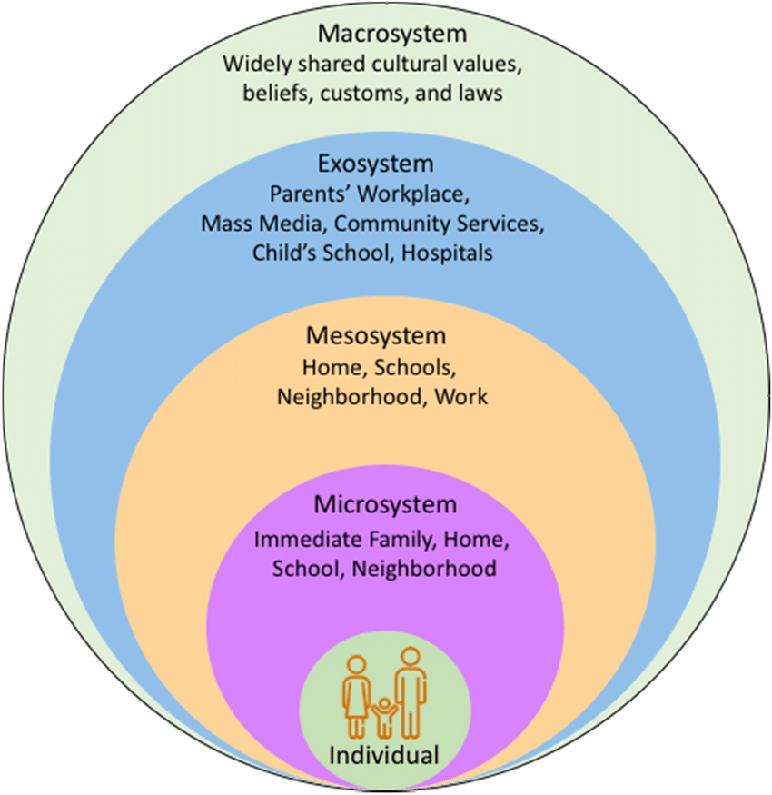
Bronfenbrenner's ecological model provides a framework for examining the intricate systems that shape human development. This model highlights the crucial role of environmental and social factors in influencing behaviour and growth. Taking a holistic perspective, the model proposes that child development results from the dynamic interaction of environmental, societal, biological, and psychological influences. According to Bronfenbrenner, development is shaped by a reciprocal relationship between the individual and the multiple layers of influence within their surroundings. This model explains how individuals interact with their environments and how these complex relationships shape development over time. It emphasizes that a person’s surroundings consist of multiple interconnected systems that work together to influence growth and behaviour. Development is affected by both an individual’s immediate environment and the larger cultural context in which they live. The theory highlights the interdependence between people and their surroundings, with Bronfenbrenner proposing that supportive and nurturing environments contribute to more positive developmental outcomes (Cherry, K. 2023).
Each system in Bronfenbrenner’s model interacts in complex ways with other systems. For instance, a child's family environment (microsystem) can influence how they engage with peers and teachers at school (another microsystem). The connections between these environments, known as the mesosystem, can then affect a child's behaviour and academic performance. These systems do not operate in isolation, nor are their effects limited to adjacent levels. Interactions at one level can create ripple effects across multiple layers of influence. For example, parental workplace stress may affect how they interact with their children at home. Similarly, broader economic shifts within a society (chronosystem) can impact the availability of community resources (ecosystem), ultimately influencing family dynamics (microsystem). By closely analysing these interactions, we can develop a deeper understanding of the interconnected nature of Bronfenbrenner’s ecological systems and their role in shaping development (Cherry, K. 2023).

Rosenberg, J., Leung, J.K., Harris, K., and Rosenthal, M.S. (2022)
Health
Children’s development and mental health are influenced by factors like the environments they grow up in, the relationships they form, and the experiences they encounter. Child development encompasses physical, cognitive, emotional, and social growth throughout a child's life. Mental health, which includes cognitive, behavioural, and social well-being, is shaped by this development, along with additional influences such as trauma and abuse. All aspects of a child’s health and development are interconnected, contributing to their overall well-being. Our resources are designed to help you learn more about child health and development, recognise and address signs of mental health concerns, and support positive health and growth in children (NSPCC, 2025). Protecting and enhancing children's health is crucial. Over the past few decades, significant progress has been made in improving child health and reducing mortality rates. For example, the number of children dying before the age of five was reduced by half from 2000 to 2017, and more mothers and children are surviving than ever before. Nevertheless, much work remains to be done to further improve children's health outcomes. The world faces a dual challenge. Over half of child deaths result from conditions that could be easily prevented or treated with access to healthcare and improvements in living conditions. At the same time, children must be provided with a stable environment where they can thrive, including proper health and nutrition, protection from harm, and access to opportunities for learning and development. Investing in children is one of the most vital actions a society can take to ensure a better future (World Health Organization (WHO), 2025).
To reach their full potential, children require high-quality healthcare and services, particularly during the early stages of life. The period between pregnancy and age 3, when the brain is most vulnerable to environmental factors, is critical for a child’s growth and development. Every child, including those with disabilities, developmental delays, those living in poverty, and those affected by conflict or displacement, needs nurturing care and healthcare services to survive and thrive. Unfortunately, millions of children do not receive the care they need. In many areas, healthcare systems are not adequately equipped to support regular health interactions between children, families, and caregivers. Without consistent monitoring, some children miss out on specialized health services and developmental support that are essential for helping them reach their full potential. Early interventions are particularly vital for children with developmental delays and disabilities, yet many lack access to primary healthcare systems that can provide these services (UNICEF, 2025).

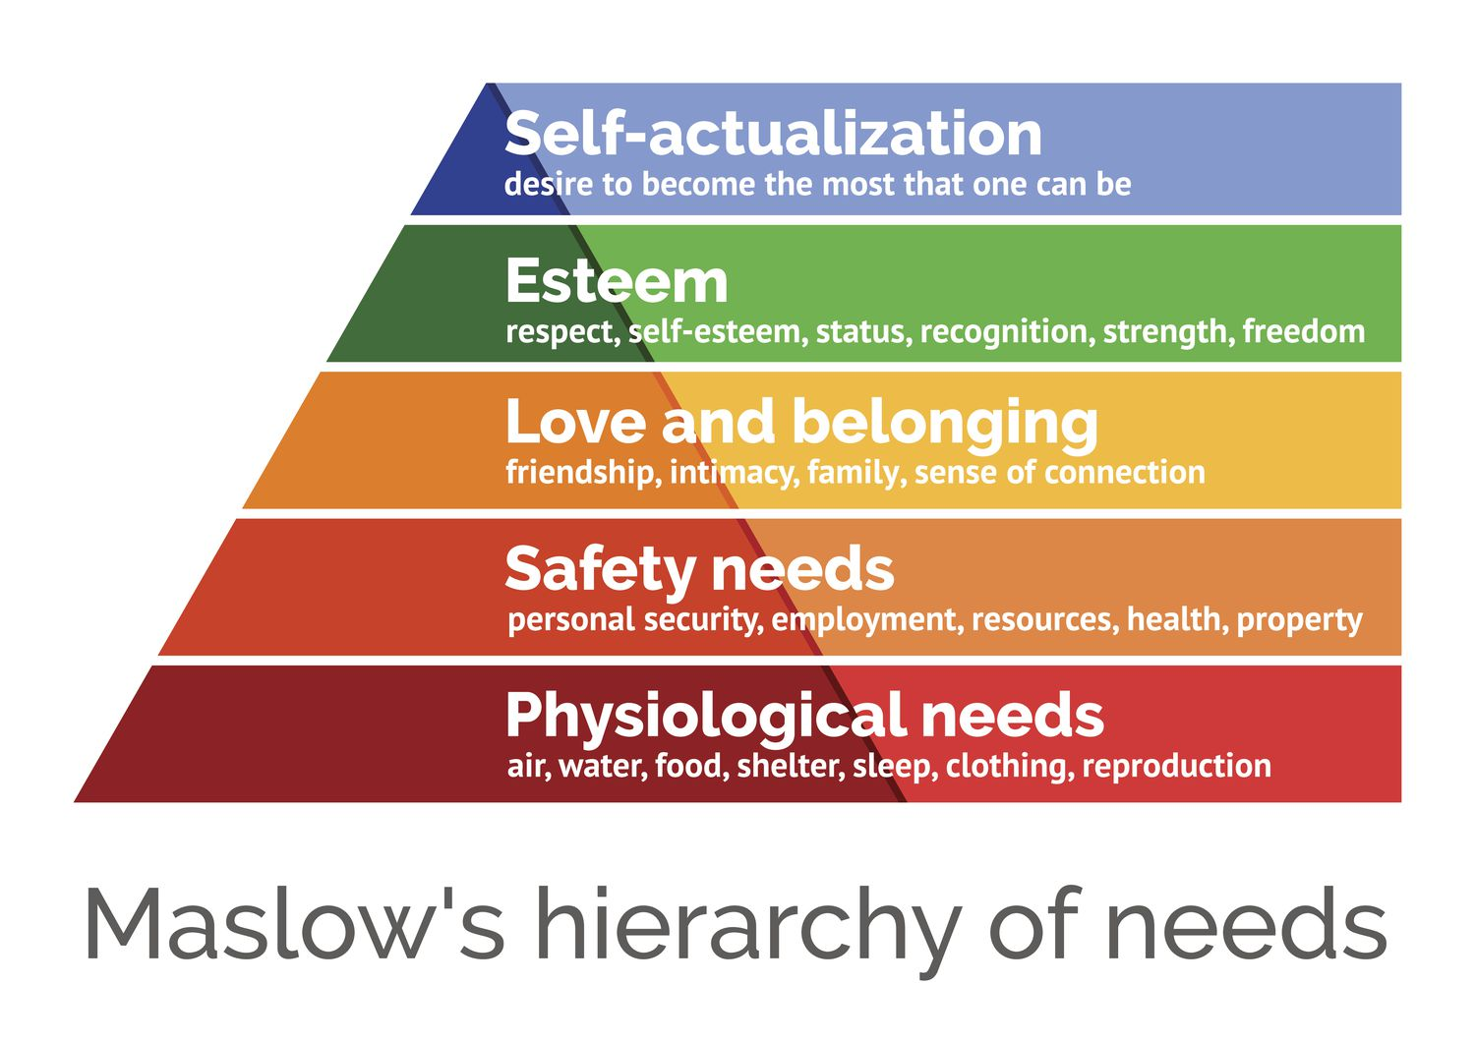
Hopper, E. (2024)
Abraham Maslow first introduced the theory of a Hierarchy of Needs in his 1943 paper, labelled "A Theory of Human Motivation," and again in his successive book, "Motivation and Personality." This hierarchy indicates that people are motivated to supply basic needs before transferring on to another, extra progressed requirements While many psychological approaches of the time, such as psychoanalysis and behaviourism, primarily focused on problematic behaviours, Maslow was more interested in understanding what contributes to human happiness and the steps individuals take to achieve it. As a humanist, Maslow argued that people have an innate drive toward self-actualization—fulfilling their full potential. However, before reaching this ultimate goal, certain fundamental needs must first be satisfied, including physiological necessities like food, as well as the need for safety, love, and self-esteem (Lester et al., 1983). Maslow viewed these needs as instinctual and essential motivators of human behaviour. His theory outlines five distinct levels of needs, beginning with the most basic physiological requirements (Cherry, K. 2024)

References for Poster
Addiction Therapy & Research Journal, 2025. Balancing a child’s intake of sugary treats and engaging in activities for a well-balanced lifestyle. [online] Available at: https://www.addictiontherjournal.com/articles/jatr-aid1028.php#:~:text=Balancing%20a%20child's%20intake%20of,for%20a%20well%2Dbalanced%20lifestyle [Accessed 15 January 2025].
Alderman, H., 2021. Health promotion and its effects on absenteeism, academic outcomes, and risk behaviour prevention. PMC [online] Available at: https://pmc.ncbi.nlm.nih.gov/articles/PMC10169174/#:~:text=Health%20promotion%20also%20leads%20to,disease%20%5B14%2C%2080%5D [Accessed 29 January 2025].
Bradshaw, J., Hoelscher, P. and Richardson, D., 2009. Child wellbeing in the UK: A study of the factors influencing the well-being of children in the UK. [pdf] Available at: https://assets.publishing.service.gov.uk/media/5a7acd89ed915d71db8b2946/Child-Wellbeing-Brief.pdf [Accessed 29 January 2025].
Cherry, K. (2023). 'A Comprehensive Guide to the Bronfenbrenner Ecological Model', Verywell Mind. Available at: https://www.verywellmind.com/bronfenbrenner-ecological-model-7643403 (Accessed: 29 January 2025).
Cherry, K. (2024). 'Maslow's Hierarchy of Needs', Verywell Mind. Available at: https://www.verywellmind.com/what-is-maslows-hierarchy-of-needs-4136760 (Accessed: 29 January 2025).
Department for Education, 2013. Smart restart: An overview of the children’s wellbeing in England. [pdf] Available at: https://assets.publishing.service.gov.uk/media/5a7c72c5e5274a5255bceb73/Smart_Restart_280813_web.pdf [Accessed 29 January 2025].
Dilan & Me, 2025. How do my child’s lifestyle choices impact their education? [online] Available at: https://dilanandme.com/how-do-my-childs-lifestyle-choices-impact-their-education/#:~:text=In%20conclusion%2C%20a%20child's%20lifestyle,and%20reach%20their%20full%20potential [Accessed 15 January 2025].
Hopper, E. (2024). 'Maslow's Hierarchy of Needs Explained', ThoughtCo. Available at: https://www.thoughtco.com/maslows-hierarchy-of-needs-4582571 (Accessed: 29 January 2025).
NSPCC, 2025. Child health and development. [online] Available at: https://learning.nspcc.org.uk/child-health-development#:~:text=Children's%20development%20and%20mental%20health,health%20and%20development%20in%20children [Accessed 28 January 2025].
NSPCC, 2025. Promoting mental health and wellbeing. [online] Available at: https://learning.nspcc.org.uk/child-health-development/promoting-mental-health-wellbeing [Accessed 15 January 2025].
Rosenberg, J., Leung, J.K., Harris, K., and Rosenthal, M.S. (2022). 'Bronfenbrenner Ecological Systems Theory', in Recently Arrived Afghan Refugee Parents’ Perspectives About Parenting, Education and Paediatric Medical and Mental Health Care Services, Journal of Immigrant and Minority Health. Available at: https://www.researchgate.net/figure/Bronfebrenner-ecological-systems-theory_fig1_351281465 (Accessed: 29 January 2025).
The Children's Society, 2025. Well-being. [online] Available at: https://www.childrenssociety.org.uk/what-we-do/our-work/well-being#:~:text=Right%20now%2C%20children's%20wellbeing%20is,It's%20unacceptable [Accessed 28 January 2025].
UNICEF, 2025. Health and child development. [online] Available at: https://www.unicef.org/health/health-and-child-development [Accessed 28 January 2025].
World Health Organization (WHO), 2025. Child health. [online] Available at: https://www.who.int/health-topics/child-health#tab=tab_1 [Accessed 29 January 2025].

Speech
How does mental health in children affect their learning
Introduction (Define your chosen theme)
Today I will be talking about Mental Health in children. Mental health issues in children are typically described by disruptions or changes in thinking, behaviour, social skills, or emotional dysregulation. These challenges cause distress for children and interfere with their ability to function effectively at home, in school, or other social environments (Mayo Clinic, 2024).
Poverty plays a major role in contributing to mental health issues among young people and their families. There is an Emotional Support for Young People program which has demonstrated that poverty also limits a family's ability to offer the emotional support necessary for children to grow into healthy adults (Kelly, M and Whitworth, A, 2024). A strong connection exists between broader factors influencing health, like economic stability, and the mental health outcomes of young people. Studies have demonstrated that emotional support can serve as a protective factor or a "buffer" for young people’s mental health.
In the Health Foundations inquiry on the future health of young people, participants aged 12–24 highlighted a clear relationship between their mental health and the emotional support they received from their families. They also acknowledged how social and economic conditions impacted their family members’ ability to provide this support (The Health Foundation, no date).
An NHS England 2024, article states that one in 5 children aged 8 to 25 had mental problems in 2023 (NHS England, 2024). Children’s mental health can have relations to their living environment, poverty can be a key risk for children to develop mental issues; the commonness of mental ill health among children and young people has increased with the cost of living because more children and young people are currently living in poverty which can affect a child's mental wellbeing (Save the Children, 2023).
Due to the COVID-19 pandemic, the direct effects of lockdown on the mental health and well-being of children and young people show mixed results. Some research suggests that children in quarantine may be more likely to experience Post Traumatic Stress Disorder (PTSD) symptoms. In general, studies indicate higher levels of distress, anxiety, and worry. Contributing factors likely include heightened feelings of loneliness, as well as concerns about school and the future (Mental Health Foundation, 2020).
Many children, teenagers, and young adults continue to shy away from school, social interactions, or taking part in team sports and activities. Some children who were previously involved in such activities before the pandemic may struggle with inclusion. Others have developed a strong interest in video games, as they offer an opportunity for escape and immersion in a virtual, engaging environment without needing in-person interactions (Psychology Today, 2023).
Why is it significant (For example obesity, how can it affect health and well-being in young children?)
Mental health is just as fundamental to a child's safety and well-being as their physical health. It can affect every aspect of their life, including their physical health, relationships, and academic success. A child's mental health can fluctuate over time, varying in severity and influenced by different factors.
Mental health is a significant concern for children. In 2023/24, more than half of all Childline counselling sessions were related to mental or emotional health and well-being.
Negative experiences such as abuse, and neglect can have a harmful effect on a child's mental health. In some cases, mental health problems may lead to child protection and safeguarding concerns, especially if the child's mental health starts to pose a risk to themselves or others (NSPPC Learning, no date).
Adverse Childhood Experiences (ACEs) are becoming an increasingly significant global issue. Research shows that the challenges faced during childhood can have long-lasting effects on health. Children who grow up in stressful and unhealthy environments are more likely to engage in behaviours that harm their health during adolescence, potentially leading to mental health disorders and chronic diseases like cancer, heart disease, and diabetes later in life. ACEs are not only a health concern but also impact other areas of life. Individuals who experience ACEs are more prone to academic struggles, higher rates of criminal involvement, and are ultimately less likely to contribute positively to society (Public Health Wales, 2015).
Young people with mental health disorders are more prone to feeling unhappy at school, experiencing higher rates of absence, or facing interruption or removal. Their ability to learn is hindered by issues such as poor focus, obliviousness, difficulty remembering information, strained peer relationships, and aggressive behaviour. Additionally, they may become withdrawn and hard to involved in activities (Youth.gov, no date).
The connections a parent has with their child are crucial for their emotional growth. When they feel heard and supported, it aids them in learning how to handle life's challenges and manage negative emotions. This capacity to endure, adapt, and bounce back is known as resilience (Children First, no date).
Who tells us ( Use a range of resources to support your discussions)
Many articles talk about mental health in children, and many of these talk about poverty and mental health. From my findings, it seems that poverty is the main factor in children’s mental health. The environment in which children and adolescents grow up plays a crucial role in their well-being and development. Negative early experiences in settings like homes, schools, or online spaces—such as exposure to violence, parental mental illness, bullying, and poverty—heighten the risk of mental health issues.
Mental health conditions, including childhood epilepsy, developmental disabilities, depression, anxiety, and behavioural disorders, are significant contributors to illness and disability in young people. Globally, 8% of children and 15% of adolescents suffer from mental disorders, but most do not seek or receive treatment. Suicide ranks as the third leading cause of death among 15-29-year-olds. Failing to address mental health and psychosocial development in children and adolescents can have long-lasting effects into adulthood, hindering their ability to lead fulfilling lives (WHO 2023).
The World Health Organization (WHO) aids Member States in creating and executing multisectoral, evidence-based, human rights-centred strategies to promote mental health, prevent mental disorders, and ensure access to mental health care for children, adolescents, and their families (World Health Organization (WHO), 2023)
The British Education Research Association 2023, article states that early education was significantly interrupted by the COVID-19 Pandemic, millions of children across the globe missed out on the opportunity to be in school, due to the schools being closed and only open to key workers children. Studies have highlighted the effect on children’s learning, development, and their social well-being, the research was carried out across the UK and Ireland, the children this affected the most, are children who come from deprived backgrounds and children with special learning needs (BERA, 2023).

Application ( What can we do about it, give example from practice and research evidence)
To improve access to early mental health support in schools and colleges, school practitioners are increasing the number of Mental Health Support Teams (MHSTs). These teams assist with common mental health issues like anxiety and low mood and also help schools and colleges develop their approach to mental health and wellbeing. They work with local specialist services when necessary. By March 2025, the goal is to extend this support to at least 50% of pupils and students across England.
Additionally, they are creating an online hub that will offer a variety of practical, evidence-based resources for mental health leads. This will include an interactive toolkit designed to help schools and colleges identify and develop targeted support for pupils and students with Social, Emotional, and Mental Health (SEMH) needs (Department for Education, 2023).
Launched in 2018, the Children and Young People’s Mental Health Implementation Programme aims to enhance mental health support for individuals aged 5 to 18 years. This government-led initiative funds mental health support teams and mental health leads in schools and further education colleges (excluding universities). In the programme's first phase, 58 mental health support teams were established, serving 1,050 schools across 25 ‘Trailblazer’ areas in England. These teams focus on supporting children with mild to moderate mental health issues while promoting overall well-being in schools. They offer guidance to teachers and coordinate with external specialist services to ensure pupils receive appropriate support and can continue their education. The programme also introduced a new role, the education of mental health practitioners.
Researchers have examined the experiences of those involved in setting up and managing these mental health support teams during the programme's first phase (National Institute for Health and Care Research (NIHR), 2023).
By identifying the signs, fostering open dialogue, working with professionals, supporting self-care, and embracing diversity, educators can serve as pillars of hope and assistance for children dealing with mental health issues. Through collective effort, we can guide our students towards mental well-being and a brighter future. Additionally, many organizations provide useful resources and guidance to teachers who are concerned about their students' mental health (Sugarman Education, 2025).
In conclusion, it is important to recognize that every individual has mental health, just as they have physical health. Just like physical health can change over time due to various factors, mental health can also fluctuate throughout a person's life. For babies and young children, the concept of mental health primarily refers to their overall well-being, particularly in relation to their emotional and social development. Each baby or young child will experience and express mental health in their own unique way, influenced by their temperament, environment, and early life experiences.
Several factors play a significant role in shaping a child's social and emotional development. One of the most critical influences is the quality of relationships they have with their parents and caregivers. Loving, responsive, and nurturing interactions help build a secure emotional foundation, while inconsistent or stressful relationships may contribute to challenges in mental well-being. Additionally, proper nutrition is essential for a child's overall development, including brain function, emotional regulation, and social engagement. Even experiences before birth, such as maternal stress, exposure to toxins, or prenatal nutrition, can have lasting effects on a child's mental health.
References for speech
British Educational Research Association (2023) Ethical Guidelines for Educational Research (5th edition). Available at: file:///C:/Users/Student/Documents/second%20year/ECEY5010/Ethical-Guidelines-for-Educational-Research-5th-edition.pdf (Accessed: 31/1/25).
Children First. (no date). Mental health issues in children. Available at: https://www.childrenfirst.org.uk/get-support/advice-for-families/guidance-advice/articles/mental-health-issues-in-children/#:~:text=Building%20coping%20skills,child%20development:%20Meet%20the%20Brains [Accessed 9 January 2025].
Department for Education, 2023. How we're helping look after the mental health of children and young people. [online] Available at: https://educationhub.blog.gov.uk/2023/10/how-were-helping-look-after-the-mental-health-of-children-and-young-people/ [Accessed 13 January 2025].
Kelly, M. and Whitworth, A., 2024. What is happening to young people’s mental health? The Health Foundation. Available at: https://www.health.org.uk/features-and-opinion/blogs/what-is-happening-to-young-people-s-mental-health?gad_source=1&gclid=CjwKCAiAm-67BhBlEiwAEVftNs0YISzEb93HfWU8ULj0Lk7pD4mxjOc6YQgQqOrusrQz8cbTWpA7GRoCzdoQAvD_BwE [Accessed 8 January 2025].
Mayo Clinic, 2024. Mental illness in children. Available at: https://www.mayoclinic.org/healthy-lifestyle/childrens-health/in-depth/mental-illness-in-children/art-20046577#:~:text=Mental%20health%20conditions%20in%20children,or%20in%20other%20social%20settings [Accessed 8 January 2025].
Mental Health Foundation, 2020. The impacts of lockdown on the mental health of children and young people. [online] Available at: https://www.mentalhealth.org.uk/explore-mental-health/publications/impacts-lockdown-mental-health-children-and-young-people#:~:text=Overall%2C%20studies%20point%20to%20increased,about%20school%20and%20the%20future [Accessed 13 January 2025].
National Institute for Health and Care Research (NIHR), 2023. Mental health support in schools is well-received, but challenges remain. [online] Available at: https://evidence.nihr.ac.uk/alert/mental-health-support-in-schools-is-well-received-but-challenges-remain/ [Accessed 13 January 2025].
NHS England. (2023). One in five children and young people had a probable mental disorder in 2023. NHS England. Available at: https://www.england.nhs.uk/2023/11/one-in-five-children-and-young-people-had-a-probable-mental-disorder-in-2023/ [Accessed 9 January 2025].
NSPCC. (no date). Child mental health. NSPCC. Available at: https://learning.nspcc.org.uk/child-health-development/child-mental-health [Accessed 9 January 2025].
Psychology Today, 2023. Are kids experiencing post-COVID long anxiety? [online] Available at: https://www.psychologytoday.com/gb/blog/special-matters/202303/are-kids-experiencing-post-covid-long-anxiety [Accessed 13 January 2025].
Public Health Wales (2015) Adverse Childhood Experiences and their Impact on health-harming Behaviours in the Welsh Population [PDF] Available at: https://www2.nphs.wales.nhs.uk/PRIDDocs.nsf/7c21215d6d0c613e80256f490030c05a/d488a3852491bc1d80257f370038919e/$FILE/ACE%20Report%20FINAL%20(E).pdf [Accessed 12 January 2025].
Save the Children. (2023). A dual crisis: Mental health and poverty in the UK. Save the Children. Available at: https://www.savethechildren.org.uk/content/dam/gb/reports/uk-child-poverty/centre_for_mh_a_dual_crisis.pdf [Accessed 9 January 2025].
Sugarman Education, 2025. 10 ways educators can support children's mental health. [online] Available at: https://sugarmaneducation.co.uk/10-ways-educators-can-support-childrens-mental-health/#:~:text=By%20recognising%20the%20signs%2C%20promoting,children%20facing%20mental%20health%20challenges [Accessed 15 January 2025].
The Health Foundation (no date) Emotional support for young people Available at: https://www.health.org.uk/funding-and-partnerships/programmes/emotional-support-for-young-people [Accessed 12 January 2025].
World Health Organization (WHO), 2023. Improving the mental and brain health of children and adolescents. [online] Available at: https://www.who.int/activities/improving-the-mental-and-brain-health-of-children-and-adolescents#:~:text=The%20quality%20of%20the%20environment,children%2C%20adolescents%20and%20their%20families [Accessed 13 January 2025].
Youth.gov. (no date). How mental health disorders affect youth. Available at: https://youth.gov/youth-topics/youth-mental-health/how-mental-health-disorders-affect-youth#:~:text=Elementary%20and%20Middle%20School,as%2018%20to%2022%20days.&text=The%20rates%20of%20suspension%20and,times%20higher%20than%20their%20peers [Accessed 9 January 2025].

