
Program: Master of Business Administration
Assessment 1
Title: Strategic Analysis of Spain’s Hospitality Industry and Meliá Hotels International

Name: Anika Ayub
Student ID: 2504343

Module Name: International Business Concepts
Module Code: LCMB7034

Lecturer’s Name: Gladius Kulothungan

Word Count: 5436

Term 2

Table of Contents

Section 1
1. Introduction 3
2. Industry and Country Overview 3
2.1 Introduction of the hospitality Industry within Spain 3
2.2 Size, scope, and economic importance of the hospitality industry 4
2.3 The major domestic and multinational firms operating within the industry 5
2.4 Relative positioning of key companies in the hospitality Industry of Spain 5
3. Michael Porter’s Diamond Model 7
4. Evaluation of factors impacting the Meliá Hotels International in Spain 11
4.1 PESTEL Analysis 11
4.2 Porter’s Five Forces Analysis 15
4.3 SWOT Analysis 17
4.4 Hofstede’s Cultural Distance Analysis 19
5. Conclusion 22

Section 2
Reflective Account Using Gibbs’ Reflective Cycle 23
Summary 27
Conclusion 27
Bibliography 28

Section 1
- Introduction
The hospitality industry is a vital contributor to global economic development, particularly in countries such as Spain where it plays a central role in national growth and employment. This report critically analyses the hospitality industry in Spain, focusing on its structure, competitiveness and strategic environment. It begins with an overview of the industry, highlighting its size, scope and economic importance, followed by an evaluation of key domestic and multinational firms operating within the sector (Díaz-Muñoz, 2019; UNWTO, 2020). The report then applies Porter’s Diamond Model to assess Spain’s global competitiveness in hospitality (Porter, 1990).
Furthermore, the study examines Meliá Hotels International as a major industry player through frameworks such as PESTEL, Porter’s Five Forces, SWOT and Hofstede’s Cultural Dimensions to evaluate external and internal influences on its performance (Johnson, Scholes & Whittington, 2017; Hofstede, Hofstede & Minkov, 2010). Overall, the report provides a comprehensive strategic analysis of Spain’s hospitality sector and its business environment.
- Industry and Country Overview
2.1 Introduction of the hospitality Industry within Spain
hospitality is one of the most globally integrated service industries, encompassing transportation, accommodation, hospitality, cultural experiences and leisure services (Pearce, 2018). In Spain, hospitality is a cornerstone of socio-economic development and international exchange. The sector comprises both domestic travel and inbound international hospitality, with Spain historically ranking among the world’s top destinations (Díaz-Muñoz, 2019). Characterised by its cultural heritage, diverse landscapes, Mediterranean climate, and well-established infrastructure, Spanish hospitality contributes to national identity and international soft power (Richards, 2020). The country’s hospitality landscape includes seaside resorts, urban cultural centres, rural and eco-tourism offerings, and world-renowned events such as festivals and sporting fixtures, which together shape Spain’s global tourism brand.

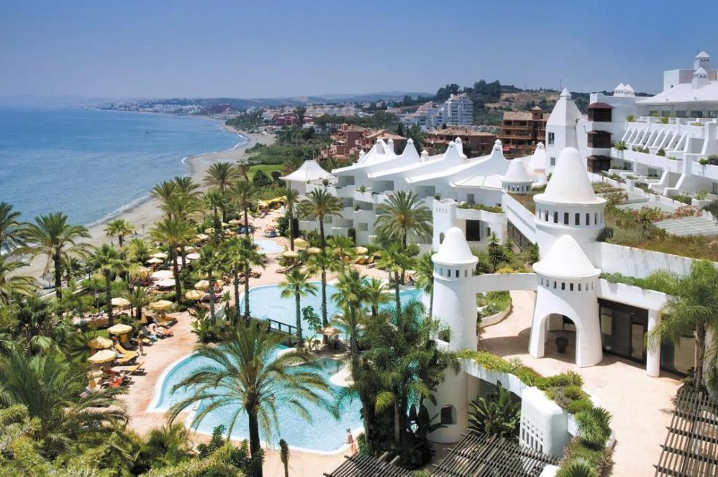
Figure 1: Hospitality Industry in Spain (The Times, 2026)

2.2 Size, scope, and economic importance of the hospitality industry
The Spanish hospitality industry represents a significant proportion of national economic activity. In 2019—prior to global travel disruptions—Spain received over 83 million international tourists, making it the second most visited country worldwide after France (UNWTO, 2020). According to the World Tourism Organization, tourism accounted for approximately 12.3% of Spain’s GDP and 13.7% of total employment in 2019 (UNWTO, 2020). Domestic tourism also remains a substantial contributor, with Spaniards undertaking millions of internal trips annually, which supports regional economies beyond international gateways.
The scope of tourism in Spain extends across geographic and product segments. Coastal regions such as the Costa del Sol and Balearic Islands dominate sun-and-sea hospitality, while cities including Barcelona, Madrid, and Seville have developed strong cultural tourism markets anchored on heritage sites, museums, and gastronomy (Díaz-Muñoz, 2019). Rural and nature-based hospitality, anchored in national parks and “pueblos blancos”, has grown in response to diversification strategies aimed at reducing seasonal dependency and overcrowding in major destinations (Richards & Wilson, 2021). This growth, however, has raised concerns regarding overtourism and environmental degradation, particularly in urban destinations such as Barcelona.
Economically, hospitality injects foreign exchange into Spain’s economy and stimulates investment in infrastructure, including airports, hotels, transportation networks and digital platforms. Multiplier effects of hospitality expenditure generate demand in construction, retail and food services, while tourism taxation provides crucial public revenues (Bello & Roig, 2017). The COVID-19 pandemic temporarily disrupted these contributions; however, recent recovery trajectories indicate a strong rebound, with international arrivals approaching pre-pandemic levels and tourism spending increasingly resilient (García & García, 2022).

2.3 The major domestic and multinational firms operating within the industry
The hospitality industry in Spain is dominated by a combination of strong domestic firms and influential multinational companies. Among domestic leaders, Meliá Hotels International, RIU Hotels & Resorts and Grupo Hotusa play significant roles in hospitality, offering global hotel operations and management services (Ivanov & Webster, 2019). eDreams ODIGEO represents Spain’s strength in digital travel distribution, serving over 21 million customers worldwide across multiple markets. Additionally, Viajes El Corte Inglés is a major domestic travel agency, particularly strong in corporate and leisure segments (Buhalis & Laws, 2001).
Multinational firms such as Marriott International, Accor and Hyatt Hotels Corporation have expanded their presence in Spain, intensifying competition (Porter, 1990). Overall, the coexistence of strong domestic firms and global players creates a highly competitive and dynamic hospitality industry.
2.4 Relative positioning of key companies in the hospitality industry of Spain

Company | Strategy | Key Market Segments | Positioning in Spain | Competitive Strengths
Meliá Hotels International | Asset-light expansion, brand segmentation and sustainability focus (Porter, 1990; Ivanov & Webster, 2019) | Luxury, upscale leisure, business travellers | Leading premium global hotel chain with strong international presence (Ivanov & Webster, 2019) | Strong brand equity, global reach, diversified portfolio, sustainability initiatives (Ivanov & Webster, 2019)
Viajes El Corte Inglés | Omnichannel distribution and service differentiation (Buhalis & Laws, 2001) | Leisure tourists, corporate travel, MICE | Dominant domestic intermediary with strong offline presence (Buhalis & Laws, 2001) | Established customer trust, extensive network, strong service quality (Buhalis & Laws, 2001)
Grupo Hotusa | Hybrid model (ownership, franchising and distribution) (Ivanov & Webster, 2019) | Business travellers, cultural tourists | Strong mid-to-upscale urban positioning (Ivanov & Webster, 2019) | Strategic city locations, diversified operations, stable year-round demand (Ivanov & Webster, 2019)
RIU Hotels & Resorts | Standardised all-inclusive resort model (Porter, 1990; Ivanov & Webster, 2019) | Mass leisure, holiday tourists | Leader in all-inclusive resort segment (Ivanov & Webster, 2019) | Economies of scale, operational efficiency, strong partnerships with tour operators (Ivanov & Webster, 2019)
eDreams ODIGEO | Digital platform strategy, price comparison and global reach (Xiang, Magnini & Fesenmaier, 2015) | Price-sensitive travellers, online users | Leading online travel agency with global reach (Xiang et al., 2015) | Scalability, technological capability, wide customer base, cost efficiency (Xiang et al., 2015)

Figure 2: Relative positioning of key companies (Source: Self Developed)
Overall, hospitality firms such as Meliá and RIU compete through differentiation and service quality, while intermediaries like Viajes El Corte Inglés and eDreams focus on distribution efficiency and customer access (Buhalis & Laws, 2001; Xiang et al., 2015). This highlights a segmented yet highly competitive hospitality industry in Spain (Ivanov & Webster, 2019).
- Michael Porter’s Diamond Model
Michael Porter’s Diamond Model of National Advantage explains how a nation’s global competitiveness is shaped by four interrelated determinants—factor conditions, demand conditions, related and supporting industries, and firm strategy, structure and rivalry—which collectively influence firms’ ability to innovate and compete internationally (Porter, 1990). Applying this framework to Spain’s hospitality industry provides a critical understanding of its sustained global leadership.
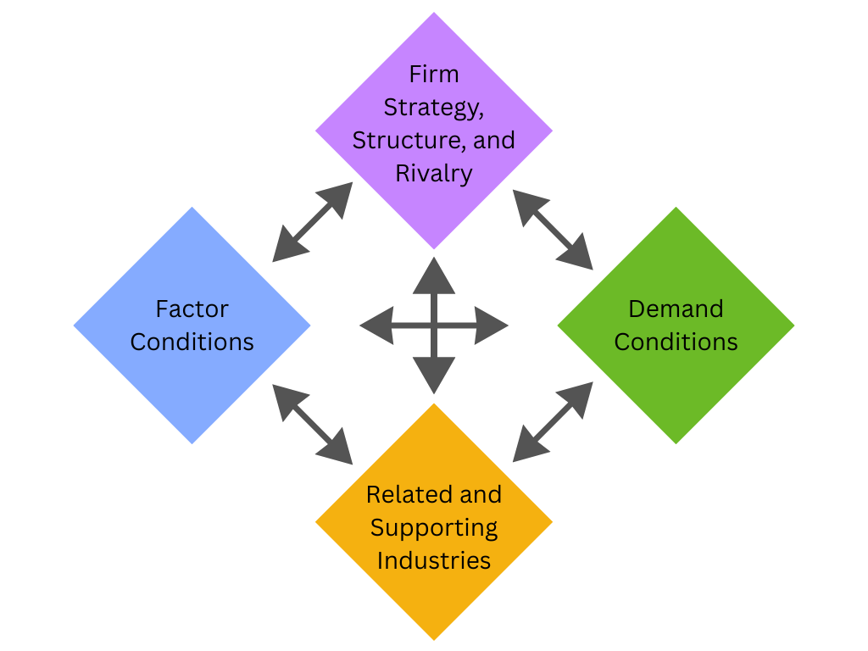
Figure 3: Porter’s Diamond Model Analysis (Source: Self Developed)

Factor Conditions
Factor conditions refer to a nation’s endowment of production factors, including natural resources, infrastructure, human capital and technological capabilities (Porter, 1990). Spain possesses strong basic factors, notably its Mediterranean climate, extensive coastline, diverse geography and rich cultural heritage. These attributes underpin its long-standing dominance in sun-and-sea hospitality and cultural hospitality markets (Díaz-Muñoz, 2019). The country’s UNESCO-listed heritage sites and globally recognised festivals reinforce its destination attractiveness.
Beyond natural endowments, Spain has invested significantly in advanced factors. High-speed rail (AVE), modernised airports and integrated highway systems enhance accessibility and inter-regional connectivity (Graham, Papatheodorou & Forsyth, 2019). Advanced hospitality training institutions and experienced service-sector labour further strengthen service quality and operational efficiency (Ivanov & Webster, 2019). Such advanced factors are crucial for sustaining competitive advantage, as Porter (1990) argues that innovation and upgrading, rather than inherited resources alone, drive long-term success.
However, heavy reliance on climate-sensitive coastal hospitality exposes Spain to seasonality and environmental stress. Overhospitality in cities such as Barcelona demonstrates the limits of resource-based competitiveness if not managed sustainably (Richards, 2020). Therefore, while Spain’s factor conditions are strong, their sustainability depends on continued investment in environmental management, digitalisation and diversification.

Demand Conditions
Demand conditions relate to the size, sophistication and diversity of home and international markets (Porter, 1990). Spain benefits from a substantial domestic hospitality market, which provides resilience during international downturns (Bello & Roig, 2017). Domestic consumers increasingly demand higher-quality, experiential and sustainable hospitality products, encouraging firms to innovate beyond standardised mass packages.
Internationally, Spain is consistently ranked among the world’s most visited destinations, with diversified source markets across Europe and growing long-haul demand (UNWTO, 2020). Exposure to sophisticated European travellers exerts competitive pressure on Spanish firms to maintain high service standards, multilingual capabilities and differentiated offerings. Porter (1990) suggests that demanding customers drive innovation, and Spain’s need to satisfy culturally diverse visitors fosters adaptability.
Nevertheless, dependence on a limited number of European markets, particularly the UK and Germany, creates vulnerability to economic or political disruptions in those countries. The COVID-19 pandemic illustrated how external demand shocks can significantly reduce hospitality flows (García & García, 2022). Hence, while demand conditions stimulate competitiveness, concentration risks persist.

Related and Supporting Industries
Competitive industries are reinforced by strong domestic clusters of related sectors (Porter, 1990). Spain’s hospitality industry benefits from a well-developed transportation sector, including globally connected airlines and efficient airport infrastructure (Graham et al., 2019). The integration of low-cost carriers has stimulated inbound hospitality by increasing affordability and route density (O’Connell & Williams, 2016).
Spain’s gastronomy sector, recognised for culinary innovation and regional diversity, strengthens gastronomic hospitality and destination branding (Richards, 2020). Construction and real estate industries have historically supported large-scale resort development, particularly in coastal regions (Bello & Roig, 2017). Furthermore, digital platforms and online travel agencies enhance distribution efficiency and global reach.
Cluster effects are evident in hospitality-intensive regions such as the Balearic Islands and Catalonia, where hotels, entertainment providers and transport operators interact closely. Porter (1990) argues that such clusters promote knowledge spillovers and productivity gains. However, excessive concentration can also generate environmental degradation and social resistance, threatening long-term sustainability (Richards, 2020). Thus, while related industries enhance competitiveness, spatial imbalances remain a challenge.

Firm Strategy, Structure and Rivalry
Firm strategy and domestic rivalry are central to national advantage (Porter, 1990). Spain’s hospitality sector is characterised by strong competition among domestic hotel chains, international brands and low-cost airlines. Domestic firms such as Meliá and NH Hotel Group have pursued internationalisation strategies, sustainability certification and brand segmentation to maintain global relevance (Ivanov & Webster, 2019). Their expansion into Latin America and Asia demonstrates strategic upgrading.
Intense rivalry in the airline sector, particularly between full-service carriers and low-cost operators, has driven cost efficiencies and route expansion (O’Connell & Williams, 2016). Competition among accommodation providers has stimulated innovation in service differentiation, loyalty programmes and digital transformation. Porter (1990) maintains that such rivalry fosters productivity and global competitiveness.
However, smaller hospitality enterprises, which form a significant proportion of Spain’s industry, may lack capital and technological capacity to compete with multinational corporations. The uneven distribution of resources within the industry may weaken aggregate competitiveness if SMEs cannot upgrade effectively. Additionally, pressure to reduce prices in mass hospitality segments risks eroding profitability and brand value.

Critical Evaluation
Applying Porter’s Diamond reveals that Spain’s hospitality competitiveness is underpinned by strong natural and advanced factors, sophisticated international demand, robust supporting industries and dynamic domestic rivalry. The interaction among these determinants reinforces Spain’s global position as a leading hospitality destination.
Nevertheless, structural vulnerabilities persist. Environmental degradation, seasonality, market concentration and overhospitality challenge sustainable growth. Porter (1990) emphasises that competitive advantage is dynamic and requires continuous upgrading. Spain’s long-term competitiveness will depend on diversifying markets, investing in sustainable practices and strengthening SME innovation capacity.
Overall, the Diamond Model demonstrates that Spain possesses a resilient and multifaceted competitive base in hospitality, yet maintaining global leadership requires strategic adaptation to environmental, economic and demand-side changes.
- Evaluation of factors impacting the Meliá Hotels International in Spain

4.1 PESTEL Analysis
PESTEL analysis is a strategic framework used to evaluate the macro-environmental factors—political, economic, social, technological, environmental and legal—that influence an organisation’s performance and strategic decision-making (Johnson, Scholes & Whittington, 2017). Applying this framework enables a critical evaluation of the external factors shaping Meliá Hotels International’s operations in Spain.
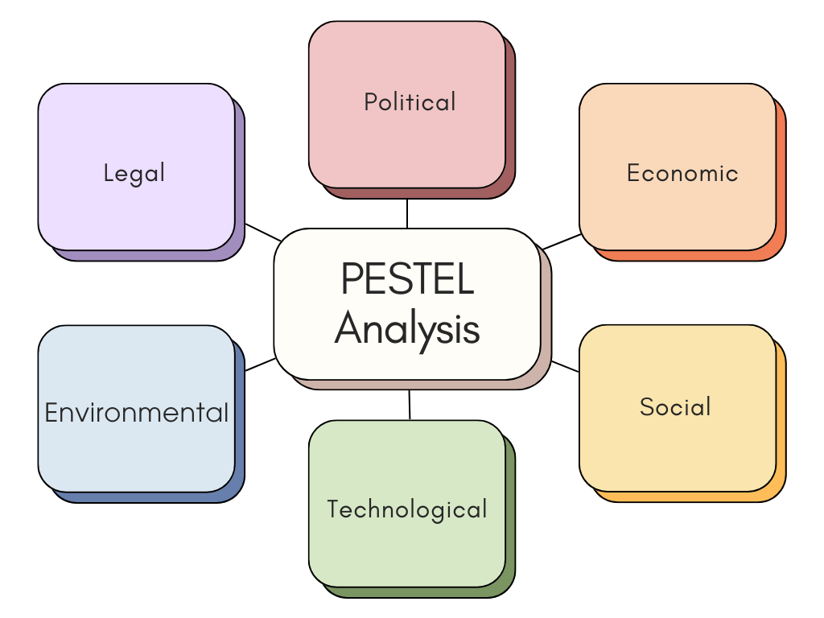
Figure 4: PESTEL Analysis of Meliá Hotels International (Self Developed)

Political Factors
Spain provides a relatively stable political environment, which supports hospitality development and long-term investment (Porter, 1990). Government policies strongly support hospitality due to its contribution to GDP and employment, encouraging infrastructure investment and international promotion (Dwyer, Forsyth & Dwyer, 2020). This creates favourable conditions for Meliá’s expansion and operational stability.
However, increasing political attention to overhospitality has led to stricter local regulations in destinations such as Barcelona and the Balearic Islands (Richards, 2020). These include potential limits on tourist numbers and tighter zoning laws, which may restrict hotel expansion. Therefore, while political stability enhances market attractiveness, regulatory tightening may constrain future growth (Porter, 1990).

Economic Factors
hospitality demand is highly sensitive to economic conditions, as it is largely discretionary spending (Dwyer et al., 2020). Spain’s strong hospitality-driven economy supports Meliá’s revenue growth, particularly through high international arrivals and spending. Improved performance indicators such as occupancy rates and revenue per available room reflect this favourable environment (Ivanov & Webster, 2019).
Nevertheless, Meliá faces exposure to economic volatility. Inflation, rising labour costs and energy prices increase operational expenses, while global economic downturns can reduce travel demand (Dwyer et al., 2020). Additionally, heavy reliance on the Spanish and European markets increases vulnerability to regional economic shocks. Thus, although the economic environment is attractive, it remains cyclical and risk-prone.

Social (Cultural) Factors
Social and cultural factors significantly influence hospitality demand. Spain’s rich cultural heritage, gastronomy and lifestyle enhance its global appeal, supporting sustained tourist inflows (Richards, 2020). Changing consumer preferences towards experiential and sustainable hospitality create opportunities for Meliá to differentiate its offerings and strengthen brand positioning.
However, rising anti-hospitality sentiment in major cities, driven by concerns over housing costs and overcrowding, presents challenges (Richards, 2020). This may lead to stricter regulations and reputational risks for large hotel chains. Additionally, labour shortages in the hospitality sector, partly due to rising living costs, create operational difficulties (Ivanov & Webster, 2019). Therefore, while cultural attractiveness supports demand, social tensions may negatively impact long-term sustainability.

Technological Factors
Technological advancements play a critical role in enhancing competitiveness in the hospitality industry. Digital platforms, online booking systems and data analytics enable firms to improve customer experience and operational efficiency (Buhalis & Law, 2008). Meliá has adopted digital transformation strategies to strengthen direct bookings and customer relationship management.
However, the rise of online travel agencies increases price transparency and intensifies competition, reducing margins for hotel operators (Xiang, Magnini & Fesenmaier, 2015). Continuous investment in technology is necessary to remain competitive, but this also increases costs. Thus, technology presents both opportunities for innovation and challenges in maintaining profitability.

Environmental Factors
Environmental sustainability is increasingly important in hospitality competitiveness. Spain faces environmental challenges such as climate change, water scarcity and coastal degradation, which directly affect hospitality destinations (Gössling, Scott & Hall, 2015). These issues are particularly relevant for Meliá due to its concentration in coastal areas.
Regulatory pressures for sustainability are increasing, requiring firms to reduce emissions and adopt environmentally friendly practices (Gössling et al., 2015). Meliá’s sustainability initiatives enhance its brand image and align with growing consumer demand for responsible hospitality. However, these initiatives involve significant investment, increasing operational costs. Environmental risks, including extreme weather events, also pose potential threats to long-term performance.

Legal Factors
The legal environment shapes operational conditions through taxation, labour laws and regulatory compliance (Johnson et al., 2017). Spain’s corporate tax structure and VAT on hospitality services directly impact profitability. Additionally, compliance with EU regulations, such as data protection laws and consumer rights directives, increases operational complexity.
Labour regulations, including minimum wage policies and employment protections, contribute to rising labour costs but ensure workforce stability (Dwyer et al., 2020). Furthermore, stricter regulations on short-term rentals may benefit hotel operators by reducing competition from alternative accommodation providers. However, increasing legal restrictions related to sustainability and hospitality management may limit expansion opportunities.

Critical Evaluation
Spain remains a highly attractive market for Meliá due to strong demand, advanced infrastructure and government support. Political stability and sophisticated consumer demand enhance competitiveness. However, the PESTEL analysis highlights several challenges.
Economic volatility, environmental pressures and social resistance to overhospitality present significant risks. Technological advancements require continuous investment, while legal regulations increase compliance costs. According to Porter (1990), sustained competitive advantage depends on the ability to adapt and innovate in response to such external pressures.
Meliá’s strategic focus on premium services, sustainability and digital transformation aligns well with these challenges. However, its reliance on the Spanish market increases exposure to local risks. Therefore, diversification and continuous innovation are essential to maintain long-term competitiveness.

4.2 Porter’s Five Forces Analysis
Porter’s Five Forces analysis is a framework used to assess the competitive structure of an industry by examining five forces—competitive rivalry, threat of new entrants, bargaining power of suppliers, bargaining power of buyers, and threat of substitutes—that determine profitability and strategic positioning (Porter, 2008). Applying this model helps evaluate the factors influencing the success of Meliá Hotels International in Spain.

Competitive Rivalry (High)
Competition in the hotel and hospitality industry is intense due to the presence of both global chains and domestic operators. Firms compete on pricing, service quality, branding and customer experience (Porter, 2008). Meliá faces strong rivalry from multinational brands such as Marriott and Accor, as well as regional players. Competitive rivalry within the tourism industry is intense due to the presence of a large number of competing firms (Porter, 2008). However, Meliá’s focus on premium and luxury segments enables differentiation, reducing direct price competition and supporting higher profitability. Nevertheless, continuous innovation and branding are required to maintain its competitive position.

Threat of New Entrants (Moderate)
The threat of new entrants in the hotel industry is generally moderate due to high capital requirements and barriers to entry (Porter, 2008). New entrants face relatively low barriers to entry through digital platforms (Guttentag, 2015). Additionally, established firms like Meliá benefit from strong brand recognition and customer loyalty, creating further barriers.
However, the rise of asset-light business models and franchising reduces entry barriers, allowing new players to enter without owning physical assets. Digital platforms also enable smaller firms to reach global markets more easily. Thus, while entry barriers remain significant, evolving business models slightly increase competitive pressure.

Bargaining Power of Suppliers (Moderate)
Suppliers in the hospitality industry include labour, technology providers, food suppliers and property owners. Generally, supplier power is moderate, as hotels can switch between many suppliers (Cheng, 2013). However, specialised suppliers—such as technology providers and luxury food vendors—can exert higher influence due to limited alternatives.
For Meliá, reliance on property owners under asset-light strategies increases supplier power, as owners influence contract terms and operational decisions . Additionally, rising labour costs and skilled workforce shortages further strengthen supplier bargaining power. Therefore, while supplier power is not dominant, it remains a significant cost driver.

Bargaining Power of Buyers (High)
Buyers in the hospitality industry, including individual travellers, tour operators and online travel agencies, possess high bargaining power (Porter, 2008). Customers can easily compare prices across platforms, increasing price sensitivity and reducing switching costs (Xiang, Magnini & Fesenmaier, 2015).
The bargaining power of customers is high due to the availability of information and low switching costs (Guttentag, 2015). For Meliá, this creates pressure on pricing and margins. Although brand loyalty and premium positioning reduce sensitivity among high-end customers, overall buyer power remains high due to transparency and competition.

Threat of Substitutes (Moderate)
Substitutes in the hotel industry include alternative accommodation options such as hostels, serviced apartments and short-term rental platforms (Porter, 2008). While traditional hotels offer superior service and amenities, cost-conscious travellers may switch to cheaper alternatives.
The threat of substitutes such as Airbnb has significantly intensified competition in this sector (Guttentag, 2015). However, for luxury and business travellers—key segments for Meliá—substitution is relatively limited due to the importance of service quality, brand reputation, and facilities. Thus, the threat of substitutes is moderate but growing.

Critical Evaluation
Porter’s Five Forces analysis indicates that Meliá operates in a highly competitive industry characterised by strong rivalry and high buyer power. While barriers to entry and brand strength provide some protection, increasing competition from digital platforms and alternative accommodations challenges profitability.
Meliá’s strategic focus on premium segments, brand differentiation and asset-light expansion helps mitigate these pressures. However, sustained success depends on continuous innovation, cost management and adaptation to evolving competitive forces within Spain’s hospitality industry.
4.3 SWOT Analysis
SWOT analysis is a strategic framework used to evaluate an organisation’s internal strengths and weaknesses, alongside external opportunities and threats, in order to assess its overall strategic position and competitiveness (Johnson, Scholes & Whittington, 2017). Applying this model provides insight into the factors influencing the success of Meliá Hotels International in Spain’s hospitality industry.
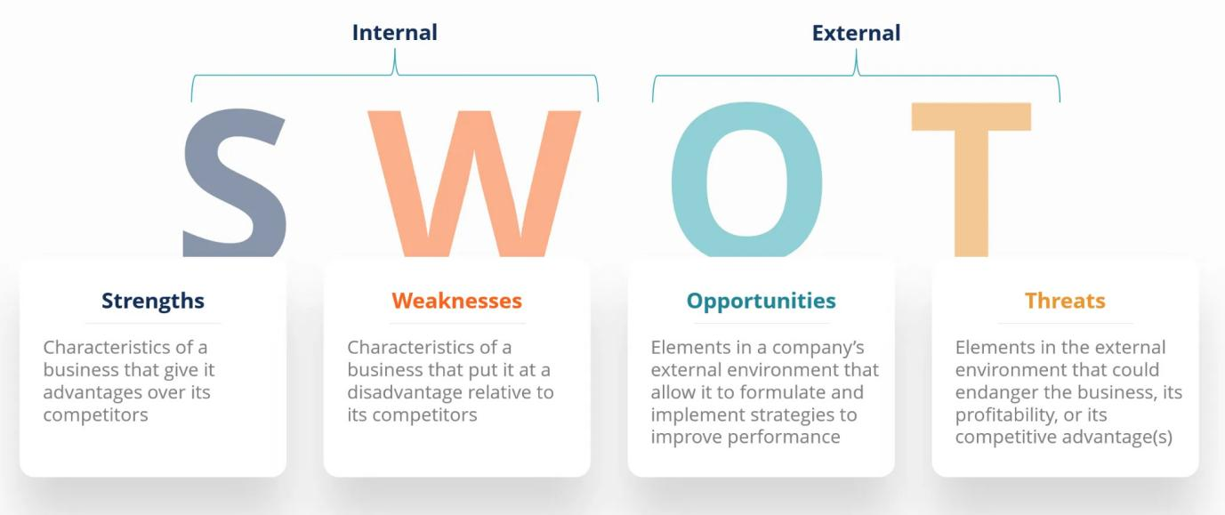
Figure 5: SWOT Analysis (Source: Corporate Finance Institute, no date)

Strengths | Weaknesses
Meliá Hotels International benefits from strong brand recognition and a well-established global presence, particularly in the upscale and luxury hotel segments (Ivanov & Webster, 2019). Its diversified brand portfolio enables it to target multiple market segments, from premium leisure to business travellers. Additionally, the company’s asset-light strategy—focusing on management contracts rather than ownership—reduces capital requirements and enhances financial flexibility (Porter, 1990).  Meliá’s commitment to sustainability and digital transformation further strengthens its competitive advantage, aligning with evolving consumer preferences and regulatory expectations (Gössling, Scott & Hall, 2015). These strengths support higher occupancy rates and customer loyalty, reinforcing its market position in Spain. | Despite its strengths, Meliá has a significant dependence on the Spanish and European markets, which increases vulnerability to regional economic fluctuations (Dwyer, Forsyth & Dwyer, 2020). High operational costs, particularly labour and energy expenses, also affect profitability in Spain’s competitive hospitality sector.  Additionally, reliance on online travel agencies for distribution reduces direct customer relationships and increases commission costs, limiting margins (Xiang, Magnini & Fesenmaier, 2015). The company’s exposure to seasonal hospitality demand further creates fluctuations in occupancy and revenue.
Opportunities | Threats
Spain’s strong hospitality demand and global attractiveness provide significant growth opportunities for Meliá. The increasing demand for experiential, sustainable and luxury hospitality aligns with the company’s strategic positioning (Richards, 2020). Expansion into niche segments, such as wellness and eco-hospitality, offers further growth potential.  Technological advancements also present opportunities for improving operational efficiency and customer experience through digital platforms and data analytics (Buhalis & Law, 2008). Furthermore, regulatory restrictions on short-term rentals may reduce competition, benefiting traditional hotel operators. | Meliá faces intense competition from both multinational hotel chains and alternative accommodation providers, increasing price pressure and reducing market share (Porter, 1990). The rise of platforms such as Airbnb intensifies substitution threats, particularly in urban markets.  Economic uncertainty, including inflation and global downturns, can significantly reduce hospitality demand (Dwyer et al., 2020). Environmental challenges, such as climate change and overhospitality, also pose risks to key destinations in Spain (Gössling et al., 2015). Additionally, increasing regulatory pressures related to sustainability and hospitality management may limit expansion opportunities and increase compliance costs.

Figure 6: SWOT Analysis of Meliá Hotels International (Source: Self Developed)

Critical Evaluation
The most critical issue is Meliá’s dependence on European markets, which increases exposure to regional shocks. The SWOT analysis indicates that Meliá’s strong brand, global presence and strategic focus on premium and sustainable hospitality provide a solid foundation for success in Spain. However, external threats such as intense competition, economic volatility and environmental challenges create significant risks.
To maintain competitiveness, Meliá must leverage its strengths in branding and innovation while addressing weaknesses such as market dependence and cost pressures. Strategic diversification and continued investment in sustainability and technology are essential for long-term success in Spain’s dynamic hospitality industry.
4.4 Hofstede’s Cultural Distance Analysis
Hofstede’s Cultural Distance Analysis is based on Hofstede’s cultural dimensions framework, which evaluates differences in national cultures across dimensions such as power distance, individualism, masculinity, uncertainty avoidance, long-term orientation and indulgence, to understand how cultural variations affect organisational behaviour and international business performance (Hofstede, Hofstede & Minkov, 2010). Applying this framework helps assess the cultural factors influencing Meliá Hotels International’s operations in Spain.
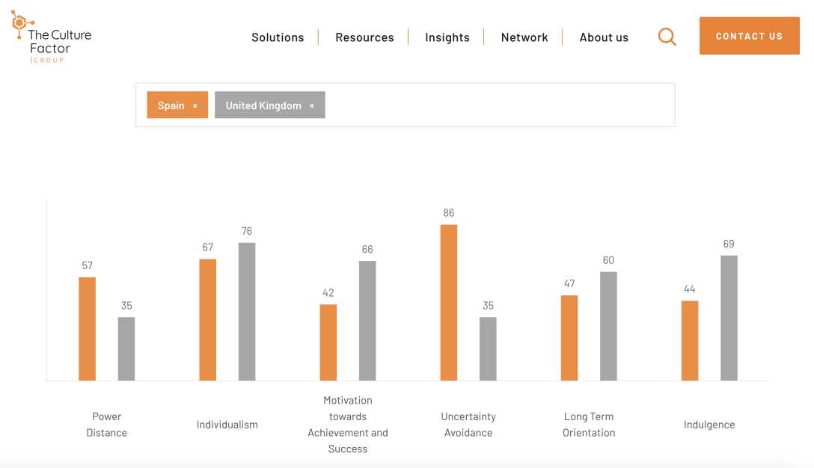
Figure 7: Cultural Comparison Between Spain and the UK (The Culture Factor, 2026)

Dimension | Spain | UK | Comparison
Power Distance | 57 (Moderate–High) | 35 (Low) | Spain has a more hierarchical culture with greater acceptance of authority, whereas the UK favours flatter structures and equality (Hofstede, Hofstede & Minkov, 2010).
Individualism | 51 (Moderate) | 89 (High) | Spain is relatively collectivist and relationship-oriented, while the UK is highly individualistic, emphasising independence and personal achievement (Hofstede, Hofstede & Minkov, 2010).
Motivation toward Achievement (Masculinity) | 42 (Low–Moderate) | 66 (High) | Spain focuses more on quality of life and cooperation, whereas the UK is more competitive and success-driven (Hofstede, Hofstede & Minkov, 2010).
Uncertainty Avoidance | 86 (High) | 35 (Low) | Spain strongly prefers rules and structured environments, while the UK is more comfortable with ambiguity and change (Hofstede, Hofstede & Minkov, 2010; Johnson, Scholes & Whittington, 2017).
Long-Term Orientation | 48 (Moderate) | 51 (Moderate) | Both countries show a balanced approach between short-term results and long-term planning, with minimal difference (Hofstede, Hofstede & Minkov, 2010).
Indulgence | 44 (Moderate) | 69 (High) | Spain values leisure and enjoyment, but the UK is more indulgent, showing a stronger orientation towards gratification and lifestyle (Hofstede, Hofstede & Minkov, 2010).

Figure 8: Hofstede’s Cultural Dimensions for Spain and UK (The Culture Factor, 2026)

Critical Analysis
Spain’s cultural characteristics—particularly high uncertainty avoidance, moderate collectivism and a focus on quality of life—strongly support hospitality operations by encouraging structured service delivery and relationship-oriented customer experiences (Hofstede, Hofstede & Minkov, 2010). However, cultural differences with the UK, especially in individualism and risk tolerance, highlight the need for Meliá Hotels International to adapt its management practices and service strategies across markets to maintain competitiveness (Johnson, Scholes & Whittington, 2017).
- Conclusion
The hospitality industry in Spain remains one of the most competitive and globally recognised sectors, supported by strong natural resources, advanced infrastructure and high international demand. The industry’s economic significance is evident through its substantial contribution to GDP and employment, reinforcing its role as a key driver of national development (UNWTO, 2020). The presence of both domestic and multinational firms, such as Meliá Hotels International, demonstrates a highly competitive environment characterised by strategic differentiation and innovation (Ivanov & Webster, 2019).
The application of Porter’s Diamond Model highlights Spain’s strong competitive advantages, particularly in factor conditions, demand sophistication and supporting industries (Porter, 1990). However, challenges such as seasonality, overhospitality and environmental sustainability pose risks to long-term growth.
The analysis of Meliá Hotels International further reveals that while the company benefits from strong branding, global presence and strategic positioning, it operates within a complex environment influenced by economic volatility, technological disruption and regulatory pressures. Frameworks such as PESTEL and Porter’s Five Forces demonstrate that high competition and buyer power significantly impact profitability, while SWOT analysis identifies both growth opportunities and operational risks (Johnson et al., 2017).
Overall, Spain remains an attractive market for hospitality, but sustained success for firms like Meliá depends on continuous innovation, sustainability initiatives and strategic adaptability. Long-term competitiveness will rely on balancing growth with environmental and social considerations.
In conclusion, Spain’s hospitality industry is highly competitive and contributes significantly to the economy.
Overall, while Spain maintains strong competitive advantages, its long-term sustainability will depend on balancing growth with environmental and regulatory constraints.
Section 2
Reflective Account Using Gibbs’ Reflective Cycle
Gibbs’ Reflective Cycle is a structured model that enables individuals to learn from experience through six stages: description, feelings, evaluation, analysis, conclusion and action plan (Gibbs, 1988). This model encourages critical thinking and continuous improvement by systematically reflecting on experiences. This reflective account evaluates my learning process while completing the report on Spain’s hospitality industry and the strategic analysis of Meliá Hotels International.

Figure 9: Gibbs Reflective Cycle (Channell, 2025)

Description
This assignment required me to conduct a comprehensive analysis of Spain’s hospitality industry using multiple strategic frameworks. These included Porter’s Diamond Model to assess national competitiveness, PESTEL analysis to evaluate the macro-environment, Porter’s Five Forces to examine industry competition, SWOT analysis to identify internal and external factors, and Hofstede’s Cultural Dimensions to understand cultural influences. Additionally, I had to analyse key firms in the Spanish hospitality industry and critically evaluate Meliá Hotels International’s position within this competitive environment.
The task involved extensive research using academic books and journal articles, as well as the application of theoretical concepts to real-world business scenarios. I also had to ensure proper academic writing, including Harvard-style referencing, maintaining strict word limits and presenting arguments in a structured and logical manner.

Feelings
At the beginning of the assignment, I felt overwhelmed due to the wide scope of the task and the requirement to apply multiple frameworks accurately. I was particularly concerned about whether I would be able to integrate theory with practice effectively. The strict word limits added additional pressure, as I needed to be concise while maintaining critical depth.
However, as I progressed, my confidence gradually increased. I began to understand how each framework contributed to the overall analysis and how they could be interconnected. I found the process of applying theoretical models to a real company, such as Meliá Hotels International, both interesting and rewarding. By the end of the assignment, I felt a sense of accomplishment and satisfaction with my work.

Evaluation
One of the key strengths of my work was the ability to apply multiple strategic frameworks to analyse a real-world industry. This helped me develop a deeper understanding of how theoretical concepts are used in practice (Johnson, Scholes & Whittington, 2017). I also improved my research skills by using academic sources and incorporating in-text citations appropriately.
Another positive aspect was my improved ability to structure a report logically. I was able to organise the content into clear sections, making it easier to present arguments systematically. This reflects the importance of structured thinking in academic writing.
However, there were also some weaknesses. At times, I focused too much on describing the frameworks rather than critically analysing their implications. This limited the depth of my evaluation in certain sections. Additionally, managing the word limit was challenging, as I had to balance detail with conciseness. Time management was another issue, as the assignment required significant research and careful editing.

Analysis
This assignment highlighted the importance of integrating theory with real-world application. For example, using Porter’s Diamond Model helped me understand how Spain’s competitive advantage in hospitality is influenced by interconnected factors such as infrastructure, demand and industry rivalry (Porter, 1990). Similarly, PESTEL analysis demonstrated how external factors such as political stability, economic conditions and environmental challenges impact business operations.
The use of multiple frameworks also emphasised the complexity of strategic analysis. Each framework provided a different perspective, and combining them allowed for a more comprehensive understanding of the industry. This aligns with the idea that no single model can fully explain organisational performance, and multiple approaches are needed for effective analysis (Johnson et al., 2017).
Furthermore, this experience reinforced the importance of critical thinking. According to Gibbs (1988), reflection involves analysing both positive and negative aspects of an experience to improve future performance. I realised that effective academic work requires not only understanding theories but also evaluating their relevance and limitations.
Another important learning point was the significance of cultural factors in international business. Applying Hofstede’s Cultural Dimensions helped me understand how cultural differences influence management practices and customer expectations. This highlighted the importance of adapting business strategies to different cultural contexts.
Additionally, the assignment improved my ability to use academic references effectively. I learned how to integrate citations into my writing to support arguments and enhance credibility. This is a crucial skill in academic and professional contexts.

Conclusion
Overall, this assignment was a valuable learning experience that significantly enhanced my understanding of strategic analysis and international business. I developed important skills in research, critical thinking and academic writing. While I faced challenges such as managing word limits and ensuring critical depth, I was able to overcome them through practice and revision.
The experience has increased my confidence in applying theoretical frameworks to real-world situations. It has also highlighted areas for improvement, particularly in developing stronger critical analysis and time management skills. Reflecting on this experience has helped me identify both my strengths and weaknesses, which is essential for continuous learning and development (Gibbs, 1988).

Action Plan
In the future, I plan to improve my critical analysis skills by engaging more deeply with academic literature and focusing on evaluating rather than describing concepts. I will practise writing concise arguments that demonstrate deeper insight within limited word counts.
To address time management issues, I will start assignments earlier and create a structured plan with specific deadlines for each section. This will help me manage workload more effectively and allow sufficient time for revision and improvement.
I also aim to enhance my academic writing skills by practising proper referencing and improving the clarity and coherence of my arguments. Additionally, I will continue applying theoretical frameworks to real-world case studies, as this approach strengthens my understanding and practical application of concepts.
By following this action plan, I aim to improve my academic performance and develop the skills necessary for future studies and professional success in the field of business and management.

Figure 10: Meliá Hotels International (Source: Hospitality ON, no date)
Summary
This report analyses Spain’s hospitality industry, examining its economic importance, competitive structure and key firms, focusing on Meliá Hotels International. Using Porter’s Diamond, PESTEL, Five Forces, SWOT and Hofstede frameworks, it identifies demand, infrastructure and rivalry as advantages, highlighting risks from seasonality, regulation and environmental pressures (Porter, 1990; UNWTO, 2020).
Conclusion
In conclusion, Spain’s hospitality industry remains competitive and significant, supported by infrastructure and demand. However, sustainability depends on addressing environmental challenges, regulatory constraints and market dependence. Meliá Hotels International must prioritise innovation, diversification and sustainability to maintain competitiveness and adapt to pressures (Johnson et al., 2017; Gössling et al., 2015).

Bibliography
Bello, L. and Roig, J. (2017) Tourism economics and policy. London: Routledge.
Buhalis, D. and Law, R. (2008) ‘Progress in information technology and tourism management’, Tourism Management, 29(4), pp. 609–623.
Buhalis, D. and Laws, E. (2001) Tourism distribution channels: Practices, issues and transformations. London: Continuum.
Channell, M. (2025) Gibbs Reflective Cycle – A Practical Guide. The Skills Workshop. Available at: https://www.tsw.co.uk/insights/gibbs-reflective-cycle/ (Accessed: 15 April 2026).
Cheng, M. (2013) ‘Analysis of the hotel industry using Porter’s Five Forces model’, Journal of Tourism Studies, pp. 1–10.
Corporate Finance Institute (no date) SWOT analysis. Available at: https://corporatefinanceinstitute.com/resources/management/swot-analysis/ (Accessed: 12 April 2026).
Díaz-Muñoz, E. (2019) Tourism in Spain: Historical and contemporary perspectives. Cham: Springer.
Dwyer, L., Forsyth, P. and Dwyer, W. (2020) Tourism economics and policy. 2nd edn. Bristol: Channel View Publications.
García, J. and García, R. (2022) ‘Post-pandemic recovery in European tourism: The case of Spain’, Journal of Travel Research, 61(4), pp. 558–574.
Gibbs, G. (1988) Learning by doing: A guide to teaching and learning methods. Oxford: Oxford Polytechnic.
Gössling, S., Scott, D. and Hall, C.M. (2015) ‘Inter-market variability in CO₂ emission-intensities in tourism’, Tourism Management, 46, pp. 265–277.
Graham, A., Papatheodorou, A. and Forsyth, P. (2019) Aviation and tourism: Implications for leisure travel. London: Routledge.
Guttentag, D. (2015) ‘Airbnb: disruptive innovation and the rise of an informal tourism accommodation sector’, Current Issues in Tourism, 18(12), pp. 1192–1217.
Hofstede, G., Hofstede, G.J. and Minkov, M. (2010) Cultures and organizations: Software of the mind. 3rd edn. New York: McGraw-Hill.
Hospitality ON (no date) Meliá Hotels International. Available at: https://hospitality-on.com/en/companies/melia-hotels-international (Accessed: 19 April 2026).
Ivanov, S. and Webster, C. (2019) Hotel management and operations. London: Pearson.
Johnson, G., Scholes, K. and Whittington, R. (2017) Exploring strategy. 11th edn. Harlow: Pearson.
O’Connell, J.F. and Williams, G. (2016) Air transport in the 21st century: Key strategic developments. London: Routledge.
Pearce, D. (2018) Tourism: Principles and practice. 6th edn. Harlow: Pearson Education.
Pons, C. (2025) ‘Spain’s tourism sector expects slowdown in summer sales’, The Independent, 11 July.
Porter, M.E. (1990) The competitive advantage of nations. New York: Free Press.
Porter, M.E. (2008) ‘The five competitive forces that shape strategy’, Harvard Business Review, 86(1), pp. 78–93.
Richards, G. (2020) ‘Cultural tourism in Spain’, Annals of Tourism Research, 82, pp. 102–123.
Richards, G. and Wilson, J. (2021) Designing creative tourism experiences. Wallingford: CABI.
The Culture Factor Group (2026) Country Comparison Tool. Available at: https://www.theculturefactor.com/country-comparison-tool?countries=spain%2Cunited+kingdom (Accessed: 15 April 2026).
The Times (2026) The best all-inclusive hotels in Spain. Available at: https://www.thetimes.com/travel/destinations/europe-travel/spain/the-best-all-inclusive-hotels-in-spain-rrs09pp8f (Accessed: 15 April 2026).
UNWTO (2020) International tourism highlights. Madrid: UNWTO.
Xiang, Z., Magnini, V.P. and Fesenmaier, D.R. (2015) ‘Information technology and consumer behaviour in travel and tourism’, Annals of Tourism Research, 48, pp. 244–249.

