

Student Name: Mirela Margareta Lazar
Student ID: 1921853

Module Name: Introduction to Physiology

Module Code: BMHP5003_LON

Lecturer Name: Noura Mohamed

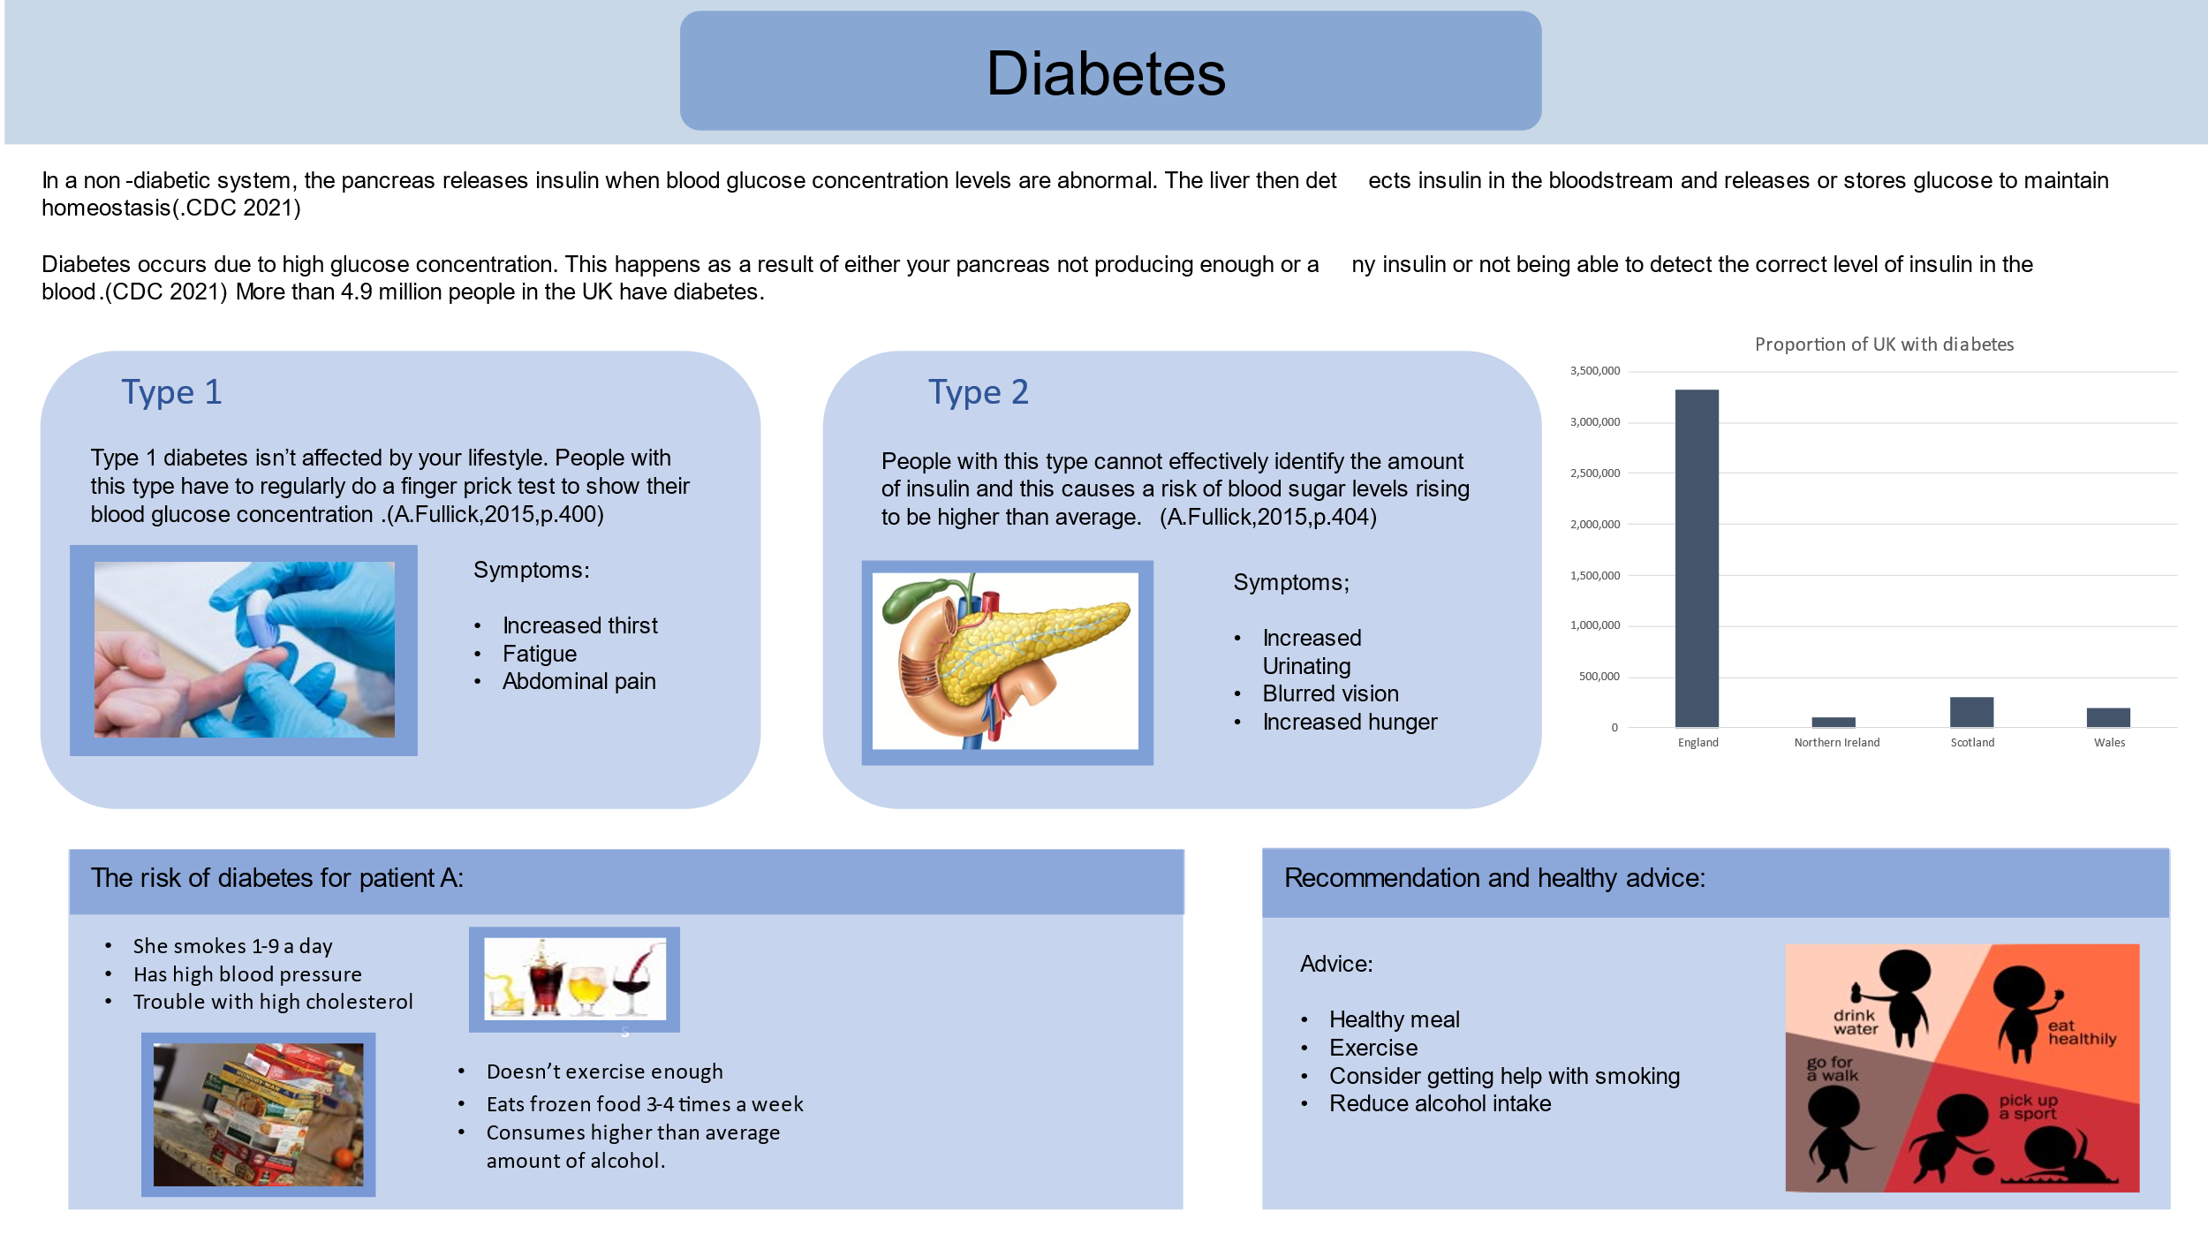
Poster presentation

References:

Ann Fullick , Jo Locke & Paul Bircher (eds.) April 2015, A-Level Biology, pages 400-404/> (Accessed 25 July 2021)
Centers for Disease Control and Prevention (2021). Diabetes Data and Statistics | CDC. Available at: <https://www.cdc.gov/diabetes/data/index.html> [Accessed: 25 July 2021].

Diabetes Self-Management. 2021. Metformin, the Liver, and Diabetes - Diabetes Self-Management. <https://www.diabetesselfmanagement.com/blog/diabetes-metformin-and-your-liver/> (Accessed: 25 July 2021)
Joslin Diabetes Center. 2021. The Difference Between Type 1 and Type 2. [online] Available at: <https://www.joslin.org/patient-care/diabetes-education/diabetes-learning-center/difference-between-type-1-and-type-2 ( Accessed 26 July 2021)

Speaker Notes:
Speaker notes
Definition
- Diabetes is a lifelong disease that cause the person’s blood sugar to become high. Lots of people have blood sugar level above the normal range, but not enough high to be diagnosticated with it. (Diabetes, 2021)
Physiology

- Insulin acts as a messenger hormone and helps maintain communication between the liver and the pancreas.
- Alongside this, it can also happen because of an autoimmune response where the immune system attacks the cells where insulin is produced. The constant raised blood sugar can over time lead to serious damage to the nerves and the blood vessels.
- They are 4.9 million people in the UK have diabetes. Out of Out of the 4.9 million reported cases 90% of those are type 2 and 8% are type 1 diabetes. It’s estimated that around 850 thousand people are living with undiagnosed diabetes. (UK, basics, diagnosed? and possible, 2021)
- People up to age 40 are most likely to develop diabetes, especially children. Type 2 diabetes become more common in young people and children and each year there are more and more cases reported.
- In diabetes Type 1 our body attacks the cells in the pancreas, which means it cannot produce any insulin.
- A person with Type 1 diabetes has to inject the correct dose of insulin depending on their blood glucose concentration as there’s a lack of natural production of insulin.
- This can happen at any point of someone’s life and has both environmental and genetic contributions.
- In diabetes Type 2 our body is unable to make enough insulin, or the insulin we produce doesn’t work properly. The symptoms can be easier to miss because they show slowly, some people having no symptoms and they can live with it for years without knowing they have it.
- As a medication for this usually they prescribed Metformin ,Riomet and so on.
Cause and risk factors
- As per our case study were the Patient A present to us with high blood pressure (140-90) and trouble with cholesterol and after reviewing the answers, I’ve concluded that there is a high risk of developing diabetes.
- She also mentions that she smokes 1-9 cigarettes a day, she’s not exercising enough she’s having 3-4 times a week frozen food and also, she consumes higher than average amount of alcohol.
Interventions
- High blood pressure is often called the silent killer and affects millions of people every year. The illness with high pressure can cause stroke, heart disease or even death.
- My first recommendation is the patient to start talking to a doctor about developing an exercise program, on how to lower blood pressure naturally. But to start with I will recommend walking 10-20 minute a day and then to find more suitable ways to exercise that fits her need.
- The second recommendation is to try to change the eating style and try to eat more fresh and home cooking if possible, to try to lower the high blood sugar as in time there is a risk of having problems with kidney, nerves or eyes disease.
- Maybe she would like to get some help with smoking habits, so he can reduce the number of cigarettes or in time to give up if possible.
- And she needs to reduce the amount of alcohol which at the moment is too high (3-6 units), the recommended units is 1 unit a day.
- All these changes will help the patient to reduce their high blood pressure and their trouble with high cholesterol. If she continues the same way, both the high pressure and cholesterol can cause the development of a cardiovascular disease. The exercise and fresh cooked meals will decrease the amount of bad cholesterol. Alongside this, reducing the smoking and drinking will decrease blood pressure. (Tips for Heart-Healthy Living With Diabetes, 2021)

References

Ann Fullick , Jo Locke & Paul Bircher (eds.) April 2015, A-Level Biology, pages 400-404/> (Accessed 25 July 2021)
Centers for Disease Control and Prevention (2021). Diabetes Data and Statistics | CDC. Available at: <https://www.cdc.gov/diabetes/data/index.html> [Accessed: 25 July 2021].
Diabetes Self-Management. 2021. Metformin, the Liver, and Diabetes - Diabetes Self-Management. <https://www.diabetesselfmanagement.com/blog/diabetes-metformin-and-your-liver/> (Accessed: 25 July 2021)
Joslin Diabetes Center. 2021. The Difference Between Type 1 and Type 2. [online] Available at: <https://www.joslin.org/patient-care/diabetes-education/diabetes-learning-center/difference-between-type-1-and-type-2 ( Accessed 26 July 2021)
National Health Service, 2016. Diabetes - NHS. https://www.nhs.uk/conditions/diabetes/
Nhs.uk. 2021. Diabetes. [online] Available at: <https://www.nhs.uk/conditions/diabetes/> [Accessed 3 August 2021].
UK, D., basics, D., diagnosed?, N. and possible, Y., 2021. Diabetes: the basics. [online] Diabetes UK. Available at: <https://www.diabetes.org.uk/diabetes-the-basics> [Accessed 3 August 2021].
WebMD. 2021. Tips for Heart-Healthy Living With Diabetes. [online] Available at: <https://www.webmd.com/diabetes/diabetes-heart-health> [Accessed 3 August 2021].

