A Critical Evaluation of the Humber Health Partnership Digital Strategy 2025–2028

I confirm this essay is my own original work and does not include text created by a generative artificial intelligence tool.

Shaun Burgess (2516958)
Date: 10/04/2026
Contents
Executive Summary 2
Business Drivers 3
Technology & Digital Transformation 5
Operational Systems 5
Infrastructure Capability 6
Cyber Security and Digital Resilience 6
Interoperability and Information Standards 7
Data Analytics Capability 7
Strategic Aims and Transformation Programmes 8
Strategic Analysis 8
External Environment: PESTLE Analysis 9
Organisational Alignment: McKinsey 7S Framework 11
References 12

Executive Summary
Digital transformation has become a priority worldwide for healthcare systems, as organisations face increased pressure to meet rising demand for services, address workforce shortages, and manage financial pressures. In publicly funded systems such as the National Health Service (NHS), digital tools are seen as a necessity for improving productivity, supporting patient safety, and enabling easier information sharing across different parts of the NHS, including hospitals, community services, mental health, and social care. The Humber Health Partnership (HHP) Digital Strategy 2025-2028 is a strategic response to these pressures. Setting out a programme of change designed to modernise digital infrastructure, improve interoperability and strengthen data-driven decisions across the organisation.
The digital estate includes over 200 applications, supported by around 520 servers and thousands of user devices. Although these systems deliver core clinical and operational functions, this reflects historical, organisation-specific procurement decisions, rather than a unified digital infrastructure. As a result, clinicians often face operational inefficiencies, including slow system performance, repeated data entry across multiple systems, and difficulty accessing patient information across organisational boundaries.
The Digital Strategy 2025-2028 aims to address these structural challenges through a transformation programme supported by strategic missions that outline the organisation's long-term digital direction. Together, these missions reflect that digital transformation requires not only technical investment but also organisational change, workforce capability and strengthened governance.
This report provides a critical analysis of the HHP Digital Strategy 2025-2028, assessing its strategic robustness, the practicality of its technology ambition, and its alignment with current digital health transformation standards and frameworks. The evaluation draws on two analytical tools, namely PESTLE and the McKinsey 7S model, to assess external influences, organisational readiness, and internal conditions that may affect the successful delivery of digital technologies.
The analysis identifies several strengths within the strategy, including a clear focus on reinforcing digital infrastructure, strengthening interoperability, and improving data integration across organisational systems. However, the review also identifies areas requiring further development, particularly those relating to workforce digital capability, benefits realisation processes and the sequencing of technological innovation projects. In addition, the success of the strategy will depend on HHP’s ability to reduce digital inequalities, apply consistent governance and ensure that staff receive the support and training needed to use new systems effectively. These factors are especially important given the size of the organisation and the pressures it faces, making the effective delivery of the strategy a key focus of the analysis.
Overall, the findings highlight specific strengths and weaknesses in HHP’s approach, which are examined in greater depth in the report's full critical analysis.

Business Drivers
Digital strategies in the NHS are driven and created to address internal pressures like funding, rising demand and legacy infrastructure, as well as national policy requirements for modernisation (Hakim, 2025). For HHP, the Digital Strategy 2025-2028 has been developed to address the current digital issues, manage increasing pressure on healthcare services, and align with the national policies to adopt digital technology across the NHS (Humber Health Partnership, 2025a). Importantly, this digital strategy is not a standalone document, it forms part of a wider group strategy 2025-2030, which sets the overall direction for the organisation for the next five years and ensures the digital transformation aligns with the group’s strategic goals (Humber Health Partnership, 2025b). Understanding these drivers is essential for assessing whether the organisation's digital transformation plans are strategically sound and can be realistically carried out. The long-term direction of the digital strategy 2025-2028 is defined by its five digital missions, which set out how HHP will unlock productivity, strengthen secure and resilient digital foundations, improve the real-time use of data, expand virtual care models, and enhance digital inclusion; see figure 1.

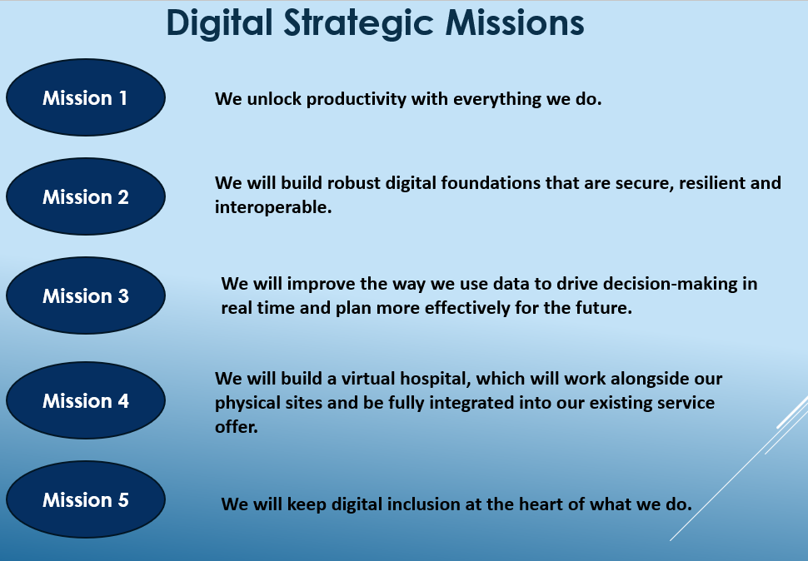
Figure 1. Digital Strategy Missions, Adapted from (Humber Health Partnership, 2025a).
One of the key internal drivers for this strategy is the operational inefficiency caused by the organisation’s current digital infrastructure. The staff engagement conducted during strategy development highlighted persistent problems, including slow system performance, unreliable devices, time wasted waiting for equipment to load, and the need to re-enter the same information across several applications (Humber Health Partnership, 2025a). Research has shown that these inefficiencies increase staff administrative workload and affect productivity and patient experience (Sinha, 2024).
The duplication of digital systems across organisational sites is another internal driver concern. HHP was created through the merger of two NHS trusts, resulting in many clinical and administrative systems being procured and deployed separately (Humber Health Partnership, 2025a). This has resulted in multiple systems carrying similar functions across different hospitals, adding unnecessary complexity to the digital environment and increasing operational costs. Digital transformation programmes often aim to reduce this type of fragmentation by consolidating systems and improving interoperability (Cresswell, Sheikh and Williams, 2022).
The reliability and the maturity of digital infrastructure are also major internal drivers for change. The strategy highlights that many existing systems lack integration, resilience, and unified governance, indicating limitations in their ability to support modern, digitally enabled care models (Humber Health Partnership, 2025a). This suggests a need to improve system resilience and standardisation to ensure consistent performance across clinical environments and support future digital transformation. This is supported by evidence showing that good system connectivity and strong digital foundations are essential for reliable performance and successful digital change in healthcare organisations (Ebo et al., 2025).
External policy drivers also influence the strategy. Particularly, national expectations around interoperability, data use and digital-supported care models (Department of Health & Social Care, 2022; NHS England, 2026a). Evidence from NHS clinicians highlights the impact of poor interoperability on day-to-day care, reinforcing the importance of these national priorities (Li et al., 2025). National policy frameworks highlight the importance of interoperable systems, effective use of health data and digital services that help improve organisational efficiency and the delivery of care (Department of Health & Social Care, 2022; NHS England, 2026a). These expectations encourage NHS organisations to modernise their digital infrastructure to improve service quality and patient outcomes.
Regional health needs also influence the strategy’s development. HHP operates within a healthcare system experiencing some of the highest demand in the UK, driven by a high disease burden and an ageing population(Humber Health Partnership, 2025a). This is supported by wider national evidence highlighting the need for digital-enabled service redesign (Wachter, 2016). Digital tools are identified as essential for enabling virtual care models and improving collaboration across organisational boundaries (Humber Health Partnership, 2025a).
Financial constraints also play a major role in the organisation’s digital ambitions, as the strategy highlights significant pressures on resources, including buildings, technology and finances. The strategy reports that digital spend currently accounts for only 1.9% of organisational turnover, which is low for a system of this scale (Humber Health Partnership, 2025a). This means the organisation must prioritise initiatives that deliver clear improvements in productivity and patient care while remaining affordable.
Overall, these internal and external drivers (Table 1) show why digital transformation is vital for HHP. The Digital Strategy 2025-2028 aims to tackle inefficiencies, improve system integration and align the organisation with the wide NHS digital goals.
Table 1, Internal and External Drivers
Driver Classification | Identified Drivers | Key issues
Internal | Operational inefficiencies | Slow system, unreliable devices, repeated data entry
 | System duplication | Multiple systems, legacy procurement, complexity
 | Infrastructure limitations | Poor resilience, inconsistent performance, outdated estate
 | Lack of integration | Isolated systems, no interoperability
 | Workforce digital capability | Low digital confidence, Limited training
 | Finance constraints | 1.9% digital spend, limited resources
External | National digital policy | Interoperability requirements, data-driven NHS
 | Regional health pressures | High demand, ageing population, high disease burden
 | Service redesign requirements | Virtual care, cross-boundary workflows
 | National financial constraints | NHS-wide finding constraints, sustainability challenges

Technology & Digital Transformation
Evaluating the digital transformation strategy of HHP requires an understanding of the organisation's current technological environment and the strategic initiatives proposed to enhance digital capability. Over many years, the organisation’s digital landscape has evolved through separate procurement decisions made across different hospitals. This has resulted in a complex ecosystem of clinical systems, infrastructure platforms and data management tools that support day-to-day healthcare delivery (Humber Health Partnership, 2025a).

Operational Systems
Operational systems form the centre of digital healthcare delivery within HHP. The organisation currently uses over 200 applications that support clinical documentation, diagnostics, administrative tasks and operational management. These include systems for electronic clinical notes, diagnostic imaging, laboratory management and specialist departmental tools (Humber Health Partnership, 2025a).
Although these systems support clinical activity, their integration is limited because they are built on different vendor platforms and technical architectures. Many of these applications were procured separately across the legacy Trusts before the partnership's formation, resulting in a set of isolated systems that cannot easily communicate with one another (Humber Health Partnership, 2025a). As a result, clinicians need to move between multiple systems to retrieve patient information, increasing administrative workload and contributing to clinical inefficiencies (Cresswell, Bates and Sheikh, 2013).
The digital strategy identifies this fragmentation as a significant barrier to effective transformation. A major initiative within the strategy is the planned introduction of a unified Electronic Patient Record (EPR) system to replace 32 existing clinical applications (Humber Health Partnership, 2025a). Implementing a single EPR system is to simplify access to patient information, reduce repeated data entry and support more informed clinical decision-making (Buntin et al., 2011). This aligns with the wider NHS policy, encouraging the consolidation of legacy systems and the adoption of integrated clinical platforms to improve quality and operational efficiency (NHS, 2023; NHS England, 2026b). The level of fragmentation described in the strategy suggests that the organisation may be operating at a low level of digital maturity on the Healthcare Information and Management System Society (HIMSS) Electronic Medical Record Adoption Model (EMRAM) scale, around stage one or two, where multiple standalone systems exist, and interoperability is limited, Highlighting why a unified EPR is needed to improve digital maturity. However, EMRAM prioritises technical capability over organisational readiness (Wachter, 2016).

Infrastructure Capability
The reliability and performance of the digital infrastructure represent another major part of the organisation's digital environment. HHP currently operates 520 servers that host clinical and administrative applications, along with thousands of desktop and laptop devices used across clinical settings. While this infrastructure underpins digital service delivery, staff feedback during strategy development highlighted inconsistent performance levels across hospital sites (Humber Health Partnership, 2025a).
Healthcare professionals (HCP) frequently reported slow device performance and delays in accessing key systems, creating disruption to clinical workflows and reducing productivity (Humber Health Partnership, 2025a). These challenges are particularly significant in healthcare environments, where reliable access to digital systems is essential to support timely and safe patient care (Li et al., 2022).
Infrastructure resilience is especially important, as system downtime can have direct consequences for service delivery and patient safety. Improving the stability, speed, and reliability of the underlying technology is therefore a major priority (Larsen, Rao and Sasangohar, 2020). The strategy highlights the need to modernise ageing infrastructure, standardise device procurement and ensure that technical performance is consistent across all areas (Humber Health Partnership, 2025a).

Cyber Security and Digital Resilience
Cybersecurity has become an important issue for healthcare organisations due to the rising number of cyberattacks targeting healthcare systems. NHS organisations hold a large amount of sensitive patient data, making them attractive targets for cybercriminals. Cyber incidents can lead to widespread operational disruption, financial loss, reputational damage and risks to patient safety (Rajput, Darzi and Ghafur, 2025).
The HHP strategy places strong emphasis on improving cybersecurity capability and ensuring compliance with national information governance standards. Key objectives include reducing reliance on outdated operating systems, strengthening network monitoring capability and embedding robust cybersecurity practices across all departments (Humber Health Partnership, 2025a). Improving digital resilience is essential, as disruptions to digital systems within healthcare environments can have immediate and serious implications for clinical operations and patient care (Scantlebury et al., 2021).

Interoperability and Information Standards
Interoperability is a key enabler of digital transformation in healthcare. It allows patient’s information to be shared across clinical settings, supporting coordinated care and reducing duplicate work (Torab-Miandoab et al., 2023; Ademola, George and Mapp, 2024). However, within HHP, the current digital environment remains constrained by limited system-to-system connectivity, restricting the organisation’s ability to realise these benefits.
The digital strategy identifies this as one of the core challenges and outlines plans to develop a unified digital architecture that enables seamless data exchange across platforms (Humber Health Partnership, 2025a). Achieving this will require the adoption of a consistent information standard, technical frameworks and data governance processes (NHS England, 2025). This would usually involve using standard clinical codes, such as SNOMED CT, and interoperability standards, such as HL7 FHIR, to enable systems to share data accurately and in real time (NHS England, 2024, 2026c). Research continues to highlight the importance of interoperability in enabling digital programmes to deliver tangible benefits, with evidence demonstrating improvements in patient safety, care quality, and efficiency. Although impacts on clinical workflows are viable and are widely influenced by socio-technical factors and the context in which systems are implemented (Greenhalgh et al., 2017; Li et al., 2022).
The move towards a unified EPR and an integrated digital architecture aligns with national NHS initiatives to improve digital maturity and enable cross-organisational information sharing (NHS England Board, 2025). By adopting standardised approaches to data exchange, HHP aims to improve clinical efficiency, reduce error rates and support integrated models of care.

Data Analytics Capability
Data analytics is becoming important within health care, which helps with clinical decisions, population health management and supporting planning for future services (Shahzad et al., 2025). However, the fragmented nature of the organisation’s current systems limits their ability to use data effectively.
The digital strategy suggests creating one central place to store all the organisation's data (Humber Health Partnership, 2025a). This platform would consolidate information from multiple operating systems, creating a consistent and reliable data source for analysis. With this in place, managers and clinicians could access real-time performance data, supporting proactive decision-making and more informed resource planning.
Improving analytics capability offers benefits for service quality. For example, data can be used to identify early clinical risks, track health trends in the community, and check whether service changes are working (George et al., 2025; Shahzad et al., 2025). By building a comprehensive data analytics platform, the organisation aims to make better use of the information it already collects and be more prepared for changing healthcare needs (Humber Health Partnership, 2025a).

Strategic Aims and Transformation Programmes
The digital transformation strategy sets out several programmes to improve the organisation’s digital tools. These include introducing a unified electronic patient record, creating a central data warehouse, and upgrading digital systems to support virtual care services (Humber Health Partnership, 2025a).
One of the key goals in the strategy is to develop a virtual hospital model. This approach uses digital tools such as remote monitoring and online consultations to care for patients at home instead of in a hospital setting (Humber Health Partnership, 2025a; Pugmire et al., 2025). These virtual care approaches can help prevent unnecessary admissions and allow people to be discharged earlier from inpatient care, improving efficiency and patient experience (Pugmire et al., 2025).
The strategy also highlights the need for digital inclusion. While the use of digital tools can offer many advantages, research shows patients can lack confidence or skills to use these digital tools and may struggle to access the necessary devices (Xue et al., 2026).
The HHP is still at the early stages of its digital transformation. While there are already many digital systems in place, it still needs major improvements in interoperability, data integration and will need the necessary governance to achieve the strategic ambition set out in the digital strategy (Humber Health Partnership, 2025a).

Strategic Analysis
To review the HHP Digital Strategy 2025-2028, frameworks are needed to assess both the organisation's preparedness and the factors influencing digital change. This evaluation uses two frameworks: PESTLE analysis looks at external factors, political, economic, social, technological, legal and environmental, that influence organisation strategies (Vilas Belsare, 2025), and the McKinsey 7S Model that helps assess whether different elements of the organisation are working together to support digital change (Jurevicius, 2025).
These frameworks help evaluate the external pressures, internal readiness and the conditions required to support digital change. This approach allows a more critical assessment of whether the strategy can be delivered, rather than just setting out ambitions.

External Environment: PESTLE Analysis
Healthcare organisations such as HHP operate within a complex external environment where national policies, funding pressures, population needs, new technologies, and regulatory requirements all influence organisational strategies. These factors shape decisions about digital investment, system integration, and the speed at which new models of care can be introduced (Wachter, 2016). For HHP, understanding these external influences is important because they highlight both the opportunities to move digital change forward and the challenges the organisation must manage when delivering the Digital Strategy 2025-2028 (Unsworth et al., 2021).
While the strategy recognises many of these factors, the way they are turned into clearly funded and planned actions is inconsistent across the plan. Figure 2 summarises the key external factors influencing HHP’s digital strategy.

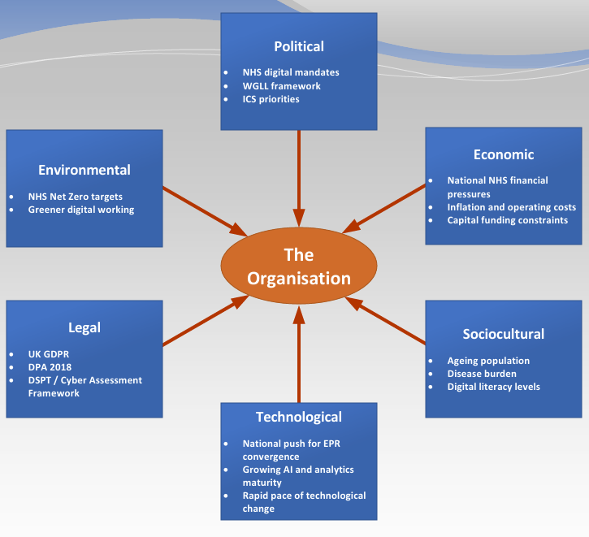
Figure 2. PESTLE factors influencing HHP, Adapted from (Vilas Belsare, 2025).
Political factors are significant in the NHS, as national organisations set the rules and expectations for how digital change should happen. Research shows that NHS digital programmes, including digital health technology, must align with requirements set by NHS England, NICE and other national regulators (Unsworth et al., 2021). This means that national policies and priorities strongly shape digital plans in healthcare. The HHP strategy reflects this by focusing on interoperability, integrated care, and data-driven decision-making (Humber Health Partnership, 2025a). However, the strategy's timeframes is not fully clear. Although it is described as a three-year digital strategy, some parts refer to timescales linked to the five-year Group strategy (Humber Health Partnership, 2025a, 2025b). This can cause confusion about what should be delivered and by when, and suggests some content may have been carried across without full alignment. This lack of clarity may reduce accountability and make performance harder to measure.
Economic pressures also influence the strategy. The NHS is working with increasingly tight budgets, but digital transformation still needs major investment in infrastructure, cybersecurity and staff training. National-level guidance points out that funding shortages affect digital readiness and that digital change moves faster than resources available to support it (NHS Providers, 2024). This is relevant for HHP, which allocates only a small proportion of spending to digital services, potentially limiting the feasibility of large-scale ambitions (Humber Health Partnership, 2025a). While financial sustainability is acknowledged, clear cost details for staff training, virtual wards and long-term system support are limited (Humber Health Partnership, 2025a). This makes it harder to judge whether the digital ambitions are affordable within the three-year timeframe.
Social pressures make digital change even more important. An ageing population and more people living with long-term conditions are increasing demand on hospitals. Evidence shows that virtual wards can reduce admissions, and support early discharge (Pugmire et al., 2025). HHP’s strategy responds to these demographic shifts by emphasising virtual care and enhanced remote monitoring (Humber Health Partnership, 2025a). However, the strategy gives limited attention to digital exclusion. Some groups, such as older people and those on lower incomes, may struggle to use virtual services. Without clear support or alternatives, this could increase the risk of health inequalities.
New technology, such as artificial Intelligence (AI), improved data-sharing standards, and modern digital health platforms, offers significant opportunities for improving care. However, these tools can only work well when an organisation has a stable system and strong governance (Hussein et al., 2026). The strategy recognises this by prioritising digital foundations and unified platforms, although achieving this will require significant investment, clear leadership and careful planning (Humber Health Partnership, 2025a). Despite this recognition, the strategy provides limited detail on how capability will develop in stages. More advanced initiatives, such as AI and real-time analytics, are planned alongside foundational work, creating a risk that technological ambition may outpace organisational readiness within three years.
Legal requirements around data protection, cybersecurity, and patient privacy also influence the strategy, especially because tools such as remote monitoring and virtual hospitals rely on secure data sharing. The strategy reflects this through its focus on cyber-resilience, unified governance, and reducing risks associated with legacy systems. Meeting these requirements will require significant organisational effort and investment (Humber Health Partnership, 2025a). This approach must comply with the Data Protection Act 2018 and the UK General Data Protection Regulation (UK GDPR), which set legal requirements for the lawful, fair and secure processing of health data (Stratton, 2026). The strategy, however, provides little detail on how legal responsibilities and data governance will be managed when virtual care involves multiple organisations, which could create risks as digital services expand.
Environmental factors also affect how HHP delivers its digital ambitions, especially the NHS goal of achieving Net Zero and reducing the environmental impact of care (Humber Health Partnership, 2025a). Digital tools can support more sustainable ways of working by cutting paper use, reducing travel through virtual care and updating older infrastructure to improve energy efficiency (Usher, Williams and Jackson, 2024). While sustainability is mentioned in the strategy, it is not a clear focus. There is a limited explanation of how digital initiatives will deliver long-term environmental or operational sustainability benefits, suggesting they are treated more as a supporting outcome than as a core part of the strategy (Humber Health Partnership, 2025a).

Organisational Alignment: McKinsey 7S Framework
The HHP strategy sets out clear aims, such as improving system reliability, enabling digital systems to connect more effectively, and strengthening data use (Humber Health Partnership, 2025a). These priorities align with research indicating that robust digital foundations must be in place before more advanced technologies can be introduced safely (Unsworth et al., 2021). However, some ambitions, like real-time analytics and virtual models of care, may be difficult to achieve straight away, given that the organisation is still in the early stages of its digital maturity. Figure 3 illustrates the key components of the McKeninsey 7S Framework and their interdependencies. Highlighting the alignment between hard and soft elements.
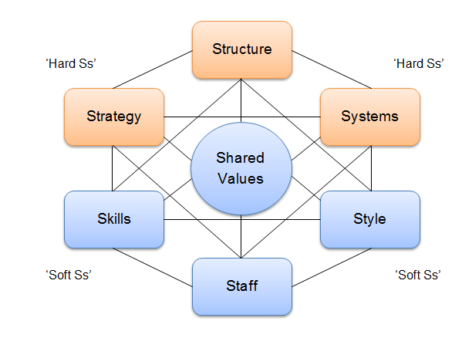
Figure 3. McKinsey 7S Framework (Jurevicius, 2025)
In terms of structure, moving towards a single digital governance model is a positive change. The strategy highlights that the current systems and responsibilities are fragmented, and centralising governance could reduce duplication and improve overall control (Humber Health Partnership, 2025a). However, the strategy provides little detail on how this new governance model will operate in practice, creating uncertainty about accountability and its implementation across Trusts that have previously operated separate digital systems.
The system element shows one of the biggest changes in the strategy, by bringing in a single EPR and creating a shared data warehouse (Humber Health Partnership, 2025a). Research shows that these kinds of system changes can improve care coordination and help organisations make better decisions when they are implemented well (Cresswell, Bates and Sheikh, 2013). However, rolling out a unified EPR across several hospital sites is complex. It can cause disruption, and the strategy does not fully address the extent of change management this will require.
Regarding staff and skills, the strategy recognises that many employees have low digital confidence (Humber Health Partnership, 2025a). External research also shows that digital exclusion affects the workforce, with staff often lacking skills, confidence and access to the right technology to use digital tools effectively (Alotaibi, Wilson and Traynor, 2025). Although the strategy mentions training and digital inclusion, it does not set out a clear, long-term plan for developing digital skills across the organisation.
The strategy promotes collaboration and partnership working, which reflects its approach to organisational culture and shared values (Humber Health Partnership, 2025a). Creating a culture that supports digital innovation is important. However, the strategy does not go into much detail about how ready the organisation's culture is for this change, and it is unclear how prepared clinical teams are to adopt new ways of working.
Overall, the strategic analysis shows the digital strategy is well aligned with national digital priorities and clearly recognises the need to improve core digital systems. However, its success will depend on how well the key challenges, such as staff digital skills, governance and funding, are managed, so that the organisation’s ambitions lead to lasting and practical improvements

References
Ademola, A., George, C. and Mapp, G. (2024) ‘Addressing the Interoperability of Electronic Health Records: The Technical and Semantic Interoperability, Preserving Privacy and Security Framework’, Applied System Innovation, 7(6), p. 116. Available at: https://doi.org/10.3390/asi7060116.
Alotaibi, N., Wilson, C.B. and Traynor, M. (2025) ‘Enhancing digital readiness and capability in healthcare: a systematic review of interventions, barriers, and facilitators’, BMC Health Services Research, 25(1), p. 500. Available at: https://doi.org/10.1186/s12913-025-12663-3.
Buntin, M.B., Burke, M.F., Hoaglin, M.C. and Blumenthal, D. (2011) ‘The Benefits Of Health Information Technology: A Review Of The Recent Literature Shows Predominantly Positive Results’, Health Affairs, 30(3), pp. 464–471. Available at: https://doi.org/10.1377/hlthaff.2011.0178.
Cresswell, K., Sheikh, A. and Williams, R. (2022) ‘“Managed convergence” in health system digitalisation’, Journal of the Royal Society of Medicine, 115(8), pp. 284–285. Available at: https://doi.org/10.1177/01410768221098274.
Cresswell, K.M., Bates, D.W. and Sheikh, A. (2013) ‘Ten key considerations for the successful implementation and adoption of large-scale health information technology’, Journal of the American Medical Informatics Association, 20(e1), pp. e9–e13. Available at: https://doi.org/10.1136/amiajnl-2013-001684.
Department of Health & Social Care (2022) Data saves lives: reshaping health and social care with data - GOV.UK. Available at: https://www.gov.uk/government/publications/data-saves-lives-reshaping-health-and-social-care-with-data/data-saves-lives-reshaping-health-and-social-care-with-data (Accessed: 15 March 2026).
Ebo, T.O., Clement David-Olawade, A., Ebo, D.M., Egbon, E. and Olawade, D.B. (2025) ‘Transforming healthcare delivery: A comprehensive review of digital integration, challenges, and best practices in integrated care systems’, Digital Engineering, 6, p. 100056. Available at: https://doi.org/10.1016/j.dte.2025.100056.
George, J., Ramsay, A.I.G., Crowe, S. and Hayward, A. (2025) ‘Using population risk prediction for healthcare planning: a qualitative study of healthcare planners’ experiences and views’, Journal of Public Health, 47(3), pp. 540–549. Available at: https://doi.org/10.1093/pubmed/fdaf070.
Greenhalgh, T., Wherton, J., Papoutsi, C., Lynch, J., Hughes, G., A’Court, C., Hinder, S., Fahy, N., Procter, R. and Shaw, S. (2017) ‘Beyond Adoption: A New Framework for Theorizing and Evaluating Nonadoption, Abandonment, and Challenges to the Scale-Up, Spread, and Sustainability of Health and Care Technologies’, Journal of Medical Internet Research, 19(11), p. e367. Available at: https://doi.org/10.2196/jmir.8775.
Hakim, R.W.B.I.A. (2025) Digital transformation in the NHS: a reference guide | NHS Confederation. Available at: https://www.nhsconfed.org/publications/digital-transformation-nhs-reference-guide (Accessed: 6 March 2026).
Humber Health Partnership (2025a) ‘Digital Strategy 2025-28’. Available at: https://www.nlg.nhs.uk/wp-content/uploads/2025/07/Digital-Stategy-2025-2028.pdf (Accessed: 26 February 2026).
Humber Health Partnership (2025b) ‘GROUP STRATEGY’. Available at: https://www.nlg.nhs.uk/wp-content/uploads/2025/07/Group-Strategy-2025-2028-1.pdf (Accessed: 26 March 2026).
Hussein, R., Zink, A., Ramadan, B., Howard, F.M., Hightower, M., Shah, S. and Beaulieu-Jones, B.K. (2026) ‘Advancing healthcare AI governance through a comprehensive maturity model based on systematic review’, npj Digital Medicine, 9(1), p. 236. Available at: https://doi.org/10.1038/s41746-026-02418-7.
Jurevicius, O. (2025) McKinsey 7S Model: The 7S Framework Explained - SM Insight. Available at: https://strategicmanagementinsight.com/tools/mckinsey-7s-model-framework/ (Accessed: 25 March 2026).
Larsen, E.P., Rao, A.H. and Sasangohar, F. (2020) ‘Understanding the scope of downtime threats: A scoping review of downtime-focused literature and news media’, Health Informatics Journal, 26(4), pp. 2660–2672. Available at: https://doi.org/10.1177/1460458220918539.
Li, E., Clarke, J., Ashrafian, H., Darzi, A. and Neves, A.L. (2022) ‘The Impact of Electronic Health Record Interoperability on Safety and Quality of Care in High-Income Countries: Systematic Review’, Journal of Medical Internet Research, 24(9), p. e38144. Available at: https://doi.org/10.2196/38144.
Li, E., Lounsbury, O., Hasnain, M., Ashrafian, H., Darzi, A., Neves, A.L. and Clarke, J. (2025) ‘Physician experiences of electronic health record interoperability and its practical impact on care delivery in the English NHS: a cross-sectional survey study’, BMJ Open, 15(6), p. e096669. Available at: https://doi.org/10.1136/bmjopen-2024-096669.
NHS (2023) ‘Planning for managing legacy systems and decommissioning digital healthcare technologies This Guide covers: From: Medicines and Healthcare products Regulatory Agency (MHRA)’. Available at: https://digitalregulations.innovation.nhs.uk/regulations-and-guidance-for-adopters/all-adopters-guidance/planning-for-managing-legacy-systems-and-decommissioning-digital-healthcare-technologies/pdf/ (Accessed: 22 March 2026).
NHS England (2024) FHIR UK Core - NHS England Digital. Available at: https://digital.nhs.uk/services/fhir-uk-core (Accessed: 10 April 2026).
NHS England (2025) Information standards for health and care - NHS England Digital. Available at: https://digital.nhs.uk/data-and-information/information-standards (Accessed: 20 March 2026).
NHS England (2026a) NHS England » Interoperability. Available at: https://www.england.nhs.uk/digitaltechnology/connecteddigitalsystems/interoperability/ (Accessed: 15 March 2026).
NHS England (2026b) NHS England » Interoperability. Available at: https://www.england.nhs.uk/digitaltechnology/connecteddigitalsystems/interoperability/ (Accessed: 22 March 2026).
NHS England (2026c) SNOMED CT - NHS England Digital. Available at: https://digital.nhs.uk/services/terminology-and-classifications/snomed-ct (Accessed: 10 April 2026).
NHS England Board (2025) ‘Digital, Data and Technology Transformation’. Available at: https://www.england.nhs.uk/wp-content/uploads/2025/03/agenda-item-8-data-digital-and-technology-transformation.pdf (Accessed: 20 March 2026).
NHS Providers (2024) Digital transformation hampered by budgets, NHS pressures and poor IT infrastructure. Available at: https://nhsproviders.org/news/digital-transformation-hampered-by-budgets-nhs-pressures-and-poor-it-infrastructure (Accessed: 24 March 2026).
Pugmire, J., Ashish, A., Chadwick, A., Wilkes, M., Meekin, D., Zaniello, B. and Zahradka, N. (2025) ‘A 2-Year Retrospective Clinical Evaluation of a Novel Virtual Ward Model’, Journal of Primary Care & Community Health, 16. Available at: https://doi.org/10.1177/21501319251326750.
Rajput, K., Darzi, A. and Ghafur, S. (2025) ‘Overlooked and under-reported: the impact of cyberattacks on primary care in the UK National Health Service’, The Lancet Digital Health, 7(7), p. 100879. Available at: https://doi.org/10.1016/j.landig.2025.100879.
Scantlebury, A., Sheard, L., Fedell, C. and Wright, J. (2021) ‘What are the implications for patient safety and experience of a major healthcare IT breakdown? A qualitative study’, DIGITAL HEALTH, 7. Available at: https://doi.org/10.1177/20552076211010033.
Shahzad, K., Khan, S.A., Latif, M., Javeed, A.M.D. and Iqbal, A. (2025) ‘Big data analytics in healthcare: current practices, innovations, and future prospects’, Journal of Big Data, 12(1), p. 242. Available at: https://doi.org/10.1186/s40537-025-01288-2.
Sinha, R. (2024) ‘The role and impact of new technologies on healthcare systems’, Discover Health Systems, 3(1), p. 96. Available at: https://doi.org/10.1007/s44250-024-00163-w.
Stratton, P. (2026) ‘THE COMPLETE GUIDE TO UK-GDPR’. Available at: https://www.legislation.gov.uk/ukpga/2018/12/contents/enacted (Accessed: 10 April 2026).
Torab-Miandoab, A., Samad-Soltani, T., Jodati, A. and Rezaei-Hachesu, P. (2023) ‘Interoperability of heterogeneous health information systems: a systematic literature review.’, BMC medical informatics and decision making, 23(1), p. 18. Available at: https://doi.org/10.1186/s12911-023-02115-5.
Unsworth, H., Dillon, B., Collinson, L., Powell, H., Salmon, M., Oladapo, T., Ayiku, L., Shield, G., Holden, J., Patel, N., Campbell, M., Greaves, F., Joshi, I., Powell, J. and Tonnel, A. (2021) ‘The NICE Evidence Standards Framework for digital health and care technologies – Developing and maintaining an innovative evidence framework with global impact’, DIGITAL HEALTH, 7. Available at: https://doi.org/10.1177/20552076211018617.
Usher, K., Williams, J. and Jackson, D. (2024) ‘The potential of virtual healthcare technologies to reduce healthcare services’ carbon footprint’, Frontiers in Public Health, 12. Available at: https://doi.org/10.3389/fpubh.2024.1394095.
Vilas Belsare, H. (2025) ‘PESTLE ANALYSIS’, International Journal of Advanced Research, 13(02), pp. 608–612. Available at: https://doi.org/10.21474/IJAR01/20411.
Wachter, R.M. (2016) ‘Making IT Work: Harnessing the Power of Health Information Technology to Improve Care in England’. Available at: https://www.mendeley.com/reference-manager/reader/00c8a5ed-54e1-3a30-b609-b2af2b77581c/7b781f28-395a-67c3-51f2-067c436eb6d2 (Accessed: 20 March 2026).
Xue, Z., Zhou, N., Wu, Y. and Qi, H. (2026) ‘Digital exclusion in healthcare services: a scoping review’, International Journal for Equity in Health, 25(1), p. 37. Available at: https://doi.org/10.1186/s12939-025-02755-1.

