ASSESSMENT 2 – REPORT

The execution of this multimedia project was designed to coincide with my main Independent Project: The Pit, a short horror film. At the same time, it hinges on how much time I have available while working on it. Therefore, I may only proceed with elements of this multimedia project or none of it at all.

Were I to choose which elements to go ahead with, I would at least the following:

- A trailer video in the lead up the release date.
- A vertical ten second trailer for social media reels
- An Instagram page rather than a website, as this is free and acts as an image journal for any behind the scenes content.
- A limited run of Blu-ray dvds with just the final edit of The Pit

This way, the promotional material for The Pit is easily shared across social media, and there is at least a small high-quality piece of merchandise to act as a souvenir for all involved.

WEBSIODE PREQUELS

The primary content of this multimedia project are the “webisodes” that would be shared as vertical format, minute long films featured on Instagram stories, Facebook reels and YouTube shorts.

I wrote three scripts for each scene featured in these webisodes, which would be set the very day before the events of The Pit, and connect together as different times across the same day.

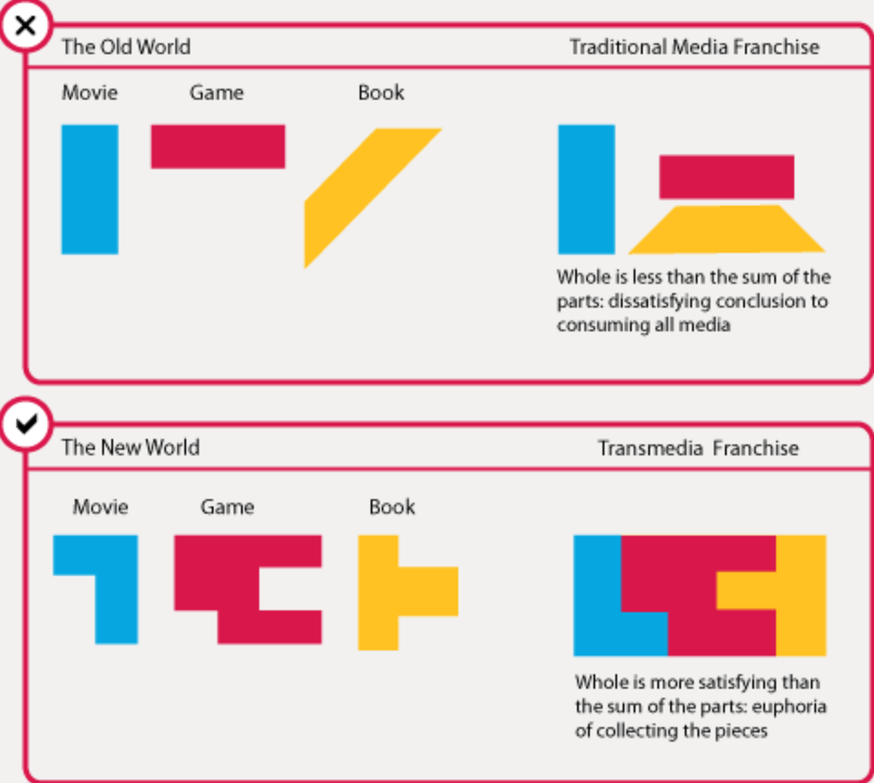
As indicated in this transmedia franchise diagram, this opens up the limited world that is The Pit as a short film, and expands upon the protagonist. Were the audience to watch these prequels before The Pit, they are given a broader insight into Davies’ personality and an investment into his fate by the end of the film.

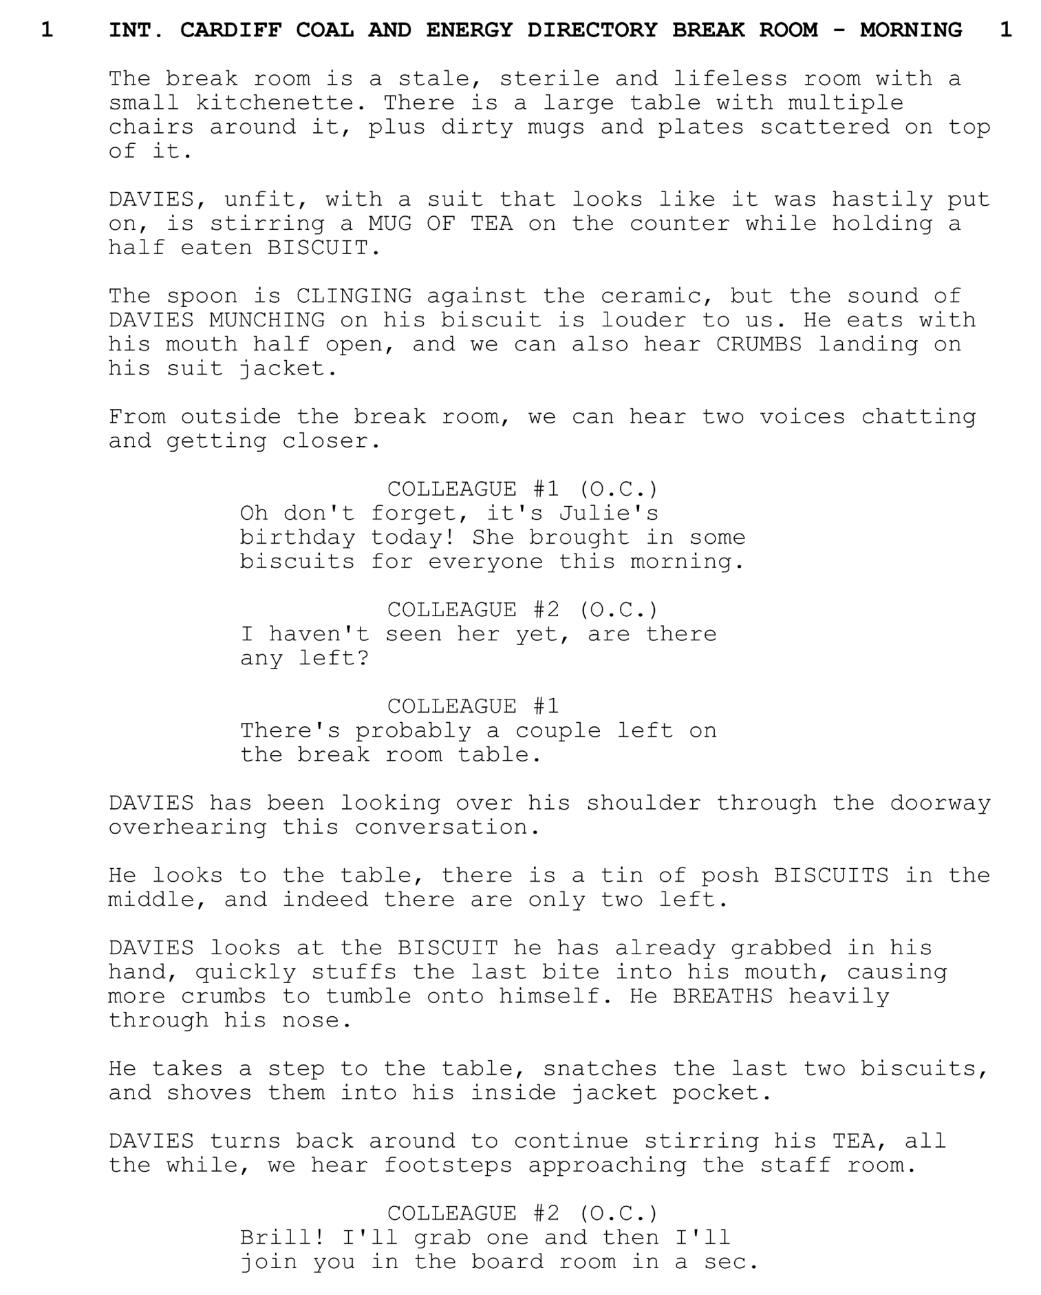

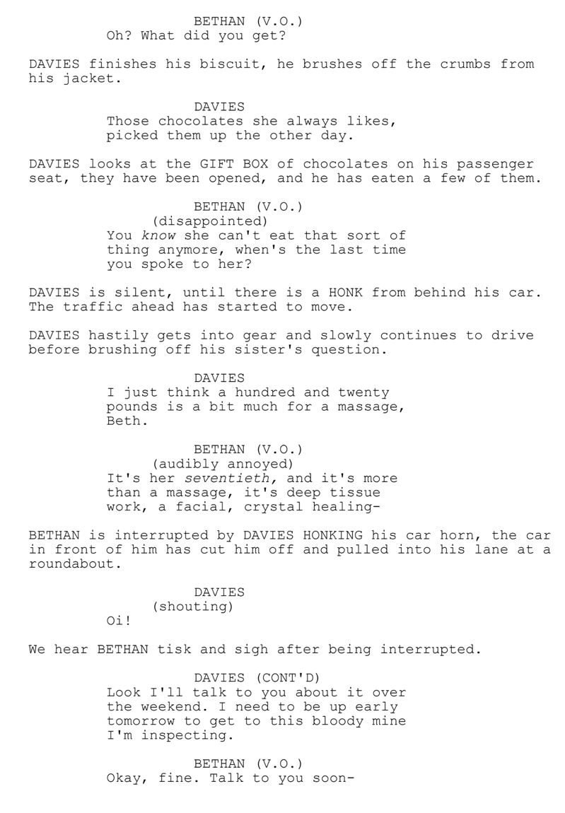
This approach covers all three C’s of transmedia storytelling:

- Convenience – The webisodes are accessible and easily shared across different social media platforms.
- Character – We a given further insight into the protagonist and an expansion of the “world” of The Pit
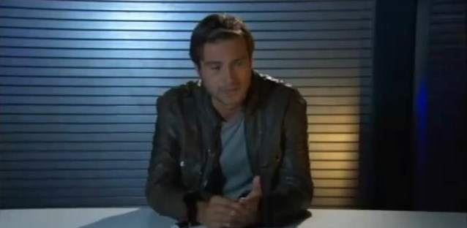
- Community – Audience can participate by commenting and casting their votes on the featured polls regarding the questions about Davies’ character.
Figure 1 Primeval: Series 4 Prequal Webisode 1 - Anomaly Research Centre (2011)
As an example, the ITV series Primeval made use of webisodes to act as links between season 3 and 4, covering gaps in the story and as a way to build anticipation.

“The webisodes give a short glimpse of the Anomaly Research Centre during the year that Abby and Connor were stuck in the Cretaceous. It primarily introduces new team members Matt Anderson and Jess Parker and explains in more detail why the changes in the Anomaly operation occurred.”

These were three-minute-long segments screened on ITV between programmes; as this was 2011, YouTube and video sharing platforms weren’t as popular as they are today, so it made sense for the marketing teams to air these “webisodes” on mainstream TV, where they would reach the broadest audience.

VERTICAL FORMAT
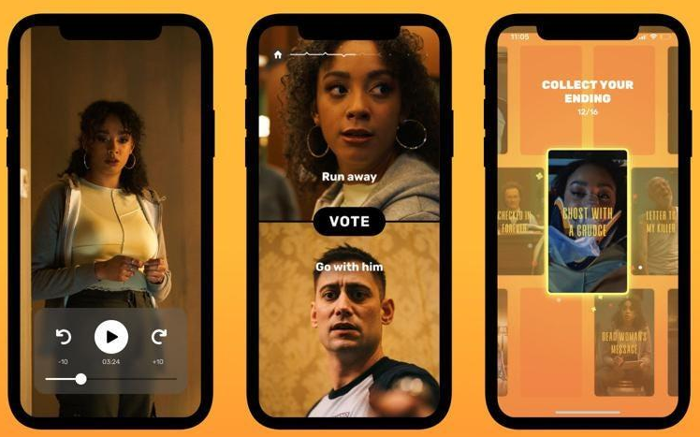
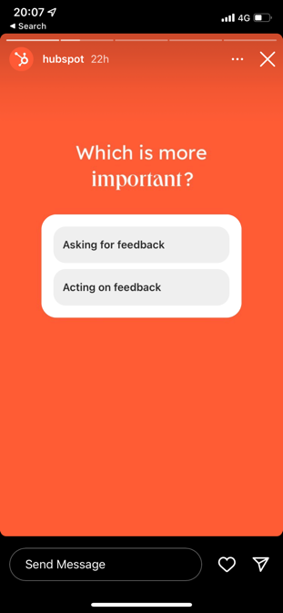
Figure 2 Whatifi: Interactive Movies App

The reason I planned to film these webisodes in vertical format is that (arguably) the most consumed forms of video online are in the form of vertical reels/shorts. This way it is seen on the most accessible devices (everyone’s mobile phones), covering the Convenience aspect of the three C’s.

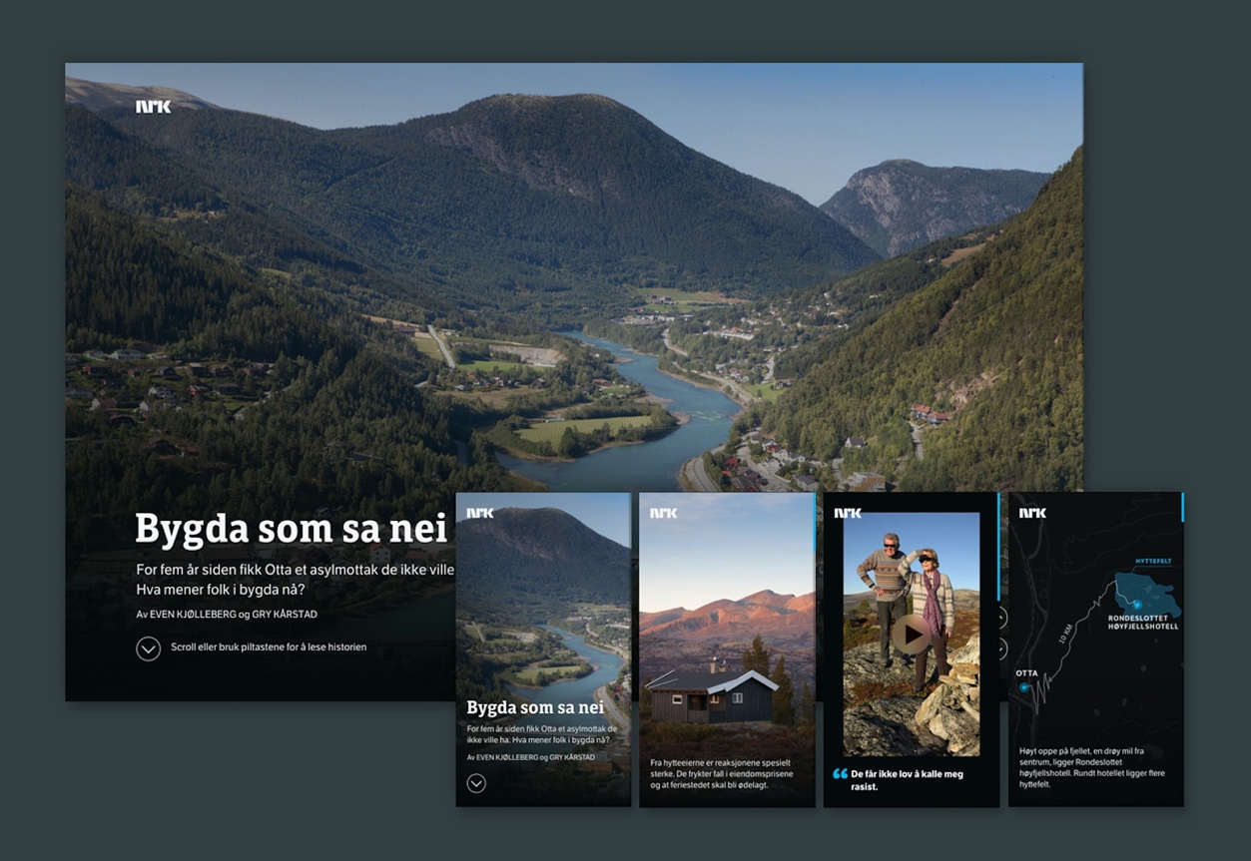
As depicted above, vertical format allows for easier interactivity when it comes to answering questions and polls, as the viewer can remain holding their phone in the most comfortable way.
Figure 3 Bygda som sa nei (The Village that said No) 2015-16
As an artistic approach, vertical filmmaking offers an alternative approach to watching videos, and is particularly suited to those with a focus on portraiture.

Bygda som sa nei was a series of interviews focused on a small Norwegian community as part of a sociopolitical documentary. Though it released content across Norwegian social media, its primary platform (and how the documentary itself is presented) was on it’s own website page via NRK. When viewed on mobile phones, the page adapts to the phone screen and allows the viewer to scroll down to view all the articles, quotes, and the short interviews featuring the townsfolk of Otta.

“Refreshing to see storytelling tailored for mobile. Both content, design and technical solution are adapted to the small, vertical screens. The content is of high quality and is presented piecemeal in smaller parts through a "deck of cards" concept that creates an easy-to-understand and engaging user experience. An important work that should characterize journalism in the future. Vertical videos are back!”
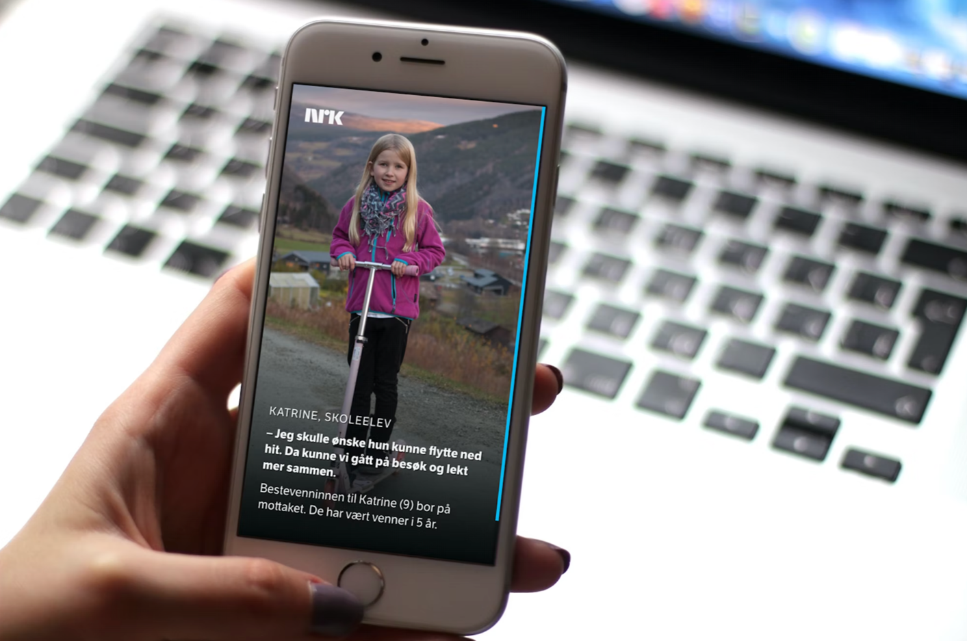
(Translated from Norwegian: Grafill Pamelding Visuelt 2016)

I felt this piece of digital communication covers two of the three C’s of transmedia; character in that it shines an intimate spotlight on each of its subjects and the stories they have to tell; and convenience in that it is tailored for vertical viewing on a platform that can be accessed by everyone.

BLU-RAY DVD RELEASE

The main reasoning behind my idea to create a limited run of Blu-ray DVDs of The Pit, was to collate every piece of related content onto one piece of physical, tangible merchandise.

It can be argued that home DVD viewing is a decreasingly popular format of entertainment in comparison to online streaming, the sales of which reflect the shortening of demand.

Chris Stokel-Walker’s data (2020) indeed shows a slow decrease in DVD’s popularity, but also suggests a niche crowd that still shows demand, calling it a “legacy format”.

“The number of total physical video transactions made worldwide has dropped from 6.1 billion in 2011 to 1.2 billion in 2021, according to market research firm Omdia. Just 300 million DVDs are expected to be sold worldwide this year, down from an average of 2 billion every year between 2005 and 2009. But there are still 300 million of the things—even if your collection is long gone or gathering dust on the bookshelf. And as demand for DVDs has plummeted, video streaming has risen in its place. Subscriptions to services like Netflix have increased from 39 million worldwide in 2011 to 1.2 billion today—almost swallowing the DVD industry whole. Almost, but not quite.”
(Chris Stokel-Walker, Wired 2021)

He also indicates that audio quality is lost when streaming movies, and that DVDs (Blu-ray best of all) retain the best audio experience with the likes of Dolby Atmos.

I plan for The Pit to rely heavily on sound to immerse the audience in a surround stereo experience; there will be quiet ambient diagetic and non-diagetic sound effects, as well as effects that will be heard from “behind” the audience from rear speakers.

When burning The Pit to DVD, I will be uploading a different edit to suit home surround-sound systems, which will be a different edit than the one screened at Carmarthen Bay.

CONCLUSION

I feel that I have understood this project brief well, but only when adapting it to coincide with my Independent Project. I struggled to invent a standalone idea, even as a hypothetical. However, the benefit of this multimedia project means that I can execute some or none of it’s elements depending on the time and resources available to me in order to expand on the universe of The Pit.

REFERENCES

Aggersberg, B. (2018) Transmedia Stretegy. HPMF6004 Multiplatform Content. UWTSD. Unpublished.

Primeval Series 4 Prequel Webisodes (2019) Available at: https://primeval.fandom.com/wiki/Series_4_Prequel_Webisodes (Accessed 16th Jan 2023)

Anthill Inc (2022) Whatifi: Interactive Movies (version 4.1.1) Available at: https://apps.apple.com/nz/app/whatifi-interactive-movies/id1460628333 (Accessed 16th Jan 2023)

Visual Online Documentary “The Village that said no” (2016) Available at: https://www.grafill.no/visuelt/vinnere/2016/digital-design/redaksjonell-design-og-datavisualisering/visuell-nettdokumentar-bygda-som-sa-nei (Accessed 16th Jan 2023)

Stokel-Walker, C. (2021) Why Do DVDs Still Exist? Available at: https://www.wired.co.uk/article/dvd-sales-streaming#:~:text=The%20number%20of%20total%20physical,year%20between%202005%20and%202009. (Accessed 16th Jan 2023)

