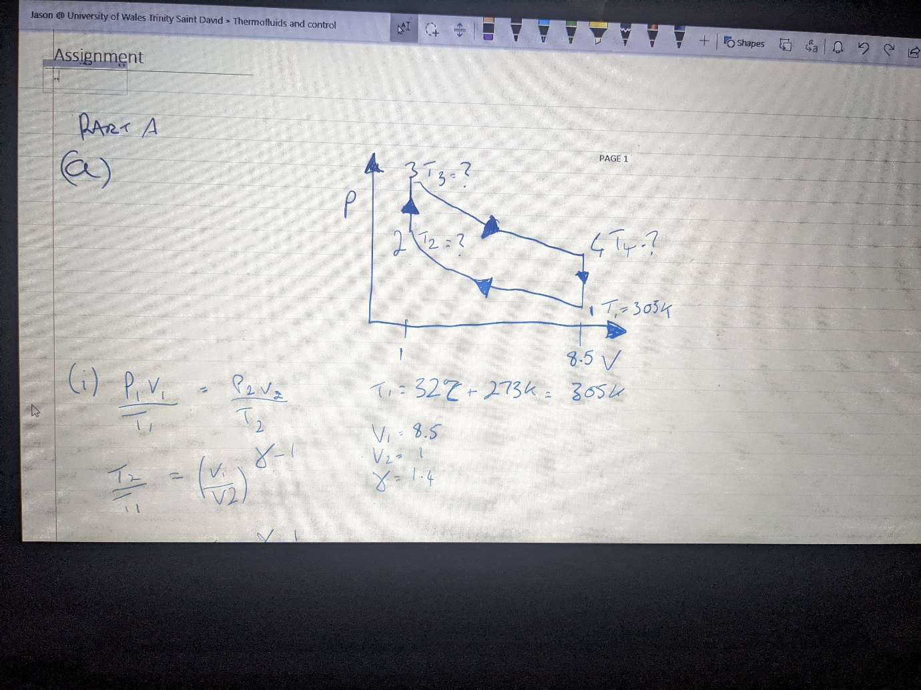
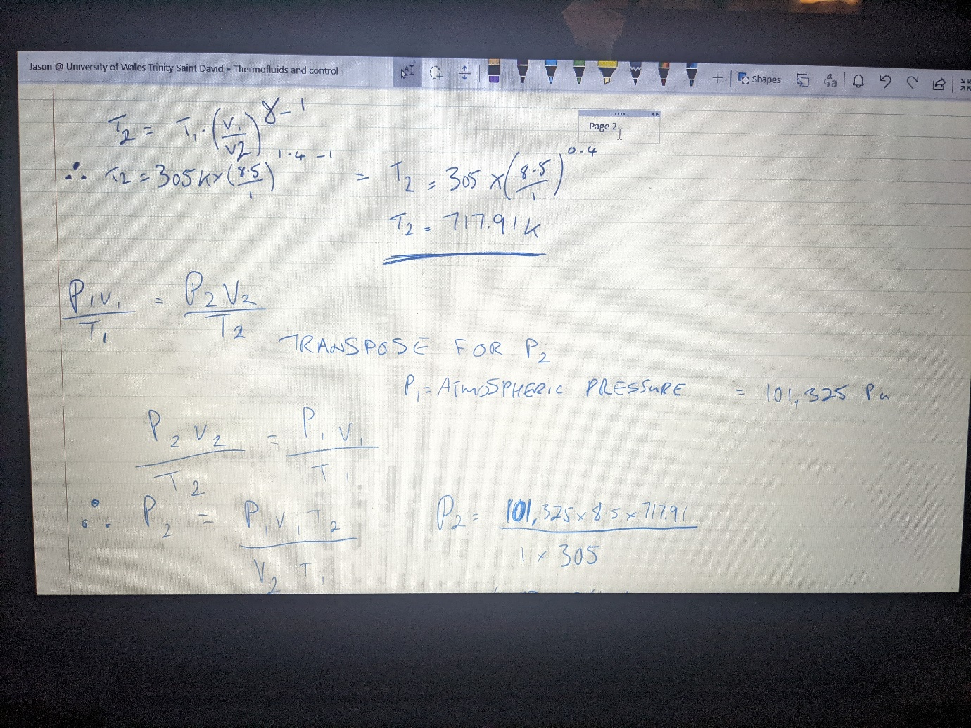
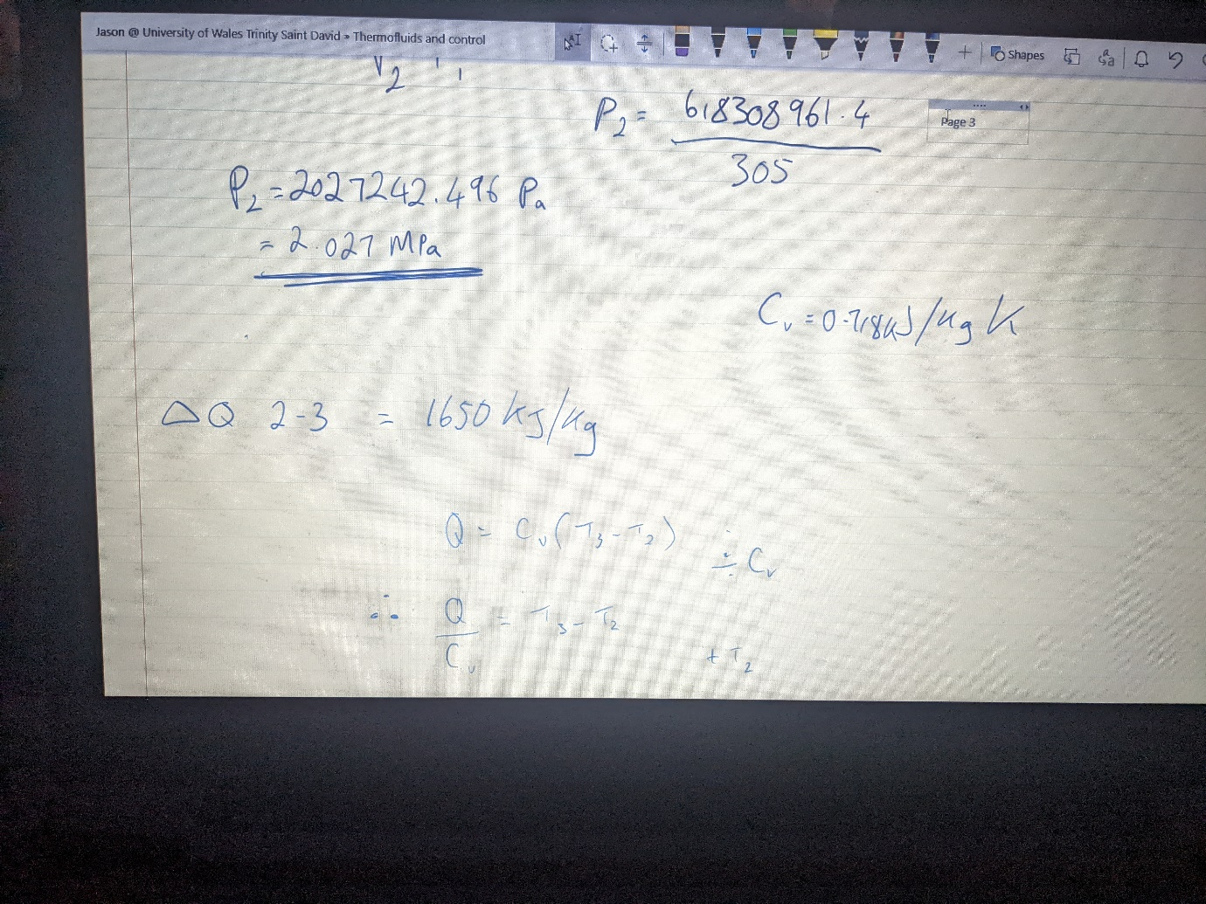
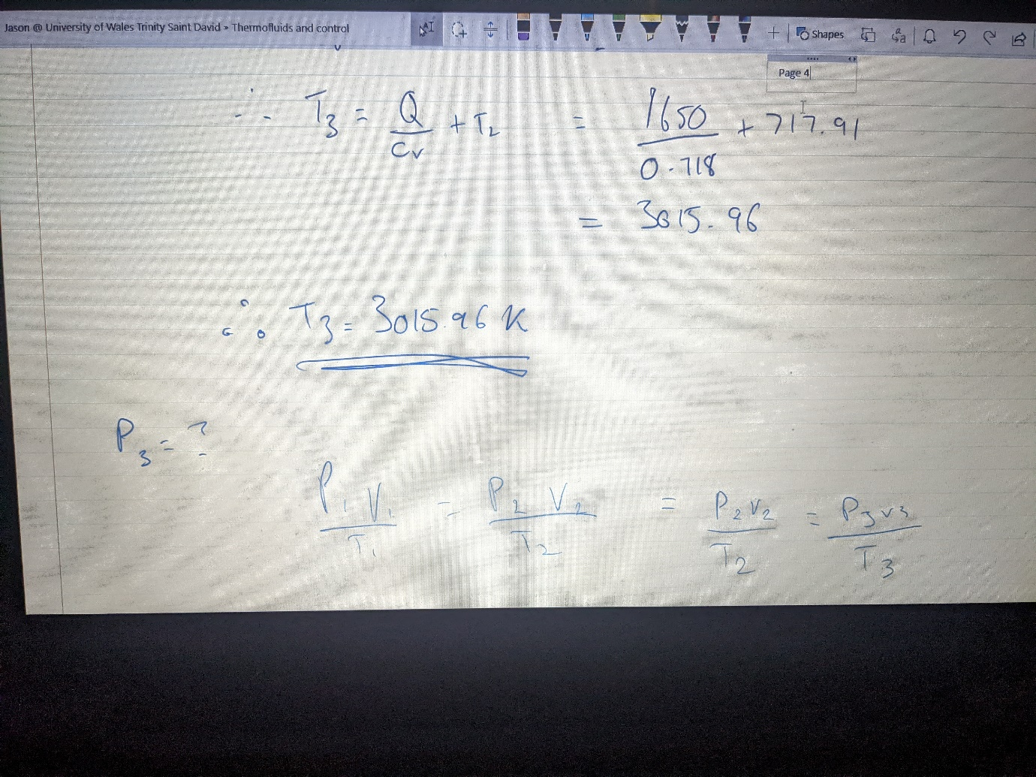
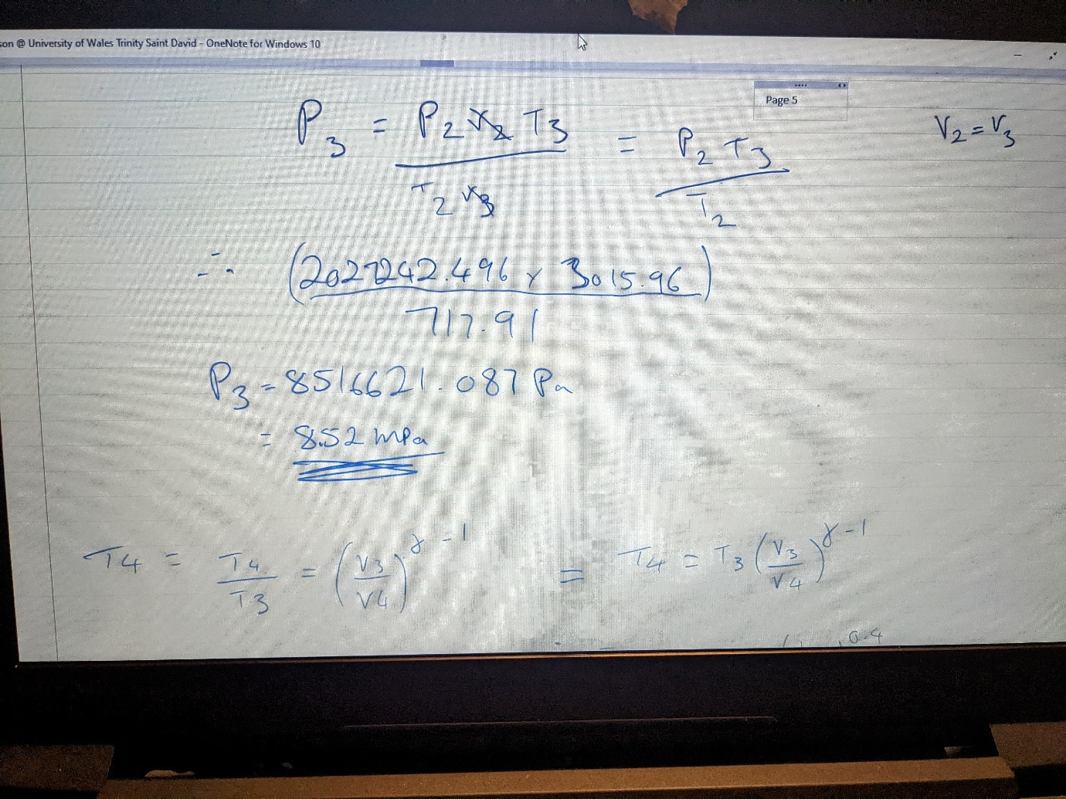
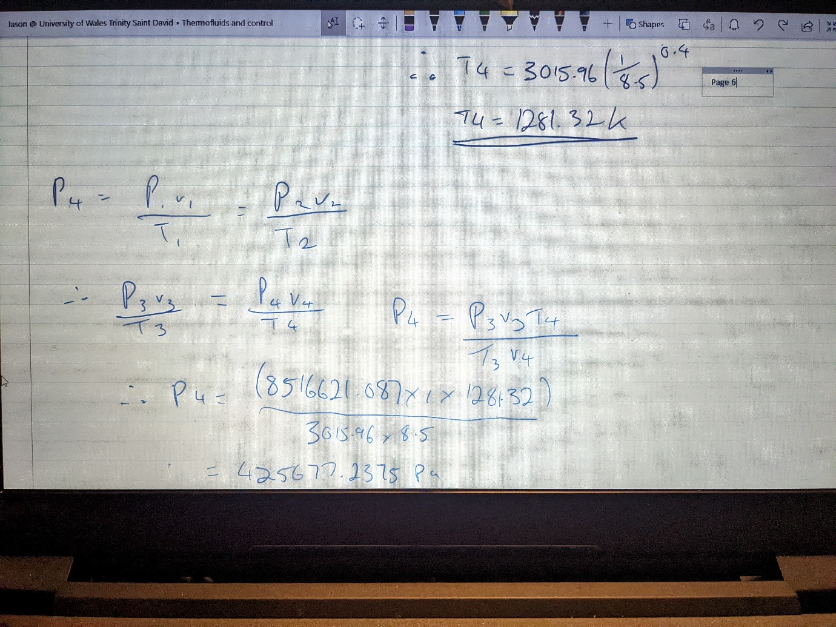
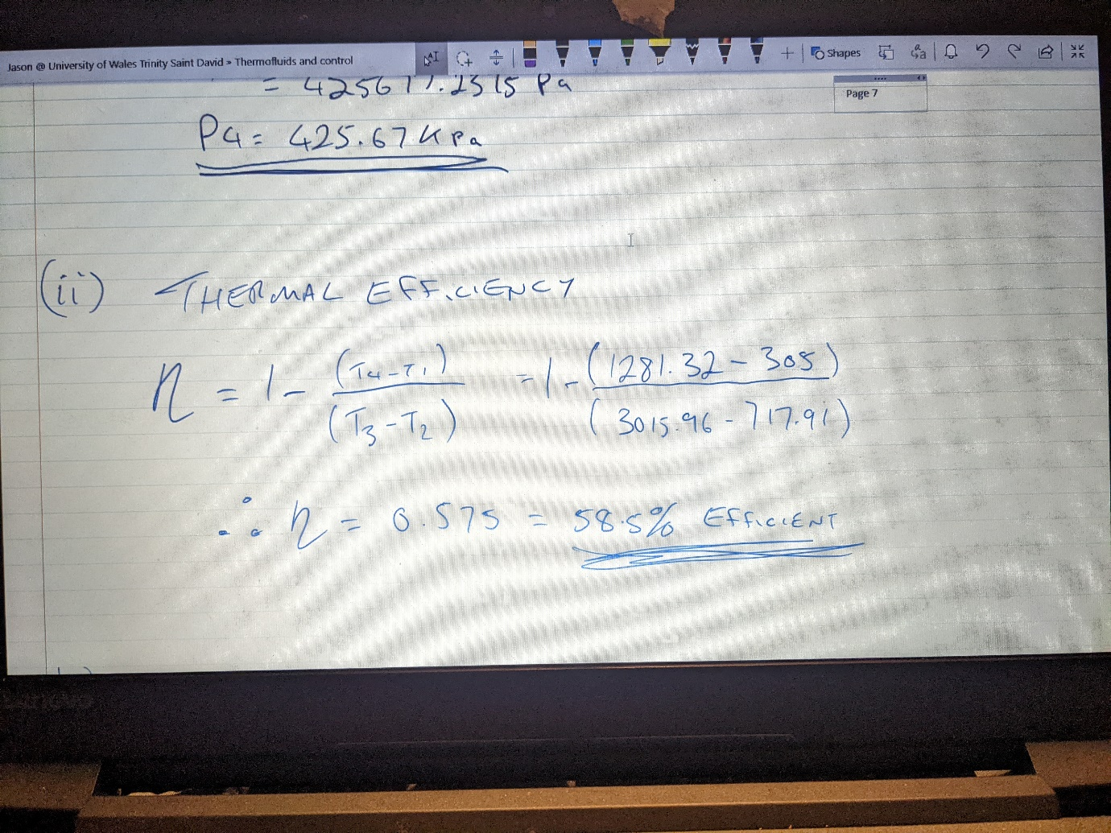
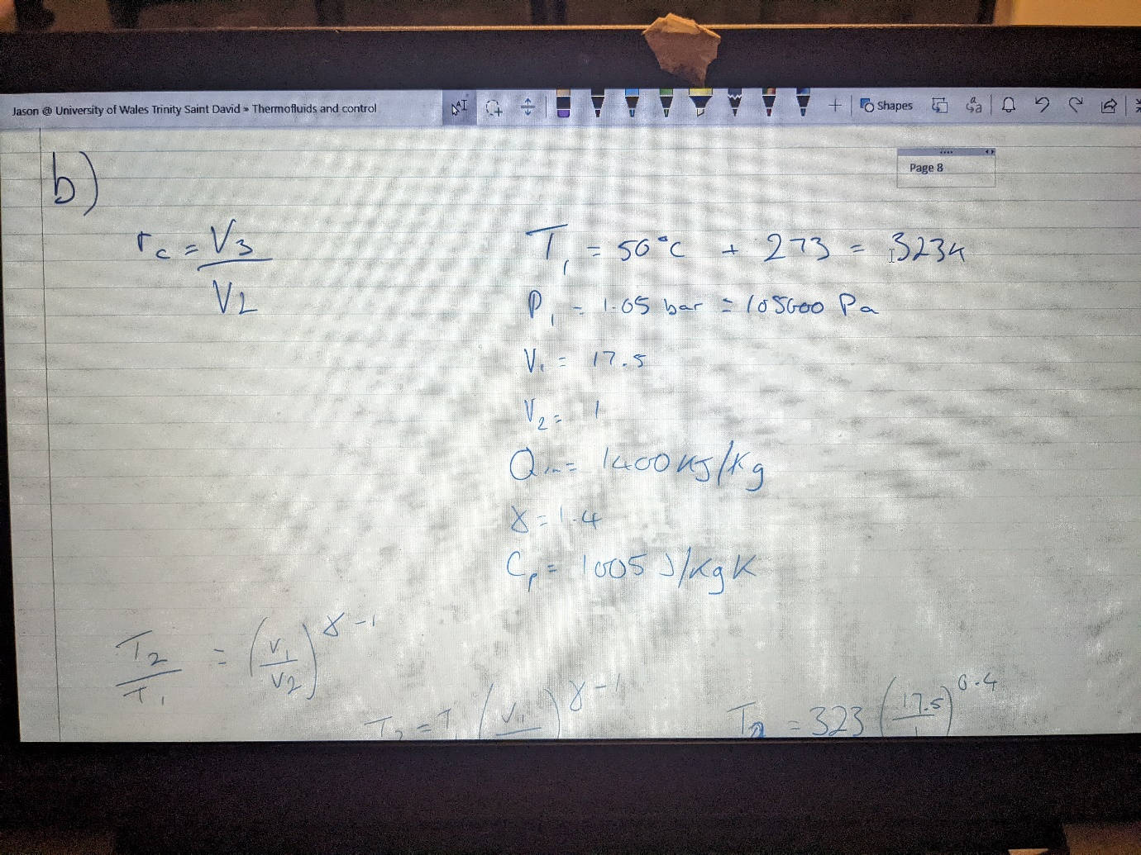
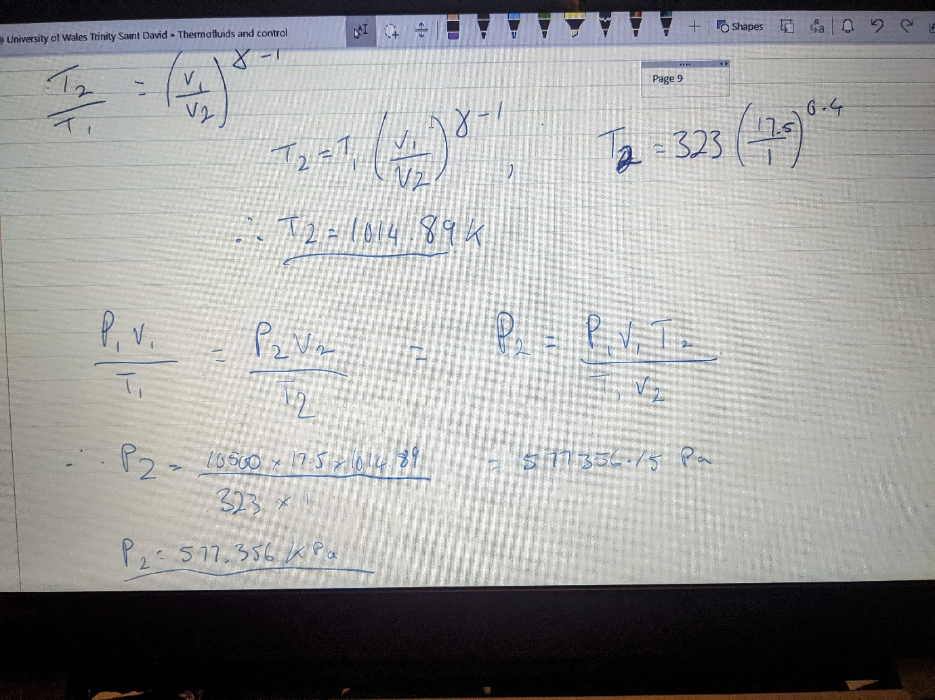
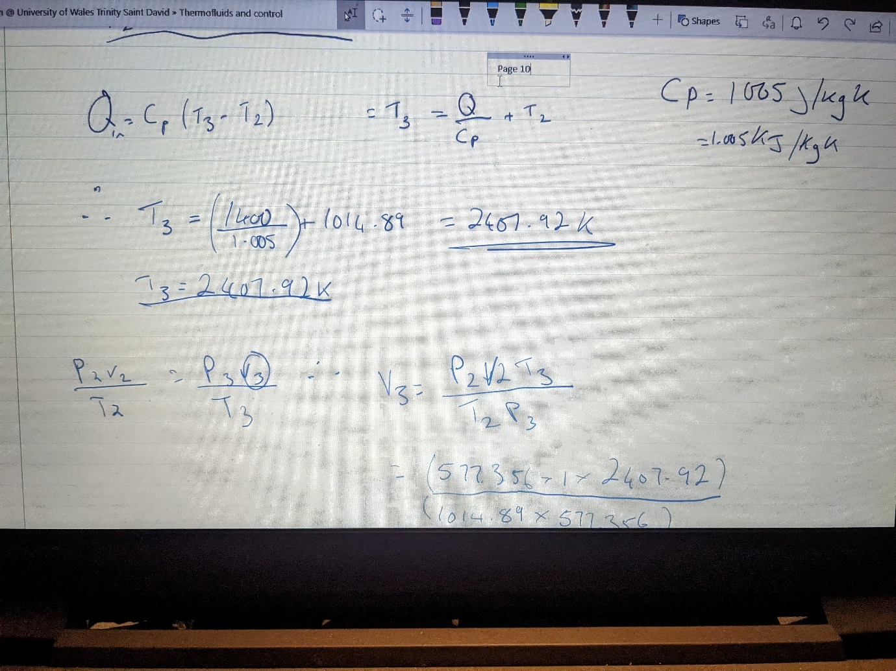
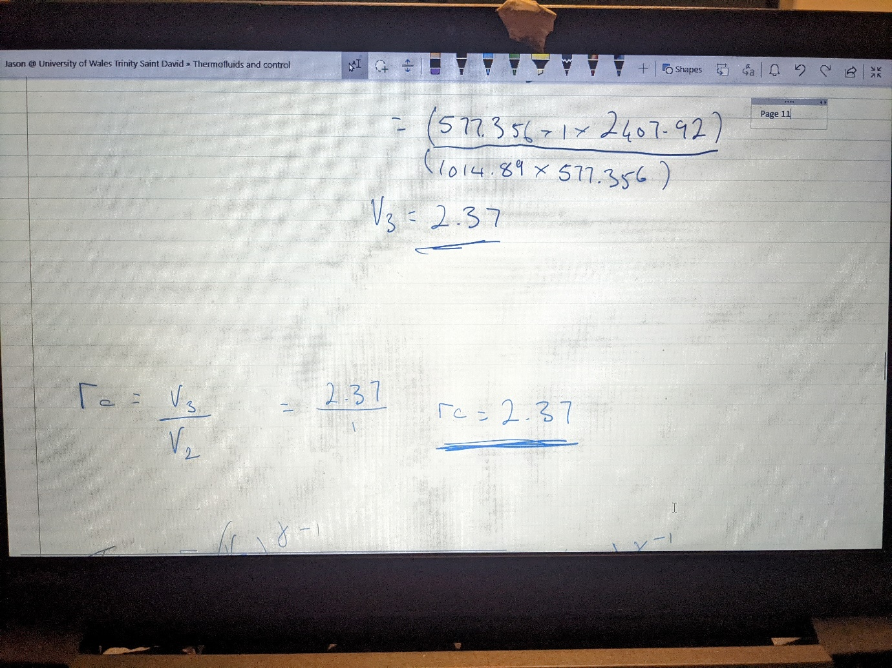
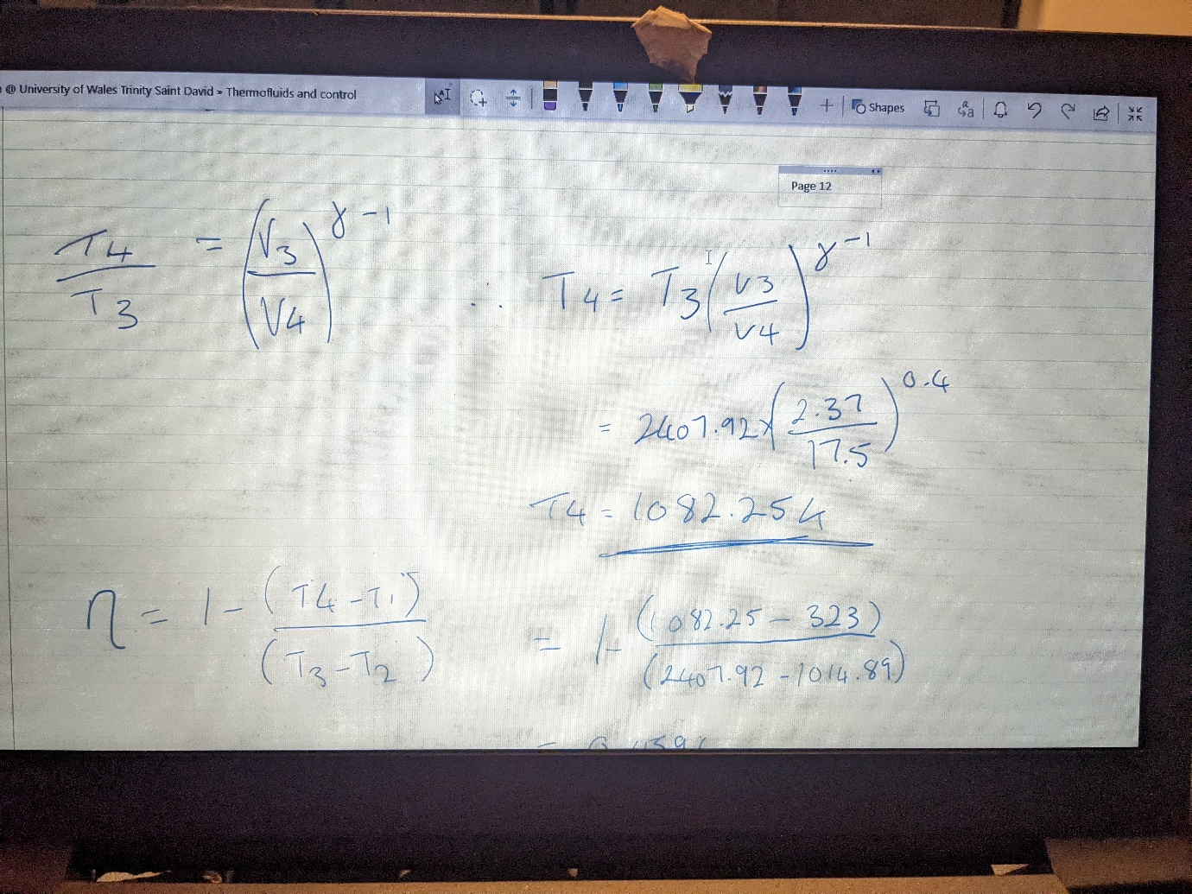
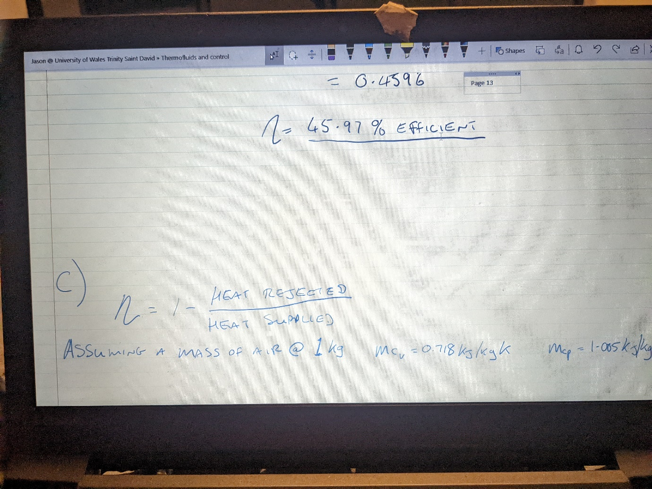
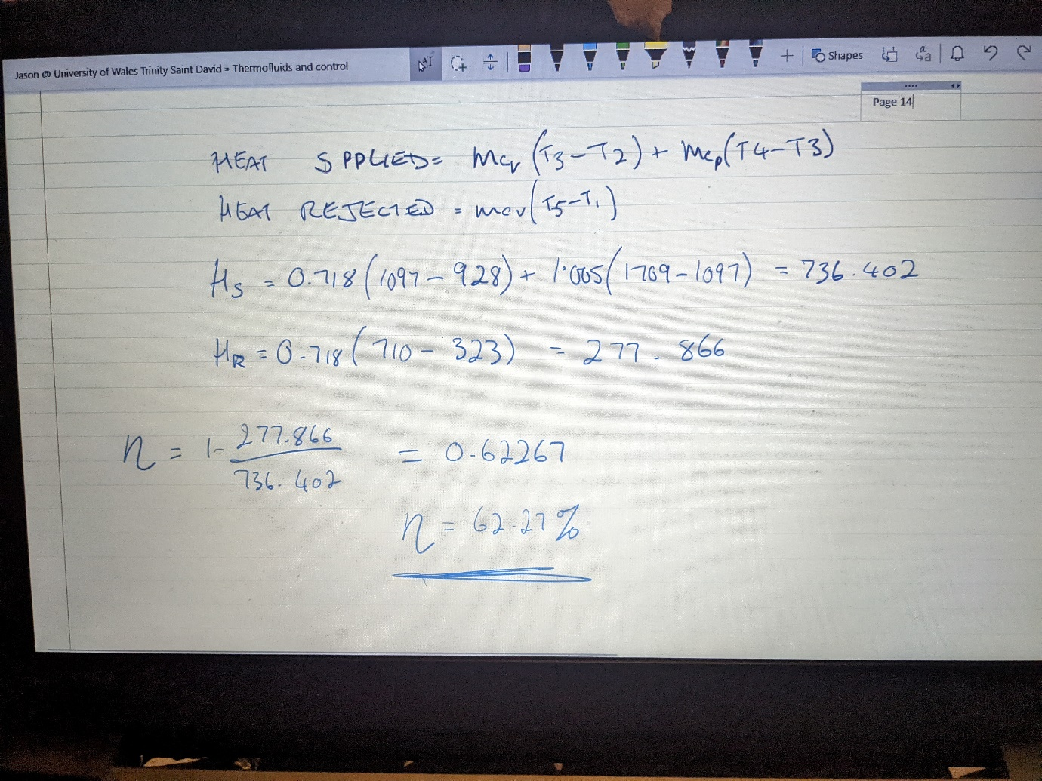
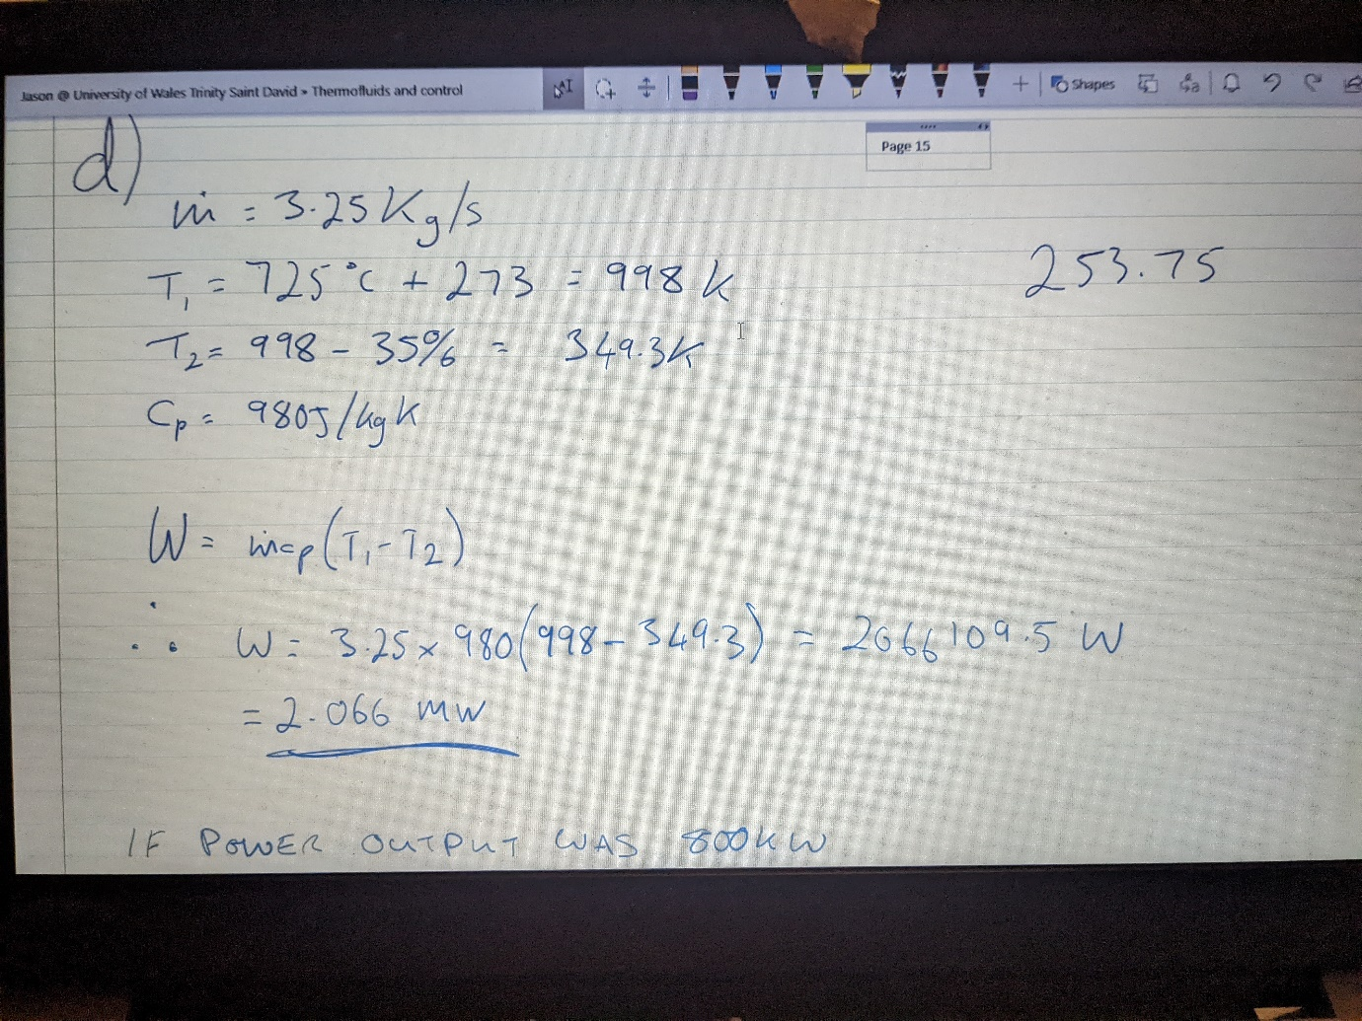
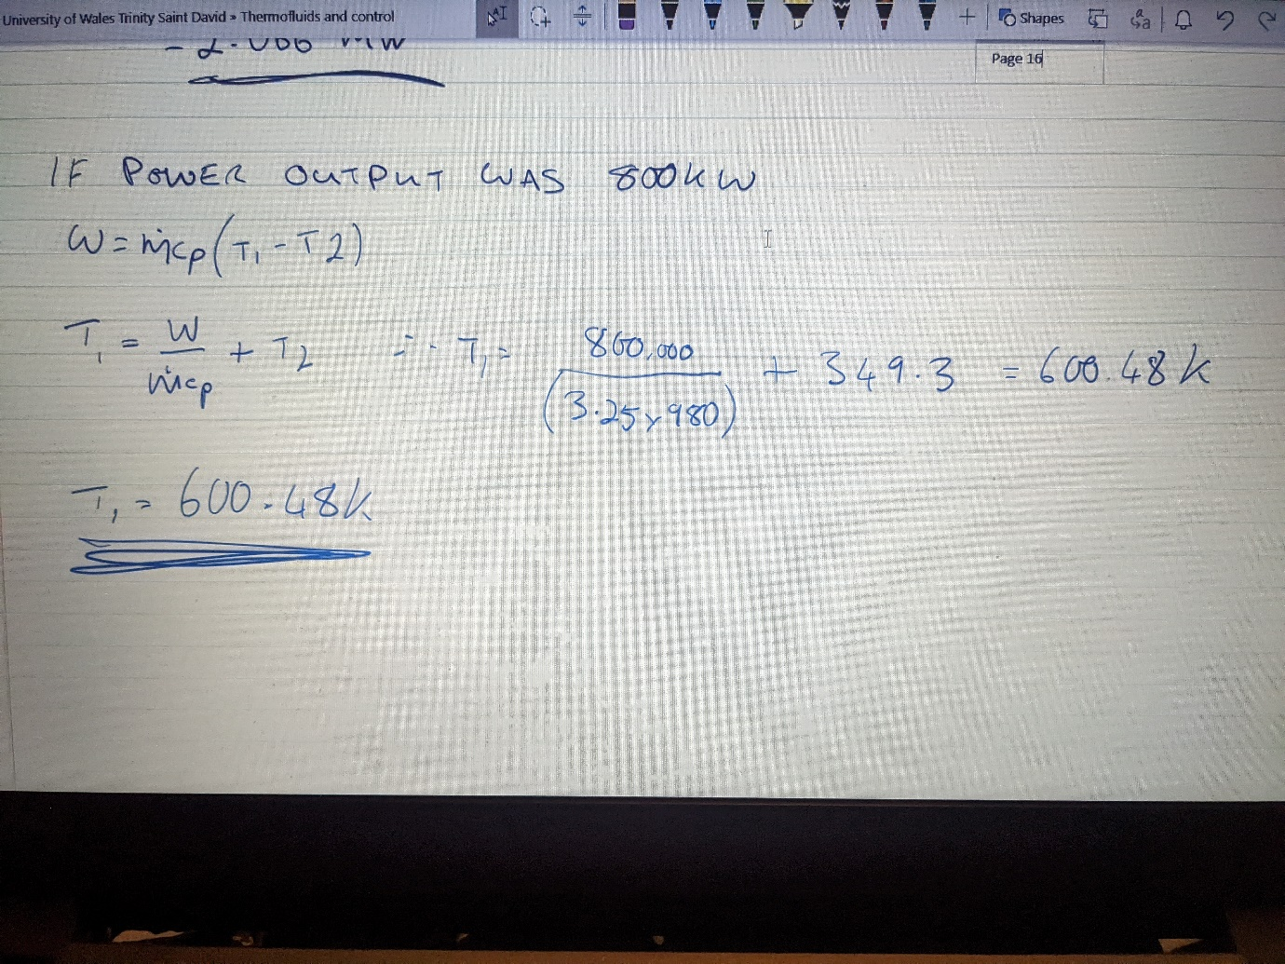
Part B
To improve efficiency in a gas turbine plant there are several different methods that are commonly used, as an example regeneration, reheating and intercooling to name but a few.
The first of these is a method which uses the exhaust gases from the turbine, this is funnelled to the heat exchanger to heat the compressed air before it goes into the combustion chamber. This helps reduce the cost of fuel for combustion as the gas has already been heated somewhat and therefore would take less heat to combust.
Reheating is a method for increasing the work done by the system. It actually takes place in two different turbines. The first is a high pressure turbine which allows the gas to expand to mean pressure and then funnelled back to the boiler where the gas is heated to a much higher “superheated” temperature which is in turn sent to another turbine thus increasing work done.
Intercooling is a method that reduces the temperature of the air entering the system or different parts of the system thus increasing the percentage of thorough combustion. This basically takes away heat generated from compression, as the increase in pressure increases the temperature, thus decreasing the amount of work the compression needs to do thus making it more efficient
Part C

