James Dexter (1907923)
Tutor: Jessica Shore
Developing Social Enterprise
Distinctivenss & Regeneration

Blaenafon Outdoor Education Eco Centre

Proposition to be submitted to: University of Wales Trinity Saint David’s Carmarthen

Figure 1

The location chosen for this appraisal will be Blaeafon

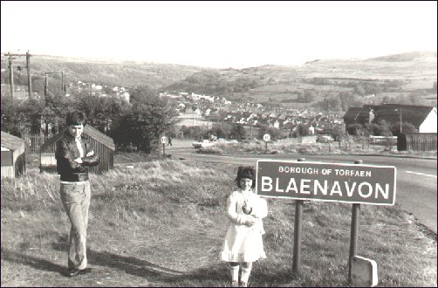
Figure 2

Blaenafon Outdoor Education Eco Centre Summary

Blaenafon

Blaenafon is place located in Wales that has helped impact the world in many ways from mining coal, creating iron and steel that would be disturbed all over the UK and worldwide. Blaenafons landscape was naturally made and was actually created by work that was undertook there which goes back to the beginning of the Industrial Revolution. The mining of coal and iron here led to a boost in human evolution leading to many materials we use today, in December 2000 it was announced to be a World Heritage site (Visit Blaenavon).

Since the end of the Industrial Revolution Blaeafon has not had much to offer and because of the closure of the pits there has been a massive drop in the money that is being created in this old town. Local shops can struggle to keep afloat and even harder to try a new business in the area. Being a heritage site does bring some tourism to the area during the better months of the year but always difficlut times during bad weather.

Addressing the issues for Blaenafon there has been many discussions for ideas which could help create more tourism and money to the area. An idea that came to mind for this community is an Outdoor education eco centre. There seems to be groups set up in blaenafaon including scouts and crafts as an example, these sorts of activities seem to be held in separate locations, this led to thinking about creating a place everyone can use and learn different skills and engage with others. with being eco-friendly and self-sustainable the project hopefully would be able to stay for many years and not see the fate of other business ideas. There is so many different opportunities that can be taken up that Blaenafon has to offer and this centre can help bring a new facility to provide activities that they may not have the opportunity to try, engage in and socialise hopefully bringing more to a community in need.

Contents Page

Page 1. Title page……………………………………………………………………………..

Page 2. Summary………………………………………………..……………………………

Page 3. Contents page……………………………………………………………………….

Page 4-6. Blaenafon…………………………………………………………………………..

Page 7. Outdoor Education Eco Centre …………………………………………….

Page 8-9. Conclusion…………………………………………………………………………

Page 10. References…………………………………………………………………………..

Blaenafon

Historical development

During the 18-19th century the Industrial Revolution had sparked, this time period shifted the way in which products were manufactured through an invention of steam engines, because of these large agricultural areas would transform into industrialised areas (A&E television). The invention of steam engines relied on coal as a fuel for the engines to work, Blaenafon was known for some of the best coal and as a result of the area and the rich minerals found in the hills made this location a hot spot for mining. Iron and steel were also made in Blaenafon making it even more popular and fuelling the revolution as transportation would start to be built in order to transport all these products across Britain and further. Originally Blaenafon would be used to mine its coal but later opening an iron works in 1789 due to an ambitious business idea by three entrepreneurs, these gentlemen had created a new way in which to extract iron and advancing the production of iron (Britain express, 2020).

Changing fortunes

Blaenafon used to be the largest and most important industrial landscapes of the century for producing iron ore. During the 1960’s the iron works was closed down and later that century in 1980 the pit known as The Big Pit was also officially closed for mining (visit Blaenavon). This would cause a huge impact for the Blaenafon community, the closure of the big pit would make more than 250 people out of employment. The pit being the main source of money for Blaenafon would impact all areas of this community as more people were becoming more financially restrained as there was no income. Being made into an industrial town was great for that period of time but nothing was put into place as a contingency for what would happen if the mines did close. The decision to make this site a world heritage site managed to bring some life back into the area and put a big stamp on the map. This has been a blessing for the area but does have limitations and is not always available to view. Although Blaenafon has created museums and attractions such as Big Pit, tourism is still on a down and also the engagement of community.

Existing features
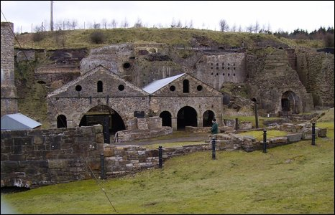
Figure 3
There are still plenty of features that Blaenafon have to offer, ranging from the iron works to even cycle paths.

Iron works – To this day some of the decommissioned equipment can still be seen in the area, many of the buildings in and surrounding the heritage site still stand and are protected by the site. The furnaces are still visible today with all theremains of the cast house, water balance tower and also the foundry (cadw).

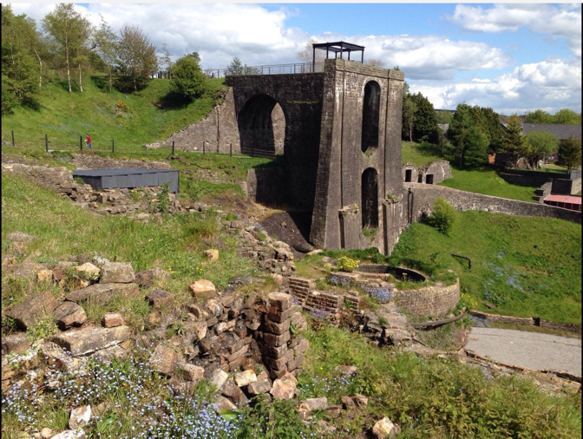
There is also a water balance tower that has been left for ruin but still stands strong and holds a good presence of the height of what was going on at Blaenafon. this tower was part of a multifunction furnace that was built in 1839 and is one of the best-preserved examples (Engineering Times). This part is one factor that made Blaenafon so unique in the industrial revolution and gave them the push they needed.
Figure 4

Mines – Being a mining community there are still mines that have been closed off since the closure of the operation. These mines can vary being open cast or closed meaning that some places have to be dug into where-as some coal can be found closer to the surface. This leaves a lot of unused areas that used to be constantly used and educational. The Big Pit is still open for the public to off the world heritage site, this is not open all year round and will need some planning as the pit can be closed during winter seasons and weather depending.

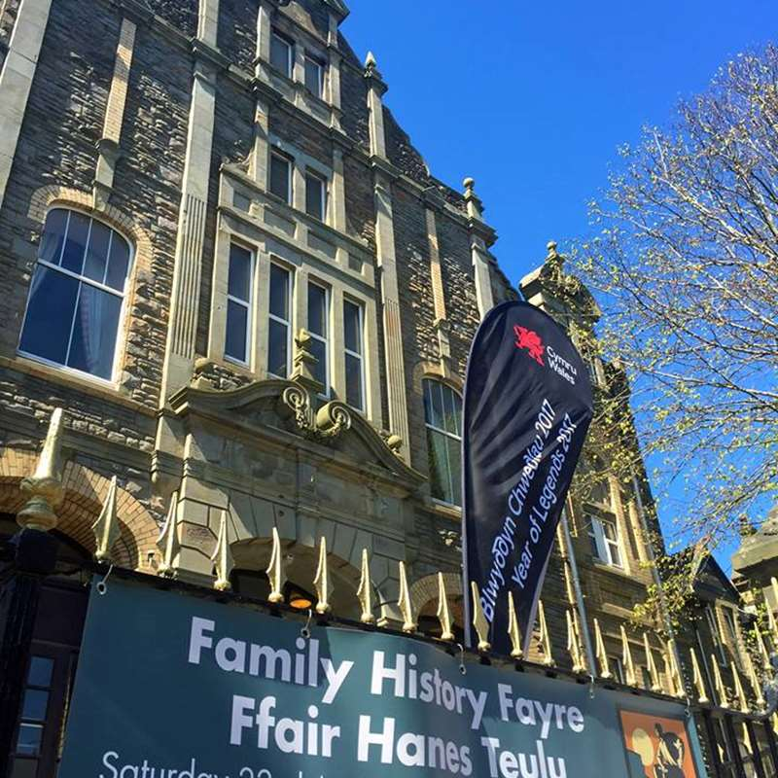
Museums – Once Blaenafon Big Pit became a world heritage site this led to museums being created allowing the history and the culture of Blaenafon to carry on and be available to anyone who visits. One of the museums has free entry and this one is located at the Bit Pit site, it does have some amazing artefacts and information boards that really get the feel of what the big pit was all about. Not just this but gave an insight to how people worked and lived and also survived the Industrial Revolution.
Figure 5

There is also the community museum that is not linked to the Big Pit and is its own individual museum, there is a small charge to enter and take the tour of the museum but all the money made from the museum goes back into the building to cope for bills and maintenance and also some items on loan.

Mountain, hill and flat areas – The location of Blaenafon is quite rural and is surrounded by mountains and hills, just all kinds of scenery.This makes Blaenafon such a beautiful place to visit even if there isn’t much to do. Due to the location and geography of Blaenafon initially made it so popular for mining. There can be so much done with the areas that are there even the flat parts of the area. these flat areas have so much potential to become anything.

Mountain bike trails – Looking into Blaenafon and the area for mountinbiking there is plenty of opportunity just there is no certified routes that can be taken. The only information found about cycling routes in Blaenafon are ones that people have created using their smart devices for mapping their routes. View Ranger (2020) has a post from cyclists that seem to use the Blorenge trail which tends to be around 7 miles long with medium difficulty.

Community groups – Blaenafons council has set up a website called Blaenavon Town Council, on this website there is a lot of information about Blaenafon itself and also what goes on in the town. There is a page that lists all of the community groups that have been formed in the area for anyone. This is a great way for Blaenafon to engage the community as there can be any group set up to get everyone involved. The groups vary from different activities to different reasons being set up. As mentioned in the summary was scouts and cubs, as you can imagine being a Welsh town there are football and rugby clubs available, there is even a horticultural society. Although there is a good amount of community groups there doesn’t seem to be one place in which everyone can get together and engage in their interest or even hold events other than the town hall. One thing noticed was that there is an environmental group associated with Big Pit that aims to help protect the landscape and features. There are also jogging and stroll groups that meet up to help people’s well-being and help progress (Blaenavon Town Council).

Local & Regional Development Strategies

Sustainable Development defines regional development as “Regional development strategy defines the objectives and instruments for the construction of the overall development potential, contribute to reducing inequalities in regional development and enhance the potential of those parts of the country which are lagging behind in the direction of the greater competitiveness.”. During the same post discusses are the relevant objectives for local developments as well again to help local communities tackle issues they have and to progress as a community. Finding what issues arise and focusing on these to help eliminate any possible issues in the future.

These sort of development strategies can also include to help communities and regions to become more sustainable and be aware of environmental impacts that they have and how to deal with these. These plans can be very hard to implement and to get passed certain groups like councils and communities. These can make a massive impact to communities all over and really can be stepping-stone in the right direction if done correctly.

Outdoor Education Centre

A social enterprise business of an Outdoor Education Eco Centre would be an amazing facility that anyone of all ages, abilities and walks of life can get together and engage in activities that can help them progress their skills or just have a meeting. This facility will be eco-friendly to minimise the impact that it would have on the environment and lesson of eco programmes like recycling to help education on how to help the environment and the impacts it can have. This can include solar power energy instead of fossil fuelled ones and also water treatment tanks as examples. There are many activities that the community take part in and this could become a Hub for every club to use. Other than community groups there are some unexplored activities that could really help give a new outlook to what can be done in Blaenafon other than visiting a world heritage site.

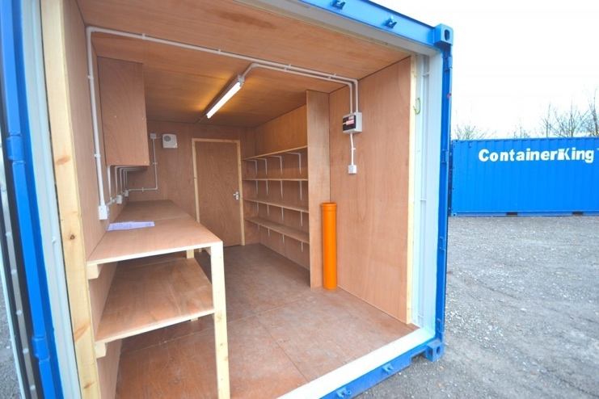
The centre would have to be a sizeable building to carter for multiple functions and have the necessary requirements like bathrooms and kitchen. Along with the building could be a storage container with a workshop to help maintain and repair any equipment used as well have plenty of room to keep the equipment, this will be a lockable unit. This can be a place for workshops sessions and crafting desks.
Figure 6

Outdoor activities could include mountain biking, mountaineering, skateboarding, rock climbing, potholing, orienteering, camping, trips out of Blaenafon, forest classes to learn how to craft in nature. This doesn’t mean these would be set as there will always be room for people to suggest and use their own groups or ideas. With outdoor activities some sessions would have to be sourced such as qualified rock-climbing leaders if there was an event to do a abseil down the water tower or even Duke of Edinburgh awards.

Indoor activities could include arts and crafts, environmental classes, sewing, yoga, computer lessons. The list for indoor can be massive but well-being is a must when it comes to building this facility as the centre will hold classes for people who may have issues and want somewhere to relieve stress and talk to other genuine people. This centre will be used as a hub meaning that it being community-based events could be held such as birthdays or fundraisers helping give a place anyone can use.

Conclusion
Blaenafon being a rural neglected area since the closures of the mines has left the town to find ways to entertain the community itself and try and generate money in a sort of lost heritage town. The community still has an amazing sense of community if anyone was to visit, they would find out. So, although there is a sense of community there still not much for people to partake in even the community groups already set up. On a field trip to the town of Blaenafon conversations were had with the local people in the shops and pubs finding out what they thought about Baenafon. This included how long they had loved in Blaenafon, their sense of community and what they thought could be improved. Technical issues meant information was not recorded other than mental notes.

Blaenafon has had many changed throughout the years and business have tried and failed in this rural town. Bringing something new and exciting to a town that has no limits to who can use it will allow more people to allow some of their ideas to become a reality. Being able to hire a room of the facility will enable people to gather in one place and be more organised. These bookings can be booked by anyone and for anything.

This building can have endless results in helping the community, one way it can help is by being eco-friendly setting a mark of what people can do to become more sustainable. Having the building run from solar panels and water treatment tanks means this business can be sustainable meaning less upkeep and less bills to be paid allowing more money to be reinvested. With the world being environmentally friendly conscious lessons can be taught in terms of what they can do to make themselves have less of an imprint on the environment with recycling and growing own food.

Outdoor activities like listed previously in this report allow people to get a sense of exercise with enjoyment. These activities can help people grow their skills whether it is personal or helping others everyone would play a part. Some people may never explore sports further than rugby and football offered by schools so introducing more may help relieve antisocial behaviour as they will have something else to put their energy into. Outdoor events are another great opportunity the facility can help with as bookings could be made to bring say rock climbers who can set up climbing walls, another one could be skateboarding sessions with portable ramps. There are outdoor clubs that could come in from other areas to engage with the Blaenafon community and vice versa allowing more tourism into the area

Parents as imagined these days can struggle to find ways other than games consoles and mobile devices to entertain their children, offering a place that can offer all kinds of sessions like arts and crafts, yoga, sewing etc can help keep anyone occupied if they want to learn something new. Well-being lessons could be held at this centre to help people who want to reach out but can’t feel confident in a place-others feel the same.

This Outdoor Education Eco Centre could become one of Blaenafons most important facilities due to versatility of the facility. The potential benefits that it could bring for the community can be amazing. A place that everyone can enjoy and adapt to their own needs, somewhere for people to grow as a person. An Educational tool that young people can use to set their minds in the right mindset for the future with different experiences they may have been closed off to. People from all areas of the UK and further can get involved if they want to hold their own sessions in the facility or get bookings from Blaenafon.

References

Figure 1, University of Wales Trinity Saint Davids picture University of Wales Trinity Saint David’s, 2020, https://www.uwtsd.ac.uk/undergraduate/

Figure 2, Blaenafon picture, Memebers Tripod (2020), Blaenafon, Introduction to Blaenafon, http://members.tripod.com/~Family_Thomas/blaenafon.htm

Visit Blaenavon, Learning, Visit Blaevon (2020), https://www.visitblaenavon.co.uk/en/Education/Education.aspx

A&E television, History, updated 2019, retrieved from: https://www.history.com/topics/industrial-revolution/industrial-revolution

Britain express, Britain express, Blaenavon Ironworks, 2020, https://www.britainexpress.com/attractions.htm?attraction=840

Cadw, Welsh Government 2020, visit Blaenavon Ironworks, Overview, https://cadw.gov.wales/visit/places-to-visit/blaenavon-ironworks#facilities

Figure 3, Davies G, BBC East Wales, Blaenavon’s heritage 2009, http://news.bbc.co.uk/local/southeastwales/hi/people_and_places/newsid_7909000/7909894.stm

Engineering times, water balance tower, Blaenavon ironworks 2020, http://www.engineering-timelines.com/scripts/engineeringItem.asp?id=139

Figure 4, Blaenafon water balance tower picture, Trip Advisor, Blaenavon Ironworks 2020, https://www.tripadvisor.co.uk/Attraction_Review-g1475934-d2092332-Reviews-Blaenavon_Ironworks-Blaenavon_Torfaen_South_Wales_Wales.html

Figure 5, Blaenafon community museum picture, Blaenafon Town Council, Community Museum, 2020, http://www.blaenavontowncouncil.co.uk/our-town/community-museum/

View Ranger, mountain bike routes, Blorenge Wales, 2020, https://my.viewranger.com/route/details/MTQ3NjEwMQ==

Sustainable Development, Sustainable Development, Regional Development Stategy 2020, https://sustainabledevelopment.un.org/partnership/?p=2116

Fidure 6. Container king, new build 20ft x 8ft workshop and store container. Built to order, 2020, https://www.containerking.co.uk/buy-cabins/buy-cabins-single/kng71605-new-20ft-workshop-store-container-conversion

